AUSTRALIA INDONESIA BASIC EDUCATION PROGRAM (AIBEP)

SUMMARY REPORT OF AIBEP SCHOOL AND DISTRICT SURVEY 2009-2010
(Part 3, Chapter 4)

TABLE OF CONTENTS
TABLE OF CONTENTS
Chapter 4 – The Students 36
4.1 Enrolment 36
4.2 The Feeder Schools: From where do the students come? 42
4.3 Children from Poor Families 42
4.4 Number of children refused a place 42
4.5 Physical Disabilities and Intellectual Problems 43
4.6 Absenteeism, Drop Out and Promotion 44
4.7 School Leavers and Aspirations to Pursue Senior Secondary School 45
4.8 Prospective Students for Non Formal Education (NFE) 47
4.9 Students’ Views on Schooling 48
4.10 Factors contributing to student learning 49
4.11 A Summary Comment 50

Chapter 4 – The Students

  - Enrolment

- The prime objective for constructing 2000 BEP schools was to improve access and participation at the post primary level by bringing junior secondary education closer to the community especially in poor and remote regions of the country. The targets are on track to be successfully achieved, as by the school year 2009-2010, the 1899 operational schools had enrolled more than 137,000 students. Figure 19 shows the overall growth in enrolment since 2007.

- Of 137,033 students in school year 2009-2010, 47% (64,813) of them are in Grade 7. This figure is important in projecting forward the likely enrolment when all schools are fully operational.

Figure 23: Total Enrolment in BEP schools

- The total enrolment of more than 137,000 also represents a high level of gender parity with 48.7% of female students.

- On a per school basis the average enrolment of 129 students per USB is less than the national average of 328 students per school but greater than the average for USBs in eastern Indonesia which is only 90 students per school (MoNE database, 2008). The average enrolment in the BEP SATAPs is currently only 62 students per school. These figures can be expected to increase over the next two years as community awareness increases and the schools reach maximum intake.

- However, across all BEP schools the distribution of student enrolment about the average is uneven. For illustration, a SATAP school in Poso, Central Sulawesi, has only 14 students, compared to a SATAP school in the nearby district (Parigi Moutong) with 330 students. For USB, the range of student enrolment is from 15 (Kotawaringin Barat) to 563 (Manggarai NTT). The smallest MTs is in Nganjuk, East Java with 8 students and the biggest is in Jepara, Central Java with 339 students.

- During the period 2006 to 2009, the National Gross Enrolment Rate (GER) at junior secondary level increased from 88.68 to 96.18 an increase of 7.8%. In the BEP MoNE districts where school construction and other capacity building took place, the increase was from 75.98 to 88.40, an increase of 16.34%.

- The change in the Net Enrolment Rate (NER) at junior secondary level was even more noticeable with the BEP district rate increasing on average by 25.2% over the three years from 55.07 to 69.10 compared to a national increase in NER from 66.01 to 71.60 or an increase of 8.5%. The graphs below (Figures 24 and 25) show the GER and NER distributions for the 141 BEP districts where BEP has constructed schools in partnership with MoNE. Figures (26 and 27) show the reduction in the number of BEP MoNE districts with low GER and NER levels between 2006 and 2009.

Figure 24: Distributions of BEP Districts by GER (JSS – Junior Secondary School) 2006 and 2009
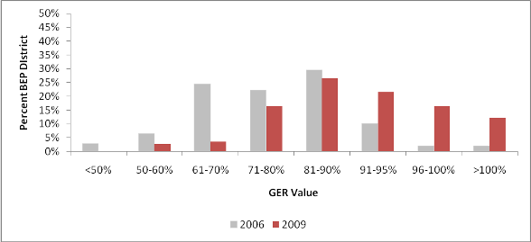

Figure 25: Distributions of BEP Districts by NER (JSS – Junior Secondary School) 2006 and 2009
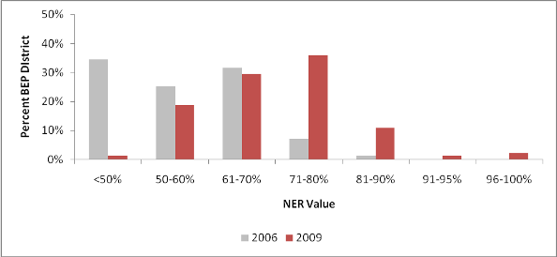

Figure 26: GER at JSS (Junior Secondary School) in BEP Districts
Median GER 2009: 88.40

Figure 27: NER at JSS (Junior Secondary School) in BEP Districts

- National figures show that 81% of JSS students are within the age cohort of 13-15 years, and most (79%) of the students in BEP schools are also within this correct age group (see Figure 28). The 9 percent of JSS students below 12 years old in BEP schools was similar to the national figure of 10%. 12% of BEP school students are over the age of 15 years compared to only 9% of students nationally. This may be the result of students previously enrolled elsewhere taking advantage of the new schools to complete JSS closer to home, perhaps after a period of dropout or other break in study.
Figure 28: Age of Students

- The average (Mean) number of students at Grade 7 in the first year of operation is decreasing (Figure 29). In the case of MoRA schools the change is dramatic from 62.58 in 2007 to 20.5 in 2009. The first 45 MoRA schools in 2007 were located in relatively large Pesantren which had established primary schools (MI) with most students being boarders. The MI provided a strong feed of students to the new MTs and explains why those 45 schools had greater Grade 7 enrolments than the SMPs first established in 2006-2007. MTs established in later years were often located within smaller pesantren with smaller MI enrolments and have so far generated lower Grade 7 enrolments. Average Grade 7 enrolments at government SMP slumped after the first year but seem to have stabilised since then.

Figure 29: Enrolment at Grade 7

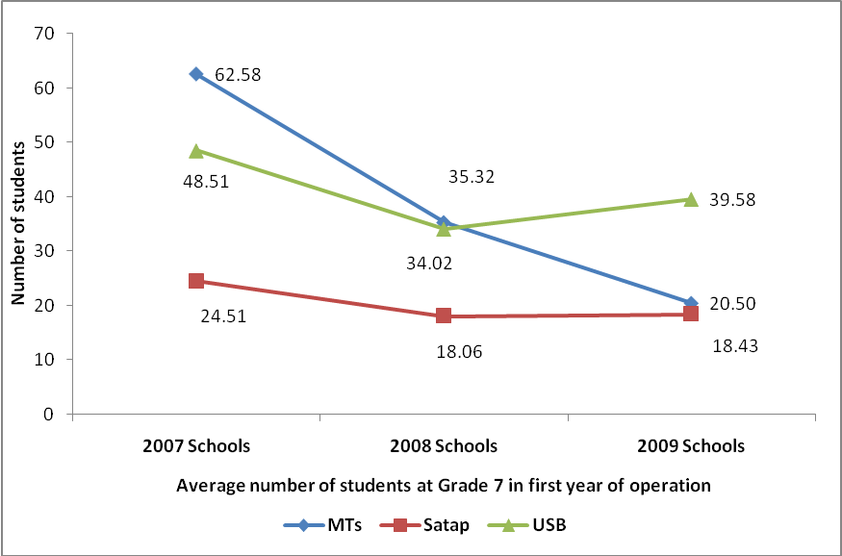

- Examination of Figure 30 reveals that over the past three years the enrolment at each grade level in 876 MoNE SMP that became operational in 2007 is moving closer and closer to parity. Enrolment at Grade 7 is stabilising and a high rate of through-put or promotion and low dropout means that Grade 8 and 9 enrolments are trending towards the Grade 7 level. This suggests that the long term enrolment at these schools will be perhaps at best a little more than three times the current Grade 7 enrolment or about 100,000 to 105,000 students. A similar pattern is apparent for the 45 MTs that were also opened in 2007 – Figure 23.

Figure 30: Enrolment Progress in 876 MoNE first opened in 2007

Figure 31: Enrolment Progress in BEP MoRA schools

- Figure 32 shows that some of the new SMP especially some SATAPs had already allowed students to study for Grades 7 and 8 before the new school was completed and that some students had transferred from other schools. Those latter students took advantage of the easier and almost certainly cheaper access to the new school. However, the proportion of enrolments at Grade 8 and Grade 9 is decreasing, meaning that this sort of shift is probably a ‘one off’ event and cannot be expected to continue.

Figure 32: Grade 8 and Grade 9 enrolments in First Year of Operation

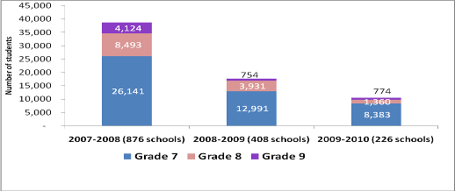

- In total, there are 365 BEP schools that have less than 20 children enrolled in Grade 7. More than two thirds (68%) are SATAP schools, 19% are USB, and 12% of them are MTs. One third of these schools are located in ten districts i.e. Banggai, Banggai Kepulauan, Bolaang Mongondow, Kapuas Hulu, Kotawaringin Barat, Kupang, Minahasa, Minahasa Selatan. Minahasa Utara, and Melawi. Figure 33 below shows the proportion of BEP schools with fewer than 20 children at Grade 7 in each MoNE province.

- It is possible that these low enrolment figures are due to fact that the majority of these schools (74%) are in their first year of operation. However there are 95 schools (26%) which are already in the second and third year of operation. These 95 schools consist of 42 SATAP schools, 22 USBs and 31 MTs. An investigation to the feeder schools for these 95 schools found that on average only 19% of the leavers from these feeders went to BEP schools, the majority of them (around 78 %) went to non-BEP schools available in the same areas.

Figure 33: Proportion of BEP Schools with Children at Grade 7 less than 20

  - The Feeder Schools: From where do the students come?

- One of the criteria used in the site selection for new school construction is the number of Grade 6 students in potential feeder schools near to the site.

- In February 2010, BEP visited 1,000 feeder schools listed on the selection database collecting enrolment data and information about the students who graduated from Grade 6 in June 2009, how many went to: (i) BEP schools (ii) non-BEP schools (iii) did not continue to JSS.

- The survey found that on average a USB school has five feeders, SATAPs have an average of three feeders and each MTs has around seven feeders. For all MoNE schools, the feeders are local primary schools (SD and MI). In the case of MTs, the seven feeders may include up to four MI from outside the local area.

- The main feeders on average provide between 60%-85% of the students. About 65% of the students in BEP MoNE schools come from two feeders; three feeders on average contribute about 80% of the new enrolment.

- SATAP schools on average get nearly half (45%) of their Grade 7 enrolees from the SD to which the SMP has been added.

- In the 1,000 feeder schools surveyed, about 66% of their students who graduated in June 2009 went to BEP schools, 30% to non-BEP JSS, and 4% were reported as not continuing to JSS, instead either working at home or in other employment.

  - Children from Poor Families

- The survey defined a poor family as a family who is listed in the government’s “Keluarga Miskin (Gakin)” scheme. This definition is used to provide a consistent standard in assessing poverty. In total the schools reported a slightly lower proportion of students from poor families between the 2008 and 2009 surveys – down from 51% in 2008 to 48% in 2009 – but absolute numbers were higher.

- The three provinces in 2009 reporting the highest percentage of students from poor families were NTT (92%), Maluku (85%), and Gorontalo (79%). Together with Papua and Papua Barat, these three provinces are among the poorest in Indonesia. In particular, Gorontalo is the poorest province in Sulawesi (Susenas 2009).

- However, this survey found that poor families are not necessarily associated with malnourishment, as the proportion of malnourished students was reported as being only 3%. However, these data cannot tell us about the nutrition status of the children.

  - Number of children refused a place

- The 2009 survey found that 24 schools had refused applicants a place in the new school. A total of 58 students were excluded because no place was available at the time of application. All refusals applied to students wishing to enter at Grade 7. An examination of the enrolment data at Grade 7 for these 24 schools combined with the number of classrooms indicated that 18 schools were overpopulated and the other six schools (all of them are MTs located within Pesantren) reported that the applicants were refused a place because they were unable or not willing to live in the Pesantren as boarders. This of course challenges one of the main premises on which the BEP construction program was based – namely to meet local demand for junior secondary education where no access was available – and also raises the issue of choice and whether parents were consulted and given a choice as to whether a government school or a Madrasah was the preferred option for meeting that demand. No students were reported as being rejected because of disabilities.

  - Physical Disabilities and Intellectual Problems

- BEP has positively supported the concept and practice of IE by requiring that the BEP schools be constructed with ramps and special toilets that cater better for children with physical disabilities. The Government of Indonesia’s policies as reflected in the recent Ministerial Regulation (No. 70/2009) on Inclusive Education on 5th October 2009 require that schools not refuse places to children with physical or learning disabilities and actually promote the idea that schools should reflect the broader mix of the society and not simply be enclaves for the most able. The interviews revealed that the commitment and also the capacity of BEP schools to respond to this regulation are still varied (see Text Box 5).

- The proportion of students with intellectual problems was reported as higher than for students with physical handicaps (Figure 34). The principals in the school survey asked the Ministry to consider providing a more comprehensive level of support such as more trained specialist teachers, special learning and library facilities, and to promote peer group acceptance to affirm the value of inclusive educational settings.
Text Box 5:
Service to Disabled Students:
Commitment and Capacity of the School

“...Our school is committed to observe the equal rights of the students with physical and mental challenge to get education... Our school has built the infrastructure, which is friendly for students with physical or mental challenge, for example sitting toilet and one special path” (Adhi Wahyu, Headmaster, Kotawaringin Barat)

“...Teachers are not ready to have students’ physical and mental disability, because of the limitation of our capacity as well as our facility and infrastructure”
(A teacher from Gorontalo)

- Many studies have shown a close association between physical, intellectual, health and social problems. Both the 2008 and 2009 survey reported that there were virtually no students with physical and intellectual disabilities who also showed evidence of social maladjustment. While this suggests that local communities, including school communities are very supportive of children with disabilities it also suggests that the BEP, and especially the WSD component, have successfully helped to overcome any latent stigmatisation.

Figure 34: Physical Handicaps and Intellectual Disabilities

  - Absenteeism, Drop Out and Promotion

- Absenteeism

- The schools were asked provide the numbers of children in each grade who did not attend the school on the day when the survey was conducted. This was essentially a one day snapshot of attendance patterns. The attendance was verified through direct observation of the individual classes by the enumerators.

- The reported Absenteeism rate in 2009 was a little higher than 2008. The major reasons given for absenteeism in 2008 and 2009 were similar – (i) the child is sick and (ii) he or she is helping parents at home. Interviews with students in October 2009 documented that raining season in 2009 came earlier that year which meant that many parents were busy with their farming and needed the help of their children.
Figure 35: Absenteeism and Drop Out

- Of MoNE students who were absent on the day of the survey, 74% were reported as ill, 12% were reported to be helping their parents, 8% having problems with transportation, and 6% as being absent for other reasons. The survey also found the level of absenteeism among boys was higher than girls for all types of BEP schools and in all grades. Follow up interviews with students in Kalimantan Tengah and Sulawesi Selatan conducted a few weeks after the school survey found that the absenteeism rate among boys was higher because boys were asked by their parents to help them work on the rubber plantations (Kalimantan Tengah) and with fishing (Sulawesi Selatan).

- Drop-out

- The drop-out rates for girls in all grades are less than the rates for boys (Text Box 7). In 2009, the drop-out rates for Grades 7 and 8 were slightly higher than in 2008, but showed no difference for Grade 9. In total, in 2009 some 2,936 children (2.2%) dropped out and are no longer attending school and reportedly have not moved to another school.

- The reasons given for these drop-outs include:- low income of parents (36%), looking for a job (25%), helping parents (18%), marriage (10%), no motivation (9%), intellectual problems (1%), long distance to school (1%), and physical disabilities (only 1 student). The first three reasons which are all poverty related accounted for 79% of the reported drop-out.

- The overall drop-out rate was still below the national average of 3.4%, although four provinces had very high drop-out rates, namely NTT (22%), Sulawesi Selatan (18%), NTB (16%), and Kalimantan Barat (11%). Follow-up interviews with parents and students in NTT, Sulawesi Selatan, and NTB further supported the poverty effect. “Becoming migrant workers” and “helping their parents” were the major reasons reported by both parents and students

Text Box 6:
Why drop out among boys is higher than for girls

“The drop out cases among boys is generally because they have to help their parents to work at home”. Mr. Suwandi, Parent, Kotawaringin Barat, Kalteng

“Students dropping out from school are commonly boys because they have to help their parents earning money” Mr. Ridwan, Principal, Polman, Sulsel)

“There are many male students quitting which is caused by two factors, personal and environment. Parent’s economy ability also one of the factors. There are also male students having big postures and become an ‘ojek’ (motorcycle taxi driver) and it makes them reluctant to go back to school because they can already earn their own income.” Ms. Rosa Maria, Teacher, Nagekeo, NTT

- Promotion

- Promotion is only applied by the school in Grade 7 and Grade 8, as promotion in Grade 9 is decided through National examination. There were 1,857 MoNE students (1.5%) and 302 MoRA students (2.5%) NOT promoted for continuing study in 2009-10. The proportion of students not being promoted halved from the previous year, yet was still higher than the national figure of 0.42% in 2008. There is no significant difference between boys and girls in terms of promotion from grade to grade.

- National examinations

- In total, 9,693 grade 9 students were reported as taking the national examination (Ujian Nasional) in 2009 with effective gender parity - 4,877 boys and 4,816 girls. Their reported pass rate was 87.63% - below the national pass rate for Grade 9 of 92.75%, but slightly higher than the pass rates for all schools in BEP districts (87.46%).

  - School Leavers and Aspirations to Pursue Senior Secondary School

The Leavers

- Nearly 90% of students leaving BEP junior secondary schools in June 2009 went on to attend senior secondary school (SMA, MA or SMK) compared to less than 80% of students leaving Class 9 in non BEP schools in the same districts (see Figure 36).

Figure 36: Where did the school ‘leavers’ go?

- The survey reported only a small percentage (2%) of parents who did not want their children to continue to senior secondary school (SSS). The student survey reported also that only a small percentage (less than 2%) of students do not want to continue their study. SMA is preferred by the great majority of students (70%) as well as by the parents (65%). As students’ plans are strongly aligned with parents’ aspirations, the decision about what students will do after JSS graduation is generally the result of negotiation between parent and child (Figure 37).

Figure 37: Who makes the decisions about what students will do after JSS graduation?

- Every effort is made by planners to ensure that schools are only built at sites where there is a sufficient and sustainable supply of students within the catchment area. Students and graduates of BEP JSS are definitely a significant supply for senior secondary schooling (SSS), and so there is a need for further investigation on the urgency of opening new SMA and SMK. The 2009 survey put additional questions to help the GoI identify those SMA and SMK to which the graduates of the BEP SMP and MTs are graduating.

- In fact, 28 of the BEP junior secondary schools are currently providing senior classes to enable their junior secondary graduates the opportunity to continue their education even though no SSS is available nearby. Since the local authorities have limited ability to construct new schools, the response to the increased demand for SSS was overcome by operating what might best be called ‘emergency’ SSS classes at the site of existing BEP schools. The need was confirmed by more than 50% of school principals who admitted that their graduates do not have sufficient access to Senior Secondary School (SSS).

- In relation to SSS access within the areas, 74% of parents confirmed that their children would have sufficient access in the sense that places are available, but the distance to the nearest senior school was regarded as being too far – often more than 10 kilometres.

- Parents and the principals have different aspirations on how access to senior secondary education should be increased (see Figure 38). A majority of parents (61%) preferred to have SATAP type development by adding Grades 10-12 on to an existing SMP, whereas a majority of school principals (56%) suggested the building of more new senior secondary schools of the USB type.

- The data indicates that there is a need for all districts to begin planning for a more integrated provision of infrastructure from pre-school through to and including senior secondary. Failure to do so will almost inevitably result in wastage of scarce resources and other operational inefficiencies and also a lack of opportunity for many junior secondary graduates in the BEP districts.

Figure 38: Strategies to increase access to Senior Secondary Education favoured by parents and principals

  - Prospective Students for Non Formal Education (NFE)

- Non formal education may take place both within and outside educational institutions and cater to persons of all ages. The education program offered includes adult literacy, basic education for out-of school children, life-skills, work skills, and general culture. Some programs – Pakets A, B and C – are designed to provide for students who have previously failed to complete primary, junior secondary and senior secondary respectively. 564 (28%) BEP schools reported strong demand (more than 32 potential students per school) for NFE from the communities surrounding the schools with total potential student numbers in excess of 25,000 (see Figure 39). Almost half of the demand is for Paket B (10,350). BEP schools have the potential to meet this demand as more than half of BEP schools (59%) are willing to provide a room and teachers for non-formal education classes after school hours.

- Across all schools and communities the total potential demand for NFIE programs of all types was 34,565 students.
Figure 39: Non Formal Education in BEP Districts

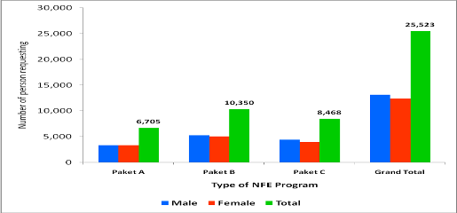

- MCPM ascertained from the district survey that there are few if any barriers to the BEP schools offering to provide NFE classes. Generally, all that is required is a letter of request to the Head of District Education (Kepala Dinas Pendidikan). Some BEP schools have already begun offering classes at the request of their communities.

  - Students’ Views on Schooling

- It is interesting to read answers from students about the schools they attend.

- Figure 40 shows that students strongly agreed that learning in their schools is fun (71%), that teachers encourage them to be part of active learning (71%), that they are encouraged to study for themselves (65%), and that they like the school because they are with their friends. This is undoubtedly a strong motivator for attending a local school which is also most likely to be attended by your friends and relatives.

Figure 40: Attitudes to schooling: the students’ views

- On the learning process and perhaps in some ways contradictory to the previous views (para 175 above) students also said that they have to make many notes, commit much to memory, and do homework every day after school (Figure 41). However, teacher favouritism of the better academic students is not regarded as a problem, only one out of four students strongly agreeing that their teachers favour the best students.

Figure 41: Students’ views on the learning process

- Positive support both from their teachers and parents is strongly identified by the students as motivation for learning. Figure 42 shows that more than 50% of students strongly agreed that their parents are supportive to their studies. They also agreed that their teachers help them to learn from their environment and to maintain a purposeful linkage with their environment.

Figure 42: How parents and teachers support student learning: Student views

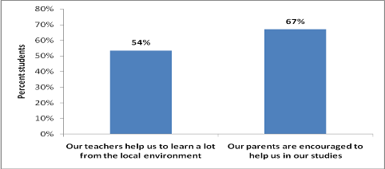

  - Factors contributing to student learning

- When asked to indicate their choice of the three most important requirements for improved student learning, students gave high importance to having improved school facilities, availability of text books, and classroom testing. When the same questions were asked of parents, they indicated the same factors i.e. greater availability of textbooks, classroom testing, and school facilities (see Figure 43). Many students and the parents seem to share the view that their teachers are qualified enough and so the answer to improved learning does not necessarily depend on teacher training. Their priorities instead are focused on improving general school resources and activities including text books and better use of classroom testing, although both of these require competent teachers if they are to be effective in raising learning performance.

Figure 43: Perceived importance of factors contributing to student learning:
Parental views and Student views

  - A Summary Comment

- A total of 137,033 students were enrolled across Classes 7, 8 and 9 in school year 2009-2010 with 48% of those students coming from families qualifying for Government support under the Keluarga Miskin (GAKIN). Even so, despite this support, drop-out due to financial considerations is still a major concern. The boys’ drop-out rate is higher than for girls due to the fact that more boys are expected to help out by working at early age to bring more income for the family. However, the fact that nearly 90% of students leaving BEP schools in June 2009 went on to attend senior secondary school (SMA, MA or SMK) compared to less than 80% of students leaving Class 9 in non BEP schools in the same districts reflects highly on their finishing grades in junior secondary, on their teachers and parents, and on their aspirations to keep learning even though the economic difficulties are great.

- Gender parity in BEP schools is high with 48.7% of female students. BEP schools fully support the principles and practice of Non Formal Education (NFE) and Inclusive Education (IE) by providing NFE classes and through their efforts to accommodate the needs of all students, including those with disabilities. No student was reported to have been refused a place because of physical or intellectual disability.

- Overall, the enrolment in the BEP schools is expected to increase over the next few years as community awareness and appreciation of the importance of children’s education becomes more extensive and the existence of these newly constructed BEP schools becomes more widely known.

- Of course, the potentially negative impact of having insufficient places in reasonable proximity for all those Grade 9 graduates wishing to continue their senior secondary education should be a matter of concern to authorities at all levels.

MoNE (2008), Indonesia Educational Statistics in Brief 2007/2008, Jakarta
Survey Sosial Ekonomi Nasional (Susenas) is annual social economy survey conducted by BPS (Badan Pusat Statistik - Indonesian Statistics Agency). The 2009 Susenas data were published by BPS in “Statistical Yearbook of Indonesia 2009”.
In the survey, the students were asked to circle the number (1=strongly agree to 5=strongly disagree) that they felt best represented their views.

