A proposed pilot scheme aimed at harnessing the potential of Agricultural Seeds and Services (Pvt) Ltd. to improve smallholder food security

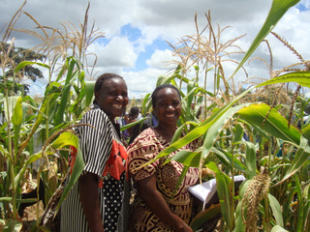

Harare, 28 August 2009

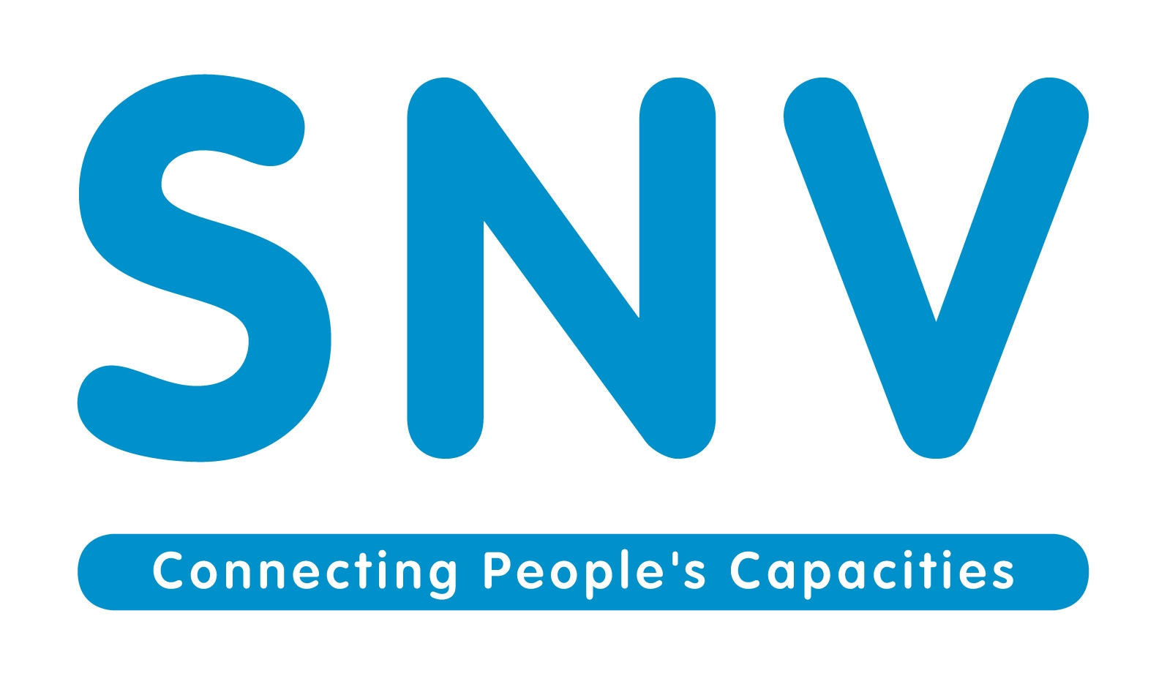

- Executive summary
This proposal describes an innovative pilot programme which comes at a highly appropriate time when Zimbabwe is embarking on agricultural recovery. The administrative, resource and grower base of AgriSeeds is utilized to assist 2,200 smallholder farmer households (13,200 people) in two provinces become food secure. Farmers will also be contracted to grow seed for food crops (sorghum, cowpeas and groundnuts) which are important food sources for rural Zimbabweans. Income security of contracted farmers will also be secured through guaranteed minimum market prices. Farmer beneficiaries will be expected repay input loans to AgriSeeds which will credit a revolving fund. Benefits accruing to farmers include (1) food security, (2) income security (3) training in Good Agricultural Practices and (4) training in basic business management. Benefits to the company include (1) seed supply, (2) improved productivity and reliability of contract grower base, (3) good will from growers and local authorities and (4) potential increase of grower base. Food security will also be enhanced at the national level because food seeds are in short supply at national level. Sustainability of the programme is met in a number of ways. Firstly, the use of farming methods that conserve soil and water will introduce growers to a sustainable farming system. Secondly, farmers will continue to receive embedded agricultural services and guaranteed markets through the continuation of the contract farming system with AgriSeeds. Thirdly, project sustainability is guaranteed by the establishment of a revolving input fund which will circulate input loan repayments made by farmer beneficiaries to guarantee input supply for the coming years.

This approach is a joint effort by the Dutch Ministry of Development Cooperation (DGIS) and the Australian Agency for International Development (AusAid). The approach promotes gender mainstreaming throughout the whole program. Women will be economically empowered.

Note on timeframe
This proposal describes a programme that will be implemented in the 2009/10 agricultural season. The success of this programme depends on the early transfer of funds because:
- Some of the inputs may have to be imported. This could take 2 months depending on the sources
- Farmer selection must take place as soon as possible
- Training of extension services and beneficiaries has to start soon
- The agricultural season starts in 3 months (November 2009)

- Introduction
In recent years Zimbabwe has been characterised by political and economic instability. Agricultural productivity has dwindled and the country, once dubbed ‘the breadbasket of Africa’, has become a net importer of food. The destruction of input and extension support services has contributed to historically low productivity in the agricultural sector. Figure 1 shows the trends in national productivity for maize and cotton which represent the most important food and income generating crops for smallholder farmers, respectively. Two important observations should be noted:
- The decline in cotton yield has been less than the maize yield decline. This is because cotton marketing companies provide contracted farmers with input and extension support.
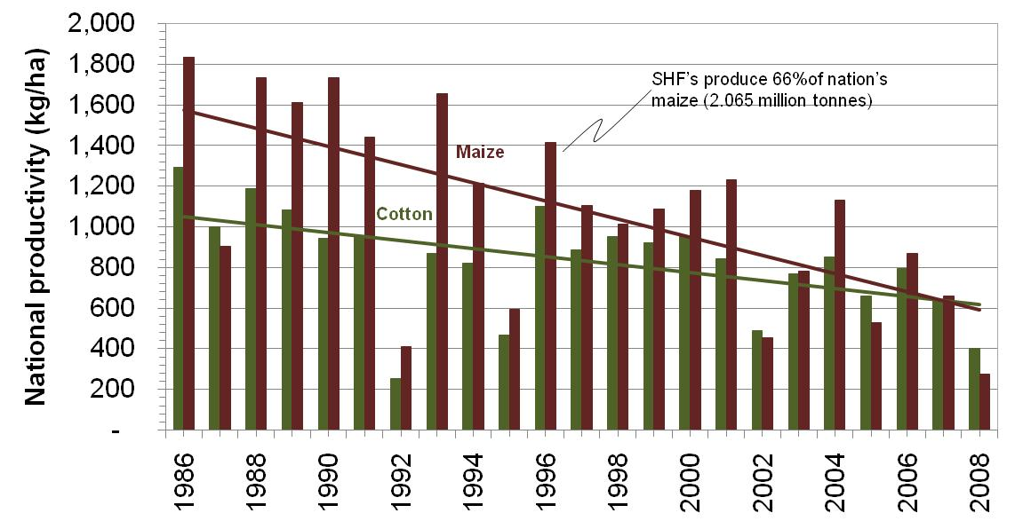
- Average maize production in good years is low. Zimbabwean hybrid maize varieties have the potential to produce in excess of 10,000 kg/ha. The yield potential of open-pollinated varieties (OPV) is slightly lower at 7,000-8,000 kg/ha.
Figure 1 Average national maize and cotton productivity for the past 20 years

The formation of an inclusive government at the beginning of 2009 has ushered in an era of greater political stability. These political developments were accompanied by significant economic reforms which together have laid the foundations for agricultural recovery. However, there are indications that recovery will be slow. The new ‘multi-currency’ based economy is characterised by a shortages of funds. Donor support is urgently required in agriculture because government does not have the capacity to assist farmers with input and extension services.

In recent years the donor and NGO communities have made good progress in increasing smallholder farmer productivity. The reason for this change is that interventions have progressed from focusing purely on provision of agro-inputs and now include technical extension support. Many donors promote conservation agricultural (CA) methods that focus on proven soil and water conserving methods including land rotation, minimum tillage, mulching and potholing. This methodology has empowered farmers throughout Zimbabwe. Impressive increases in yield have been reported in numerous programmes that prove that smallholder farmers are capable of producing sufficient harvest to become food secure.

Despite these advances, smallholder farmers are still a long way from becoming commercially viable. Productivity will not be sustainable unless the farmers have annual access to input and extension resources. Governments and donors should not be expected to continue the long-term funding of input and extension services. Commercial viability (i.e. sustainability) of smallholder farming starts with the recognition that farmers have constraints other than access to input and extension services including lack of profitable markets, transport, business acumen, finance and infrastructure. The majority of NGO programmes are unsustainable because they do not have a holistic approach to smallholder farming constraints.

An alternative model is to develop existing contract farming arrangements that exist between farmers and the private sector. Companies have the capacity to provide farmers with a comprehensive range of embedded services that enable them to successfully produce and market their crops profitably. Another advantage of the private sector approach to smallholder farming is that it is commercial driven and therefore aligned to teaching farmers commercially realities. Conversely, the NGO approach has a humanitarian focus and rarely advocates on farming as a smallholder business opportunity. Use of the private sector in this programme will therefore assist farmers to become more professional in the production of important food security crops.

AgriSeeds has been working with smallholder farmers since 1988. Farmers are contracted by the company to grow a wide variety of crops for seed including maize, sorghum, millet, cowpeas, Jugo beans, sugar beans, groundnuts and sunflower. The depth of experience that the company has in dealing with the smallholder farming community creates significant synergies with donor organisations with food security programmes.

This proposal describes an intervention in which AgriSeeds will contract 2,200 smallholder farmers to produce legume and grain seed. Food security will be enhanced at two levels:
- Household food security will be enhanced through the production of maize and the income security of contracted farmers;
- A sustainable contribution to National food security will be made through the production of important food seed crops for the national seed market.

- Goal and Objectives
The goal is to implement a pilot project in the smallholder agricultural sector that will make farmers food secure and contribute to national food security through the production of quality seeds which is currently a constraining input.
Impact targets
The intervention will result in the food and income security of 2,200 farmer households (totally 13,200 people) and result in the production of 308, 660 and 1,320 metric tonnes of cowpea, groundnut and sorghum seed, respectively. Distribution of these seeds in the following season will result in the production in the following season of cowpea, groundnut and sorghum on areas of 15,400, 4,000 and 132,000 ha, respectively. The sale of seeds will provide a gross income of 562 USD per household. Additionally all participating households will be food-secure through their maize production.

  - Objectives
The objectives of the intervention are:
- Household food security. About 1,0 metric tonnes makes a household with 6 members food secure. The surplus of maize can be sold at the local market by the farming resulting into income an the supply of maize at the local market resulting into the increasing availability of maize in the communities
- Income generation for contracted farmers. Additional income by the farmers can be used to improve their diets and for education. The farmers will receive basic business training and will be encouraged to invest a part of their income to improve their farmers. Farmers also will receive intense extension support. Eventually this will result in increasing farmer productivity and the possibility that farmers will employ people from the communities to increase production.
- Sustainable links between smallholder farmers and AgriSeeds resulting into increasing farmer productivity, income and local employment opportunities.
- Project sustainability through the establishment of a revolving input scheme. It is expected that in year one, 20 percent of the farmers will default. Because of intensive extension support, farmer selection and business training, farmer defaulting will be reduced to 2 percent in year two. Farmers will pay a modest service charge of 10 percent to cover fund management costs and losses due to farmer defaulting. Contrasting to traditional funds managed by MFIs, debt collection is the responsibility of the contractor (Agriseeds) resulting into low transaction costs.

  - Measurement of project success
The success of the project is measurable by
- Baseline survey
The baseline survey will establish the situation of farmers at the start of the programme, on a sample basis.
- Needs assessment
The needs assessment will establish the requirements for capacity building at the start of the programme.
- Pre- and post harvest yield assessments
Quantitative assessments are done to determine potential and actual yields. Table 1 gives indicative yield levels that might be used to judge the success of the programme.

Table 1 Assessment of farmer productivity
Crop | Crop yield (kg/ha) |  |  |  | Net Income generation ($/ha)¹
Crop | Poor | Expected | Good | Break even | Poor | Expected | Good
Maize | 1800 | 3000 | 4500 | 1659 | 37 | 355 | 753
Sorghum | 1000 | 3000 | 4500 | 839 | 433 | 973 | 1648
Groundnuts | 1000 | 1500 | 2000 | 642 | 179 | 429 | 679
Cowpeas | 500 | 700 | 900 | 406 | 66 | 206 | 346
¹Most of the maize will be withheld for food security. The values are given for comparison purposes. Maize will be grown on 0,4 ha per farming household, the other crops 0,2 each giving a total of 1 ha per household.

- Company records of farmer produce deliveries
Records for seed crops will be cross referenced to pre-and post harvest yield assessments
- Company records of payments to farmers – to establish that the company keeps within its contractual agreements with regard to remuneration and time of payment. These records will also confirm the level of income security for farmers. Table 1 gives guidelines for the evaluation of project success
- Repayments into the revolving input fund – the level of repayment into the fund will also be an important indicator of the success of the intervention. Farmers will be charged a small premium (10%) on inputs to cover administration fees and price fluctuations. Historical evidence shows that in the first year a 20% default rate can be expected. After selection of defaulting farmers after the first year it is expected that 98% of the value of inputs will be recouped. Anything less than this would be considered as poor.
- Impact assessment – the assessment will make use of data from the baseline survey, needs assessment, yield assessments and company records to establish how farmers have benefited from the programme.

  - Strategy
Smallholder farmers are faced with many constraints that, if not individually addressed, will reduce sustainable food security and increase vulnerability. Contract farming is a system with the potential to provide farmers with the most of the services that they require. The ongoing discussion first describes how the proposed project will provide solutions for smallholder farmers, and then focuses on the selection criteria that will be important in making the programme a success. Finally a description is given of the planned financial structure for the programme.

    - Contract farming solutions for smallholder farmer constraints
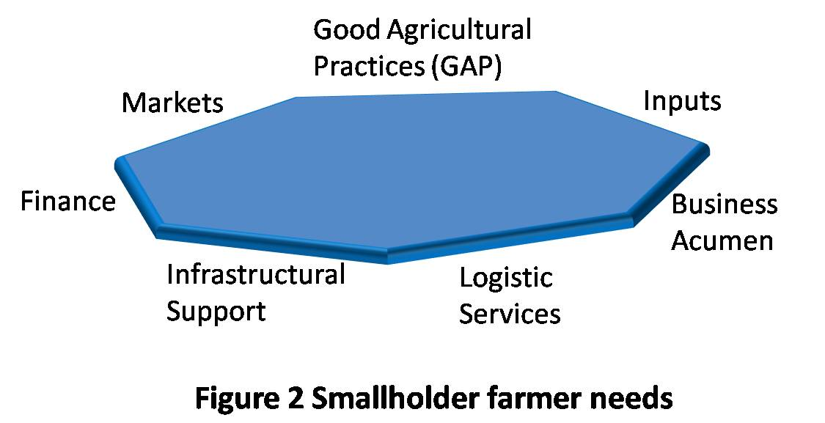
Intervention sustainability of agricultural programmes is likely to prove elusive if programmes are not designed to address each of the factors illustrated in Figure 2.

      - Access to agro-inputs
In 1996 smallholder farmers produced 66% of the nation’s maize crop which was over 2,000,000 metric tonnes, largely as a result of a government input support scheme (Figure 1). Likewise, Malawi has become a net exporter of grain as a result of a national input distribution programme. These success stories underline the importance that input support schemes play in boosting crop yields and food security.

Zimbabwe’s rural agro-dealership network has all but disappeared after successive years of economic decline. Farmers have no local access to inputs. Neither do most farmers have access to cash. It is unlikely that the bankrupt government will be able to afford input distribution schemes in the coming season and the grim reality is that the majority of farmers will not have access to inputs. The two main ways in which a limited number of smallholder farmers will access inputs will be through donor-funded interventions and contract farming. The inputs being distributed in the former will be part of food security programmes which give little consideration for sustainability. In contrast, inputs distributed in numerous contract farming programmes across Zimbabwe must be done in a commercially viable manner. Farmers are taught how to do business.

In the current proposal, farmers will receive sufficient inputs to produce commercially viable yields of maize and seed crops. High yields are essential if farmers are to become food secure and make acceptable profits from their contract crops. Many contract farming schemes do not realise their full potential because companies do not provide farmers with sufficient input and extension support. The result is that farmers produce low yields and are unable to repay input credit. The temptation to side-market is very high for underperforming farmers. The maize component of the rotation is aimed at making farmers food secure by provision of sufficient inputs to produce a minimum of 1 tonne per household.

Soils in communal areas are characterised by low pH which can seriously compromise yield potential. Provision is made in the budget for application of lime at a rate of 500 kg/ha which will assist in improving the fertility.

Farmers will be required to repay the invoiced value of the inputs that they receive plus a small (10%) service charge.

      - Good Agricultural Practices
The value of extension cannot be overstated. Government extension service has collapsed due to poor staff service conditions and lack of mobility. Communal farming systems are characterised by poor timing and quality of field operations which result in wasted resources.

In order to overcome these constraints, AgriSeeds will employ sufficient additional agronomists and resident extension officers to ensure that a ‘directed farming’ approach is adopted. Directed farming is where smallholder farmers are managed or organized by private sector and involves a high level of management involvement in the farmer’s production. This approach is characterised by farmer mentoring rather than the more commonplace, but less effective, one-off training events. These farmers will be trained in CA. One of the spin-offs of the programme will be the cross-pollination between project extension staff and local Agritex officers. AgriSeeds has a good working relation with Agritex officers at the sites that will benefit from the extension and business training programme.
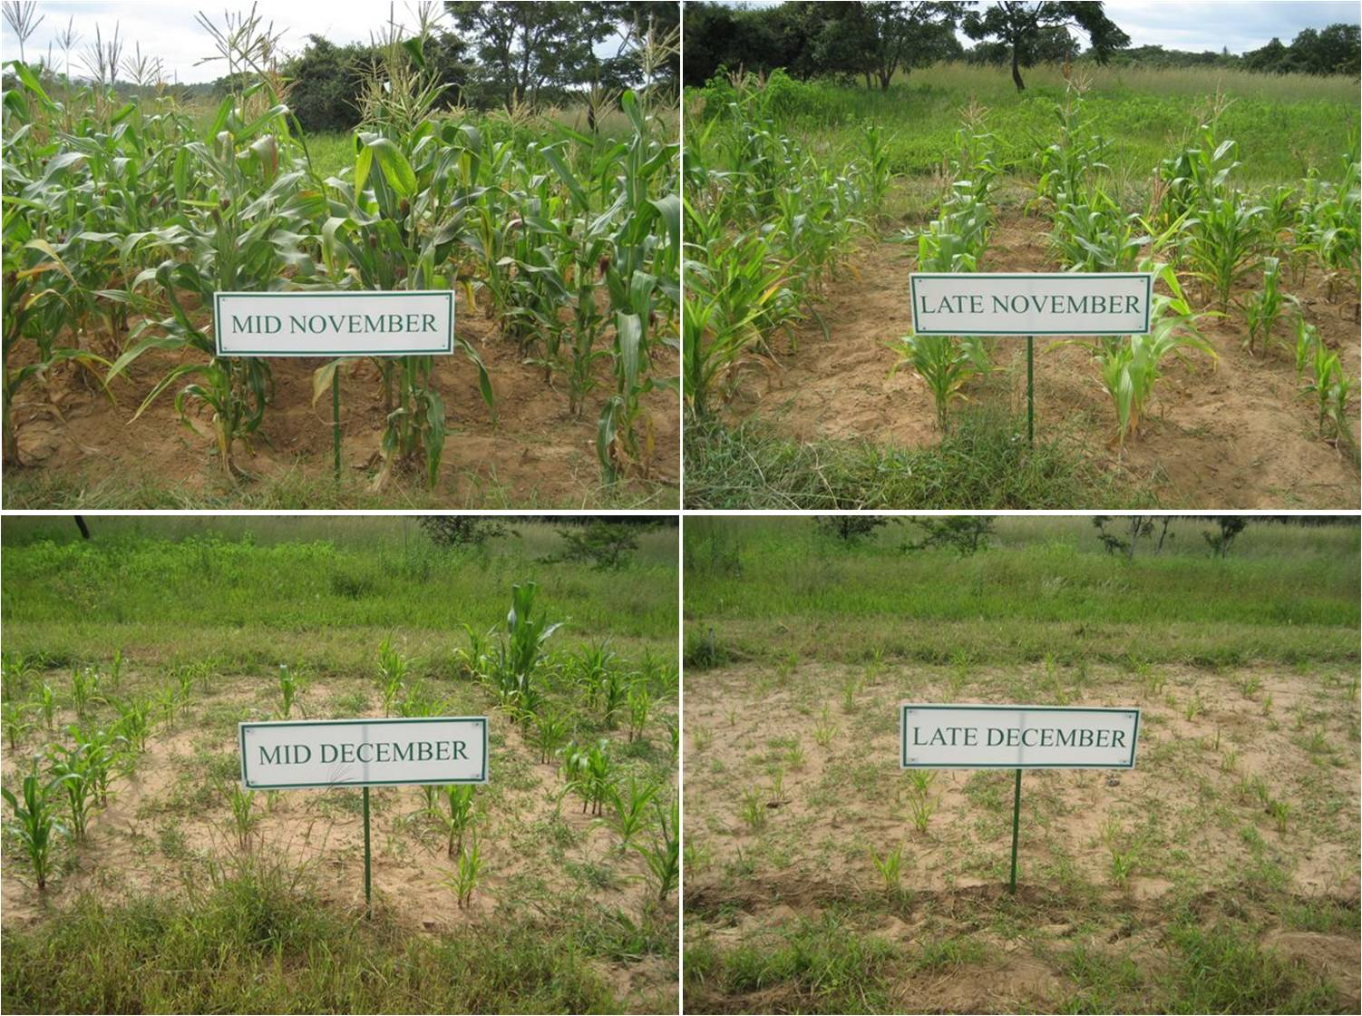
Figure 3. Planting date demonstration at a local
demonstration plot

The company will ensure that there is a maximum ratio of about 100 farmers to each resident extension officer. Each agronomist will look after five – six extension officers. The programme will therefore require a total of 22 extension officers and four agronomists. In order to fulfil their duties the extension workers will need to be mobile. Provision is made in the budget for vehicles and motorbikes for the agronomists and extension workers, respectively.

For ease of administration, farmers will be organised into groups of 50. The extension will be based on the successful local demonstration plot approach. In this approach a local site is selected and demonstration plots used to exhibit the effect of planting date and cultural practices on crop performance (Figure 3). These sites also serve as a weekly meeting place for farmer training. Farmers discuss and practice farming activities at the plot before implementation on their own plots.

Another important extension method will include a focus on group work and peer pressure. The group of 50 farmers will self select into sub-groups of about 10 farmers, with one lead farmer. These farmers will work with each other in most field operations including holing out, sowing and fertilizer application. Included in each group will be a dedicated individual responsible for the knapsack application of crop chemicals. The lead farmer will be monitoring group performance and address any difficulties with help of the extension worker. A production incentive scheme will be used.

Farmers will be trained in conservation agricultural (CA) techniques that conserve soil and water. Long term use of these techniques will ensure the return to health of these worked out soils. These techniques will help farmers to benefit from maximum yield potential through planting at the correct time. Farmers will also receive training on composting in order to reduce their reliance on inorganic fertilizers. Farmers will use non-toxic chemicals for weeding. Chemicals will be dripped and not sprayed reducing inhalation risks. The extension workers will inform farmers extensively on the use and storage of chemicals when and after distributing the knapsacks. All chemicals used are allowed by Zimbabwean law.

After two years farmers productivity have sufficiently increased to justify the downscaling of extension intensity. Agriseeds will take over the financing and continue to provide these services to farmers.

      - Business Acumen
Farming is not generally treated as a business activity by smallholder farmers. Without basic business understanding, farmers make poor partners for contracting companies. SNV Netherlands Development Organisation will be responsible for producer group strengthening and comprehensive business training based on a needs assessment. The business training programme may include record keeping, business planning, budgeting, costing, pricing and profit calculation and contract negotiation.

Farmer associations will be formed which will receive appropriate training for their functioning.

The preferred method of SNV service delivery is through locally based Local Capacity Builders (LCB). SNV will identify suitable LCB’s at the implementation sites and conduct a needs assessment to identify organizational capacity gaps. A training programme will be designed to strengthen the organization’s ability to provide quality services to farmers. The LCB will be required to adopt a mentoring approach to train farmers in business skills throughout the season.

      - Logistic Services
Farmers need transport for inputs and outbound produce. Lack of transport is a key constraint for farmers throughout Zimbabwe and one of the embedded services provided by all contracting companies. AgriSeeds will deliver inputs and collect produce at harvest time.

      - Financial Services
Zimbabwean smallholders do not generally have access to finance. In the past, micro-finance schemes were not suited to cropping cycles. Most of these schemes have collapsed during the past years of economic decline. This proposal partially addresses farmer’s financial requirements through the provision of input support through the revolving fund. Agriseeds through their contracting will ensure repayment to the fund. Contracted farmers will need to find alternative coping mechanisms to deal with their inter-harvest cash requirements. The availability of profitable markets can go a long way to reducing reliance on financial services.

      - Infrastructural Support
Economic decline has resulted in deterioration of infrastructure through rural and urban Zimbabwe. Infrastructure rehabilitation and development are outside the scope of this project. Therefore part of the site selection criteria will be the presence of good infrastructure.

      - Profitable markets
The food secure farmer requires an income for other basic needs including ensuring a balanced diet, payment of school fees and purchase of medicines. Education is highly valued in rural Zimbabwe and farmers have been known to risk their food security by selling maize stocks in order to send children to school. The same decision will also be made when farmers are faced with situations where family need treatment for illness including HIV-related sickness.

Access to profitable markets for the sale of agricultural surplus can go a long way in improving income security. However profitable markets are not always easy to find: harvested produce is often sold into the informal sector for low returns during periods of market oversupply. In many instances farmers make a loss. Forward-planned contract farming arrangements can help reduce marketing risk for both smallholder farmers and companies – farmers are assured of a market at an agreed price and companies are able to plan to receive certain volumes of produce of a specified quality.

AgriSeeds will contract farmers to grow seed crops under contract. Contracts will be designed to empower farmers through provision of information required to make business decisions. The contracts will include best practices developed by the CA Union Project and specifications will include minimum quotas, quality requirements, input prices and minimum produce prices.

      - Gender Mainstreaming
The majority of the population as well as farmers in the districts are female. Training and extension activities will prioritize female farmers. It will be tried that at least 50 percent of the selected 120 lead farmers will be female (depending on the cultural acceptability of female farmers to visit male neighbours – this sometimes differs per site). Furthermore the project is aiming to contract at least 50 percent female farmers. There were appropriate Agriseeds will promote dual signing of both husband and wife of contracts.

    - Selection criteria
The success of this food security intervention lies in the careful selection of private sector, contracted products, site, farmers and gender.

      - Company selection
Contract farming is an agreement between ‘unequals’. The system uses the resource-base of a relatively economically powerful company to improve the productivity of resource-poor farmers to create inflows of raw materials. Fears that companies will (1) profit directly from the use of public funds and (2) exploit smallholder farmers have prevent donors from seriously considering this system in past years. However, such risks are minimised through careful assessment of the prospective company partner and many donors are now encouraging partnerships between private sector and farmers. In Zimbabwe, contract farming is the designed exit strategy from smallholder farmer sites for the EU-funded CA Union Project – highly productive farmers represent a low risk for companies in need of raw materials.

Agriseeds has proven to be a reliable company for dealing with smallholders.

    - Product selection and contracted area
The proposed seed crops have been carefully selected and take into consideration:
- National food requirements. Most of Zimbabwe’s population cannot afford regular purchases of meat and legumes represent an important source of protein;
- Smallholder cropping patterns. Cowpeas, sorghum and groundnuts are drought-tolerant crops, well suited to drier Natural Regions IV and V where there is frequent food insecurity’
- Profitability. Both farmers and company need to make a profit from the contract agreement. Seed crops are a good option for contract farmers because they attract premium prices compared to commodity prices. Table 2 shows that the cost: benefit analysis for the maize and contracted seed crops are reasonable (see Appendix 1 for a more detailed analysis).

Each farmer in the programme will grow a total of 1.0 ha comprising 0.4 ha OPV maize and 0.2 ha each of sorghum, groundnuts and cowpeas. This mixture of crops is designed to ensure that (1) farmers will be food secure, (2) farmers practice crop rotation and (3) the company requirement for seed is met with.

The decision that each farmer should grow 1.0 ha was made by considering:
- Farmer profitability: farmers should grow a minimum of 1.0 ha if they are to achieve a reasonable income for their families
- Farmer capacity: farmers will be using labour-intensive conservation techniques in preparing their land and should do no more than 1.0 ha in the first year of adoption.

Table 2 Cost benefit analysis for maize and contracted seed crops
 |  | Maize | Cowpea seed | Sorghum seed | Groundnut seed
Producer prices | USD/kg | 0.27 | 0.70 | 0.45 | 0.50
Expected yield | kg/ha | 2000 | 700 | 3000 | 1500
Producer costs | USD/ha | 440 | 285 | 377 | 321
Gross Return | USD/ha | 530 | 490 | 1,350 | 750
Profit/(loss) | USD/ha | 90 | 206 | 973 | 429
$ return: $ invested | - | 1.21 | 1.72 | 3.58 | 2.34
Break-even yield | kg/ha | 1659 | 406 | 839 | 642

    - Site selection
Sites have been carefully selected that permit both farmers and company to profit from the programme. Site selection criteria considered include land tenure system, natural region, existing farmer group structures, utilities and communications and local political support. Table 3 shows the potential sites that AgriSeeds is considering for the programme. None of the sites are located in the drier Natural Regions IV and V.

Table 3 Potential project implementation sites
Province | District | Site Name | Natural Region | Number of farmers
Mashonaland East | Hwedza | tba* | IIB | 850
Mashonaland East | UMP | tba* | III | 1000
Manicaland | Mutasa | Bonda | I | 350
* To be advised

    - Farmer selection
This programme differs in approach from many other donor-funded interventions because of the focus on sustainability through ‘farming as a business’. It should be recognised that not all communal farmers are equally interested in commercial crop production and targeting needs to be carefully done to ensure that only the most productive farmers are selected. Farmers will be selected using a combination of company experience and local knowledge from Agritex, traditional leadership, local government and NGO’s. Other selection criteria that will be considered will be sufficiency of land and labour and gender.

Training and extension activities will prioritize female farmers. At least 50 percent of the selected 120 lead farmers receiving business training will be female. Furthermore the project is aiming to contract at least 50 percent female farmers.

  - Financial model
    - First year of project implementation
      - Recovered costs
On signing of the contract between SNV Netherlands Development Organisation and the Australian Agency for International Development (AusAid) funds will be transferred into an SNV nominated account. SNV will be responsible for making timely payments to AgriSeeds for the procurement of inputs, other assets and basic extension salaries. AgriSeeds will purchase and distribute inputs to farmers who will grow the contracted crops. Repayment of input loans will be done with a pre-determined volume of produce to AgriSeeds. On receipt of the produce, AgriSeeds will make payment into the revolving fund account.

The project will also invest in a number of assets. AgriSeeds have indicated that they will require 5 pick-up trucks and 22 motorcycles to provide extension services to growers. Knapsack sprayers will also be required for application of crop chemicals. These assets will be the property of the fund and will be either maintained or sold in subsequent years.

      - Non-recovered costs
Non-recovered costs include
- Extension support – employment of additional staff to support the programme;
- Capacity building of Local Capacity Building Organisations (LCBs);
- Capacity building of farmers;
- Levies and licence fees;
- Vehicle R&M and running costs;
- Insurance to cover crop inputs in the event of default. Insurance will also be required to ensure that participating farmers have at least 1 metric tonne per family unit; If no insurance can be found then a designated fund will have to make up the default.
- Project management related costs;
- Costs for parent maize seeds (to be used as farmer food crop);
- Project administration costs.

      - Funding Mechanism
The recovered and non-recovered costs have to be funded by way of a grant. A total first instalment of USD 1,300,000.00 has to be made in September in order to cover purchase costs of inputs, motor vehicles, motor cycles, motor vehicle insurance, fund insurance, parent seed costs and project management costs. An instalment of USD 860,000 is requested from AusAid in September in order to purchase good at time for the coming planting seanson. The remaining costs for project management, administration and fuel costs, salaries and other costs for the Agriseeds Project Manager, Agronomists and Extension Workers will occur at a monthly base.

    - Second year of project implementation
Experience has shown that one year is not enough for farmers to achieve sufficient productivity levels and to guarantee a successful contract scheme. In the second year the programme continues to provide the needed training and will work with selected farmers. The revolving fund will finance all the input costs for the second year. If proven successful the project can be upscaled with additional funds.

  - Summary of the advantages of the proposed intervention
Table 4 summarises the advantages of the programme that have been discussed above
Table 4 Advantages that the proposal poses for farmers and the company
Advantages for the farmers | Advantages for the company
- Food security  - Income security  - Training in conservation agriculture  - Establishment of producer groups  - Training in farming as a business  - Stable market linkages  - Long-term support for maize production | - Guaranteed produce supply  - Expansion of grower base  - Improved capacity of growers to produce and appreciate a business approach  - Goodwill from farmers and local authorities

  - Project alignment and harmonisation
Zimbabwe is entering a period of agricultural recovery which is resulting in a change of donor emphasis from emergency aid to food security. The EU-funded CA Union Project, officially launched in 2008, combines food security and income security. The exit strategy is to leave behind well functioning contract farming arrangements between companies and productive farmers. This programme fits in well with donor early recovery strategies. For example, DfID and World Bank are starting up input voucher schemes and contract farming arrangements. The project is also in line with complimentary efforts between AusAid, DGIS and other donors, and with policy priority of fragile states and recovery.

  - Results
Table 5 gives details of the expected outcomes together with their measurements. The combination of input and extension support will ensure high productivity and food security for 2200 households. Farmer groups will be formed and strengthened using a mentoring training approach. Farmers at both group and individual levels will be empowered to make business decisions making them better partners for contracting companies and resulting in stable market linkages.

Table 5 Results of the proposed intervention
Activity | Expected outcome | Measurement
Provision of input credit | 2200 farmers food secure | - Each family unit has 1 MT maize  - Surplus maize sold in local market  - Repayment of input credit
Provision of extension support | - 2200 farmers producing minimum 3000 kg/ha maize  - 2200 farmers trained and applying CA practices
RSP strengthening | LCB’s at each site are providing improved services to farmers | Assessments before and after project implementation
Farmer group strengthening | 2200 Farmers are working in producer groups | - Constitutions  - Enforcement of by-laws  - Successful implementation of group contracts
Business training | - 2200 farmers trained in basic business skills and contract management becoming reliable contract partners for business  - Company continues and expands in next season | - Adherence to individual contract agreements  - Repayment of input credit
Market linkage provision | - 2200 farmers have guaranteed market  - Company assured of reliable supply of quality seed contributing to national food security | - Crop sales and income earned by farmers  - Contracts renewed

Table 6 Sustainability of the action
Natural resources
Conservation Agriculture | Implementation of CA improves physical and chemical soil properties resulting in reduced soil erosion and improved rainwater infiltration.
Soil fertility | Soil analysis determines fertility of the soil. Lime application increases soil pH in the medium term. Nutrient application preserves soil nutrient status. Compost application improves soil organic matter content.
Farming constraints
Input availability | Composting knowledge reduces reliance on inorganic fertilizers. Contracting companies supply inputs in subsequent years through the revolving fund.
Logistic services | Contracting company provides logistic services for incoming inputs and outbound produce
Good Agricultural Practices | Extension support provided by contracting company
Local capacity development | Local Capacity Builders or Rural Service Provider have improved capacity to provide services to farmers
Business acumen | Local Capacity Builders continues to mentor farmers through a financial agreement with the contracting company
Markets | Contracting company continues to support production of maize and seeds required for national food security
Project continuity
Revolving input fund | Continued circulation of funds from the input support scheme. The fund attracts new donor support and continues to expand to support company food security programmes.

  - Sustainability
Sustainability of the project will be achieved at a number of different levels (Table 6). The communal farming system is characterised by annual ploughing and mono-cropping – practices that lead to soil degradation and erosion. Sustainable land use practices will reverse this decline. The main reason for low yields in the communal areas is that farmers do not plant at the correct time due to a reliance on borrowed draft. The emphasis of Conservation Agriculture on manual land preparation empowers farmers to prepare their land in advance of the November rains and plant on time – the first important step to high yields and long term sustainability. Farmers will be taught how to make maximum use of local materials by training in composting. This will reduce reliance on imported inorganic fertilizer materials.

Table 7 Risk assessment
Actor | Description | Mitigating measure
Country risk | Collapse of unity government | - Business training  - Insurance will cover the cost of inputs and household food security (1 MT per family unit)
Company risk | Unproductive farmers | - Farmer mentoring and monitoring  - Project costs covered by donor funds
Company risk | Company does not honour contract and/or project agreements | - Careful company selection  - A contractual clause will specify legal action for breach of agreement
Company risk | Company bankruptcy | - Company selection (due diligence)  - Input insurance
Company risk | Change in company project manager (e.g. illness/departure) | - Company selection (company has extra staff capacity)
Farmer risk | Late arrival of funds | - Legume seed is optimally sown at the end of December
Farmer risk | Unreliable company | - Company selection  - Contract agreements between farmers and company specify company responsibilities  - Legal action
Farmer risk | Decline in seed prices | - Minimum contract prices  - Commodity diversification
Farmer risk | Poor weather conditions, pests and diseases | - Selection of drought tolerant crops  - Diversification of commodities  - Input and food insurance
Farmer risk | Farmers default through input diversion or neglect of crops | - Farmer and crop selection  - Monitoring and directed farming approach  - Peer management through producer groups
Farmer risk | Farmers don’t repay input loan | - Farmer and crop selection  - Business training  - Yield assessments  - Contract enforcement  - Peer management  - Threat of exclusion
Budget risks | Revolving fund mismanagement | Management of fund by reputable bank
Budget risks | Change in monetary policy
Budget risks | Transfer delays
Budget risks | Fluctuating exchange rates
Budget risks | Increase in agro-input costs

The farming constraints vital for sustainability (Section 3.3.1) are largely overcome through contract farming. As discussed, contracted farmers benefit from a wide range of embedded services which address constraints that would otherwise make a planned programme exit strategy difficult to achieve. The SNV capacity building formula empowers LCB’s which will continue to provide long-term services to farmers. Farmers with business acumen are able to make informed decisions making them better business partners which will lead to profitability and sustainability.

The project will have an element of sustainability built into it through the establishment of the revolving input fund. By paying for their inputs, farmers will be taught the commercial realities of farming instead of the message of donor-reliance that many interventions teach.

- Project risks
Table 7 categorises risks according to actor. This intervention comes at a time in Zimbabwe’s history when the Unity Government is still new. The collapse of the Unity Government might affect a project of this nature if farmers take advantage of political instability to renege on input loan repayments. Such risk can be mitigated through farmer training and insurance. It is proposed that insurance be taken out to
- protect the revolving fund from default in input loan repayment
- ensure that farmers will be maize secure (1 metric tonne per household)

Contracting companies face two financial risks when farmers are unproductive:
- Loss of funds invested into the programme including direct and overhead costs
- Loss in potential earnings through forward planned processing and/or sale of the commodity.
The proposal mitigates against company losses through an emphasis on farmer training, mentoring and monitoring and through donor support.

There are also risks associated with company default. This might occur due to poor company conduct, bankruptcy or staff changes. The main line of defence against this type of default is company selection. AgriSeeds has a good reputation as reliable and honest company in the donor community.

A programme of this nature also poses risk to farmers. Donor projects are notorious for the late arrival of funds which can pose a considerable risk to farmers. Another risk to farmers is when the contracting company is unreliable in collection of produce or payment to farmers. Contracts will provide the framework for the agreement between farmers and the company. Rain-fed agriculture is an inherently risky activity and farmers run the danger of a poor agricultural season. This is mitigated through crop selection and insurance. Finally there are risks associated with unreliable farmers. Common contract farming risks include
- input diversion: application of inputs to non-contracted crops
- side-marketing: sale of crop to non-contracting partners
- input credit default: non-repayment of input loans
These risks are mitigated through farmer selection, crop selection (seed crops have high return), monitoring, mentoring, training and persuasion. Unscrupulous farmers are persuaded by peer pressure and contract enforcement procedures.

Besides fund mismanagement, most of the budget risks cannot be mitigated against.
- Changes in monetary policy: The cash-deficit Zimbabwe Government may resort to confiscation of funds held for development organisations.
- Transfer delays might jeopardise the timely acquisition and distribution of inputs.
- Exchange rate fluctuations. The US Dollar is the preferred currency of Zimbabwe – strengthening of the Dollar: The Dutch counterpart will finance in EURO. EURO exchange rate will result in less funds available for programme implementation.
- Increasing agro-input prices. Commodity and agro-input prices have been characterised by considerable fluctuations in recent history.

- Stakeholders

Agricultural Seeds and Services (Pvt) Ltd. (see Appendix 2) is a well known actor in the Zimbabwean seed industry. The company differs from other seed companies in that from inception, its strategy has been to work with smallholder farmers. The company is an established supplier of seeds and agro-inputs to the donor funded community in Zimbabwe and is a founding member of the Market Linkage Working Group. The company has highly innovative and capable management team who have expanded the company during an extended period of national economic decline. This expansion has been made possible by picking up market share from less resourceful competitors.

SNV Netherlands Development Organisation is a Dutch Foundation which was privatised from the Ministry of Foreign Affairs of the Netherlands in 2003 and now is an independent organisation but fully sponsored by and reporting to the Ministry of Foreign Affairs of the Netherlands. SNV provides advice to organizations in developing countries in support of the fight against poverty. SNV works worldwide with 1,300 organizations in over 33 countries in Africa, Asia, Eastern Europe and Latin America. The organization is dedicated to a society where all people enjoy the freedom to pursue their own sustainable development. SNV advisors contribute to this by strengthening the capacities of local organizations. The strategy of working with local capacity builders is SNV’s way of contributing to long term capacity development and sustainability of development support.

- Implementation

  - Budget overview
The total budget for the action is USD 1,761,260.80 in the first year. DGIS will fund the amount of USD 778,447.69. AusAid is requested to fund USD 982,813.11 in the first year. A grant of USD 391,859.71 is required to continue the project in the second year. After the second year, the project will be self-sustaining with Agriseeds as a contracting partner purchasing seeds from 2,200 farmers and contributing to their incomes.

Table 8 summarises the budget for the programme. The donor will fund the cost of vehicles, vehicle running expenses, agro-inputs, parent seeds for food crops, insurance cover, agronomic and business skills training of farmers and project administration. AgriSeeds will fund parent seeds for cash crops, inward and outward transportation of agricultural inputs and produce and various government levies. SNV will build the capacity of LCBs to provide services to farmer beneficiaries and ensure field coordination.

Table 8 Budget summary and details of contributors in the first year of project implementation

Year 1 | Total donors | AusAid | DGIS | Agriseeds | SNV | Total
Total Budget (in USD) | 1.761.260,80 | 982.813,11 | 778.447,69 | 252.880,00 | 43.005,00 | 2.057.145,80
Basic salaries¹⁾ | 181.610,00 | 118.110,00 | 63.500,00 |  |  | 181.610,00
National Social Security Assoc.²⁾ | 5.448,30 | 3.543,30 | 1.905,00 |  |  | 5.448,30
Manpower Development Fund³⁾ | 1.816,10 | 1.181,10 | 635,00 |  |  | 1.816,10
Standards levy⁴⁾ | 1.816,10 | 1.181,10 | 635,00 |  |  | 1.816,10
DSA⁵⁾ | 24.200,00 | 15.840,00 | 8.360,00 |  |  | 24.200,00
Field days⁶⁾ | 44.000,00 | 24.000,00 | 20.000,00 |  |  | 44.000,00
Gvt registration & inspection fees⁷⁾ |  |  |  | 22.000,00 |  | 22.000,00
Vehicle Purchase Costs⁸⁾ | 125.000,00 | 75.000,00 | 50.000,00 |  |  | 125.000,00
Motorcycle Purchase Costs⁹⁾ | 33.000,00 | 18.000,00 | 15.000,00 |  |  | 33.000,00
Motor Vehicle fuel¹⁰⁾ | 65.391,73 | 46.307,73 | 19.084,00 |  |  | 65.391,73
Motor Vehicle R&M¹¹⁾ | 16.000,00 | 12.800,00 | 3.200,00 |  |  | 16.000,00
Motor vehicle insurance¹²⁾ | 6.320,00 | 4.720,00 | 1.600,00 |  |  | 6.320,00
Stationery and extension materials¹³⁾ |  |  |  | 3.000,00 |  | 3.000,00
Parent seed cost¹⁴⁾ |  |  |  | 99.880,00 |  | 99.880,00
Inputs¹⁵⁾ | 656.601,44 | 343.746,24 | 312.855,20 |  |  | 656.601,44
Credit Insurance¹⁶⁾ | 146.016,29 | 94.045,25 | 51.971,04 |  |  | 146.016,29
Transport outwards¹⁷⁾ |  |  |  | 72.000,00 |  | 72.000,00
Transport inwards¹⁸⁾ |  |  |  | 56.000,00 |  | 56.000,00
Knapsack sprayers¹⁹⁾ | 8.800,00 | 4.800,00 | 4.000,00 |  |  | 8.800,00
Revolving fund administration (3% of inputs)²⁰⁾ | 18.906,04 | 10.313,39 | 8.592,65 |  |  | 18.906,04
Training of farmers by LCB's²¹⁾ | 113.600,00 | 56.800,00 | 56.800,00 |  |  | 113.600,00
Training of LCB's and AgriSeeds²²⁾ | 95.650,00 | 50.650,00 | 45.000,00 |  | 23.265,00 | 118.915,00
Field coordination²³⁾ | 84.600,00 | 49.350,00 | 35.250,00 |  | 19.740,00 | 104.340,00
Project Management²⁴⁾ | 132.484,80 | 52.425,00 | 80.059,80 |  |  | 132.484,80

Year 2

Year 2 | Total donors | AusAid | DGIS | Agriseeds | SNV | Total
Total Budget (in USD) | 391.859,71 | 191.373,35 | 200.486,35 | 366.643,78 | 13.395,30 | 771.898,78
Basic salaries¹⁾ | 159.816,80 | 79.908,40 | 79.908,40 | 39.954,20 |  | 199.771,00
National Social Security Assoc.²⁾ | 4.794,50 | 2.397,25 | 2.397,25 | 1.198,63 |  | 5.993,13
Manpower Development Fund³⁾ | 1.598,17 | 799,08 | 799,08 | 399,54 |  | 1.997,71
Standards levy⁴⁾ | 1.598,17 | 799,08 | 799,08 | 399,54 |  | 1.997,71
DSA⁵⁾ | 19.360,00 | 9.680,00 | 9.680,00 | 4.840,00 |  | 24.200,00
Field days⁶⁾ | 22.000,00 | 11.000,00 | 11.000,00 | 22.000,00 |  | 44.000,00
Gvt registration & inspection fees⁷⁾ |  |  |  | 22.000,00 |  | 22.000,00
Vehicle Purchase Costs⁸⁾
Motorcycle Purchase Costs⁹⁾
Motor Vehicle fuel¹⁰⁾ | 32.695,87 | 16.347,93 | 16.347,93 | 32.695,87 |  | 65.391,73
Motor Vehicle R&M¹¹⁾ | 8.800,00 | 4.400,00 | 4.400,00 | 8.800,00 |  | 17.600,00
Motor vehicle insurance¹²⁾ | 3.476,00 | 1.738,00 | 1.738,00 | 3.476,00 |  | 6.952,00
Stationery and extension materials¹³⁾ |  |  |  | 3.000,00 |  | 3.000,00
Parent seed cost¹⁴⁾ |  |  |  | 99.880,00 |  | 99.880,00
Inputs¹⁵⁾
Credit Insurance¹⁶⁾
Transport outwards¹⁷⁾ |  |  |  | 72.000,00 |  | 72.000,00
Transport inwards¹⁸⁾ |  |  |  | 56.000,00 |  | 56.000,00
Knapsack sprayers¹⁹⁾
Revolving fund administration (3% of inputs)²⁰⁾
Training of farmers by LCB's²¹⁾ | 56.800,00 | 28.400,00 | 28.400,00 |  |  | 56.800,00
Training of LCB's and AgriSeeds²²⁾ | 28.539,60 | 14.269,80 | 14.269,80 |  | 7.134,90 | 35.674,50
Field coordination²³⁾ | 25.041,60 | 12.520,80 | 12.520,80 |  | 6.260,40 | 31.302,00
Project Management²⁴⁾ | 27.339,00 | 9.113,00 | 18.226,00 |  |  | 27.339,00

Ad 1 – 4: Basic salaries, social security costs, manpower development fund and standards levy
The following additional manpower is required by Agriseeds in order to implement the project:

Total

Human Resources | FTE | Monthly gross salary per FTE 2009 | Monthly gross salary per FTE 2010
Project Manager | 1 | 1,500 | 1,650
Agronomist | 4 | 1,000 | 1,100
Field Inspectors | 22 | 400 | 440

Australia

Human Resources | FTE
Agronomist | 3
Extension workers | 12

Netherlands

Human Resources | FTE
Project Manager | 1
Agronomist | 1
Field Inspectors | 10

FTE = Full Time Equivalent.

Salaries will be increased with 10 percent in 2010. In addition to salaries, social contributions and legal fees have to be paid. In year two, 20 percent of 2010 salary costs and salary increases will be paid by Agriseeds. To the salaries different levies have to be added like NSSA, MDF, etc.

After year 2 only half of the staff will be needed, where Agriseeds will assume the full cost.

Ad 5: Daily Subsistence Allowance (DSAs)
The 22 extension workers employed by Agriseeds will receive an additional allowance of USD 5.00 per day when working in the fields to provide extension support to the farmers in order to cover meals and out of pocket expenses. It is common that accommodation is provided by the farmer communities. No budget for accommodating the extension workers is required. DSAs will be paid using an incentive scheme. 22 Extension workers will be employed for 12 months, 22 working days per month, given a total of 29,040 USD. AusAid will pay for 12 extension workers.

In year two, 20 percent of the DSAs will be paid by Agriseeds.

Ad 6: Field days
Field days will be organised to promote the project to governmental organisations and donors as well as to generate goodwill for the project in the communities. All participating farmers, local Agritex officials, traditional leaders as well as representatives of donors, FAO and other international organisations relevant to the project will participate in the field days. The costs per farmer are estimated at USD 10.00 for transportation, food, drinks, and organisation. In the year 2 field days will be organised. This will amount to a total of 44,000 USD.
AusAid will finance 24,000 USD.

In year two, 50 percent of the costs for field days will be paid by Agriseeds.

Ad 7: Government registration and inspection fees
Compulsory levy of USD 10 per ha. To be paid by Agriseeds.

Ad 8: Vehicle purchase costs
Five Mazda BT 50 (or similar brand) pick-up trucks of 25,000 USD each for use by the Manager (1) and Agronomists (4) and will be used to train extension workers and farmers on site. Furthermore, the agronomists will use demonstration plots in order to educate farmers on good agricultural practices and CA and need the vehicles in order to transport inputs to the demonstration plots. Vehicles will be owned by the trust fund and can be auctioned after the project or sold to Agriseeds at market price. Revenues resulting from the sales of vehicles will be re-invested in the trust fund.

Three trucks to be used by three agronomists will be funded by Australia. Two trucks to be used by the fourth agronomist and the project manager will be funded by the Netherlands.

It has to be noted that the farmers involved are located at remote locations and that agronomists and extension workers need vehicles to train farmers at site. Intensive extension support is required in order to improve the productivity of the participating farmers resulting in intensive use of vehicles in the first years. After two years the productivity of the participating will increase and the need for extension support will decrease to a level that the need for vehicles will decrease significantly. At this stage Agriseeds will be able to finance the transportation costs of remaining agronomists and extension workers from the revenues of the sales of seed products purchased from the farmers. Hence the vehicles can be liquidated or be used in another similar project with another company.

Ad 9: Motor cycle purchase costs
Twenty-two motorcycles of USD 1,500 for the extension workers (12 funded by Australia; 10 funded by The Netherlands). Vehicles will be owned by the trust fund and can be auctioned after the project or sold to Agriseeds at market price. Revenues resulting from the sales of vehicles will be re-invested in the trust fund.

Ad 10: Motor vehicle fuel costs

Fuel costs | Project Manager (1) | Agronomists (4) | Extension workers (22)
Assumed daily travel (km/day) | 280 | 140 | 140
Working days per month | 22 | 22 | 22
Travel per month (km) | 6,160 | 3,080 | 3,080
Travel to Harare @ 2 trips per month (km) |  | 1,000
Total travel per month (km) | 6,160 | 4,080 | 3080
Fuel consumption (km/litre) | 9 | 9 | 40
Fuel use (litres) | 684 | 453 | 77
Fuel cost (USD/litre) | 1.30 | 1.30 | 1.30
Monthly cost per vehicle (USD) | 889.78 | 589.33 | 100.10
Number of vehicles | 1 | 4 | 22
Total projected cost (USD per month) | 889.78 | 2,357.33 | 2,201.20
Australia |  | 1,768.00 | 1,201.20
Netherlands | 889.78 | 589.33 | 1,001.00

In year two, 50 percent of the fuel costs will be paid by Agriseeds.

Ad 11: Vehicle repair and maintenance
Cost of minor service (5,000 km, monthly): USD 200
Cost of major service (10,000 km): USD 400

In year 2 Agriseeds will pay 50%

Ad 12: Motor vehicle insurance
Based at an annual premium of 4 percent of the purchase value of the vehicle.

Ad 13: Stationary an extension materials
Material to be used by extension workers in order to train farmers on good agricultural practices.

Ad 14: Parent seed costs
Costs of seeds for cash crops (sorghum, cowpeas and groundnuts) to be pre-financed by Agriseeds and to be repaid by farmers (specified at next page). The purchase of parent seeds in year 2 will be financed by re-utilising the revolving fund.

Ad 15: Inputs
Costs of fertilizer, herbicides, crop chemicals and seeds for food crops (maize seeds) to be pre-financed by donors (AusAid and DGIS) and to be repaid by farmers (specified at next page).
The purchase of inputs in year 2 will be financed by re-utilising the revolving fund (specified at next page).
Table 9 Specified costs of parent seeds and fertilizers to be pre-financed by Agriseeds (seeds excluding OPV maize seed) and AusAid (OPV Maize seed, fertilizer, herbicides and crop chemicals

Inputs | Unit | Cost per | Maize |  | Cowpeas |  | Sorghum |  | Groundnuts |  |  | Project volumes and costs
 |  | unit (USD) | Quantity | Cost | Quantity | Cost | Quantity | Cost | Quantity | Cost |  | Total Volume | Total cost
 |  |  | (1 ha) | (USD/ha) | (1 ha) | (USD/ha) | (1 ha) | (USD/ha) | (1 ha) | (USD/ha) |  | (t/1,000 ha) | (USD/1,000 ha)
SEED |  |  |  |  |  |  |  |  |  |  |  | 41 | 68,880
OPV Maize (ZM521) |  | 1.5 | 20 | 30 |  |  |  |  |  |  |  | 10 | 14,400
Cowpea (CBC2) |  | 1.8 |  |  | 20 | 36 |  |  |  |  |  | 5 | 8,640
Sorghum (Macia) |  | 1.1 |  |  |  |  | 10 | 11 |  |  |  | 2 | 2,640
Groundnut (Ilanda) |  | 1.8 |  |  |  |  |  |  | 100 | 180 |  | 24 | 43,200
FERTILIZER |  |  |  | 277 |  | 219 |  | 277 |  | 172 |  | 1,044 | 293,280
Lime | kg | 0.09 | 500.00 | 45 | 500.00 | 45 | 500.00 | 45 | 500.00 | 45 |  | 600 | 54,000
Compound D | kg | 0.58 | 200.00 | 116 | 200.00 | 116 | 200.00 | 116 |  |  |  | 192 | 111,360
Compound L | kg | 0.58 |  |  |  |  |  |  | 150.00 | 87 |  | 36 | 20,880
Ammonium nitrate | kg | 0.58 | 200.00 | 116 | 100.00 | 58 | 200.00 | 116 |  |  |  | 168 | 97,440
Gypsum | kg | 0.20 |  |  |  |  |  |  | 200.00 | 40 |  | 48 | 9,600
HERBICIDES |  |  |  | 39 |  | 0 |  | 15 |  | 0 |  | 3.42 | 25,068.00
Roundup | litre | 7.60 | 2.00 | 15 |  |  | 2.00 | 15 |  |  |  | 1.44 | 10,944
Lasso | litre | 6.10 | 3.00 | 18 |  |  |  |  |  |  |  | 1.44 | 8,784
Gramoxone | litre | 5.50 | 1.00 | 6 |  |  |  |  |  |  |  | 0.48 | 2,640
Gaucho | kg | 45.00 | 0.13 | 6 |  |  |  |  |  |  |  | 0.06 | 2,700
CROP CHEMICALS |  |  |  | 15 |  | 12 |  | 4 |  | 0 |  | 2.74 | 10,998.24
Dimethoate | litre | 10.00 |  |  | 1.20 | 12 |  |  |  |  |  | 0.29 | 2,880
Dipterex | kg | 2.00 | 4.00 | 8 |  |  |  |  |  |  |  | 1.92 | 3,840
Karate | litre | 11.94 | 0.20 | 2 |  |  |  |  |  |  |  | 0.10 | 1,146
Thionex | litre | 7.25 | 0.60 | 4 |  |  | 0.60 | 4 |  |  |  | 0.43 | 3,132

Ad 16: Credit insurance
It is anticipated that 20 percent of the parent seeds and inputs provided to the farmers will not be repaid because of farmer defaulting in year one. The input fund will be replenished with an amount of 20 percent of the initial value in order to reduce the risk of a possible fund reduction in year two.

Agriseeds will bear the risk of defaulting farmers pertaining the pay back of the parent seeds of cash crops provided.

Ad 17: Transport outwards (delivery to farmers)

Total weight of parent seeds, lime/fertilizer, herbicide, crop chemicals | 1,091
Truck capacity | 30 tonnes
No. trucks | 66
Rounding up for inefficiencies | 72
Radius | 250 km
Cost (EUR per loaded km) | USD 4.00
Total transport costs | USD 72,000
- Contribution Australia | USD 39,000
- Contribution Netherlands | USD 33,000

Ad 18: Transport inwards (collection from farmers)

Total weight of produce | 1,480 tonnes
Truck capacity | 30 tonnes
No. trucks | 49
Rounding up for inefficiencies | 56
Radius (km) | 250
Cost (USD per loaded km) | USD 4.00
Total Transport costs | USD 56,000
- Contribution Australia | USD 28,000
- Contribution Netherlands | USD 28,000

Ad 19: Knapsack sprayers
Totally 440 knapsacks required (five farmers will share a knapsack). Cost of knapsack: USD 20.00. Same knapsacks will be used in year two. Australia will contribute 240 knapsacks; The Netherlands will contribute 200 knapsacks).

Ad 20: Revolving fund administration
Cost of debt collection by financial service provider (Standard Chartered Bank) estimated at 3 percent of the total input costs to be provided to the farmers at a debt base. The total fund value is USD 630,201. Total costs in year 1: USD 18,906.04 (USD 10,312.39 to be funded by Australia; USD 8,593.66 to be funded by The Netherlands).

The participating farmers will pay a service charge of 10 percent over the value of the inputs provided to them. Collected fees partly will be used to pay administration costs in year two (and subsequent years).

Ad 21: Training of farmers by Local Capacity Builders

A. Training of lead farmers
Totally 220 lead farmers (10 percent of the participating farmers) will be provided with business skills training in the following subjects:

  - Introduction on the project
  - Group management
  - Record keeping
  - Costing
  - Contract management and side marketing

Totally 7 training days will be provided to each trainee + additional mentoring. Each trainee represents a group of 10 -15 farmers and will pass on his knowledge to his group. The most suitable farmer to receive training within each group will be selected by way of utilising a farmer group leader selection tool developed by SNV.

One training can accommodate about 30 farmers so eight training groups are required to train the 220 lead farmer group representatives.

At least two Local Capacity Builders will be identified to train the 120 lead farmers.

Activity | Number of days
7 training sessions of one day each provided to Eight groups of 25-30 trainees | 56
Training preparation: four days curriculum development per subject for the five subjects requires 20 days. Two LCBs will operate from 4 different locations resulting into 80 days required | 80
Site preparation and reporting by LCB: 2 days required per training x 56 training sessions | 112
Weekly mentoring visits: 40 days for each LCB/site | 160
Total | 408

Training will continue with rehearsal and farmers selected additionally in year two.

B. Training of Associations
The 2,200 participating farmers will establish four associations (500 – 700 farmers per association). These associations will receive the following training:

- Introduction in the formation of associations
- Leader selection
- Association committees
- Constitutions and bylaws
- Enforcement and payback

Activity | Number of days
5 training sessions of one day; 4 associations | 20
Training preparation: four days curriculum development per training session; 5 training sessions | 20
Site preparation and reporting by LCB: 2 days required per training; 5 training sessions; 4 associations | 40
Mentoring visits of associations: 2 visits per month for 10 months; 4 associations | 80
Total | 160

Costs per LCB day: USD 200
Total LCB days (A+B): 568

Training will continue with rehearsal and farmers selected additionally in year two.
The total cost of LCB provided services is 113,600 USD.

AusAid will finance 50% amounting to 56,800 USD.
The Netherlands will finance the other 50%.

In year 2 only half of the training days will be needed.

Ad 22: Training of LCBs and Agriseeds Extension workers

- SNV capacity building for LCBs
In order to provide a quality standard in business skills and association training the LCBs themselves will need training and mentoring. The LCBs will be trained in order to train the 220 farmers adequately. The training of the trainers will focus on the subjects indicated under 21 and includes training in curriculum development. The trainers will be trained in classroom settings and on site.

Activity | Number of days
5 days per training session for farmer representatives; 5 training sessions; 2 groups | 50
5 days per training sessions for associations; 5 training sessions; 2 groups | 50
Evaluation of trainings 2 days per site; 4 sites; 2 groups | 16
Total | 116

- SNV capacity building of the 22 Agriseeds Extension workers
SNV will train 22 extension workers in providing extension services to the farmers.

Activity | Number of days
Preparation and design of an appropriate agricultural extension system | 20
Classroom training of 3 days of the 22 Agriseeds extension workers | 3
Field training of 2 days of extension workers; 22 extension workers at 4 different sites | 8
Further mentoring (4 sites x 4 visits) | 16
Total | 47

Costs of SNV per day (A+B): USD 705 (or 500Euro per advisory day)
Total days for SNV (A+B) : 163

Of these 163 days SNV will finance from its own budget 33 days.
Financed by donors: 130 days. This amounts to 91,650 USD of which AusAid will finance 50%.

The 22 extension workers will receive intensive training on CA by Foundations for Farming:

Activity | Unit | Number of days
Class room training of 22 extension workers at Foundations for Farming Facility including Board and Lodging: USD | USD | 1,600
Field training of extension workers at site; 2 days per site; 4 sites | Days | 8

Costs of Advisor of Foundations for Farming per day: USD 300
Total days for Foundations for Farming: 8

Total costs Foundation for Farming site and class room training: USD 4,000 financed by AusAid.

The LCBs will be capacitated to provide training with some support in year two (30% of days).

Ad 23: Field Coordination

Activity | Unit | Amount
Monitoring of activities of implementers: 2 visits per months; 4 sites; 10 months | Days | 80
Reporting: 4 days per month; 12 months | Days | 48
Coordination with Agriseeds, HIVOS and AusAid | Days | 20
Total |  | 148

Costs of SNV per day: USD 705
Total days for SNV: 148

The LCBs will be capacitated to provide training without external support in year two.
SNV will finance 28 days. The remaining 120 days are 60% funded by AusAid and the remainder by the Netherlands.

Ad 24: Project Management

Australian Contribution

Activity | year 1 | year 2
Stationary | 1000
Overheads, office costs | 2000
Financial oversight by SNV Accountant (4 days x USD 450 x 12 months) | 21,600 | 4,400
Communication cost 12 months x USD 150 | 1,800 | 800
Mid term review ( 5 days x USD 705) | 3,525 | 1,500
Annual Financial Audit | 12,000 | 12,000
Final evaluation* | 10,000 | 0
Miscellaneous | 500 | 500
Total | 52,425 | 27,200

Dutch Contribution and Company Due Diligence

Activity | Year 1 | Year 2
Primary assessment implementing partners | 7,050.00 | 0.00
Monitoring by SPO (16 hours x USD 105.75 x 12 months) | 20,304.00 | 20,304.00
Financial oversight by HIVOS Accountant (8 x USD 105.75 x 12 months) | 10,152.00 | 10,152.00
Travel and out of pocket costs annual site visit by SPO 5 days x USD 423 | 2,115.00 | 2,115.00
Communication cost 12 months x USD 141 | 1,692.00 | 1,692.00
Programme stakeholder meeting 2 times x 12 people x USD 28.20 | 676.80 | 676.80
Mid term review ( 5 days x USD 423) | 2,115.00 | 0.00
Annual Financial Audit | 16,920.00 | 16,920.00
Final evaluation | 14,100.00 | 14,100.00
General office cost 12 months x USD 352.50 | 4,230.00 | 4,230.00
Miscellaneous | 705.00 | 705.00
Total | 80,059.80 | 70,894.80

* Final evaluation will be completed after close of project and can be moved forward to year two.

  - Non financial contributions

Each of the actors brings considerable experience to the programme.

Appendix 1: Smallholder farmer cost benefit analysis
 |  |  | Cowpeas |  | Sorghum |  | Maize |  | Groundnuts
Producer prices |  | USD/kg |  | 0.70 |  | 0.45 |  | 0.27 |  | 0.50
Expected yield |  | kg/ha |  | 700 |  | 3,000 |  | 3,000 |  | 1,500
Producer costs |  | USD/ha |  | 285 |  | 377 |  | 440 |  | 321
Gross Return |  | USD/ha |  | 490 |  | 1,350 |  | 795 |  | 750
Profit/(loss) |  | USD/ha |  | 206 |  | 973 |  | 355 |  | 429
$ return: $ invested |  | - |  | 1.72 |  | 3.58 |  | 1.81 |  | 2.34
Break-even yield |  | tonne/ha |  | 406 |  | 839 |  | 1,659 |  | 642
Inputs | Unit | Cost per | Cowpeas |  | Sorghum |  | Maize |  | Groundnuts
 |  | unit (USD) | Quantity | Cost | Quantity | Cost | Quantity | Cost | Quantity | Cost
 |  |  | (1 ha) | (USD) | (1 ha) | (USD) | (1 ha) | (USD) | (1 ha) | (USD)
SEED |  |  |  | 20 |  | 10 |  | 30 |  | 0
Maize seed | kg | 1.50 |  |  |  |  | 20.00 | 30
Cowpea seed | kg | 1.00 | 20.00 | 20
Sorghum seed | kg | 1.00 |  |  | 10.00 | 10
Groundnut seed | kg | 1.00 |  |  |  |  |  |  | 100.00 | 100
FERTILIZER |  |  |  | 219 |  | 276 |  | 276 |  | 201
Lime | kg | 0.09 | 500.00 | 45 | 500.00 | 45 | 500.00 | 45 | 500.00 | 45
Compound D | kg | 0.58 | 200.00 | 116 | 200.00 | 116 | 200.00 | 116
Compound L | lg | 0.58 |  |  |  |  |  |  | 200.00 | 116
Ammonium nitrate | kg | 0.58 | 100.00 | 58 | 200.00 | 115 | 200.00 | 115
Gypsum | kg | 0.20 |  |  |  |  |  |  | 200.00 | 40
HERBICIDES |  |  |  | 0 |  | 11 |  | 39 |  | 0
Roundup | litre | 7.60 |  |  | 1.50 | 11 | 2.00 | 15
Atrazine | litre | 5.85
Lasso | litre | 6.10 |  |  |  |  | 3.00 | 18
Gramoxone | litre | 5.50 |  |  |  |  | 1.00 | 6
Gaucho | kg | 45.00 |  |  |  |  | 0.13 | 6
CROP CHEMICALS |  |  |  | 6 |  | 0 |  | 15 |  | 0
Dimethoate | litre | 10.00 | 0.60 | 6
Dipterex | kg | 2.00 |  |  |  |  | 4.00 | 8
Karate | litre | 11.94 |  |  |  |  | 0.20 | 2
Thionex | litre | 7.25 |  |  |  |  | 0.60 | 4
LABOUR |  |  |  | 40 |  | 80 |  | 80 |  | 120
Pre-season | days | 2.00
Seasonal | days | 2.00 | 20 | 40 | 40 | 80 | 40 | 80 | 50 | 100
Harvesting | days | 2.00 |  |  |  |  |  |  | 10 | 20
Grading | days | 2.00

Appendix 2 AgriSeeds Company Profile



Agricultural Seeds & Services

Vision

To be an effective leader in the Food Chain in Africa

Mission Statement

To supply quality seed for a range of crops along with other agricultural services to farmers in Zimbabwe and the region, profitably.

 | 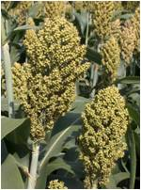 | 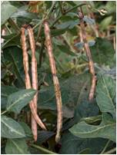 | 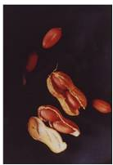

The Company
  - Agricultural Seeds & Services (Private) Limited, popularly known as Agriseeds, was established in 1988.

  - Head Office in Harare

  - Agriseeds also has a 30 ha research farm incorporating a 4,300sq.m seed conditioning plant and warehouse, located at Mt. Hampden, 20kms north of the city centre.

  - All seed is grown under contractual arrangement with communal, smallholder and large-scale farmers. Seed quality is controlled by the stringent requirements of the Certification Scheme through frequent inspections, both in the field and during processing, utilising our own and government seed inspectors.

  - Agriseeds markets their extensive product range both in Zimbabwe and the region.

CORE VALUES
Development | The company is committed to encourage and support staff to develop and advance. (Recognition of skills, initiative, commitment, results)
Integrity | Business will always be conducted with integrity (Honesty, fair dealing, value for money)
Responsibility | All members of the Company will conduct themselves responsibly (Behaviour, due care, respect, accountability
Enterprise | The Company will continuously seek new business opportunities (New ventures, costs savings, greater efficiency)
Communication | The company is committed to communicate to all stakeholder towards total understanding and knowledge
Teamwork | The bond for success (Togetherness, respect, leadership, understanding)

Current Seed Product Range

Large Grain

Maize

R201, a short season, drought tolerant white hybrid that is widely adapted to drier regions

R215, a short season white hybrid similar to R201, but with greater

yield potential in higher rainfall areas

ZM521, a short season open pollinated variety (OPV) with moderate grey leaf spot (GLS) tolerance that adapts to moisture and nitrogen stress traits.

Small Grains

Sorghum
Macia, an OPV white food grain variety developed by ICRISAT best suited to drier environments where maize is less viable, but also performs well in higher rainfall areas

Millet
PMV & PMV3 are short season crops that are well adapted to very dry, or dry climates, grown in areas where other grains generally fail.

Pulses

Cow Peas
IT18, is a very short season ICRISAT variety, maturing in 90 days, that provides both grain and leaf vegetable food.

CBC2, is similar to IT18, but with a larger, red-brown seed.

Jugo beans

Sugar beans

Oil seeds

Groundnuts
Natal Common, a short season OPV variety with multiple food uses, well adapted to areas of low rainfall, but performs better in areas of higher rainfall.

Sunflower

Peredovik, a shorter season crop used for oil extraction and supplementary animal feed

Executive Management Team

- Chairman, Rob Kelly, (PhD. Lond )

- Managing, Walter Chigodora

- Research, Dean Muungani

- Operations, Tyler Cornish

- Production, Emmanuel Nyamusa

- Financial, Simon Nyanhete

- Marketing, Brien de Woronin

Agricultural Seeds & Services

Head Office

5, Wimbledon Drive, Eastlea, Harare
P.O. Box 6766, Harare. , Zimbabwe
Tel: 263 4 700655, 728021, 723278
Fax; 263 4 702023
e-mail; agriseed@zol.co.zw

 | 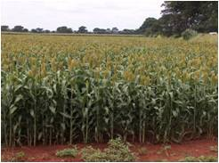 | 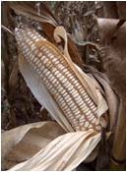 | 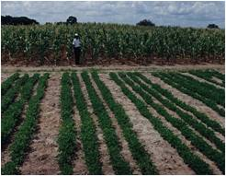

Factory

8kms along Old Mazowe Road at
Sandhurst Farm
Tel: 263 4 2915140

Data sourced from Agritex and the Cotton Ginners Association (CGA)
The National Budget presentation and Reserve Bank of Zimbabwe Monetary Policy Statements in January 2009 paved the way for the use of foreign currencies and the removal of pricing and marketing restrictions

