

AECSP Annual Review

**ASEAN-Australia-New Zealand Free Trade Area Economic Cooperation Support Program (AECSP)**

2014

Peter van Diermen

Economic Development Services Pty Ltd

March 2015



Economic Development Services Pty Ltd

PO Box 125, Unley BC 5061, South Australia

admin@edsfirst.com

www.edsfirst.com

Table of Contents

Abbreviations & Glossary 1

Executive Summary 3

1. Introduction 1

2. AECSP Overview 3

A. ECWP Projects Overview, 2010 to 2014 3

B. ECWP Projects’ Compared Between 2013 and 2014 7

3. Review of AECSP Projects 10

A. Examples of Selected Projects 10

B. Progress Highlights of Selected Activities 14

4. Program Quality 17

A. AECSP Quality Assessment 18

Relevance 19

Effectiveness 20

Efficiency 22

Sustainability 24

Gender Equality 24

B. AECSP Monitoring & Evaluation 26

Options for Improving Reporting on Results 27

5. Going Forward 30

Annex A: Terms of Reference 32

Annex B: List of Meetings 35

Annex C: List of Documents Consulted 37

Annex D: Findings from the 2013 Independent Progress Report 38

# Abbreviations & Glossary

AADCP II ASEAN Australia Development Co-operation Program Phase 2

AANZFTA Agreement Establishing the ASEAN-Australia-New Zealand Free Trade Area

AECSP AANZFTA Economic Co-operation Support Program

AMS ASEAN Member State

ANZ Australia & New Zealand

AQRF ASEAN Qualifications Reference Framework

ASEAN Association of Southeast Asian Nations

ASEC ASEAN Secretariat

ASU AANZFTA Support Unit

AusAID Australian Agency for International Development

CER Australia-New Zealand Closer Economic Relations

CLIP Competition Law Implementation Program

CLMV Cambodia, Laos, Myanmar and Vietnam (ASEAN sub-grouping)

CPR Committee of Permanent Representatives

CSIRO Commonwealth Scientific and Industrial Research Organisation

DFAT Department of Foreign Affairs and Trade (Australia)

DFID The Department for International Development

EC European Community

ECWP Economic Co-operation Work Program

FDI Foreign Direct Investment

FJC AANZFTA Joint Committee

FTA Free Trade Agreement

GDP Gross Domestic Product

IPET Ideal Patent Examination Training

IPR Independent Progress Report

M&E Monitoring and Evaluation

MFAT Ministry of Foreign Affairs and Trade (New Zealand)

MRAs Mutual Recognition Arrangements

NQF National Reference Framework

ODA Official Development Assistance

OECD The Organisation for Economic Co-operation and Development

PAF Performance Assessment Framework

PSM Phytosanitary and Sanitary Measures

QAI Quality at Implementation

ROO Rules of Origin

RPET Regional Patent Examination Training Program

SEOM Senior Economic Officials Meeting

SPS Sanitary and Phytosanitary Measures

STRACAP Standards, Technical Regulations and Conformity Assessment Procedures

TA Free Trade Agreement

ToR Terms of Reference

WIPO World Intellectual Property Organization

# Executive Summary

The purpose of the Annual Review is to assess the performance in 2014 of the AANZFTA Economic Cooperation Support Program (AECSP). A second objective of the Annual Review is to appraise the M&E framework and activities with the aim of providing options for improving it.

In 2015, the AECSP faces a period of transition. Not only is it coming to the end of its own project cycle, but it is also operating in an environment where ASEAN member States (AMS) are preparing for the full implementation, by the end of December 2015, of the ASEAN Economic Community (AEC), and at the same time, planning for the next phase of economic integration post 2015.

The report is divided into five chapters; Chapter 1 provides the outline and methodology for the report; Chapter 2 provides an overview of the AECSP; Chapter 3 illustrates the program’s performance through several case studies and a number of themes. Chapter 4 addresses the quality of the program through the six QAI criteria; and Chapter 5 provides an outline of findings and recommendations for going forward.

As of the end of October 2014, the ECWP consisted of 56 projects comprising 25 completed, six nearly completed, five substantially completed, 11 partially implemented and nine approved but not yet started.

In comparison to the 30 projects in 2013, there were 33 projects active during 2014. This is more than in any previous year of the program. Comparing the two years, the distribution across components remains much the same. When measured by number of projects, services, investment and IP dominated in both years, followed closely by rules of origin. In terms of approach, in both years about half of all projects focused on economic integration[1] and in terms of participation in activities, the split was equal between men and women for both years.

The examples of case studies provide a means to identify several relevant themes. The ASEAN Qualifications Reference Framework (AQRF) was developed through series of regional capacity-building interventions under ECWP (AANZ-0007-SER01 and Project AANZ-0021-SER03 while AANZ-0021-SER06 supports national capacity building). The AQRF is an ongoing program of activities that will require substantially more work before it achieves its ultimate goal of free flow of skilled labour. However, it has been highly praised in a number of forums outside AECSP and by ASEAN Ministers and senior officials.

A second case study is that of the ASEAN Regional Diagnostic Network.[2] It was started in 2011 (AANZ-0008-SPS-01). The objective of the project was to support emerging ASEAN diagnostic capabilities for identifying plant pests and diseases. It has already achieved a measure of success through sharing of experience in identifying pest insects between Australian and other international experts with ASEAN diagnosticians and improving national officers’ capacity to identify pests, including a new plant virus in Myanmar.

Implementation of AECSP as a whole highlighted several themes, including:

1. The AECSP is consistent with Australia and New Zealand’s trade interests and provides Aid for Trade outcomes. Implementation/uptake of the AANZFTA agreement has been advanced and at the same time contributed to increasing ASEAN and particular, CLMV members’ capacity and confidence to participate in trade related areas.
2. Engagement by Committees’ in the ECWP varies in degree and depth. An opportunity exists for analysing the needs of those Committees that so far have not taken the opportunity to be very actively involved with the AECSP. And, were this supported by the analysis, assist in translating their agenda into well designed and implemented projects.
3. The AECSP has taken on the lessons from previous reports and has moved to a more programmatic approach in capacity building. However, capacity building is a long term commitment and in measuring success we need to be mindful of this.
4. The ECWP aligns well with the AEC Blue Print. However, there is a need to consistently highlight this wherever possible.
5. The impact of the AECSP, while recognised by ASEAN Ministers and senior officials, has not been evaluated. No evaluations have been done of projects implemented, other than by the implementers who are usually government officials or private contractors with an interest to report the project has gone well.
6. For ASEC desk officers and AMS officials, the AANZFTA model of economic cooperation is the preferred modality and one they would like to see replicated in other FTAs.[3]

The AECSP was reviewed using the six QAI criteria of relevance, effectiveness, efficiency, monitoring and evaluation (M&E), sustainability and gender equality against which most Australian aid investments are measured. The findings were;

1. **Relevance**: As previous QAIs have identified, the program remains very relevant for the implementation of the AANZFTA and ASEAN’s AEC Blue Print. The design and activities align well with Australia’s trade priorities and Aid for Trade agenda. Furthermore, learning through the ECWP has between a two way process, with Australia better able to understand the position of their Cambodia, Laos, Myanmar and Vietnam (CLMV) counterparts.
2. **Effectiveness:** The AECSP remains an effective tool for supporting the implementation of the AANZFTA. It compares well against other ASEAN FTA economic cooperation chapters. However, the uncertainty around the future of AECSP has a negative impact on the program’s effectiveness in terms of project execution and continuity, managing relationships, forward planning, and eventually, staff retention.
3. **Efficiency:** The AECSP is making good progress against its work plans. For the size of the financial expenditure, the AECSP is a complex program and the governance arrangements remain complex. An extensive range of reports and data are generated for different stakeholders, including additional ad hoc reports often requested.
4. **Sustainability:** The benefits from the ECWP to support the AANZFTA are likely to last beyond the project life. Based on earlier advice, the AECSP is shifting to a more programmatic approach and institutional networking and relationship building, thereby increasing the likelihood of sustainability.
5. **Gender equality:** The ASU continues to collect disaggregated data for workshops, but has not yet made any major changes in this part of its operations. The DFAT recently commissioned gender report should provide the basis for a dialogue and actions for improvements in this area.

The ASU has done a realistic job of collecting data and documenting individual project progress. However, there is poor systematic collection of evaluation data. The need for information for the new communication tools seems to drive the M&E data produced, rather than the other way around.

In a positive development, the comment made by previous reports that the program was seen by some in ASEC as an additional burden that did not fit with ASEC‘s main work, was not observed at the desk officer level or with senior management interviewed. This could be an issue of different management styles and recently implemented improved communications. Nevertheless, effective communications remain a priority.

Going forward, the proposed CLIP project under the Competition Committee will grow significantly and dominate all other activities in the other eight components. If the program is extended beyond 2015 there will need to be some consideration of what to do with the very large CLIP project.

Moving to longer term and a more programmatic approach for capacity building should continue and be supported. However, recognition should be given, and the program accommodate accordingly, the need to remain flexible and be able to respond to short term and emerging needs.

In regards to M&E, a greater focus should be given to collecting more rigorous evaluations and thinking more innovatively about what constitutes success. All options for improving the M&E have resource implications (financial and personnel) and this should be considered in implementing recommendations. It would also help to have a consistent approach and continuity in human resources working on M&E.

Business outreach to help the private sector take advantage of the AANZFTA is not a natural fit for the ASEAN secretariat. One option is to outsource this to a contractor.

Achieving greater gender awareness and seeking opportunities to address gender issues remains a challenging task for the AECSP. Options for improving include, requiring individual project designers and implementers to pay more attention to this. Second, the ASU should initiate one or more separate studies, starting with the preparation of a technical brief.

The following are specific recommendation identified in this report:

|  |  |
| --- | --- |
| No. | Recommendations |
| 1 | As early as possible, begin planning for the next phase of the AECSP and inform key stakeholders of the process and outcomes so as to reduce uncertainty and assure a smooth transition. |
| 2 | Increase the resources (financial and personnel) allocated to M&E and consider deploying such resources in line with one or more of the following options:   1. Outsourcing some or all of the work; 2. Employing a dedicated M&E officer; 3. In addition to or separate to the ORS M&E officer, extend the M&E Adviser role or replace the position with a dedicated part-time M&E specialist; 4. Use the performance assessment framework to drive the communications strategy; and 5. Give greater emphasis to project implementers carrying out evaluations of their projects. |
| 3 | A review should be carried out of the extensive range of reports produced and data collected by the ASU for different stakeholders with a view to streamlining and simplifying reporting requirements.  This should include considering more “innovative” ways to measure performance of the AECSP to demonstrate the contribution of individual project’s to the AANZFTA implementation. |
| 4 | Evaluate outsourcing the business outreach aspect of the AECSP. At the same time, the communication requirements could also be evaluated for outsourcing. |
| 5 | Adapt and implement the gender adviser’s report (AADCP II Gender Adviser Report, November 2014) of preparing a technical brief to highlight relevant gender issues and responses in one sector. |
| 6 | Commission a relatively simple and quick review of how the CLIP program will be managed post 2015. |
| 7 | In planning for the next phase, analyse the needs and consider whether to engage and how with those AANZFTA Committees’ that so far have not taken the opportunity to be very actively involved with the AECSP. |

# Introduction

The purpose of the Annual Review is to assess the performance in 2014 of the AANZFTA Economic Cooperation Support Program (AECSP). Specifically, it focuses on the six criteria of relevance, effectiveness, efficiency, monitoring and evaluation (M&E), sustainability and gender equality. These criteria are standard measurements used by DFAT across most projects to gage the quality of aid programs.

An initial Annual Review was carried out in 2013. That Review focused on providing a “dashboard” overview of the various components of the Economic Cooperation Work Program (ECWP). It also provided an initial report on the M&E tools and their application. As far as possible, the current review uses the 2013 Review as a baseline for comparison.

A second objective of the Annual Review is to appraise the M&E framework and activities with the aim of providing options for improving the M&E reporting. The focus is on practical recommendations and options that will provide better information for understanding the impact, decision making and learning what worked to help improve future projects.

The Terms of Reference (ToR) for this report are attached as Annex A. The ToR list the six criteria for measuring quality and provide details for each criteria.

The Methodology for the Review included a desk study of AECSP documents and semi-structured interviews with key stakeholders. Questions asked centred on the six criteria mentioned above and were used to measure quality. Documents included the M&E’s framework, tools and reports, AANZFTA Support Unit (ASU) generated documents and AECSP project documents and other related material. Interviews were not held with direct recipients or beneficiaries of the AECSP projects. Stakeholders interviewed however included:

1. Gender Specialist;
2. ASU Staff;
3. DFAT – trade officers:
4. DFAT – Australian Mission to ASEAN – HOM and DC staff;
5. ASEAN Secretariat (ASEC) desk officers;
6. AANZFTA Co-Chairs;
7. FJC Leads; and
8. ASEC Dialogue partners.

In the last two years a number of reports have been produced covering the AECSP. As previously mentioned, in 2013 the first Annual Review was produced. Since 2012, the ASU has helped produce the ASEAN Secretariat’s Annual Progress Report on AECSP submitted at the end of March each year as provided in the AECSP contribution arrangement. Also in 2013 the Australian Government contracted external consultants to produce an Independent Progress Report. While each of these reports had a different focus and purpose, there are nevertheless a number of common themes that emerge from them. This report – the Annual Review, is written mindful of those reports and in not duplicating their work but highlighting where there is general common agreement.

Many AECSP projects are multi-year, making it difficult to accurately compare 2014 activities against previous years. Nevertheless an attempt is made to concentrate the review on activities that primarily fall within 2014. Where activities span wider, this is noted, and where possible, the analysis is for 2014 only. A further complication is that the data being used is current to the end of October 2014. However, these limitations, while noted here, do not necessarily affect the overall assessment significantly.

The remainder of the report is divided into four additional chapters. The following briefly describes the content of each Chapter:

1. Chapter Two provides an overview of the AECSP and is most directly comparable with the 2013 Annual Review. It breaks down the Program’s activates by several criterial that replicate those used in 2013.
2. Chapter Three, provides an analysis of the AECSP through several general themes that have emerged during the desk review and fieldwork. The Chapter also provides several examples of different types of projects.
3. Chapter Four directly addresses the quality of the program through the use of the six criterial that were mentioned at the beginning of this Chapter. Special emphasis is given to evaluating the use of M&E and providing options for going forward.
4. The final Chapter Five, provides an outline of the findings and discusses lessons learned. It also summarises the recommendations and options for the program.

# AECSP Overview

The AECSP consists of the Economic Cooperation Work Program (ECWP) and the ASU located in the ASEAN Secretariat. The AECSP was established in 2010 as a five year program with funding of AUD 20-25 million. The Program aims to support the ASEAN Secretariat in servicing the AANZFTA Joint Committee (FJC) and its Committees to assist Parties with the implementation of the AANZFTA. The program was extended up to end of December 2015.

The ECWP is made up of nine components, most of which reflect chapters of the AANZFTA. The nine components are:

1. Component 1: Rules of Origin and other Aspects of Implementation of Tariff Commitments (Roo);
2. Component 2: Sanitary and Phytosanitary Measures (SPS);
3. Component 3: Standards, Technical Regulations and Conformity Assessment Procedures (STRACAP);
4. Component 4: Services;
5. Component 5: Investment;
6. Component 6: Intellectual Property (IP);
7. Component 7: Sectoral Integration;
8. Component 8: Customs; and
9. Component 9: Competition

## ECWP Projects Overview, 2010 to 2014

As of the end of October 2014, the ECWP consisted of 56 projects, made up of the following categories:

1. 25 completed;
2. Six nearly completed (four pending financial acquittal and M&E reports and two projects with change in scope under consideration);
3. 5 substantially completed (at least 80% of core activities completed);
4. 11 partially implemented (less than 80% of core activities completed); and
5. Nine approved but not yet started.

Figure 1 shows the distribution from 2010 to 2014 of the 56 Projects across the nine components and by implementation status. Briefly, in terms of number[4], it shows that there where a small number of projects for SPS, STRACAP, Customs and the General category[5] and no projects for sectoral integration.[6] Over the life of the ECWP and in terms of number of projects, Roo, Services, Investment and IP have dominated.

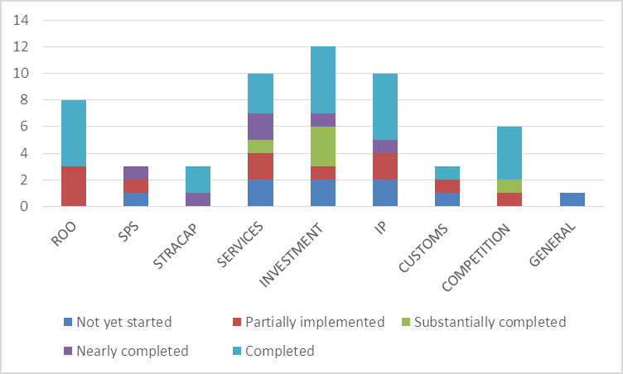

Figure 1: Project Implementation Status by Component, 2010 – 2014

Figure 2 shows by year the number of new and change of scope endorsement for projects. What is significant here is the increase in number of new projects for the first three years and then from 2012 to 2014 a number of projects were endorsed for a change in scope. The increase in number of projects each year for the first three years is normal in new development cooperation programs and reflects the AECSP obtaining momentum. The change in scope is a reflection of projects that were extended or modified. The interpretation, based on interviews with stakeholders, is that this is a reflection of the flexibility of the program and the extension of successful projects for additional work.

Figure 2: Project Endorsement, 2010 – 2014

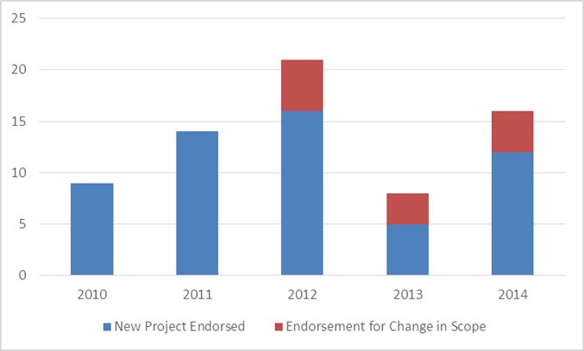

Table 1 below provides a summary overview of the 33 projects either active or approved and scheduled to start in 2014. Projects no. 7, 11, 12 and 25 are highlighted in red numbers and with an asterisk to indicate the projects are substantially completed and waiting either financial acquittal or the final M&E report. Those highlighted in yellow are new projects endorsed by the FJC but have not yet started (as of end October 2014).

Only two of the 33 current 2014 ECWP projects are shown to extend beyond the end of 2015. This is somewhat artificial as the life of the AECSP is currently to the end of 2015 and therefore projects cannot be shown to span beyond this. For the two exceptions, the projects are being directly managed by either the Australian or New Zealand Government and therefore are able to fall outside of the AECSP timeframe.[7] The two projects are; a) the ASEAN Import Health Standard: Priority Line and Capacity Development (AANZ-0009-SPS-02) and b) the Comprehensive Patent Examination Training (AANZ-0029-IP-05). Together, the two projects have a budget of just over AUD 2 million.

Projects are delivered through a range of partnerships and instruments. These range from contracted consultants, through national government agencies and international collaboration. The collaboration with international organisations has been particularly effective. For example, the very successful investment policy reviews were in partnership with the OECD and using the OECD Investment Policy Review Framework. Another successful partnership has been with the World Intellectual Property Organization (WIPO) helping AMS in implementing their intellectual property commitments and gain accession to the Madrid protocol.

The proposed CLIP project under the Competition Committee will grow significantly and dominate all other activities in the other eight components. The size of the program and the range of activities that includes skills transfer and institutional capacity support for all the region’s emerging competition authorities, suggests that it will require, in addition to the substantial financial resources, significant management inputs. Therefore, if the AECSP is extended beyond 2015 there will need to be some consideration of how to manage the very large CLIP project.

Table 1 illustrates what has been briefly mentioned, that is, there is now a well-established program momentum. If we compare the solid green lines in 2014, indicating on going or new activities, it appears to reflect as much if not more activities than in the previous years.

Table 1: Summary of the Economic Cooperation Work Program (ECWP), 2014

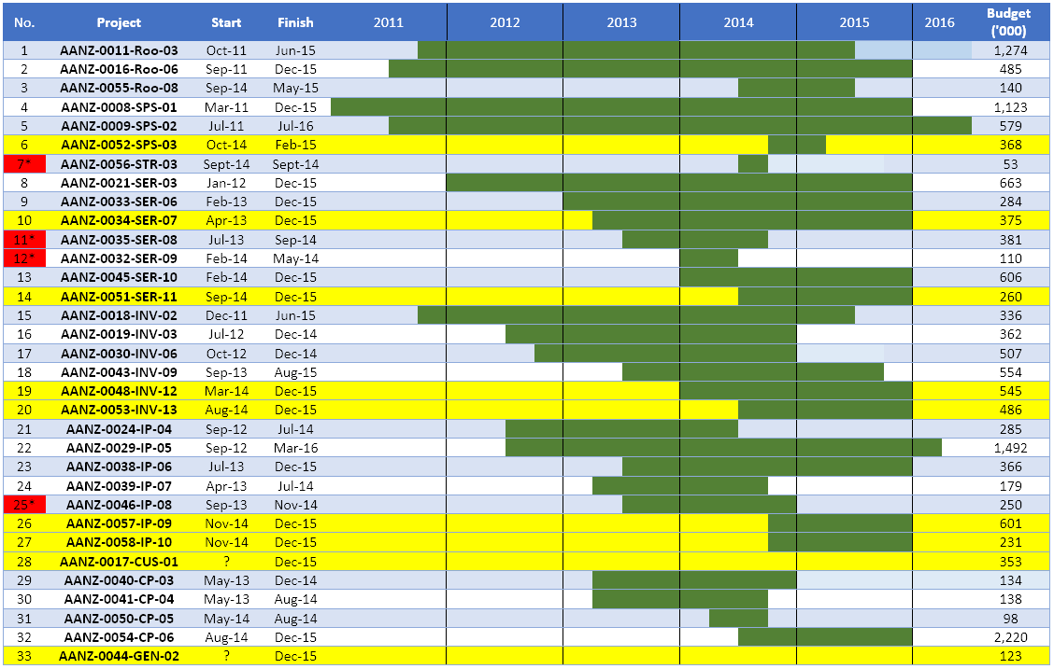

|  |  |  |  |  |  |  |
| --- | --- | --- | --- | --- | --- | --- |
| KEY: |  | Project duration |  | New/ not yet started | * | Substantially completed |

## ECWP Projects Compared Between 2013 and 2014

In comparison to the 30 projects in 2013, there were 33 project active during 2014. Figures 3 and 4 below show the distribution of projects across components for the years 2013 and 2014. Comparing the two years, the distribution across components remains much the same. When measured by number of projects, services, investment and IP dominate in both years, followed closely by rules of origin.[8]

Figure4: Projects by Component, 2014

Figure 3: Projects by Component, 2013

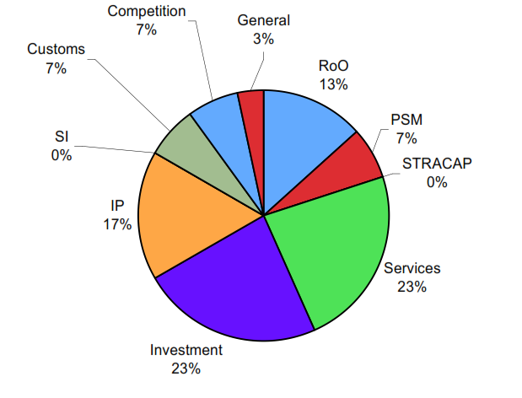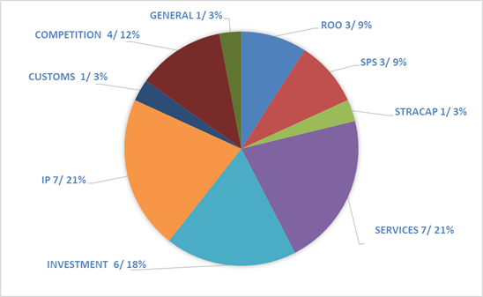

When comparing financial allocation by component, as shown in Figures 5 and 6 below, the distribution of funding between 2013 and 2014 remains very similar with rules of origin, SPS, services, investment and IP dominating, as they did when measured by number of projects in the previous figure. In Figure 6, actual expenditure is shown for 2014 in AUD ‘000, as well as, the percentage of the total.

Figure 5: Financial Allocation by Component, 2013

Figure 6: Financial Allocation by Component, 2014

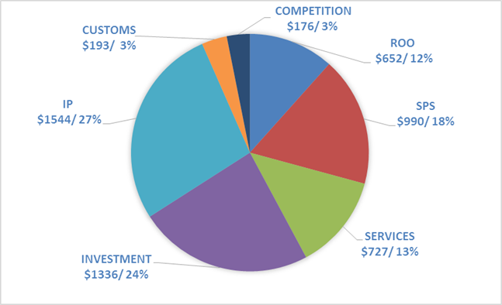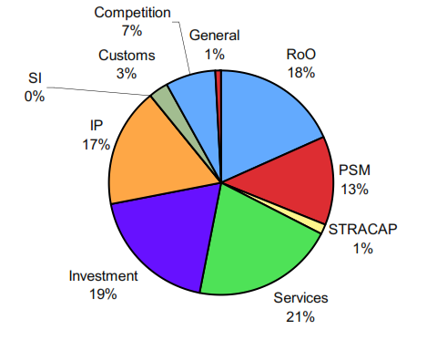

Each project was classified as having one or more strategic approach to economic cooperation. The four approaches were: Economic Integration, Build-in Agenda, Operationalization, and Business Utilisation. Figure 7 shows the distribution across the four categories for 2013 and Figure 8 for 2014.

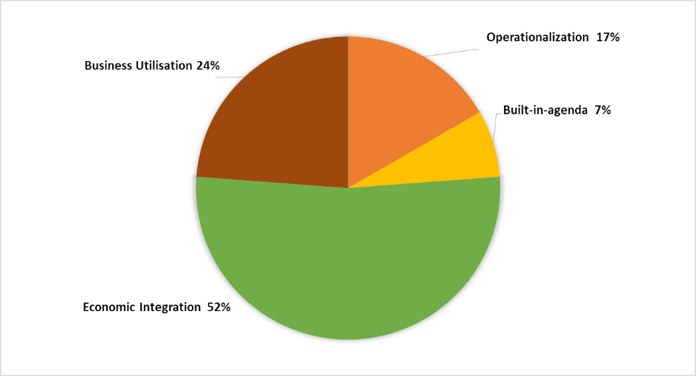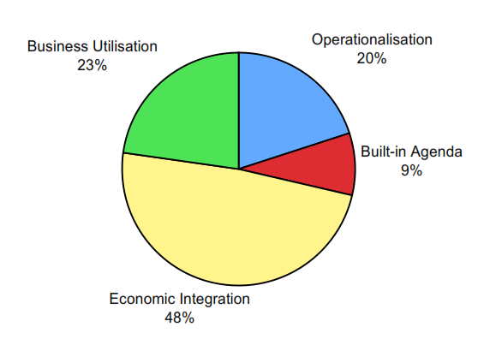

Figure 7: Strategic Approach, 2013

Figure 8: Strategic Approach, 2014

The distribution across the four categories remains much the same from one year to the other. Business utilisation is almost the same: 23 compared to 24 Percent. Economic integration has gained somewhat from 48 to 52 percent, and operationalization and the built-in-agenda lost slightly from 2013 to 2014.

The gender balance for training and workshops remained much the same. The ECWP includes a large number of workshops and training activities which are held either regionally or in-country. In the 2013 Annual Report these were disaggregated by gender for each of the major components. However, for 2014 we have provided only a total figure comparison as the breakdown by component did not add much to the analysis. As can be seen from Figures 9 and 10, from 2013 to 2014 the number of participants declined by approximately 40 percent. However, this does not include the October to December quarter and projects directly implemented by ANZ agencies. The final figure may well be more comparable to the previous year in terms of numbers. Despite the preliminary nature of the data, the gender split remained the same, that is, for each year it was approximately a 50/50 split. This occurred naturally rather than a policy induced outcome.

Figure 9: Participation by Gender, 2013

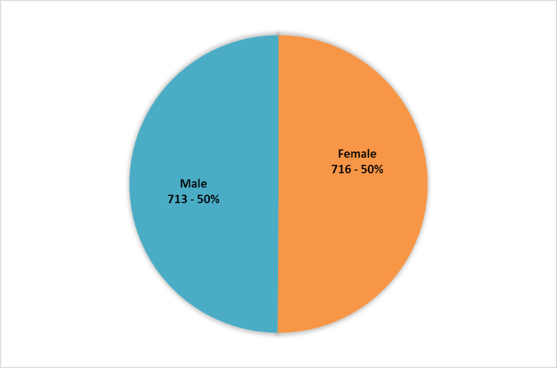

Figure 10: Participation by Gender, 2014

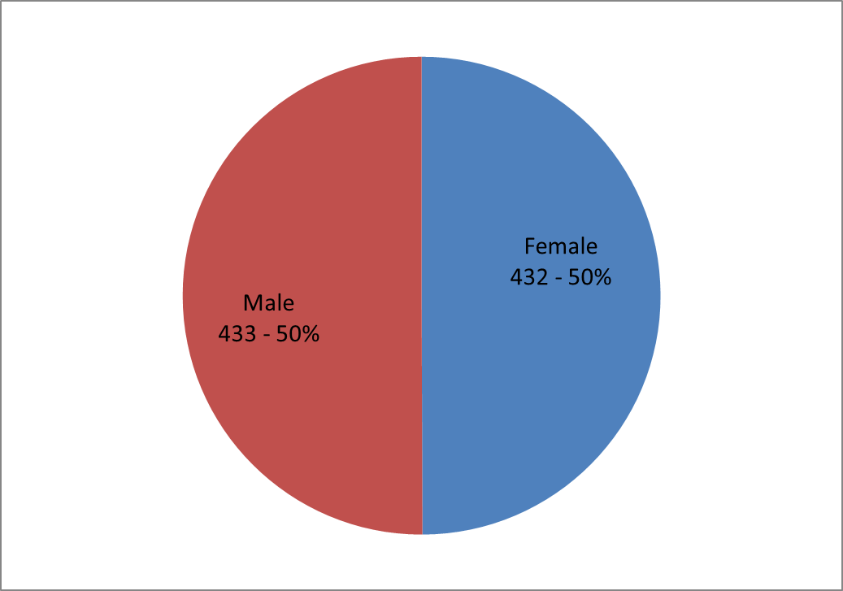

# Review of AECSP Projects

This chapter includes a more detailed description and analysis of some of the ECWP projects. It is not possible in this report to cover in detail all 56 projects or even the 2014 current 33 projects. However, it is possible to provide several case studies. By presenting these examples, and based on the data collected, it is then possible to identify several themes that shed light on the quality of the program. Together, the case studies and the themes presented provide a snap shot of the quality of the program in 2014.

## Examples of Selected Projects

### ASEAN Qualifications Reference Framework (AQRF)

Skilled labour mobility is essential for the effective implementation of services and Foreign Direct Investment (FDI) liberalization, as well as, a goal in itself for deeper economic integration of the AEC. Since 1997, ASEAN has emphasized the need to liberalize services trade through the adoption of the ASEAN Framework on Trade in Services (AFAS). The ASEAN Economic Community Blueprint, launched in 2008 outlines the vision for the AEC and the steps towards its realization. ASEAN is committed to the “Free Flow of Skilled Labour” as outlined in the ASEAN Blue Print and highlighted in Box 1, showing the relevant goals and actions.

The ECWP has supported the movement of skilled labour through a proposal (AANZ-0007-SER01) for the ASEAN Qualifications Reference Framework (AQRF).[9] The draft concept proposal was considered during the 1st AANZFTA Joint Committee Meeting in May 2010 in Manila and approved inter-sessionally in July 2010.

**Box 1: ASEAN Economic Community Blue Print: A5.Free flow of skilled labour**

33. In allowing for managed mobility or facilitated entry for the movement of natural persons engaged in trade in goods, services, and investments, according to the prevailing regulations of the receiving country, ASEAN is working to:

Action:

1. Facilitate the issuance of visas and employment passes for ASEAN professionals and skilled labour who are engaged in cross-border trade and investment related activities.

34. In facilitating the free flow of services (by 2015), ASEAN is also working towards harmonisation and standardisation, with a view to facilitate their movement within the region.

Actions:

1. Enhance cooperation among ASEAN University Network (AUN) members to increase mobility for both students and staff within the region; and
2. Develop core competencies and qualifications for job/occupational and trainers skills required in the priority services sectors (by 2009); and in other services sectors (from 2010 to 2015); and
3. Strengthen the research capabilities of each ASEAN Member Country in terms of promoting skills, job placements, and developing labour market information networks among ASEAN Member Countries.

ASEAN Economic Community Blueprint, Endorsed by 39th AEM, 24 August 2007, Makati City, the Philippines.

Since the original project, two more Phases have been implemented (See Table 1, Project AANZ-0021-SER03 and AANZ-0033-SER06). The projects provides assistance to a Task Force comprising representatives from ministries of education, labour, trade and qualification agencies. The Second Phase carried out the design and management of the common reference framework whereas the third Phase focused on the capacity and capabilities of the ASEAN parties to develop and implement the National Reference Framework (NQF) through bilateral technical exchanges. The three related projects started in April 2011 will continue to the end of 2015. Total approximate cost of the three projects is slightly less than AUD 1.23 Million.

The AQRF developed with AECSP support has been endorsed in 2014 at two ASEAN Ministerial bodies – namely Economic and Education. It is currently being considered inter-sessionally by the Labour Ministers (see Box 2). More work will be required in the lead up to the actual implementation of the AQRF. Ongoing cross-sectoral coordination and a collective undertaking by the relevant bodies will be required. This will include extension of technical assistance and support for the Task Force to continue its work including the adoption of the referencing criteria, the implementation processes, the quality assurance criteria and the terms of reference for the AQRF Board.

The AQRF is a significant step towards assisting ASEAN with future MRAs. Mutual Recognition Arrangements (MRAs) are policy instruments that are designed to promote economic integration and increased trade between participants, particularly between nations. This is achieved by reducing regulatory impediments to the movement of goods and services.[10]

The AQRF has assisted with setting up regionally agreed benchmarks for mutual comparison of and recognition of national qualifications to facilitate the mobility of professionals within ASEAN. The successful development and acceptance of the AQRF is a significant milestone for achieving the AEC Blue Print ambition in the free flow of skilled labour.

Aside from the development of the framework itself, the project has helped institutionalize cross-sectoral cooperation among trade, labour and education officials in ASEAN. It is important to note that the international community and organizations have recognized the contribution made by the Task Force and its members have been engaged as resource persons by ILO, UNESCO, ADB, IOM and others, for related initiatives.

**Box 2: AQRF Endorsement by the Relevant Ministerial Meetings**

A. 46th ASEAN Economic Ministers (AEM) - 25 August 2014, Nay Pyi Taw, Myanmar

Excerpt from the Report of 46th AEM:

“39. The Meeting endorsed the ASEAN Qualifications Reference Framework (AQRF) noting that given the cross-cutting nature of the agreement, it will also be endorsed by the respective sectoral Ministerial meetings. The Meeting agreed to express its appreciation to Australia and New Zealand at the 19th AEM-CER Consultations.”

B. 19th AEM-CER Consultation - 26 August 2014, Nay Pyi Taw, Myanmar

Excerpt from the Joint Ministerial Statement of 19th AEM-CER Consultation:

“13. Ministers welcomed the endorsement of the ASEAN Qualification Reference Framework (AQRF) at the 46th ASEAN Economic Ministers’ Meeting. The AQRF, which will enable comparisons of qualifications across ASEAN Member States, is a step further towards the ASEAN Economic Community goal of free flow of skilled labour. The Ministers acknowledged the work undertaken by the Task Force on AQRF, which comprised representatives from ministries of labour, education, trade, and qualification agencies. ASEAN thanked Australia and New Zealand for their continued support to the Task Force through the AECSP.”

C. 8th ASEAN Education Ministers Meeting (ASED) - 11 September 2014, Vientiane, Lao PDR

Excerpt from the Joint Statement of 8th ASED:

“6. The Ministers expressed its appreciation to the Task Force of the ASEAN Qualifications Reference Framework (AQRF) for its efforts in producing the Framework. Recognizing its importance towards the vision of ASEAN Community 2015, the Ministers agreed to endorse the Framework as a guideline for the ASEAN Member States to voluntarily adopt.”

### ASEAN Regional Diagnostic Network

A second case study is that of the ASEAN Regional Diagnostic Network. It was started in 2011 (see Table 1: AANZ-0008-SPS-01) and will continue through to the end of 2015. Originally envisaged as a small one-off project for AUD 275 thousand, its success saw it grow to AUD 1.12 million (and recently up to AUD 2.25 million as endorsed by FJC in 2014) and extended to the end of the AECSP in 2015.

The objective of the project was to support emerging ASEAN diagnostic capabilities for identifying plant pests and diseases. The ECWP project supports a larger ASEAN-wide project of the ASEAN Regional Diagnostic Network that aims to establish a cooperative system for delivering credible plant pest disease diagnostic services.[11] The ECWP project supports training and mentoring activities. Specifically, it provides training for all ASEAN Member States on important plant pests and diseases. It furnishes each AMS with at least one person who is capable of preparing and identifying specimens, and recognising which specimens should be referred to specialists for further examination. The Project is delivered through a series of workshops, mentoring visits and specialist training activities. Participants were assessed before and after workshop training to determine the application of skills and knowledge. Mentoring activities involved specialist trainers visiting a small number of ASEAN countries to deliver training and field surveys. Training of specialist diagnosticians was delivered through short-term laboratory attachments, short-term projects or surveys. As part of this project equipment associated with training activities and remote microscopy units were also provided. As the Independent Progress Report noted, the project has already achieved success through:

1. Establishing a pilot clearing house for the ASEAN Regional Diagnostic Network in a laboratory in Malaysia to manage the flow of plant pest and disease samples between submitters and diagnostic experts. The clearing house has already successfully identified pest insects using international experts outside the ASEAN region
2. Building capacity through workshops that provide training in the diagnostics of pest nematodes. Assessments found that the share of participants that could identify pest nematodes increased from 33 per cent to 100 per cent after participating in the training workshop.

Other measurable benefits include the identification of new plant virus in Myanmar and a move to a more risk-based assessment of quarantine detection which will reduce cost and time in processing agricultural exports. The development of the network has also helped resolve agricultural trade issues between AMS.

The Network plans to move to a sustainable basis by introducing a fee for service model. This will be supported by the development of strong regional networks with significant centres of expertise in Thailand and Cambodia. The network is supported by Australia through several institutions, including CSIRO, Murdoch University and the Plant Biosecurity Cooperative Research Centre in Australia.

## Progress Highlights of Selected Activities

Several themes emerge from the case studies, the desk study of AECSP documents and semi-structured interviews with key stakeholders. In this section of the report the themes are explored in more detail. The themes provide a baseline for future comparison. The two case studies presented above provide examples of how the ECWP projects have provided real and measurable benefits to the AMS. While not all of the 56 ECWP projects will have the same level of success, nevertheless, the two case studies are not outliers and are reasonable representative of the projects being implemented. Also, the ASU has produced several short summaries of different projects that help identify key themes. An example of one of the summaries is shown below.

The case studies and data collection demonstrate how the AANZFTA agreement has been advanced and at the same time how there have been development outcomes. Thus meeting both the national interest of the AANZFTA parties and the Aid for Trade development objectives. This is important as all ASEAN member states and Australia and New Zealand are AANZFTA Parties, but only Australia and New Zealand are also OECD member countries.

Not all the various committees are engaged at the same level in the ECWP. The projects that make up the ECWP are approved by the FTA Joint Committee (FJC) and supported by the various committees that report to the FJC. Figure 11 shows the five sectoral committees and the four sub-committees that make up the AANZFTA Committee Structure. There exists significant difference across the nine AANZFTA components in terms of participation. For example, the Committee on Goods has met ten times, ROO Sub-Committee nine times, Investment and the IP Committee have each met six times, while Services and SPS Subcommittee has met three times and Competition and STRACAP Subcommittee twice. An opportunity exists for analysing the need to engage more with those Committees that so far have not taken the opportunity to be very actively involved with the AECSP. And, were supported by the analysis, assist in translating their agenda into well designed and implemented projects.

Those that are engaged in the ECWP have over time improved their projects through a process of learning what works. The ECWP is overwhelmingly involved in capacity building. As the Independent Progress Report noted and this Annual Report concurs with, capacity building activities have undergone a transformation since the beginning of the ECWP. Initially, the projects were ad hoc activities addressing issues of AANZFTA implementation. As the ECWP program matured, projects were still linked to AANZFTA implementation, as they should be, but have moved to longer term programs that involve institutional building and addressing issues beyond individuals’ capacity. While this does not guarantee sustainability, it makes it more likely. Nevertheless, the ECWP should also continue to retain the ability to program short term activities in response to immediate needs.

Figure 11: AANZFTA Committee Structure

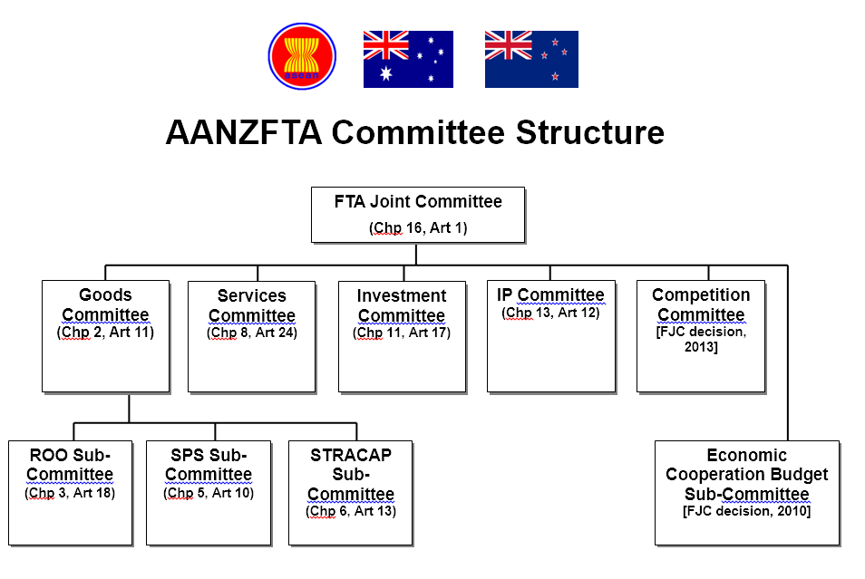

There is a close link between the agenda being pursued under the AECSP and the AEC Blue Print. Many of the projects in the ECWP directly support or implement parts of the AEC Blue Print.[12] Nearly all the ASEC desk officers acknowledge the link and see the activities of the ECWP and the support received through the ASU as directly benefitting their work and that of the AMS. The implementation of the ECWP through the ASEC helps with this alignment. However, the ECWP also creates additional coordination work for desk officers.

It is difficult to evaluate the impact of the AECSP. Measures of efficiency can be assessed for the ECWP and ASU and a range of stakeholders can be asked for their view of the benefits from the ECWP projects. The impact on the Parties’ ability to implement the AANZFTA is difficult to measure through secondary data, despite high-level officials making very positive statements in official meetings and other forums. The M&E system developed for the AECSP has only been partially implemented and is partially successful. Good data has been collected from participants in workshop and training etc. But, no case studies, outcome assessments or impact evaluations have been done of specific projects. At the end of each project a project completion report is done. However, these are more an administrative process than an evaluation.

The AECSP may well benefit from a systematic and selective evaluation of a small number of ECWP projects. This should focus on more direct collecting of evidence from beneficiaries in different ASEAN countries. It could be done through a mixed method of collecting qualitative and quantitative data from agencies and people managing or directly benefiting from specific programs. It is likely that this will provide lesson for future Aid for Trade programs and projects, particularly for regional programs. Finally, it may provide scope for examining the synergies between different Australian government FTA/ASEAN support programs and some strategic thinking/scoping of how different regional support programs might fit together in the future.

The AECSP (comprising ECWP and the ASU) is unique in its modality when compared to other FTAs’ economic cooperation arrangements. The economic cooperation program was a first for Australia, however, several other ASEAN+1 FTAs have economic cooperation chapters. Many of these remain underutilised, and could be more effective in providing the anticipated benefits. The AANZFTA model of economic cooperation may have lessons for other regional agreements. This point has been somewhat neglected in terms of documenting the reasons for success and how this can be replicated to other agreements.

# Program Quality

This Chapter takes a more technical approach to examining the AECSP. It directly addresses the quality of the program through the use of six criteria that were mentioned at the beginning of this report. The six criteria are listed in Table 2 with a description of the key questioned used to asses quality. The M&E criteria is dealt with separately. Special emphasis is given to assessing the use of M&E and providing options for better reporting.

Table 2: Criteria Used to Assess AECSP Quality

|  |  |
| --- | --- |
| **Criteria** | **Assessment** |
| * 1. Relevance | Is this still the right thing to do?   * Is the goal (long-term outcome) is still reflecting the current needs? * Are the EOPOs(End-of-Program Outcomes) are still inline or going to contribute to GOAL, given the current context |
| * 1. Effectiveness | Are we making the difference that we expected at this point in time?   * Are we making adequate progress towards the EOPOs * Is progress continuing well since 2013? |
| * 1. Efficiency | How well is our resources and time being used to achieve outcome?   * Are we making adequate progress against the Work Plan? * Are we making adequate progress against the Budget Plan? * Are the resources adequate? |
| * 1. Monitoring and Evaluation | Is an M&E System being used to effectively measures progress and generate lessons learned?   * How can the improved M&E system be finalised and implemented? |
| * 1. Sustainability | Will the benefits/intended outcomes last? |
| * 1. Gender Equality | How well do we respond to gender equality concerns? |

For the size of the financial expenditure, the AECSP is a complex program. As mentioned in Chapter 2, the ECWP consists of a large number of projects across nine components with each project having several activities. In 2014, there were at least 33 projects either active or approved to start. For most projects the ASU takes a hands-on approach in terms of project management, including drafting agendas, identifying venues, speakers and organising logistics. The ASU team is ASEC-contracted and reports on a day to basis to the ASEC, while guided by the JFC for strategic directions and managed by DFAT Jakarta Post. It also liaises with ASEC desk officers and AANZFTA Committee leads in the design, implementation and reporting of projects. It also assists with the preparation of reports as requested by the AANZFTA Parties (e.g., for AEM-CER meetings, Australia and New Zealand summits). The following then is an assessment using the six criteria.

## AECSP Quality Assessment

The question often asked of development projects is: what does success look like? One way to measure this is against the original objectives set out in the design document. In this case, the original design document identified success of AECSP in terms of five objectives:

1. Enhanced government desire to engage in economic integration generally and AANZFTA implementation in particular;
2. Increased business awareness leading to increased utilization of AANZFTA opportunities and increased trade and investment flows;
3. Enhanced capacity of ASEAN Member State institutions to engage in trade liberalization and to implement the AANZFTA Agreement specifically;
4. Strengthened working relationships between the Parties through the establishment of, and deepened engagement in, functional sectoral networks; and
5. Increased confidence in AANZFTA Economic Co-operation (Support Unit and Work Programme activities) as the preferred model for ASEAN-based FTA implementation.

These objectives were used by the 2013 Independent Progress Report (IPR) which reported that “progress is being made”. The IPR Findings are summarised in the Annexes to this report. The focus here is more on the operational side – that is the six previously mentioned criteria.

However, before delving into the details of measuring the criteria, it is instructive to consider the wider context of what the value added is of the AECSP (ASU and ECWP). Here and elsewhere, the high regard for the program by ASEAN Ministers and Senior Officials is well documented. In particular Ministers and Senior Officials have acknowledged in several communiqués their appreciation for the assistance received with improving the capacity of many AMS to engage in trade related activities and for supporting ASEAN “one single market” priority.

Since the “one single market” is a priority for the ASEAN member states and the 2003 Rome Declaration on Harmonisation and the 2005 Paris Declaration on Aid Effectiveness has as its first and second principles strengthening partner countries’ national development strategies and increasing alignment of aid with partner countries’ priorities, the AECSP through the official statements of the ASEAN Ministers and senior officials has, in line with OECD principles, demonstrated that it is well aligned to and helped AMS to achieve their priorities.

Where the AECSP has been less successful, is developing evidence to show the contribution of individual project objectives to the strategic, long-term development outcomes articulated by AMS Ministers and senior officials in their statements of support. This is more a failure of the performance assessment framework in measuring success than a failure in achieving success. As a review of DFID and EC Aid for Trade monitoring and evaluations practices noted, there is some evidence that trade, growth and poverty are interlinked and very few countries have grown without expanding their trade, nevertheless, empirical studies have been unable to establish a systematic link between trade and poverty alleviation[13] In this respect, the AECSP is no different to many other Aid for Trade programs, in that success is inherently difficult to measure.[14] Difficult to measure doesn’t mean it hasn’t occurred, it just means we need to be more innovative in measuring success.

### Relevance

The program remains very relevant for the implementation of the AANZFTA and ASEAN’s AEC Blue Print. The design and activities align well with Australia’s trade priorities and Aid for Trade agenda. The FJC and Ministers have already asked for the program to continue beyond 2015.

The ECWP has been important for helping AMS implement the AANZFTA. As one ASEC senior officer commented; “the AANZFTA has really been moving”. At the recipient level the program is improving individual officer’s ability to implement the AANZFTA. For example, the IP component has had several important successes in improving capacity. This includes the Regional Patent Examination Training Program (RPET), Ideal Patent Examination Training (IPET) and Accession to the Madrid Protocol activities. Similarly, the ROO training for some of the CLMV (See Projects AANZ-0011-R00-03, as well as earlier year projects), has improved those countries’ ability to participate in the AANZFTA Roo Sub-Committee, as well as, in other regional dialogues and trade negotiations.

The learning process has not only been one way and the Roo Sub-Committee acknowledges that through the ECWP process of engagement, the Australian delegates were better able to understand the position of their CLMV counterparts. This helped in achieving a mutually acceptable position in regards to the Roo, which had previously not been possible. As part of this exchange of views through the AECSP, it has narrowed the gap between different interpretations or positions among AANZFTA Parties. In doing so it has assisted both Australia and their CLMV counterparts.

Over time the ECWP has taken up the advice, given through several different reports, to move from one-off capacity building activities to more holistic and sustainable programs which have included institutional linkages and driven more by recipients demand. As much as possible this trend of programmatic capacity building should continue with particular attention given to supporting institutional capacity development of the CLMV. Such programs can continue to include short term activities and, as listed in the design document, supporting the ASEAN Secretariat servicing the FTA Joint Committee and to assist Parties in the implementation of the AANZFTA.

The ECWP also aligns well with the AEC Blue print. There is a natural alignment between the advancement of the AANZFTA and the AEC Blue Print. Fundamentally, they attempt to do the same thing – create a single market for goods and services. The main difference is that the Blue print doesn’t include ANZ and is broader in nature, whereas the AANZFTA is more specific in its scope. Given this natural alignment it’s not surprising that much of the ECWP aligns well with the AEC Blue Print.

The main issue regarding the subject of alignment is one of communicating this to external parties and consistently including this in documentation with public stakeholders. The earlier difficulties noted in the 2013 IPR, seem to have disappeared, partly through improved communications. In its work, the ASU documents how individual ECWP activities aligns with the AEC objectives.

Therefore, the program remains very relevant at the higher policy goal level in terms of the aid agenda and trade priorities, and on a practical level supporting implementers.

There is a perception among stakeholders that as the AECSP matures, the AMS in the various AANZFTA committees and sub-committees are able to take greater advantage by initiating projects. These initiations are often at a conceptual level, leaving the design to other experts. Given the steering committee arrangement of approval through the FJC, the AMS will always have a voice but what is important is the gradual shift as the program matures from being passive to actively initiating projects.

### Effectiveness

The AECSP remains an effective tool for implementing the AANZFTA. It’s a model that ASEC senior desk officers have recommended for other FTAs. The process of learning through the AECSP has also helped AMS with negotiations for other FTAs.

Given the existence of other ASEAN+1 FTAs with economic cooperation chapters and a range of dialogue partners that work with the ASEC, desk officers were asked how the AECSP compared with other similar programs. All ASEC desk officers rated the program as the most effective to work with. When asked why this was, it was first ascribed to the ECWP aligning well with their own agenda and priorities and second, the ASU ability to work directly with desk officers and the AMS sectoral bodies. And third, the ability to bring into play very relevant and useful expertise that directly addressed Parties’ needs.

Based on feedback from a range of stakeholders, including ASEC desk officers, the FJC and AMS, the AECSP is making a difference that broadly aligns with what we would expect. ASU directly supports sectoral bodies and desk officers in developing ideas into full-fledged proposals, including to support the work programme of each committee. In the implementation arrangements, desk officers generally consider the ECWP as very responsive and flexible to their needs and that of the sectoral bodies. The flexibility in logistics and meeting the needs of recipients makes the program highly valued among the stakeholders but also requires intense resourcing.

ECWP is one of the few (if not the only program) where the project team (ASU) attend the sectoral body meetings. This is an advantage in terms of working closely with counterparts and good “development practice”. It’s a disadvantage in so far as it is resource intensive as the ASU is heavily involved in finalising project proposals with the various ASEC bodies.

Progress since 2013 against the ECWP has been good. Since 2013 the program continues to expand and take a more programmatic approach and continues to grow in number of total activities. Several activities have more than one phase, which is an indication of initial success and demand for further work related to the relevant area. If measured against the nine Components in the ECWP, progress continues to be made. As Table 1 showed, 19 of the 33 projects carried over from 2013 to 2014. There were 12 projects that were started in 2014 and of these five were of less than one year duration. This demonstrates a continuity in a more programmatic approach, and by implication, an effective program.

Within ASEC there is a relatively large number of new desk officers. This has both a positive and negative side to it. On the negative side, the large number of new people means there is limited corporate memory of the AECSP and other similar programs. On the positive side, most, if not all, of the new desk officers have a positive attitude to working with the AECSP and see it as a real benefit in their work of advancing the AEC Blue Print.

There is a general concern among stakeholders about the ending of the program in 2015. This has two impacts on effectiveness, first, it makes programming difficult for longer term projects and second, it raises implementers and recipients’ uncertainty, making it more difficult for them to implement. It is understood that this issue may have resolved itself, it was nevertheless, a significant issue of discussion initiated by the various stakeholders interviewed. Clarity should be provided as soon as possible on the future of the program so as to give recipients and implementers greater certainty in planning and executing programs.

The issue of outreach, in particular addressing the issue of an increase in business awareness leading to increased utilization of AANZFTA opportunities was less obvious. For most of the implementers at ASEC or AANZFTA leads this did not seem to be their priority for the AECSP. The focus was very much on the technical aspects of implementing the AANZFTA and dealing with the operational aspects of moving to an AEC single market. While the ASU had made some efforts to engage the private sector this was largely additional rather than part of core activities. Given the technical nature and government focus of ASEC desk officers and the ASU work, increasing the focus on outreach to the private sector will always be difficult to achieve and will need to be more programmed into work plans. Or a different approach could be to design a program and tender the implementation work out to a contractor who will be dedicated to the work and can be more suited to the type of activities, i.e. an organisation or individual specialising in private sector engagement work. It is possible to also consider some form of outsourcing for the communication products currently being managed by ASU. Such a move will need to carefully consider how this will be done and managed.

### Efficiency

The AECSP is making good progress against its work plans. In comparing 2014 activities against previous years of operation, the number of projects is greater than any year previous (see details in Chapter 2). As part of the 33 active projects, it has run a large number of training courses, although this appears to be down from 2013. In comparing the operation costs of the ASU against the ECWP as shown in Figure 12, it appears that based on this simple financial efficiency measure, the AECSP is doing well. The data for 2014 (both financial and course participants) is perhaps somewhat understated as the figures for the year are not yet finalised.

Figure 12: Comparison of ASU with ECWP

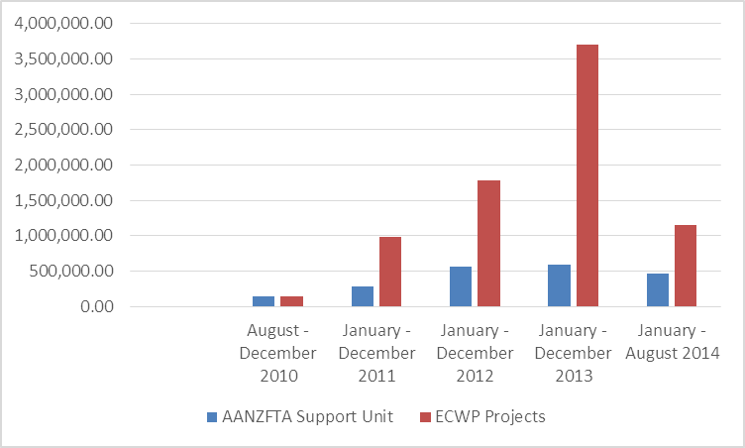

Spending against budget has been somewhat problematic. It has exceeded expectations in so far that the midyear financial snapshot indicated a potential shortfall of AUD 3.6 million, taking into account the committed expenditure, pending proposals and anticipated savings. This was very much the reverse of its earlier years when it accrued budget savings.

Resources are adequate, however, any additional tasks will require additional resources as there is limited capacity to increase the workload. ASU has a small dedicated staff working to support the ECWP. They are hands on managing the activities and are well regarded by their ASEC colleagues in terms of their flexibility and ability to manage programs and activities. For part of 2014, between one and two of the junior positions allocated to the ASU were vacant and the recruiting of new staff appeared to be a difficult process. This Annual Review will make several recommendations on how the AECSP can be improved. Almost all of these have resource implications. While not having done a systematic review of workloads, it appears from discussions and observations that the ASU is working near capacity and any additional tasks will need to factor this in.

In terms of efficiency, and as previously mentioned the governance arrangements are complex. There appears no simple solution to resolve this issue in terms of simplifying the design or reporting lines. On the plus side, the system works and has made for an effective, if perhaps not necessarily the most efficient model. One implications of the governance arrangement is that the various Parties should be mindful of the bureaucratic burden, particularly as it relates to reporting, and seek to coordinate and streamline reporting requirements from the ASU.

Currently an extensive range of reports and data are generated for different stakeholders. In addition to the systematic reporting requirements additional ad hoc reports are often requested. This in part reflects the nature of the governance arrangement. It may be possible to streamline and simplify the reporting through a review of what is required by whom and when.

The comments made by previous reports that the program was seen as an additional burden and did not fit with ASEC main work was not observed at the desk office level or with senior management interviewed. This could be an issue of different management styles and recently implemented improved communications. Nevertheless, effective communications remain a priority.

### Sustainability

The benefits from the ECWP to support the AANZFTA are likely to last beyond the project life. The capacity building for many of the sectoral bodies of the AMS have long term benefits. Individual capacity building, such as the IP training for patent examiners, are being supplemented in later iterations with networking between ANZ and AMS institutions. These institutional arrangements can be expected to continue long term and are enhanced by the individual relations created through the networking and training.

The shift to more programmatic approach and institutional networking and relationship building increases the likelihood of sustainability. Similarly the bottom up approach to identifying projects by AMS, and the balance shifting from ANZ to AMS initiated projects are good signals for sustainability. An example of AMS led initiatives include the initial program support for the country level OECD Investment Policy Reviews (AANZ-0020-INV-04). Following this initial project, several other requests were received for carrying out the same process, including from all four CLMV countries.

Among all the stakeholders interviewed there is a general perception that the capacity of AMS participating in projects has improved their ability to deal with AANZFTA related issues. ASEC officers also believe this has carried over into participants’ capacity to deal with broader AEC issues.

### Gender Equality

Not much has changed since the last review. The ASU continues to collect disaggregated data for workshops and other events, as has been reported in an earlier chapter. In activities, such as workshops, seminars, training etc. the gender balance is good, with a 50/50 split.

Achieving greater gender awareness and seeking opportunities to address gender issues remains a challenging task. All AECSP Quality at Implementation (QAI) reports since 2010 have identified support for gender as limited and ad hoc. Gender remains an important issue for the OECD and Australia’s aid program in particular. Gender issues tend to get less attention from AMS, AMS trade programs and in the AEC. The recent gender adviser report highlighted that gender is not part of the AEC and that even with significant resources allocated for gender the impact could be minimal.[15]

A gender adviser was employed to advise the ASEAN Australian dialogue partner program - AADCP II. The gender adviser briefly met with the ASU and has shared her findings for the AADCP II program. The Gender adviser’s report recommends a pragmatic response that could start with the preparation of a technical brief to highlight relevant gender issues and responses in one sector. However, the report also advises that significant changes are needed in the AEC environment before investing heavily into improving gender mainstreaming.

## AECSP Monitoring & Evaluation

Briefly, the main issues are summarised here and then explored in more details in the following paragraphs. The development and implementation of the M&E framework[16] has suffered from frequent changes. The collection and recording of monitoring data has been relatively good for the purpose of managing the program. Reporting to AMS senior officials has been good and well recognised. The main short coming has been in collecting information for evaluation purposes (i.e. reporting on results) and carrying out evaluations. Improved collection of such information would provide better evidence for what difference the AECSP has made and provide useful data for communicating impact to stakeholders and the wider community. Several options can be considered for improving the system.

The AECSP Performance Assessment Framework (PAF) has undergone a significant number of changes since the AECSP initial design. The framework has been modified and updated several times and a number of specialists have come and gone to advice on the design and implementation of the M&E framework and its tools. Each person has had a slightly different view on what was needed and how to implement the framework and report on outcomes. The result has been a patch work of tools and implementation processes. Over the life of the program there has not been a consistent management of the process to adjust and fine-tune the framework and tools as needed and based on learning from experience. Given this history, it is not recommended that the PAF be changed or revised. Rather, the focus should be on fine tuning the exiting tools and methodologies within the PAF.

The ASU has done a realistic job of collecting data and documenting individual project progress. There is an M&E plan and a reasonable set of tools for collecting monitoring data. The data generated has been sufficient for recording project and activities progress and for the FJC to make decisions on, as well as, meet the needs of AMS senior officials.

For a multi-stakeholder program such as the AECSP the use of monitoring data to systematically report on progress and achievement is critical for keeping a diverse range of stakeholders involved and informed. Reporting has been good in keeping the various AANZFTA Parties informed of project and activities progress. Less successful has been the use of data to communicate results to a wider audience and or meeting the more rigorous requirement of the aid program.

There is poor systematic collection of evaluation of data. What data is collected is primarily used to illustrate the fact sheets for the communication strategy. The pilot activity of the two focus groups seems not to have produced useful data, or at least difficult to interpret by a third party. The follow up M&E tool of emailing recipients 6 months after the event has not worked. Experience from other projects shows this type of follow up normally has a very low response rate.

The communication strategy need for information seems to drive the M&E agenda. In an ideal situation this would be the other way around. Communication of outcomes is an important aspect of the ECWP as there are 12 countries and the ASEC involved that all have a stake in benefiting from the program. However, in a well-developed performance assessment framework the data collected would provide the necessary, if not all, the requirements for the communication strategy. The problems with communication driving the evaluation process is that it may not necessarily produce the data required for reporting or learning from to improve the program.

The AANZFTA website could be an ideal tool to communicate progress and success. However, the website is currently more a calendar of events and a repository of documents than an outreach communication tool. Even as a repository of information for AANZFTA parties, it could be more user friendly.

Impact of the ECWP “on the ground” is hard to demonstrate without additional data collection. Benefits of ECWP to AANZFTA parties could probably be demonstrated, as well as, wider benefits to AMS through a series of case studies and national level analysis. This could be done through focus groups, semi-structured interviews and surveys.

### Options for Improving Reporting on Results

The focus is on practical advice and options for improving the tools and collection of data. The PAF as currently structured is sufficient to cover the improvements recommended here. All recommendations for improving the tools and collection of data have implications for resources that need to be considered. The analysis and options listed do not markedly differ from previous reports, but rather are couched in more practical terms and provide additional details.

It appears that ECWP is “underspending” on M&E. The World Bank estimates that about 3 to 5 per cent of program funds are normally used for M&E. This varies depending on type of program. For the ECWP it’s difficult to measure given the design of the AECSP and what to include in such a measure. Nevertheless, the impression is one of underspending in this area. Additional resources may need to be employed on M&E for adequate covering and generating the data needed to feed into the communication plan.

Regular quality evaluations and analysis are required. From the foregone analysis, it is clear that the ASU already collects a range of data and provides several different reports. This should continue. What is recommended is supplementing this with additional activities. In practical terms, what is missing is consistent and regular and external evaluations of what the projects have achieved, that is systematic and high quality evaluations of the projects against the program objectives. Complementary to this, there is a needed for regular reporting of these results in high quality, easy to consume and well-designed reports targeted at key stakeholders and for more general distribution.

The baseline for determining what additional work is needed is identifying what different stakeholders need. At least two groups are neglected by the current reporting arrangement. First, those concerned with the impact of the aid program are not sufficiently catered for in the analysis of information that measures the contribution of individual projects to national and regional economic development. Second, a range of AANZFTA and ASEC stakeholders could be better served through the development of evaluations that are well targeted and communicated. Both groups can be served by the same collection and analysis of data. Where they differ, is how the communication strategy would use the information generated.

Several opportunities can be identified for improving reporting that would meet the needs of the neglected stakeholders:

1. Fine tune data collection for activities and adjust existing tools based on learning what works and what doesn’t. The six months follow up emails should be discontinued given the low response rate. Fine tuning will require the ASU working with the M&E Adviser on trial and error testing of several methods. The solution lies in understanding the operational details and finding the right point at which to intercede.
2. Better utilise monitoring data for analysis and regularly reporting progress. Currently a significant amount of data is collected but often poorly utilized in terms of analysis and reporting other than for committee meetings. The end of project reports, activities reports and workshop data collected provide a rich source of material for analysis that can be included into the existing reporting cycle.
3. Complement monitoring data with evaluations of projects at the sectoral body level and in-country case studies. Consideration should be given to annually carrying out one or two such studies. This will provide greater amount of detail and evidence of projects impact.
4. Utilize the website as a tool to communicate results. This is already in the process of being done through the redesign of the website. The website can also be used to pilot surveys using innovative tools such as Survey Monkey (www.surveymonkey.com) and similar tools. This should be done on a trial and error basis as previously mentioned.
5. Link evaluations more directly to learning and the communication tools. Evaluations are particularly useful for identifying what worked and why. This can help design and implement better projects. The evaluations should feed into identifying and learning for subsequent work and be used in the communication strategy’s publications.

All of the above suggestions have resource implications. As already mentioned, the assumption is that the current ASU staff are working close if not already at full capacity. Asking them to undertake all of the additional task is not realistic in terms of assuming they have the time and the skill set required. Therefore, consideration should be given to funding these recommendations out of an expanded M&E budget. Several options can be advanced for implementing the above recommendations and overcoming the capacity constraints of the ASU. This includes:

1. Outsourcing some or all of the work. This is already being done with the redesign of the website. It can also be done for some of the analysis needed and other aspects of reporting on the performance assessment framework. For example, a series of evaluations of selected projects could be commissioned.
2. Employing a dedicated M&E officer. This can be a full time Openly Recruited Staff (ORS). This would follow the AADCP II model. Such a person could be responsible for:
3. Collecting monitoring data;
4. Help with the adjustment of monitoring tools; and
5. Help with reporting.
6. In addition to or separate to the ORS M&E officer, extend the M&E Adviser role or replace the position with a dedicated part-time M&E specialist that is responsible for:
7. The overall M&E framework;
8. Guiding the ORS in collection and presenting data;
9. Analysing and reporting on the data collected; and
10. Carrying out evaluations of projects with sector bodies and in-country case studies.
11. Use the performance assessment framework to drive the communications strategy rather than vice versa. This would require identifying what reporting is required for measuring performance. Specifically, evaluations of projects at the sectoral body level and in-country case studies could then feed into the communications strategy.
12. Give greater emphasis to project implementers carrying out evaluations of their projects. Currently, this work is often done or assisted by the ASU. It would require a slight redesign of the end of project report and greater emphasis on project implementers completing this part of the project.

# Going Forward

This Annual Review has been a review of the 2014 activities and as such it has looked back over the year and reported on activities. In analysing how the AECSP has performed a number of issues were raised and the most significant of these are now brought together to highlight what are the recommendations for going forward and what lesson can be learned for future activities, projects and the program.

To recap, the program has grown and has 33 projects either active or approved and scheduled to start in 2014. This number is larger than any previous year. The scheduled end of the AECSP in 2015 will require that some decisions regarding managing projects are made soon in terms of winding down activities or migrating them to ASEC, other programs or bi-lateral donors.

In 2014 the number of activities continue to be dominated by three of the Committees under the AANZFTA structure. These are Intellectual Property, Services and Investment with Rules of Origin following closely behind. However, going forward, the proposed project (CLIP) under the Competition Committee will grow significantly and dominate all other activities. If the program is extended beyond 2015 there will need to be some consideration of how to design the program so as to allow for the very large CLIP project. A second consideration should be an analysis of the needs and strategy to engage more with those Committees that so far have not taken the opportunity to be very actively involved with the AECSP.

As in previous years, capacity building has dominated activities in 2014. The AECSP has benefited from a range of reviews in moving to longer term and a more programmatic approach for capacity building. This should continue and be supported. However, the program should also remain flexible to respond to more immediate needs.

Monitoring and evaluation remains a weak point for the AECSP. This is partly as a result of not integrating it into the original design and partly the nature of Aid for Trade type of programs that make it difficult to measure results. Going forward, a focus on collecting more rigorous evaluations and thinking more innovatively about what constitutes success is necessary. One important aspect for improving is to first give it a higher priority through the allocation of resources (financial and personnel) and second to have a more stable and consistent approach. As with any management system, it takes time to fine tune and adjust the system based on learning. This is difficult in an environment where the framework for measuring and the personal changes frequently and, as previously mentioned, funding for M&E appears to be below optimal.

The material generated for the communication strategy as well as other reports have demonstrated that important progress in areas of priority to ASEAN/AEC has taken place, and Ministers and Senior Officials have supported this and made clear that the program is well regarded. Its’ flexibility and practicality was noted as best practice by ASEC staff members.

Much of the positive feedback relates to the program directly aligning with and supporting the ASEAN Blue Print and the ability for the ASEAN members to have a voice in the details of projects. The ASU flexibility in implementation and hands on approach has also contributed. Two important implications emerging from this are; first, it is important to capture more systematically what has worked and link this to learning for future projects and programs. Second, going forward, expectations need to be managed. Even if the program is extended, there is already some anxiety among stakeholders about the future of the program. More attention to the M&E system can help mitigate both these implications. Finally, the previously identified concerns by ASEC management was not noticeable during this Review.

Business outreach has not been a major focus of the program. It is the nature of the program that it has very much focused on enabling the parties to the AANZFTA to implement and operationalise the agreement. And, this has meant a significant focus on building capacity within the AMS. Business outreach to help the private sector take advantage of the AANZFTA is not a natural fit for the ASEAN secretariat serving 10 governments plus dialogue partners or the ASU which physically sits within ASEC and reports directly to management in the organisation. For the current AECSP greater effort will need to be made to mainstream what has previously been a neglected area and does not necessarily fit well in terms of the organisational structure of the ASEC.

Achieving greater gender awareness and seeking opportunities to address gender issues remains a challenging task for the AECSP. The program faces an environment where often the issue is not seen as a priority. The issue can be addressed on two fronts. First, project designers and implementers can be asked to insert a greater amount of “space” in their designs regarding reporting and analysing the potential gender impacts.

Second, the M&E framework can also address this issue. The DFAT commissioned gender report can be used as a basis for discussion and considering further actions. The report recommends’ a pragmatic response that could start with the preparation of technical brief to highlight relevant gender issues and responses in one sector. However, the report also advices that significant changes are needed in the AEC environment before investing heavily into improving gender mainstreaming.

# Annex A: Terms of Reference

*As of 30 September 2014*

**The Second Annual Review of ASEAN AUSTRALIA New Zealand Free Trade Area Economic Cooperation Support Program (AECSP) 2014**

**Terms of Reference**

**Background**

1. The first annual review of AECSP was conducted in November 2013 focused on keeping track of the necessary details of program implementation and outcomes and provided a series of graphic dashboards that describe progress to date.
2. As well, a significant revision of the M&E framework made in late 2013. There are three sets of such instruments, with each set targeting one of the three methods by which projects generally attempt to meet their objectives, namely:
   1. Capacity Building (includes formal training, workshops, seminars, etc.)
   2. Assisting in the development of plans or guidance (includes plans, strategies, reports [containing recommendations], manuals, etc.)
   3. Direct Implementation (provision of Technical Assistance, etc.)
3. A priority is to develop the M&E framework into a usable tool for ASU.
4. An Aid Quality Check (AQC) , previously QAI, reporting is a key part of the DFAT’s system for monitoring and improving the quality of Australian aid. It is prepared annually using data gathered from implementing partner reporting, monitoring visits, reviews and evaluations. The AQC reflects on performance over the previous 12 months.
5. A second priority, therefore is to review the program against AQC criteria as the basis to develop DFAT’s AQC report and also Aid Program Performance Report (APPR).

**Objective**

1. The 2014 program review is expected to focus on program’s quality and performance in 2014 against AQC criteria.
2. The objectives are to:
3. Assess performance of AECSP in 2014 against the AQC criteria of relevance, effectiveness, efficiency, monitoring and evaluation, sustainability and gender equality.
4. Help build robust M&E for Performance Assessment methodologies which are appropriate to program management resources.

**Outputs**

1. The expected outputs from the review are:
2. A Review report that provides assessment against the AQC criteria.

| **Criteria** | **Assessment** |
| --- | --- |
| * 1. Relevance | Is this still the right thing to do?   * Is the goal (long-term outcome) is still reflecting the current needs? * Are the EOPOs(End-of-Program Outcomes) are still inline or going to contribute to GOAL, given the current context |
| * 1. Effectiveness | Are we making the difference that we expected at this point in time?   * Are we making adequate progress towards the EOPOs * Is progress continuing well since 2013? |
| * 1. Efficiency | How well is our resources and time being used to achieve outcome?   * Are we making adequate progress against the Work Plan? * Are we making adequate progress against the Budget Plan? * Are the resources adequate? |
| * 1. Monitoring and Evaluation | Is an M&E System being used to effectively measures progress and generate lessons learned?   * How can the improved M&E system be finalised and implemented? |
| * 1. Sustainability | Will the benefits/intended outcomes last? |
| * 1. Gender Equality | How well do we respond to gender equality concerns? |

1. No more than 10 pages summary of outcomes and achievements intended for circulation amongst stakeholders, that consist of:
   1. Key results, describing accomplishments and progress toward outcomes in the 10 project components of AECSP.
   2. Other results, describing key accomplishments of individual projects
   3. Success stories
   4. Lessons learned and Best Practices

**Timing and Duration**

1. The review will take place from 1 October 2014 to 30 November 2014. It will require up to 15 days. The following phases are required:

|  |  |  |  |
| --- | --- | --- | --- |
| **Task** | **Location** | **Input** | **Output** |
| Preparation and Desk Review | Home-based | 1 day | Draft outline for the review and the indicative timing for visit to Jakarta |
| Annual review meetings | Jakarta | Up to 10 days (including travel) | Discussions with relevant stakeholders including personnel from ASEAN, ASEC and DFAT, collect relevant data, prepare and present initial findings to AECSP team and DFAT |
| Draft report preparation | Home-based | Up to 2 days | Draft Report by 30 November |
| DFAT feedback | Jakarta |  | Comments provided by 8 December |
| Finalisation of annual report | Home-based | Up to 2 days | Final annual performance review report to DFAT by 22 December 2014 at the latest |

**Attachments to the ToR**

* 1. 2013 Annual Review
  2. 2014 AECSP Annual reports
  3. AADCP II 2013 QAI reporting

# Annex B: List of Meetings

|  |  |  |  |
| --- | --- | --- | --- |
| Date | Name | Agency | Position |
| 19-9-2014 | George Beardsley  Dorothea Lazaro  Susanna Manurung  Kunto Suseno | DFAT  ASU  ASU  ASU | Executive Officer  Team Leader |
| 24-9-1014 | Pat Duggan  Katty Danni  Eko Setiono  Carol Holmes | DFAT  DFAT  DFAT  DFAT | Counsellor  Deputy Head of Mission |
| 26-9-2014 | George Beardsley  Milton Churche  Fabien DeVel-Palumbo | DFAT  DFAT  DFAT | Executive Officer |
| 2-10-2014 | Pat Duggan  Dorothea Lazaro  Gillian Brown  Fairlie Williams | DFAT  ASU  ASU  AADCP II  Consultant  AADCPII/DFAT | Counsellor  Team Leader  Gender Adviser  Program Director |
| 3-10-2014 | Michael Mugliston  George Beardsley  Milton Churche  Fabien DeVel-Palumbo | DFAT  DFAT  DFAT  DFAT | Special Negotiator |
| 6-10-2014 | Pat Duggan | DFAT | Counsellor |
| 7-10-2014 | Susanna Manurung | ASU |  |
| 20-10-2014 | Tan Tai Hiong  Hoang Yen  Madelyne Almazora  Hilvy Hanriany | ASEC  ASEC  ASEC  ASEC | Assistant Director  Senior Officer  Senior Officer  Senior Officer |
| 21-10-2014 | Yap Lai Peng  Phan Manh Ha  Wai Mun Hong  Ahmed Tirmiko Indra | ASEC  ASEC  ASEC  ASU | Senior Officer  Technical Officer |
| 22-10-2014 | Sita Zimpel  Frank Tibitanzl  Isagani Creencia Erna  Zuraidah Said  Sri D. Kusumawardhani | GiZ  GiZ  ASEC  ASEC  ASEC | Adviser  Principal Adviser  Senior Officer  Technical Officer  Senior Officer |
| 23-10-2014 | Elizabeth Alarilla  Fairlie Williams | ASEC  AADCP II | Senior Officer  Team Leader |
| 24-10-2014 | Reza Pahlevi Chairul | ASEAN Cooperation | Deputy Director |
| 27-10-2014 | Ho Quang Trung | ASEC | Director |
| 28-10-2014 | Simon Merrifield  Pat Duggan | DFAT  DFAT | Ambassador to ASEAN  Councillor |
| 29-10-2014 | Michael Mugliston  Greg Andrews  Tutiaty Hj Abd Wahab  Safwan Sulaiman  Donna Gultom  Seng Sarith  Jonathon Jones  George Beardsley  Milton Churche  Louise Hingee  Carol Holmes  Eko Setiono  Ho Quang Trung  Phan Manh Ha  Dorothea Lazaro  Susanna Manurung | DFAT  NZ MFAT  Brunei MFAT  Brunei MFAT  Indonesia MOT  Cambodia MOEF  NZ MFAT  DFAT  DFAT  DFAT  DFAT  DFAT  ASEC  ASEC  ASU  ASU | Special Negotiator |

# Annex C: List of Documents Consulted

ASU. 2014. ASEAN Secretariat Progress Report on the Implementation and Outcome of 2013 AECSP Projects and Activities.

ASU. 2014. ASEAN-Australia-New Zealand Free Trade Area (AANZFTA) Economic Cooperation Work Programme.

ASU. 2010. Minutes of the AANZFTA FTA Joint Committee meeting.

ASU. 2011. Minutes of the AANZFTA FTA Joint Committee meeting.

ASU. 2012. Minutes of the AANZFTA FTA Joint Committee meeting.

ASU. 2013. Minutes of the AANZFTA FTA Joint Committee meeting.

AusAID. 2009. AANZFTA Economic Co-operation Support Programme: Design Document.

Basnett, Y. et.al. 2012. Increasing the Effectiveness of Aid for Trade: The Circumstances Under Which it Works Best. ODI Working Paper 353.

Brown, Colin. 2013. Australia-New Zealand Free Trade Area (AANZFTA) Monitoring and Evaluation Report.

Brown, Gillian. 2014. Enhancing gender equality and women’s empowerment in the ASEAN Australian Partnership.

ERIA. 2014. Economic and Technical Cooperation under Regional Comprehensive Economic Partnerships.

Majid, Susan. 2014. ASEAN-Australian Development Cooperation Program Phase II (AADCP II) 4th Annual Review Report.

Mallon, R. and Deacon, P. 2013. Independent Progress Report: Agreement Establishing the ASEAN-Australia-New Zealand Free Trade Economic Cooperation Support Program.

Peter van Diermen. 2011. AANZFTA Economic Cooperation Support Programme Monitoring and Evaluation Framework.

Turner, L, and Rovamaa, L. (undated). Aid for Trade: Reviewing EC and DFID Monitoring and Evaluation Practices. London, Saana Consulting and TradeCraft.

# Annex D: Findings from the 2013 Independent Progress Report

Progress is being made towards the five core targeted AECSP outcomes:

1. Enhanced government desire to engage in economic integration, particularly AANZFTA implementation. Regional leaders have noted (see appendix 7 for examples) that by supporting efforts to resolve practical issues, AECSP is contributing to implementation of AANZFTA and progressing the broader regional integration agenda. Progress with establishing a forum on an ASEAN Regional Qualifications Framework to support trade in education services and temporary movement of natural persons is one concrete example in terms of impact on ASEAN integration. The support for OECD investment reviews is another example of efforts to identify and share information on practical barriers to integration.
2. Increased business use of AANZFTA and increased trade and investment flows. Systems for monitoring business use still need to be developed and implemented. AECSP has supported activities to help raise business awareness. While the team received mixed messages about the level of business awareness, there are indicators of accelerating business interest. For example, the Department of Foreign Affairs and Trade indicated that use of AANZFTA preferences for imports into Australia from the seven ASEAN countries had reached 66 per cent in 2011. AECSP supported in-country training on rules of origin for Cambodia and Lao PDR––as well as the publication and dissemination of supporting material––and helped officials and businesses in the lower income ASEAN member states to use AANZFTA.
3. Enhanced capacity of ASEAN member state institutions to engage in trade liberalisation and to implement the AANZFTA agreement. There has been steady progress in building capacity––momentum has been strongest in goods and intellectual property and is increasing in other areas, including in investment and services. The reported use of AANZFTA preferences is encouraging and there is a need for regularly updated information on user rates for all countries. Capacity development initiatives are now specifically targeting partner institutions.
4. Strengthened working relationships through the establishment of, and deeper engagement in, functional sector networks. Tangible progress is being made in several key areas including the ASEAN Regional Diagnostics Network on sanitary and phytosanitary measures (part of a wider long-term effort to create an ASEAN-wide system for delivering credible plant pest and disease diagnostic services), work on intellectual property (standards and cooperative approaches to training) and with establishing an ASEAN regional qualifications framework.
5. Increased confidence in the AECSP and AANZFTA Support Unit as the preferred model for ASEAN-based free trade agreement implementation. Regional leaders recognise the role played by AECSP and the AANZFTA Support Unit in facilitating the cooperation and partnerships needed to make AECSP work. The Free Trade Agreement Joint Committee Chair noted that AECSP “is a program that we in ASEAN are trying to emulate under our other free trade agreements.” Additional effort is needed to ensure that ASEAN Secretariat leadership is fully aware of AECSP linkages with the secretariat’s core responsibilities.

BACK COVER

**Economic Development Services Pty Ltd**

PO Box 125, Unley BC 5061, South Australia, AUSTRALIA

Phone: +61 408 853 376

petervandiermen@edsfirst.com

**Indonesia Regional Office**

One Pacific Place, Level 11, Sudirman Central Business District

Jl. Jend. Sudirman Kav. 52-53, Jakarta 12190, Indonesia

Phone: +62 812 99 53371

rony@edsfirst.com

1. After economic integration, the other categories of classification were: Build-in Agenda, Operationalization, and Business Utilisation. See Chapter 2 for details.
2. See ARDN factsheet: <http://aanzfta.asean.org/uploads/docs/AECSP_Factsheets/AECSP_Fact_Sheet_ARDN_Nov14.pdf> .
3. For evidence, see for example: <http://aanzfta.asean.org/uploads/jms/AEM-CER_18.pdf> .
4. While some categories have a small number of projects, for example, SPS, these are very large in terms of value. See next section which compares number and size of projects.
5. The “General” category is not a component per se but a classification given to a project with no specific sectoral focus at the time of its design or approval. The SME activity in Component “General” has since the Bali, October 2014 meeting been moved to Component 1: ROO.
6. The Sectoral integration category addresses “residual impediments” and as such is less likely to be of immediate interest to the AANZFTA Parties seeking to implement the various Chapters’ under the agreement.
7. However, for those activities directly managed by either the Australian or New Zealand Government, the ASU is still involved in the organisation of workshops and other activities.
8. Note, the use of the acronym PSM in the 2013 Review has in the 2014 review been replaced with the more common acronym SPS. The two are directly comparable.
9. The movement of skilled labour has also been supported by the AADCP II considerable work on implementing the MRAs for the 3 existing professions.
10. MRAs are an important policy tool for promoting economic integration and increasing trade between participants. Several ASEAN wide MRA’s have been finalised by ASEC, including in 2005 and 2006 in Engineering and Nursing respectively, and between 2007 and 2009 in the fields of architecture, surveying, medical practitioners, dental practitioners and accountancy
11. See the Factsheet on ARND at: <http://aanzfta.asean.org/uploads/docs/AECSP_Factsheets/AECSP_Fact_Sheet_ARDN_Nov14.pdf>.
12. For further evidence of how AECSP contributes to the AEC and to the IAI initiative see the ASEC report dated March 2014 and the Factsheet “how the AECSP project supports ASEAN and AEC”. See: <http://aanzfta.asean.org/uploads/docs/AECSP_Factsheets/AECSP_Fact_Sheet_IPR_OECD_Nov14.pdf> and <http://aanzfta.asean.org/uploads/docs/AECSP_Factsheets/AECSP_Fact_Sheet_ARDN_Nov14.pdf>.
13. Turner, L, and Rovamaa, L. (undated). Aid for Trade: Reviewing EC and DFID Monitoring and Evaluation Practices. London, Saana Consulting and TradeCraft.
14. Basnett, Y. et.al. 2012. Increasing the Effectiveness of Aid for Trade: The Circumstances Under Which it Works Best. ODI Working Paper 353.
15. See: Brown, Gillian. 2014. Enhancing gender equality and women’s empowerment in the ASEAN Australian Partnership.
16. The terms: M&E Framework and the Performance Assessment Framework (PAF) are used interchangeable. The AECSP documents refer to the M&E Framework while DFAT uses the term PAF in its documentation.