Accessibility Design Guide

Universal design principles for Australia’s aid program

The Accessibility Design Guide supports the Australian Government’s disability-inclusive development strategy—*Development for All 2015-2020 Strategy for strengthening disability-inclusive development in Australia’s aid program*.

The *Accessibility Design Guide* provides practical information about how barriers to the built environment, such as to schools, health clinics and courthouses, can be minimised to improve access for people with disabilities. Improved accessibility also benefits the elderly, pregnant women, children and people with a temporary illness or injury. By minimising barriers to the built environment, the aid program enables people to participate more fully in social and economic life.

The following **top 10 tips** can be used by DFAT and its partners to promote universal design in Australia’s aid program.

1. Identify and understand a partner country’s legislative framework and building standards and codes.
2. Establish early collaboration between government representatives, infrastructure designers and disabled people’s organisations.
3. Consult with a representative range of disability groups as equal participants throughout the project cycle and after the project is complete, to assess the effectiveness of the design and to collect lessons learned.
4. Learn how local people with disability and their families adapt their environments to make them more accessible.
5. Include people with disability on general planning committees to ensure a better understanding of the barriers they face.
6. Include costs for inclusive design as part of overall construction costs during planning, and not as an add-on.
7. Ensure that contractors and consultants consider employing people with disability in design, construction and administration.
8. Raise the importance of universal design with other development partners, using DFAT’s Accessibility Design Guide as a reference tool.
9. Advocate for universal design principles to be reflected in local laws and policies.
10. Capture lessons learned to ensure they are incorporated into planning of future Australian aid-funded infrastructure projects and publicise good practice.

Electronic copies are available from DFAT’s website at [www.dfat.gov.au](http://www.dfat.gov.au/).Printed copies are available on request by emailing [disability.inclusive.development@dfat.gov.au](mailto:disability.inclusive.development@dfat.gov.au).



External ramp, Auki Court House, Malaita Province, Solomon Islands. Photo:Greg Eames, SKM Reeves

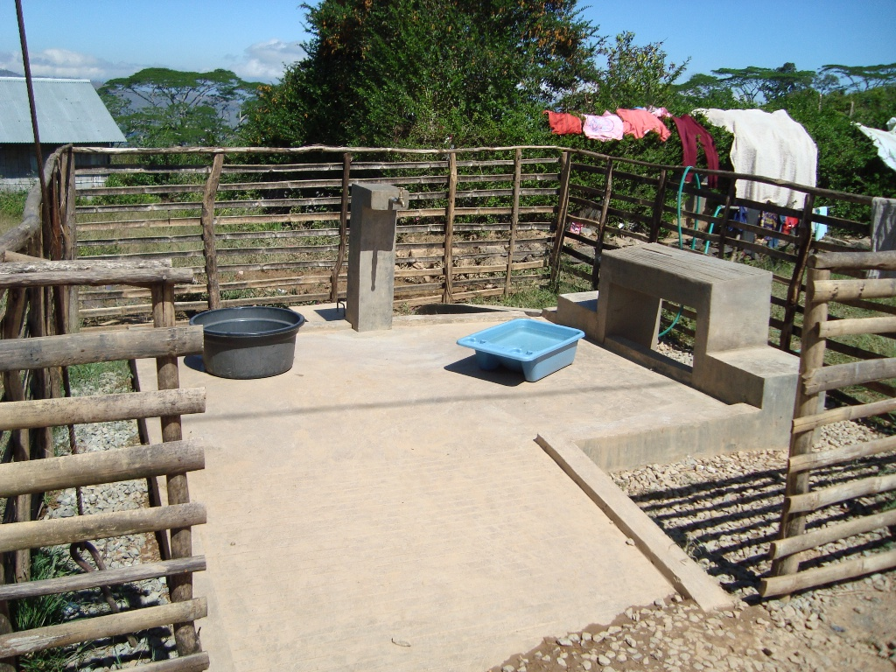

Ramp and wheelchair turning -accessible washing area, Timor-Leste.   
Photo: Olivier Gaucher, BESIK