**Aid Advisory Services Standing Offer Panel Request for Tender**

**Industry Briefing Transcript (March 2012)**

**1. Welcome**

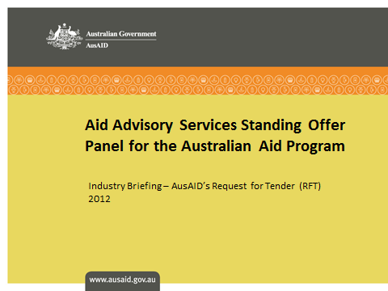

Welcome to the Australian Agency for International Development (AusAID) Request for Tender industry briefing to establish an Aid Advisory Services Standing Offer Panel for the Australian aid program.

**2. Aim of this Briefing Presentation**

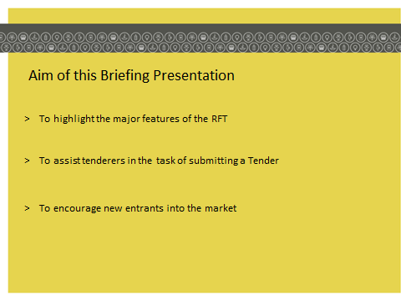

The aim of this briefing is to provide Tenderers with an overview of the Request for Tender (or RFT, as public tenders are usually referred to). The RFT was released on 28 February 2012, and this briefing will assist Tenderers to respond to it.

This briefing is not intended to be comprehensive, and of course, there is no substitute for potential Tenderers reading the RFT carefully. This briefing will highlight the major features of the RFT to make the task of submitting a tender as simple as possible.

This presentation includes information about:

* why AusAID has decided to establish this Panel;
* the benefits of the Panel;
* how to become a member of the Panel;
* the tender process; and
* a range of other important tips to assist you in your tender preparation.

Additional materials, including a *“Guide to the RFT”* which will walk Tenderers through the tendering process, have been provided in the RFT document, and will include a greater level of detail (and instruction) regarding the key features of the RFT and how to lodge a Tender.

**3. The Panel**

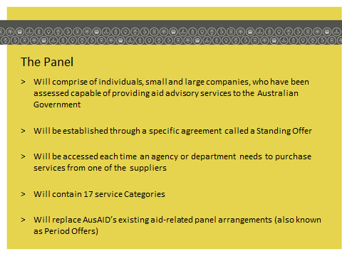

The Panel will be comprised of service providers that have been evaluated as capable of providing aid advisory services, to Australian Government agencies and departments, in specific Panel Categories. The Panel will be established through a specific type of agreement in the Australian Government called a *Standing Offer*. A Standing Offer is an arrangement where a number of suppliers may each be engaged to supply goods and services to an Australian Government agency or department as specified in the Panel arrangement. There is no guarantee of work under the Panel. A contract is formed under the Standing Offer each time an agency or department purchases services from a supplier on the Panel.

**4. The 17 Categories**

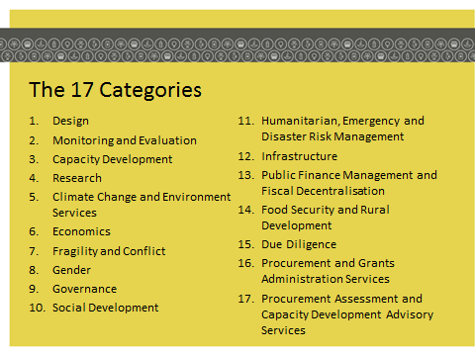

The Aid Advisory Services Panel will contain 17 Categories. These are:

1. Design;
2. Monitoring and Evaluation;
3. Capacity Development;
4. Research;
5. Climate Change and Environment Services;
6. Economics;
7. Fragility and Conflict;
8. Gender;
9. Governance;
10. Social Development;
11. Humanitarian, Emergency and Disaster Risk Management;
12. Infrastructure;
13. Public Finance Management and Fiscal Decentralisation;
14. Food Security and Rural Development;
15. Due Diligence;
16. Procurement and Grants Administration Services; and
17. Procurement Assessment and Capacity Development Advisory Services.

Many of these Categories include sub-categories.

This Panel will replace AusAID’s existing aid-related Period Offers, and it includes new service Categories to ensure full coverage of aid advisory services in line with the Australian Government’s aid policy.

Other Australian Government agencies that deliver Official Development Assistance will also be able to source aid advisory services from this Panel, including: the Australian Broadcasting Corporation (ABC), the Australian Federal Police (AFP), the Australian Centre for International Agricultural Research (ACIAR), the Department of Climate Change and Energy Efficiency, the Department of Immigration and Citizenship, the Department of Broadband, Communications and the Digital Economy, the Australian Public Service Commission (APSC), the Australian Human Rights Commission and the Australian Sports Commission (ASC).

The decision to establish the Panel is the result of several factors. Firstly, by way of background, AusAID is responsible for managing the Australian Government’s official overseas aid program. The fundamental purpose of Australian aid is to help people overcome poverty. This also serves Australia’s national interest by promoting stability and prosperity, both in our region and beyond.

The Australian aid program comprises a range of delivery mechanisms including program and project aid, training and commodity assistance as well as contributions to international organisations. The main geographic focus for the Australian aid program is the Asia-Pacific region including our nearest neighbours in the Pacific region, Papua New Guinea, Indonesia, and East Timor. At the same time, the aid program is providing increased assistance to South Asia and Africa while continuing to support development efforts in Afghanistan and Pakistan, with targeted support elsewhere, including South America.

A review of AusAID’s procurement and agreements processes, undertaken in 2011, recommended that AusAID explore further ways to encourage competition amongst aid contractors, including developing mechanisms to encourage new entrants into the market. The Australian aid program is fully untied, which means that all suppliers have the same opportunity to tender for this RFT, regardless of their country of origin. The Australian Government’s procurement processes do not discriminate against Tenderers according to their degree of foreign affiliation or ownership, their location or their size. All tenders received will be considered on the basis of their suitability for the intended purpose of the Panel and not on the basis of the tenderer’s country of origin or legal structure.

The Australian aid program relies on external service providers where the necessary expertise does not exist in-house, and/or where contractors represent the most reasonable and cost-effective choice.

The Panel is a key outcome of efforts to ensure:

* greater competition between service providers;
* equitable treatment for all contractors undertaking work for AusAID; and
* value for money outcomes.

**5. Benefits of the Panel**

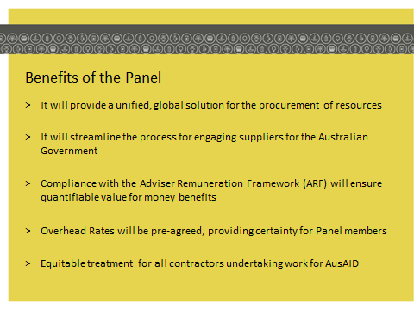

The Panel will deliver significant benefits to both AusAID and its suppliers and will provide a unified, global solution for the procurement of advisory services that the Australian aid program needs to deliver development outcomes around the world.

Some of the major benefits the Panel will deliver include:

* **Streamlining the process for engaging resources**. Once all suppliers have been appointed to the Panel, AusAID will be in a position to readily identify the appropriate resource for every activity, in the right geographical region and at the right time. A Panel management database will enable advisers to be matched to roles. In addition, Panel operating procedures will simplify the internal processes for obtaining quotes and approvals.
* Within a common commercial framework, the Panel **enables the participation of a wide range of suppliers**, ranging from large companies to individuals. The Panel will be managed centrally within AusAID, which will act as a *“one-stop-shop”* for supplier engagement.
* **Continuous improvement and quality control systems will be strengthened**. Panel management processes will facilitate monitoring of the ongoing performance of Panel members. By monitoring key performance indicators and other performance requirements, AusAID will be able to ensure quality outcomes for its projects.
* The Panel will deliver **quantifiable value for money benefits**. All suppliers on the Panel will be required to provide resources in accordance with the Adviser Remuneration Framework (ARF). The ARF sets out remuneration requirements for internationally and commercially contracted advisers working for the Australian aid program, and includes a set of market-based remuneration rates and allowances. Compliance with the ARF is mandatory for all Tenderers responding to this RFT. When implemented, AusAID will be able to readily obtain the skills it needs according to the various ARF classifications, and will be able to easily compare resources from different Panel members. Panel members will also be able to manage resources provided to AusAID with certainty, as they will know in advance the acceptable rate ranges.
* Another value for money benefit that will be achieved through the Panel RFT, is that as an outcome of the evaluation process, **overhead rates will be pre-agreed, providing certainty for Panel members**.
* Engagements under this Panel may take the form of either Short Term Assignments (i.e. up to 6 months in duration) or Long Term Assignments (i.e. up to 3 years in duration). There will be a process to “refresh” the Panel every three (3) years, and this will **enable AusAID to regularly maintain its complete list of approved panel members**, and to update its service requirements from time to time – for example, through the introduction of new Panel Categories during the life of the Panel.

**6. How to be appointed to the Panel**

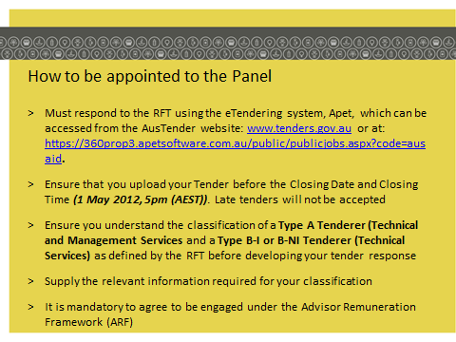

In order to be appointed to the Panel, you must respond to the Request for Tender (RFT). The RFT will be published on the AusTender website and will remain open to the market for a period of eight (8) weeks. The website address is [www.tenders.gov.au](http://www.tenders.gov.au).

To respond to the RFT and lodge a Tender, Tenderers will be required to access APET, the eTendering system from the AusTender website. Tenderers must also submit any questions about the RFT or the tender process through APET using the ‘Contact Job Manager’ button. Do not send questions or CV’s to the email listed on AusTender. You must submit your tender on APET before the Closing Date and Time.

Late tenders will not be accepted, so ensure that you submit your tender well before the Closing Time. Please read the tender documentation carefully and ensure you submit your Tender by Monday, 1 May 2012, before 5pm, Australian Eastern Standard Time.

A *“Guide to the RFT”* will be included at Part 1 of the RFT document, and will provide instructions about every step of the RFT process, including how to access APET and the steps you should take to complete and submit a Tender in APET.

**7. Information you need to provide**

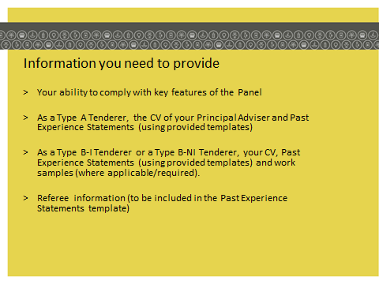

If the RFT is read sequentially, the information that you need to supply in your tender is clear. In summary, the type of information which AusAID is seeking includes:

* **Information about the capability and capacity of your organisation:** You will be required to demonstrate the extent and relevance of your organisation’s or your expertise with respect to the specific requirements of the relevant Panel Categories or sub-categories you tender for, as outlined in the RFT.
* **Your ability to comply with key features of the Panel:** such as the Adviser Remuneration Framework (ARF), the Panel Deed of Standing Offer and a range of other ongoing contract management information and requirements.
* **If you are a Type A Tenderer you will need to provide the CV of your Principal Adviser and Past Experience Statements:** these will assist you to demonstrate your organisation’s capacity to perform the required indicative services and management services and to provide quality assurance on any outputs delivered in the relevant Panel Category.
* **If you are a Type B Tenderer you will need to provide your CV (or the CVs of your nominated Contractor Personnel) and Past Experience Statements:** it will be important for you to demonstrate the extent and relevance of your skills with respect to the specific requirements of the Panel sub-category you tender for, as outlined in the RFT.
* **Referee Details and other relevant information:** to support Past Experience Statements and due diligence checks that AusAID will conduct on Tenderers.

Whilst any type of organisation may apply to be on the Panel, the Panel RFT draws a distinction between **Type A Tenderers** and **Type B Tenderers**. The RFT will provide detailed information on how to determine whether you tender as a Type A or Type B Tenderer.

In essence, for the purposes of the Panel RFT:

* **Type A Tenderers** are able to provide Technical and Management Services across an entire Category and can provide experts at a minimum of three ARF job levels, if required;
* **Type B Tenderers** are able to provide Technical Services only at the sub-category level, and are capable of providing their services to one or more Panel sub-categories.

In various parts of the RFT, Type A and Type B Tenderers, are required to provide different information, and are subject to differing contractual and commercial provisions in some areas. Please familiarise yourself with these concepts as they appear in the RFT.

**8. Key steps of the RFT Process**

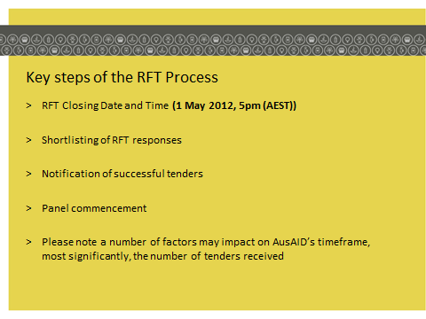

The RFT outlines the process for tendering in detail. In summary, the key steps are:

* RFT closing date and time: 1 May 2012, 5pm (AEST);
* Shortlisting;
* Notification of successful tenders; and
* Panel commencement.

A number of factors may impact upon AusAID’s timeframe, the most significant one being the number of tenders received.

**9. Tips for Tenderers**

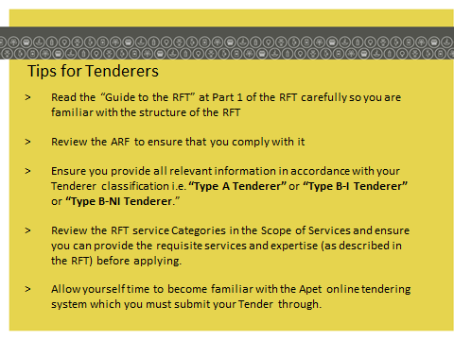

The following are some important tips if you, or your organisation, are considering submitting a tender to be appointed to the Panel.

* The RFT includes important instructions and a checklist, as well as a *“Guide to the RFT”* at Part 1. Please read these sections carefully and thoroughly to familiarise yourself with all requirements, and ensure that any other members of your team that may be working on your tender do likewise.
* Before commencing your tender, read the *“Guide to the RFT”* to familiarise yourself with the structure of the RFT, particularly if your organisation does not regularly respond to Government RFTs, as these can be difficult to follow if you are unfamiliar with them.
* All Tenderers must agree to provide resources or be engaged under the Adviser Remuneration Framework (ARF). The ARF prescribes the rate ranges advisers can receive for AusAID projects. Please review the ARF in detail to ensure that you or your organisation can comply with it, and consider the resources you may be offering and how these resources may align with the ARF professional discipline categories and job levels. If you, or your organisation, are unable to comply with the ARF, your tender will not be considered.
  + Please note that the Panel Categories and sub-categories are reflected in the four professional discipline categories in the ARF, labelled A through to D. The job levels are determined by AusAID at the point of developing the terms of reference for sourcing specific services from the Panel after it is established.
* AusAID will undertake a review of ARF rates in 2012. The remuneration rates current at the time a Services Order is issued under the Panel, once it is established, are the rates applicable.
* Carefully consider whether, **as defined by the Panel RFT**, and I stress the words *“as defined by the RFT”*, you are classified as a Type A Tenderer or a Type B Tenderer. Please ensure that you supply the required information depending upon your classification.
* Carefully review the various Panel Categories or sub-categories for which you may be eligible to apply. Whilst you may apply for as many Categories as you wish (if you are a Type A Tenderer ) and sub-categories (if you are a Type B Tenderer), it is strongly recommended that you only apply for those Categories or sub-categories for which you have the requisite skill sets as described in the RFT. Simply applying for as many Categories or sub-categories as you can, may detract from the overall evaluation of your tender.
* Familiarise yourself early in the process with APET, the software that you must submit your Tender through, as well as any questions about the RFT or the tender process. You can register for, and use, APET from the moment the Panel RFT opens. You can “save as you go” prior to formally submitting your tender electronically. APET is user-friendly and intuitive. Detailed instructions for use are provided in the RFT. Please also note that the information you submit through the APET system will be kept in an outsourced data centre that is compliant with Defence Signal Directorate Information Security Manual requirements.
* **Tenderers are strongly advised not to start their Tender response on the Closing Date.** **The RFT closing Date and Time will be strictly implemented. Late tenders will not be accepted.** It is recommend that you submit your tender electronically through APET the day before the tender Closing Date. APET will email you an automatically generated receipt once you have submitted your tender. If there are any problems with electronic lodgement, they can be identified and resolved prior to the tender Closing Date and Time. If you are still unsure, you can ask questions early in the process through APET using the ‘Contact Job Manager’ button. APET can be accessed from the AusTender website at [www.tenders.gov.au](http://www.tenders.gov.au). Answers to all questions received will be posted (without identifying who asked the question) as an addendum to this RFT process through APET. This process will give you plenty of time to review the responses and to ask any follow-up questions, if necessary. Please note that any questions you ask, together with AusAID’s response, will be reproduced for the benefit of all potential Tenderers. This is an important probity principle.

**10. Assistance**

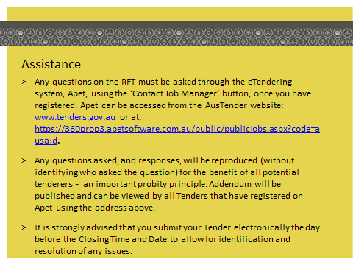

**If you have any questions, please do not make personal contact with AusAID staff or representatives in relation to this RFT**. To do so would be a breach of the RFT conditions and a probity breach. Only use the ‘Contact Job Manager’ function in APET to ask any questions.

In conclusion, the Aid Advisory Services Panel will establish a streamlined approach to the appointment of advisers that promotes the participation of a wide range of suppliers, while ensuring quantifiable value for money benefits.

The Panel will ensure that AusAID engages in a partnership relationship with its suppliers, in an efficient, strategic and mutually beneficial way. As a member of the Panel, you or your organisation will be able to manage your resources ahead of time and with confidence, based on the structures provided under the Panel.

Please read the RFT documentation carefully, and if you believe you meet the requirements to provide Type A or B services of one or more of the Panel Categories or sub-categories, we encourage you to consider applying to become a member of this Panel.