Mid Term Review of the Aus4Innovation (A4I) program - Phase Two
Final Report
By // Scott Rankin, Chi Pham, Will Scott-Kemmis, Hanh Nguyen
Date // July 2026
International Organisation Development Ltd
IOD PARC is the trading name of International Organisation Development Ltd
Registered in England and Wales, No. 3613839
Registered Office: Omega Court, 362 Cemetery Road, Sheffield, S11 8FT, United Kingdom
Omega Court
362 Cemetery Road
Sheffield
S11 8FT
United Kingdom
Tel: +44 (0) 114 267 3620
www.iodparc.com

Acknowledgements
This Mid-Term Review (MTR) of the Aus4Innovation (A4I) program was commissioned by CSIRO and the Australian Embassy in Vietnam. The Review Team comprised Scott Rankin as Team Leader, Chi Pham as National Advisor and Inclusion Lead and Will Scott-Kemmis as Innovation Specialist. Hanh Nguyen of IOD-PARC supported the process as a Quality Assurance Advisor and Contract Manager.
We would like to thank the many people who gave generously of their time, knowledge, and perspectives over the course of this review. In particular, we would like to thank the many representatives of Government, research institutions, private sector organisations and community groups who spoke freely and with deep consideration of their perspectives of Vietnam’s innovation landscape and the contribution of A4I. Their broad collective insight was invaluable in terms of understanding progress, challenges, opportunities and risks with regards to further strengthening Vietnam’s innovation system.
We would also like to thank the A4I team at the Australian Embassy in Hanoi, notably Kim Wimbush and Nguyen Thi Hoang Ha who were forever helpful in assisting the MTR team clarify and unpack issues related to A4I performance. We also extend great appreciation to Thu Ha Mai for supporting us with planning and scheduling of meetings during the field work.

Contents
Acknowledgements ii
Acronyms and Abbreviations v
Executive Summary vii
Key Findings vii
Recommendations x
1. Introduction 1
2.2 Review context 1
2.3 Purpose of the Mid-Term Review 5
1.3 Methodology 5
1.4 Limitations 7
2. Review Findings 7
2.1. To what extent are A4I’s objectives and delivery approach relevant to Vietnam’s evolving STI priorities? 8
2.1.1. Relevance to GoV priorities 8
2.1.2. Implications for the remainder of Phase Two 11
2.2. Is A4I making progress towards its IOs and EOPOs, including higher-level or catalytic impact on policy eco-systems? 11
2.2.1. A4I is making progress against its EOPOs 11
2.2.2. Broader issues relating to effectiveness 21
2.2.3. Implications for the remainder of Phase Two 26
2.3. Does the MEL and Reporting system collect sufficient and useful evidence, and is it capable of demonstrating progress towards the four EOPOs? 26
2.3.1. MEL Background and context 26
2.3.2. Suitability of the A4I Theory of Change 27
2.3.3. Benefits and Limitations of the Approach 31
2.3.4. Opportunities for Improvement 31
2.3.5. Implications for the remainder of Phase Two 33
2.4. What has A4I done to enhance the sustainability of its actions? 33
2.4.1. General observations regarding sustainability 33
2.4.2. What can be done in the remaining time of the program to enhance the sustainability of its actions? 34
2.4.3. Looking beyond A4I 35
2.4.4. Implications for the remainder of Phase Two 36
2.5. Is the investment coherent and making an efficient use of Australia's resources to achieve the expected outputs and outcomes? 36
2.5.1. Overall assessment of efficiency 36
2.5.2. Setting the context for assessing efficiency 36
2.5.3. How well is A4I aligned and coherent with other Australian and Vietnamese government initiatives in innovation, agriculture, and digital transformation? 37
2.5.4. How efficient has the operating model and approach been? 37
2.5.5. Are resources distributed optimally? 38
2.5.6. Has A4I coordinated effectively with other development partners and programs? 39
2.5.7. Implications for the remainder of Phase Two 39
2.6. How has A4I advanced social inclusion innovation, especially gender equality and disability equity? 40
2.6.1. Context of inclusion activities 40
2.6.2. To what extent is A4I progressing inclusion through its approach and activities? 40
2.6.3. To what extent is A4I contributing to the embedding of inclusive innovation principles into institutional and policy legacies? 41
2.6.4. Implications for the remainder of Phase Two 43
2.7. What benefits (intended or otherwise) does the program generate for the bilateral relationship between Australia and Vietnam? 43
Annex One: Key Review Questions and Sub-Questions I
Annex Two: Stakeholder and Activity Mapping III
Annex Three: People consulted through MTR process IV
Annex Four: Summary of Resolutions 57 and 193 X
Resolution 57-NQ/TW 57-NQ/TW X
Resolution 193/2025/QH15 X
Annex Five: Alternate text for A4I report diagrams XII

Acronyms and Abbreviations
A4I Aus4Innovation
ASF African Swine Flu
CTU Can Tho University
CIC Coffee Innovation Cluster
CPG Commercialisation Plus Guidelines
CSIRO Commonwealth Scientific and Industrial Research Organisation
DLIC Dak Lak Innovation Center
DFAT Australian Department of Foreign Affairs and Trade
EOPO End of Program Outcome
GEDSI Gender Equality Disability and Social Inclusion
G2G government to government
GoV Government of Vietnam
HIC Horticulture Innovation Club
HUS Hanoi University of Science and Technology
IAS-SV Institute of Agriculture Science – South of Vietnam
ID International Development Cooperation
ID A4I Investment Design Document
IO Intermediate Outcomes
IPE Innovation Policy Evaluation Framework
IP Innovation Partnership Grant
KR Key Review Question
MAIC Mekong Aquaculture Innovation Cluster
MEL Monitoring, Evaluation and Learning
MAE Ministry of Agriculture and Environment
MoF Ministry of Finance
MERL Monitoring, Evaluation, Research and Learning
MST Ministry of Science and Technology
NASATI National Agency for Science and Technology Information
NATEC National Agency for Technology Entrepreneurship and Commercialization Development
NIAS National Institute of Animal Science
PEA political economy analysis
PSC Program Steering Committee
PBIA Pork Bio-security Innovation Alliance
R&D Research and Development
RAF Resilience and Agriculture Foods
RAI Responsible Artificial Intelligence
SQs Review Sub Questions
SATI State Agency of Technology Information
SII Socially Inclusive Innovation
STI Science, Technology and Innovation
TNU Tay Nguyen University
UOL University of Law (Vietnam National University)
USQ University of Southern Queensland (USQ)
VAAS Vietnam Academy of Agriculture Science
VAST Vietnam Academy of Science and Technology
VISTI Vietnam Institute of Science Technology and Innovation
VNSC Vietnam National Space Center
VNU HCMUT Vietnam National University – Ho Chi Minh Uni. of Technology
VNUA Vietnam National University of Agriculture
WASI Western Highlands Agriculture and Forestry Science Institute

Executive Summary
The Aus4Innovation (A4I) program is a flagship Australia–Vietnam partnership that aims to strengthen Vietnam’s national innovation system to support an innovation-led, inclusive and sustainable growth trajectory. Commenced in 2018, A4I is implemented through a strategic partnership between Australian Department of Foreign Affairs and Trade (DFAT), Australia’s Commonwealth Scientific and Industrial Research Organisation (CSIRO) and Vietnam’s Ministry of Science and Technology (MST) and reflects a broader shift away from traditional development modalities towards long-term, capability-based government-to-government (G2G) collaboration.
The first phase of A4I ran from 2018-2022 and was characterised by exploration and relationship building. Phase Two of A4I (2023–2028) aims to build on Phase One lessons to create systemic impact through a sharper thematic focus on resilient agriculture and food systems, stronger policy engagement, and greater attention to localisation, sustainability, and inclusive innovation. The program is structured around four interconnected program elements that align closely with the four End of Program Outcomes (EOPOs):
- Innovation Policy Dialogue primarily contributes to EOPO One - Enhanced capacity for institutional, policy and regulatory reform in targeted Ministries that enables inclusive innovation
- Network of Innovation Actors primarily contributes to EOPO Two - Improved ability of targeted innovation ecosystems in the selected sector to continuously respond to an evolving context
- Innovation Funding and Finance primarily contributes to EOPO Three - Inclusive national and regional innovation support mechanisms connect people, ideas, investment and resources to respond to innovation opportunities and challenges
- Innovation Partnerships primarily contributes to EOPO Four: Sustainable, mutually beneficial partnerships that strengthen Australia and Vietnam Innovation Systems
This Mid-Term Review (MTR) assesses progress made in Phase Two, from April 2023 through to late 2025, but considers this in the context of the broader program. The MTR examines relevance, effectiveness, efficiency, sustainability, inclusion, and bilateral value, and provides forward-looking recommendations to maximise impact over the remaining implementation period. The review was undertaken at a time of significant change in Vietnam’s governance and policy environment, including major ministerial restructuring and the adoption of landmark innovation resolutions, by both the Party and National Assembly.

Key Findings
Relevance and Strategic Positioning
The review finds that there is a widely held perspective that A4I is operating in the right place at the right time, with exceptionally strong alignment to Vietnam’s evolving science, technology, innovation and digital transformation agenda. The adoption of Resolution 57 (2024) and Resolution 193 (2025) has elevated innovation to a whole-of-government priority and created a uniquely dynamic reform moment. These shifts significantly enhance A4I’s strategic relevance, while also increasing complexity, coordination demands, and political economy risks.
A4I’s highly responsive and flexible delivery model is widely valued by Vietnamese counterparts and has enabled the program to build deep trust, access and influence - particularly within MST and its agencies. This responsiveness has positioned A4I as a preferred partner during periods of rapid reform. However, the review also finds that this same responsiveness also carries risks. Efforts can be diluted and strategic focus lost if responses are not carefully prioritised and managed within finite resources and timeframes. Striking the right balance is key and the MTR team finds that A4I is currently managing this tension well, and clear of the need for more explicit consolidation to prioritise gains over the remaining implementation period.
While MST remains the A4I’s primary partner, this review concludes that A4I’s continued relevance increasingly depends on its ability to broaden and deepen engagement across other ministries - particularly the Ministry of Agriculture and Environment (MAE) - as well as provincial governments and the private sector. This is a logistical and resource challenge but remains critical to achievement of program EOPOs.
This might require some trade-offs to be agreed upon between A4I and DFAT, since the remaining period will inevitably require stepping back from some current activities – which in turn could present relational challenges. However, the review team believes that now is an appropriate time to prioritise and be selective in identifying and progressing those activities deemed most important and most likely to achieve strong, sustainable outcomes.
Progress Towards Outcomes and Systemic Change
Overall, the review finds that A4I is making credible progress across its Intermediate Outcomes and End-of-Program Outcomes (EOPOs). The program has demonstrated influence at policy, institutional and network levels, and has contributed to shifts in how innovation is understood, governed and practiced within parts of Vietnam’s system. There is important interaction and synergy between different program components that offer potential for the ‘A4I whole’ to be greater than the sum of its EOPOs given the strength and advisory influence that comes from its relationships with key actors on the innovation landscape. It will be essential that concrete policy outcomes are achieved across the remaining two years for this potential to be realised.
A4I’s strongest systemic contributions are evident in:
- Strengthening capacity of A4I partners to effectively navigate the institutional, policy and regulatory landscape, where Australian technical expertise has been drawn upon to inform major policy instruments and regulatory reforms, including commercialisation frameworks, technology development guidelines, and innovation policy evaluation tools; and
- Enabling key innovation eco-systems to emerge, through network-based intermediation efforts in agriculture, where coalitions and alliances have strengthened coordination, problem-solving and participation across value chains, including women and ethnic minority producers.
At the same time, the review identifies ambiguity in outcome definitions and diverging stakeholder expectations as a constraint on demonstrating effectiveness. While many stakeholders report meaningful institutional and cultural change, these shifts are difficult to attribute and measure within DFAT’s performance framework. There is a risk that promising systemic contributions are under-recognised, while expectations for tangible, scalable results remain unmet. There are also instances where contributions are contributing to advancing pathways to systemic change, but outcomes are not yet substantive. Different expectations create different views on success. From one perspective, it could be said the program has not yet delivered enough substantive results, but from another, it has laid the foundations for more systemic and sustainable results.
Performance of Program Elements
- Innovation Policy Dialogue
A4I has demonstrated a strong ability to influence innovation policy processes and norms through responsive, trust-based partnerships. The program has successfully moved beyond one-off advisory inputs to support the development of enduring policy tools, principles and capacities. However, the review highlights increasing distance between A4I and downstream reform outcomes, making attribution difficult and reinforcing the importance of local ownership and inter-ministerial alignment.
- Innovation Funding and Finance (Innovation Partnership Grants – IPGs)
The IPG mechanism has generated clear bilateral value by modelling transparent, merit-based innovation funding processes and facilitating Australian-Vietnamese research partnerships. However, the IPGs consume a substantial share of program resources and deliver uneven results. Many grants lack clear pathways to adoption, scaling or institutional embedding, limiting their contribution to systemic change and raising value-for-money concerns. While grants model effective governance and the value of partnerships, while also demonstrating the potential of a grant mechanism to stimulate innovation, more needs to be done to capture their systemic contribution.
- Network of Innovation Actors (Resilient Agriculture and Food – RAF)
RAF innovation networks represent one of A4I’s most promising systemic achievements. These multi-stakeholder coalitions have improved coordination, information flows and adaptive problem-solving at provincial level. They also demonstrate meaningful progress on participation and inclusion. However, sustainability pathways - including financing, institutional anchoring and policy uptake - remain uncertain and uneven across networks.
- Innovation Partnerships (Cross-Program)
Bilateral partnerships are emerging across policy dialogue, grants and networks, but remain relatively shallow and fragmented. Ambitions such as an Australia–Vietnam Innovation Centre and alumni networks have yet to materialise. The review finds that while A4I contributes to partnership formation, expectations regarding depth and durability need to be realistic given program scale and time remaining. There remains significant opportunity for this to occur given the trust A4I has established with key partners, and also A4I’s ability to easily collaborate with MST on such initiatives.
Monitoring, Evaluation, Learning (MEL)
The review finds that A4I’s MEL system has improved significantly during Phase Two, following a slow start. The updated MEL Framework provides a stronger foundation for learning-oriented management and adaptive decision-making. However, challenges remain in linking diverse activities to outcome-level evidence, clarifying expectations around systemic change, and using MEL more strategically to prioritise effort during the remaining program period. Overall, the current MEL system struggles to fully capture progress towards EOPOs and IOs, largely because the program is structured around the four program elements described above.
Sustainability and Localisation
A4I demonstrates a clear orientation towards diffusion, localisation and local ownership. Examples such as the uptake of Commercialisation Plus by Vietnamese agencies and the growing leadership of local partners within innovation networks illustrate the program’s potential to outlast direct Australian support. However, sustainability remains uneven and highly dependent on institutional incentives, financing arrangements and political support beyond MST. The review concludes that more explicit and prioritised sustainability strategies are needed in the final phase of implementation, with project specific strategies needing to identify and target achievable sustainability outcomes within the specific context of that activity.
Inclusion, Gender Equality, Disability and Social Inclusion (GEDSI) and Climate
The review finds that A4I has made progress in integrating gender equality, disability inclusion and climate considerations into innovation discourse and selected activities, particularly through the Socially Inclusive Innovation (SII) strategy and policy tools such as the Innovation Policy Evaluation Framework (IPEF). Before each project commences, it needs to outline upfront an inclusion/GEDSI plan, then meets regularly with the SII team to support ongoing guidance. While this is welcomed, integration remains opportunistic and fragmented rather than systematic. While this demand-driven approach has enabled progress in shifting and sensitive policy environments, it limits the program’s ability to demonstrate consistent inclusion outcomes.
Bilateral Value and Strategic Benefits
Beyond development outcomes, A4I generates significant bilateral benefits for the Australia–Vietnam relationship. The program operationalises the Comprehensive Strategic Partnership (CSP) by demonstrating a modern, reciprocal form of cooperation centred on shared interests in innovation, productivity and resilience. A4I enhances Australia’s policy influence, soft power and reputation as a trusted, technically credible partner at a time when Vietnam is transitioning away from traditional aid relationships. As the program approaches closure and more tangible results become apparent, it is likely that there will be opportunities for DFAT to engage and leverage these results in future development programming in Vietnam.
Conclusion
The review concludes that A4I is a strategically relevant, well-regarded and influential program operating in a highly dynamic environment. It has achieved meaningful progress towards systemic change, particularly in innovation policy and agricultural intermediation, and delivers clear bilateral value. However, its breadth, responsiveness and ambition stretch available resources and complicates performance measurement. Moving forward, sharper prioritisation, stronger links between program elements, and more explicit pathways to sustainability will all be key. Without these, there is a risk that the program’s full potential will not be realised within the remaining timeframe. The final two years will need to be managed strategically and optimally to ensure that the many strong foundations laid can result in tangible outcomes.

Recommendations
Area 1: Program Management and Coordination
Recommendation 1: A ‘stock take’ of current programming should be undertaken documenting pathways and targets towards embedding and institutionalisation of A4I supported initiatives within the Vietnam innovation landscape.
Drawing on the results of the ‘stock take’, a systematic review should be undertaken of the overall A4I portfolio to assess the ‘status’ of different interventions and for decisions to be taken around opportunities to consolidate, reduce and restructure interventions, based on their likelihood of achieving tangible systemic results by the end of 2027. This should include review of individual Grants in order to assess pathways related to the technical feasibility, financial viability and desirability/appetite for adoption.
It is important that this process not shy away from hard decisions (i.e. cut projects that are not performing and reallocate funds). In cases of a decision to discontinue, focus should then turn to ‘responsible closure’, in terms of maximizing lessons learned from the activity to date and maintaining a positive relationship with impacted stakeholders.
Lead responsibility and resourcing: A4I Program Director, working with Senior Management (using internal resources).
Recommendation 2: For those activity areas that will continue, A4I should engage partners in co-development of concrete plans for embedding and institutionalising A4I supported activities and learning. This process should be explicitly framed as ‘handover and sustainability’ planning and focus on what can be achieved in the next two years.
This should include a systematic, project-by-project review of opportunities and strategies for co-financing with partners (recognising that this reflects a deepening of partnerships), but also likeminded programs.
Lead responsibility and resourcing: Under direction of A4I Program Director, A4I Senior Management working with leadership of key partners (using internal resources).
Recommendation 3: Based on Recommendations 1 & 2, program strategies for embedding and institutionalising should be revised and documented as ‘element workplans’, including clear timelines, milestones and targets that guide the coming two years. Noting the need for additional (likely internal) support to be made available to the Grants team, given review of the current status and opportunities of the whole Grants portfolio will be a significant exercise
Lead responsibility and resourcing: Program teams working with key partners.
Recommendation 4: A4I should prepare a formal Exit Strategy and Closure Plan outlining handover steps, necessary sustainability measures, and clear documentation of which activities will be completed or stopped before program end.
Lead responsibility and resourcing: A4I Program Director, working with Senior Management (using internal resources).
Recommendation 5: A4I, in conjunction with the Embassy of Australia in Vietnam, should explore opportunities to facilitate a high-level meeting of key stakeholders - prioritising Ministry of Science and Technology (MST), Ministry of Agriculture and Environment (MAE) and Ministry of Finance (MoF) participation - focused on identifying additional options for Research and Development (R&D) and innovation financing, given imminent closure of A4I. This would shed light on financing needs, pathways and obstacles (noting that Resolution 193 highlights the importance of innovation financing), while also providing a platform for sharing knowledge and progress of IPG activities and the IPG process with key audiences.
This should include consideration of options for more explicitly integrating and/or harmonising A4I’s grants with Government of Vietnam (GoV) innovation eco-system functions such as the National Innovation Centre, including discussion of the role and/or feasibility of the mooted Australia-Vietnam Innovation Centre.
Lead responsibility and resourcing: A4I Program Director, in consultation with DFAT Development team (cost dependent on agreed scale and reach of event – est. AUD 25,000).
Recommendation 6: A strategy needs to be urgently developed for more systematic and strategic engagement of MAE at national level with a view to motivating more active engagement with A4I across the remaining two years – focused on embedding and institutionalising learning emerging through (Horticulture Innovation Club (HICs) and other Resilience and Agriculture Foods (RAF) work.
Lead responsibility and resourcing: A4I Program Director, working primarily with RAF and Policy teams (using internal resources).
Recommendation 7: A4I should clarify plans in terms of development of a mechanism that enlists A4I and other relevant ‘Australia-connected’ Alumni as a program asset given their potential to contribute to fostering of an ‘innovation culture’ in Vietnam, and also their contribution to strong Australia-Vietnam ties. Great alumni programs use minimal resources effectively to facilitate more peer-to-peer and peer-led support, taking the pressure off organisers and moving to a more sustainable model.
Lead responsibility and resourcing: A4I Program Director, in consultation with DFAT Development team (drawing on budget line proposed for alumni development).
Recommendation 8: A4I and DFAT should coordinate to enhance connection and coordination with different DFAT teams, particularly focusing on issues with cross-cutting relevance, for example (including but not limited to):
- Integrating security issues in science, technology and innovation (STI) policy discussions.
- Actions related to climate resilience.
- Learning from the various policy shifts supported by A4I passenger passengers carry on.
- Effective policy pathways.
- Utilising political economy analysis (PEA) outputs to stay abreast of opportunities.
Lead responsibility and resourcing: A4I Program Director, in consultation with DFAT Development Counsellor (using internal resources).
Area 2: Monitoring, Evaluation and Learning (MEL) and Reporting
Recommendation 9: Based on the above-described process of portfolio review and refinement, A4I should adapt program reporting approaches to explicitly monitor and measure progress towards systemic change targets.
Lead responsibility and resourcing: A4I Program Director, in consultation with DFAT Development Counsellor (using internal resources).
Area 3: Policy impact and influencing
Recommendation 10: Strengthen program capacity (human and financial) for ‘strategic communications’ in support of system change objectives, recognising the important need of strategic engagement and knowledge sharing in facilitating institutionalisation. This should be viewed as a different skillset to public diplomacy, since it must reflect and support program strategy and end of program outcomes.
Lead responsibility and resourcing: A4I Program Director, working with program team (potentially external consultant support).
Recommendation 11: Organise a joint policy dialogue (and/or research) on the role of intermediary organisations in agricultural innovation, co-chaired by the MAE and MST, as a strategy for raising awareness of the key role played by such organisations, and also the importance of MAE and MST collaboration on the subject.
Lead responsibility and resourcing: A4I Program Director, working with Senior Management and Communications Advisor (cost dependent on agreed scale and reach of event – est. AUD 10,000).
Area 4: Gender Equality, Disability and Social Inclusion (GEDSI) and climate change
Recommendation 12: Give priority to more systematic approaches to institutionalisation of GEDSI learning emerging from different work areas, including promotion and refinement of the SII framework as a potential resource for carriage of innovation inclusion post A4I. Lead responsibility and resourcing: A4I Program Director, working with Socially Inclusive Innovation (SII) and GEDSI Advisors (using internal resources).
Area 5: Risk Management
Recommendation 13: Ensure CSIRO is able to maintain a prominent profile in-country (including the CSIRO Counsellor role) since a failure to do so would present significant risk in terms of leveraging progress already made, undermining high levels of trust achieved, ensuring high level access to senior government partners, and perceptions of commitment to seeing such a well-positioned program through until completion.
Lead responsibility and resourcing: CSIRO, in consultation with DFAT (using internal resources).

Introduction

Review context
The Aus4Innovation (A4I) program aims to contribute to Vietnam being an innovation-led economy better placed to ensure sustainable development. Commenced in 2018, the purpose of A4I is to strengthen Vietnam’s national innovation system so it can adapt to emerging economic, technological and environmental challenges through approaches that align with the country's rapid economic transformation, while ensuring new opportunities are inclusive. It was allocated an initial budget of AUD17,000,000, of which the Australian Department of Foreign Affairs and Trade (DFAT) allocated AUD15,000,000 and Australia’s Commonwealth Scientific and Industrial Research Organisation (CSIRO) AUD 2,000,000. The program is now working to an actual budget of AUD 17,540,865.
Building on achievements and lessons of its first phase (2018-22), A4I’s second five-year phase (2023-28) aims to support Vietnam’s ambition to become an ‘Innovation Nation’ by 2045. The initiative continues to be anchored within a strategic partnership between DFAT, CSIRO, and Vietnam’s Ministry of Science and Technology (MST), reflecting strong bilateral commitment and deepening trust established through Phase One’s success in advancing innovation capability and strengthening institutional linkages. CSIRO co-funds (11.7% of the initial funding allocation) and plays a central program management and technical leadership can you, acting as the managing partner and delivery lead. It also provides the intellectual and technical backbone of the program and draws on its global science, technology and innovation expertise to convene and connect innovation system actors.
Phase Two focus was informed by a Phase One evaluation that highlighted:
- ​​The importance of a design logic that is explicit in detailing how best to secure strong linkages between the different program elements of A4I.
- The need for a more clearly articulated thematic focus.
- Growing realisation of the need to take a more systems focused approach to
promoting innovation that strengthens the interconnected aspects of individual innovation systems, including more attention being given to supportive policy and regulatory frameworks and the platforms that enhance connections and networks
- The need for more adaptive program management able to tailor approaches to the specific context and reality of each partner with the aim of fostering a truer sense of partnership
- The need for greater focus to be placed on fostering local ownership (localisation), as a key sustainability measure.
Consistent with the above, Phase Two adopted a sharper thematic focus on resilient agriculture and food systems, notably within its grants portfolio. This acknowledges the central linkage in Vietnam between agriculture and food systems to sustainable livelihoods and food security – especially for women and rural households. This focus also reflects Vietnam’s acute vulnerability to climate change and the impact that inevitably has on agriculture and downstream production. By prioritising specific sectors, Phase Two is better placed to demonstrate how innovation, digital transformation and applied research can address real-world constraints, improve productivity, and support equitable growth and inclusion in the Vietnamese context. As such, innovation pilots and research collaboration are being used to inform macro-level strategy development and policy reforms, strengthen institutional capability, and contribute to the architecture of a more coordinated national innovation ecosystem that positions innovation as a whole-of-government responsibility.
Program Structure
Phase Two is structured around four interconnected program elements that align closely - but not completely - with four End of Program Outcomes (EOPOs) and supportive Intermediate Outcomes (IOs), as follows:
- EOPO One: Enhanced capacity for institutional, policy and regulatory reform in targeted Ministries that enables inclusive innovation
  - IO 1.1. Tools and protocols developed by A4I increase understanding of targeted policy makers and institutions on how to integrate inclusivity and sustainability into innovation policy dialogues
  - IO 1.2. Frameworks and guidelines to evaluate existing policies, and design novel options, developed and applied to strengthen capacity for the analysis of innovation system performance in targeted ministries
- EOPO Two: Improved ability of targeted innovation ecosystems in the selected sector to continuously respond to an evolving context
  - IO 2.1 Targeted ecosystem actors engage with tools and platforms developed by A4I to enhance networks, generate ideas, address challenges, and increase resources for innovation
- EOPO Three: Inclusive national and regional innovation support mechanisms connect people, ideas, investment and resources to respond to innovation opportunities and challenges
  - IO 3.1 Mechanisms for connecting people, ideas, investments, and resources are developed to respond to innovation opportunities and challenges
- EOPO Four: Sustainable, mutually beneficial partnerships that strengthen Australia and Vietnam Innovation Systems
  - IO 4.1 Vietnamese innovation system actors access Australian science, technology and innovation that is relevant and valuable
While slight misalignment between elements and EOPOs presents challenges in terms of clear communication of results, successful establishment and implementation of the elements can be understood as a proxy for progress against EOPOs. A4I’s four program elements are:
- Innovation Policy Dialogue aims to strengthen the national innovation system by fostering an enabling policy environment. This is being achieved through collaboration with government agencies, think tanks, and academia to co-design tools and frameworks that support the development of effective and inclusive innovation policies.
- Network of Innovation Actors is dedicated to strengthening the national innovation ecosystem by facilitating and supporting effective collaboration among key stakeholders, such as government agencies, academia, the private sector, and communities to foster information exchange, knowledge sharing, and more effective resource mobilisation.
- Innovation Funding and Finance provides crucial grant support for scalable innovation, based on cutting-edge technologies, through collaborative partnerships between Australian and Vietnamese organisations. Not only is it a funding mechanism, but this element also ensures that partnerships are enduring, enabling long-lasting collaboration beyond the program’s support.
- Innovation Partnerships is designed to enhance and leverage connections within and between the Vietnamese and Australian innovation systems. Our focus centres on strengthening the relationships among actors in the Vietnam innovation system while also fostering a collaborative environment with Australia as a trusted partner to Vietnam in STI. A4I will facilitate collaborations between Vietnam and Australia, promoting robust and dynamic innovation partnerships.
These elements are designed to create systemic impacts by linking policy experimentation, capability development, technology adoption, and collaboration between key actors. However, effective application and leveraging of synergies between different elements presents a complex management challenge - an issue that will be a focus of this review. Being structured around ‘components’ also complicates monitoring and evaluation, given the need to report progress specifically against the EOPOs, IOs and their indicators.
The foundational approach of the program is to support innovation policy dialogue aiming to build MST’s capacity to develop and test innovation policy in a more coherent and evidence-based policy environment. At the same time, the program aims to strengthen networks across government, universities, research institutions, the private sector, and innovation intermediaries. The aim of facilitating connectivity is reflected in plans to establish an alumni network to support peer learning, greater collaboration, and mobilise local champions of change. However, establishment of the A4I Alumni has been slow to progress.
One of A4I’s key work streams is a competitive innovation grants mechanism aimed at supporting proven technologies and partnerships ready for scaling. Grant rounds, each awarding up to six grants ranging from AUD 250,000-700,000, provide support to Australian- Vietnamese partnerships that demonstrate plausible pathways to technology adoption and sustainability. Individual grant applications are scored including criteria as to whether or not the grant has potential to enhance climate resilience, support small and medium sized enterprises (SMEs), and contribute to gender equality, disability and social inclusion (GEDSI). In addition, A4I Phase Two has the intention of exploring complementary financing models to identify mechanisms that can help ensure innovations can achieve scale beyond grant funding – however these have not progressed far at this stage. It is noted that the most recent Grant Round (awarded in February 2026) will not conclude until very near the time when A4I itself ends, raising questions around their ability to contribute to EOPOs and IOs, as well as issues related to value for money and sustainability. Issues related to the Grants program, sustainability and value for money will be discussed further in the report.
Partnership sits at the centre of the A4I operating model. A high-level Program Steering Committee (PSC) co-chaired by DFAT and MST provides strategic oversight, while a new Advisory Board has been assembled with the ambition of providing access to diverse technical expertise, including in digital transformation, agriculture, GEDSI and impact investment. The program is also exploring a dedicated Australia-Vietnam Innovation Centre to create a lasting platform for collaboration between innovation systems, linking research expertise, industry interests and policy priorities. However, this has not progressed at this stage.
Building on lessons learnt from Phase One, A4I Phase Two is aiming to strengthen A4I’s approach and capacity for adaptive, Results-Based Management and delivery. A new Monitoring, Evaluation and Learning (MEL) Framework prepared as part of the Phase Two design was finalised in December 2024 to better guide outcome measurement, support learning, and drive program adaptation. Dedicated resources are now in place to ensure gender-disaggregated data, real-time performance tracking, and applied learning across each program pillar. This upgrade responds to the Phase One evaluation which found a need for clearer integration across program elements and strengthened outcome-level evidence.
Deeper consideration of GEDSI and climate resilience also reflect responses to the Phase One evaluation, which found these had previously not received sufficient focus. GEDSI approaches are now encapsulated in A4I’s innovative Socially Inclusive Innovation (SII) strategy, which aims to guide researchers, developers and innovators to improve social inclusion outcomes, while bedding GEDSI approaches within the specific approach of A4I Phase Two.
It is important to note that the program has needed to navigate significant changes over the course of Phase Two, in addition to the reorientation from Phase One. In March 2024, the bilateral relationship between Australia and Vietnam was elevated to a Comprehensive Strategic Partnership (CSP) during the visit of the Vietnamese Prime Minister to Australia, with it being agreed that one of the key pillars of this high-level bilateral commitment would be continued support for science, technology, innovation (STI), and digital transformation. Towards the end of 2024, Vietnam commenced a process of significant government reform involving ministry mergers, the dissolution of three Central-level government agencies, and major personnel changes across all levels of government. As part of this effort, MST was merged with the Ministry of Information and Communications (MIC), leading to substantial personnel and institutional changes within the “new MST”. In parallel, there was also fundamental change in terms of provincial governance, with 63 provinces across Vietnam being restructured down to 34 administrative units (28 provinces and six centrally governed cities). The middle layer of the administrative system (Districts) was removed. While these governance changes have required a suite of new relationships be established, this Government of Vietnam (GoV) restructure also brought advantages in terms of even stronger government emphasis being placed on science, technology, innovation and digital transformation as key drivers of growth and economic transformation.
This commitment to and focus on STI was clearly reflected in Resolutions 57 and 193, issued by the General Secretary of Vietnam, which provide both strategic guidance and practical guidance to support the government in achieving its STI objectives. The details of these two highly significant resolutions will be discussed deeper in the report (and in further detail at Annex Four).
Figure One: A4I progression from commencement to conclusion (See Annex 5 for written version.)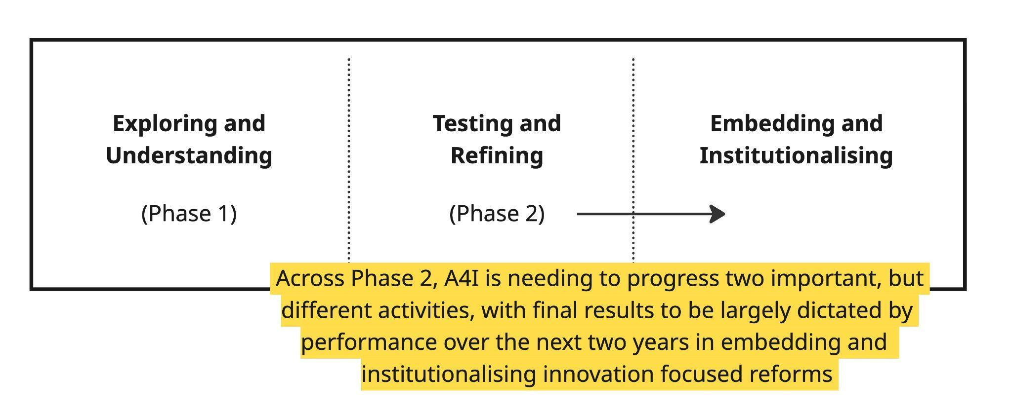
Both the A4I team and government partners spoke of Phase One being characterised by a process of “understanding and exploring” potential entry points on the STI landscape, and “careful preparation”. This deliberate but cautious start (compounded by COVID 19 related restrictions) meant that the A4I program team began Phase Two with a considerable challenge ahead of them, given the need to rapidly translate ‘exploring and understanding’ into action and impact across a wide range of complex systems. The team also needed to navigate a revised Phase Two strategy that involved varied partners, diverse stakeholders and broad geography. The upside of Phase One was that it provided a strong foundation of understanding and trust for Phase Two. However, many stakeholders reported that a slow start to Phase Two had increased the pressure for tangible results. Figure One above describes the position of A4I as it works to progress towards systemic change, highlighting that there is a lot to be done in terms of embedding and institutionalising program achievements over the remaining two years.

Figure Two: EOPO and IO interaction with Program elements (See Annex 5 for written version.)
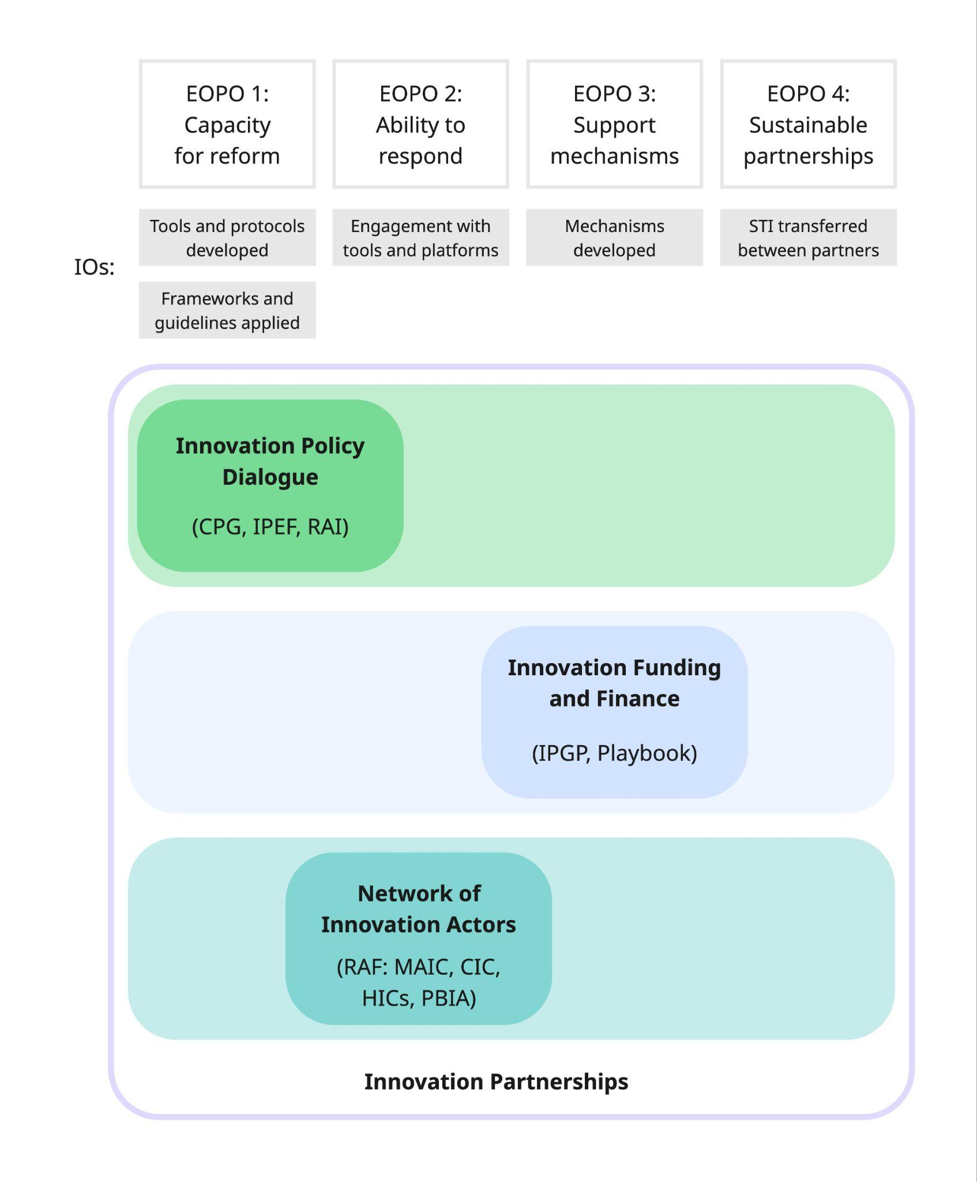

Purpose of the Mid-Term Review
The primary purpose of the MTR was to assess progress towards the program’s EOPOs and provide clear recommendations that are contextually fit-for-purpose to assist in making improvements, where needed, across the remaining implementation period.
The MTR focuses on the Phase Two implementation period from April 2023 until late 2025, while also noting that several ongoing A4I activities were begun in the first Phase, and transitioned into the second Phase.
The principal audience for the review will be the Australian Embassy in Hanoi (particularly the DFAT Development team), A4I management and CSIRO teams (Research and Executives), It is also intended that the review findings will be shared with MST, Program Steering Committee members. As per DFAT Monitoring and Evaluation Standards, the MTR will be published (in full or partially) on the DFAT website.

Methodology
The methodology for the MTR was outlined in the Review Plan submitted to A4I prior to Fieldwork being undertaken. The Plan was developed following initial (remote) key informant interviews (KIIs) with A4I Senior Management, as well as review of key A4I documentation. An initial process of stakeholder mapping was also undertaken to guide these early discussions, in order to both test and clarify the MTR team’s understanding of the overall program landscape ahead of submission of the Review Plan. (see Annex Two)
Following this process, key review questions (KRQs) were developed - as outlined below.
- KRQ 1 - To what extent are A4I’s objectives and delivery approach relevant to Vietnam’s evolving STI priorities?
- KRQ 2 - Is the A4I Program making progress towards its Intermediate Outcomes and End of Program Outcomes (EOPOs), including higher-level or catalytic impact on policy eco-systems?
- KRQ 3 - Does the MEL and Reporting system collect sufficient and useful evidence, and is it capable of demonstrating progress towards the four EOPOs?
- KRQ 4 - What has A4I done to enhance the sustainability of its actions?
- KRQ 5 - How has A4I advanced social inclusion innovation, especially gender equality and disability equity?
- KRQ 6 – How has A4I advanced social inclusion innovation, especially gender equality and disability equity?
- KRQ 7 - What benefits (intended or otherwise) does the program generate for the bilateral relationship between Australia and Vietnam?
Review Sub-Questions (SQs) were also prepared to provide further granularity to each area of inquiry. The full set of KRQs and SQs is attached to this report as Annex One.
The MTR team was tasked with both assessing A4I performance to date against its EOPOs and IOs, as well as proposing measures to ensure strong performance in its remaining three years. To fully address both aspects, the MTR team used a mixed-method approach aiming to comprehend and synthesise the broad range of strategic documentation and reporting that has been prepared by A4I to determine program cohesion and effectiveness. At the same time, the MTR team worked to consider the suitability of the MEL strategy and the Socially Inclusive Innovation strategy in supporting program performance.
As mentioned above, Phase Two is structured around four interconnected program elements that align closely with four EOPOs and five IOs. These alignments are shown above in Figure two. While periodic reporting has evolved over the course of Phase Two to more specifically focus on reporting through the lens of the EOPOs and IOs, there remains a degree of misalignment in the nuanced difference of these two project framings. To address this, the Review Team undertook key informant interviews with the primary aim of I’m packing and assessing the contribution of different activities to EOPOs and IOs, rather than assessing them through the different component lens.
Through a process of document review, initial engagement of key A4I actors, and consideration of preliminary results, the MTR team developed a plan for making optimum use of limited time available in the field. A purposive sampling approach was taken to ensure the review team gained sufficient coverage across A4I’s different work areas. The Fieldwork plan centred on key informant interviews to gather qualitative data on program performance and direction, together with more open, reflective discussions to validate and triangulate emerging findings.
Field work occurred over the first two weeks of December 2025, including KIIs with key A4I stakeholders and partners in Hanoi from government, research and private sectors. Field work also involved visits to Can Tho, Soc Trang and Dak Lak provinces, as well as Ho Chi Minh City. Additional virtual KIIs were undertaken with key stakeholders who were unavailable during the field work period. Across the review process, the MTR team met with more than 70 key informants. See Annex Three for a list of people consulted during the MTR.
Following field work, the MTR team presented and discussed initial findings during an in-person debriefing with the A4I and DFAT teams in Hanoi on the 12th of December. Select follow-up meetings occurred following the field work to help consolidate understanding of key themes.

Limitations
The A4I program is marked by considerable breadth (‘horizontal’ engagement of varied stakeholders across different sectors), and depth (‘vertical’ engagement from national ministries to small cooperatives). This points to a wide range of activities and operating contexts, which makes engaging sufficient stakeholders a challenge. Given the MTR team had limited time, this presented a challenge for the review team in terms of not being able to engage in each investment area, and therefore not being able to consider the full spread of program approaches employed in the program. This challenge reflects a major finding of the Review - that the relatively small program management team based in Hanoi is stretched working across a vast landscape of different activities with different demands and system changing ambitions.
A related challenge is that program reporting is unable to report fully on program performance, given the breadth and fluidity of activities. This is further complicated by the program being structured around four elements that do not neatly align with the four EOPOs and compounded challenges described above in terms of not to the full cross-section of A4I activities, and the important variation between activities.
Efforts were made through the document review to assess the totality of A4I, but some activities were simply out of scope. For example, the MTR team was not able to meet with partners from each of the 15 grants, nor with provincial departments of key Ministries which have apparently been actively engaged in more local program activities.
Government restructuring also presented a challenge in terms of staff movement, the merging of provinces and ministerial restructuring. While some key staff had already moved on from their ‘relevant’ position, support was provided by the A4I team to secure meetings with some of these people, in light of their status as ‘key informants’. At the time of the field work, the restructure was ongoing and this highlights another limitation for the Review and challenge for the A4I team: there is disruption within GoV but also redirection of energy to support the ongoing process, and enduring uncertainty.

Review Findings
This chapter presents findings from the MTR with supporting evidence, organised around the areas of inquiry defined by the Key Review Questions (KRQs). Each section includes a brief summary of key findings and related recommendations.
In developing findings, the Review team applied a conceptual framework for understanding and discussing A4I program dynamics and progress within the context of ‘strengthening innovation systems in Vietnam’ – described in Figure Three below. In this framework, A4I is organised around a process of ‘spinning out’ solutions to innovation system issues. The process spans different levels of activity with A4I taking on a diminishing role as solutions move outwards. This involves solutions being developed and adopted by partners, increasingly making the process one of increasing diffusion and localisation.
Figure Three: A4I conceptual framework (See Annex 5 for written version.)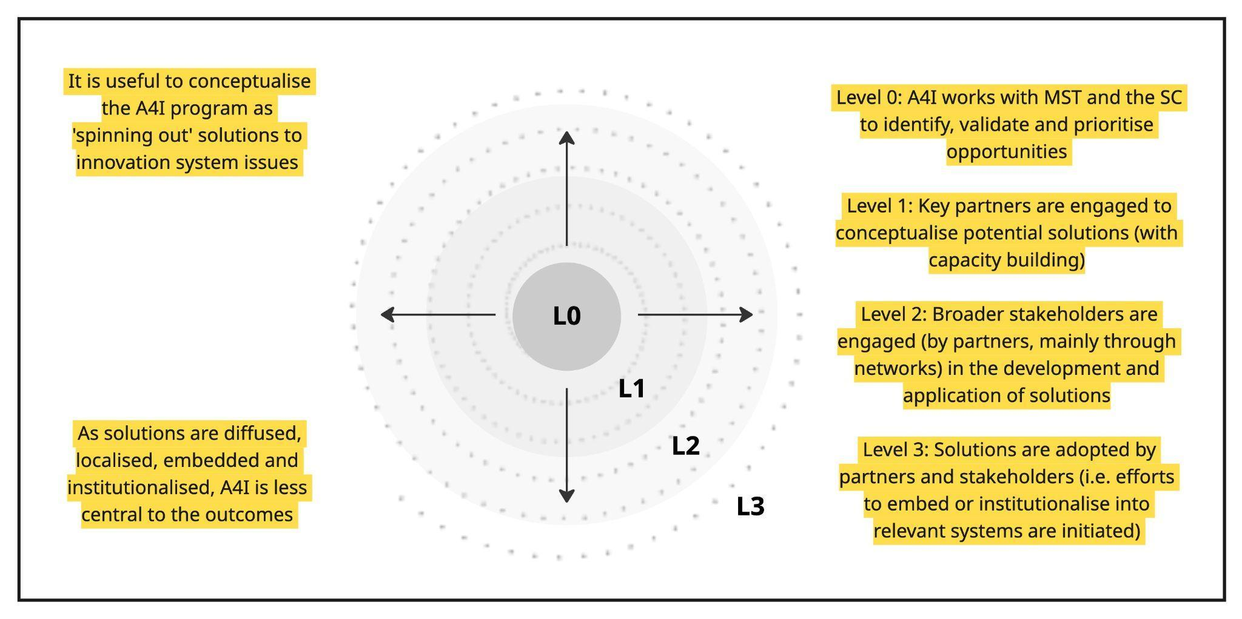
This conceptual framework allowed assessment of where different activities currently sit in terms of their potential to be embedded and institutionalised, while also providing guidance as to where focus could or should be placed across the remainder of Phase Two.
- To what extent are A4I’s objectives and delivery approach relevant to Vietnam’s evolving STI priorities?

Relevance to GoV priorities
A sentiment repeated across the review from the full cross-section of different stakeholder groups was the ‘value’ of A4I’s unique position as a trusted partner, and the inherent opportunities that presented given A4I’s unique alignment with the emphasis and priority that the Government of Vietnam (GoV) has placed on science, technology and innovation (STI) and digital transformation over recent years – generally framed as A4I being ‘the right program, in the right place, at the right time’. This assessment reflected the capacity of A4I to address known constraints to innovation in Vietnam, notably a fragmented policy environment, limited access to innovation finance, human capacity constraints and weak lateral linkages between different innovation actors. A4I’s multifaceted capacity is therefore highly relevant to defining and consolidating pathways that could translate experimentation into institutionalised mechanisms.
At the time of Phase Two design, A4I already aligned well with GoV priorities in terms of its direct relevance to Vietnam’s 2021-2030 Socio-Economic Development Strategy, which identified STI as key drivers for sustainable development, as well as digital transformation – with all four of A4I’s program elements seen as inter-connected pillars and relevant to GoV strategy and progression of the required supporting policy ecosystem.
While the Ministry of Science and Technology (MST) was the initial partner for A4I, broader GoV reforms described above have brought increasing demand from other ministries to better understand, engage and leverage innovation. This demand reflects growing expectations within the GoV that STI be ‘mainstreamed’ across government, the private sector and society. Given this context, there is appreciation for the specific value that the Commonwealth Scientific and Industrial Research Organisation (CSIRO) brings as a world-renowned research partner in science and technology, and as a national innovation agency with the necessary experience to support MST to establish itself as the driver and engine room of innovation in Vietnam. MST also looked to CSIRO to help strengthen its capacity to enhance innovation performance across the whole of government. Equally, CSIRO greatly appreciates the capacity and commitment of MST as their primary partner and is looking forward to maintaining a lasting relationship with MST in the future.
From the outset, A4I positioned ‘responsiveness’ as central to the program approach, reflecting A4I’s ambition to maintain relevance in a rapidly changing context. While this approach requires sustained engagement and adaptability, it also generated high levels of trust and positioned A4I to act quickly and strategically when opportunities emerged. Examples of A4I responsiveness include establishment of the Pork Bio-security Innovation Alliance in response to an African Swine Flu (ASF) outbreak; preparation of the Commercialisation Plus Guidelines (CPG); and support to development of Vietnam’s pioneering Responsible Artificial Intelligence (RAI) guidelines.
While these individual activities have all achieved important outcomes in their own right, their importance also lies in demonstrating A4I capacity to respond broadly to GoV priorities by providing advice and options around pathways forward. This ability for rapid response was widely cited across different Vietnamese stakeholder groups as heightening the relevance and status of A4I, and also levels of trust afforded to the program in terms of dealing with sensitive issues. This contributed to A4I being viewed by MST as a ‘preferred development partner’ with one senior official commenting that:
“Traditional ODA approaches will not work [given the pace set by Resolution 57], since there are too many delays. The A4I management model is flexible and fast, which is very important in Vietnam right now.”
However, responsiveness runs the risk of distracting from the achievement of agreed EOPOs and IOs – especially as more and more partners seek opportunities to draw on CSIRO expertise. Concerns were expressed by different stakeholder groups regarding risks associated with responsiveness, namely how it can diminish focus as resources are spread too thin. Given Vietnam’s growing focus on innovation and the program’s responsive approach, ensuring focus on sustained pathways to tangible systemic change outcomes remains crucial. As it stands, the Review Team assesses that A4I is generally doing a good job in managing the tension between responsiveness and focus on long-term results. This requires a delicate balance given A4I is viewed by MST as a ‘go-to’ resource when responding to emerging GoV priorities, while also needing to remain focused on achievement of agreed EOPOs and IOs. The challenge for A4I over its remaining time is to prove that it got this balance right, by delivering tangible ‘EOPO relevant’ outcomes, while demonstrating that responsiveness to emerging opportunities was strategically managed and contributed to an enabling environment for subsequent program activities.
Resolutions 57 and 193
Across 2024 and 2025, two highly significant resolutions were passed by the Vietnamese Communist Party Central Committee that aimed to bring clear structure and strategy to the promotion of innovation as a whole of government responsibility. While Resolution 57 anchors the political mandate for innovation, Resolution 193 establishes the instruments through which change is being tested. Collectively, these set a national strategic direction for transforming Vietnam’s development model by prioritising STI and digital transformation as core drivers of economic growth, governance, and competitiveness.
Annex 5 provides detailed analysis of each and their implications for A4I. Resolution 193 significantly reshapes the A4I operating environment by creating new policy laboratories in precisely the domains that A4I seeks to influence through its innovation policy dialogue, grants and partnerships - namely innovation finance, regulatory reform, public-private collaboration, digital platforms and emerging technology ecosystems. This heightens the relevance of A4I’s engagement of counterparts, particularly in supporting learning from pilots, providing international comparative experience from Australia, and contributing to the design of safeguards, evaluation frameworks and scaling strategies for new mechanisms.
Broadening relationships
The passage of Resolutions 57 and 193 presents both a need and opportunity for A4I to broaden and strengthen relationships across the GoV, national research system and private sector. Given the propensity of ministries to work in siloes, this broadening requires delicate management but will be acutely important in terms of maintaining program relevance and leveraging opportunities. As one key informant said, “there is reluctance to engage across ministries, since there are no favorable conditions for this, so people work from their experience and focus on their core programs”. As A4I’s focus on agriculture increases, it is important that it continues to strengthen relationships with key actors of relevance to agricultural innovation, notably the Ministry of Agriculture and Environment (MAE) and its various agencies. At the same time, it is vital that A4I protects and further progresses its very strong relationship with MST and maintain MST as its primary strategic partner. The key challenge here is A4I must be reliant on MST to facilitate an improved relationship with MAE.
While relationships have been established with the Institute of Strategy and Policy for Agriculture and Environment (ISPAE), the Vietnam Academy of Agricultural Sciences (VAAS) and provincial departments of agriculture and environment, connectivity with MAE at the national level seems limited. The Review team feels there is an urgent need to address this, to ensure that important lessons being learned through provincial activities are carried upwards into national policy and budgeting discussions. It is important to note here that the Government has set ambitious targets for MAE across its 2026-30 Five-Year Plan:
- Average agriculture GDP growth target of 3.7% per year (with aspirations of ~4%)
- Export growth and value chain development with exports in key products increasing 6–8% annually
- Strategic emphasis on sustainability, which demands productivity gains be linked to climate resilience, digital transformation, green agriculture and reduced emissions
While MST can play a role in driving agricultural innovation, there is important work needed to establish what this role involves and how it can complement MAE’s efforts and facilitate greater traction for A4I within the key ministry. There will be a ‘sweet spot’ wherein MST and MAE are able to work harmoniously and draw on their individual strengths towards achieving agricultural innovation outcomes, but it is not clear that this has yet been determined.
Relevance also needs to be assessed by examining A4I’s responsiveness to the private sector and – given the focus on agriculture – the context of average Vietnamese farming households. The development of various multi-stakeholder Innovation Clubs and Clusters (ICs) demonstrates the program’s responsive approach, while strong stakeholder participation in these ICs attests to their relevance. These mechanisms of ‘intermediation’ reflect multi-stakeholder coalitions through which producers, industry, researchers and government are coordinating at provincial level to explore the role of innovation in resolving challenges and advancing opportunities across different value chains. However, the legal status of these bodies remains unclear, and in need of clarification.
Innovation Partnership Grants
A4I’s innovation partnership grants (IPG) provide a mechanism for moving research-driven technologies from ‘proof of concept’ to ‘proof of application’. While the technologies and partnerships advanced through IPGs serve as valuable, concrete examples of innovation and bilateral cooperation and facilitate uptake of highly innovative solutions that have strong spillover effect, the additional value of the IPG is that the overall portfolio models an effective innovation grant mechanism for the GoV to observe and localise. Recognition of this value can be seen in the request for the IPG methodology and lessons to be documented and shared. This ‘modelling’ is highly valued by MST as they work towards meeting their obligations as a driver of innovation and transition from traditional R&D funding towards innovation focused funding mechanisms. The IPG also contributes significantly to the achievement of EOPO 4, as it facilitates innovation partnerships between Australian and Vietnamese innovation actors. IPG activities also provide case studies related to policy considerations, thus advancing EOPO 1.
While these program contributions are significant, the IPG consumes roughly 25% of the overall Phase Two budget (when factoring in staff and other support). It is therefore vital that the grants demonstrate impact and value for money, but also dynamic and critical decision-making about their individual performance. While mechanisms like this will always have varied portfolios (because of the high dependency on grantees), they also need to justify costs and rationalise the process to build the case for expansion. Put another way, the relevance of the IPG is largely determined by the degree to which A4I and its partners are able to leverage the grants in support of broader systemic change. Moving forward, it will be important that A4I support the National Foundation for Science and Technology Development (NAFOSTED) in operationalising the new innovation fund, such an achievement would be an important systemic outcome.

Implications for the remainder of Phase Two
The acute relevance of A4I to the current context and direction context of the GoV could be described as both a blessing and curse. The program’s relevance ensures its strong profile and interest at the highest levels of government. However, this prominence means that there is significant demand for the program to be broadly responsive across Vietnam’s innovation landscape, which presents the risk of program resources being spread too thin.
In terms of maintaining relevance, it is critical that A4I remains disciplined and focused on what is most important in consolidating Vietnam’s innovation landscape and maximising the opportunities of this moment, since this will help ensure the delivery of tangible results.

Is A4I making progress towards its Intermediate Outcomes (IOs) and End of Program Outcomes (EOPOs), including higher-level or catalytic impact on policy eco-systems?

A4I is making progress against its EOPOs
Figure Four: A4I – a continuously evolving Program landscape (See Annex 5 for written version.)
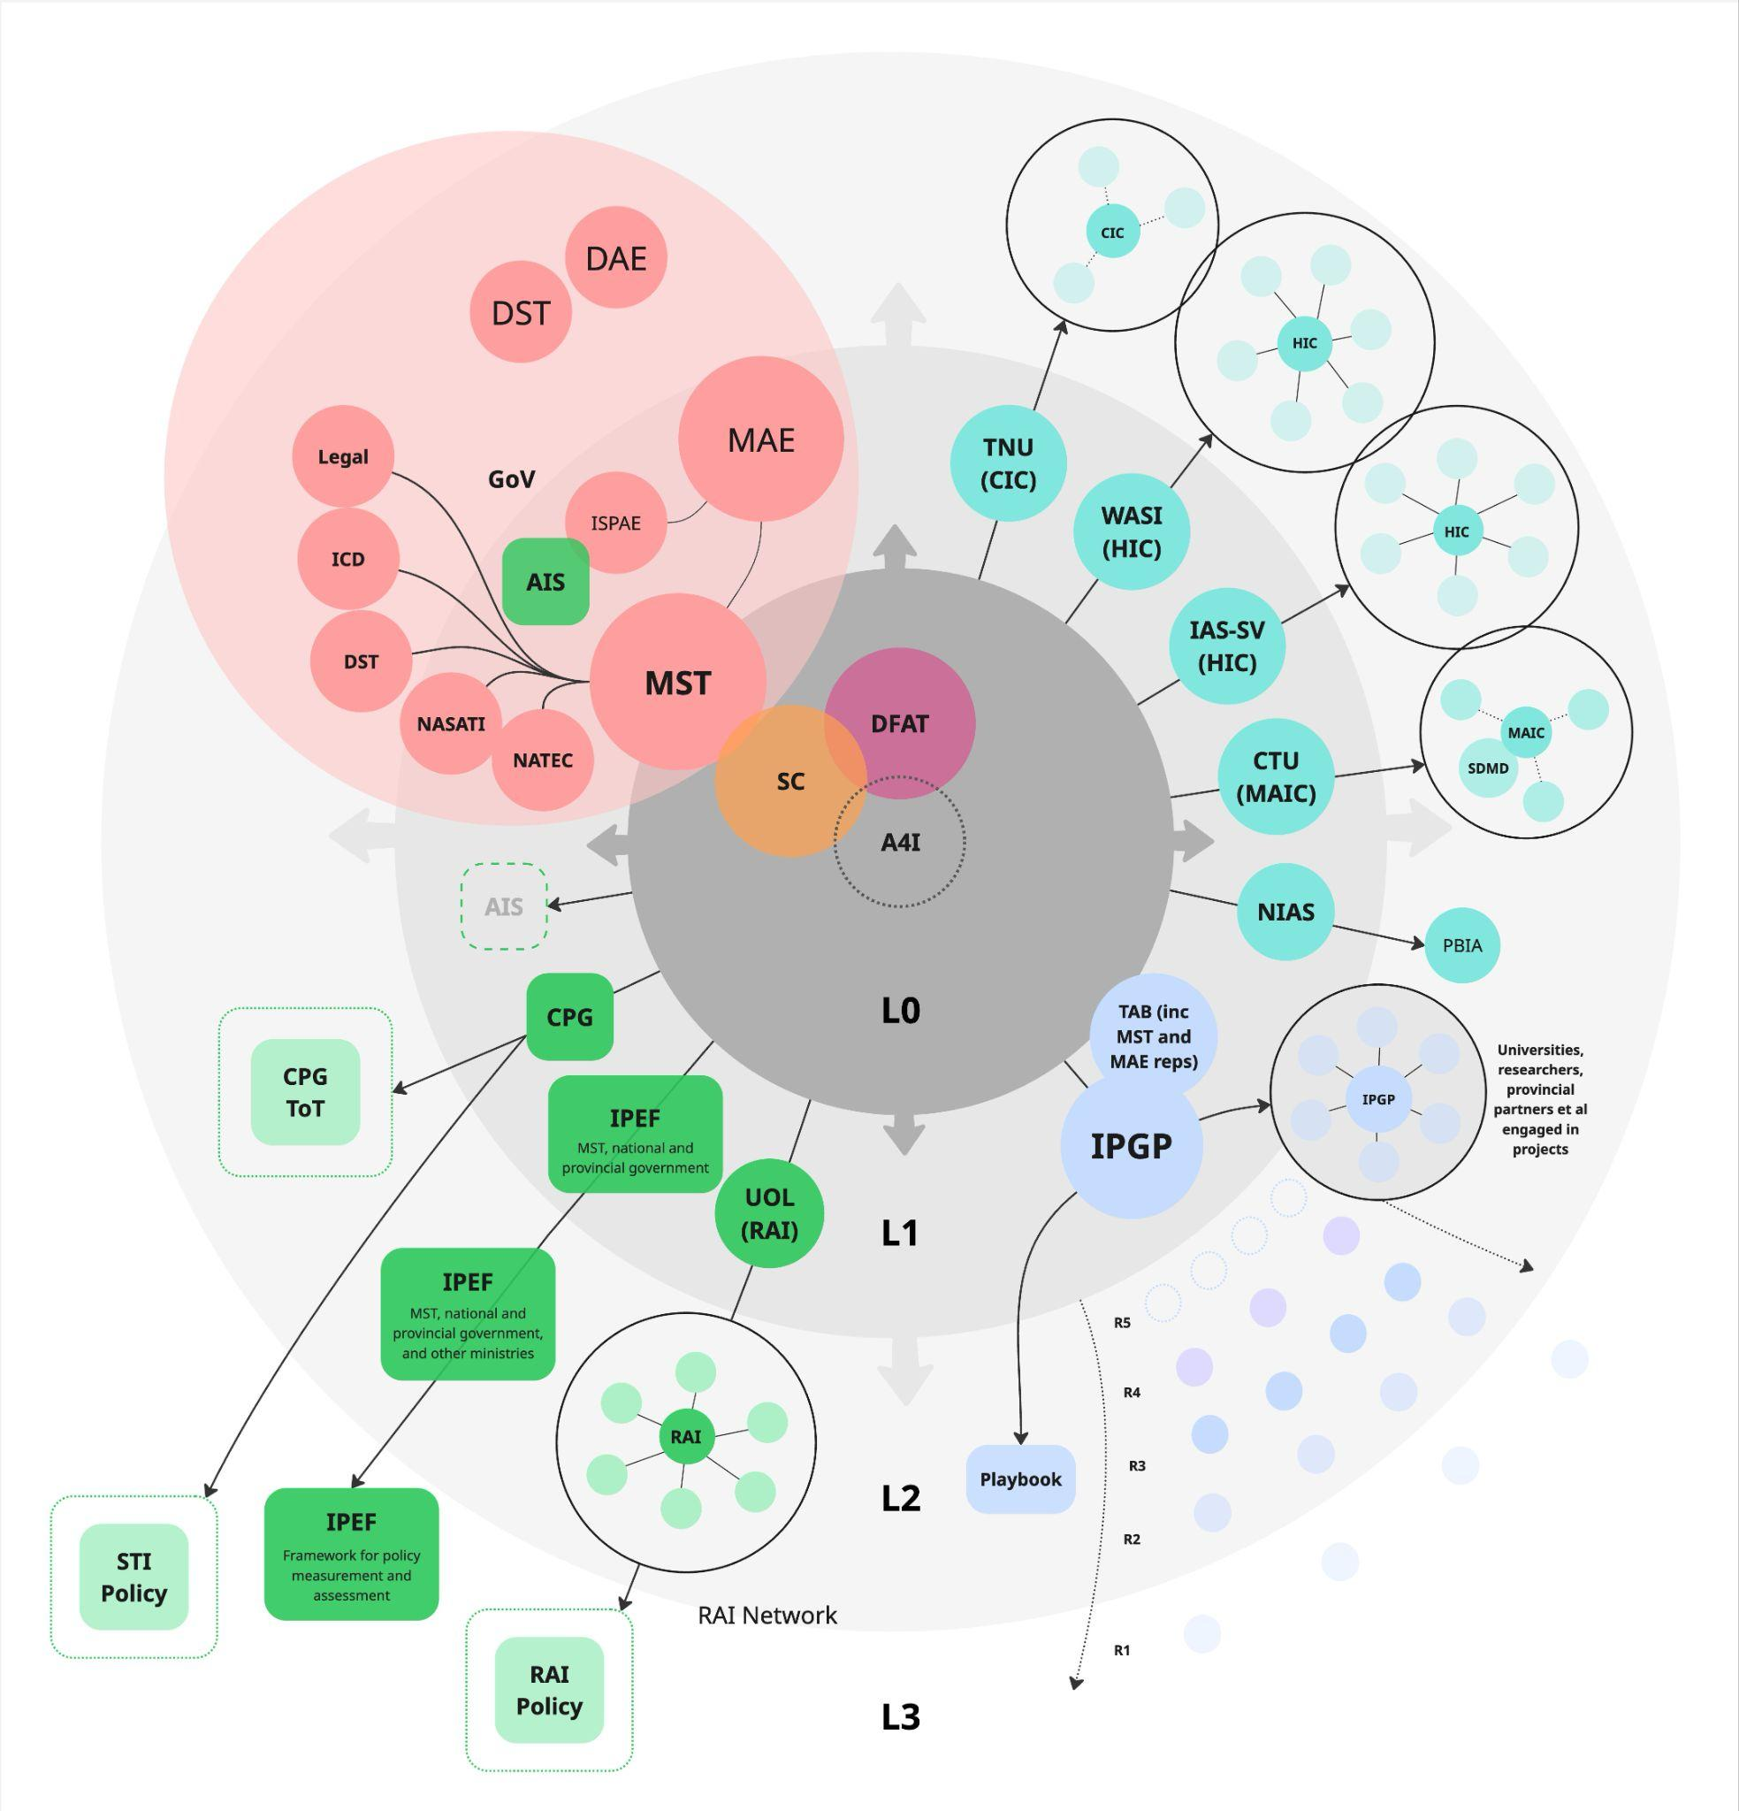
There is notable progress being made towards all IOs and EOPOs, but the ambiguity of these outcomes creates the space for divergent expectations, with different stakeholders interpreting their intent differently. This divergence then undermines arguments related to the program’s effectiveness. In an effort to provide a clearer picture, the Review reports on key achievements (shared and observed) while also reflecting on what has enabled those achievements and their dependencies. As it relates to MTR RQ3, we expand on the issue of IO/EOPO ambiguity given the component focus of the program and diverging expectations in the MEL section of this Review.
In this section we use the conceptual framework introduced earlier to reflect on A4I’s achievements. The concept of A4I ‘spinning out’ solutions was first used to create an overview of the program dynamics and its mechanisms, seen above in Figure Four. In different Figures below we use the framework to provide an overview of the program elements and their solutions. In the remainder of this section, we ‘zoom in’ on parts of this picture to expand on the key achievements and issues of each program element. The ‘spinning out’ framing also helps conceptualise the continuum of institutionalizing A4I efforts, given that institutional embedding may not be feasible or optimal in some circumstances. It is also noted that measuring performance against individual EOPOs often misses that significant synergies and interactions exist between A4I’s the sum of its EOPOs.

EOPO One: Enhanced capacity for institutional, policy and regulatory reform in targeted Ministries that enables inclusive innovation
- IO 1.1. Tools and protocols developed by A4I increase understanding of targeted policy makers and institutions on how to integrate inclusivity and sustainability into innovation policy dialogues
- IO 1.2. Frameworks and guidelines to evaluate existing policies, and design novel options, developed and applied to strengthen capacity for the analysis of innovation system performance in targeted ministries

A4I efforts in relation to EOPO One primarily occur through Program Element One (Innovation Policy Dialogue), while also being informed through activity occurring under Program Elements Two and Three.
Through being strategically responsive, A4I has repeatedly demonstrated a capacity to influence innovation policies and regulations currently under consideration, and the processes through which they are developed. This has involved identifying and responding to emerging opportunities with key partners, and pushing beyond initial requests (for events, reports or tools) to develop guiding processes and principles. These efforts reflect the program’s ambition to develop an enduring culture of innovation in its partners. This quote from an A4I team member captures the sentiment:
“Innovation process and principal formalisation is key to creating value independent of politics – value that can last through changing winds.”
An example of this approach can be seen in A4I’s partnership with the National Agency for Technology Entrepreneurship and Commercialization Development (NATEC) during Phase One. Early engagement identified constraints on commercialisation as a key issue, leading to a series of influential seminars and the creation of the Commercialisation Plus Guide (CPG). The CPG was then used by NATEC to structure a train-the-trainers (ToT) program focused on universities. This approach has not only generated and disseminated valuable knowledge but created a system for its ongoing dissemination and development. NATEC reported that over 80% of participants in the ToT program found the knowledge highly relevant, and over 50% planned to immediately apply it. The agency also gave numerous examples of individual researchers using and re-delivering the training. Years later, recommendations from the CPG and a raft of subsequent work undertaken by A4I was incorporated into Resolution 193 and the new law on the capital. This achievement is highly significant but took time and straddled Phases One and Two - and it will take more time to see the broader impact. Moreover, as they progress, these processes of training, policy implementation and reform become increasingly independent of A4I, so while reporting on such work becomes more difficult, the evolution of the concept provides evidence of both diffusion and localisation. This was reflected by a senior NATEC official who noted that:
”A4I is not just funds but also expertise (and this) is highly appreciated, as is the long-term focus… Without A4I support it would have been very difficult to pursue the STI strategy.”
A4I work on Responsible Artificial Intelligence (RAI), delivered in partnership with the University of Law (UOL), tells a similar story of an evolving strategy with expanding and deepening influence but also increasing distance and local ownership. As does the work with the National Agency for Science and Technology Information (NASATI), which began as a foresight project but expanded into the development of an Innovation Policy Evaluation Framework (IPEF). Informed by the SII strategy, the IPEF has been designed to guide policymakers to consider innovation ‘directionality’ and Gender Equality Disability and Social Inclusion (GEDSI) factors in their analysis. These results point to enhanced capacity for reform, at least in MST (which covers NATEC and NASATI), but they also highlight two critical dependencies:
- The tools and processes developed by A4I can enhance capacity and create impact, if they are locally owned, integrated and used appropriately;
- Other ministries (e.g. Ministry of Finance (MoF), which controls state budgeting and taxation) need to be better aligned, informed and supportive of MST learning for meaningful reform to be possible and to become embedded.
Figure Five: Program Element One - Innovation Policy Dialogue (Policy) Dynamics (See Annex 5 for written version.)
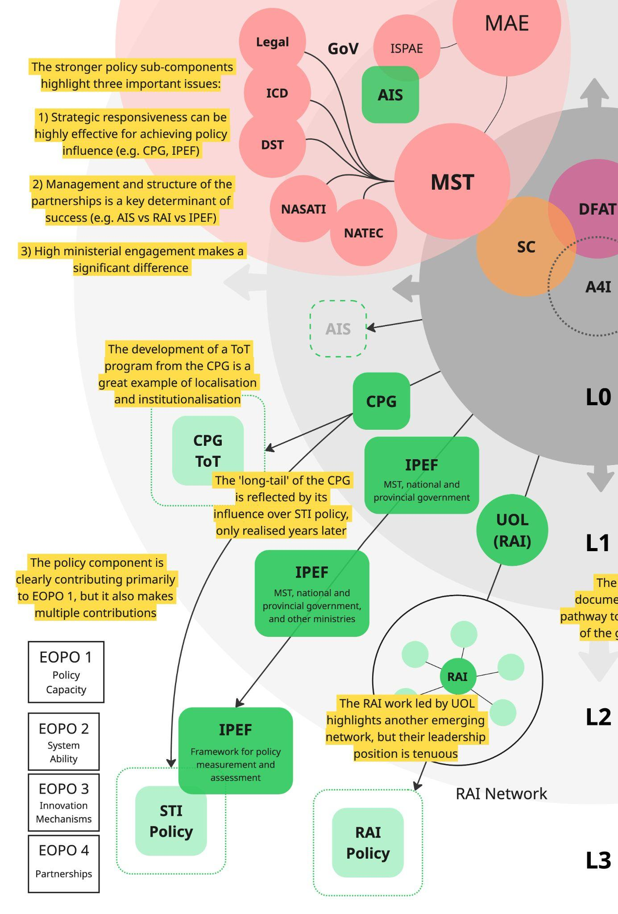
To some extent, these dependencies (and the risks associated with them) are ‘baked’ into the A4I program design, raising a question about the extent of political economy analysis (PEA) undertaken, before and during the program. As this issue cuts across the program elements, we expand it in the broader discussion at the end of this section.
Strong relationships and appropriate partnership structures have been crucial enablers of these achievements, as they underpinned the responsiveness that made shifting political economy dynamics navigable. When relationships are managed by Vietnamese team members with more contextual awareness and local connectivity (including Australians of Vietnamese origin), traction appears to improve; but partnerships need to be structured in ways that enable the program team to maintain influence, not just oversight. The work with ISPAE on agricultural innovation systems highlights these issues, as it reflects more service delivery than partnership and as such there is “no evidence of this getting hard-wired” into the agency, let alone the ‘parent’ ministry (MAE). This also reflects a broader pattern - despite sustained A4I team efforts to engage ISPAE and MAE as partners in the program, limited traction appears to have been achieved. For example, highly relevant work on ‘intermediation’ through ICs in agricultural innovation systems (expanded on below) appeared to be of scant interest to ISPAE when consulted as part of this review. While A4I team members shared their disappointment about this, most were unsurprised and acknowledged the difficulty of engaging. From a performance perspective, this disconnect is of concern since it is entities such as ISPAE that will be central in embedding and institutionalising knowledge and strategies emerging from these activities.
A strong grasp of the context and political economy dynamics, together with the connections and structure to respond to those dynamics seem to be crucial ingredients in terms of ensuring solid and feasible pathways towards systemic change. However, through the CPG and RAI work in particular, A4I has demonstrated that well-timed and well-positioned expert guidance from Australia can also be hugely influential. Senior GoV officials were glowing in their assessment of experts brought in by A4I, and of the policy work more broadly, with the MST Vice Minister directly connecting the policy dialogues to the development or updating of more than 30 laws, including the pioneering RAI law. He went on to state that these changes are helping Vietnam to attract international tech companies, while also feeding into regional ASEAN and international processes. This assessment suggests not just enhanced capacity but also reform and impact. Clearly, A4I has developed the relationships, trust and position to influence innovation policy (and the deeper principles that shape it), but the distance/diffusion inherent to their work makes attribution difficult and creates dependencies that limit control.
This approach challenges established ways of measuring and reporting on effectiveness, since diffusion and strong local ownership is an important outcome in its own right. It is also important to note that the degree with target ministries partners actually institutionalise instruments introduced through A4I should not be the sole criteria for performance measurement, with understanding of innovation behavioural shift in ministries such as MST very important in terms of managing innovation forward across long reformed cycles. The achievements and issues of the policy program element are summarised in Figure Five above.
EOPO Two: Improved ability of targeted innovation ecosystems in the selected sector to continuously respond to an evolving context.
  - IO 2.1 Targeted ecosystem actors engage with tools and platforms developed by A4I to enhance networks, generate ideas, address challenges, and increase resources for innovation

A4I efforts in relation to EOPO Two primarily occur through Program Element Two (Innovation Funding and Finance), while also informing Program Element One and being supported through Program Elements Three and Four.
The primary A4I level for achievement of EOPO Two is the Innovation Partnership Grants program. To date, 4 rounds of grants have led to the funding of 15 projects (12 in Phase One), and a 5th round was mid-process at the time of the Review. An important ‘higher level’ achievement is that the program has demonstrated to MST the potential of a well-managed, open innovation grant-making process to stimulate innovation. The IPG program also provided an opportunity to document learning for adoption by relevant agencies/ministries and led to development of outputs (e.g. the IPG Playbook) that capture lessons and insights that can support replication of such a process. In the words of a senior DFAT staff member, GoV engagement in the IPG has been “a key value add and big deal, really” as this process demonstrated the value of open application, meritocratic selection and targeted funding approaches. However, the cost of the IPG is high (~ 20% of total program resources) and outcomes mixed, so its role requires scrutiny.
The stated focus of the IPG was clear: grants would support technology application projects, rather than proof of concept, and these projects had to involve Vietnamese and Australian partners (thus facilitating EOPO 4). In other words, proven technologies needed to be applied to address challenges facing Vietnam, in ways that strengthened connections between research institutions. This brings into focus the different impact metrics for the IPG. First, there is impact through technology application. Second, there is impact on the partnerships, partner capacities and their innovation processes. Third, there is impact on GoV processes, policies and regulations that support innovation. These can be conceptualised as micro, meso and macro-level impacts (see Ten for details). There is also the potential for projects to trigger investment in technology adoption.
The scope of these impact metrics illustrates the many roles that the IPG is expected to play within the A4I program and raises questions of whether this is reasonable and if A4I staffing is commensurate. Many A4I program team members may have contributed to the IPG at different points, but managing a diverse portfolio of grant projects and partners focused on highly specialised technologies is clearly a significant body of work that demands sustained and collaborative engagement. Staffing changes (particularly within Australian grant partners) have created additional challenges for this engagement, but there is a bigger resourcing issue.
Projects focused on demonstrating applicability of a technology cannot be fairly evaluated in the same way as projects focused on applying a technology (where potential has already been demonstrated), as the start and end points are different. Given limited staffing and timeline of the IPG and broader (meso and macro) expectations, demonstration seems like a reasonable target, but our discussions suggest there is some misalignment here. The A4I team is clear that evidence of technology impact at scale is not what the IPG was designed to deliver. The technology application impacts of the grants therefore can be expected to be modest in quantity. However, given they are intended to be demonstrative, these impacts must be high quality and clearly focused on building the case for broader application or adoption. This should include the development of some form of strategy or documentation that defines a pathway forward for the grant investment, beyond the A4I program. A related issue is that more recent grant rounds are understandably less progressed, and more likely to not be in a position at the program’s close that is conducive to neat conclusion and clarity around their contribution. This is especially the case with Grant Round Five where funding will conclude at much the same time of A4I closing itself, making results capture and analysis difficult, and all-important support regarding ‘what next’ problematic.
On all metrics, IPG achievements are varied. While there is clearly some traction at the macro-level (i.e. engagement and interest in the ‘Grant Playbook’), this is not yet connected with existing GoV innovation support functions like the National Innovation Centre or the National Foundation for Science and Technology Development (NAFOSTED). Within the grant portfolio there are many great examples of technology demonstration, but few of broader application and adoption (e.g. BMH telehealth). For many grants, the adoption or further development of the technology seems uncertain, given research and engagement are ongoing, business models are still being explored, policy briefs have been shared, but pathways and resourcing remain unclear. It is the view of the Review Team that in the context of a program like A4I, grants need to be designed and resourced in ways that are clear-sighted in terms of how they will foster adoption from the outset. While applicants are expected to articulate strategy in the grant application process, this needs to be frequently revisited as learning progresses. Strategies like co-funding or demand-driven development could have been beneficial, as these recognise the constraints faced by the grant projects and respond to the crucial dependency of securing further support. The achievements and issues of the IPG program element are summarised below in Figure Six.
Figure Six: Program Element Two - Innovation Funding and Finance (IPGP) Dynamics (See Annex 5 for written version.)
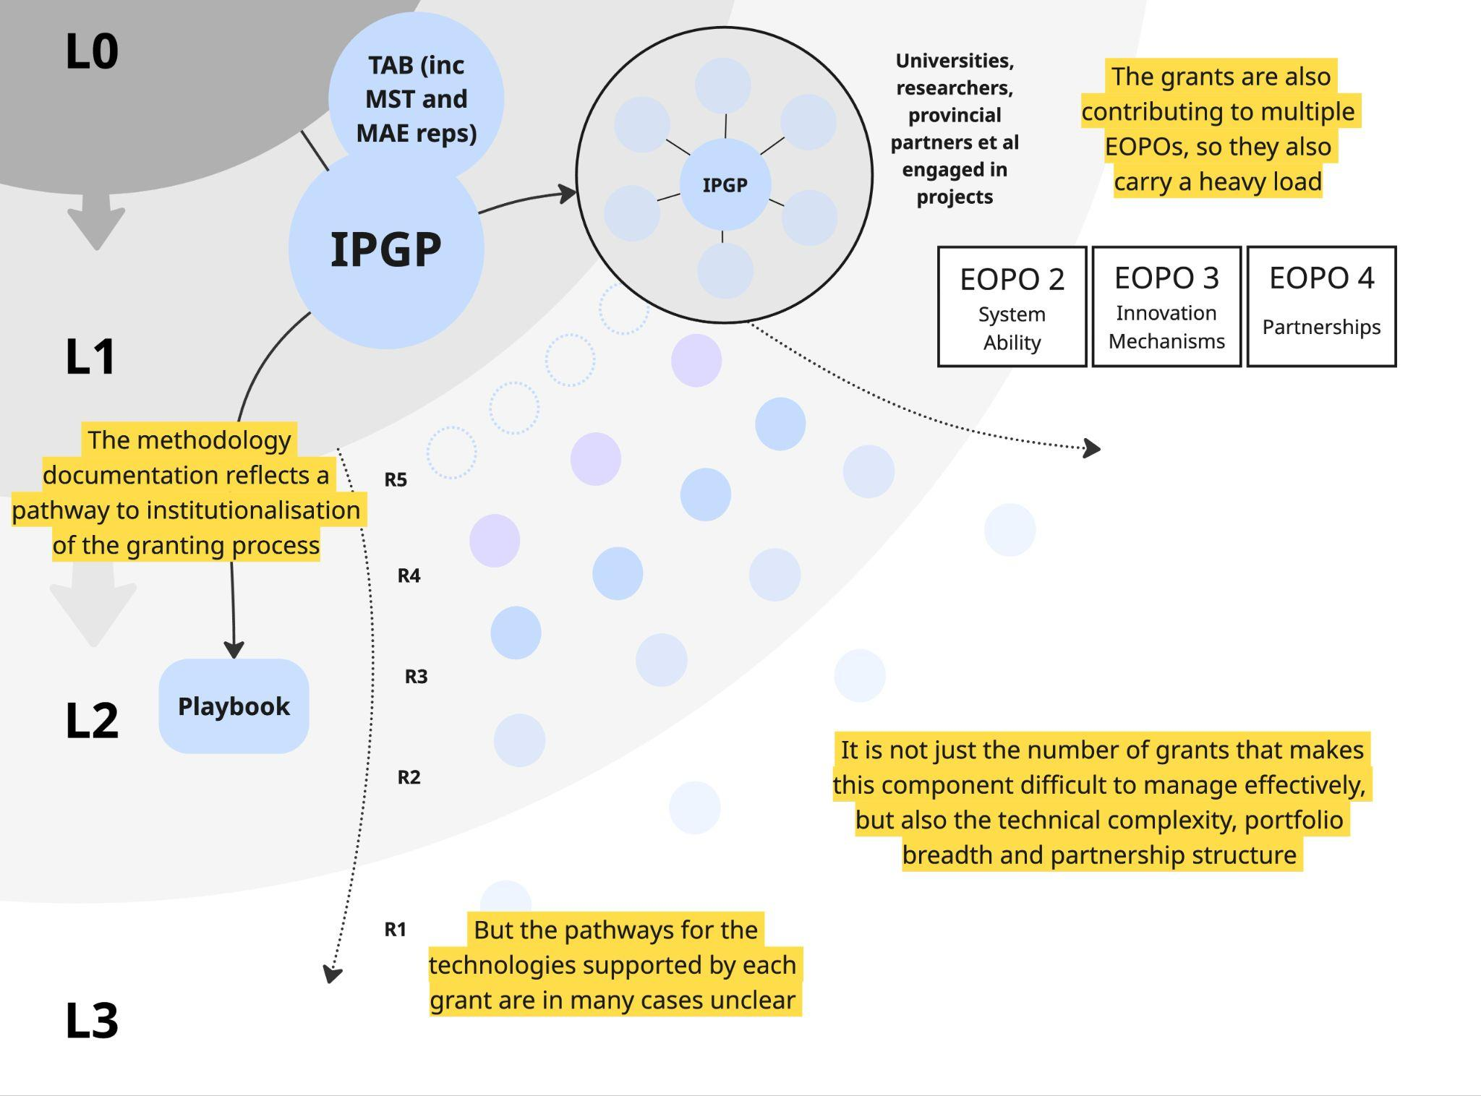
EOPO Three: Inclusive national and regional innovation support mechanisms connect people, ideas, investment and resources to respond to innovation opportunities and challenges
- IO 3.1 Mechanisms for connecting people, ideas, investments, and resources are developed to respond to innovation opportunities and challenges

A4I efforts in relation to EOPO Three are primarily actioned through Program Element Three (Network of Innovation Actors), while also informing Program Element One and being supported through Program Elements Two and Four.
Network building is largely centred around A4I’s Resilient Agriculture and Food (RAF) program, which has been developing ICs as networks of ‘intermediation’ for the agricultural innovation system. However, with formal ‘innovation relevant’ networks can be seen more broadly across the program. The RAF strategy, which is informed by international and Australian experience with agricultural intermediaries, has also been evolving in response to emerging opportunities. While initially focused on emerging provincial innovation centres (e.g. the Dak Lak Innovation Centre - DLIC) and government auspiced technology transfer offices, it was quickly recognised that these efforts needed to be organised around specific agricultural systems and production processes to effectively motivate stakeholder participation. Building both off earlier work undertaken by Australian Centre for International Agricultural Research (ACIAR) and different RAF initiated consultations, the A4I team engaged have engaged a broad range of key partners to support development of agricultural production-focused ICs. Over time, these further evolved into the horticulture-focused HICs, coffee-focused Coffee Innovation Cluster (CIC) and aquaculture-focused MAIC. More recently – in response to an ASF outbreak – A4I partnered with the National Institute of Animal Science (NIAS) and Charles Sturt University to set up the Pork Biosecurity Innovation Alliance (PBIA). Each of these has benefited greatly from A4I support and exposure to ‘best practice’ available internationally.
A wide range of stakeholders are involved in these growing networks, with the lead partners Western Highlands Agriculture and Forestry Science Institute (WASI), Tay Nguyen University (TNU), Institute of Agriculture Science – South of Vietnam (IAS-SV) and Can Tho University (CTU) playing increasingly central, leading roles, including network expansion. VAAS was also an important contributor. The way these networks have grown and evolved under the leadership of these partners represents a considerable achievement and can be said to be innovative in its own right. Each network has different tiers of engagement, from regular adaptive management meetings with key stakeholders, to online Zalo groups where hundreds of members engage with each other on production and distribution issues. In these groups, members ranging from farmers and buyers to researchers share their questions and suggestions, knowledge and concerns. The level of engagement and the impacts are varied, but internal reports developed by WASI and IAS-SV on the HIC networks highlighted success in terms of Identifying challenges, disseminating new information, and connecting different system actors in ways that resolve ‘bottlenecks’, stimulate production and facilitate the roll-out of new approaches. In discussions with stakeholders involved in these networks, numerous examples were provided of issues being identified and problem-solving processes initiated. For example, recognition of the export risk posed by heavy metal contamination in durians led to coordinated sampling across the Central Highlands and Mekong Delta. These networks also made progress in terms of inclusion, giving voice to women and ethnic minorities (especially in the Central Highlands). Another important observation of the review team was the degree to which network leaders understood the value of participatory approaches in network management, which they attribute to the efforts of A4I. Success in moving partners away from top-down leadership has generated broad participation of system actors and added to the perceived value of members and participating in the network.
These preliminary results present a compelling picture of increasing stakeholder connectivity, consultation, coordination and responsiveness to the evolving context. They also provide a great example of diverse but effective stakeholder engagement, including private sector actors spanning key agricultural value chains, and provincial departments under both MST and MAE. Most importantly, there seems to be a strong appetite among the stakeholders engaged to continue supporting the networks and expanding their activities. During stakeholder discussions for the Review, ambitions for the different networks were shared not just by lead partners, but by an impressively wide range of key stakeholders coming from different socio-economic strata, indicating considerable local ownership. However, the results are varied and pathways to sustainability are unclear. Identifying and consolidating relevant pathways that carry local learning to policy discussions should be a key priority for the remaining two years, since there is a strong evidence space available through the IC experience to underscore their purpose and utility.
The capacity for lead partners to secure resourcing for network management is a critical dependency, and on this point, efforts by IAS-SV to trial a membership fee are notable. Explorations of relevant MST budget lines and new cooperative laws are underway, as are discussions about the legal structures that would enable membership fees to be collected and managed, but all of this work is early and inconclusive. The sustainability issue is recognised by A4I and partners (see section 2.4 for more detail), but review concludes that enhanced MAE and MoF engagement will be needed in order to resolve such issues. On a promising note, a senior GoV official made it clear that:
“MAE recognises the value of a coordinated approach” and “have an open mind, but we need to engage.” This requires “documenting the methodology” to produce clear “guidelines on how to facilitate innovation.”
A4I clearly has an important role in this work. Seemingly simpler issues, like the technical limitations of Zalo groups for effectively managing growing networks also need to be addressed in a way that positions them for sustainability and growth.
There are also, as mentioned above, varied results. While the HIC networks have achieved considerable traction and the CIC appears to be gaining momentum (e.g. through the 2025 Climate-Smart Coffee Innovation Challenge), the MAIC is less convincing. Like the other networks, the CTU-led MAIC has many engaged stakeholders (including, notably, many young people through its Professional Shrimp Farmers Training workshops and Innovations and Start-up for Young Practitioners initiatives), but its activities seem fragmented and short-sighted. Super-intensive shrimp farming may be an effective production system, but without a pathway to widespread adoption its relevance is limited. An Artificial Intelligence (AI)-driven application developed for learning and translating unique sign languages is technically compelling and certainly GEDSI-aligned, as is the work with a local cooperative, but it is unclear how these activities will progress, or how they can contribute meaningfully to program EOPOs. It is also hard to determine the additionality of some work, particularly in the case of the Cooperative in Hoa De District, which is something of a ‘donor-darling’ having been supported by other programs - including intensive Oxfam support for over a decade. The business case and financing strategies for wider adoption reflect crucial dependencies for much of this work, yet these have received limited attention.
The Sustainable Development of the Mekong Delta (SDMD) events and publications certainly reflect longer-term thinking and provide an important coordination point given province participation and commitment to the concept, but beyond the many outputs there is little to point to. Some of the MAIC activities reflect the A4I need for tangible (micro) outcomes that demonstrate a specific innovation’s potential, but in the absence of efforts focused on adoption (through meso or macro enablers), the potential for impact and sustainability is low.
Reflecting on the stronger networks, it appears that effective intermediation requires lead partners that are not only capable, but also open-minded, well-connected and adaptable. They need to be open to learning about what is needed with other stakeholders, clear about the alignment of the network with their ambitions, able to foster buy-in and participation, and oriented towards system-level impact. There are limits to the extent that these characteristics can be nurtured, so partner selection is crucial, but the modelling of and coaching on adaptive management has clearly been effective. A4I’s use of a ‘maturity model’ to measure and relay progress with different partners is a valuable tool, since it is able to demonstrate and provide evidence regarding the progress of leadership transfer to TNU, WASI, NIAS, VAAS and CTU. However, the Review team sees opportunity for further strengthening and broader application (See MEL Section at 2.3).
In discussions with lead partners, the benefits of this approach were repeatedly cited. One of the A4I leads elaborated: “It’s an art - you have to get pulled by them (partners) at the same time you push… to build for longevity and a sustainable result.” As a result, these networks highlight a pathway towards dynamic intermediary networks driving innovation in Vietnam’s agricultural systems through multi-stakeholder coalitions and coordination. Now the challenge is to take experiments with intermediation that have demonstrated their potential, and to advance their embedding and institutionalisation into relevant systems. As the program element lead noted, provincialisation and finance are key and “there are funds available, but we need evidence… and joint elevation of the issue.” There is also a need for crystal clear understanding of system dynamics and actors, as well as strategic communication and dissemination of results and lessons learned. This is where and why it is vital that A4I maintain deep relationships and regular communication with upstream actors that have the capacity to utilise knowledge and advocate for system reform at national level. In particular, there’s a need for strength and effort at ensuring national level understanding within MAE of the processes and results of the different efforts occurring at provincial level.
In this section we focused on the RAF program element of A4I but want to acknowledge that other program elements also contain network development activities that align with this EOPO. For example, the RAI work (led by UOL) involves a multi-stakeholder coalition approach. This has been highly effective in generating broader GoV and private sector engagement, as well as influencing policy, but now faces a similar challenge of becoming more “official” (i.e. becoming embedded and institutionalised in revised policy). Achievements and issues of the RAF program element are summarised in Figure Six above.
Figure Seven: Program Element Three - Network of Innovation Actors (RAF) Dynamics (See Annex 5 for written version.)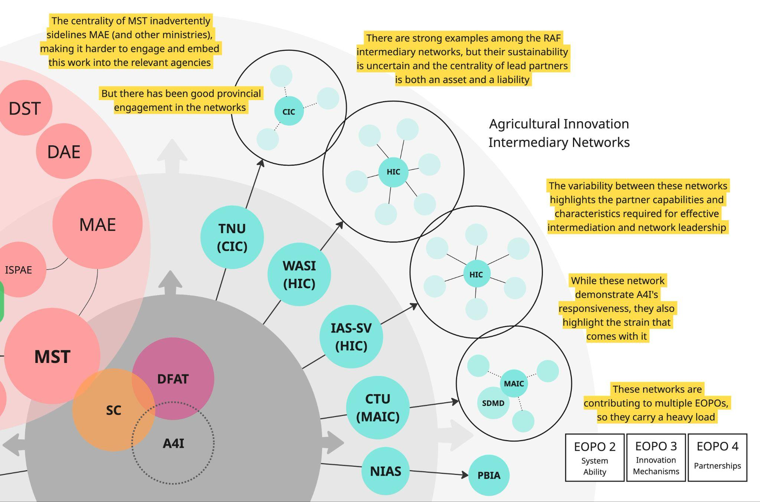
EOPO Four: Sustainable, mutually beneficial partnerships that strengthen Australia and Vietnam Innovation Systems
  - IO 4.1 Vietnamese innovation system actors access Australian science technology and innovation that is relevant and valuable

A4I efforts in relation to EOPO Four are primarily actioned through Program Element Four (Innovation Partnerships), though we note that the work of this program element is still relatively nascent and that the actual Innovation Partnerships budget line is only $200,000 - a fraction of the other work area budget lines. We also note that all other program elements contribute in some form to the broad concept of ‘innovation partnerships’ – notably the IPG program. Given this observation, the review team assessed this program element as cross-cutting, with each program element contributing to both the EOPO and IO of ‘Vietnamese innovation system actors access Australian science technology and innovation that is relevant and valuable’.
In terms of the budget line, there is an intention to establish an ‘A4I Alumni Network’, but this is still under development. There has also been discussion of an Australia-Vietnam Innovation Centre being established, but this has not progressed into action.
Under the policy program element, bilateral partnerships are being developed between key national agencies (e.g. CSIRO, NATEC and NASATI). The RAF networks are strengthening the connections between agricultural innovation systems in Vietnam and Australia through CSIRO expert engagement in the intermediary networks, while the IPG program element is built around partnerships between research institutions focused on innovation. That said, the sustainability and mutual benefit aspects of all these partnerships are less clear, so these issues will be further discussed in sections below. More generally it is noted that all A4I ‘partnerships’ benefit from the broader program effort in terms of access to sustained advisory relationships, repeated collaboration, joint research outputs, and senior-level policy access.
In Figure Eight (below) we highlight the different impact pathways for each program element. These highlight the various ways each is working with partners to contribute to the EOPOs. It also reflects on what has made each program element effective and raises the question of where program scope ends. These issues are further discussed in the sustainability section.

Broader issues relating to effectiveness
In this section we step back to review broader issues related to effectiveness that cut across the full spread of A4I program activities. We begin by reflecting on concerns about the breadth and coherence of activities, using the concept of ‘connective tissue’ to discuss links between program elements. Following this, we review what we see as the primary mechanisms of change being employed by the program: (1) responsive partnering to embed and institutionalise socially inclusive innovation, (2) multi-stakeholder coalitions to drive innovation, and (3) technical experiments to demonstrate innovation - all of which are augmented by the close relationship established between the A4I team and partners (which we regard as an important enabler of institutionalisation). These mechanisms are all central to the ‘spinning out’ concept described above, in which A4I works deliberately and systematically towards diffusion, embedding, institutionalisation and localisation. We then review efforts to integrate (Gender Equality Disability and Social Inclusion) GEDSI and climate into innovation decision-making, and efforts to localise program activities. Lastly, we reflect on the effectiveness of A4I program communications and return to the discussion of political economy dynamics, and the degree to which these have been factored in and/or leveraged program outcomes.

Developing ‘Connective Tissue’
The breadth of and coherence between A4I program elements and activities came up repeatedly through the MTR process, though views were mixed. At the top echelons of MST, A4I is viewed as having been “designed in a special way to influence the whole system [...] from top to bottom, through trial and error.” But for one DFAT staffer, the view was different: “There is so much activity, but what is the focus?” More commonly, key informants spoke of coherence as a work-in-progress: “Given the size and scope of A4I, it is hard to connect the elements.” Where there was more alignment in perspectives was on the potential for the A4I whole to be more than the sum of its parts, if clearer links can be established. During our MTR discussions, we began to conceptualise these links as ‘connective tissue’ between program elements that in some cases is already growing well, whereas in other cases, it is not yet discernible. While this context was widely acknowledged and being responded to by the Program team, the evidence of strategy to substantively develop these links is less clear.
Given the responsive and partnership-focused approach of A4I, the potential for linking is largely shaped by key partners. For example, the RAF agricultural innovation networks and the work with Institute of Strategy and Policy for Agriculture and Environment (ISPAE) on agricultural innovation systems is oddly disconnected, at least in part because of limited partner interest in linking these activities up. While the Innovation Partnership Grant (IPG) has become more closely linked with other program elements in Phase 2, it remains constrained to proven technologies developed by research institutions, so the potential for harnessing this program element to respond to the needs of others is limited by its structure. There are some examples of thematic alignment across the program elements (e.g. AI in policy, IPG and RAF networks), but these do not yet exist as clear-cut linkages. However, opportunities for linking are being explored through key partnerships and the Program Steering Committee (PSC), but is this work strategic and occurring proactively, or is it more reactive? Could closer links between program elements improve sustainability (and by extension, effectiveness) as the program winds down? It is noted that starting each project proposal is expected at commencement to outline how they can engage with other A4I projects, but this doesn’t seem to always follow-through in implementation. Clarity about this is important, and broader stakeholder alignment on it could be a powerful mobiliser.

Figure Eight: Program Element Four - Innovation Partnership (Cross-Program) Dynamics (See Annex 5 for written version.)
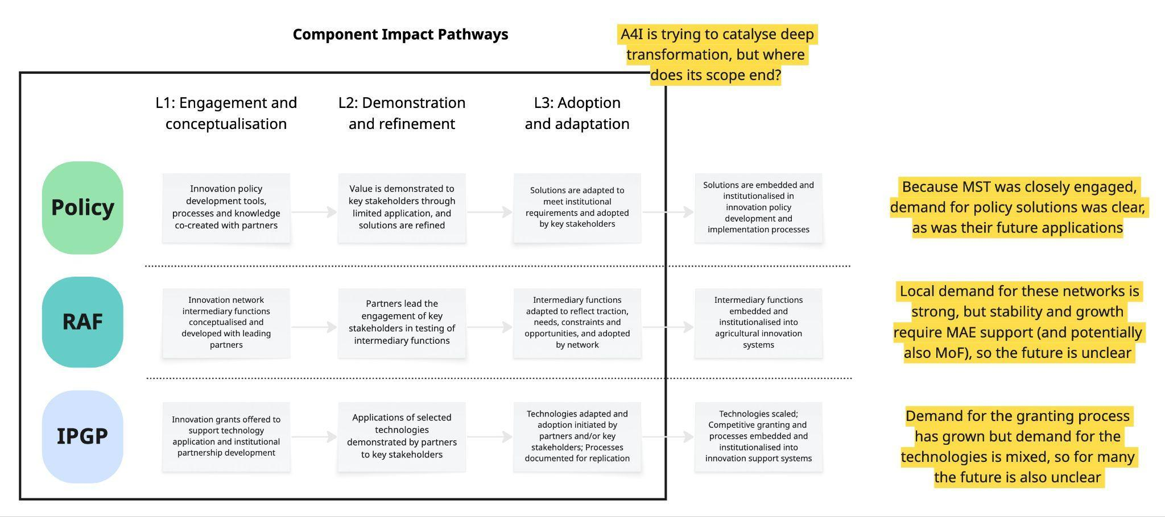
The notion of ‘interlinked EOPOs’ and program elements is understandable given the program approach, but how did this affect management and measurement? Was decision-making across program elements sufficiently adaptive and coordinated? Has A4I been strategic enough in carrying learning forward? A view from the A4I MEL team is illustrative: “A4I is designed as a portfolio-based, systems-oriented program. Strategic coherence does not necessarily require tight operational integration, particularly in a volatile institutional context.” There is a valid argument that coherence is reflected in the responsiveness of the program, but if this is the case then the contributions of each project and program element to the EOPOs would need to be dynamically tracked and fed into decision-making to keep the program on track. We return to this issue in sections 2.3 and 2.4.
As discussed above, securing additional or ongoing funding is a key issue for many of the projects initiated with partners under the IPG and RAF program elements of A4I. Strengthening the connective tissue, illustrating the potential gains from linkage, and increasing alignment on its value could all be hugely beneficial for these projects. As a senior GoV official noted, when reflecting on the challenges for A4I going forward: “I don’t think finance is the problem – linking is the problem.” This official went on to argue that ‘linking’ needs to expand outwards from program elements to both existing and new stakeholders, like sub-national government and private sector companies. Strengthening and expanding these links could be beneficial, but with A4I winding down, this work needs to be clear-sighted and agreed and anchored to partners or programs with more stability.

Mechanisms of Change
We see three primary mechanisms through which A4I is advancing socially inclusive innovation:
- responsive partnering
- multi-stakeholder coalitions, and
- technical experiments
While each mechanism is oriented towards diffusion and localisation, they work in different ways. Responsive partnering is focused on the (macro) shift towards more innovative approaches, so it targets partners who can influence innovation policy, processes and culture. Multi-stakeholder coalitions are focused on the (meso) intermediary structures that drive innovation, so it targets partners that can develop and lead such networks. Technical experiments are focused on (micro) demonstrations of technologies, providing concrete examples of innovation potential, and in some cases, they progress to adoption (such as the AQUAM System). Despite this variation, many partners involved in different program elements reported a similar benefit from their engagement - claiming that the values, culture and practices of innovation are growing in their organisations, and that efforts are being made for this to occur inclusively. While this is an important achievement, these broad indicators of ‘innovative culture’ are difficult to evaluate, attribute and quantify, and therefore unlikely to form a sufficiently tangible result in terms of DFAT expectations for the program. It is also noted that it is the nature of innovation programming that activities take time to achieve traction.
This growing culture of innovation suggests that some institutional and systemic change is taking place, and that there are different ways of working that highlight the changes underway. Examples cited by key A4I partners include:
- Ministries commissioning, reusing, applying and adapting analytical tools rather than treating them as one-off studies
- Institutions acting as innovation solution co-designers and implementers (i.e. in grant projects) and as innovation brokers and agenda-setters (i.e. in RAF activities) rather than project hosts
- Intermediaries increasingly shaping priorities and pathways, not just convening events
- Efforts to facilitate inclusion are increasingly authentic and based in enhancing effectiveness of an initiative rather than donor compliance
These examples align with the perspectives of senior MST officials who talked about growing levels of integration of A4I research, tools and even the A4I MEL system into ministry processes, though they also highlighted that these are very much works-in-progress rather than ‘concrete results’. Examples like these highlight the deeper transformation that A4I is supporting but also speak to the importance of broader engagement across the innovation landscape through ministries such as MAE.

Integrating Directionality and Socially Inclusive Innovation to enhance effectiveness
The concept of ‘directionality’ came into focus in Phase Two, as a way of integrating GEDSI and climate into the discussions and decision-making about innovation. Coming from the field of innovation studies, the concept emphasises that innovation does not reflect a single path but a set of possible directions. This brings into focus discussions about the costs and benefits of innovation, and associated options. While introducing the concept of directionality, the A4I team also developed a Socially Inclusive Innovation (SII) strategy to provide more explicit, normative guidance and a clear rationale to the concept. These two approaches reflect A4I’s considerable effort to better integrate GEDSI and climate factors, while also responding to different program element needs, but they also suggest some disconnection. Currently, key partners in RAF, Policy and Grants have all received training in SII in order to help strengthen the foundation of GEDSI work. Ongoing mentoring and support are being provided that is relevant to the workstream. Evidence of either approach being effective is limited and unfortunately the ongoing GoV restructure seems to be narrowing focus to a growth oriented resilient economy rather than prioritizing inclusion and sustainability, so prospects for more progress here may be limited. Further effort is needed here to explore the degree to which linkages exist in terms of growth and inclusivity.
While there are examples of GEDSI integration across the A4I program (see section 2.5), these reflect a more opportunistic and fragmented approach than a cohesive strategy. One A4I team member argues that this makes sense: “It is case-by-case, as it’s not the same with everyone or every issue. We’re trying to solve problems in the most appropriate way [...] but it is difficult to see how economic, social and environmental can go forward together.” The effectiveness of this approach is highlighted by the Innovation Policy Evaluation Framework (IPEF) work, which started as simply econometric analysis but now includes a checklist for innovation policy that brings into focus GEDSI factors. IPG Round 5 also demonstrates adaptation and effort to integrate directionality and SII, given its focus on tackling climate change challenges for inclusive development – further reinforcing the role of technology application in inclusive development, not only for economic purposes This approach has also surfaced tensions, as norms differ. Apparently, a push for GEDSI factors to be included in the RAI work met with an argument from a partner for “responsibility aligned to Vietnamese cultural values.” Clearly, this aspect of the work needs to be approached with nuance and sensitivity to these differences. As one A4I team member noted: “People are talking about environmental factors, but social inclusion is difficult; the focus is still very much on economic growth [...] so you have to frame it (inclusion) as an opportunity.”
While an opportunistic and responsive approach does not automatically ensure effectiveness, it can facilitate a valid pathway towards effectiveness. A4I’s better examples of GEDSI and climate integration reflect what is possible, but they also highlight the limitations of this approach. A more rigid training and compliance-oriented approach would have offered more defensible program metrics. A strength of A4I is that it is very much demand-driven, which creates challenges when pushing GEDSI in the absence of ‘demand’. The approach taken by A4I appears to be making some progress and has clearly started discussions about “a more holistic approach to innovation”. While there is some evidence of behavior change and increased demand, this is limited.

Working Towards Localisation
In all of the mechanisms used by A4I there is an orientation towards the diffusion of solutions and with this, opportunities to strengthen localisation. For example, the CPG was co-created with local partners to ensure it met their needs. The effectiveness of this approach can be seen in what happened next, as NATEC then used the CPG to structure and deliver a ToT program that continues to expand during phase two, without A4I involvement. Moreover, the CPG directly informed the new policy - one example of A4I TA informing new policy.
While growing the RAF networks, the team has also focused on building local partners capacity to take on network leadership. Though the context is very different, this has again proven effective. These examples prompted the MTR team to think about the common aspects to A4I’s localisation approach which brought the following into focus:
- the importance of a locally connected, culturally aware relationship manager
- ensuring relevance through a responsive approach focused on local demand and needs; and
- availability of a range of knowledge, exposure, tools and processes, from analytical frameworks to capacity building, expert guidance and even knowledge co-creation that empower localisation
The A4I program element leads were understandably proud of these successes, but also quick to emphasise the critical roles played by Vietnamese team members, with one senior CSIRO contributor observing that “there has been much better traction where there has been a Vietnamese lead [on policy work].” There was also recognition that “redirecting accountability from donor to local actors has been key” to the success of localisation efforts. For the RAF networks, this has involved nurturing different leadership and new ways of working, then demonstrating the value of a more responsive approach. The strong and diverse engagement in these networks attests to the success of these efforts, but localisation contributes to sustainability; it does not equate to it. This points to the crucial, ongoing work of embedding and institutionalisation needing to be done in the remaining time.

Strategic Communications and Public Diplomacy
Program communications were repeatedly noted to be a source of friction, particularly between the A4I team and DFAT staff. This is in spite of a Communications Strategy having been developed for Phase Two and receiving DFAT endorsement.
Given the systemic focus of the program, and the complexity of networks and policy activities, the story is not always easy to tell. While much of the value of the work lies in new processes, these changes are difficult to communicate in a compelling way. Because of this, the Grants have played an important role, providing clear stories with tangible outputs and locations. These examples of innovative technologies have also helped the program team and partners to illustrate the potential of innovation to broader GoV stakeholders.
However, these stories need to feed into a coherent approach that encompasses both strategic communications and public diplomacy, and most DFAT staff agreed that there is considerable room for improvement here in terms of moving beyond activity related communications towards more robust systems focused stories. These efforts could also benefit from making clearer links between program activities and outcomes. Given the significant challenge of carrying forward all of A4I’s learning, there is an acute need for clear understanding, strategic communication and strong engagement around pathways towards systemic change that best progress and capture the performance of A4I in promoting innovation in Vietnam.

The Political Economy of Transformation
A4I was designed around partnerships and responsiveness, enabling it to be opportunistic and to navigate shifting political economy dynamics. This has been crucial for many of A4I’s achievements, but this design also constrains the program. For example, the partnership with MST has been and will remain integral to the policy program element’s effectiveness, but it has inevitably sidelined MAE and other potentially important ministries, making the work of the RAF and IPG program elements harder. As the GoV restructure unfolds, key relationships formed with senior officials can shift from assets to liabilities, and new relationships will need to be made. While it is vital that the MST be protected and remain the central relationship, it is critical that stronger linkages into MAE be developed.
There is no easy solution, but this context does highlight the importance of A4I clearly understanding and monitoring shifts in the political economy, especially given the period of significant change that the program is navigating. This already occurs informally and with sophistication at higher levels but needs to also occur closer to the specific context of each activity. As the program approaches its final two years it will be important that high-quality, targeted PEA be undertaken in order to chart efficient and effective pathways towards specific systemic change that take into consideration other ministries, provincial dynamics and long-term sustainability risks. This is particularly the case in understanding the inner workings of MAE and points of leverage for A4I to strengthen this key relationship. Clear understanding of MST and the role expected to act as a driver of innovation within higher levels of government must also be clearly understood and navigated.

Implications for the remainder of Phase Two
The challenge for A4I across its remaining implementation period is to ensure that the firm foundations and relationships established can be leveraged into tangible systemic results by program end. Given that substantive programming needs to conclude within two years, there is a lot still needing to be done in a relatively short timeframe. This is especially the case for many of the Grants, with many still relatively new and limited in their ability to articulate their strategy moving forward.

Does the MEL and Reporting system collect sufficient and useful evidence, and is it capable of demonstrating progress towards the four EOPOs?

Monitoring, Evaluation and Learning (MEL) background and context
While the Phase One evaluation concluded that A4I had performed strongly at the level of activities, outputs, and partnerships - providing credible early outcome signals - it also noted that the MEL system was not suited to tracking or communicating progress towards system-level impact. These concerns stemmed from the orientation towards accountability and activity tracking, and insufficient focus on strategic learning and performance management. In response to these concerns, a revised MEL system was developed and finalised in late 2024 (18 months into Phase Two) following a 3-day Theory of Change (ToC) and performance framework and activity redesign workshop.
The A4I 2.0 MEL Strategy focuses on performance management aligned with EOPOs and Intermediate Outcomes and aims to embed strategies consistent with adaptive learning. Despite these efforts to address concerns, DFAT remains frustrated by A4I reporting, with multiple DFAT staff stating that it continues to place too much emphasis on activities and outputs and does not sufficiently capture the program’s ‘systemic change’ achievements. This makes it hard to discern pathways and progress towards EOPOs and the ‘systemic change’ being sought through the program. The revised ToC provides the program with direction and the ability to be flexible and responsive to a fluid operating landscape but offers limited granularity in terms of EOPOs and IOs.
This reflects different perspectives and a continuing lack of alignment between A4I and DFAT on what is needed in program reporting. Systems theory, for example, recognises the important role that a collection of strategic activities can play in establishing foundations and a roadmap towards systemic change. High activity density can build momentum, and the dynamics and interactions that surround a cluster of related activities can solidify key relationships and allow for pilots the test and present preconditions for institutionalisation.
While reporting tensions are not unusual with systemic change focus programs, it is crucial that differences are unpacked in order to arrive at a clear understanding of what constitutes suitable, high-quality reporting. While some efforts have been made here, enduring frustration about reporting makes it clear these have been insufficient. There are constraints in typical reporting processes to take into account (e.g. the bias towards quantifiable, visible changes, and the devaluing of more obscure, often deeper shifts), but these need to be navigated in a way that reflects the different views (and needs) of program stakeholders. Figure Nine below aims to simply highlight how different perceptions emerge around performance.
Figure Nine: The importance of shared understanding to clear MEL reporting (See Annex 5 for written version.)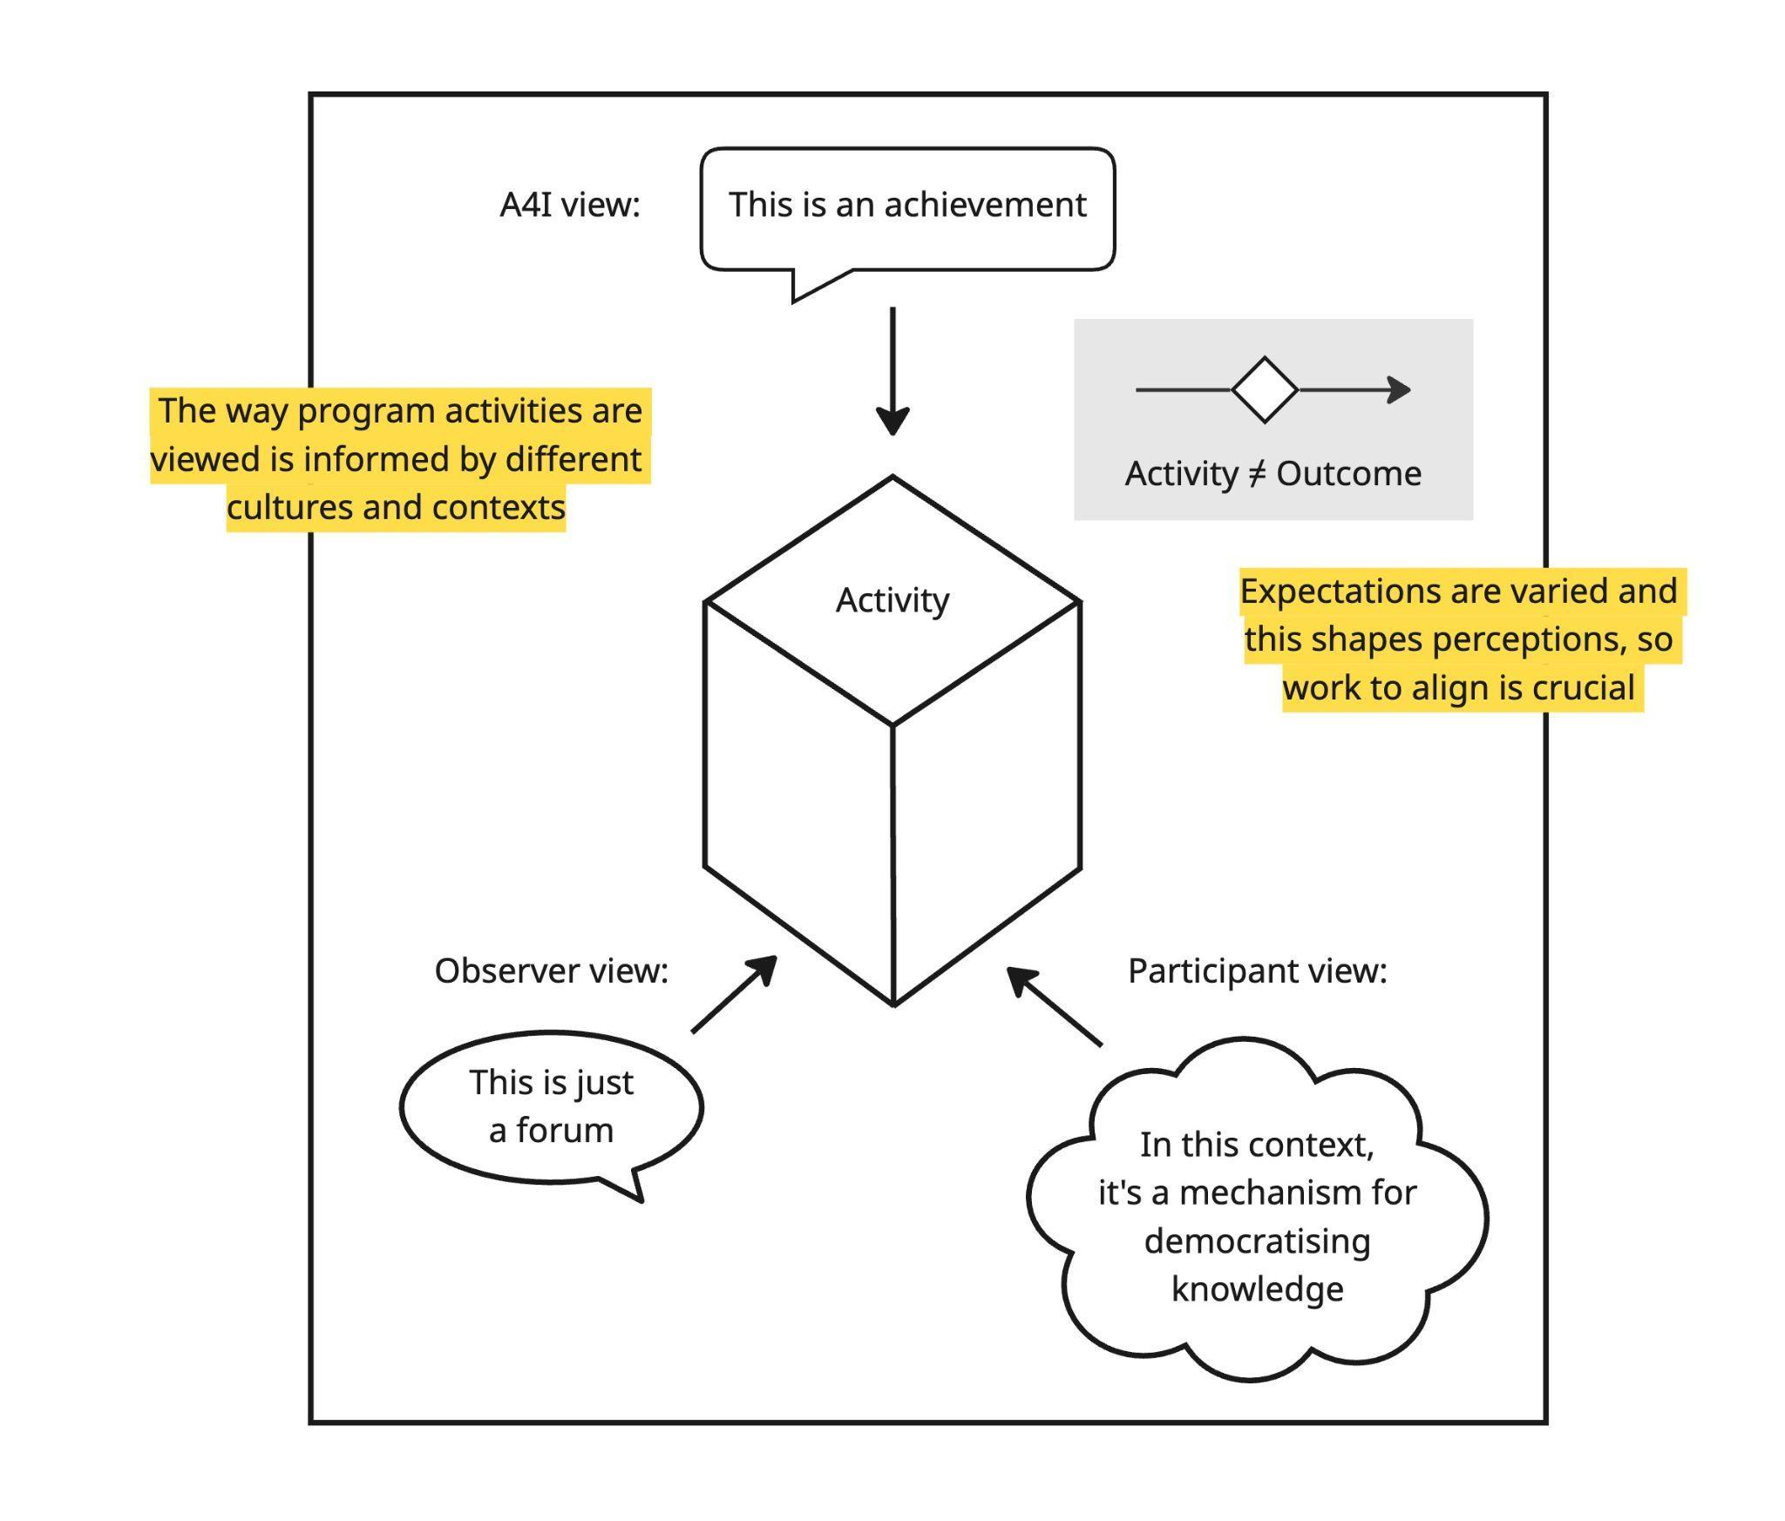
This issue is likely exacerbated by the fact that CSIRO is not a typical development partner, and also one that has its own performance management systems and culture – which don’t neatly harmonise with DFAT processes, systems and expectations. This results in a different relational dynamic than that of the contractor who see it as their responsibility to fully align with DFAT systems and requirements. On top of this, the ‘achievement narratives’ being used in A4I reporting to articulate pathways towards systemic change often read as a list of activities and outputs. This does not meet DFAT expectations of indicators for tracking scale, sustainability and/or resilience, which would provide evidence of whether or not A4I is shifting how systems function, beyond individual projects and relationships.

Suitability of the A4I Theory of Change
As highlighted above, there is a widely held sentiment that A4I is very much in ‘the right place at the right time’, and also that CSIRO is the ‘right partner’ and uniquely well suited in terms of supporting MST to respond to demands and expectations emerging from the passage of Resolutions 57 and 193. While this is mostly a positive dynamic for A4I, the reality is that the spotlight on innovation is increasing expectations. As pressure and expectations related to these resolutions spread across the GoV, MST and A4I are facing new opportunities and challenges. While there is potential to be more responsive and supportive to other ministries, their innovation efforts reflect an increasingly complex landscape.
Given these shifting sands, the MTR considered the ToC through two lenses: (1) as a roadmap for guiding program strategy and performance in the current dynamic context, and (2) as a framework for assessing progress and effectiveness.

Figure Ten: A4I Phase Two Theory of Change (See Annex 5 for written version.)
The program elements that shape the A4I ToC were determined in conjunction with MST, CSIRO and DFAT and each was designed to leverage the work of others – indicating strong local ownership of the approach. Considered holistically, it was felt that the four program elements were appropriate to strengthen the architecture of Vietnam’s system for national innovation, while also strengthening capacity within that system. As discussed above, the four program elements broadly line up with the agreed EOPOs, but not entirely, presenting an immediate disconnect given that A4I views the program through the lens of the program components, whereas DFAT is focused on progression towards an achievement of the EOPOs. It was further identified that the causal pathways of the ToC needed to be interlinked and mutually reinforcing if the potential of the four EOPOs was to be maximised. While this makes perfect sense, the simplicity of the ToC fails to bring that important need and dynamic to life.
While the ToC was prepared at a time when STI was already a priority, the profile given to innovation has increased significantly in the period since. The high-level and broadly defined ToC enables navigation of a shifting environment and responsiveness to emerging opportunities, but its broadly articulated EOPOs and Intermediate Outcomes provide limited granularity on tangible outcomes likely to emerge from the investment. The MEL framework addresses this to a certain extent but also lacks sufficient granularity to clearly measure A4I performance on the complex and shifting landscape that it operates.
The following section to consider each of the program elements of the ToC and the logic underpinning their flow through to the agreed EOPOs. The section also considers the appropriateness of the overall ToC to the current context. Findings were as follows:

Program Element: Innovation Policy Dialogue (primarily aligned in the ToC towards EOPO One - Enhanced capacity for institutional, policy and regulatory reform in targeted Ministries that enables inclusive innovation)
Given the current context, momentum and increasing emphasis being placed on the promotion of innovation across the ‘whole of government’, this work area has become even more relevant in Phase Two, given the value placed on it by MST and more broadly across government – including at the highest levels. Of note here is the high level of trust established by the A4I team through Phase One ‘policy dialogue’ efforts, as well as the close working relationships formed that have positioned A4I as a MST’s ‘partner of choice’. These relationships exist at the highest levels of MST and have positioned A4I to work very closely with MST as it works to respond to new expectations of its role in building the necessary architecture for innovation in Vietnam.
While this positions A4I to potentially make a highly significant contribution, the performance challenge for A4I will be the degree to which i/ targeted ministries actually adopt and institutionalise the policies, protocols and tools emerging through A4I dialogue (IO 1.1), and ii/ the degree to which these demonstrate policymakers’ enhanced understanding of and ability to apply ‘inclusive innovation’ (EOPO One). The MTR team assesses that potential for this outcome to be achieved is very much reliant on performance across the other three EOPO areas of work that is needed to carry policy to practice. Success will also require A4I achieving traction beyond MST, in terms of policy adoption, implementation and openness to cross-ministerial collaboration.
While facilitating access to an evidence base will be important in terms of policy evolution, the relevance of this work will inevitably be dictated by the degree to which A4I is able to effectively navigate the ‘politics of change’ and the complex relational dynamics that commonly (negatively) impact collaboration and cross-ministerial cooperation. This requires astute and sophisticated management, as well as an ability to interpret and rapidly respond to shifts in the political economy.

Program element: Innovation Funding and Finance (primarily aligned in the ToC towards EOPO Two - Improved ability of targeted innovation ecosystems in the selected sector to continuously respond to an evolving context)
Competitive grant rounds have the potential to demonstrate and model grant management mechanisms for adoption within Vietnam as the country aims to foster a culture of innovation. Individual grants provide ‘real world’ opportunities for application of the tools and platforms being modelled through A4I, while also progressing specific issues of relevance to the Vietnamese context and demonstrating the values of ‘inclusive innovation’.
Grants and innovation financing remain highly relevant to the EOPO Two ambition of strengthening targeted innovation ecosystems since they have dual systemic and substantive potential if managed optimally. However, the sustainability and impact of A4I provided funding and finance will be linked closely to EOPO One, given the importance of lessons learned being captured in strengthened policy performance and outcomes.
The major challenge here in terms of relevance is ensuring overall cohesion of the effort within each eco-system, since there is a need to progress systemic change while also ensuring value for money within each individual investment. Value for money in the instance of grants relates to both end results, but also the degree that the ‘grant story’ is understood and captured upstream in ways that influence systemic change. This dynamic is adequately captured in I.O. 2.1, which aims for ‘targeted ecosystem actors engaging with tools and platforms developed by A4I to enhance networks, generate ideas, address challenges, and increase resources for innovation’. However, program reporting has been less convincing in terms of demonstrating strategy and the necessary linkages for program funding and finance efforts to become embedded and demonstrative of systemic change.

Program element: Network of Innovation Actors (primarily aligned in the ToC to EOPO Three: Inclusive national and regional innovation support mechanisms connect people, ideas, investment and resources to respond to innovation opportunities and challenges)
Support for the development of inclusive, multi-stakeholder platforms remains acutely relevant given their potential to mobilise a diversity of expertise, perspectives and resources – including location and sector specific knowledge. Such mechanisms can both inform and benefit from the policy dialogue efforts of A4I. Conversely, they can be negatively impacted by the absence of a policy framework that legitimises network development and ensures pathways whereby localised, granular knowledge can inform policy development.
Relevance therefore depends upon upstream consolidation and institutionalisation of different networks in forms that allow them to share the knowledge and lessons learned that they assemble in forms that influence policy and results in decision-making that supports inclusive innovations being promoted at local level. It is also imperative that A4I focus determinedly on supporting MST to develop systems that allow it to work beyond its own corridors, strategically and proactively engaging across government, as per its mandate. This is important in terms of fostering a culture for innovation, but also in terms of supporting MST into the role that is now expected of it following the passage of Resolution 57. It’s noted here that the proposed Grant Playbook will present processes and case studies related to major issues impacting innovation that need to be addressed as enabling STI laws are established.
The MTR team assess that there are clear linkages in place that connect this program element to EOPO Three, given the dynamism of the targeted networks and also A4I’s contribution in terms of demonstrating and facilitating ‘mechanisms for connecting people, ideas, investments, and resources are developed to respond to innovation opportunities and challenges’ (I.O. 3.1). However, it will be important over the remaining period that work undertaken within the policy realm to help consolidate the results of network development.

Program element – Innovation Partnerships (aligned in the ToC to EOPO Four: Sustainable, mutually beneficial partnerships that strengthen Australia and Vietnam Innovation Systems)
While aligned in the ToC schematic to EOPO Four, the reality is that ‘innovation partnerships’ sit at the core of A4I and can be seen across all aspects of A4I work – and in relation to the pathway is developed for all four EOPOs. It is also clear that I.O. 4.1 – that Vietnamese innovation system actors access Australian science technology and innovation that is relevant and valuable – has been achieved.
Partnerships facilitated through A4I play multiple roles and make multiple contributions in terms of strengthening innovation systems and also promoting the concept of an innovation economy. Strengthening ties between Australian and Vietnamese innovation actors is of itself relevant in terms of progressing the bilateral relationship, but also in terms of allowing emerging Vietnamese innovators exposure to the processes and practices of leading (often world leading) research institutions.
While these partnerships help build capacity, model values of collaboration and deliver important advances around highly specific issues of importance to Vietnam, their relevance and ability to be institutionalised would be further enhanced by more clearly defined pathways being documented as the proposed roadmap towards a specific systemic change. More proactive management and engagement by A4I brainstorming such strategic pathways would both provide an important management tool but also help identify nuanced program support that could resolve challenges and enhance progress towards systemic change.
Intentionality and systemic change
The A4I program would benefit considerably from clearer definition of its systemic change ambitions, and better tracking of its pathways and progress. While flexibility is important in a complex and dynamic context, there still needs to be more alignment (and documentation) around enablers and processes of change, more tracking, and more connection between performance management and portfolio-based decision making. This absence is critical in terms of demonstrating the appropriateness of the ToC, since this documentation would provide ‘connective tissue’ of the intended strategy towards achieving systemic change.
While there has been value in the program’s breadth given the government’s ‘whole of government’ objectives for innovation, there is a need for the program to deliver tangible results by closure with ‘time’ now emerging as a risk. As the program enters its final two years, review and rationalisation of the overall program needs to occur in order to bring clear understanding, focus, strategy and sufficient resources to specific sectors/areas where it is felt that ‘innovation relevant’ systemic change can realistically be achieved by program close.

Benefits and Limitations of the Approach
As highlighted in Figure Eleven below, A4I is oriented around approaches informed by systems thinking. A challenge faced throughout implementation has been effectively translating this approach to DFAT’s MEL system where the program is obliged to demonstrate progress towards the EOPOs. While DFAT (and the development sector more broadly) is increasingly moving towards systems approaches, strategies are changing faster than reporting processes. It is also noted that CSIRO, as Australia’s national science agency significant experience of systemic change programming
Figure Eleven: The complex challenge of reporting on a complex system focused program (See Annex 5 for written version.)
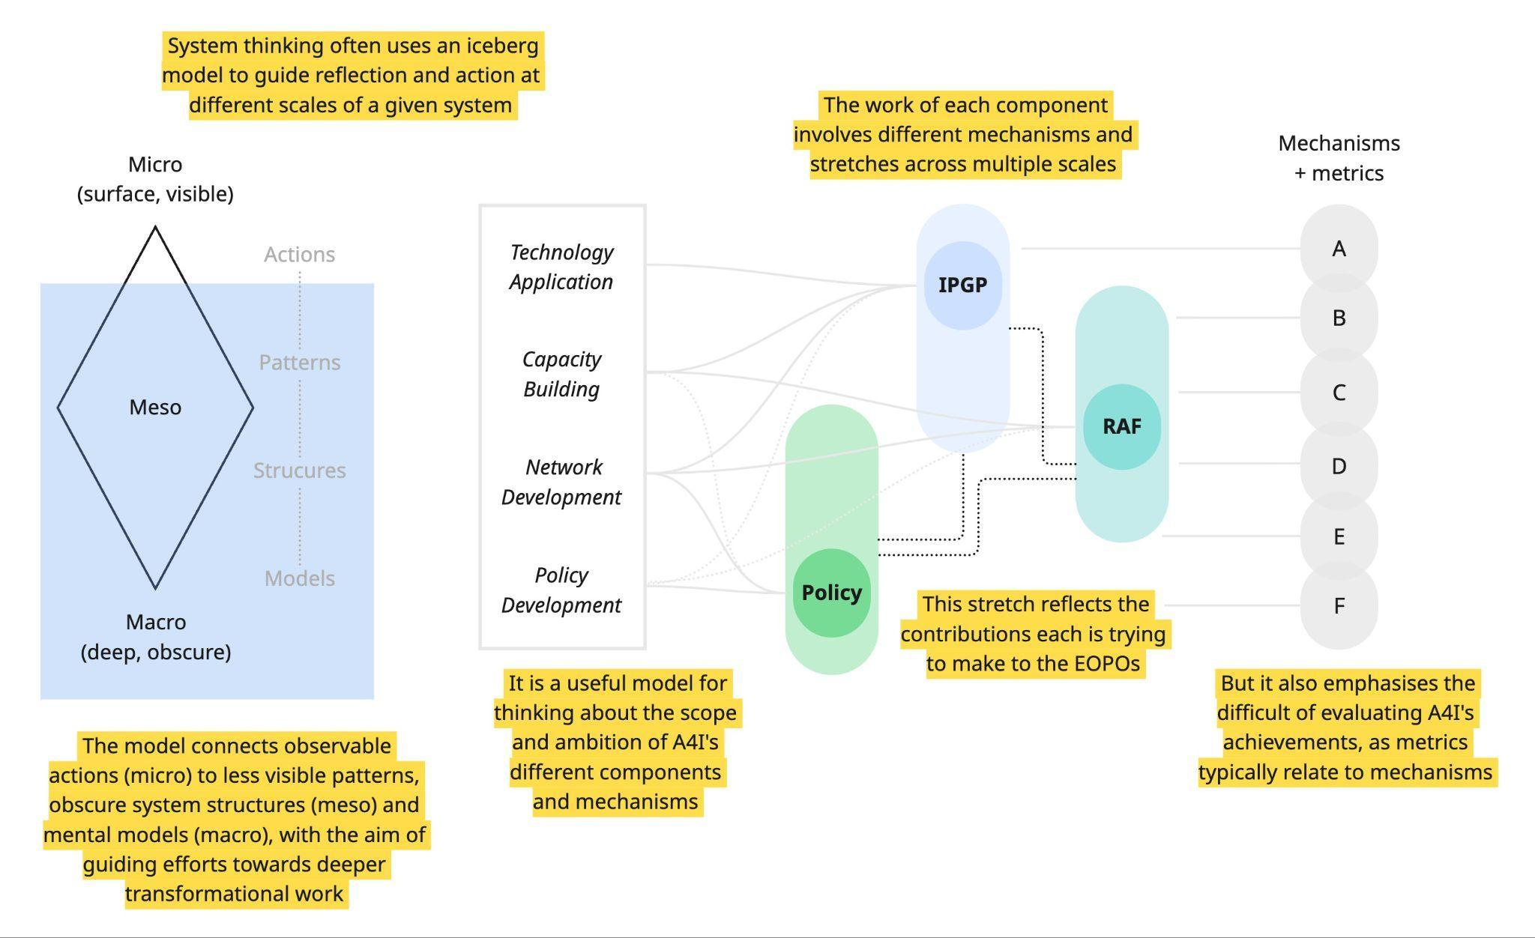
While it is non-negotiable that A4I responds to the requirements of DFAT M&E Standards, as they currently stand, reporting alignment would benefit from a mutual calibration of expectations around systemic influence and evidence of this. While reporting is acknowledged as presenting a complex challenge for a program such as A4I, it is important that the program team continue to engage the DFAT team at the Embassy in Hanoi to resolve ongoing concerns in relation to reporting quality and suitability to DFAT needs.

Opportunities for Improvement
While A4I’s broad architecture for MEL is in place, there is still a need to improve the evidence and narrative power of the reporting in order that future reporting more credibly captures A4I’s often high-quality systemic change efforts. Currently, reporting continues to place heavy emphasis on activities delivered, products produced and institutions engaged. While this information is relevant to system change, there remains significant room to better describe each different story of change. Options for reporting adaptations include
Restructuring the ‘achievement narrative’ section of report so that they more clearly focus on individual systems and their contribution to the four EOPOs, while also answering the following four questions in relation to ‘individual system change’ in the reporting period:
  - What has changed in how the system behaves?
  - Which system actors are now doing something differently, and why?
  - What new relationships, incentives, or norms are emerging within the system?
  - Why does the change described matter and how does it contribute to systemic change?
This approach could be augmented by a ‘System Change Summary’ section at the front of each report that identifies a limited number of ‘headline system shifts’ that highlight progress within each of the four EOPOs, as well as interaction between the EOPOs – noting that clear articulation of the reality of individual ‘systems’ advancing all four EOPOs appears to be a particular challenge given the need to report against individual EOPOs. Each ‘headline’ would succinctly describe what has changed, provide supporting evidence, and then detail why it matters. As much as possible, headlines should align with the relevant EOPO(s).
Recognise directionality as key - A related issue is that complex ‘systems’ focused programs such as A4I need to be understood as directional rather than binary, with change generally occurring in the form of milestones progressing along a pathway or continuum. Institutions, policies, and behaviors do not switch from “unchanged” to “changed” in a single step. Instead, they move gradually and unevenly along trajectories of improvement, consolidation, or sometimes regression. While there can be important learning even within the context of uneven progress, it is important that clear sighted strategy be in place that underpins directionality within each individual implementation context. Effective monitoring and reporting therefore needs to track movement over time — for example, from piloting to routine use, from donor-led to institution-led, or from informal practice to formal policy — rather than relying on yes/no indicators. The key question is not whether change has happened, but whether the system is moving in the desired direction, how far it has moved, and what is influencing that trajectory. i.e. change normally involves progression along a continuum towards a certain destination, not a ‘simple system has changed’ yes-no question.
A4I already aims to reflect this dynamic within the ‘Maturity Model’ used by A4I’s RAF team which aims to capture progression within individual systems development. While the review team sees this as a highly relevant reporting tool, we also feel that consideration could be given to further refining the ’Maturity Model’ through approaches such as:
- Collaborative efforts amongst system actors to disaggregate information emerging from the system in relation to barriers and progress to inform risks and areas of weakness that require additional focus or strategic adjustment. This could draw on the maturity model using “Change over time” boxes framed under each EOPO.
- Mapping anticipated/targeted results in the coming reporting period through the use of ‘light-touch' progress markers (a type of Outcome Mapping) that identify anticipated milestones and what A4I expects to see; would like to see or would love to see!
Introduce a system strengthening scorecard - A further option for strengthening reporting would be to introduce a simple 3-column ‘System Strengthening Scorecard’ for each EOPO that details:
- Scale – is the change spreading?
  - More provinces? More agencies? More budget? More buy-in? More sectors?
- Institutionalisation – what do we know about whether or not the change is sticking?
  - In policies? Standard Operating Procedures? Through budgets/financing? Evolving policies and mandates? Captured in job descriptions? Levels of participation?
- Resilience – is the System surviving shocks and leadership changes?
  - Have the desired outcomes been able to persist through restructuring, budget uncertainty, institutional uncertainty, staff turnover, etc.
Use contribution analysis methodology - There is also an option to utilise ‘contribution analysis methodology’ in order to more fully and granularly reflect A4I’s role as a ‘system influencer’. Such an approach would likely ensure evidence that A4I is viewed as more than just a simple ‘direct delivery’ agent. Instead of distilling performance down to a question of assessing whether or not ”A4I caused a policy change”, breaking down different A4I contributions to institutionalisation and embedding of systemic change efforts occur by considering the contribution of factors (outputs) such as:
- System mapping
- Generation of supporting evidence
- Support pain at building necessary capacity
- Coalition building and convening of system actors
- Financial and technical support for piloting and testing of models/tools
- Creating “political space” for innovation to take hold
- Communication and knowledge dissemination
It is also important to acknowledge smaller milestones. For example, early behavioural and relational shifts, even where not yet formalised in standard operating procedures (SOPs) or budgets, may represent meaningful movement in how a system functions and could be recognised as precursors to institutionalisation. Reporting could also be strengthened through further developing ‘Case Studies' as a tool able to holistically illustrate broader program performance and lessons learned through approaches that are more analytical than descriptive. These would allow ‘storytelling’ that brings detailed focus to the unique characteristics of a specific system, and A4I’s responsiveness to each unique context.
Different Case Studies could be structured uniformly through a structure that answers questions such as:
- What part of the system changed?
- Why was the system stuck before?
- What unlocked it (disaggregating A4I contributions from contributions of other system actors)?
- What is now possible that wasn’t before?
- Why is this durable or scalable? (or what is necessary to make it durable and scalable?)

Implications for the remainder of Phase Two
Reporting quality has been an ongoing tension across the course of A4I, due to difficulties related to clear reporting of program performance against EOPOs and IOs. Continued dialogue must occur between A4I and DFAT to identify agreed reporting approaches that respond to DFAT’s concerns. It is possible that reporting challenges will ease as the program culminates, and an evidence base is developed in relation to the program’s intended systemic results.

What has A4I done to enhance the sustainability of its actions?

General observations regarding sustainability
The mid-term review (MTR) is explicit that A4I is operating at an unusually favorable moment in Vietnam’s innovation reform trajectory, but that the breadth of the current portfolio creates a major risk that achievements will not be provided the critical mass of support required to embed results before program close. Sustainability will not occur automatically through ‘localisation’ or good partnerships, but will require deliberate, structured exit and handover planning that sets agreed targets and is tailored to different mechanisms and sectors. It is further noted that success and deliberation around sustainability should not be solely predicated on full institutionalisation at program close, given budget issues, the time required for the passage of new laws, and organisational issues that might need to be navigated.
This review frames sustainability across five interlinked dimensions that could form the organising structure for advancing sustainability over the final two years of work:
- Institutional sustainability - in terms of i/ clarity and acceptance around the Ministry of Science and Technology (MST’s) role as host ministry and driver for science, technology and innovation (STI) in Vietnam, and ii/ MST having the necessary vision, capacity, resources and structures to fulfil its role of driving innovation forward
- Financial sustainability - in terms of A4I facilitating an evidence base that promotes government willingness to invest and fund innovation through approaches such as i/ government co-funding, ii/ support to initiatives such as Commercialisation Plus, iii/ normalisation of private sector and university co-investment for innovation, and iv/ the emergence of national programs and instruments able to progress STI into the future (in place of donor funded programs)
- Policy and regulatory sustainability - in terms of national initiatives such as resolutions 57 and 193, but also more localised regulations that endorse and facilitate public-private collaboration and multi stakeholder platforms, encourage and incentivise universities to commercialise their Intellectual Property, and deliberate public procurement policies that advance a culture of innovation. Key to this will be the degree to which the Government of Vietnam (GoV) policy and regulatory framework is holistic and replicated at ministerial and provincial levels
- Market sustainability - in terms of more dynamic ‘innovation partnerships’ beginning to emerge that occur without specific subsidies, through i/ public agencies using innovation procurement, ii/ the private sector increasingly looking for technical solutions and being willing to pay for Research and Development (R&D), iii/ universities being increasingly able to commercialise their work, and more active application of multi stakeholder platforms
- Capability and network sustainability - in terms of an increasing cadre of Vietnamese innovation specialists committed to utilising multi stakeholder platforms to promote innovation
In summary, sustainability should be measured by a central strategic shift from key stakeholders “demonstrating innovation” to a context of “locking in the conditions for innovation to persist without A4I.”

What can be done in the remaining time of the program to enhance the sustainability of its actions?
Move from a Portfolio approach towards a “managed exit and embedding plan”
The review is clear that there is no single sustainability pathway for A4I’s different mechanisms (policy dialogue, networks, grants, partnerships, financing instruments). Therefore, in the next 6–9 months A4I should require each major workstream, network, and mechanism to develop a ‘handover, embedding and closure plan’ that identifies Vietnamese institutional owners, works with broader network actors and collaborates with the aim of securing a financing and mandate pathway (or an explicit exit decision). Even with two years to go, this needs to be treated with some urgency and same as a core management process, not an add-on.
Rebalance the Portfolio Towards Fewer, Deeper Bets
The MTR identified risks associated with spread and responsiveness potentially undermining sustainability and efficiency. Risk will heighten as pressure builds across the final two years to demonstrate tangible results from the program. A recommendation of the program is that a process be undertaken with the aim of identifying activity areas that are unlikely to achieve meaningful/relevant results by the end of 2027. Such a review would contribute to a situation whereby the program is able to focus over the remaining implementation period on:
  - Initiatives and networks that are genuinely scalable and ‘institutionalisable’
  - Strategic policy platforms that are likely to be adopted
  - Grant pathways that have a credible route to replication or absorption
Such an approach will require A4I to be prepared to stop, merge, downgrade or close activities that cannot be concluded in a form that leaves them with a realistic chance of becoming embedded by program end (or soon after). Refining the number of focus areas will enhance the program’s capacity to strategically advocate for resourcing and investment in those areas that are perceived as critical to consolidating Vietnam’s innovation architecture.
Bring focus to the required institutional architecture - roles, mandates, ownership
A key finding of the review relates to the opportunities presented by MST’s system-shaping mandate and role as the critical anchor for long-term sustainability, while also noting political economy factors, capacity and historical challenges related to cross-ministerial coordination as risks that A4I can support MST to navigate. Recognising these related risks, A4I needs to adjust (with nuance) its posture from “partner” to “capability builder and handover enabler”, by working to support the embedding of tools, processes and policy frameworks inside MST and key agencies. This will require A4I to systematically broaden its engagement to include the Ministry of Agriculture and Innovation (MAE) and Ministry of Finance (MoF), given the need for network financing, budget integration and co-financing mechanisms, as well as facilitating cross-ministerial collaboration in relation to enabling Resolutions 57 and 193. It is noted that MoF engagement would need to occur in closest collaboration with the Embassy.
As discussed above, every major work area of A4I should aim to develop and document a formal adoption pathway (decision, circular, guideline, or regulation), including the identification and assigning of a Vietnamese institutional custodian. It will also be important that A4I (and the Australian Embassy in Vietnam more generally) reinforce at every opportunity that without domestic financing mechanisms, it is likely that efforts to ensure the sustainability of A4I will fail. This is a sensitive argument to push, but critically important. It is also noted that the GoV has already committed to increasing its budget for R&D from 0.5% to 3% in coming years.
Network and Platform Sustainability
Multi-stakeholder networks are among A4I’s strongest achievements. However, sustainability pathways are still unclear and fragile both in terms of their institutional status and how they will be resourced and financed moving forward.
All A4I networks have a story to tell allowing for comparative analysis to determine key success factors and also approaches that have proven less successful. By differentiating approaches across the network portfolio, priority can be given to Horticulture Innovation Club (HIC) and Coffee Innovation Cluster (CIC) type platforms which already enjoy strong traction, while also informing steps necessary to strengthen (or conclude) less dynamic and/or relevant platforms such as the Mekong Aquaculture Innovation Cluster (MAIC).
For each priority network, efforts should be taken to assess their ‘status under law’ (legal form), their financing model, capacity of the hosting institution and linkages that do or do not exist in relation to their capacity to affect policy processes. This data could then be documented into a “network facilitation methodology” that could be used for engagement of MST/MAE to inform policy, but also in aid of scaling.
Policy and Regulatory Sustainability: Shifting from Dialogue to Policy and Procedures
A key finding of the MTR is that A4I must now begin to pivot its focus from dialogue and activities to utilising lessons learned in support of institutionalisation. Put another way, focus needs to more explicitly shift towards turning pilots into rules, guidelines, and budgeted programs – while noting that this is ambitious and should not be the sole indicator of performance. Central to this should be leveraging and highlighting alignment with Resolutions 57 and 193 with a focus on embedding innovation practice across government through mediums such as Innovation Financing structures, Innovation Procurement approaches, Commercialisation frameworks, and Public–private collaboration mechanisms (including co-financing programs alongside other Development Partners).
While the above might seem ambitious, the MTR assesses that A4I is well placed to affect mechanisms for policy change given senior GoV officials repeatedly referred to Australia as their ‘partner of choice for innovation’, citing the long-term focus of A4I and historical bilateral programs like those offering scholarships.

Looking beyond A4I
As noted throughout this report, the GoV is explicit in its direction that the adoption and consolidation of an innovation culture in Vietnam will require a whole of government effort, cutting across all ministries and provinces, and requiring input from all levels of government. Given this context, opportunities exist for establishing more substantial links between A4I and other DFAT programming, notably ACIAR and Aus4Growth which are both active on the innovation landscape. In particular, Aus4Growth has a remit to work broadly across different ministries and has a specific mandate to work in the digital transformation space. While it is not structured to do the research and evidence gathering that has been a feature of A4I, it is well placed (in terms of approach, capacity and resourcing) to utilise and carry forward already gathered (and proven) research towards a policy outcome. If there is interest in dovetailing A4I and Aus4Growth in ways that draw on Aus4Growth as a vehicle for carrying forward and sustaining the work of A4I beyond its conclusion, this would need to be decided sooner than later given it would affect how A4I goes about its final two years. However, an important caveat here is whether or not a Managing Contractor can effectively ‘replace’ CSIRO, given CSIRO’s status as a world class, government funded research organisation.
Irrespective, there remains an important role and demand for CSIRO to continue its work in Vietnam post A4I given its status, credibility and the important levels of trust that have emerged between it and MST. This is based in large part on the G2G nature of the relationship, and the ease with which CSIRO is able to quickly access the highly nuanced expertise sought by MST as it reshapes itself post Resolution 57 and 193.

Implications for the remainder of Phase Two
As outlined in above, the program has a busy two years ahead as it works to bed down its work to date. Each activity is going to require a unique approach towards tailored institutionalisation that helps ensure the sustainability of A4I efforts. Development of sustainability pathways must sit at the centre of planning for the remaining two years, and will require deft, nuanced leadership, strategy and work planning.

Is the investment coherent and making an efficient use of Australia's resources to achieve the expected outputs and outcomes?

Overall assessment of efficiency
This section aims to assess the efficiency and value for money of the A4I investment, with a particular focus on whether the program’s design, operating model and resource allocation are coherent and represent an efficient use of relatively limited resources given the scope and ambition of the program.
At the time of the review, the program’s flexible, responsive and relationship-driven model has generated exceptional access, trust and policy influence. However, this same model is relatively expensive, stretching a small in-country team across many fronts. This has weakened portfolio discipline and impacts the program’s capacity to convert progress to clearly institutionalised and durable results.
To date, efficiency has been strongest in high-leverage system-shaping work (notably in policy dialogue, frameworks, and agenda-setting). It has been weaker in portfolio management, particularly in relation to grants and geographically and thematically dispersed initiatives where pathways to adoption, scaling or institutionalisation are uncertain.
The Review concludes that whether A4I ultimately represents strong value for money will depend less on what it initiates, and more on what it successfully embeds, hands over, and locks into the Vietnamese system over the remaining two years. This will then quantify whether the program represents an efficient use of resources.

Setting the context for assessing efficiency
While not a ‘pure’ Government to Government (G2G) initiative, A4I has many G2G characteristics and is viewed (internally and externally) as ‘different’ to more traditional development programming. However, while not a traditional development partner, CSIRO is often treated as one and is (appropriately) expected to meet the same standards for management, safeguarding, reporting etc. that ‘standard’ development partners must meet. However, there are situations where CSIRO is not fully integrated within DFAT’s broader development effort in Vietnam. This sets it apart from the broader suite of DFAT investments in Vietnam and likely contributes to a situation whereby linkages with other relevant DFAT investments such as Aus4Growth, the Partnership for Infrastructure (P4I) and GREAT (Gender Responsive Equitable Agriculture and Tourism) are not optimally leveraged. A contributing factor to some of these challenges is that the A4I Program Director also holds the status of Counsellor in the Embassy which presents a significantly different management scenario to oversight and engagement of a managing contractor. While all parties bring goodwill to managing this tension, these nuanced differences create challenges in relation to monitoring and evaluation, confusion around reporting lines, communications and the potential to establish synergies between A4I and these are programs which also maintain commitment to innovation. As A4I approaches its conclusion, it will be important that continued efforts are made to ensure A4I is able to both contribute to and be supported by other programs in the DFAT Vietnam portfolio – especially if it is felt that other programs could support the sustainability of A4I outcomes.
The above is more observation than criticism. DFAT has identified CSIRO as a uniquely appropriate partner for MST at this moment in time. In many respects, the A4I program and CSIRO-MST partnership can be viewed as a modelling the evolution of the Australia- Vietnam bilateral relationship, as well as laying the foundations for the bilateral relationship moving beyond traditional development programming, towards the context of sustained, mutually beneficial government-to-government (G2G) partnerships. These ambitions harmonise well with the Comprehensive Strategic Partnership (CSP) which envisions more mature partnerships moving forward that bring benefit to both countries.
It is also noted that the number of development partners active in Vietnam is shrinking, in large part due to the country’s impressive economic growth but also related to shrinking development partner budgets. As Vietnam moves towards becoming a high-income economy, this is altering the nature of development partnerships towards relationships that are more equitable and reciprocal. In this sense, the CSIRO-MST partnership offers insight regarding the future of Australian-Vietnam bilateral relations, which brings value in its own right.

How well is A4I aligned and coherent with other Australian and Vietnamese government initiatives in innovation, agriculture, and digital transformation?
As mentioned above, an important review finding was the universal perspective that A4I is exceptionally well aligned with the GoV’s strategic direction, particularly following the adoption of Resolution 57 and Resolution 193. A4I operates near the centre of an unusually dynamic and politically salient reform environment. The adoption of the two resolutions, combined with major machinery-of-government restructuring, has elevated STI and digital transformation to the centre of Vietnam’s development strategy. In this context, the Review consistently heard A4I described by senior counterparts as being “in the right place at the right time”, with Australia widely seen as a “partner of choice” for innovation policy and system reform. This is a highly significant and valuable achievement and should not be undervalued. The program is also strongly aligned with Australia’s broader bilateral objectives under the Comprehensive Strategic Partnership, particularly the shift towards more mature, G2G knowledge partnerships as the bilateral relationship transitions away from traditional aid modalities.
However, alignment with national policy runs the risk of undermining coherence, given a very broad engagement footprint (sectoral and geographic), limited in-country resources and the challenges posed by a transformational reform agenda that has generated high demand for A4I services. An example of this risk can be seen in the agriculture space where alignment with MAE remains significantly weaker than with MST, despite the priority given to agriculture in the Phase Two redesign. While it is understandable that relations with MST are stronger given their role as the program’s major partner, this context contributes to a context whereby the translation of provincial-level innovation experience and lessons learned into national policy and institutional frameworks remains underdeveloped. This can be rectified but highlights the challenges that emerge when a program is spread thin.
On the Australian side, connections with other DFAT investments (e.g. Aus4Growth, ACIAR, GREAT, P4I, the Australian Department of Agriculture, Forestry and Fisheries (DAFF) exist but are not optimally leveraged as part of a structured and explicit Australian Agriculture portfolio strategy, limiting coherence and efficiency at the whole-of-portfolio level.

How efficient has the operating model and approach been?
A4I’s operating model was variously described as ‘deliberately flexible’, ’responsive’, ‘adaptive’ and ‘relationship-driven’, and that these approaches have been central to its success in building trust, access and influence with senior Vietnamese counterparts. This approach is widely valued by partners and has enabled A4I to respond rapidly to emerging priorities such as commercialisation reform, ‘Responsible AI’ and biosecurity (African Swine Fever). It has also given the program a very high profile with it reported that the program offering is understood in detail at the highest levels of government.
However, the model is inherently resource-intensive, requiring continuous adaptation to a fast-changing political and institutional environment, and subsequent time needing to be invested in relationship management. In effect, A4I has been operating in a “high relevance, high transaction cost” mode. This has been appropriate during a volatile reform period, but it is questionable whether this is the most efficient mode for delivering and locking in a meaningful list of durable systemic changes.
As suggested above, the breadth of engagement and high profile established by A4I might contribute to it delivering extraordinary results over its remaining two years. However, it is the assessment of the Review team that it will be important over the next six-month period to rationalise the program footprint by selectively backing those pathways assessed as most likely to lead to institutionalisation of reforms.

Are resources distributed optimally?
Actual program expenditure aligns closely with the budget at the time of the Phase Two redesign, suggesting that resource allocation continues to be framed around the historical program logic rather than a hard-nosed assessment of marginal impact and institutionalisation potential.

Figure Twelve: Project budget by program element (See Annex 5 for written version.)
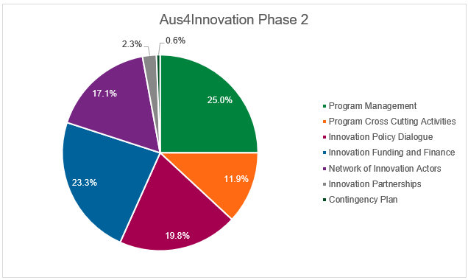
Grants have absorbed approximately 20% of total Phase Two resources when management and support costs are included. This investment has delivered value in terms of demonstration of transparent, merit-based grant processes to government, modelling of collaborative, international innovation partnerships, while also unearthing some promising technology applications. However, the Review finds that the cost-effectiveness of the IPG portfolio is mixed, given that:
- Outcomes are uneven across projects
- Many grants lack clear adoption, scaling or embedding pathways
- Several projects remain at demonstration stage with uncertain futures
- The program is understaffed and management allocation needs to be enhanced if there are expectations of a systemic return emerging from Grants
While the Innovation Partnership Grants (IPG) has strong symbolic and demonstration value, in terms of modelling and facilitating partnerships, it is an expensive instrument for achieving system-level change unless individual grants are much more deliberately structured around downstream adoption and institutional uptake.
The RAF intermediary networks appear to offer stronger system-building returns per dollar, but faces underinvestment in terms of institutional anchoring, financing models, and pathways to policy uptake.
The policy and system-shaping work such as the Commercialisation Plus Guidelines (CPG), Responsible Artificial Intelligence (RAI), the Innovation Policy Evaluation Framework (IPEF) and Grant Playbook) has likely delivered the highest leverage impact relative to cost but remains highly dependent on relationships and networks rather than institutional mandates.
Notably, program management costs (essentially the Hanoi based Program team) account for 25% of program expenditure, yet such is the spread of effort of A4I that the Review assesses the program to be understaffed for management of a portfolio of this breadth.

Has A4I coordinated effectively with other development partners and programs?
Coordination with likeminded partners exists but appears to be more ad hoc and opportunity-driven than deliberate and strategic targeting of potential collaborators and co-financiers. As discussed above, the program has some connection with Aus4Growth, ACIAR, DAFF and other DFAT investments, but opportunity exists for deeper collaboration towards what can easily be envisaged as a ‘win-win’ situation contributing to enhanced performance of Australia’s overall development portfolio. The current situation reduces overall system efficiency and limits Australia’s ability to draw on its different ‘assets’, while also restricting options for A4I to hand off mature initiatives to other, better suited instruments.
The Review also identifies a need for a line of communication to be established with the Ministry of Finance in relation to the ‘higher level knowledge being generated through the program, and the importance of finance being available to progress, embed and institutionalise matured initiatives. While this should be led by respective ministries, there is a role to be played by A4I in terms of backstopping such engagement. There is also a role for the broader Australian Embassy to support A4I through existing relationships that they hold with MoF.
Overall, the Review finds that A4I is not yet sufficiently engaged with the broader network of innovation-interested actors in Vietnam and regionally, as well as those involved in specific activities where there is close alignment between A4I and other development actors’ interests, such as ‘carbon farming’ which has broad interest from a diverse range of entities. The benefits of stronger coordination would potentially:
- Allow A4I to focus more on upstream system design and piloting,
- Allow other programs to take on scaling, mainstreaming or policy rollout roles,
- Improve sustainability and reduce duplication or fragmentation.
This is particularly important given Vietnam’s transition away from traditional Overseas Development Assistance and towards hybrid, multi-actor innovation financing and delivery models.
However, coordination requires the investment of time and resources and as noted above these are in short supply within A4I given the program team in Hanoi is spread quite thin. Network development and outreach therefore need to be targeted and purposeful to avoid it becoming a burden to help ensure that efforts strengthen the overall program.

Implications for the remainder of Phase Two
A repeated concern expressed throughout this review is that while A4I has established a wide cross-section of important partnerships and laid very firm foundations for innovation relevant reform and systemic change, it has left itself a hefty workload for the remaining program period if it is to fulsomely achieve its EOPOs and IOs. The program team is small and fully stretched. It will therefore be very important but A4I considers its overall portfolio and opportunities for rationalisation as it enters its final two years. Such a process would provide multiple benefits in terms of clarifying specific needs of specific systems and also informing how best to optimum distribute resources in the remaining period.
Without clarity around what can realistically be achieved by program closure, there is an acute risk of program resources being spread too thinly across too broad a spread of activities and subsequently impacting the potential to progress ‘best bets’.

How has A4I advanced social inclusion innovation, especially gender equality and disability equity?

Context of inclusion activities
Gender Equality Disability and Social Inclusion (GEDSI) is a core priority for DFAT-funded investments and is expected to be reflected not only in participation metrics but in the quality of innovation processes and the distribution of innovation benefits. DFAT’s GEDSI Good Practice Note frames GEDSI analysis as the foundation for preventing unintended harm and exclusion, and for promoting rights, equitable opportunities and benefits for socially disadvantaged groups. DFAT’s gender strategy likewise adopts a “twin-track” approach - aiming to mainstream gender equality across investments while also supporting targeted actions where needed. In this context, A4I’s relevance and performance on GEDSI is best assessed through two lenses:
- whether GEDSI is being mainstreamed through program rules, incentives and institutional practices; and
- whether there is credible evidence of substantive change in agency, leadership and access to innovation benefits.

To what extent is A4I progressing inclusion through its approach and activities?
Gender equality: from compliance to practice change
Overall, the MTR finds that gender equality integration is moving beyond compliance in parts of the portfolio but remains highly dependent on facilitation capacity and has not yet been institutionalised consistently across all delivery modalities. The evidence base indicates that Phase Two has moved beyond “checkbox” gender requirements in several parts of the program, particularly where A4I has worked through capacity building, conditionality in grant selection, and adaptive implementation.
The program’s socially inclusive innovation (SII) framing explicitly positions inclusion as a dimension of innovation quality and impact - linking diverse participation and knowledge to improved innovation design and uptake. This is important because it aligns GEDSI with A4I’s core innovation purpose, rather than treating it as an external reporting requirement. The SII maturity scale is helpful in providing structure to GEDSI related engagement and efforts.
A4I has embedded gender considerations into delivery pathways in at least three ways:
- Policy dialogue and system influence: A4I’s policy work now treats inclusion as a decision criterion rather than an afterthought. Notably, the Innovation Policy Evaluation Framework approach includes social inclusion as a criterion in regulatory assessment, and national dialogue activities have included diverse stakeholders.
- Grants (Innovation Funding & Finance): The SII Strategy notes that GEDSI and environmental impact were used as criteria for selection, that a local GEDSI specialist now forms part of the Grant selection process (with CSIRO, DFAT and Government), and that SII/Responsible Innovation training has been delivered to grant recipients. While female leadership at team lead level remains variable, Round 4 reporting suggests women constitute around 30% of Grant team members, with women taking some program element lead roles, and nearly 40% of pilot users being female in at least one project stream.
- Innovation networks and clusters (Resilience and Agriculture Foods): Inclusion has been operationalised through diagnostic work and targeted capacity building. For example, the MAIC explicitly included SII training, value chain and gender training, situational assessments, identification of women’s needs, and training tailored to women’s priorities (e.g., marketing, e-commerce, processing). The cluster’s reported shift from under 10% to almost 40% female participation on an online platform provides early evidence of changes in access and engagement, not just attendance.
These elements indicate A4I is helping shift gender equality from “who attends” to “who shapes, decides and benefits.” However, performance is still uneven across clusters and grants, with gender results strongest where there are capable conveners and intentional facilitation, and weaker where inclusion is treated primarily as disaggregated reporting. This pattern is consistent with DFAT’s view that gender equality requires both mainstreaming and targeted practice change.
Disability inclusion: credible intent, practical innovations, but structural constraints on identification and measurement
A4I’s Phase Two approach to disability inclusion aligns well with DFAT’s disability-inclusive development commitment, which treats disability inclusion as a core feature of development effectiveness and equity. Program documentation indicates disability has been incorporated in multiple ways: partnerships with DPOs in cluster work, disability emphasis within Responsible AI initiatives, and a practical focus on assistive functions in digital tools. At the same time, there have been persistent implementation constraints that are not fully within A4I’s control. Round 4 reporting notes under-reporting and low disclosure of disability status, compounded by certification requirements and administrative burden that can discourage self-identification, which in turn limits the reliability of disability-disaggregated data. The Washington Group Short Set of questions would be a good entry-point to have a look at identification and functional capacity questions.
This is a known challenge in many contexts, and it implies that absence of reported PWD participation cannot be treated as absence of need. The stronger practice therefore appears to be where A4I and partners work through disabled peoples organisation (DPO) relationships, accessible design features, and co-design/user testing - approaches that are consistent with DFAT expectations on practical inclusion.
Social inclusion and Socially Inclusive Innovation: a coherent framework that strengthens GEDSI, but requires stronger consolidation of evidence at program level
A4I’s Socially Inclusive Innovation (SII) framework provides a coherent bridge between GEDSI and the innovation system lens. It defines SII as enabling women, people with a disability (PWD), youth and marginal groups to engage in knowledge generation and decision-making across the innovation system - not just as end users, but as researchers, business operators and policy makers. The accompanying SII Guide translates this into a structured set of principles covering context analysis, bias reduction, inclusive test cases, equitable access to benefits, and learning-oriented MEL.
From an evaluation standpoint, this is a strength: it means GEDSI is not an “add-on,” but part of how innovation quality is defined and pursued. The key remaining challenge is less about the absence of frameworks, and more about evidence synthesis and consistency. A4I is generating strong examples (e.g., Mekong cluster learning, assistive features, engagement shifts), but program-level reporting to more routinely distinguishes between:
- participation (who is present),
- influence/agency (who shapes decisions and design), and
- benefit distribution (who gains, and whether exclusion risks were mitigated).
Such an approach would more closely align A4I with DFAT’s GEDSI framing, which emphasises preventing harm and ensuring equitable opportunity and benefit.

To what extent is A4I contributing to the embedding of inclusive innovation principles into institutional and policy legacies?
A4I has dedicated time and resources to strengthening its performance in relation to inclusive innovation principles in Phase Two and is working to lay the foundations for these to become part of Vietnam’s institutional and policy architecture—particularly through policy tools, evaluative frameworks, and strengthened decision-making norms. However, inclusive innovation principles are not yet fully embedded as system defaults, with the current status best characterised as “emerging and credible, but not consolidated”, with clear potential to deepen if current tools are institutionalised through formal policy, funding, and regulatory mechanisms.
There have been important achievements in terms of A4I influencing how innovation policy is designed, assessed, and revised. This is most readily seen in the IPEF, which includes a regulatory checklist that incorporates social inclusion criteria and has been piloted during sectoral policy reviews and the revision of innovation relevant laws. There are also signs of the IPEF becoming embedded in ongoing use by the government, which will be key to its potential as an enduring policy legacy.
While some uptake of inclusion principles is evident, most are currently only embedded through soft instruments (guidelines, checklists, evaluative frameworks) rather than codified mandates, meaning durability depends on continued institutional adoption. This is another example of A4I progressing along a maturity continuum towards institutionalisation, highlighting that while good work is being done, there remains further to go in terms of bedding down inclusion within innovation related policy. This is aided by the five-level maturity model of the SII Strategy, which provides a shared institutional language for inclusion and a pathway from individual actions to organisational practice.
It is important to note that there was diverse evidence at the time of the MTR of A4I contributing to shifting institutional awareness and practice around inclusive innovation, with a broad cross-section of interviewees articulate in describing their enhanced capacity (personal and organisational) to generate and use evidence on GEDSI within innovation policy and programming. This leaves A4I well positioned, but with a lot to do in the remaining two years. As is commonly the case, disability inclusion is proving more challenging than gender inclusion with slower progress related to difficulties with ensuring disability responsiveness in approaches. Currently, disability inclusion remains project-specific, with systemic barriers (certification, institutional readiness, data availability) and resistance limiting broader institutional uptake.
Case Study: Hòa Đê Cooperative: Gender-first inclusion and assistive technology piloting
Hòa Đê Cooperative provides various insights as to how Aus4Innovation’s GEDSI agenda can contribute to substantive change in both innovation design and benefit distribution at community level. Through the Mekong Aquaculture Innovation Cluster, Can Tho University worked with the cooperative and local disability organisations to undertake value-chain and inclusion diagnostics examining who contributes labour, who occupies technical roles, and who influences production and investment decisions. This analysis highlighted that women were central to day-to-day operations yet under-represented in technical functions and leadership positions.
In response, CTU-supported training and cooperative-strengthening activities were redesigned to enable women to take on more technical tasks, build skills in marketing and digital sales channels, and diversify household incomes through value-added processing rather than being stranded selling raw product. These gender-responsive adjustments have helped strengthen women’s agency within the cooperative and reshaped how innovation priorities were set.
Disability inclusion was deliberately integrated into the same innovation process rather than treated as a parallel activity. A deaf cooperative member assumed a supervisory role in fish-processing teams and reported improved income stability and recognition from peers. At the same time, CTU researchers and students piloted an AI-enabled sign-language and speech-to-text application to support communication during training sessions and daily operations. This experimentation with assistive technology illustrates how digital innovation can reduce participation barriers while generating learning for replication across other cooperatives and value chains.
In short, the Hoa Đê case illustrates the type of GEDSI-responsive innovation that A4I is seeking to catalyse across its portfolio, highlights the importance of codifying such practice so that results do not depend disproportionately on a small number of high-capacity partners. However, Hoa Đê sits as a relatively isolated example of innovation with a multi-faceted GEDSI focus. It is also an isolated activity that builds off the legacy of more than ten years support to this cooperative by Oxfam, making replication difficult. Scaling of the AI-enabled tech initiative might yet be possible, but at the time of the review there was little clarity about how this potentially very important innovation would be carried forward or scaled.

Implications for the remainder of Phase Two
A4I is well-positioned to deepen GEDSI results given it has already embedded inclusion in grants criteria, cluster methods and policy dialogue tools. The next step is to consolidate learning from leading cases (such as Hoa Đê Cooperative and the Mekong cluster) into clearer program-wide expectations and comparable evidence, to ensure GEDSI performance does not depend disproportionately on a small number of highly capable convenors.
Overall, the MTR finds that A4I Phase Two has established a credible and increasingly sophisticated GEDSI architecture, combining conditionality in funding, inclusive cluster methodologies, policy dialogue tools and a structured SII framework. This positioning remains highly relevant to DFAT priorities and to Vietnam’s evolving STI reform agenda, particularly as innovation policy and digital transformation pilots expand under new national resolutions. At the same time, the uneven depth of GEDSI outcomes across the portfolio suggests that effectiveness in the remainder of Phase Two will depend on A4I’s ability to consolidate learning from leading cases, strengthen program-level synthesis through MEL, and institutionalise inclusive practice across grants, networks and policy engagements. How well A4I translates promising GEDSI pilots into durable system-level influence will therefore be a key consideration in assessing the program’s continuing relevance and effectiveness going forward.

What benefits (intended or otherwise) does the program generate for the bilateral relationship between Australia and Vietnam?
The mid-term review (MTR) assesses that A4I generates substantial and multi-layered benefits for the Australia–Vietnam bilateral relationship that extend well beyond conventional development cooperation. While strengthening Vietnam’s innovation system is the program’s primary objective, A4I has also functioned as a strategic instrument for deepening trust, positioning Australia as a long-term innovation partner, while also being a significant contributor to the “Supporting STI and Developing Digital Transformation” pillar of the Comprehensive Strategic Partnership (CSP).
Supporting the transition to a more mature bilateral partnership
A4I has facilitated relevant, trust based, working-level relationships between Australian institutions – most notably CSIRO and DFAT – and Vietnamese counterparts, particularly MST. The program’s adaptive and responsive operating model has enabled Australia to engage credibly with Vietnam during what is an extraordinary period of reform. A4I’s ability to respond to that context has positioned Australia as a “go-to” partner for policy dialogue on STI and digital transformation, contributing to Australia’s reputation as a trusted, technically capable and politically neutral partner
A4I is also insightful in terms of the evolution of the Australia–Vietnam relationship away from traditional aid modalities towards a more reciprocal, capability-based partnership. A4I is a different type of development program, and as Vietnam approaches high-income status and the number of traditional development partners declines, the CSIRO – MST partnership model demonstrates a future-oriented approach grounded in mutual learning, co-design and shared strategic interests. This aligns closely with the CSP’s ambition to deepen cooperation in STI and digital transformation, and positions Australia strategically as Vietnam enters its next phase of economic transformation.
Through sustained policy engagement and technical contributions to development of frameworks such as the Commercialisation Plus Guidelines (CPG) and Responsible Artificial Intelligence (RAI), and innovation policy evaluation tools, A4I has enabled Australian expertise and values to inform Vietnam’s emerging innovation policy architecture. These contributions have had demonstrable downstream influence on national legislation and regulatory reform. In the case of A4I, this influence is exercised through trust-based, collaborative engagement, contributing to perceptions of Australia as a respectful, reliable and effective partner and collaborator, rather than an externally driven reform actor.
Strengthening institutional and people-to-people linkages
A4I is also working as a vehicle for the expansion and diversification of institutional linkages between Australian and Vietnamese research organisations, universities, innovation agencies and private sector actors. Innovation Partnership Grants, policy dialogues, and innovation networks have all fostered durable professional relationships that will in many cases extend beyond the life of individual projects. These linkages will contribute to longer-term people-to-people connections, create pathways for future collaboration in priority sectors such as agriculture, digital technologies and climate resilience, and position Australia to more deeply engage with Vietnam’s innovation ecosystem as it emerges.
Demonstrating Australia’s value in a contested regional landscape
In a context of intensifying regional competition for influence in Southeast Asia, A4I provides Australia with a distinctive value proposition. By combining high-quality technical expertise, flexibility, and a systems-level understanding of innovation reform, the program differentiates Australia from both traditional donors and more transactional partners. This enhances Australia’s strategic relevance in Vietnam and supports broader Indo-Pacific objectives by reinforcing norms around responsible innovation, inclusivity and evidence-based policymaking.
Collectively, these bilateral dividends represent an important - if sometimes under-articulated - return on Australia’s investment, with A4I providing value that extends beyond its program-level development outcomes and into the strategic, institutional and relational foundations of the Australia–Vietnam partnership.

Annex One: Key Review Questions and Sub-Questions
1. To what extent are A4I’s objectives and delivery approach relevant to Vietnam’s evolving Science, Technology and Innovation (STI) priorities and the Australian Department of Foreign Affairs and Trade (DFAT’s) development cooperation goals?
a. To what extent do A4I’s objectives and delivery remain relevant to Vietnam’s evolving STI priorities and strategy?
b. To what extent does A4I align with and contribute to DFAT’s Country Strategy Partnership for Vietnam (2025-2030)?
2. Is the A4I Program making progress towards its Intermediate Outcomes and End of Program Outcomes (EOPOs), including higher-level or catalytic impact on policy eco-systems?
a. To what extent has A4I been effective in enhancing capacity for institutional, policy and regulatory reform in targeted Ministries that enables inclusive innovation?
b. To what extent have A4I-supported interventions been effective in improving the ability of targeted innovation ecosystems to respond and adapt to an evolving context?
c. To what extent have A4I-supported interventions been effective in supporting mechanisms to connect people, ideas, investment and resources to respond to innovation opportunities and challenges?
d. What evidence exists of A4I’s contribution to broader systemic change or influence on Vietnam’s innovation policy and practice?
e. To what extent are A4I’s outcomes locally led?
f. To what extent are A4I’s actions responsive to the challenges and emerging opportunities (such as AI, Climate Change, and recent innovation imperatives arising from Ministerial restructuring) that key actors face in the Vietnamese innovation system?
g. What lessons can be drawn from A4I’s performance that can be applied to improve the A4I program in the remaining time?
h. Have there been unintended consequences of the program – positive or negative?
3. Does the Monitoring, Evaluation and Learning (MEL) and Reporting system collect sufficient and useful evidence, and is it capable of demonstrating progress towards the four EOPOs?
a. Is the current reporting system suitable to clear articulation of A4I results?
b. How has the MEL system evolved to address changing needs of decision makers and program stakeholders?
c. To what extent does A4I’s learning approach facilitate adaptive management and inform future program design?
d. To what degree is the current theory of change sufficient in terms of articulating a roadmap for achievement of EOPOs?
e. To what extent does A4I’s MEL system meet the needs of program management and external stakeholders?
f. To what degree is the overall MEL strategy aligned to DFAT’s Monitoring and Evaluation standards?
g. Are A4I systems sufficient in terms of proactively managing and mitigating program risks (child protection, preventing sexual harassment, fraud, corruption), including political risks?
4. What has A4I done to enhance the sustainability of its actions?
a. What can be done in the remaining time of the program to enhance the sustainability of its actions?
b. How are sustainability strategies being applied and adapted based on insights and lessons learnt?
c. How is A4I contributing to changes to relevant policies, regulations, institutional arrangements and/or individual capacity outside of targeted Ministries, such as Innovation and Partnership Grants (IPG) and Resilience and Agriculture Foods (RAF) partners?
d. Does demand exist for further Australian support for STI in Vietnam?
5. Is the investment coherent and making an efficient use of Australia's resources to achieve the expected outputs and outcomes?
a. How efficient has the operating model and approach been? To what extent does the program represent value for money?
b. To what degree is the allocation of resources, including financial and human resources, in alignment with and supportive of EOPOs?
c. How has the program’s adaptive planning approach enabled the efficient use of program resources?
d. How well is A4I aligned and coherent with other Australian and Vietnamese government initiatives in innovation, agriculture, and digital transformation?
e. How effectively has A4I coordinated with/complemented investments by other development partners and programs including?
6. How has A4I advanced social inclusion innovation, especially gender equality and disability equity?
a. To what extent is A4I progressing inclusion through its approach and activities?
b. To what extent is A4I contributing to the embedding of inclusive innovation principles into institutional and policy legacies?
c. Does A4I collect and actively use disaggregated data in developing its strategy and reporting on program performance?
d. How has A4I approached meaningfully involving people with disabilities and/or organisations in activities (including, where applicable, resourcing disability-related activities and providing reasonable accommodations)?
e. To what extent is A4I progressing social inclusion in terms of facilitating opportunities for ethnic minority participation in programming?
f. How is the program capturing and sharing lessons on the emerging practice of socially inclusive innovation?
g. What barriers and constraints exist to further progressing inclusion in A4I’s work (gender equality, disability equity and social inclusion)?
7. What benefits (intended or otherwise) does the program generate for the bilateral relationship between Australia and Vietnam?
a. How does A4I contribute to the Australia-Vietnam Comprehensive Strategic Partnership?

Annex Two: Stakeholder and Activity Mapping
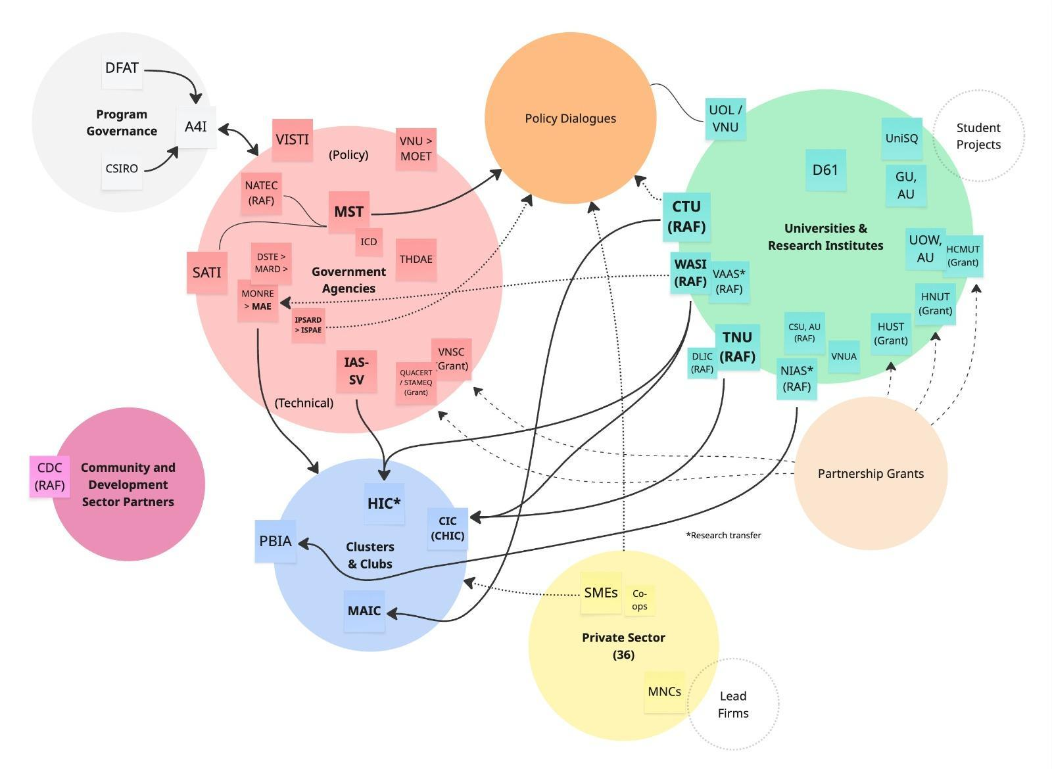

Annex Three: People consulted through MTR process
# | Name | Organisation | Role
1 | Kim Wimbush | A4I | Program Director
2 | Nguyễn Thị Hoàng Hà | A4I | Deputy Program Director
3 | Mai Thu Hà | A4I | Corporate Manager
4 | Thao Nguyen | A4I | Grants Manager
5 | Ngoc Vu | A4I | Project Officer
6 | Mai Vu | A4I | RAF Partnership Manager
7 | Andy Hall | A4I | Policy Team Leader
8 | Hien Pham | A4I | Policy Senior Researcher
9 | Thang Chu | A4I | Policy Coordinator
10 | Jennifer Kelly | A4I | RAF Team Leader
11 | Michaela Cosjin | A4I | RAF and GEDSI Advisor
12 | Minh Nguyen | A4I | RAF Senior Researcher
13 | Matt Smith | A4I | MEL Advisor
14 | Viên Kim Cương | A4I | National MEL Advisor
15 | Larelle McMillan | CSIRO | Agriculture and Food Research Director
16 | Thanh Tam Nguyen | Griffith University | Grant - Certification & Traceability
17 | Renee Deschamp | Australian Department of Foreign Affairs and Trade (DFAT) | Deputy Head of Mission (and Steering Committee member)
18 | Naomi Cook | DFAT | Counsellor
19 | Trần Phương | (DFAT) In charge of A4I program | A4I Program Manager
20 | Madeleine Plocki | DFAT | Second Secretary
21 | Nguyễn Tuấn Anh | QUACERT | Deputy Director
22 | Prof. Dr. Bui The Duy | Ministry of Science and Technology (MST) | Vice Minister
23 | Ly Hoang Tung | MST | Director General – Artificial Intelligence
24 | Nguyen Thi Hai Xuan | STAMEQ (Commission for Standards, Metrology and Quality of Vietnam) | Program Officer
25 | Dr Tran Cong Thang | Institute of Strategy and Policy for Agriculture and Environment (IPSAE) | Director General
26 | Dr Truong Thi Thu Trang | IPSAE | Deputy Director General
27 | Ms. Thảo | Association of People with a Disability | Vice Rector of Association
28 | Ngô Xuân Chính | CART | Director
29 | Mr. Mạnh | CART | Staff Member
30 | Ms. Uyên | CMU Logistics Company | Company Manager
31 | Prof Tran Ngoc Hai, | Can Tho University (CTU) | Vice Rector for Science, Technology and Innovation
32 | Prof. Nguyễn Hữu Trung | CTU | Vice Director
33 | Dr Truong Minh Thai, | CTU | Dean of Software Engineering
34 | Anonymous | CTU, Faculty of Software technology, GEDSI team | Lecturer, Team member
35 | Ms. Lê | CTU, GEDSI team | Lecturer, Team member
36 | Prof. Hải | CTU, School of Technology | Lecturer
37 | Lý Hoàng Tùng | Department of Science and Technology | Deputy Director
38 | Ms. Hân | Horticulture Innovation Cluster (HIC) | Active supporter
39 | Ms. Quyên | HIC | Active supporter
40 | Mã Văn Hồng | Hòa Đê Cooperative | Manager
41 | Ms. Nhung | Hòa Đê Cooperative | Cooperative member (Person with disabilities)
42 | Ms. Ly | Hòa Đê Cooperative | Cooperative member
43 | Ms. Nhân | Hòa Đê Cooperative | Cooperative female member
44 | Ms Nguyen Thi Kim Nga | Soc Trang School of Children with Disability | Teacher
45 | Prof. Nguyễn Phi Lê | Hanoi University of Science and Technology (HUST), Institute for AI Innovation and Societal Impact | Director
46 | Dr. Lê Thị Ánh | HUST, School of Chemistry and Life Science | Lecturer
47 | Nguyễn Công Thắng | National Agency for Science and Technology Information (NASATI) | Director General
48 | Nguyen Duc Hoang | NASATI | Head of International Cooperation
49 | Phạm Đức Nghiêm | National Agency for Technology Entrepreneurship and Commercialization Development | Deputy Director
50 | Phan Thị Thu Hiền | Post-Import Plant Quarantine Center 2 | Director
51 | Mr Le Van Vuong | Vuong Thanh Cong Company | Deputy Director
52 | Nguyễn Thanh Tâm | School of Information and Communications Tecnology, Griffin University | Researcher
53 | Prof. Trần Ngọc Hải | Sustainable Development of the Mekong Delta | Vice Director
54 | Nie Pot Henry | Ede Cafe (Coffee Company)
55 | Tống Thị Lan Chi | Tay Nguyen University (TNU), Department of Science, Partnership and Innovation | Deputy Director
56 | Ass.Professor, PhD Lê Đức Niêm | TNU | Vice Rector
57 | Nguyễn Thị Quế Anh | University of Law, Vieynam National University (VNU) | Former Rector
58 | Thảo | University of Law, VNU | Lecturer
59 | Đào Thế Anh | Vietnam Academy of Agriculture Science | Former Vice President
60 | Nguyễn Phúc | Vietnam Fruit and Vegetable Association | Secretary-General
61 | Ms. Huế | Vinatinti Group | Representative of the Group
62 | Lâm Đạo Nguyên | Vietnam National Space Center (VNSC) | Director
63 | Pham Thi Thao Nhi | VNSC | Researcher
64 | Dr. Phan Việt Hà | Western Highlands Agriculture and Forestry Science Institute | Deputy Director
65 | Dr. Vu Van Nhan | Bach Mai Hospital | Deputy Director of the Bach Mai Institute of Medical and Pharmaceutical Training and Research

Annex Four: Summary of Resolutions 57 and 193

Resolution 57-NQ/TW 57-NQ/TW
In December 2024, systems and structures for promoting innovation as a whole of government responsibility were significantly advanced when the Communist Party Central Committee adopted what is commonly referred to as ‘Resolution 57’. This set a national strategic direction for transforming Vietnam’s development model by prioritising science, technology, innovation and digital transformation as core drivers of economic growth, governance, and competitiveness. ^{[1]}
A core purpose of Resolution 57 is to provide a roadmap for shifting Vietnam’s growth model away from reliance on inputs such as labour, capital and natural resources towards one based on productivity improvements, knowledge, and technology-led competitiveness. This is intended to occur through embedding innovation and digital technologies across government, business and society, while strengthening Vietnam’s capacity in strategic technologies (such as data, AI, and digital infrastructure). The Resolution aims to lift innovation capacity, support growth, and underpin Vietnam’s 2045 ambitions. Importantly, the Prime Minister has been a prominent advocate for translating this political decision into action across the state and society. This has included repeated calls for ‘vigorous, systematic implementation of Resolution 57’, emphasising the need for coordinated action across ministries, localities and sectors. ^{[2]}
Resolution 57 has made science, technology, innovation and digital transformation central to the national development strategy. Every ministry, sector and province is now required to demonstrate integration of this agenda into their strategies. While this further elevates the relevance of an innovation focused program such as A4I, it also presents challenges, as the Resolution aims to shift ‘innovation’ to an approach that every ministry is responsible for (not just MST). This is broadening the demand for innovation support but also complicating the operating environment. For now, MST is still looked to as the ‘knowledge centre’ for innovation and is expected to play a critical coordinating role in the national innovation system and in shaping innovation policy.
The implications for A4I are significant – MST now has a mandate to set incentives, rules and structures for innovation. This offers the potential to shape how research and development is funded; how research institutions and universities are operated and funded; how intellectual property, technology transfer and commercialisation rules are set; and most importantly, how national priorities are determined. As MST grows and shifts to respond to this mandate, these new demands and ways of working.

Resolution 193/2025/QH15
In parallel with the strategic repositioning articulated in Resolution 57, the National Assembly adopted Resolution 193, which provides an operational and regulatory vehicle for accelerating innovation and digital transformation through time-bound pilot mechanisms and targeted fiscal incentives. Whereas Resolution 57 establishes a whole-of-government strategic mandate, Resolution 193 translates this ambition into concrete instruments, including new approaches to Research and Development (R&D) financing, commercialisation of research outputs, risk-tolerant experimentation, special procurement arrangements for digital projects, and state co-investment in strategic technologies.
A central feature of Resolution 193 is the creation of regulatory and financial space for experimentation. It authorises pilot mechanisms for enterprise spin-offs from public research, acceptance of research risk, and new commercialisation pathways, alongside fast-tracked public procurement for national digital platforms and administrative systems. It also introduces major infrastructure interventions, including subsidies for accelerated 5G roll-out, incentives for new international submarine cable systems, controlled piloting of low-earth-orbit satellite services, and substantial public co-financing for Vietnam’s first specialised semiconductor fabrication facility. Collectively, these provisions signal a shift towards a more interventionist and market-shaping state role in innovation policy, particularly in frontier technologies and digital infrastructure.
For A4I, Resolution 193 significantly reshapes the operating environment. The Resolution creates new policy laboratories in precisely the domains that A4I seeks to influence through its innovation policy dialogue, grants and partnerships - namely innovation finance, regulatory reform, public-private collaboration, digital platforms and emerging technology ecosystems. This strengthens the relevance of A4I’s engagement with national counterparts, particularly in supporting learning from pilots, providing international comparative experience from Australia, and contributing to the design of safeguards, evaluation frameworks and scaling strategies for new mechanisms.
At the same time, Resolution 193 introduces a more complex institutional landscape for A4I to navigate. The proliferation of pilot schemes, special financing windows and infrastructure initiatives across multiple ministries and provinces risks increasing fragmentation, coordination demands and competition for reform leadership - particularly in the context of ministerial mergers and provincial restructuring described above. For A4I, this heightens the importance of its system-level focus: convening actors across government, supporting coherence between experimentation and longer-term reform, and ensuring that mechanisms are informed by principles of inclusivity, sustainability and responsible digital transformation.
Taken together, Resolutions 57 and 193 create an unusually dynamic reform moment for Vietnam’s innovation system. While Resolution 57 anchors the political mandate, Resolution 193 establishes the instruments through which change is being tested. The extent to which A4I is positioned to engage with, inform and learn from these pilots - and to support their translation into durable institutional reforms - will therefore be a critical dimension of the program’s continuing relevance during the remainder of Phase Two.

^{[1]} Party Central Committee of the Communist Party of Vietnam. (2024, December 22). Resolution No. 57-NQ/TW on breakthroughs in the development of science, technology, innovation, and national digital transformation. See https://xaydungchinhsach.chinhphu.vn/toan-van-nghi-quyet-ve-dot-pha-phat-trien-khoa-hoc-cong-nghe-doi-moi-sang-tao-va-chuyen-doi-so-quoc-gia-119241224180048642.htm
^{[2]} Vietnam Law Magazine. (2025, March 18). PM orders translation of Resolution No. 57 into reality with tangible results. Vietnam Law Magazine. See https://vietnamlawmagazine.vn/pm-orders-translation-of-resolution-no57-into-reality-with-tangible-results-73781.html

Annex Five: Alternate text for A4I report diagrams
Alt text for Figure One: A4I progression from commencement to conclusion
Horizontal three-stage process diagram showing A4I's progression over time, left to right, with dotted vertical dividers between stages.
- Stage 1 — "Exploring and Understanding (Phase 1)" — the leftmost box.
- Stage 2 — "Testing and Refining (Phase 2)" — the middle box, with an arrow extending rightward into the third stage.
- Stage 3 — "Embedding and Institutionalising" — the rightmost box, the arrow pointing into it indicating ongoing movement.
A highlighted caption beneath the diagram reads that across Phase 2, A4I needs to progress two important but different activities, with final results largely dictated by performance over the next two years in embedding and institutionalising innovation-focused reforms.
Alt text for Figure Two: EOPO and IO interaction with Program elements
Layered diagram linking the four End of Program Outcomes (EOPOs) and Intermediate Outcomes (IOs) to the four program elements.
- Top row — four EOPO boxes left to right: EOPO 1 Capacity for reform, EOPO 2 Ability to respond, EOPO 3 Support mechanisms, EOPO 4 Sustainable partnerships.
- Second row — IO boxes sitting under their respective EOPOs: "Tools and protocols developed" and "Frameworks and guidelines applied" (under EOPO 1), "Engagement with tools and platforms" (under EOPO 2), "Mechanisms developed" (under EOPO 3), and "STI transferred between partners" (under EOPO 4).
- Lower section — four nested, coloured rounded panels representing program elements and showing their alignment with the EOPOs and IOs above:
  - Innovation Policy Dialogue (green, listing key components: CPG, IPEF, RAI) aligned primarily with EOPO 1 but also partially with EOPO 2;
  - Innovation Funding and Finance (blue, listing key components IPGP, Playbook) aligned primarily with EOPO 3;
  - Network of Innovation Actors (teal, listing RAF networks: MAIC, CIC, HICs, PBIA) aligned primarily with EOPO 2; and
  - Innovation Partnerships (light purple, wraps around the other elements) which each program element contributes to, and aligns with EOPO 4.
The layout conveys that the program elements broadly map to the EOPOs and IOs above them, while overlapping to show interaction.
Alt text for Figure Three: A4I conceptual framework
Concentric-circles ("spinning out") diagram showing how A4I solutions diffuse outward through four levels (L0-L3), with arrows radiating from the centre.
- Centre (L0) — a solid dark circle labelled "L0": A4I works with MST and the Steering Committee (SC) to identify, validate and prioritise opportunities.
- L1 — Key partners are engaged to conceptualise potential solutions, with capacity building.
- L2 — Broader stakeholders are engaged, mainly through networks, in the development and application of solutions.
- L3 — the outermost ring: Solutions are adopted by partners and stakeholders, with efforts to embed or institutionalise them into relevant systems.
Highlighted captions note that it is useful to conceptualise A4I as "spinning out" solutions to innovation system issues, and that as solutions are diffused, localised, embedded and institutionalised, A4I becomes less central to the outcomes.
Alt text for Figure Four: A4I – a continuously evolving Program landscape
Large radial systems map placing A4I at the centre and showing its relationships across the innovation landscape, organised by the same L0–L3 levels as Figure Three.
- Centre — A4I, DFAT and the Steering Committee (SC) at the core (L0).
- Left cluster (red/pink) — Government of Vietnam actors grouped around MST, including key agencies and departments: MAE, DST, DAE, Legal, ICD, ISPAE, AIS, NASATI and NATEC.
- Right clusters (teal/blue) — agricultural innovation networks and partners, including CIC, multiple HICs, MAIC, SDMD, PBIA, and lead institutions TNU (CIC), WASI (HIC), IAS-SV (HIC), CTU (MAIC) and NIAS.
- Lower-left (green) — policy tools and their pathways: CPG and CPG ToT, IPEF at successive levels, UOL (RAI), leading down to STI Policy and RAI Policy at L3.
- Lower-right (blue) — the Innovation Partnership Grants Program (IPGP), the Technical Advisory Board (including MST and MAE reps), grant rounds R1–R5, the Playbook, and universities and provincial partners engaged in projects.
Outer rings mark levels L1, L2 and L3, showing solutions moving outward from A4I toward adoption and institutionalisation.
Alt text for Figure Five: Program Element One – Innovation Policy Dialogue (Policy) Dynamics
A "zoomed-in" version of the radial map focusing on the policy program element, with MST at the centre of a red Government-of-Vietnam cluster (including MAE, ISPAE, Legal, ICD, DST, NASATI, NATEC) and A4I, DFAT and SC to the right.
Green policy outputs flow outward and downward across levels L0 to L3: CPG and its train-the-trainers (ToT) offshoot; IPEF at MST/national/provincial level, then extended to other ministries, then as a framework for policy measurement and assessment; and UOL-led RAI work with its RAI Network, leading to STI Policy and RAI Policy at L3. A column at lower left lists the four EOPOs (Policy Capacity, System Ability, Innovation Mechanisms, Partnerships).
Highlighted callouts make several points: the stronger policy sub-components highlight three issues — (1) strategic responsiveness can be highly effective for policy influence (e.g. CPG, IPEF), (2) management and structure of partnerships is a key determinant of success (e.g. AIS vs RAI vs IPEF), and (3) high ministerial engagement makes a significant difference. Further notes observe that the CPG-to-ToT development is a strong example of localisation and institutionalisation, that the CPG's "long tail" influenced STI policy only years later, that the policy component contributes primarily to EOPO 1 but makes multiple contributions, and that the UOL-led RAI work is another emerging network whose leadership position is tenuous.
Alt text for Figure Six: Program Element Two – Innovation Funding and Finance (IPGP) Dynamics
A zoomed-in radial diagram of the grants program element, spanning levels L0 to L3. At the upper level, the Innovation Partnership Grants Program (IPGP) connects to the Technical Advisory Board (including MST and MAE reps) and to universities, researchers and provincial partners engaged in projects. Grant rounds R1 to R5 descend down the left side, with the Playbook positioned at L2. A small box on the right lists contributions to EOPO 2 (System Ability), EOPO 3 (Innovation Mechanisms) and EOPO 4 (Partnerships).
Highlighted callouts note that: the grants contribute to multiple EOPOs, so they carry a heavy load; the methodology documentation reflects a pathway to institutionalisation of the granting process; it is not just the number of grants that makes this component hard to manage but also technical complexity, portfolio breadth and partnership structure; and the adoption pathways for the technologies supported by each grant are in many cases unclear.
Alt text for Figure Seven: Program Element Three – Network of Innovation Actors (RAF) Dynamics
A zoomed-in radial diagram of the RAF agricultural-innovation networks. The red Government cluster (DST, DAE, MAE, ISPAE, MST) sits at left with A4I, DFAT and SC at the core. To the right, agricultural intermediary networks fan outward, led by TNU (CIC), WASI (HIC), IAS-SV (HIC), CTU (MAIC) and NIAS, with associated nodes including CIC, multiple HICs, MAIC, SDMD and PBIA. A small box lists contributions to EOPO 2 (System Ability), EOPO 3 (Innovation Mechanisms) and EOPO 4 (Partnerships).
Highlighted callouts observe that: the centrality of MST inadvertently sidelines MAE and other ministries, making it harder to embed this work in the relevant agencies; there has been good provincial engagement in the networks; there are strong examples among the RAF intermediary networks but their sustainability is uncertain and the centrality of lead partners is both an asset and a liability; the variability between networks highlights the partner capabilities required for effective intermediation and network leadership; these networks demonstrate A4I's responsiveness but also the strain that comes with it; and the networks contribute to multiple EOPOs, so they carry a heavy load.
Alt text for Figure Eight: Program Element Four – Innovation Partnership (Cross-Program) Dynamics
A matrix-style diagram titled "Component Impact Pathways" with three rows (aligned with the main program elements: Policy, RAF, IPGP) and three pathway columns left to right: L1 Engagement and conceptualisation, L2 Demonstration and refinement, and L3 Adoption and adaptation, each row ending in an embedding/institutionalisation stage with a plain-language summary on the far right.
- Policy row — innovation policy tools co-created with partners, demonstrated through limited application, adapted and adopted by key stakeholders, then embedded in policy development and implementation. Summary: because MST was closely engaged, demand for policy solutions and their future application was clear.
- RAF row — intermediary functions conceptualised with lead partners, tested by partners, adapted and adopted by the network, then embedded into agricultural innovation systems. Summary: local demand for the networks is strong, but stability and growth require MAE (and potentially MoF) support, so the future is unclear.
- IPGP row — innovation grants offered to support technology application and partnerships, applications demonstrated to stakeholders, technologies adopted and processes documented for replication, then scaled and embedded into innovation support systems. Summary: demand for the granting process has grown but demand for the technologies is mixed, so for many the future is also unclear.
A highlighted note at the top asks: A4I is trying to catalyse deep transformation, but where does its scope end?
Alt text for Figure Nine: The importance of shared understanding to clear MEL reporting
Conceptual diagram centred on a 3D cube labelled "Activity," with three differing viewpoints shown as speech/thought bubbles pointing at it from different angles.
- A4I view (top) — "This is an achievement."
- Observer view (lower left) — "This is just a forum."
- Participant view (lower right) — "In this context, it's a mechanism for democratising knowledge."
A separate arrow-and-diamond symbol to the right notes "Activity ≠ Outcome." Highlighted captions explain that the way program activities are viewed is informed by different cultures and contexts, and that expectations are varied and shape perceptions, so work to align them is crucial.
Alt text for Figure Ten: A4I Phase Two Theory of Change
Left-to-right results-chain diagram for the A4I Theory of Change (2023–2028), with five columns: Outputs per Program Element, Intermediate Outcomes, End of Program Outcomes, Objective, and Goal.
- Outputs (far left) — grouped under the four program elements (Innovation Policy Dialogue, Innovation Funding and Finance, Network of Innovation Actors, Innovation Partnerships), each listing illustrative outputs.
- Intermediate Outcomes — the five IOs, each flowing into its corresponding EOPO.
- End of Program Outcomes — the four EOPOs (enhanced capacity for reform; improved ability to respond; inclusive support mechanisms connecting people, ideas, investment and resources; sustainable mutually beneficial partnerships).
- Objective — to strengthen Vietnam's innovation system so it can respond to a changing context and support inclusive and sustainable economic development.
- Goal (far right) — to contribute to an innovation-led economy and sustainable development in Vietnam.
Two horizontal banners run across the bottom, spanning all columns: "Social Inclusion in Innovation" and "Monitoring, Evaluation and Learning," indicating these are cross-cutting throughout.
Alt text for Figure Eleven: The complex challenge of reporting on a complex system focused program
Composite diagram in three parts. On the left, an iceberg/diamond "systems thinking" model with four vertical layers: Actions (Micro, surface, visible) at the top, then Patterns, then Structures, then Models (Macro, deep, obscure) at the bottom. In the centre, four program functions (reframed from the elements as Technology Application, Capacity Building, Network Development, Policy Development) connect via crossing lines to three coloured program-element shapes (IPGP, RAF, Policy). These lines show how different elements are contributing to multiple program functions and different outcomes simultaneously. On the right is a vertical list of mechanisms and metrics labelled A through F, indicating that evaluation efforts are trying to assess A4I programs using more narrow, isolated criteria that do not necessarily capture their breadth and interconnection.
Highlighted captions explain that: systems thinking often uses an iceberg model to guide reflection across different scales; the model connects observable actions (micro) to less visible patterns, obscure structures (meso) and mental models (macro), aiming to guide deeper transformational work; the work of each component involves different mechanisms and stretches across multiple scales; this stretch reflects the contributions each is trying to make to the EOPOs; and it emphasises the difficulty of evaluating A4I's achievements, as metrics typically relate to mechanisms.
Alt text for Figure Twelve: Project budget by program element
Pie chart showing the distribution of Aus4Innovation Phase 2 budget across seven categories.
- Program Management — 25.0%, the largest share.
- Innovation Funding and Finance — 23.3%.
- Innovation Policy Dialogue — 19.8%.
- Network of Innovation Actors — 17.1%.
- Program Cross Cutting Activities — 11.9%.
- Innovation Partnerships — 2.3%.
- Contingency Plan — 0.6%, the smallest share.
The chart conveys that program management and the grants (Innovation Funding and Finance) together account for nearly half of expenditure, while Innovation Partnerships and contingency are minor shares.

Only those who substantively contributed to a meeting are included in this calculation. Some key stakeholders were met on multiple occasions, and these have all been counted as individual meetings.
Party Central Committee of the Communist Party of Vietnam. (2024, December 22). Resolution No. 57-NQ/TW on breakthroughs in the development of science, technology, innovation, and national digital transformation. See https://xaydungchinhsach.chinhphu.vn/toan-van-nghi-quyet-ve-dot-pha-phat-trien-khoa-hoc-cong-nghe-doi-moi-sang-tao-va-chuyen-doi-so-quoc-gia-119241224180048642.htm
Ministry of Agriculture and Environment. (n.d.). Nông nghiệp 2021–2025: Động lực mới để tăng trưởng “2 con số” [Agriculture 2021–2025: New drivers for double-digit growth]. Nông Nghiệp & Môi Trường. https://nongngiepmoitruong.vn/nong-nghiep-2021-2025-bai-3-dong-luc-moi-de-tang-truong-2-con-so-d793941.html
See DFAT’s GEDSI Good Practice Note (https://www.dfat.gov.au/publications/development/gender-equality-disability-and-social-inclusion-analysis-good-practice-note)

