MAN-PORTABLE AIR DEFENCE SYSTEMS
(MANPADS)

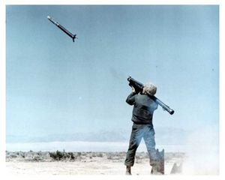

INFORMATION KIT



Information about this publication can be provided by contacting:

Director
National Security Section
International Security Division
Department of Foreign Affairs and Trade
RG Casey Building
John McEwen Crescent
Barton ACT 0221 AUSTRALIA

Revised July 2008
CONTENTS

A Guide to MANPADS 4
Typical MANPADS Composition 5

United National General Assembly Resolutions 9
United Nations General Assembly (UNGA) Resolution 59/90. Prevention of the illicit transfer 9
and unauthorized access to and use of man-portable air defence systems

United Nations General Assembly (UNGA) Resolution 62/40. Prevention of the illicit transfer and 11
unauthorized access to and use of man-portable air defence systems

Asia-Paciﬁc Economic Cooperation (APEC) Declarations on MANPADS (2003-2005) 13
2003 - Bangkok Leaders' Declaration 13
2004 - Santiago Leaders' Declaration 13
2005 - Busan Leaders' Declaration 14

Wassenaar Arrangement (WA) 15
Elements for Effective Legislation on Arms Brokering, 2003 15
Elements for Export Controls on MANPADS, 2003 (amended 2007) 17
Best Practices for Effective Enforcement, 2000 20
G8 Action Plan - Evian Summit 2003 22
Organization for Security and Co-operation in Europe (OSCE) 25
Best Practice Guide on National Procedures for Stockpile Management and Security (MANPADS) 25
Annex C, 2006
Bibliography 30
A GUIDE TO MANPADS
Man-portable air defence systems (MANPADS), commonly described as shoulder-ﬁred anti-aircraft missiles, are short range surface-to-air missiles that can be carried and ﬁred by a single individual or carried by several individuals and ﬁred by more than one person acting as a crew. MANPADS ﬁred by an individual can be easily carried in, for example, a golf or ski bag, as they are generally less than 2 metres in length and weigh around 20kg. Most MANPADS consist of:
1) A missile packaged in a tube;
2) a launching mechanism (commonly known as a “gripstock”); and
3) a battery.
There are three main types of MANPADS classiﬁed primarily by their guidance systems or “seekers”:
1) Infrared (IR) that hone in on an aircraft’s heat source, usually the engine’s exhaust plume;
2) Command Line-of-Sight (CLOS) whereby the MANPADS operator visually acquires the target aircraft using a magniﬁed optical sight and then uses radio controls to guide the missile into the aircraft; and
3) Laser Beam Riders in which the missile ﬂies along the laser beam and strikes the aircraft where the operator has aimed the laser.
MANPADS are intended to be used by legitimate national military forces to protect their troops and facilities. Typically, they are deployed by troops defending themselves or an installation from aerial attack. With their relatively short range, MANPADS are generally the last missile-based air defense and are often deployed in tandem with gun-type systems that seek to defeat attacking aircraft by destroying them with a barrage of projectiles. MANPADS can strike aircraft ﬂying at altitudes up to approximately 15,000 feet (4572 meters) at a range of up to 3 miles (4.82 kilometers).
MANPADS should not be confused with rocket-propelled grenades (RPGs). RPGs are also portable and shoulder-ﬁred. However, RPGs are designed primarily to be used against ground targets and are usually ineffective against aircraft that are in ﬂight. Some RPG attacks on low-ﬂying aircraft have been mistaken for MANPADS attacks.
Typical MANPADS Composition

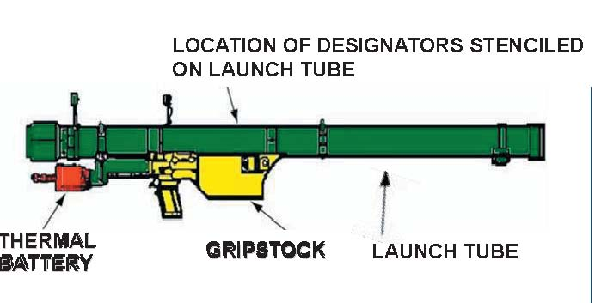

SA-24
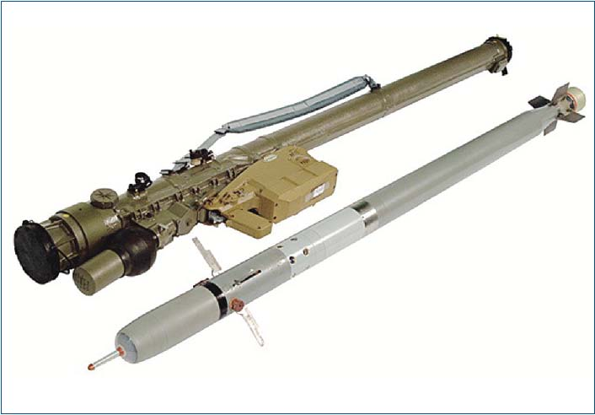

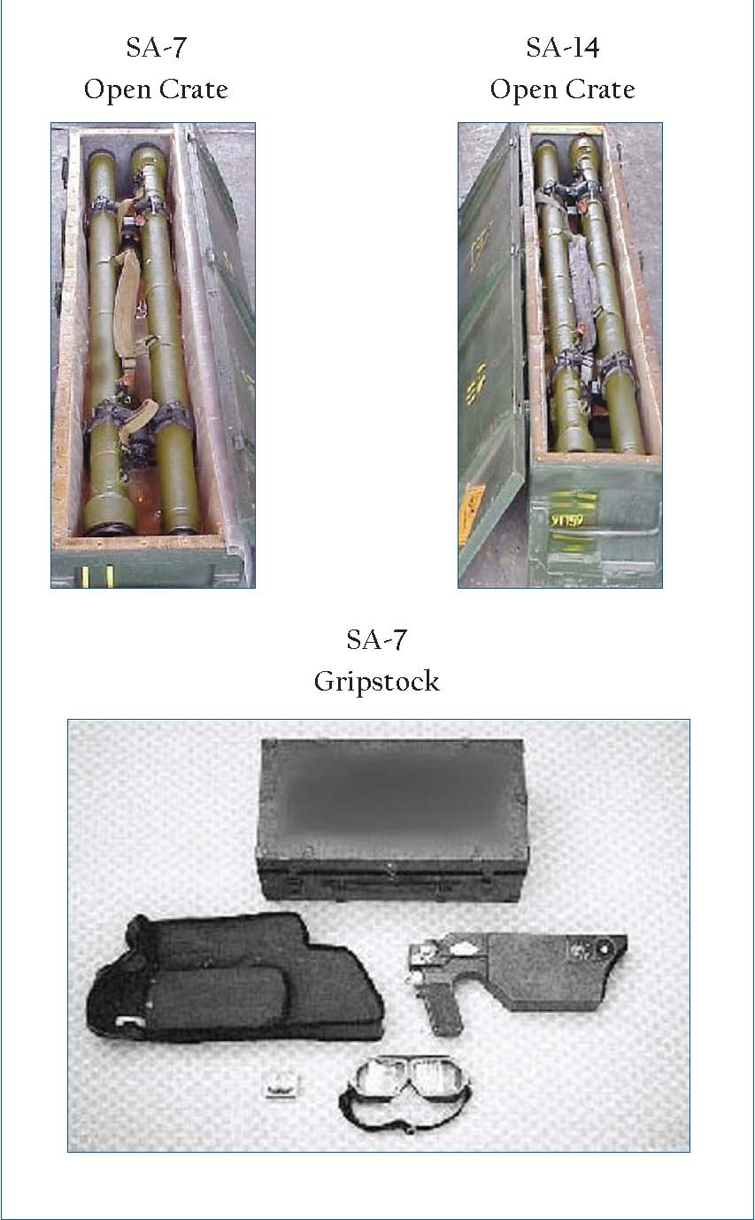

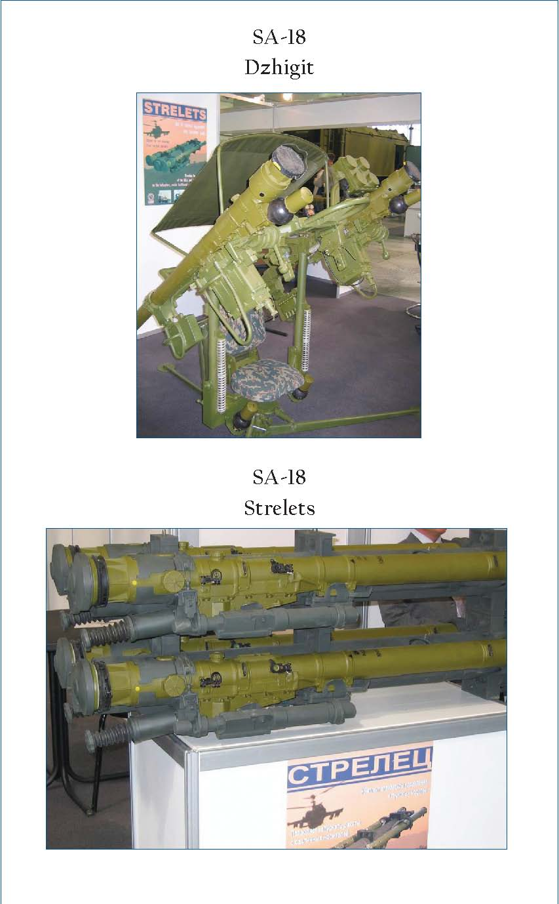

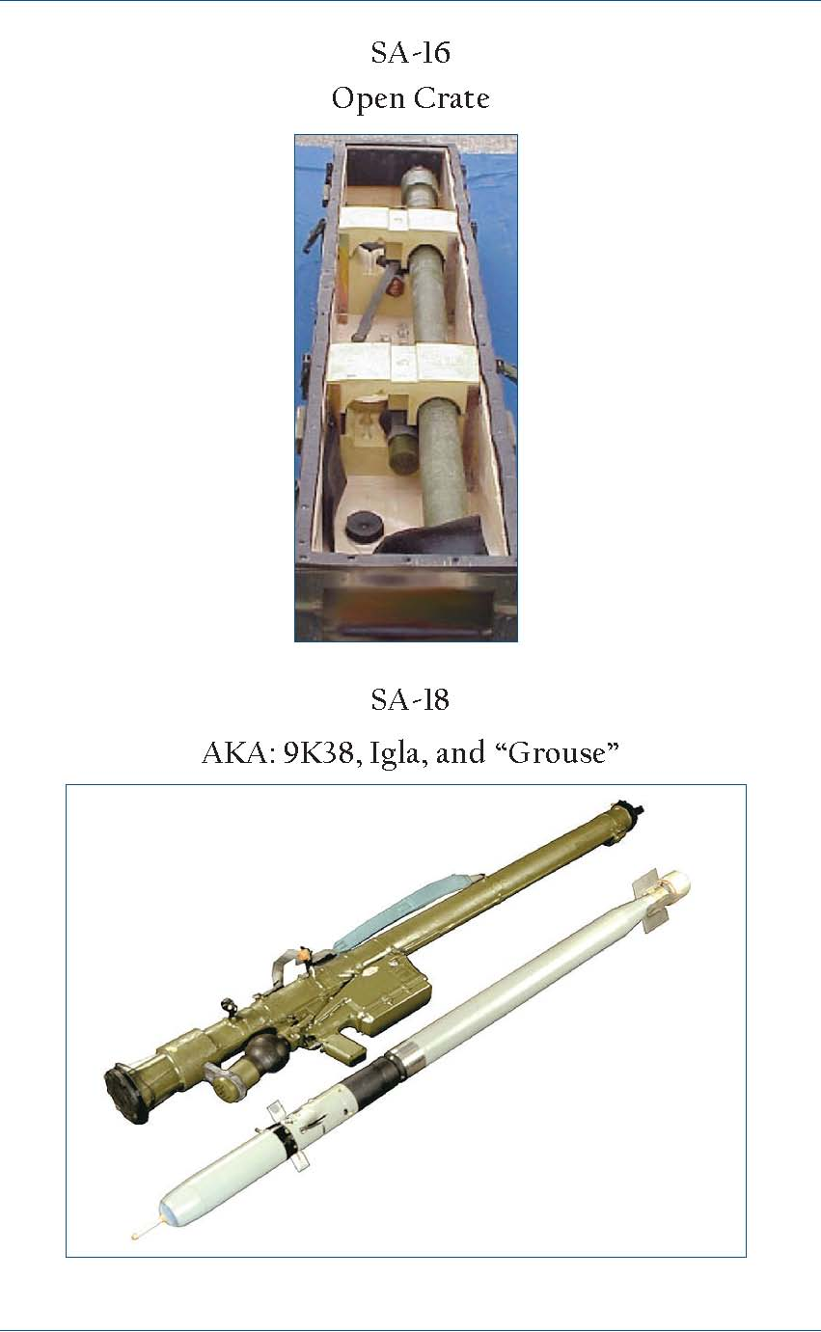
UNITED NATIONS GENERAL ASSEMBLY RESOLUTIONS
Sourced from the official website of the United Nations, www.un.org

UNITED NATIONS GENERAL ASSEMBLY RESOLUTION 59/90 (2004)
A/RES/59/90
Distr: General
17 December 2004
Fifty-ninth session
Agenda item 65

Resolution adopted by the General Assembly
[on the report of the First Committee (A/59/459)]

59/90. Prevention of the illicit transfer and unauthorized access to and use of man-portable air defence systems

The General Assembly,

Recalling its resolutions 58/42 and 58/54 of 8 December 2003 and 58/241 of 23 December 2003,

Recognizing that disarmament, arms control and non-proliferation are essential for the maintenance of international peace and security,

Acknowledging the authorized trade in man-portable air defence systems between Governments and the legitimate right of Governments to possess such weapons in the interests of their national security,

Recognizing the threat posed to civil aviation, peacekeeping, crisis management and security by the illicit transfer and unauthorized access to and use of man-portable air defence systems,

Taking into account that man-portable air defence systems are easily carried, concealed, fired and, in certain circumstances, obtained,

Recognizing that effective control over man-portable air defence systems acquires special importance in the context of the intensified international fight against global terrorism,

Convinced of the importance of effective national control of transfers of man portable air defence systems and the safe and effective management of stockpiles of such weapons,

Welcoming the ongoing efforts of various international and regional forums to enhance transport security and to strengthen management of man-portable air defence systems stockpiles in order to prevent the illicit transfer and unauthorized access to and use of such weapons,

Noting the importance of information exchange and transparency in the trade in man-portable air defence systems to build confidence and security among States and to prevent the illicit trade in and unauthorized access to such weapons,

1. Emphasizes the importance of the full implementation of the Programme of Action to Prevent, Combat and Eradicate the Illicit Trade in Small Arms and Light Weapons in All Its Aspects, adopted by the United Nations Conference on the Illicit Trade in Small Arms and Light Weapons in All Its Aspects;

2. Urges Member States to support current international, regional and national efforts to combat and prevent the illicit transfer of man-portable air defence systems and unauthorized access to and use of such weapons;

3. Stresses the importance of effective and comprehensive national controls on the production, stockpiling, transfer and brokering of man-portable air defence systems to prevent the illicit trade in and unauthorized access to and use of such weapons;

4. Encourages Member States to enact or improve legislation, regulations, procedures and stockpile management practices to exercise effective control over access to and transfer of man-portable air defence systems so as to prevent the illicit transfer and unauthorized access to and use of such weapons;

5. Also encourages Member States to enact or improve legislation, regulations and procedures to ban the transfer of man-portable air defence systems to non-State end-users and to ensure that such weapons are exported only to Governments or agents authorized by a Government;

6. Encourages initiatives to exchange information and to mobilize resources and technical expertise to assist States, at their request, in enhancing national controls and stockpile management practices to prevent unauthorized access to and use and transfer of man-portable air defence systems and to destroy excess or obsolete stockpiles of such weapons, as appropriate;

7. Decides to include in the provisional agenda of its sixtieth session an item entitled “Prevention of the illicit transfer and unauthorized access to and use of man-portable air defence systems”.

66th plenary meeting
3 December 2004

1 See Report of the United Nations Conference on the Illicit Trade in Small Arms and Light Weapons in All Its Aspects, New York, 9–20 July 2001 (A/CONF.192/15), chap. IV, para. 24.

UNITED NATIONS GENERAL ASSEMBLY RESOLUTION 62/40 (2007)
A/RES/62/40
Distr: General
10 January 2008
Sixty-second session
Agenda item 98

Resolution Adopted by the General Assembly
[on the report of the First Committee (A/62/391)]

62/40. Prevention of the illicit transfer and unauthorized access to and use of man-portable air defence systems

The General Assembly,

Recalling its resolutions 58/42 and 58/54 of 8 December 2003, 58/241 of 23 December 2003, 59/90 of 3 December 2004, 60/77 of 8 December 2005 and 60/288 of 8 September 2006, and its decision 60/519 of 8 December 2005,

Recognizing that disarmament, arms control and non-proliferation are essential for the maintenance of international peace and security,

Acknowledging the authorized trade in man-portable air defence systems between Governments,

Acknowledging also the legitimate right of Governments to manufacture, import, export, transfer and possess man-portable air defence systems in the interests of their national security and self-defence,

Recognizing the threat to civil aviation, peacekeeping, crisis management and security posed by the illicit transfer and unauthorized access to and use of man-portable air defence systems,

Taking into account the fact that man-portable air defence systems are easily carried, concealed, fired and, in certain circumstances, obtained,

Recognizing that effective control over man-portable air defence systems acquires special importance in the context of the intensified international fight against global terrorism,

Convinced of the importance of effective national control of transfers of man-portable air defence systems and their training and instruction materials and of the safe and effective management of stockpiles of such weapons,

Acknowledging the role of the unauthorized transfer of relevant materials and information in assisting the illicit manufacture and illicit transfer of man-portable air defence systems and related components,

Welcoming the ongoing efforts of, and noting declarations by, various international and regional forums to enhance transport security and to strengthen management of man-portable air defence systems stockpiles in order to prevent the illicit transfer and unauthorized access to and use of such weapons

Noting the importance of information exchange and transparency in the trade in man-portable air defence systems to build confidence and security among States and to prevent the illicit trade in and unauthorized access to such weapons,

Acknowledging the considerable efforts of some Member States to collect, secure and destroy voluntarily those man-portable air defence systems declared to be surplus by the competent national authority,

1. Emphasizes the importance of the full implementation of the Programme of Action to Prevent, Combat and Eradicate the Illicit Trade in Small Arms and Light Weapons in All Its Aspects, adopted by the United Nations Conference on the Illicit Trade in Small Arms and Light Weapons in All Its Aspects;1

2. Urges Member States to support current international, regional and national efforts to combat and prevent the illicit transfer of man-portable air defence systems and unauthorized access to and use of such weapons;

3. Stresses the importance of effective and comprehensive national controls on the production, stockpiling, transfer and brokering of man-portable air defence systems to prevent the illicit trade in and unauthorized access to and use of such weapons, their components and training and instruction materials;

4. Encourages Member States to enact or improve legislation, regulations, procedures and stockpile management practices and to assist other States, at their request, to exercise effective control over access to and transfer of man-portable air defence systems so as to prevent the illicit brokering and transfer of and unauthorized access to and use of such weapons;

5. Also encourages Member States, in accordance with their legal and constitutional processes, to enact or improve legislation, regulations and procedures to ban the transfer of man-portable air defence systems to non-State end-users and to ensure that such weapons are exported only to Governments or agents authorized by a Government;

6. Encourages initiatives to exchange information and to mobilize resources and technical expertise to assist States, at their request, in enhancing national controls and stockpile management practices to prevent unauthorized access to and use and transfer of man-portable air defence systems and to destroy excess or obsolete stockpiles of such weapons, as appropriate;

7. Decides to remain seized of the matter.

61st plenary meeting
5 December 2007

1 See Report of the United Nations Conference on the Illicit Trade in Small Arms and Light Weapons in All Its Aspects, New York, 9–20 July 2001 (A/CONF.192/15), chap. IV, para. 24
ASIA PACIFIC ECONOMIC COOPERATION (APEC) DECLARATIONS ON MANPADS 2003 - 2005
Sourced from the official website of the Asia Pacific Economic Cooperation, www.apec.org

2003 – Bangkok Leaders’ Declaration
2. Enhancing Human Security

…

We therefore committed at Bangkok to take all essential actions to:

…

Confront other direct threats to the security of our region.

We pledged to discuss at each Leaders’ Meeting our progress toward these security commitments, and to take specific actions in pursuit of them.

We agreed this year to:

Strengthen our joint efforts to curb terrorist threats against mass transportation and confront the threat posed by terrorists’ acquisition and use of Man-Portable Air Defense Systems (MANPADS) against international aviation by committing to: adopt strict domestic export controls on MANPADS; secure stockpiles; take domestic action to regulate production, transfer, and brokering; ban transfers to non-state end-users; and exchange information in support of these efforts. We agreed to continue efforts to strengthen domestic controls on MANPADS and to review our progress next year in Chile.

2004 – Santiago Leaders’ Declaration
The Leaders’ Declaration did not make direct mention of MANPADS, however the Declaration endorsed in full the Ministerial Joint Statement released at the 16th APEC Ministerial Meeting, which referred to MANPADS as follows:

They [Ministers] established guidelines on the control of Man-Portable Air Defense Systems (MANPADS), and economies committed to work individually to develop measures consistent with these guidelines and, as appropriate, with efforts taken at the United Nations, its agencies and other relevant international organizations, to prevent terrorists from obtaining and using these weapons to attack civilian aviation.

And

Ministers noted … and working to support international efforts, including those by multilateral agencies, to control access to MANPADS and other potential threats to civil aviation.

2005 – Busan Leaders’ Declaration
The Leaders’ Declaration noted the Leaders’ “[We] welcomed…the reduction of airport vulnerability to Man-Portable Air Defense System (MANPADS)…” and also endorsed in full the Ministerial Joint Statement released at the 17th APEC Ministerial Meeting, which referred speciﬁcally to airport MANPADS vulnerability assessments (MVAs):

Ministers underscored the efforts to mitigate the threat of Man-Portable Air Defense Systems (MANPADS) to civil aviation and welcomed the agreement by all APEC economies to undertake a MANPADS Vulnerability Assessment at international airports by the end of 2006. Mitigating the threat of MANPADS attacks and enhancing the security of civil aviation in APEC would ensure the continued ﬂow of people and services for business and tourism.

And

Delivery of MANPADS Component Pocket Guides by the United States to all APEC economies to assist the detection and prevention of MANPADS smuggling;

_____________________________________________________________________
Reproduced with the permission of the APEC Secretariat.
Information taken from the APEC website. For the full papers, please visit www.apec.org
___________________________________________________________________________________
WASSENAAR ARRANGEMENT
Sourced from the official website of the Wassenaar Arrangement, www.wassenaar.org

ELEMENTS FOR EFFECTIVE LEGISLATION ON ARMS BROKERING, 2003
The Participating States of the Wassenaar Arrangement, with reference to the Initial Elements and Participating States’ fulﬁlment of the objectives and intentions of the Wassenaar Arrangement, in particular the objectives
- greater responsibility in transfers of conventional arms:
- the prevention of destabilising accumulations of conventional arms;
- the need to prevent the acquisition of conventional arms by terrorist groups and organisations, as well as by individual terrorists;

Bearing in mind the “Statement of Understanding on Arms Brokerage”, the “Best Practice Guidelines for Exports of Small Arms and Light Weapons” as adopted by the 2002 Wassenaar Plenary Meeting and the “Elements for Export Controls of Man-Portable Air Defence Systems (MANPADS)” as adopted by the 2003 Wassenaar Plenary Meeting;

Recognising international commitments such as the 2001 “UN Programme of Action to Prevent, Combat and Eradicate the Illicit Trade in SALW in All its Aspects”, and the relevant provisions of the 2000 OSCE Document and other regional initiatives that Participating States are party to, and

the statement of the President of the UN Security Council of 31 October, 2002 (on behalf of the Council) stressing the importance of further steps to enhance co-operation on the regulation of brokering activities;

Afﬁrming that the purpose of these efforts is to avoid circumvention of the objectives of the Wassenaar Arrangement and UNSC arms embargoes by creating a clear framework for lawful brokering activities, and to enhance co-operation and transparency between Participating States;

Afﬁrming also that they apply strict and comprehensive national controls on the transfer of conventional arms in order to contribute to regional and international security and stability,

agree to

strictly control the activities of those who engage in the brokering of conventional arms by introducing and implementing adequate laws and regulations. Applications for licences or authorisations should be carefully assessed in accordance with the principles and objectives of the Wassenaar Arrangement Initial Elements, the Wassenaar document “Elements for Objective Analysis and Advice concerning Potentially Destabilising Accumulations of Conventional Weapons” and any subsequent amendments thereto and, where applicable, the “Best Practice Guidelines for Exports of Small Arms and Light Weapons” and the “Elements for Export Controls of Man-Portable Air Defence Systems (MANPADS)”. In order to ensure a common WA policy on arms brokering, each Participating State should include, consistent with its national legislation and practices, the following measures in its national legislation on arms brokering:

- For activities of negotiating or arranging contracts, selling, trading or arranging the transfer of arms and related military equipment controlled by Wassenaar Participating States from one third country to another third country, a licence or written approval should be obtained from the competent authorities of the Participating State where these activities take place whether the broker is a citizen, resident or otherwise subject to the jurisdiction of the Participating State.

Similarly, a licence may also be required regardless of where the brokering activities take place.

Participating States may also deﬁne brokering activities to include cases where the arms and military equipment are exported from their own territory.

Participating States may also seek to limit the number of brokers.

- Records should be kept of individuals and companies which have obtained a licence in accordance with paragraph 1. Participating States may in addition establish a register of brokers.

- Adequate penalty provisions and administrative measures, i.e. involving criminal sanctions, should be established in order to ensure that controls of arms brokering are effectively enforced.

- In addition, Participating States will enhance co-operation and transparency through:

  - exchanging relevant information on arms brokering activities within the framework of the General Information exchange;

  - assisting other Participating States on request in the establishment of effective national mechanisms for controlling arms brokering activities.

- Where brokering provisions do not currently exist, Participating States will work without delay to introduce appropriate provisions to control arms brokering activities.

- Participating States will report to the Plenary Meetings (ﬁrst time in 2004) on the progress made in meeting the objectives of the Elements.

ELEMENTS FOR EXPORT CONTROLS OF MAN-PORTABLE AIR DEFENCE SYSTEMS (MANPADS), 2003 (amended 2007)
Recognising the threats posed by unauthorised proliferation and use of Man-Portable Air Defence Systems, especially to civil aviation, peace-keeping, crisis management and anti-terrorist operations, Participating States affirm that they apply strict national controls on the export of MANPADS.

- Scope

1.1 These Elements cover:

a) surface-to-air missile systems designed to be man-portable and carried and fired by a single individual; and

b) other surface-to-air missile systems designed to be operated and fired by more than one individual acting as a crew and portable by several individuals.

1.2 National export controls apply to the international transfer or retransfer of MANPADS, including complete systems, components, spare parts, models, training systems, and simulators, for any purpose, by any means, including licensed export, sale, grant, loan, lease, co-production or licensing arrangement for production (hereafter “exports”). The scope of export regulation and associated controls includes research, design, development, engineering, manufacture, production, assembly, testing, repair, maintenance, servicing, modification, upgrade, modernisation, operation, use, replacement or refurbishment, demilitarisation, and destruction of MANPADS; technical data, software, technical assistance, demonstration, and training associated with these functions; and secure transportation, storage. This scope according to national legislation may also refer to investment, marketing, advertising and other related activity.

1.3 Any activity related to MANPADS within the territory of the producing country is subject to national laws and regulations.

- Participating States will exercise maximum restraint in transfers of MANPADS production technologies and, while taking decision on such transfers, will take into account elements, stipulated in paragraphs 3.7, 3.8, 3.9 and 3.11.

- Control Conditions and Evaluation Criteria

3.1 Decisions to permit MANPADS exports will be made by the exporting government by competent authorities at senior policy level and only to foreign governments or to agents specifically authorised to act on behalf of a government after presentation of an official EUC certified by the Government of the receiving country.

3.2 General licences are inapplicable for exports of MANPADS; each transfer is subject to an individual licensing decision.

3.3 Exporting governments will not make use of non-governmental brokers or brokering services when transferring MANPADS, unless specifically authorised to on behalf of the government.

3.4 In order to prevent unauthorised use, producer countries will implement technical performance and/or launch control features for newly designed MANPADS as such technologies become available to them. Such features should not adversely affect the operational effectiveness of MANPADS for the legal user.

3.5 Exporting governments in the Wassenaar Arrangement will report transfers of MANPADS as part of the Arrangement's Specific Information Exchange reporting requirements.

3.6 MANPADS exports will be evaluated in the light of the Wassenaar Arrangement Initial Elements and the Wassenaar document "Elements for Objective Analysis and Advice Concerning Potentially Destabilising Accumulations of Conventional Weapons" and any subsequent amendments thereto.

3.7 Decisions to authorise MANPADS exports will take into account:
- Potential for diversion or misuse in the recipient country;
- The recipient government's ability and willingness to protect against unauthorised re-transfers, loss, theft and diversion; and
- The adequacy and effectiveness of the physical security arrangements of the recipient government for the protection of military property, facilities, holdings, and inventories.

3.8 Prior to authorising MANPADS exports (as indicated in paragraph 1.2), the exporting government will assure itself of the recipient government's guarantees:

    - not to re-export MANPADS except with the prior consent of the exporting government;
    - to transfer MANPADS and their components to any third country only in a manner consistent with the terms of the formal government to government agreements, including co-production or licensing agreements for production, and contractual documents, concluded and implemented after the adoption of this document at the 2007 Plenary, as well as end-use assurances and/or extant export licences;
    - to ensure that the exporting State has the opportunity to confirm, when and as appropriate, fulfilment by the importing State of its end-use assurances with regard to MANPADS and their components¹ (this may include on-site inspections of storage conditions and stockpile management or other measures, as agreed between the parties);
    - to afford requisite security to classified material and information in accordance with applicable bilateral agreements, to prevent unauthorised access or compromise; and
    - to inform promptly the exporting government of any instance of compromise, unauthorised use, loss, or theft of any MANPADS material.

3.9 In addition, the exporting government will satisfy itself of the recipient government's willingness and ability to implement effective measures for secure storage, handling, transportation, use of MANPADS material, and disposal or destruction of excess stocks to prevent unauthorised access and use. The recipient government's national procedure designed to attain the requisite security include, but are not limited to, the following set of practices, or others that will achieve comparable levels of protection and accountability:

    - Written verification of receipt of MANPADS shipments.
    - Inventory by serial number of the initial shipments of all transferred firing mechanisms and missiles, if physically possible; and maintenance of written records of inventories.
    - Physical inventory of all MANPADS subject to transfer, at least once a month; account by serial number for MANPADS components expended or damaged during peacetime.
    - Ensure storage conditions are sufficient to provide for the highest standards of security and access control. These may include:
    - Where the design of MANPADS permits, storing missiles and firing mechanisms in locations sufficiently separate so that a penetration of the security at one site will not place the second site at risk. Ensuring continuous (24-hour per day) surveillance. Establishing safeguards under which entry to storage sites requires the presence of at least two authorised persons.
    - Transport MANPADS in a manner that provides for the highest standards and practices for safeguarding sensitive munitions in transit. When possible, transport missiles and firing mechanisms in separate containers.
    - Where applicable, bring together and assemble the principal components - typically the gripstock and the missile in a launch tube -only in the event of hostilities or imminent hostilities; for firing as part of regularly scheduled training, or for lot testing, for which only those rounds intended to be fired will be withdrawn from storage and assembled; when systems are deployed as part of the point defences of high priority installations or sites; and in any other circumstances which might be agreed between the receiving and transferring governments.
    - Access to hardware and any related classified information, including training, technical and technological documentation (e.g. MANPADS operation manuals), will be limited to military and civilian personnel of the receiving government who have the proper security clearance and who have an established need to know the information in order to perform their duties. Any information released will be limited to that necessary to perform assigned responsibilities and, where possible, will be oral and visual only.
    - Adopt prudent stockpile management practices that include effective and secure disposal or destruction of MANPADS stocks that are or become excess to national requirements.

3.10 Participating States will, when and as appropriate, assist recipient governments not capable of executing prudent control over MANPADS to dispose of excess stockpiles, including buying back previously exported weapons. Such measures are subject to a voluntary consent of the exporting government and the recipient state.

3.11 Exporting governments will share information regarding potential receiving governments that are proven to fail to meet the above export control guarantees and practices outlined in paragraphs 3.8 and 3.9 above.

3.12 To enhance efforts to prevent diversion, exporting governments will share information regarding non-state entities that are or may be attempting to acquire MANPADS.

3.13 Participating States will, when and as appropriate, provide to non-participating States, upon their request, technical and expert support in developing and implementing legislative basis for control over transfers of MANPADS and their components.

3.14 Participating States will, when and as appropriate, provide to non-participating States, upon their request, technical and expert assistance in physical security, stockpile management and control over transportation of MANPADS and their components.

4. Participating States will ensure that any infringement of export control legislation, related to MANPADS, is subject to adequate penalty provisions, i.e. involving criminal sanctions.

5. The Participating States will exchange information and review progress related to the implementation of these steps regularly.

6. Participating States agree to promote the application of the principles defined in these Elements to non-Participating States.

“End-use assurances with regard to MANPADS and their components” should be understood as their use only for purposes stipulated in the end-user certificate or any other document containing the obligations of the importing State.
BEST PRACTICES FOR EFFECTIVE ENFORCEMENT, 2000
The following list of “best practices” for effective export control enforcement were adopted by the Wassenaar Plenary as a non-binding amalgam of the enforcement practices followed by different Wassenaar Arrangement Participating States which are illustrative of an effective enforcement programme.

PREVENTIVE ENFORCEMENT

- Use threat assessment techniques and procedures for evaluating parties involved in a proposed export transaction, paying particular attention to those considered to be suspicious, unreliable, or presenting a high risk of diversion.

- Maintain a list of problem end-users to identify license applications deserving closer scrutiny.

- Conﬁrm the stated end-user and end-use of items to be exported prior to issuing an export license. As appropriate, this can be accomplished by several means, ranging from documentation to on-premise checks of the end-user and end-use.

- Obtain assurances regarding the end-use and non re-export of licensed items, as appropriate.

- Examine goods and the documentation required to be presented at point of export, using risk assessment techniques to aid selection. Detain suspect shipments and seize unauthorised or illegal exports, which may include those that are passing in-transit.

- As necessary, conﬁrm that exported goods have reached their intended destinations using appropriate means, ranging from documentation to on-site veriﬁcation.

- Conduct industry awareness programs to improve exporters’ understandings of the objectives and coverage of export controls, including controls on software and technology.

- Seek voluntary compliance by industry. As appropriate, encourage development by industry of internal compliance programs.

- Keep industry and the general public apprised of penalties for failure to comply, using, as appropriate, cases of successful prosecution as examples.

INVESTIGATIONS

- Designate law enforcement responsibilities for detection, prevention, and punishment of violations of export control laws.

- Provide adequate resources and training for enforcement ofﬁcers.

- Ensure that national laws and regulations have statutes of limitations sufficiently long to permit the detection and prosecution of export control violations.

- Consistent with national laws, policies and regulations and on a mutually-agreed basis, including international agreements for legal and customs assistance, and mutually respecting national sovereignty, governments may cooperate in the investigation and prosecution of violations of export controls cases, by:

  - Furnishing relevant documents and items relating to violations;
  - Facilitating the availability of witnesses; and
  - Providing for the extradition of violators, consistent with treaty obligations.

EFFECTIVE PENALTIES

- Establish effective penalties (including, as appropriate, criminal sanctions, civil ﬁnes, publicity and restriction or denial of export privileges) sufficient to punish and deter violations of export controls.

INTERNATIONAL COOPERATION / INFORMATION EXCHANGES

- Consistent with national laws, policies and regulations and on a mutually-agreed basis, including international agreements for legal and customs assistance, governments may, as appropriate, share information bilaterally on persons and companies considered to present a high risk of diversion. Examples of information to share include:
  - Information obtained in the course of pre-license and post-shipment veriﬁcations; and
  - Information about export control prosecutions, convictions, and restrictions or denials of export privileges.

- Consistent with national laws, policies and regulations, governments may, as appropriate, share information in the context of multilateral export control arrangements. Examples of information to share include:
  - General information on risks associated with destinations of concern;
  - Information on license denials;
  - Information on networks, agents, brokers and end-users of concern.

- Senior enforcement officials may maintain, as appropriate, formal and informal information exchanges with their counterparts in member country governments.

- Licensing and enforcement officials should respect the conﬁdentiality of information received and should ensure that access to it is restricted to those officials who have been duly authorised
G8 ACTION PLAN - EVIAN SUMMIT 2003
Sourced from the official website of the G8, www.g8.fr

ENHANCE TRANSPORT SECURITY AND CONTROL OF MAN-PORTABLE AIR DEFENCE SYSTEMS (MANPADS) - A G8 ACTION PLAN

We, the G8 Leaders, are determined to strengthen our joint efforts to curb terrorist threats against mass transportation. We shall continue to implement the Action Plan we agreed at Kananaskis to ensure safe, secure, efficient and reliable transportation world-wide. We have made important progress in implementing the plan and also have taken a number of new measures. The scope of our endeavours in this field covers five areas:

1. MANPADS
2. Air transport
3. People
4. Container security
5. Sea transport

1. Control of MANPADS
1.1. At the Birmingham Summit in 1998, we recognised the threat posed to civil aviation by the criminal use of Man-Portable Air Defence Systems (MANPADS) and called for further work to be done to address this problem. At Kananaskis, we agreed to promote transport security in the light of the terrorist attacks of 11 September 2001.

1.2. Today, at Evian, we reiterate our deep concern about the threat posed to civil aviation by MANPADS, especially in the hands of terrorists or States that harbour them.

1.3. MANPADS are surface-to-air missile systems specially designed to be carried and fired by a single individual. MANPADS are portable and easily concealed, yet capable of potentially catastrophic destruction. We are therefore implementing national measures to combat such illegal use of MANPADS, and will encourage other States to do so as well.

1.4. Given the increasing number of MANPADS in world-wide circulation, we commit ourselves to reducing their proliferation and call upon all countries to strengthen control of their MANPADS stockpiles.

1.5. In the framework of the Wassenaar Arrangement, "Elements for the Export Controls of MANPADS" were agreed by all 33 participating States in 2000. This was a valuable step forward. We undertake to promote the application of the principles defined in these "Elements" by a larger number of States.

1.6. In addition, we agree to implement the following steps to prevent the acquisition of MANPADS by terrorists:

" To provide assistance and technical expertise for the collection, secure stockpile management and destruction of MANPADS surplus to national security requirements;

" To adopt strict national export controls on MANPADS and their essential components;

" To ensure strong national regulation of production, transfer and brokering;

" To ban transfers of MANPADS to non-state end-users; MANPADS should only be exported to foreign governments or to agents authorised by a government;

" To exchange information on unco-operative countries and entities;

" To examine the feasibility of development for new MANPADS of specific technical performance or launch control features that preclude their unauthorised use;

" To encourage action in the International Civil Aviation Organisation (ICAO) Aviation Security (AVSEC) Working Group on MANPADS.

1.7 We agree to exchange information on national measures related to the implementation of these steps by December 2003. We will review progress at our next meeting in 2004.

2. Air transport
2.1. Measures already being implemented:

"Agreement to implement by November 2003 the new international standards for the installation of flight deck doors, as adopted by ICAO;

" Continued support for the implementation of the ICAO Universal Security Audit Programme of all ICAO Member States. First audits have been conducted;

"increased co-operation on aviation security between us, including implementation of this Action Plan, using ICAO and other relevant international organisations. This will strengthen overall standards across the G8.

2.2 Enhance the air security action plan and develop effective aviation security quality control systems world-wide:

" To review security procedures in place to ensure that staff do not pose a threat to aviation, including, in particular, by examining the feasibility and benefits of ensuring that all staff and items carried are screened when they enter critical parts of security-restricted areas of airports;

"To encourage further work within ICAO to review and adopt the measures related to an enhanced threat level for the standard security procedures;

" To encourage each of us to adopt and implement as soon as possible the harmonised and supplementary provisions on flight-deck door locking issued by the ICAO. Each of us intends to apply these requirements both to international and domestic flights;

" To explore experience gained, inter alia, from installation of on-board TV monitoring systems to control the security inside passenger aircraft;

" To co-ordinate aviation security capacity building efforts for non-G8 countries and to lead in donating funds and advisors to ICAO's aviation security audit programme (AVSEC).

3. People

3.1. We have developed guidelines for the implementation of international standards governing the use of biometrics to verify the identity of travellers and have forwarded them to the ICAO. We endorse the "G8 Roma and Lyon Groups Statement on Biometric Applications for International Travel" and are resolved in our continued support for the ongoing work within ICAO.

3.2. We also agree to develop a secure, verifiable seafarer identity document at the International Labour Organisation (ILO) and are working together towards agreeing on seafarers and port workers security requirements compatible with trade facilitation at the International Maritime Organisation (IMO) and the ILO.

3.3 We are working together to accelerate the use of the joint World Customs Organisation (WCO) / ICAO / International Air Transport Association (IATA) guidelines as a global standard for advance passenger information, and will work to ensure that other necessary requirements for passenger information are developed to a global standard.

4. Container security

4.1. We are working together to reinforce container security arrangements generally and to develop specifically, within the WCO, joint standards and guidelines for electronic transmission of customs data for cargo and a standardised set of data elements to identify high-risk cargo. We are also working together at the same time to combine security needs with trade facilitation.

4.2 Our active support of pilot projects that model an integrated container security regime contributed to the rapid expansion of the Container Security Initiative (CSI), which is now operational in ten major international ports, seven of which are in G8 countries. Our continued support of CSI will encourage rapidly expanding participation by other ports, further enhancing global container security. As international security is only as effective as its weakest link, we support international co-operation in the WCO to ensure a more co-ordinated approach for all ports handling international cargo.

5. Sea transport

5.1. At Kananaskis, we agreed to support in the IMO amendments to the International Convention for the Safety of Life at Sea that require mandatory ship security plans, on-board ship security officers, mandatory port facility security plans and port facility security assessments for relevant ports serving ships engaged on international voyages, to be included during the development of an International Ship and Port Facility Security Code by July 2004.

5.2. In December 2002, the IMO adopted these amendments which also provide for the fitting of Automatic Identification Systems on ships by 31 December 2004. We support the implementation of measures in this sphere as agreed at our 2002 Summit.

ORGANIZATION FOR SECURITY AND COOPERATION IN EUROPE
Sourced from the official website of the Organization for Security and Cooperation in Europe, www.osce.org

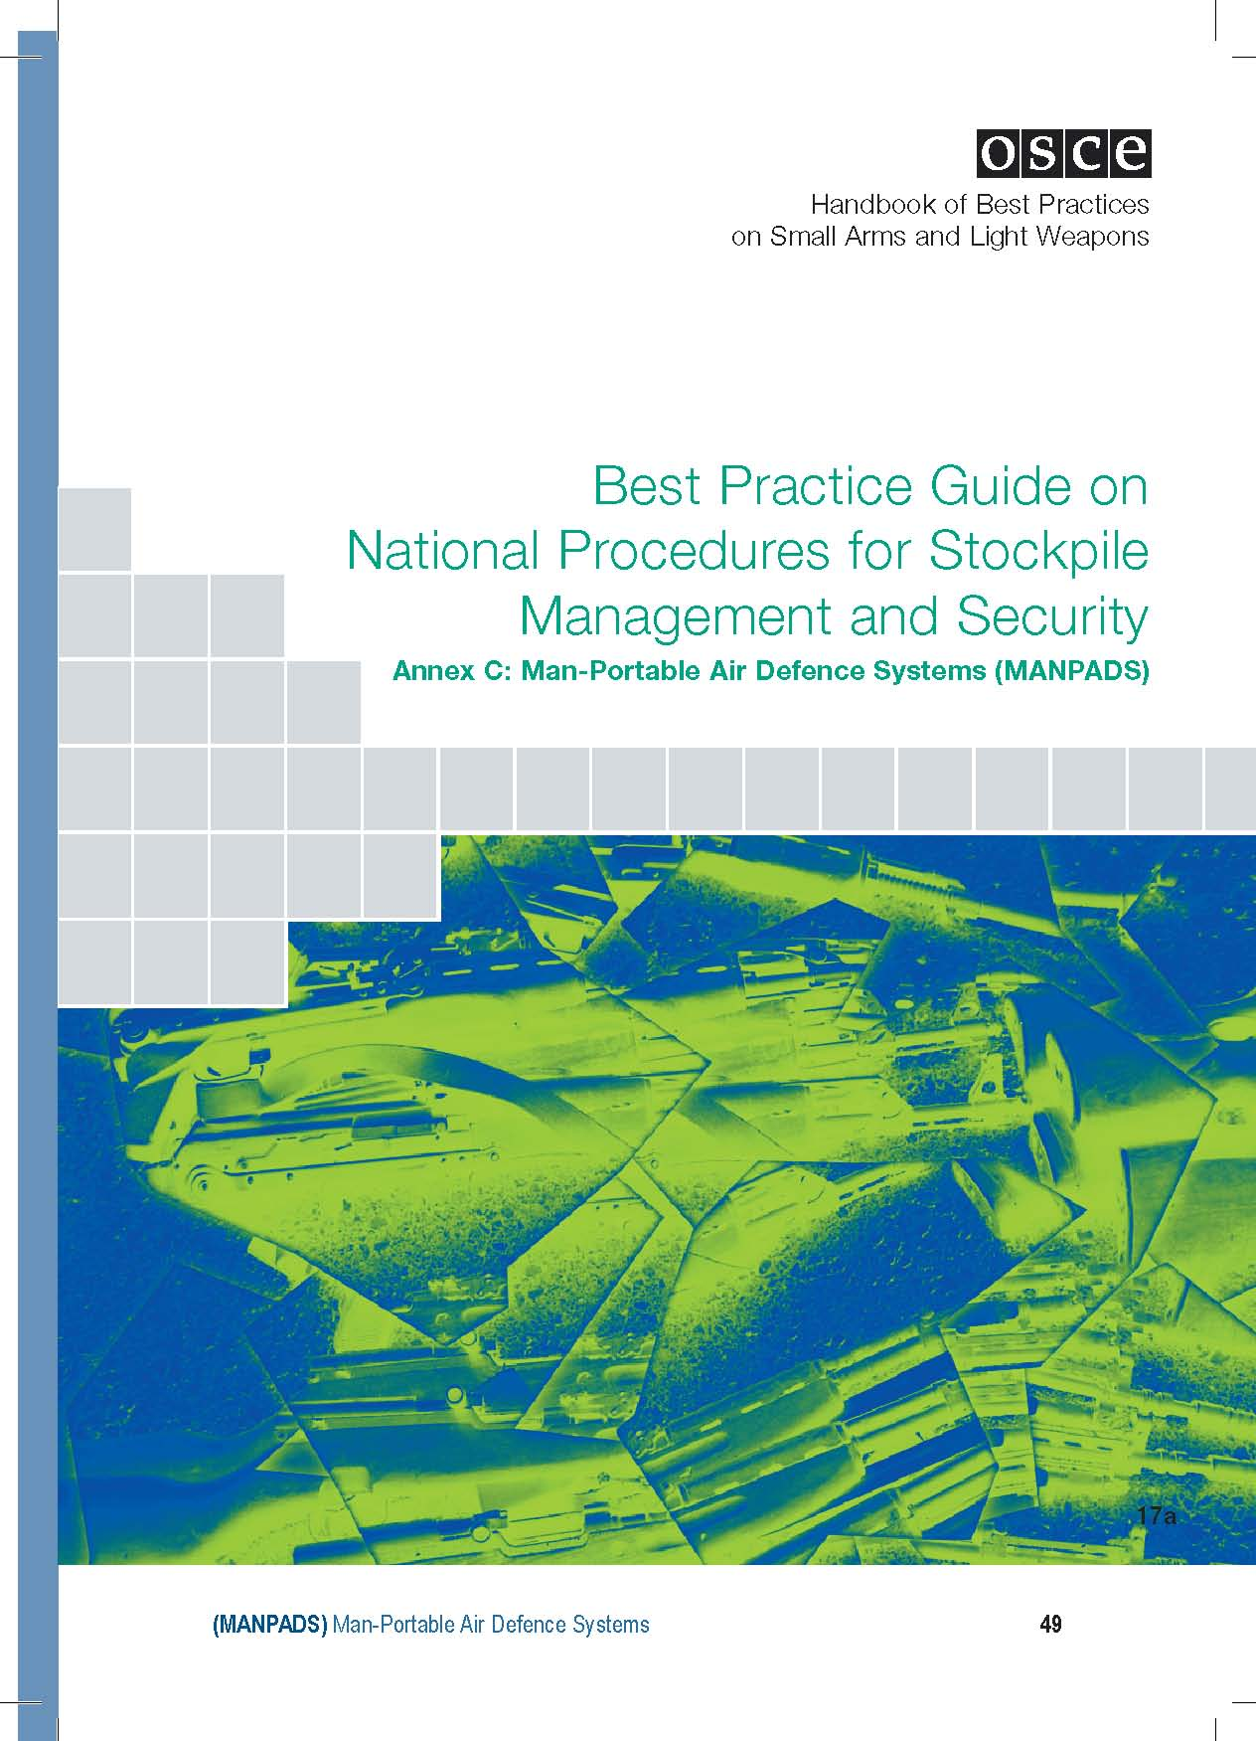

This annex was drafted by the governments of Germany, United States of America, Canada, France, United Kingdom, Italy, Russian Federation, Sweden, and Turkey

I. Introduction

1. Aim

Man-Portable Air Defence Systems (MANPADS) require special attention and consideration in view of the devastating loss of life and potential effect on the civil aviation industry that a single MANPADS attack could cause. The aim of this best practice guide is to provide best practice guidance on stockpile management and security for MANPADS including: a) surface-to-air missile systems designed to be man-portable and carried and fired by a single individual; and
b) other surface-to-air missile systems designed to be operated and fired by more than one individual acting as a crew and portable by several individuals.

2. Scope

This best practice guide covers rules and procedures applying to MANPADS, encompassing both the complete MANPADS systems, light weapons elements (i.e. grip-stock, etc) and ammunition elements (i.e. missiles).

They are recommended for complete MANPADS explosive rounds, MANPADS systems in a ready-to-fire configuration, and for jointly stored or transported MANPADS launcher tubes and/or grip stocks and the explosive round, though not in a ready-to-fire configuration. These best practices are also broadly applicable to other man-portable missile and rocket systems in similar configurations as outlined above, such as man-portable anti-tank missile systems.

3. References

A list of references can be found at the end of this document.

II. Procedures

1. Physical Security Measures for MANPADS Stockpiling

a) The appropriate characteristics of stockpile location

Where the design of MANPADS permits, missiles and firing mechanisms (gripstocks) should be stored in separate storehouses and in locations sufficiently separate so that a penetration of the security of one site will not place the second site at risk.

MANPADS should be stored in the most secure accommodation, providing the highest standards of physical security. MANPADS missiles should be stored in permanent structures, preferably in concrete ammunition store-houses equipped with adequate security doors, secured with at least two separate locks at each door (key control see below). Firing mechanisms should be stored under physical security measures, which meet at least the requirements for SALW.

The perimeter of MANPADS storage sites should have clear zones, fences and internal and external lighting. Windows and other openings or access points should be kept to a minimum. All structures should be checked by facility security personnel at prescribed intervals, and random checks should also be conducted, including during off-duty hours. In cases where two or more units share a facility, one unit should be designated as responsible for the security of the entire facility.

In addition to outer perimeter fencing, the inner (actual) MANPADS storage area should either be continuously monitored (either by personnel or video surveillance) or have its own inner fencing. The inner fencing should be situated in relation to the structure so that a breach of the fence with an explosive device would not also breach the storage structure. Unless continuously guarded, any fence gates should be kept locked. Drainage structures, water passages or other objects penetrating the fence should be small enough to prevent any possible passage. A recommended minimum height of fences for MANPADS storage sites is 2 meters (or 6.5 feet).

Locks should be certified and tested to delay unauthorized intruders attempting to gain access using battery powered tools by at least 10 minutes in order to permit security forces to respond before weapons can be removed.

Exterior building and door lighting should be provided for all structures storing MANPADS. The lighting should be of sufficient brightness to allow easy observation of unauthorized activity. Switches for exterior lights shall be installed in such a manner that they are accessible only to authorized individuals.

Additional security measures could include use of a combination of high security fencing, extra detection devices, CCTV, improved security lighting, biometric security devices, increased patrolling or the introduction of guard dogs.

b) Surveillance

MANPADS storage sites should be placed under armed guards, and subject to continuous (24-hour per day) surveillance that will immediately detect any breach of security. The sites should therefore generally be equipped with an automatically operating, electronic intruder detection alert system.

Implementation of electronic security measures to prevent simultaneous access to separately stored missiles and firing mechanisms should be considered.

MANPADS storage facility sites should incorporate an intrusion detection system with the physical security measures. The facility intrusion detection system should include point sensors on doors and other apertures allowing access by intruders, and interior motion or vibration sensors.

All alarm signals should sound at a central control or monitoring station from which a response force can be dispatched. When a MANPADS storage facility is located outside a military installation, arrangements should be made to connect to local law enforcement or commercial security services from which immediate response to activated alarms can be directed.
Alarm transmission lines should either have line security (electronically monitored to detect evidence of tampering or attempted compromise) or include two independent means of alarm signal transmission. Any visible lines should be regularly inspected for tampering. Alarm systems should also be tested regularly.

The intrusion detection alarm system, facility physical security measures and first responder security forces should be integrated so that, if an intrusion is detected and the alarm is transmitted, the physical security measures would delay any intruders and prevent access to stored MANPADS long enough for security forces to respond to the intrusion.

Storage areas should have a primary and backup means of communications that permit notification of emergency conditions. The backup system should be different from the primary.

The communication system should be tested daily. Radio could be one of the modes of communication.
Storehouses not being under permanent technical surveillance should be permanently guarded.

Ammunition storehouses, which have a defective intruder detection system or none at all, should be checked by guards at irregular intervals not exceeding 60 minutes.

Additionally, quick-reaction forces should permanently be kept on standby, to be dispatched to any ammunition storehouse in order to establish the cause of an alert.

c) Storage

MANPADS should normally be stored in original containers, banded, and sealed with tamper detection seals to reflect the integrity of the contents.

Generally containers weighing less than 225 kilograms (or 500 pounds) should be fastened to the structure, or fastened together in groups, which have a total weight exceeding 500 pounds with bolts or chains secured with padlocks unless such fastening would impede facility operations.

Recommended additional security measures include the use of internal locking devices and two person key control procedures. Hinge pins to doors should be welded or otherwise secured and windows and other openings kept to a minimum.

Unit-level stored stocks should typically be housed in a building used to store ammunition on a rifle range, or a military police/security force operations room. They should be stored in a secured arms room, vault, or a secured weapons storage container with minimum standards for their structural integrity and access doors or points.

If secured in combat vehicles, aircraft, ships, trailers, or in other configurations required by operational or training requirements, constant surveillance of the items should be established and maintained.

d) Review

The existing physical security measures for MANPADS stockpiling should regularly be reviewed and - if necessary - be adjusted.

2. Access Control Measures

a) Personal Security

Access to MANPADS and parts thereof and any related classified material and information should be limited to military and official personnel that meet the following requirements: with proper security clearance and an established need to know the information in order to perform their duties; and with access granted through a list of names issued by the head of the relevant storage facility.
Safeguards could be established under which entry to storage sites requires the presence of at least two authorised persons. All entries to MANPADS storage sites should be recorded in an access log, which should be kept as a record for a minimum period of at least one year. The quantity of MANPADS to be removed should be as small as possible to support specific missions or projects.

b) Lock-and-key handling and security

Keys to MANPADS storage areas should be stored separately from keys and devices for other conventional storage areas.

Only personnel with authorised access to MANPADS should have access to keys.
Any authorised person should be authorised to receive only one key, ensuring that access to MANPADS store-houses is generally subject to a “two-person principle.”

Whenever a key is issued or returned, the following items of information should be recorded in writing: the date and time when the key is issued or returned; the key's serial number; the signature of the person issuing or returning the key; the name and signature of the recipient.

All documents in which the issuance and return of keys is recorded should be kept for a period of at least one year after the last entry has been made.

At prescribed intervals, typically every six months, the responsible officer of the storage facility concerned should check if the keys to the MANPADS storehouses are still complete. The date and result of this check should be recorded in a security logbook, which should periodically be examined by the superior agency.

As soon as it becomes known or there is suspicion that a key has been lost or a duplicate key has been produced, the lock concerned should urgently be replaced.

3. Handling and Transport

a) Secure handling

Where applicable, principal components - typically the missile in a launch tube and the gripstock - should only be brought together and assembled: in the event of hostilities or imminent hostilities; for firing as part of regularly scheduled training, or for lot testing, for which only those rounds intended to be fired should be withdrawn from storage and assembled; and when systems are deployed as part of the point defences of high priority installations or sites.

Anyone handling or having direct access to these classified MANPADS assemblies, components or pertinent documents (e.g. user manuals) should be required to undergo a security clearance check.

b) Procedures aimed at maximising transport security

MANPADS should be transported in a manner that provides for the highest standards and practices for safeguarding sensitive munitions in transit.
Best Practice Guide on National Procedures for Stockpile Management and Security

Where the design of MANPADS permits, missiles and firing mechanisms should always be transported and transhipped separately, wherever possible in separate vehicles and at different times. MANPADS missiles and launch and control equipment should not be loaded into the same freight container. When missiles or firing mechanisms are transported or transhipped on public roads or inside civilian/military facilities, security should be provided by armed military transportation escort detachments.

Transhipments should be conducted only by cleared and authorised personnel. In the event that transportation is halted, the transport vehicles should be guarded permanently. Whenever possible rests or technical halts during a MANPADS transport should always be conducted in military facilities and placed under constant guard.

MANPADS should be transported in sealed and locked containers. When feasible, MANPADS shipments should be provided with a security vehicle escort. Positive control should be maintained over MANPADS transport as much as is possible. Clandestine transport, as detailed on page 8 of the OSCE Best Practice Guide on National Procedures for Stockpile Management and Security, is not recommend for MANPADS transport under normal circumstances.

Shipments should be tracked and monitored via satellite tracking devices and/or with escorts in contact with a command and control center to ensure additional response should the shipment come under attack or require additional assistance.

Serial number accountability should be maintained at all times from shipper to consignee. Shipping should be direct to the intended final destination, with no delays or stop-overs in transit locations. Items moved by a unit or organization transportation should be placed in the custody of a commissioned officer, warrant officer, senior non-commissioned officer, or civilian of equivalent rank.

A minimum of two personnel should be required if access to the MANPADS is necessary during transport.

Each container should be checked, tamper-detectable sealed, and locked by two agents of the shipper (in each other's presence) before delivery to the carrier. This two-person integrity should be required at each trans-shipment point and terminal whenever the shipment loses its original identity (e.g., when two or more shipments are consolidated into another container for further movement or if repacking is required).

In the case of MANPADS shipments over water, prior to the voyage a written stow plan should be provided to the ship's captain detailing the location of the arms, ammunition, and explosives aboard ship and its protection requirements.

MANPADS should be stowed in separate, locked containers, inaccessible to unauthorized personnel during ocean transit. MANPADS shipments should be direct-voyage to destination. If the cargo must be offloaded en route, it should be provided constant surveillance by government personnel, if available, or by national crew-members pending reloading.

4. Inventory management and accounting control procedures

a) Management and system

A strong system of positive controls and accountability, from the lowest to the highest level should be put into place. Written verification should be provided on the receipt of MANPADS. Diligent record keeping is required for securing stockpiles, ensuring control, and providing safety surveillance.

Training and staffing should be carefully managed to ensure dependable funding and personnel support to ensure accountability.
Inventory should be by serial number of firing mechanisms and missiles, with written records including serial numbers maintained.

Procedures should be put into place that ensure regular reporting of missiles and rockets issued for training; missiles and rockets returned unexpended from training; and expended residue, as applicable. Procedures should be established for appropriate MANPADS inventory managers to verify requisition of MANPADS. These requisition verification procedures should include positive steps for rejecting excess and unauthorized requisitions.

Any procurement plans or contracts should provide for individual item serialization.
Complete physical inventory of all MANPADS should be compiled at least once a month at the unit level, semi-annually at the installation level and annually at the depot level. A centralised national inventory should be maintained. Controls would include reconciliation of accounting documents against existing stockpiles.

Such regular inspection ensures that any discrepancies are reported promptly. A complete count of the contents of any box should be undertaken if there is any evidence of tampering

MANPADS components expended or damaged during peacetime should be accounted for by serial number. Obsolete MANPADS, MANPADS components or items beyond economical repair should be destroyed in a timely manner and in such a way as to avoid subsequent repair and re-use, with destruction accounted for by serial number.

Responsibility for destruction rests with the country owning the MANPADS. However, the original producing country should provide technical advice and assistance on destruction procedures when requested. All confirmed thefts, losses, and recoveries of MANPADS should be promptly reported to the appropriate national law enforcement.

All records of MANPADS turnover should be kept indefinitely. As far as the issuance and return of classified and/or sensitive equipment, components, documents etc. relating to MANPADS are concerned, it should be ensured that the whereabouts of the issued materiel are traceable physically and to the responsible person(s) at any time.

MANPADS producing and / or exporting countries could supplement controls further by the introduction of invisible marking procedures into the missile and firing mechanism (gripstock) technology process.

BIBLIOGRAPHY

APEC Declarations on MANPADS (2003-2005), excerpts taken from www.apec.org on 1 February 2007

FSC Decision on MAN-Portable Air Defence Systems FSC.DEC/7/03.

FSC Decision on OSCE Principles for Export Controls of MANPADS FSC.DEC/3/04

G8 Action Plan - Evian Summit 2003 “Enhance Transport Security and Control of Man-Portable Air Defence Systems – MANPADS – A G8 Action Plan”, taken from www.g8.fr on 1 February 2007

MANPADS Facts Sheet, information from United States State Department website www.state.gov on 1 February 2007

MANPADS Recognition Pocket Guide for APEC Economies (original prepared by the Government of the United States of America)

Organization for Security and Co-operation in Europe Best Practice Guide on National Procedures for Stockpile Management and Security (MANPADS) Annex C, 2006, taken from www.osce.org on 1 February 2007OSCE Strategy to Address Threats to Security and Stability in the 21st Century (interalia, paragraphs 9, 15, 29, 31, 46, 47, 48 and 54)

United Nations General Assembly Resolution 59/90. Prevention of the illicit transfer and unauthorized access to and use of man-portable air defence systems, taken from www.un.org on 1 February 2007

United Nations General Assembly Resolution 62/40. Prevention of the illicit transfer and unauthorized access to and use of man-portable air defence systems, taken from www.un.org on 1 February 2007

Wassenaar Arrangement Best Practices for Effective Enforcement, 2000, taken from www.wassenaar.org on 1 February 2007

Wassenaar Arrangement Elements for Effective Legislation on Arms Brokering, 2003 (Updated 2007), taken from www.wassenaar.org on 1 February 2007

Wassenaar Arrangement Elements for Export Controls on MANPADS, 2003, taken from www.wassenaar.org on 1 February 2007

