Man-Portable Air
Defence Systems
(MANPADS)

Countering the Terrorist Threat

This report, a product of the Department of Foreign Affairs and Trade, was prepared in collaboration with the Australian Strategic Policy Institute.

Disclaimer
This report is intended to provide background information only on Man Portable Air Defence Systems. It does not represent and should not be taken to represent the current policy or future intentions of the Australian Government.
While every care has been taken to ensure the accuracy of the information provided, the Department of Foreign Affairs and Trade, its officers, employees and agents, accept no liability for any loss, damage or expense arising out of, or in connection with, any reliance on any omissions or inaccuracies in the material contained in this publication.
The information provided in this publication is not intended for distribution to, or use by, any person or entity in any jurisdiction or country where such distribution or use would be contrary to law or regulation or which would subject the Department of Foreign Affairs and Trade to any registration requirement within such jurisdiction or country.
This publication is intended to provide general background information only and when entering into any particular transaction users should rely on their own enquiries, skill and care in using the information, should consult primary sources and should seek independent advice.

Further information
Director, National Security Section
International Security Division
Department of Foreign Affairs and Trade
RG Casey Building
John McEwen Crescent
Barton ACT 0221
AUSTRALIA

Copyright
© Commonwealth of Australia June 2008
This work is copyright. Apart from any use as permitted under the Copyright Act 1968, no part may be reproduced by any process without prior written permission from the Commonwealth. Requests and inquiries concerning reproduction and rights should be addressed to the Commonwealth Copyright Administration, Attorney-General’s Department, Robert Garran Offices, National Circuit, Barton ACT 2600 or posted at http://www.ag.gov.au/cca.

ISBN 978-1-921244-64-3.
Contents
Chapter One: MANPADS basics 5
Introduction 5
MANPADS characteristics 5
MANPADS history 6
MANPADS countermeasures 8
Engagement envelopes 9

Chapter Two: MANPADS proliferation and non-state actors 11
Spread to non-state actors 11
The effectiveness of MANPADS in the hands of non-state actors 11
Widespread production 12
MANPADS Inventories 13
Proliferation 13

Chapter Three: MANPADS and civilian aircraft 15
History of attacks and attempts 15
Survivability of civilian aircraft 17
Protection of civilian aircraft 17

Chapter Four: The cost of a successful MANPADS attack 19

Chapter Five: Counter-proliferation 20
International efforts 20
Australian efforts 21
Conclusions 22

Appendix: MANPADS Characteristics 23

Notes 24

Cover illustration: (Top) A Russian 9K38 SA–18 (Igla) MANPADS missile, launch tube and grip stick. (Bottom) A Russian 9K310 SA–16 (Igla–1) missile and launch tube. (Photo: United States Navy)

Chapter One: MANPADS basics
Introduction
MANPADS (Man-Portable Air-Defence Systems) are lightweight anti-aircraft weapons. They are designed to protect soldiers on the battlefield from attacking aircraft.
Because MANPADS are intended to be carried and deployed rapidly by ground forces, they are low cost, light, compact and mobile. They require only a single operator to use, and can be very effective against low or slow aircraft. MANPADS—along with anti-aircraft artillery-—were amongst the most effective anti-aircraft weapons deployed by Iraq in the 1991 Gulf War.1
The same characteristics that make MANPADS suitable for battlefield use by soldiers also make them attractive to terrorist groups and insurgents. They have been used in terrorist attacks against civilian aircraft targets in a number of documented cases and they have been employed as effective weapons of asymmetrical warfare in Afghanistan and Iraq.2
This document describes the nature of the threat to civilian aircraft from MANPADS and what can be done to minimise that threat. To hinder terrorist use of MANPADS against civilian aircraft a multi-layered approach is required: limiting the production, export, sale and transfer of MANPADS, securing legitimate military stores, and mitigating the risk to airports and airliners.

MANPADS characteristics
A MANPADS typically consists of three components: a disposable carriage and launch tube, containing a single missile; a disposable thermal battery or battery-coolant unit, which provides electrical power to the system prior to firing; and a re-useable gripstock assembly—also known as the trigger, or firing unit. Fully assembled, a MANPADS typically weighs 15–20 kg, and is less than 2 metres in length. These factors make the weapon relatively easy to transport and conceal.3
The amount of explosive in a MANPADS missile is quite small. However a combination of effects, including blast, fragmentation and the energy of the missile hitting the aircraft at a high speed, can have a significant destructive impact.
In military usage, MANPADS are usually the short-range component of a wider air defence system, providing the ‘last-ditch’ defence against attacking aircraft. They are effective only over ranges less than about seven kilometres, and are used against aircraft that are within view of the operator. Against aircraft that are further away, military forces can employ additional systems incorporating radar for detection and targeting and one or more long range surface-to-air missile systems. Ground-based air defence systems (GBADS) of that type are able to target aircraft from as far as hundreds of kilometres away. They require a number of well-trained personnel to operate and are vehicle-mobile only.
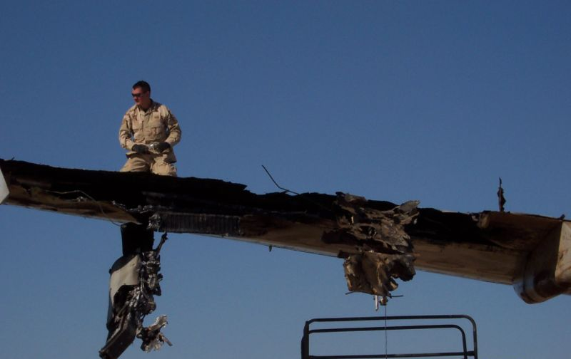
Damage caused by a fire in the wing of an Airbus A300 struck by an SA–14 MANPADS missile
on departure from Baghdad airport in November 2003.
(Photo: US Department of Defense)

MANPADS history
MANPADS were first developed in the late 1950s, in response to the advent of fast-moving jet aircraft which were initially perceived to have lowered the effectiveness of gun-based battlefield air defence systems.
First introduced into service in the late 1960s, there are now somewhere between 500,000 and 750,000 in worldwide inventories. They have been developed or produced under licence by more than a dozen countries.
MANPADS were originally designed and developed by the US and later developed by the former Soviet Union and other countries around the world. This chapter describes the characteristics of a few MANPADS to illustrate different design philosophies. Appendix A gives specific design and performance characteristics of some representative MANPADS.4
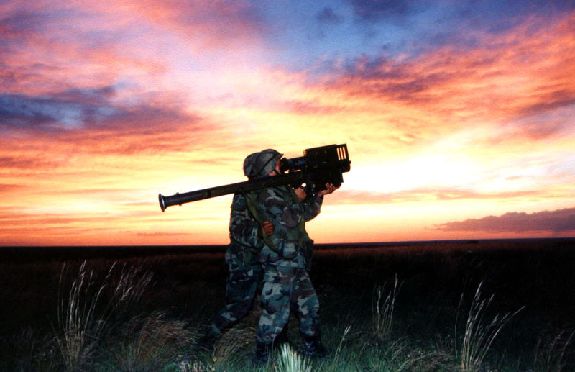

US National Guard soldiers training with a
Stinger missile in New Mexico
(Photo: US Department of Defense)

US MANPADS development
The first MANPADS deployed was the US-developed FIM–43 Redeye missile. Like most MANPADS, it is a passive infra-red homing missile that relies on detecting infra-red energy (associated with heat) emitted from an aircraft engine for its targeting. The missile is most effective when fired in a ‘tail chase’ mode where the hot exhaust of an aircraft is clearly visible. The FIM–43 Redeye was declared operational in 1968.
The well-known FIM–92 Stinger MANPADS began life as the Redeye II, and was redesignated as the Stinger in the 1970s. The FIM–92 family has formed the basis of an ongoing development program through a number of major upgrades to the missile, its seeker head and software. Later versions of the Stinger are able to engage aircraft at longer ranges. They also have the capability of attacking an aircraft from any direction, and thus are labelled ‘all aspect’ MANPADS. They are also more resistant to jamming and decoys. FIM–92 Stingers have been exported to at least seventeen countries.5
Both Redeyes and Stingers were provided to Mujahideen fighters in Afghanistan during the 1980s. They were used against Soviet helicopters and low-flying fixed-wing aircraft, including jets.

Soviet MANPADS developments
The Soviet Union also developed MANPADS. The first Soviet-designed MANPADS is known as the 9K32 Strela–2 (also known as the SA–7). When it entered service in the late 1960s, early Russian MANPADS proved inferior to their US equivalents. However, later models (the SA–7b) were significantly improved. The Strela series was replaced by the more capable Igla series (SA–16, SA–18 and SA–24). Like their western counterparts, later Russian MANPADS can be used to engage aircraft from all aspects.
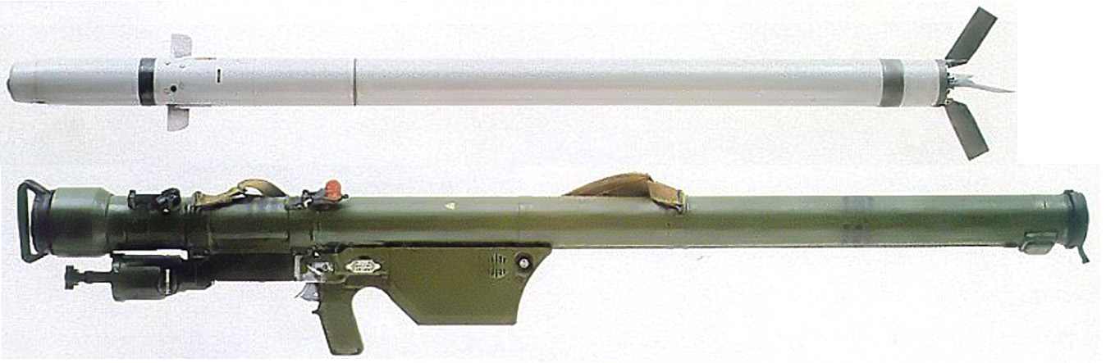
A Soviet 9K32 Strela-2 (SA-7) MANPADS. By far the most common type of MANPADS in the world,
these missiles have been widely exported and licensed for production elsewhere.
(Photo: US Army)
Russian MANPADS have been exported widely and licensed for production in a number of countries. They are the most common MANPADS on the world market.6 They have been used in a number of conflicts, including the Vietnam War and various Middle East conflicts. They have also been used by insurgent groups in Africa and elsewhere. The Iraqi insurgency has used the 9K34 Strela–3 (also known as the SA–14) to attack aircraft around Baghdad.

Later MANPADS
Although the United States and the former Soviet Union pioneered MANPADS technology, development and production of MANPADS is now more widespread. Many MANPADS continue to employ infra-red homing missiles, making them ‘fire and forget’ systems that require no operator input after firing. Other MANPADS, such as the British Blowpipe, require the operator to steer the missile with a small joystick, with course corrections communicated to the missile via radio link.
Later MANPADS designs replaced the joystick with optical or laser guidance. In the former case, the operator visually acquires the target using a magnified optical sight and then uses radio controls to guide the missile towards the target aircraft. Other systems, such as the British Starburst, require the operator to keep a laser steadily pointed towards the target. The missile then ‘rides’ the laser beam towards the target.
Such systems tend to be bulkier and more complex to operate than autonomous seekers like FIM–92 Stinger or SA–7, though they are also less susceptible to jamming or decoying. Aimed correctly, they can be very effective. However, significant training and practice is required to use them effectively.

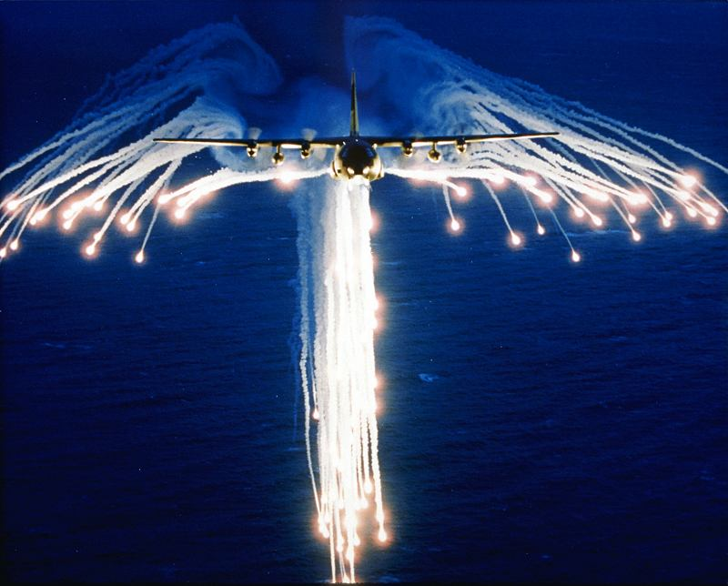
A Lockheed C-130 aircraft deploys infra-red flares in order
to decoy heat-seeking missiles away from the aircraft.
(Photo: US Air Force)

MANPADS countermeasures
Early infra-red seeking MANPADS such as the FIM–43 Redeye and SA–7 are susceptible to a number of countermeasures. Targeted aircraft could deploy heat/infra-red energy producing flares in order to decoy the missiles. Such flares produce a stronger infra-red signal than the target aircraft, decoying the missile and causing it to veer away and lose track of the target. Similarly, early missiles can lose track of the target aircraft if they are fired towards the sun. Later missile designs include ultraviolet sensors as well, allowing them to distinguish between flares and the signature of an aircraft.
As well as disposable stores such as flares, onboard laser or high-intensity lamp systems coupled with sensors that could detect and track an incoming missile offer a potential solution for MANPADS defence on aircraft. Having detected the missile, the light source would be used to produce a thin, intense beam of infra-red energy that would effectively overload the seeker on the missile, causing it to lose track of the aircraft. However, infra-red “lamp” jammers must be programmed against specific missile types, or they may inadvertently act as beacons, drawing the missile toward the target.
Engagement envelopes
Depending on their type, MANPADS have the ability to engage aircraft between three and seven kilometres away and can reach altitudes of between 10,000 and 15,000 feet above their launch point—although this is dependent upon the target’s bearing to the launcher, and its aspect. A typical ‘danger zone’ around a MANPADS is shown in Figure 1.
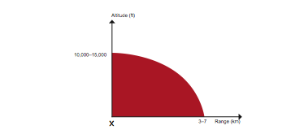
Figure 1. The engagement envelope of a typical MANPADS missile. An aircraft within the red area
is potentially in danger from a MANPADS missile fired from the point X.

While MANPADS ranges are modest compared to larger missile systems, they are large enough to have significant implications for the safety of aircraft taking off or landing. Figure 2 shows the area around a runway from which a MANPADS could be fired at an airliner with some chance of scoring a hit. The implications of this fact for civilian aviation are discussed in Chapter 3.

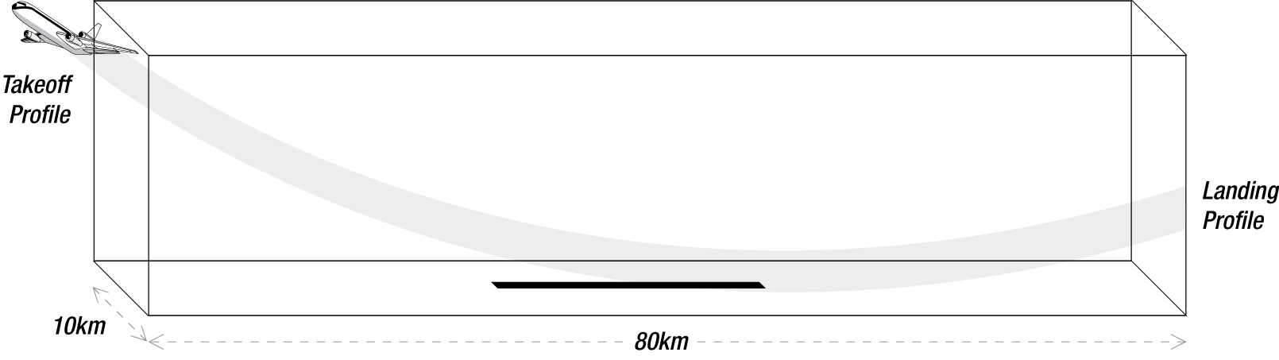
Figure 2. The typical area around an airport runway where an aircraft might be in danger from a ground-launched MANPADS missile. The total area is around 800 square kilometres.
RPGs
Because MANPADS are shoulder-launched, they can be confused with weapons such as RPGs, increasingly familiar from the wars in Iraq and Afghanistan. RPGs are colloquially termed Rocket Propelled Grenades (‘RPG’ is actually a transliteration of the Russian abbreviation of Reaktivniy Protivotankniy Granatomyot, or ‘rocket anti-tank launcher’). They are shoulder-launched unguided rockets and have a high explosive or anti-armour warhead designed to destroy vehicles. Offering only modest accuracy over a range of a few hundred metres, they would be of little use against a rapidly-moving target such as a jet aircraft on takeoff or landing, although insurgents and other groups have sometimes used them to bring down helicopters in war zones.7

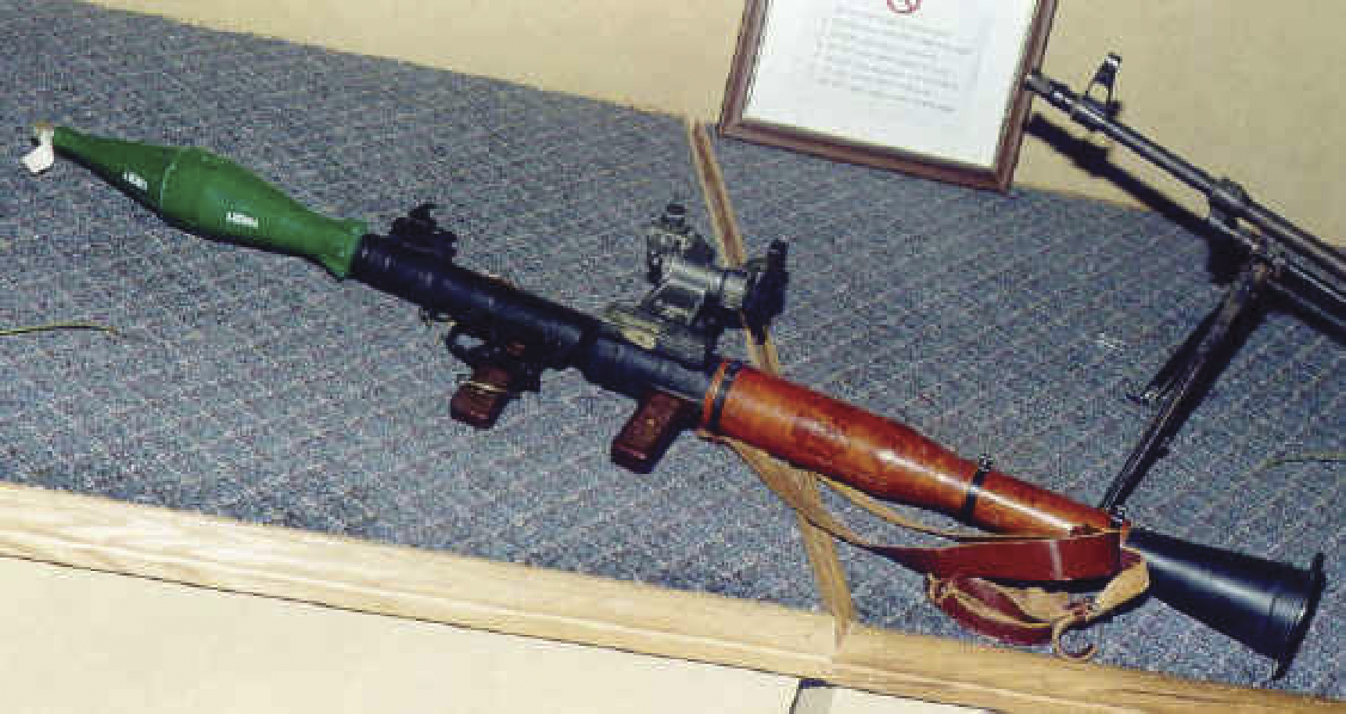

A Soviet-designed RPG–7. Such weapons are short-range unguided rocket projectiles quite distinct from MANPADS.
(Photo: US Army)

Chapter Two: MANPADS proliferation and non-state actors

Spread to non-state actors
It is estimated that worldwide inventories now hold between 500,000 and 750,000 MANPADS, developed or produced under licence by a number of countries. Many have been incorporated into military stocks where they remain today. Others have eventually been safely destroyed. However, some are known to have been illegally traded to third parties, including non-state actors.
Of the MANPADS outside state inventories, some have been used during periods of conflict by insurgent groups. And a small number have been used for attempted acts of terrorism.8
It is clear that terrorist groups actively seek to acquire MANPADS and are willing to use them against civilian aircraft given the opportunity. This chapter examines the history of MANPADS proliferation and assesses the threat posed by past transactions.

The effectiveness of MANPADS in the hands of
non-state actors
Like most weapon systems, MANPADS require a level of operator skill to use effectively. The batteries generally provide power for less than a minute, and the operator has to be able to acquire a target and launch the missile before the battery runs out, which can be difficult to do without continued practice. Additionally, much training in gauging target range, aspect and speed is required to be able to effectively employ MANPADS. Many of the MANPADS on the black market are early-generation designs that need the operator to have a rear-aspect shot to have a high probability of locking onto the target. This limits the ability of the shooter to find a suitable firing position.
These factors may explain why hit rates in Iraq and Afghanistan have been low compared to the number of missiles fired.9
In addition, the effectiveness of MANPADS in the hands of non-state actors is limited by finite battery life. MANPADS have their own battery packs to provide power to the launcher and sight and to set off the preliminary charge that pushes the missile out of the tube. The battery is a specialised piece of equipment and it has a finite life before replacement is required.
The lifetimes of rocket propellants and the coolant required for the seeker head of the missile are other factors that could limit the useable lifetime of MANPADS in the hands of non-state actors. Over time these chemicals will deteriorate, especially if the missile is stored in poor conditions with extremes of temperatures. Kept in their custom-designed storage cases, however, they could last for decades.
Mombasa MANPADS attack
On 28 November 2002, three suicide bombers crashed an SUV through a guard gate and onto the lobby steps of the Paradise Hotel, a seaside resort in Mombasa, Kenya. The detonation of the vehicle killed thirteen and injured eighty. Those killed were three Israeli tourists, two of them children, and ten Kenyan dancers who were performing to welcome 140 guests arriving from Israel.
Almost simultaneously, two shoulder-launched Strela 2 (SA–7) surface-to-air missiles were fired at a chartered Boeing 757 airliner as it took off from Moi International Airport. The missiles missed the aircraft, carrying 271 vacationers back from Mombasa to Israel, and it continued safely to Tel Aviv. Six live missiles were reportedly found at the scene.10
The missiles that were fired in Mombasa appear to have followed a circuitous route through Bulgaria to Yemen then either via an Eritrean state intermediary or directly to the group that actually fired them.11
The MANPADS fired in Mombasa in 2002 were manufactured in 1978. Despite their age, the missiles apparently missed due to operator error rather than malfunction. 12

Widespread production
Table 1 lists the countries that have developed and/or produced MANPADS. Many MANPADS producers have committed to the principle of working with other like-minded nations to ensure that exported missiles are secured and rigorously (and regularly) accounted for. The United States and the Russian Federation, for example, are working together to control exports and to bolster efforts to secure stockpiles.13

Table 1: MANPADS developers and/or producers
Countries developing and producing MANPADS | Countries producing MANPADS under licence
China | Bulgaria*
Russia* | Czech Republic*
United Kingdom* | Egypt
United States* | Germany*
 | Greece*
 | Japan*
 | Netherlands
 | Pakistan
 | Poland*
 | Romania*
 | Serbia
 | Switzerland*
 | Turkey*
 | Ukraine*
 | Vietnam
* denotes membership of the Wassenaar Arrangement export control regime for conventional weapons and dual-use goods and technologies
MANPADS inventories
An estimated 105 countries have MANPADS in their weapons inventories.14 In a May 2004 report, the US Government identified at least seventeen countries whose security over their MANPADS stockpiles raised concerns. These countries included Bosnia and Herzegovina, Liberia, Cambodia, Nicaragua, and Serbia. Total stockpiles of MANPADS in these seventeen countries are believed to number in the tens of thousands, according to the State Department.15
Destruction of known stockpiles of militarily obsolete or otherwise unwanted missiles contributes to counter-proliferation efforts. For example, the US has funded MANPADS stockpile destruction programs in Cambodia and, with NATO, in Serbia and Montenegro.16

Proliferation
The illicit proliferation of MANPADS can occur through:
• theft from manufacturers
• transfers from states to non-state actors
• loss or theft from state stockholdings
• loss of inventory control due to state collapse
• illicit transfers by black market arms dealers.
In total, the US Government estimates that ‘a few thousand’ MANPADS might be outside of government control around the world (though these are not necessarily functional). Thousands more MANPADS are in the inventories of countries that do not have the resources to impose sufficiently strict export controls, physical security or inventory controls. As such, they are at risk of being stolen or channelled into the hands of non-state actors.
The US State Department estimates that at least nine non-state actors, including al Qaeda, have obtained MANPADS at various times.17

Table 2: Terrorist groups believed to be in possession of MANPADS technology

Groups with SA-7 | Groups with Stinger
Al Qaeda (Afghanistan | Al Qaeda (Afghanistan)
Taliban (Afghanistan) | Hezbollah (Lebanon)
Hezbollah (Lebanon) | Kurdistan Workers Party (Turkey)
Kurdistan Workers Party (Turkey) | Tamil Tigers (Sri Lanka)
Tamil Tigers (Sri Lanka) | Hizbul Majahideen (Kashmir)
Harkat al-Ansar (Kashmir) | Armed Islamic Group (Algeria)
Revolutionary Armed Forces of Columbia (Columbia) | National Liberation Front (Columbia)

Following the collapse of the Soviet Union, MANPADS in several former Soviet-bloc inventories were surplus to requirements. While some stocks were destroyed, others made their way into the black or grey markets. Black market transactions generally include small numbers of MANPADS stolen by individuals from state inventories. MANPADS have also been transferred illegally from states to non-state actors. Black markets have been identified in countries and regions in or around war zones including Afghanistan, the Balkans, Iraq, Lebanon, Myanmar, Sri Lanka and a number of African countries, including Rwanda and Somalia.18
The grey arms market can apply to both legal and illegal arms transfers. Illegal transfers include those to countries subject to international sanctions or non-state end users—such as terrorist groups. ‘Grey arms’ can also refer to outwardly legitimate state-to-state transfers, facilitated by licensed arms dealers, the details of which are not immediately known to the reporting agency.
Although government to government, some deals may not meet international best practice standards of licensing and documentation. These sales can result in MANPADS in the possession of states without the means or will to control them properly. Some African states have been involved in grey market sales, and one such arrangement may have led to the missiles used in Mombasa ending up in the hands of terrorists.
Since the implementation of the Wassenaar Arrangement Elements for the Export Controls on MANPADS (2003 and amended in 2007), there has been increased regulation in reported MANPADS deals.19 These measures have largely affected the sale of modern MANPADS systems such as the Russian SA-24 MANPADS. Other bodies, such as the Organisation for Security and Cooperation in Europe—which provides advice and assistance in the control and disposal of surplus arms and ammunition, and the United Nations, have emphasised the danger presented by unregulated MANPADS.
MANPADS-producing countries—most being Wassenaar Arrangement members—subscribe to enhanced controls over exports. The remainder (including China) either have their own controls which are similar to Wassenaar controls, or have been engaged through Wassenaar Arrangement outreach programs (see Chapter Five). State collapse can also lead to proliferation. Prior to the defeat of Saddam Hussein’s forces in 2003, Iraq had a large inventory of MANPADS. Many of those were issued to security forces before the collapse of Saddam’s regime, or were looted from armouries and have passed outside of state control. This is a major source of the MANPADS missiles that have been fired at coalition or contractor aircraft since then.20 Similarly, MANPADS in the possession of the Taliban and other Afghan factions before the coalition invasion of Afghanistan were outside any rigorous control regime. Some of the missiles have been recovered or destroyed by coalition forces, but many remain outside of state control and firings against coalition aircraft have been commonplace.21

Chapter Three: MANPADS and civilian aircraft
As noted in the previous chapter, there are potentially thousands of MANPADS that are outside of official stockpiles. Many are older, less effective models and some are likely to be unserviceable today. This chapter will review the attacks that have occurred, and consider appropriate measures to lower the likelihood of future attacks and lessen the potential impact.
It is important to keep the threat from MANPADS in perspective. Attacks have been rare worldwide and almost exclusively confined to war zones. Even then, not all attempted attacks have resulted in a hit and not all hits bring down an aircraft.
MANPADS have been described by the UN as a ‘weapon of mass effect’, recognising that a credible threat of a terrorist attack is enough to affect public confidence and willingness to use civilian aviation.22 Civilian aircraft can be protected from MANPADS attacks using countermeasures. Military aircraft have carried such systems for some time but it is expensive to transfer that technology to civilian aircraft. However, technical countermeasures are only one part of a layered security approach to defeat and deter the threat posed to civil aviation posed by MANPADS. Other measures may include non-proliferation, intelligence gathering, stockpile management and airport security.

History of attacks and attempts
MANPADS attacks on civilian aircraft have occurred sporadically over the last thirty-five years. In total there have been around fifty attacks, resulting in the loss of over thirty aircraft and over 800 lives. As we know from the 2002 Mombasa attack discussed earlier and from other examples, not all attacks are successful.
Table 3 provides a summary of MANPADS attacks on civilian aircraft over the last forty years.23
Table 3: MANPADS attacks on civilian aircraft

 | Propeller-driven aircraft |  |  | Jet-powered aircraft
Flight Phase | Hits | Misses | Crashed | Hits | Misses | Crashed
Initial Climb | 5 | 0 | 5 | 2 | 1 | 1
Climb | 7 | 0 | 7 | 2 | 0 | 0
Cruise | 20 | 0 | 15 | - | - | -
Descent | 2 | 1 | 1 | 2 | 0 | 0
Approach | 2 | 0 | 1 | 6 | 1 | 3
Total | 36 | 1 | 29 | 12 | 2 | 4

Source: Study by QANTAS Group Security, 2007. Note that attack statistics vary between sources,
due in part to the difficulty of distinguishing the nature of some attacks.
The map below shows the distribution of attacks around the globe and by decade. In the 1970s, attacks occurred in Laos, Cambodia and Vietnam, where various conflicts were taking place. In the 1980s, many attacks occurred around Afghanistan, where MANPADS were in use by Mujahideen resisting the Soviet invasion or in Saharan Africa, where various conflicts occurred. The 1990s saw attacks move to the Middle East and former Soviet satellite states Georgia and Azerbaijan, coincident with the Gulf War and Chechen conflict respectively. Unstable states in Africa such as Angola, Rwanda, Congo and Sudan have been the location of many attacks over the entire time period.

Source: Study by QANTAS Group Security, 2007

By far the highest operational risk of MANPADS attack on aircraft is in war zones or places of conflict, where weapons are much more readily available, and the environment exhibits high levels of confusion, often allowing armed militants to move freely. However as the Mombasa incident shows, attacks can also occur in more peaceful locations.
Survivability of civilian aircraft
Military aircraft are designed to manoeuvre more aggressively than civilian aircraft. They are also required to be able to absorb battle damage and return to base. However, the survivability of jet-powered civilian aircraft from MANPADS attacks is high even without the defensive and avoidance capabilities of military aircraft. Many civilian aircraft designs have the inadvertent benefit of being less vulnerable to total destruction from a MANPADS hit than military aircraft, which frequently have the engines and ‘hotspots’ as a proportionally higher target surface area.
Engines in many civilian aircraft designs are mounted in pods suspended below the wings, so that damage to one will not necessarily cause damage to the others. Civilian airliners are designed, and certified by licensing authorities, to be able to fly with at least one engine inoperative. Thus, a four-engined aircraft such as a B747 can continue flight after loss of one engine, and a twin-engined aircraft, such as a B737, can operate on one engine. Prudent operation dictates that, in the event of an aircraft losing an engine, a precautionary landing is carried out at the nearest suitable airport. A hit from a MANPADS missile will not therefore necessarily result in the loss of the aircraft.
Hits on civilian aircraft by MANPADS have been infrequent, but a well-documented example of civilian aircraft survivability was provided by a DHL freight-carrying Airbus A300 that took off from Baghdad airport in late 2003. Insurgents fired two SA–7 MANPADS at it, one of which exploded on or near the left wing. The damage resulted in the loss of all hydraulic power to the control surfaces and a fire in the wing that eventually would have probably brought about its failure had the aircraft not been able to return for landing within a very-short period of time following impact.24 However, the crew managed to bring the aircraft under control to execute an emergency landing. All on board survived.
Aircrew should be able to recover the aircraft in most circumstances following a MANPADS missile impact. However, the initial damage caused by a MANPADS missile could—if corrective actions are not taken—lead to catastrophic failure of major airframe components.
US Air Force transport aircraft have been attacked flying into or out of Baghdad airport by MANPADS. A C–7 Globemaster and a C–5 Galaxy were struck by missiles, but in both cases the aircraft returned and landed safely.25 In March 2007, an Il–76 (a large four-engine Russian-designed transport aircraft) was shot down by a single SA-18 in Somalia.26

Protection of civilian aircraft
In public discussions of MANPADS threats, calls are sometimes made for the introduction of protective countermeasures on civilian aircraft.27 Military aircraft have carried such systems for some time and it seems natural to suggest that civilian aircraft should have the same protection. However, for various reasons, both technical and economic, there are significant difficulties in doing so—retrofitting systems onto existing aircraft may be prohibitively expensive. Since the September 11, 2001 hijackings in the United States, the US Department of Homeland Security (DHS) has instigated a program to investigate the feasibility of fitting civilian airliners with protective technologies.28 The RAND Corporation in the US has estimated that the ten year cost of developing, installing, operating and maintaining such systems could be as much as US$40 billion. Ongoing costs for maintenance would run to US$300,000 per aircraft thereafter.29
There are a number of ways to reduce the threat to civilian aircraft from MANPADS, including by:
• risk mitigation strategies via a coordinated intelligence-led approach
• avoiding airports where the MANPADS threat is highest
• changing the flight paths of aircraft to reduce their exposure on take-off or landing when they are most vulnerable
• increasing the secure zone around airports and/or implement a robust ground patrolling regime
• implementing a technical countermeasure system on aircraft that can decoy or defeat a missile fired at the aircraft.
While all of these measures have their place in a layered defence when the risk of MANPADS attack is high, none is infallible. And all of them have associated costs that make implementation problematic and of questionable benefit in low-risk environments.
Avoiding airports where the MANPADS threat is highest—around war zones for example—is an obvious response, but not always possible. At some stage on the cessation of hostilities, air traffic will resume but the threat may continue. As well, chartered traffic, such as aircraft carrying international negotiators or humanitarian workers, will still be at risk.
Changing flight paths is cheap and straightforward, though not always possible. For example, the threat of MANPADS attack can be reduced by routing take-offs and landings onto runways where security can be more easily maintained. Where geography allows, that could mean making more approaches from the seaward side of airports. While that is not foolproof, because MANPADS can be mounted on boats (as they sometimes are in military applications), it adds another level of complication for a would-be shooter. In times of threat alert, it would also make the job of the security authorities easier, since a vessel in the threat zone would be much more visible than a would-be shooter hiding in an urban area or in a nearby forest or jungle.
Securing and expanding an airport perimeter is not easily done in major cities. As noted in Chapter 1, the threat footprint is measured in hundreds of square kilometres. There would be a major social and economic cost to expanding the perimeter of an airport that is embedded in a suburban area. For that reason, a threat assessment of the areas surrounding an airport is crucial, as it allows law enforcement to target launching zones which present the highest risk to air traffic.
The more sophisticated sensors and software of modern missiles make them less susceptible to simple countermeasures. Countermeasure systems need to be more sophisticated, and capable of operating in a variety of settings against a range of potential missile threats. That drives up the cost and complexity of protection systems. Commercial airlines tend to be supportive in principle but concerned at the impact of increased costs.
Civilian airline representatives in the US and the International Air Transport Association have been working closely with the Department of Homeland Security and US defence industries on the development of low cost, low maintenance adaptations of the sophisticated military technical counter measures. The technology may provide viable future solutions.
The false alarm rate of existing countermeasure systems also creates a problem. While acceptable in many military settings, a false alarm on an aircraft approaching or departing a major airport creates a dilemma for air traffic control. Until the alarm is resolved—which may not be possible other than by physical inspection of the entire airport area—all other traffic would be put on hold or diverted to another airport.
Finally, no solution will be infallible in dealing with a missile that has already been launched. Any countermeasure systems have to be backed up by ongoing efforts to prevent the illicit proliferation of MANPADS to terrorists and non-state actors through strengthened export controls and secure stockpile processes.

Chapter Four: The cost of a successful MANPADS attack
Since 2001, we have witnessed a number of terrorist attacks around the world that have had major impacts on the psychology and economic interests of target nations.
The direct cost to a civilian airline of the destruction of an aircraft by a MANPADS missile would be very high. The replacement of a large passenger aircraft would cost upwards of US$250 million,30 while litigation, compensation payments and the economic loss due to death and injury could see the total cost rise to around the US$1 billion mark.31 Flow-on impacts will significantly raise the total cost.
Additionally, there is potential for collateral damage, and resultant costs should an aircraft crash into a populated area, leading to the deaths of people on the ground, and the destruction of buildings/infrastructure.
The total cost of a MANPADS attack would consist of a number of components, including: 32
• deaths of passengers and people on the ground (impact site)
• destruction of property and infrastructure
• direct cost to airline and passengers
• short-term airport closures
• productivity loss due to reduced seats for travel and/or increased travel times
• impacts on the cost and availability of airfreight space if flight numbers are reduced
• reduced tourism numbers
• longer-term impact on passenger numbers due to loss of confidence
• job losses in airline/tourism industries.
The September 11 2001 attacks in the US caused a fall in international and domestic air travel. It was three years before the industry fully recovered. The biggest impact was in the first year following the attack, with a 10% fall in international travel to and from the United States. In the second year the decline was down to 3% and by year three there was a slight increase in passenger numbers compared to the year before the attack. Without the attack, numbers would have increased steadily over the three year period in keeping with long-term trends.33
The RAND Corporation has estimated that a successful MANPADS attack in the United States would have a significant economic impact. A shutdown of all US airports for a period is estimated to cost US$3 billion during the first week. The flow on effects could rise to more than US$15 billion over the following months.34
Even an unsuccessful MANPADS attack, if reported widely, is also likely to have an economic impact, even though no aircraft is lost. The impact is likely to be less than if an aircraft crashes, but could easily still run into the billions of dollars if significant numbers of tourists decide to opt for other destinations. For example, Kenyan tourism destinations saw a marked downturn in visitors after the 2002 MANPADS attack and near-simultaneous hotel bombing.35
There is little doubt that any nation that depends on air travel and freight for a significant proportion of its economic activity is vulnerable to any disruption to commercial air transport. That is why it is important for the world community to work to minimise the opportunities for successful attacks to occur. International efforts against MANPADS proliferation is part of that effort.
Chapter Five: Counter-proliferation
International efforts
Australia has been active in promoting efforts to secure global MANPADS stocks and to bolster export controls. Other like-minded countries are also working to promote action to lower the risk of MANPADS attacks against civilian aviation. Due to the transnational nature of MANPADS production and proliferation, a sustained and coordinated international effort is required to address the truly global MANPADS threat.
The international approach aims to prevent the proliferation and illegal trade of sophisticated modern MANPADS, and to effectively manage or reduce existing military stockpiles of MANPADS. Current stocks must be stored securely and be well-accounted for. Obsolete stocks should be destroyed to prevent them from falling into the wrong hands. A number of multilateral and regional organisations have taken a proactive approach to the export control and stockpile management of extant MANPADS, and to the destruction of surplus systems.

International agreements and multilateral fora
The Wassenaar Arrangement is an important international agreement for the limitation of arms brokering, which has dedicated elements for export controls of MANPADS. The Wassenaar Arrangement aims to promote transparency and greater responsibility in transfers of conventional arms and dual-use goods and technologies, and to prevent destabilising accumulations.
The United Nations General Assembly has also been involved in MANPADS non-proliferation, adopting Australian-sponsored resolutions in 2004, 2006 and 2007 to prevent the illicit transfer of, unauthorised access to and use of MANPADS. APEC agreed on MANPADS declarations at its 2003 and 2005 meetings. The G8 has an action plan for reducing the risk to civilian aviation and the Organisation of American States also has MANPADS security and control guidelines. International efforts to curb the illicit spread of MANPADS have also been taken forward through the International Civil Aviation Organisation.
Similarly, the Leaders’ Declaration at the 2003 and 2005 Asia Pacific Economic Cooperation (APEC) meetings have made strong statements about the resolve of the participating states to strengthen joint efforts curb terrorist threats against mass transportation. In particular, the leaders resolved to meet the threat posed by the acquisition and use of MANPADS by terrorist groups.
Endorsing the elements identified by the United Nations, the 2003 APEC declaration included a review in 2004 of progress to date.36 At the 2004 meeting, the APEC Ministerial Meeting noted that they had agreed guidelines on the control of MANPADS. The participating states agreed to work domestically on implementing those guidelines and, as appropriate, to work with United Nations efforts.37
In 2005, the APEC Ministerial Meeting agreed that airport security, important for ensuring the continued flow of people and services for business and tourism, could be enhanced by conducting MANPADS vulnerability assessments at international airports. The Leaders endorsed the Ministerial Statement in full.38

Inventory management
In terms of inventory management and the elimination of surplus MANPADS, the Organisation for Security and Co-operation in Europe has published a Best Practice Guide for Stockpile Management and Security.
The United States and NATO have been active in the destruction of aging and obsolete MANPADS stockpiles. Australia has welcomed the United States’ international MANPADS destruction program in Cambodia, the Balkans and elsewhere. The program has seen over 17,000 surplus weapons destroyed in seventeen countries, with commitments to destroy thousands more.39 In addition, on 24 January 2008 the US administration appointed a Special Envoy on MANPADS Threat Reduction, to lead US non-proliferation efforts.40
The United Kingdom has been very active in promoting launch denial strategies at airports in Africa and the Middle East and has pledged support to encourage wider international implementation of effective controls over the manufacture, storage and transfer of MANPADS in the Asia–Pacific region. That includes building the capacity of regional states to provide appropriately rigorous export and inventory controls.41 France, Canada, Russia, Japan and other countries have also been important partners.42

Australian efforts
Australia has been active in raising its concerns through relevant UN bodies. In 2004, 2006 and 2007, as noted above, the United Nations General Assembly adopted by consensus an Australian-led resolution on preventing the illicit transfer of MANPADS.
Australia supports wider adoption of the Wassenaar Arrangements’ MANPADS export control standards as the international benchmark. In 2006 Australia was Plenary Chair of the Wassenaar Arrangement on Export Controls for Conventional Arms and Dual-Use Goods and Technologies, and used the forum to increase awareness of the MANPADS threat and the need for more effective export controls. During Australia’s tenure as Plenary Chair, the Australian Ambassador in Vienna led successful outreach mission to several countries. Other Wassenaar Arrangement participant states were supportive of Australia’s efforts to encourage greater cooperation, including from states that produce, export or stockpile MANPADS.
In June 2006, Australia hosted an international seminar for Geneva-based UN delegations to highlight practical international action to counter the global MANPADS threat. Late in 2006, Australia and Thailand hosted an ASEAN Regional Forum workshop on small arms and light weapons, including MANPADS. Regional experts shared information on the best methods for securing stockpiles. Australia also organised a MANPADS seminar for a UN audience in New York in January 2007.
Conclusions
The widespread production of MANPADS, the potential for proliferation to terrorist groups and the effectiveness of MANPADS in the hands of non-state actors represent a significant risk to civil aviation. The psychological impact and estimated cost of a MANPADS attack compels us to continue to take appropriate measures to mitigate the risk of an attack. Measures include:
• limiting the transfer of MANPADS production capabilities
• implementing programs to destroy surplus weapons and tightening the physical security of government MANPADS inventories
• strengthening international controls on the transfer and export of these weapons
• strengthening security around airports to make it harder for these weapons to be used
• the application of intelligence resources to identify potential MANPADS attack risks.

APPENDIX
Infra-red/heat seeking MANPADS characteristics
The table below shows the physical and performance data for a number of representative MANPADS types. Care should be taken in interpreting the data because there are variants of many types that differ in seeker and motor performance and software fits (and hence their ability to discriminate between aircraft and decoys or their final homing algorithms). The table contains broad capability parameters only.
Table. Some US and Russian MANPADS
MANPADS | FIM-92 Stinger | SA-7a Strela-2 | SA-14 Strela-3 | SA-18 Igla
Country of origin | USA | Russia | Russia | Russia
First fielded | 1987 | 1972 | 1978 | 1983
Weight (kg) | 15 | 14.5 | 16 | 17.9
Max Range (km) | 4.8 | 3.2 | 6.0 | 5.2
Min range (km) | 0.2 | 0.8 | 0.6 | 0.6
Max Height (ft) | 10,000 | 6,500 | 10,000 | 11,500
Maximum speed | Mach 2.2 | Mach 1.2 | Mach 1.8 | Mach 2.1
Seeker type | Infrared + ultraviolet | Infrared | Infrared with anti-flare filters | Infrared with anti-flare filters
Engagement aspect | All-round | From behind only | Some all-round capability | All-round
Comments | A very capable MANPADS in service with over 15 nations | The least sophisticated, but highly proliferated MANPADS | Exported to over 30 countries. More sophisticated than the SA-7 | Similar in performance to the Stinger
Sources: Federation of American Scientists, Global Security.org
Notes
1 MANPADS Proliferation’, Sarah Chankin-Gould and Matt Schroeder, January 2005,
http://fas.org/asmp/campaigns/MANPADS/MANPADS.html
2 ‘Man Portable Missiles versus Airliners’, Dr Carlo Kopp, Australian Aviation, December 2003.
3 ‘Man-Portable Air Defence Systems (MANPADS) Information Kit’, Department of Foreign Affairs and Trade, Canberra, undated.
4 Information on the characteristics and development history of many MANPADS can be found at the following websites:
Global Security: http://www.globalsecurity.org/military/intro/manpads.htm
Federation of American Scientists:
http://www.fas.org/asmp/campaigns/MANPADS/MANPADS.html
5 ‘NONPROLIFERATION - Further Improvements Needed in U.S. Efforts to Counter Threats
from Man-Portable Air Defense Systems’, US Government Accountability Office (GAO)
report GAO-04-519, May 2004.
6 ‘Man-Portable Air Defense System (MANPADS) Proliferation’, Federation of American Scientists. http://www.fas.org/programs/ssp/asmp/MANPADS.html
7 See for example ‘A terrifying scene, then a big crash (Blackhawk Down chapter 3)’, Philadelphia Enquirer, 18 November 1997.
8 The statements in the opening paragraphs and the data on proliferation in this chapter are drawn from the GAO report in footnote 6.
9 ‘According to the Chief of the U.S. Transportation Command, U.S. military cargo aircraft take ground fire in Afghanistan and Iraq from [MANPADS], anti-aircraft artillery and small arms on almost a daily basis’. Quoted in ‘Airlifters Routinely Take Ground Fire, General Says’, Defense Today, 29 July 2004, p.1
10 ‘Terror in Africa: Attacks in Mombasa’, New York Times, 30 November 2002.
11 ‘In whose hands? MANPADS proliferation to non-state actors and stockpile mismanagement’, a presentation to the Geneva Process on Small Arms by James Bevan, Small Arms Survey, at the Palais des Nations, 16 June 2006.
12 Small Arms Survey Yearbook 2004, Chapter 3, Big Issue, Big Problem? – MANPADS, available at: http://www.smallarmssurvey.org/files/sas/publications/year_b_pdf/2004/2004SASCh3_full_en.pdf
13 ‘Joint United States-Russian Federation Statement on the U.S.-Russia MANPADS Arrangement on Cooperation in Enhancing Control of Man-Portable Air Defense Systems’, US Department of State Media Note, 21 April 2006. http://www.state.gov/r/pa/prs/ps/2006/64968.htm
14 ‘MANPADS and small arms control’, The Ploughshares Monitor, Volume 25 Number 3, Autumn 2004. http://www.ploughshares.ca/libraries/monitor/mons04e.htm
15 US Government Accountability Office (GAO) report GAO-04-519, May 2004, cited above.
16 ‘Safe Passage: A Newsletter for the Humanitarian Mine Action and Small Arms/Light Weapons Communities’, US Department of State, December 2004, available at
http://www.state.gov/t/pm/wra/40291.htm#salw.
17 ‘MANPADS – Scale and Nature of the Threat’, Loren B. Thompson, Lexington Institute, 12 November 2003. http://www.lexingtoninstitute.org/docs/614.pdf
18 ‘Homeland Security: Protecting Airliners from Terrorist Missiles’, US Congressional Research Service report RL31741, updated 16 February 2006.
19 See http://www.wassenaar.org/introduction/index.html for details of the Wassenaar Arrangement and Updated MANPADS document for details of the Elements for the Export Controls of MANPADS
20 ‘The Struggle for Iraq: Missing Weapons; U.S. Can’t Locate Missiles Once Held in Arsenal of Iraq’, New York Times, 8 October 2003.
21 See footnote 14.
22 ‘Final record of the one thousand and thirty-eighth plenary meeting’, UN Conference on disarmament, Geneva, 24 August 2006.
http://disarmament.un.org/Library.nsf/a61ff5819c4381ee85256bc70068fa14/bc96aa78adfc0e408525730100697c74/$FILE/cd-pv1038.pdf
23 Much of the data in the section ‘History of attacks and attempts’ was compiled from various sources by QANTAS Group Security, provided in March 2007.
24 ‘Civilian plane hit by missile over Baghdad’, Sydney Morning Herald, 22 November 2003.
25 ‘SAMS hit aircraft in Iraq’, (US) Air Force Magazine Online, Vol 87, Number 4, February 2004. http://www.afa.org/magazine/Feb2004/0204world.asp
26 See the United nations report: Letter dated 17 July 2007 from the Chairman of the Security Council Committee established pursuant to resolution 751 (1992) concerning Somalia addressed to the President of the Security Council, 18 July 2007, paragraphs 39–40. http://www.fas.org/asmp/campaigns/MANPADS/2007/S_2007_436.pdf
27 See, for example, ‘Flying in the face of terror’, The Australian, 23 February 2007.
28 There are a number of papers and presentations on protecting civilian aircraft from MANPADS available on the Department of Homeland Security website www.dhs.gov. For example, see ‘Fact Sheet: U.S. Department of Homeland Security Programs Countering Missile Threats to Commercial Aircraft’, 25 August 2004.
29 ‘Protecting Commercial Aviation Against the Shoulder-Fired Missile Threat’, RAND Infrastructure, Safety and Environment occasional paper OP-106, 2005.
30 A Boeing 747-400ER suitable for long-range international flights is priced by Boeing at US$250 million (in 2007 dollars). An Airbus A340-600 has a list price of approximately US$230 million (2007 dollars).
31 The figure for compensation payments will vary between countries. The figure quoted here is taken from ‘The Economic Implications of terrorist Attack on Commercial Aviation in the USA’, Center for Risk and Economic Analysis of Terrorism Events Report #05-024, University of Southern California, Los Angeles, 4 September 2005.
32 This list is not exhaustive, but reflects the most significant costs. It was compiled from the reference 2 in note 31 above, and from ‘Economic Impact of a Notional Terrorism Incident at a Major Airport in Australia’, Bureau of Transport and Regional Economics, Canberra, March 2007.
33 Data from the Visitor Bureau USA, as presented in the report in note 31.
34 See the report in note 29 above.
35 ‘Terrorism taking toll on Kenya’s tourist industry’, National Geographic News, 17 June 2003. http://news.nationalgeographic.com/news/2003/06/0617_030617_kenyatourism.html
36 ‘Bangkok Declaration on Partnership for the Future’, 11th APEC Economic Leaders’ Meeting, Bangkok, Thailand, 21 October 2005.
http://www.apecsec.org.sg/apec/leaders__declarations/2003.html
37 Sixteenth APEC Ministerial meeting, Joint Statement, Santiago, Chile, 17–18 Nov. 2004. http://www.apecsec.org.sg/apec/ministerial_statements/annual_ministerial/2004_16th_apec_ministerial.html
38 ‘Busan declaration’, 13th APEC Economic Leaders’ Meeting, Busan, Korea, 18–19 November 2005. http://www.apecsec.org.sg/apec/leaders__declarations/2005.html
39 The US Department of State Fact Sheet ‘The MANPADS Menace: Combating the Threat to Global Aviation from Man-Portable Air Defense Systems’ available at
http://www.state.gov/t/pm/rls/fs/53558.htm contains a summary of multilateral MANPADS destruction activities involving the US, NATO and other parties.
40 ‘President Accords Personal Rank of Ambassador to Lincoln P. Bloomfield Jr. as Special Envoy for MANPADS Threat Reduction and Lead for United States Efforts to Protect International Aviation from Shoulder-Fired Anti-Aircraft Missiles’, US Department of State Media Note, 24 January 2008. http://www.state.gov/r/pa/prs/ps/2008/jan/99683.htm
41 ‘The real terrorist missile threat and what can be done about it’, Federation of American Scientists Public Interest Report, Volume 56, Number 3, Autumn 2003.
42 The Japanese Foreign Minister stated his country’s position on MANPADS at the UN in 2003: ‘Statement by H.E. Mr. Mitsuro Donowaki, Alternative Representative of Japan, at the First Committee of the 58th Session of the General Assembly, on the Report of the 2003 Group of Governmental Experts on the United Nations Register of Conventional Arms’.
http://www.mofa.go.jp/announce/speech/un0310-14.html Joint US/Russian efforts are detailed in the report in footnote 16.

