COUNCIL REGULATION (EEC) No 2081/92  
APPLICATION FOR REGISTRATION: Art. 17  
PDO (X ) PGI ( )

National application No: -

1. Responsible department in the Member State:

Name: Ministry of Agriculture, Directorate for the Processing, Standardisation and

Quality Control of Products of Plant Origin Tel: 5291 303 Fax: 5243 162

1. Applicant group:
2. Name: Union of Agricultural Cooperatives of Egialia, Prefecture of Aliai'a
3. Address: Corinth Road, Selinonda Bridge, PO Box 9, Egion 25100 (b) Composition : producer/processor ( X ) other ( )

3. Type of product: 1.6. Fruit and vegetables

4. Specification:

(summary of requirements under Art. 4(2))

**Κορινθιακή Σταφίδα Βοστίτσα (Korinthiaki Stafida Vostitsa**)

A truly excellent currant which has been produced traditionally in the closely defined geographical area for centuries.

The Vostizza current grape is grown exclusively in the Egialia district and in the former municipalities of Erineou, Krapidos, Fellois and Petsakon in the prefecture of Aliai'a.

The product has been produced exclusively in the abovementioned geographical area for centuries using the same traditional method of cultivation and drying etc. and the name by which it is known is the old name for Egion (Vostizza). It has enjoyed protection under Greek legislation for many decades.

After being dried naturally (in the shade or in the sun) the grapes are sorted by hand and then undergo cleaning, sieving, the machine process, washing, destalking, cleaning again, glossing in some cases with vegetable oils, standardisation and, finally, packaging by various means. The product has been produced from the currant grape variety in the same traditional way in the Vostizza area (Vostizza is the old name for Egion) for centuries. The microclimate of the area differentiates the Vostizza currant from currants produced in other areas and accounts for its exceptionally high reputation..

Aliai'a Prefecture Agriculture Directorate Patras

PDO Κορινθιακή Σταφίδα Βοστίτσα (Korinthiaki Stafida Vostitsa)

. The inspection code, the label serial number and the two final numbers of the year of

1. name:
2. description:

4.3. geographical area:

4.4. proof of origin:

4.5. method of production:

4.6. link:

1. inspection body:
2. labelling:

Name:

Address:

|  |  |
| --- | --- |
| 4.9. national requirements: | production.  The provisions of Law 553/77 and of Presidential Decrees 653/8-10-1975 and 81/93 are applicable. |
| EC No: G/GR/0358/94.01.24 |  |

Date of receipt of the full application: 20/05/97

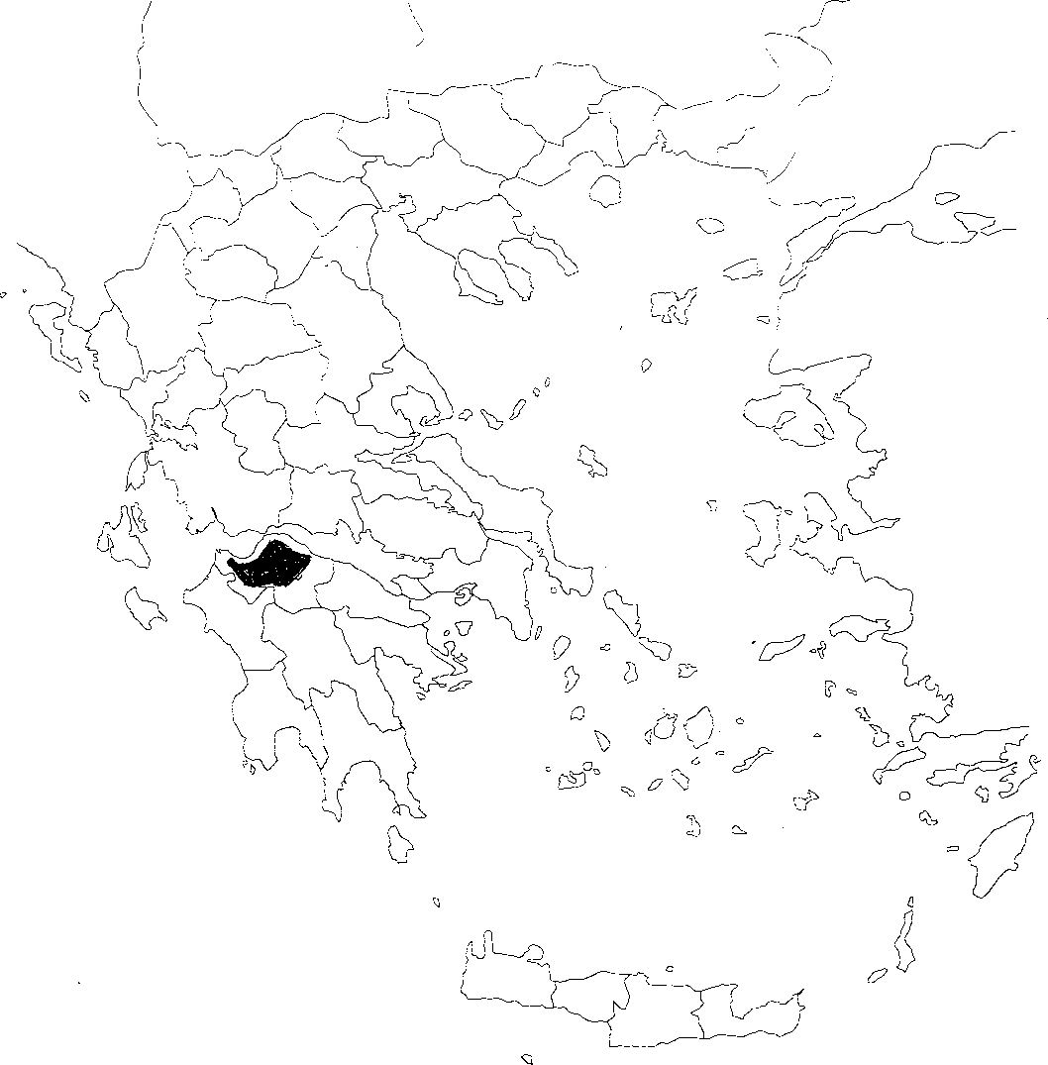

" 0oi7ifiA" fjDI]