Summary Technical Specifications
for registration of geographical indications

Name Of The Geographical Indication:
Rhum de la Martinique
Category Of The Product For Which The Name Is Protected
“Rum” (category 1 of Annex II to Regulation (EC) No. 110/2008)
”Rhum de la Martinique” rum is produced exclusively by alcoholic fermentation and distillation of sugar-cane juice as stated in point 1.aii of Annex II to Regulation (EC) No. 110/2008
Applicant:
Syndicat de Défense de l’AOC Rhum Agricole Martinique
Usine Soudon
Route du Vert Pré – 97232 LE LAMENTIN
Protection In EU Member State of Origin
First protection in France : decree of 5 November 1996 defining the controlled appellation of origin “Rhum de la Martinique”.
First protection in Europe: Council Regulation (EEC) of 29 May 1989 laying down general rules on the definition, description and presentation of spirit drinks No. 1576/1989 entered into force, as of 15 December 1989.
Description Of The Agricultural Product Or Foodstuff
Rhum agricole ”Rhum de la Martinique” (agricultural Rum) has the specific characteristics of rum marked by roundness and aromatic finesse.
The minimum alcoholic strength by volume shall be 40 %.
- Rhum agricole blanc ”Rhum de la Martinique” (white agricultural Rum) is colorless, expresses fruity, floral, spicy aromas and contains a quantity of volatile substances equal or exceeding 225grams per hectolitre of 100%vol.alcohol. This rum is left to rest in vat for a minimum period of 8 weeks after distillation.
- Rhum agricole ”Rhum de la Martinique” (agricultural Rum) maturated in casks is colored; expresses fruity, floral, spicy, balsamic and empyreumatic aromas and contains a quantity of volatile substances equal or exceeding 250 grams per hectolitre of 100%vol.alcohol. It must be stored a minimum of one year in oak containers.
- Rhum agricole vieux ”Rhum de la Martinique” (old agricultural Rum) is steady colored, ranging from honey to dark mahogany; expresses woody, fruity, spicy, empyreumatic and balsamic aromas and contains a quantity of volatile substances equal or exceeding 325 grams per hectolitre of 100%vol.alcohol. This rum must absolutely be aged in oak barrels of an under 650 liters capacity for at least three years.
The production of plant material, the harvesting and processing of sugar cane, the distillation, maturation or ageing of the rums and the packaging of rum "vieux" must take place in the geographical area.
Concise Definition Of The Geographical Area
The geographical area includes the Martinique island which is a French overseas department in the eastern Caribbean Sea,.The geographical area spreads over the island with the exception of dependent islets and rocks.  Inside the geographical area, the sugarcane production area is delimited. | 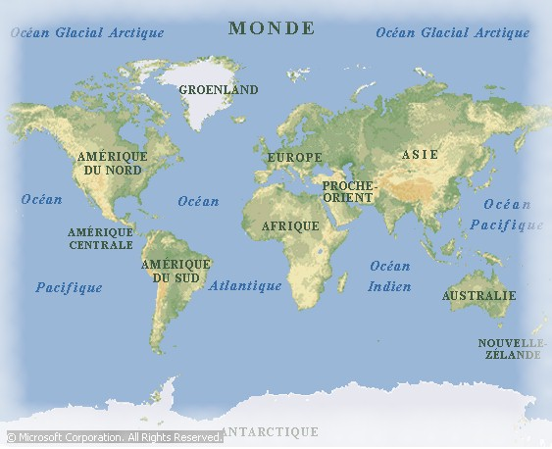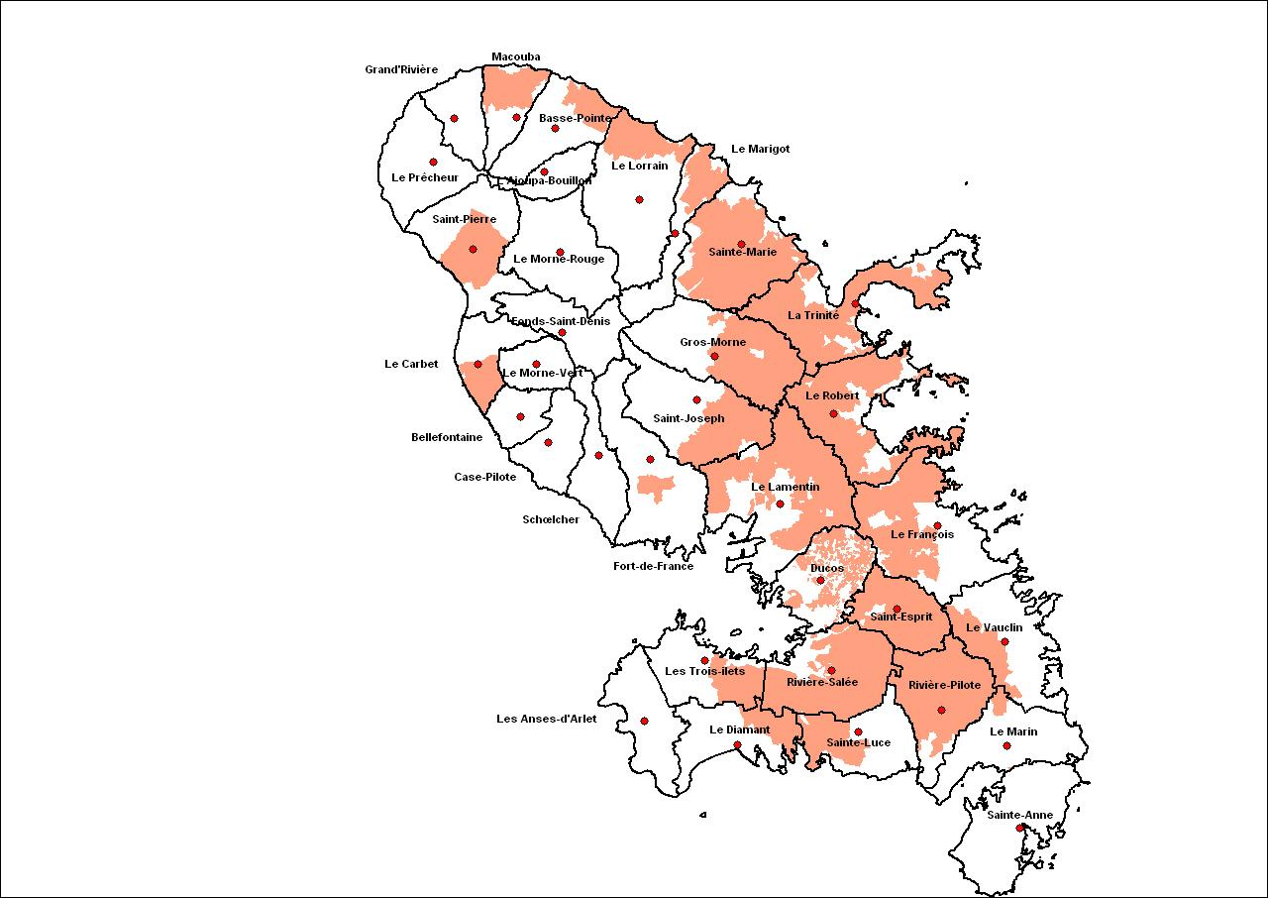
Link With The Geographical Area
Rhum agricole ”Rhum de la Martinique” is the result of a combination of elements related to the natural environment of the island and the history of rum in the French Caribbean.
The production of sugar cane is promoted by climatic conditions in Martinique which enable both vegetative growth during the wet season and its maturation during the dry season.
However, the topographical conditions of some landlocked areas of the island have prevented from following the production intensification required from the nineteenth century by the sugar industry. Thus, some plantations have been forced to give up sugar production and convert to the production of “Rhum agricole”.
The production of rum has developed with the arrival of technological innovations such as the steam engine or continuous distillation columns. These columns have been adjusted to take into account the specificities of fermented sugar cane juice derived from fermentation conditions and therefore dependent on climatic characteristics.
Under the influence of high ambient temperature and oak barrels, ageing is characterized by high evaporation, accelerated oxidation reactions and high extraction of wood, giving rhum agricole ”Rhum de la Martinique” all its organoleptic features.
Specific Rules Concerning Labelling (If Any)
- the geographical indication « Rhum de la Martinique» shall be supplemented by the supplementary terms « agricole» and « appellation d’origine contrôlée »
- the geographical indication « Rhum de la Martinique » may be supplemented by the terms «blanc» or «vieux»
Control authority/control body
Institut national de l’origine et de la qualité, 12, rue Henri Rol-Tanguy, - TSA 30003 – 93 555 Montreuil-sous-Bois cedex
Direction générale de la concurrence, de la consommation et de la répression des fraudes, 59 boulevard Vincent Auriol, 75703 PARIS Cedex 13

