**Technical file**

**Date of receipt** (DD/MM/YYYY) ...

*[to be completed by the Commission]*

**Number of pages** (including this page) 4

**Language used for submission of application** German

**File number: ...**

*[to be completed by the Commission]*

**Geographical indication to be registered**  ***‘*Wachauer Marillenbrand*’***

**Category of the spirit drink**

Product category 9. Fruit spirit, Annex III to Regulation (EC) No 110/2008

**Description of the spirit drink**

* *Physical and chemical characteristics*

Alcoholic strength: min. 38 % vol.

Total dry extract: max. 5 g/l, including no more than 4 g of sugar (expressed as invert sugar) per litre of finished product

Methanol content: max. 1 200 g/hl of 100 % vol. alcohol

Total hydrocyanic acid: max. 7 g/hl of 100 % vol. alcohol

Ethyl carbamate: max. 1 mg/l of product

Volatile matter[1]: min. 400 g/hl of 100 % vol. alcohol;

Ethyl acetate: max. 350 g/hl of 100 % vol. alcohol

Sum of iso-butanol and iso-amyl alcohols: min. 100 g/hl of 100 % vol. alcohol;

Sum of 1-Propanol, iso-butanol and iso-amyl alcohols: min. 150 g/hl of 100 % vol. alcohol;  
max. 1 000 g/hl of 100 % vol. alcohol;

* *Organoleptic properties*

‘Wachauer Marillenbrand’ is clear and colourless. Compared with ordinary apricot spirits, it has a characteristically fragrant floral smell, reflecting the full fruity taste of ripe ‘Wachauer Marille’ apricots with a fruit-pit tone that is discreet and never dominant.

* *Specific characteristics (compared to spirit drinks of the same category)*

The ‘Wachauer Marille’ PDO covers the range of varieties that were traditionally selected and planted by apricot growers and apricot nurseries in the Wachau between 1900 and 1960. These special varieties differ from other varieties of apricot by virtue of their quintessentially spicy, fresh-fruit aroma and are key to making this spirit what it is. A particular feature of ‘Wachauer Marillenbrand’ is its mellow, full flavour, with a spicy, invigorating multi-layered apricot aroma that lingers in the finish. ‘Wachauer Marillenbrand’ has a slightly higher minimum alcohol content than ordinary apricot spirit, and the amount of sugar it contains to round off the taste is very small and strictly limited. The relevant parameters are described under ‘Physical and chemical characteristics’.

**Geographical area**

**‘**Wachauer Marillenbrand’ is produced exclusively in distilleries in the defined geographical area comprising the Wachau-Mautern-Krems region.

The area comprises the municipalities of Aggsbach-Markt, Albrechtsberg, Bergern im Dunkelsteinerwald, Droß, Dürnstein, Emmersdorf, Furth, Gedersdorf, Krems, Maria-Laach, Mautern, Mühldorf, Paudorf, Rohrendorf bei Krems, Rossatz-Arnsdorf, Schönbühel-Aggsbach, Senftenberg, Spitz, Stratzing, Weinzierl am Wald and Weißenkirchen.

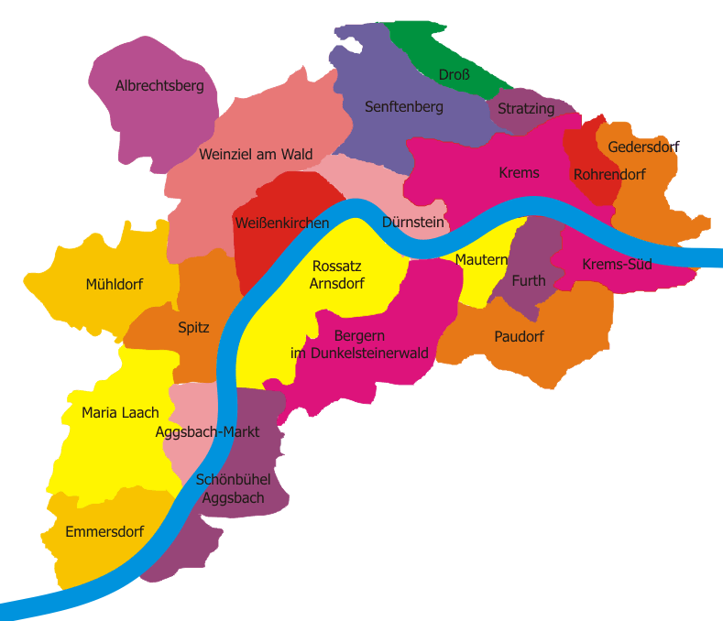

**Photo credit:** [**http://www.wachauermarille.at/cms/pages/verein/mitglieder.php**](http://www.wachauermarille.at/cms/pages/verein/mitglieder.php)

**Method for obtaining the spirit drink**

‘Wachauer Marillenbrand’ may be produced, by means of alcoholic fermentation and distillation, only from fully ripe fruit conforming to the specification for[2] ‘Wachauer Marillen’.

In order to achieve what is generally no more than a discreet fruit-pit note, the fruit is usually pitted before it is macerated.

Unpitted fruit is crushed gently so as to avoid damaging the stones as far as possible. Fermented macerates of unpitted apricots are stored only for short periods prior to distillation, and the stones are not pumped into the distillation unit.

Distillation takes place in simple stills or in stills with a dephlegmator. Continuous distillation is not compatible with traditional production methods and is not used.

The water used to reduce to drinking strength comes, if suitable, from the region and has a hardness of not more than 8.4 German degrees; otherwise de-ionised water may be used.

**Link with the geographical area**

* *Details of the geographical area or origin relevant to the link*

Upon Austria's accession to the EU on 29 August 1994 (Act of Accession (94/C 241 /08), OJ C 241, 29.8.1994, p. 21), ‘Wachauer Marillenbrand’ was listed in Annex II to Regulation (EEC) No 1576/89 as a geographical designation pursuant to Article 5(3) of that Regulation. Its listing was preceded by a long tradition of Marillenbrand (apricot spirit) production in the Wachau-Mautern-Krems region, which gave the product a reputation that extends far beyond the borders of Austria and is inextricably linked with the region.

Only ‘Wachauer Marille’ apricots from certified apricot orchards are used as the raw material for producing ‘Wachauer Marillenbrand’ and it is to these apricots that the product owes its specific fruity aroma as well as its reputation, based as it is on traditional production in the region.

* *Specific characteristics of the spirit drink attributable to the geographical area*

As a result of the region's climate, shaped by the interaction of the Pannonian and Waldviertel climates, the close proximity of the River Danube and the great differences between day and night temperatures in particular when the apricots are ripening, the effect of the soil, and the over 100-year old tradition of fruit growing, ‘Wachauer Marille’ PDO apricots and their distinctive quality also play a key part in terms of the spirit's fresh fruity-spicy flavour, aroma and other constituents.

The high regard in which ‘Wachauer Marillenbrand’ is held throughout Europe, and especially in Germany, is demonstrated in particular by contests such as the *Goldene Stamperl*, held as part of *Ab Hof! Wieselburg* (a fair specially for farmers who market their produce direct from the farm), and various other regular tasting competitions.

**European Union or national/regional provisions**

Since the Agreement on the European Economic Area (EEA Agreement, BGBl. No 909/1993) was signed, ‘Wachauer Marillenbrand’ has been one of the Austrian spirit drinks that are recognised by the signatories and hence an established geographical indication listed in Annex III to Regulation (EC) No 110/2008 of the European Parliament and of the Council of 15 January 2008 on the definition, description, presentation, labelling and the protection of geographical indications of spirit drinks and repealing Council Regulation (EEC) No 1576/89, as provided for in Article 20 of that Regulation

At national level, the specification for ‘Wachauer Marillenbrand’ has been published in Chapter B 23 - Spirits of the current edition of the Austrian Food Code [*Österreichisches Lebensmittelbuch*] and may be downloaded from the website www.lebensmittelbuch.at.

**Applicant**

Member State: Austria

Bundesministerium für Gesundheit [Federal Ministry of Health]

Radetzkystraße 2

1030 Vienna

Telephone: 0043 (0)1 71100-0

E-mail: [IIB13@bmg.gv.at](mailto:IIB13@bmg.gv.at)

**Supplement to the geographical indication**

None

**Specific labelling rules**

The name of the distillery which made the product must be indicated.

The EU symbol for registered geographical indications established in Annex V to Regulation (EC) No 1898/2006[3] may be used as provided for in Article 22 of Commission Implementing Regulation (EU) No 716/2013[4].

1. Point 12 of Annex I to Commission Regulation (EC) No 110/2008
2. Regulation (EC) No 510/2006: Amendment application in accordance with Article 9 ‘Wachauer Marille’ EC No AT-PDO-0117-1473-29.06.2011 PDO (2012/C 140/06), OJ C 140, 16.5.2012, p. 18; approved by Commission Implementing Regulation (EU) No 265/2013 of 18 March 2013.
3. OJ L 369, 23.12.2006, p. 1.
4. OJ L 201, 26.7.2013, p. 21.