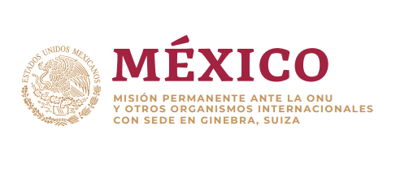

Statement of the Group of friends of the Convention on the rights of persons with disabilities

43rd session of the Human Rights Council

Annual interactive debate on the rights of persons with disabilities

March 6th, 2020

Time: 2 minutes

It is my honor to deliver this statement on behalf of the Group of friends to the Convention on the rights of persons with disabilities.

We are pleased to participate in this annual debate and welcome the distinguished panelists and their contributions as well as the report presented by the Office of the High Commissioner for Human Rights.

All around the world, persons with disabilities continue to face prejudices and stereotypes, which perpetuate discrimination against them in all aspects of life. Awareness raising is key to tackling these misconceptions and to ensuring that persons with disabilities are able to fully enjoy their rights under the CRPD.

The media plays a key role in shaping views and opinions including on disabilities. We are strongly convinced that public/private partnerships regarding media associations can be very useful for encouraging a positive portrayal of persons with disabilities and respect for their rights at all levels of society.

Likewise, in line with article 4.3, persons with disabilities should participate in all processes related to them, including awareness raising strategies and the development and implementation of laws and regulations related to the media. This is not only in line with our commitments under the Convention but is crucial to achieve positive results, change misconceptions and stereotypes.

The group of friends remains committed to the principles and purposes of the CRPD, including article 8, and we welcome that this council will adopt a resolution on this issue during this session. We encourage all delegations to engage in negotiations on the resolution and specially encourage persons with disabilities and their organizations to participate.

Finally, we would like to take this opportunity to recognize the work of the Special Rapporteur, Ms. Catalina Devandas, who´s professionalism and commitment to this agenda has made it possible to advance the mainstreaming of the rights of persons with disabilities in the Council and in the UN System.

Thank you.