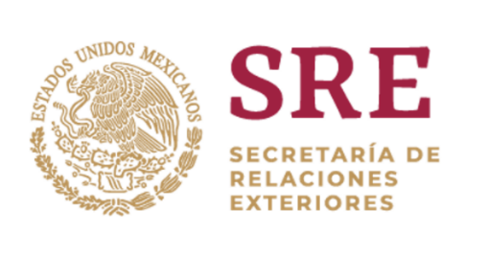

**42nd Regular session of the Human Rights Council**

19 September 2019

**ID with the Advisory Committee of the Human Rights Council**

Thank you Mr. President,

I have the honour to deliver this statement on behalf of the MIKTA group of countries: Indonesia, Republic of Korea, Turkey, Australia and Mexico. We would like to thank the Advisory Committee for the presentation of its report.

Our countries would like to address two topics that are of great priority for us, and are on the agenda of the Advisory Committee: gender parity in international organs and the impact of new technologies on human rights.

The Advisory Committee has been mandated to prepare areport on current levels of representation of women in human rights organs and mechanisms. We hope that the report will contribute to increasing the rate of women's participation in the near future, in all matters and all levels, which in turn will have an impact in eradicating social stereotypes that prevent women from being more involved or playing a leading role within the UN system.

We call upon States to nominate, elect and appoint women candidates to ensure balanced gender representation as a way to go forward in gender parity in the UN system.

Mr. President,

New and emerging technologies have an impact on every aspect of our social, economic, political and private lives, therefore, we welcome that the broad spectrum of their implications on human rights will be further analysed by the Advisory Committee. Today, as never before, we need to be aware, **of the possible impacts, opportunities, and challenges of new and emerging digital technologies regarding the promotion and protection of human rights,** as well as to ensure that both public and private actors operate in accordance with the international human rights standards.

We encourage the Advisory Committee to work closely in cooperation with all stakeholders, including civil society organizations and academia, during the preparation of these two reports. Our countries look forward to cooperating with the Advisory Committee in the fulfilment of these mandates.

I thank you.