**TECHNICAL SPECIFICATIONS FOR THE   
REGISTRATION OF THE GEOGRAPHICAL INDICATION**

**NAME OF THE GEOGRAPHICAL INDICATION**

Calvados

**PRODUCT CATEGORY**

Spirits

**COUNTRY OF ORIGIN**

France

**APPLICANT**

Syndicat des producteurs de Calvados et eaux de vie de cidre de Normandie

CICD

Immeuble Citipolis - Place Boston

14200 HEROUVILLE SAINT CLAIR

France

**PROTECTION IN THE COUNTRY OF ORIGIN**

*Date of Protection in the European Union:* 29.5.1989. Regulation (EEC) No 1576/1989 of 29 May 1989 laying down general rules on the definition, description and presentation of spirit drinks, in force since December 15, 1989.

*Date of Protection in the Member State:* 09/09/1942. Decree of 9 September 1942 defining the Calvados appellation.

**PRODUCT DESCRIPTION**

Spirits, Cider and perry (category 10 of Annex II of Regulation (EC) No 110/2008).

The Calvados Cider is obtained from the distillation of cider or perry produced from certain varieties.

The Calvados is aged in oak barrels, giving it an amber color, but is reminiscent of the organoleptic characteristics of the fruit.

The Calvados has a content of volatile substances equal to or greater than 450 g / hl of alcohol at 100% vol.

The Calvados has a maximum methanol content of 200 g / hl of alcohol at 100% vol.

The minimum alcoholic strength by volume shall be 40% vol.

The harvest of fruits, processing of musts, cider or perry, and distillation and aging of spirits, take place in the geographical area.

**DESCRIPTION OF THE GEOGRAPHICAL AREA**

The geographical area comprising most of the departments of Calvados, Orne, Manche and Eure and small parts of the departments of Mayenne, Seine Maritime, Oise and Sarthe, in western France.

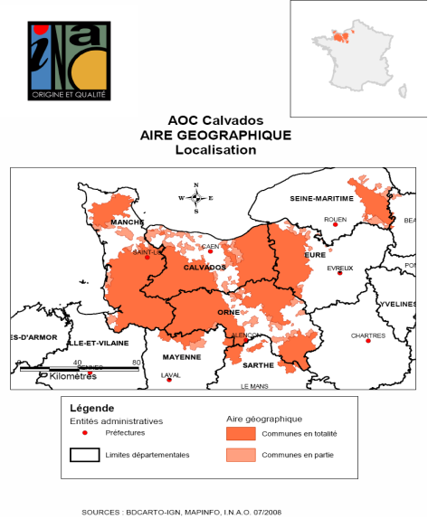

**LINK WITH THE GEOGRAPHICAL AREA**

The apple cider and perry pear trees have favorable conditions for growth due to the high and constant rainfall, mild temperatures, and the thickness and height of the hedges that protect orchards from westerly winds.

The varieties of cider apples and perry pears, rich in phenolic compounds, develop slowly- fermented ciders.

The climatic characteristics and regional grazing techniques have enabled the development of traditional orchards. This type of tree orchard allows the development of the characteristics of the fruit (variety , good storage, sugar content , little treatment ... ) .

The materials and processes are designed distillation to obtain an alcoholic cider low to medium , and result in a high concentration of aromas. Moisture conditions allowing a specific aging by promoting evaporation of the alcohol, and not the water, and on the other hand, to slow the chemical reaction. These conditions converge to preserve maximum fruity aromas of Calvados.

**SPECIF RULES FOR LABELLING, IN CASE THESE EXIST**

The geographical indication 'Calvados' may be accompanied by supplementary terms 'production fermière' or 'produit fermier'.

The geographical indication 'Calvados' may be supplemented by the words' appellation d'origine contrôlée ».

**CONTROL BODY**

Direction générale de la concurrence, de la consommation et de la répression des fraudes, 59 boulevard Vincent Auriol, 75703 PARIS Cedex 13 - Francia

Institut national de l’origine et de la qualité, 12, rue Henri Rol-Tanguy, - TSA 30003 – 93 555 Montreuil-sous-Bois cedex - Francia