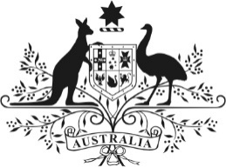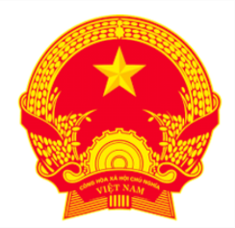
Joint Meeting Statement

2nd Australia-Vietnam Trade Ministers’ Dialogue
Melbourne, 19 November 2025
Joint statement between Australia’s Minister for Trade and Tourism, Senator the Hon Don Farrell, and His Excellency Mr Nguyen Hong Dien, Vietnam’s Minister of Industry and Trade.
Australia’s Minister for Trade and Tourism, Senator the Hon Don Farrell, hosted Viet Nam’s Minister of Industry and Trade, H.E Mr Nguyen Hong Dien for the Second Trade Ministers’ Dialogue on 19 November 2025 in Melbourne. Ministers discussed initiatives to further deepen bilateral economic cooperation under the Australia - Viet Nam Comprehensive Strategic Partnership.

Ministers acknowledged the longstanding and strong economic partnership between Australia and Viet Nam, based on complementary economies, strong people-to-people links, and a shared commitment to the rules-based global trading system. In recent years, two-way trade has increased rapidly. Viet Nam is Australia’s 10th largest two-way trading partner in goods and14th largest two-way trading partner in goods and services. Australia is Viet Nam’s 10th largest two-way trading partner in goods.

Ministers acknowledged achievements from practical initiatives under the Australia –
Viet Nam Enhanced Economic Engagement Strategy, Australia’s Southeast Asia Economic Strategy to 2040 and the Trade Ministers’ Dialogue, which have fostered fertile business environments and built a strong network of partnerships to support increased trade and investment.

Ministers discussed key sectors to outline the direction of future cooperation as well as measures to promote bilateral trade, including agriculture, education, tourism and trade promotion, and the significant opportunities to increase Australian and Vietnamese business activity in each other’s markets. Ministers welcomed progress on market access, including for Australian blueberries and Vietnamese pomelo, and agreed to further advance market access for agricultural products.

Ministers discussed priority initiatives under the Comprehensive Strategic Partnership to boost trade and investment in areas vital for future industries. Ministers emphasised the need to work together in: (i) maintaining sustainable mineral supply chains; (ii) supporting each country’s climate and energy transition goals; and (iii) exploring the strong potential to increase investment cooperation in energy and critical minerals. Ministers recognised the importance of digital trade rules and looked forward to deepening cooperation on digital transformation and the digital economy.

Ministers affirmed their strong support for the rules-based trading system underpinned by the WTO, and agreed to continue building positive momentum to support ambitious WTO reform and rulemaking ahead of the 14th WTO Ministerial Conference in 2026 and beyond. Ministers also re-affirmed their support for enforceable trade rules as demonstrated by Viet Nam’s recent decision to join the Multi-Party Interim Appeal Arbitration Arrangement.

Ministers acknowledged the importance of free trade agreements (AANZFTA, RCEP and CPTPP) in supporting trade liberalisation and inclusive economic growth, and affirmed their commitment to maximising the benefit of these agreements to businesses. Minister Farrell welcomed Viet Nam taking over from Australia as Chair of the CPTPP in 2026. Ministers reflected on the importance of the CPTPP as a high-quality agreement, agreed on the importance of a meaningful General Review and efforts to expand the Agreement. Ministers agreed to build on Australia’s work as Chair to further strengthen and expand the Agreement, which was seen as vital to Australia and Viet Nam’s shared prosperity.

Australia also welcomed Viet Nam’s hosting of APEC in 2027 and Ministers agreed to work together to ensure its success.

