|  |
| --- |
| **HIERBAS DE MALLORCA**  **PROTECTED GEOGRAPHICAL INDICATION** |

**TECHNICAL FILE**

In accordance with Article 20 of Regulation (EC) No 110/2008 on the technical files to be submitted for registered geographical indications.

**1. Name and category of spirit drink including the geographical indication**

Name: ‘Hierbas de Mallorca’.

Category of the spirit drink:Aniseed-flavoured spirit drink. Category 25 of Annex II to Regulation (EC) No 110/2008.

1. **Description**

‘Hierbas de Mallorca’ is an aniseed-flavoured spirit drink with an alcohol content of between 20 % and 50 % by volume, flavoured with plants and optionally sweetened with sucrose.

**2.*a***  **Chemical characteristics**

* Actual alcohol content:
  + Minimum: 20 % vol.
  + Maximum: 50 % vol.
* Maximum methanol content: 20 g/hl of alcohol at 100 % vol.

**2. *b*** **Organoleptic characteristics**

* Clear appearance
* Colour ranging from amber to green
* Intense and complex aroma with strong presence of aniseed. Aromas are fresh, sweet, fruity (orange and lemon) and floral.
* The flavour is identifiably sweet, medium sweet or unsweetened depending on the variety, as described in the section on ‘Varieties’: sweet, blended or dry. There is a strong aftertaste of aromatic plants.
* The sensation is dense in the case of the blended and sweet varieties.

**2. *c*** **Varieties**

There are three different varieties characterised according to sugar content and actual alcoholic strength.

1. **Dry**: minimum alcohol content of 35 % and maximum sugar content of 100 g/l, expressed as sucrose.
2. **Blended**: minimum alcohol content of 25 % and sugar content of between 100 and 300 g/l, expressed as sucrose.
3. **Sweet**: minimum alcohol content of 20 % and minimum sugar content of 300 g/l, expressed as sucrose.

Specific characteristics (compared with drinks of the same category)

The specific organoleptic characteristics are the intense and complex aroma with strong presence of aniseed. Aromas are fresh, sweet, fruity (orange and lemon) and floral. The colour ranges from amber to green. The flavour is sweet, medium sweet or unsweetened depending on the variety: sweet, blended or dry. The sensation is dense in the case of blended and sweet varieties.

1. **Definition of the geographical area**

The production and bottling area for the geographical indication is restricted to the island of Mallorca in the Autonomous Community of the Balearic Islands, Spain.

The map below shows the position of Mallorca within Europe.

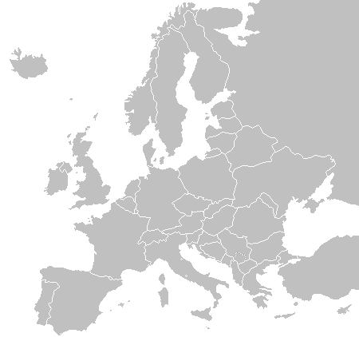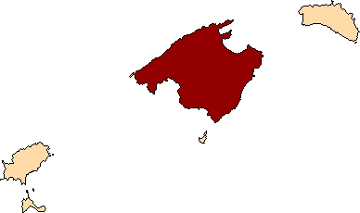

**Balearic Islands**

**Europe**

**Mallorca**

**Mallorca**

Mallorca has a total surface area of 3 626 km2. It is the largest island of the Balearic archipelago. The archipelago is located in the central-western area of the western Mediterranean, between latitude 40º05’17’’ and 38º40’27’’ and longitude 1º17’23’’ and 3º50’23’’.

1. **Ingredients**

**a) Essential**

* + - 1. Aniseed-flavoured spirit drink
      2. Alcohol of agricultural origin
      3. Distilled, deionised and/or demineralised drinking water
      4. Aromatic plants produced on the island of Mallorca:
* lemon verbena (*Lippia citriodora)*
* camomile *(Matricaria spp.)*
* orange *(Citrus sinensis)*
* lemon *(Citrus limon)*
* rosemary *(Rosmarinus officinalis)*
* balm *(Melissa oficinallis)*
* fennel *(Foeniculum vulgare)*

**b) Optional**

Sucrose

Other aromatic plants and/or authorised natural flavourings

Colouring agents authorised for spirit drinks.

1. **Method of production**

It is produced by blending an aniseed-flavoured spirit drink with a water-alcohol solution, flavoured by maceration and/or distillation of plants, with the addition of water, ethyl alcohol of agricultural origin and, optionally, sucrose.

Production follows traditional practices with three separate stages.

The first stage involves extracting the plant aroma. Producer experience is fundamental at this stage. The proportion of essential aromatic plants is selected on this basis. The selected plants are macerated in a water-alcohol solution for as long as necessary to extract the aromas. This phase can be enhanced by distilling the macerate.

In the second stage, an aniseed-flavoured spirit drink is produced from agricultural alcohol, water and extracts or distillates of aniseed and, optionally, sucrose.

In the third and final stage, the products of the previous stages are blended with the optional addition of water, alcohol and sugar, in order to achieve the desired alcohol and sugar content and organoleptic characteristics. At this stage, the producer’s experience is fundamental. It is the basis for deciding the proportion of the aromatic extract produced at the first stage in order to achieve the distinctive characteristics of ‘Hierbas de Mallorca’.

1. **Link with the geographical area**

This spirit drink is widely renowned thanks its significant production and sale throughout history. All of this can be attributed to its unique organoleptic qualities: clear appearance; colour ranging from amber to green; intense aroma with strong presence of aniseed; perceptible fresh, sweet, fruity (orange and lemon) and floral notes. Numerous sources provide evidence of its reputation throughout history, from its beginnings to the present.

The product’s traditional character dates back to its origins in the monasteries. The monks produced a wide range of spirits and spirit drinks using plants and fruits.

In the ‘*posesiones*’, as the large Mallorcan country estates were called, farmers were known to make an aniseed-flavoured spirit drink with local aromatic plants.

Production was possible in the first place thanks to the abundance of stills on the island. It is known that, at the end of the eighteenth century, there were 177 stills in Mallorca dedicated to the production of spirits. They produced 780 000 litres of distillates, of which 60 % was for local consumption. These stills enabled production of the distillate that provided the basis for manufacturing this unique spirit drink.

Furthermore, farmers’ wide-ranging knowledge of the characteristics of the island’s aromatic plants enabled them to select the most appropriate ones for flavouring the distillate. This led to the creation of ‘Hierbas de Mallorca’.

The organoleptic characteristics are what gives the product its reputation. They are clearly identifiable by the aromas of various plants from the island of Mallorca, especially fennel, rosemary, lemon verbena, camomile, lemon, orange and balm. Use of these aromatic plants did not come about by chance. Rather, it is the result of observation and knowledge of wild plants on the part of producers, with the experience passed down the generations. Producers selected the most appropriate plants in their correct proportions to give the drink a pleasant and characteristic aroma and taste.

At the end of the nineteenth century, production and consumption of the drink increased due to the opening of small traditional producer establishments. Some of those establishments are still operating today.

Since the nineteenth century, the people of Mallorca have enjoyed traditional ‘Hierbas’ at all their celebrations, family gatherings and social events. Recent studies demonstrate the product’s current popularity. For example, according to the publication ‘Diagnosis de la producción y comercialización de los productos con denominación de calidad 2010’ [Analysis of the production and placing on the market of products with quality designations in 2010] produced by the Balearic Island Agrifood Quality Institute, sales increased by 11 % between 2009 and 2010, reaching a total sales volume of 1 301 457 litres.

This spirit drink is notably traditional in character. Nevertheless, it should be pointed out that the aforementioned study shows sales rising in EU countries in 2010, up 64 % compared with the previous year. This proves that the product is rated highly among European consumers.

Today it is drunk in homes, bars and restaurants. Traditionally the product is drunk before or after a meal, or with dessert. One of the great pairings is a glass of ‘Hierbas’ with ‘*buñuelos*’ [sweet, fried dough-balls]. Thanks to its popularity, its uses have evolved and it is also used in cocktails including the following: ‘Agua de Mallorca’ containing the sweet variety of ‘Hierbas’, kiwi and ‘*gaseosa*’ [sweetened soda water]; ‘El viento del Teix de Mallorca’ containing the unsweetened variety of ‘Hierbas’, Cointreau and blue After Shock; ‘Cielo abierto’ containing blended ‘Hierbas’, coconut milk and a dash of crème de cacao; and ‘Ca Nostra’ containing unsweetened ‘Hierbas’, Palo de Mallorca and Gin de Mahón.

Note that this drink has numerous culinary uses as an ingredient. For example, it is used to preserve dried figs and to impart a characteristic aroma and flavour to them.

The drink’s prestige is confirmed by its mention in various publications, for example *Herbes i Remeis Casolans* (Ripoll, Ll. 1985) and *Llibre de la Ratafia* (Fábrega, J. 2001). It should also be noted that it appears in international publications. This is especially significant given that current production is carried out in traditional form and by only seven producers. Relevant examples include:

* Brandl, F, 2003. Brandls Bar Buch, published by Matthaes Verlag GmbH, winner of the Goldmedalle gastronimische akademie Deustschlands E.V.
* Dominé, A. et al., 2009. El libro del Bar y de los Cócteles, published by H.F. Ullmann, which lists the most internationally successful distillates.

Furthermore, indirect proof of its wide reach, reputation and prestige can be found by considering the number of references on the internet. A Google search for ‘Hierbas de Mallorca’ on 3 April 2012 returned around 96 200 hits. The same search in Catalan, ‘Herbes de Mallorca’ returned 95 000 hits. The hits are linked to websites on gastronomy, tourist guides, recipes and newspaper articles, among others.

Specific characteristics attributable to the geographical area

The geographical influence lies in the agricultural and climatic conditions and in the human factor. On one hand, the agricultural and climatic conditions of Mallorca are ideal for growing the aromatic plants lemon verbena, camomile, lemon, orange, rosemary, balm and fennel. These give the drink its organoleptic characteristics. On the other hand, the human factor, especially the producers’ experience, are crucial for achieving the unique characteristics of ‘Hierbas de Mallorca’. Decisions about proportions of plants in the macerate, as well as blending aromatic extract with the aniseed-flavoured spirit drink, are based on the producer’s experience and on organoleptic analysis of the product.

1. **Applicable requirements**

* Regulation (EC) No 110/2008 of the European Parliament and of the Council of 15 January 2008 on the definition, description, presentation, labelling and the protection of geographical indications of spirit drinks and repealing Council Regulation (EEC) No 1576/89.
* Law 1/1999 of 17 March 1999 on the Statute of Balearic Island agrifood producers and industries.

Producers with the geographical indication must meet the following requirements.

1. They must be listed in the Register of Manufacturers and packagers of ‘Hierbas de Mallorca’.
2. Bottling in the place of origin: the drink can only be placed on the market when bottled at the place of origin. The purpose behind this restriction is to ensure that the geographical indication is protected and justified on the basis of the following reasons:

*b.1.* Guaranteeing, safeguarding and protecting product quality and hence the reputation of the geographical indication. Operators assume this responsibility as a group and in full, for the following reasons.

* The fact that packaging takes place in the production area is vital in helping to preserve the specific characteristics and quality. It means that application and checking of packaging standards is entrusted to producers and the inspection body. These bodies have the necessary knowledge and skills. They also have a fundamental interest in preserving the reputation acquired, along with implementation and enforcement of all the rules on bottling.
* The production area is situated on the island of Mallorca. Bulk transport to other areas could involve one or more sea crossings of considerable duration. This can pose a risk to preserving the finished quality of the product as one of the essential factors of its distinctive quality is the particular aroma. It is therefore essential to preserve the aroma acquired during production and to avoid the presence of alien aromas. In order to ensure the essential characteristics, bottling must be done at the place of origin and by the producers themselves.
* Simultaneous existence of just two different bottling processes, inside or outside the production area, with or without regular checks, could reduce the consumer trust enjoyed by the geographical indication. Consumers are confident that all stages of production and packaging are conducted under the supervision and responsibility of the beneficiary of this geographical indication.

*b.2.* To guarantee traceability and ensure control

Permitting packaging outside of the demarcated area would compromise the guarantee of the origin of the product covered.

1. The product covered is presented in transparent packaging with a maximum capacity of three litres. In exceptional circumstances, other types of packaging can be used with prior authorisation by the competent authority. It is permitted for the packaging to contain aromatic plants in maceration.

Specific labelling rules: the product covered by the geographical indication must include the following on its label:

1. The name ‘Hierbas de Mallorca’ in letters of at least 2 mm in height. Optionally, this can be followed by one of the three varieties described in section 3.*c*.

2*.* One of the following two logos: Option A in colour or Option B in black and white.

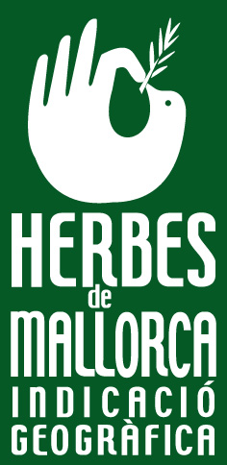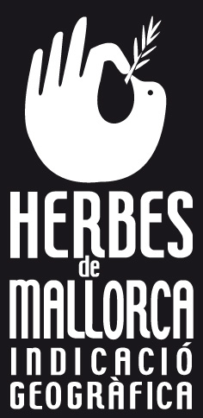

Option A Option B

3. An alphanumeric control number.

1. **Applicant**

Name: Consell de Fabricants de Begudes Espirituoses de Mallorca

Address: Carrer Gremi d’Hortolans, 11, planta 3, despacho 3.

Polígon Son Rossinyol

07009 Palma

1. **Checks**

**9.a Competent authority**

Name: Directorate-General for the Rural and Marine Environment, Department of Agriculture, Environment and Land, Regional Government of the Balearic Islands

Address: C/ dels Foners nº 10

07006 Palma, Mallorca (Balearic Islands)

SPAIN

Tel.: 0034 971176666

Fax No: 0034 971177275

**9.b Checking process**

Scope of checks

1. Chemical analysis

There is verification that the operator performs chemical tests to guarantee that the requirements set out in section 3.a and 3.c of this technical file are met.

1. Operators

Checks are conducted to ensure that operators are capable of producing ‘Hierbas de Mallorca’ under the conditions set out in the technical file and particularly:

* the existence of a registration system guaranteeing identification and traceability of the production and packaging process;
* during the first month of the subsequent year, operators submit a statement of production, sales and stocks to the competent authority using a standard form.

1. Products

Random sampling is used to check that ‘Hierbas de Mallorca’ complies with the established analytical characteristics and includes an alphanumeric control number on the label.

Control methodology and annual verification

1. There are regular checks on the self-checking system for operators producing ‘Hierbas de Mallorca’ with the following objectives:

* to check that the ethyl alcohol is of agricultural origin;
* to check for the addition of the seven required aromatic plants specified in section 5 *a*;
* to check that product traceability is managed;
* to check that bottling takes place in the production area;
* to check that there is testing to ensure that the product meets the specifications set out in section 3.

1. Random checks

* to check batch traceability;
* to check analytical parameters by taking product samples.