**Technical file for the 'Pelinkovec' geographical indication**

**(a) Name and category of the spirit drink, including the geographical indication**

'Pelinkovec' with a geographical indication is a liqueur produced in Slovenia. It belongs to Category 32 (Liqueur) of Annex II to Regulation (EC) No 110/2008.

**(b) Description of the spirit drink, including the principal physical, chemical and/or organoleptic characteristics of the product, as well as the specific characteristics of the spirit drink as compared to the relevant category**

'Pelinkovec' with a geographical indication is a liqueur produced only in Slovenia. It is made of ethanol or distillate of agricultural origin or one or more spirit drinks or mixes thereof, with the addition of sugar and natural wormwood extracts. Extracts of other herbs, aromas and natural colourings may also be added. 'Pelinkovec' with a geographical indication must have an intensive taste and aroma of wormwood.

'Pelinkovec' with a geographical indication must contain:

– no less than 80 g of sugar per litre,

– a minimum of 25 % alcohol by volume,

– thujone of wormwood origin, up to the maximum level laid down in Annex III of Regulation (EC) No 1334/2008 of the European Parliament and of the Council of 16 December 2008 on flavourings and certain food ingredients with flavouring properties for use in and on foods.

**Characteristics**

The main characteristic of 'pelinkovec' is a distinctive aroma and taste of wormwood; other aromatic substances merely complement its taste and aroma. 'Pelinkovec' contains 80 g of sugar per litre, which softens the bitter taste of wormwood, and has an alcohol by volume content of at least 25 %. The wormwood extract gives it the characteristic brown to dark brown colour.

What distinguishes it from the other drinks in the category is mainly the bitter taste, the taste of wormwood and the lower sugar content. Sugar is used principally to counteract the bitter taste. 'Pelinkovec' is similar to gentian liqueur in that both are bitter and rely on sugar to tone down the bitterness.

**Aroma profile:**

The aroma and taste of the wormwood extract must complement each other; the after-taste must be pleasantly soft.

**(c) Definition of the geographical area concerned**

The territory of the Republic of Slovenia.

**(d) Description of the method for obtaining the spirit drink and, if appropriate, the authentic and unvarying local methods**

The basic ingredient for the drink is wormwood extract, which is obtained by soaking the herbs in an alcohol solution. The extract is prepared from dried and cut plants of the common wormwood (*Artemisia absinthium*), which meet the following criteria: maximum water content of 12 % and no more than 0.5 % of impurities. The soaking stage is over when the extract acquires the characteristic colour, aroma and taste. Other herbal extracts and aromas may be added, as provided for by the regulation governing aromatic compounds (mainly aniseed for a rounder taste), and the product may be coloured with natural colourants (caramel), as provided for by the regulation governing food additives. The following main characteristics are checked before it is used: – alcohol, aroma, colour and taste,

'Pelinkovec' is obtained by mixing together alcohol of agricultural origin, sugar, wormwood extract, other additives (aromas, colourings), and water.

After all the ingredients are combined, the following quality parameters are checked:

– alcohol

– sugar

– aroma, taste, colour and clarity.

Following any modifications that may be necessary, the product is filtered until clear, glass bottled and batch numbered.

Resting of the macerate

Organoleptic and chemical testing

Preparation according to the recipe

Chemical and organoleptic analyses

Modifications, if required, and re-checking

Stabilisation, filtration

Maceration of wormwood (*Artemisia absinthium*) plants in alcohol

Bottling, labelling

**(e) Details bearing out the link with the geographical environment or the geographical origin**

In classical antiquity, wormwood (*Artemisia absinthium*) was recognised as one of the most potent medicinal herbs. The first written records of wormwood go as far back as an Egyptian papyrus from 1 600 BCE. It was recommended as a stimulant, disinfectant and a cure for chills and menstrual pain. Pythagoras firmly believed that wormwood soaked in wine helped in childbirth, while Hippocrates recommended it against anaemia and rheumatism. The ancient Roman natural historian Pliny believed wormwood to be good for the stomach and digestion in general. In the 17th century, wormwood was given as a cure against a number of afflictions, including stomach trouble, but it was also drunk as an elixir of youth and as a cure against bad breath.

Wormwood is well known in Slovenia. The leaves are used to brew wormwood tea and make 'pelinkovec', both of which are said to soothe belly problems. An 800 year-old written record says about 'pelinkovec': 'This drink eases melancholy, clarifies the eyes, strengthens the heart, the lungs and the stomach, cleans the gut and encourages digestion.' In addition to the wormwood extract, 'pelinkovec', the bitter liqueur, contains extracts of other herbs and bitter plants, which give it a brown colour. It also has low alcohol content.

Wormwood preparations, obtained by soaking the herb in vinegar, wine, spirit or oil, have always enjoyed great popularity. The most popular was an infusion of ground fresh wormwood soaked in a bottle of spirit and left to sit in the sun for eight days. People who lost their appetite would sip 'pelinkovec' by spoon every morning and every night.

After several centuries, the drink evolved into more than merely a bitter cure, and independent distilleries began production on an industrial scale.

'Pelinkovec' is first mentioned in Marko Pohlin's 1783 grammar of the Slovenian language (*Kraynska grammatika, das ist: Die kraynerische Grammatik, oder Kunst die kraynerische Sprache regelrichtig zu reden und zu schreiben*) alongside other spirit names, such as 'brinovc' (juniper spirit), 'češplovec' (plum spirit), 'pelinovz' (wormwood spirit), etc.

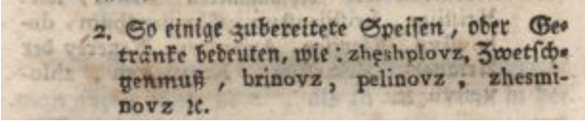

The following is an extract from the story entitled *Zlata hruška*, published on 28.10.1851 in the newspaper Ljubljanski časnik (year 2, No 86): 'Our fate has strange ways, and just as we think we could not be happier, things turn bitter, much like "pelinovc", and we cannot but think that the bad luck that follows is of our own making and well deserved.'

Another extract, taken from the article *Glasnik iz domačih in tujih krajev* published on 15.8.1858 in the monthly Slovenski glasnik (year 1, No 4), reads: 'Therefore indulge your friends, like Ganymede indulged Zeus the Father, with the ambrosia of fine sciences, yet spare them not the 'pelinkovec' of bitter satire since *amara sunt stomacho cara*.' On 22.10.1887 the political daily Slovenec (year 15, No 241) published the story *Sviftijada*, which also makes reference to 'pelinkovec': 'This time they got me. And serves me right. What business do I, "pelinovec", seek with the wasps and hornets that only drink "medica" (honey spirit) and sting mercilessly those of their kind who smell not of honey.'

The following is an extract from the story entitled *Olimpija*, published on 28.8.1893 in the newspaper Slovenski narod (year 26, No 196): 'The Greeks sport this unusual practice of spoiling wine by mixing in resin. Such wine becomes bitter like "pelinovec" and the taste of it sends shudders down one's spine.'

Trgovski list, a newspaper for trade, industry, craft and monetary matters, published an article on 6.6.1914 (year 2, No 15) that reads: '[...] his creditor, tells him that he has got himself a "fine" job working for a liqueur maker and proposes that the creditor make an order and deduct an amount from the debt. The creditor liked the offer and was quick to order a barrel of "pelinkovec". But in the end he had to pay for the drink, because the debtor had forged the document.'

The following advertisement was published on 4.12.1918 in Edinost, a political newspaper for Slovenians living in the area of Trieste (year 43, No 33): 'Cognac, rum, "pelinkovec", a choice of liqueurs, sparkling and dessert wines, available retail or wholesale, at moderate prices from Jakob Perhauc's shop in Trieste.'

We have found the following advertisement published on 8.9.1925 in Trgovski list (year 8, No 105):



We have also found a 'pelinkovec' advertisement in a German-language newspaper. Mariborer Zeitung (year 78, No 178) published the following advertisement on 7.8.1938:

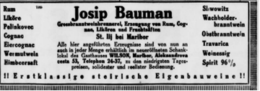

'Pelinkovec' was also marketed beyond Slovenia's borders. Glas naroda (No 5), the first newspaper of Slovenian workers in the United States, published the following advertisement on 21 September 1903: 'Fred Kalin's wholesale wine and spirits shop. In stock: Real Carniolan and Croatian plum spirit, grape marc spirit, juniper spirit, "pelinkovec", etc.'

The same newspaper (year 37, No 45) also published a story entitled *Steklenica pelinkovca* ('A Bottle of Pelinkovec') on 23.2.1929, which goes to show that 'pelinkovec' was popular with Slovenian expatriates too.

Enakopravnost (year 31, No 51), the independent daily for the Slovenian community in the United States, published the following letter to the editor on 12.3.1948: 'We are quite happy with our spirits. The old guard – plum, juniper, pear, cherry, fruit, pine shoot, grape marc spirit and "pelinkovec" – have been joined by a variety of herb infused spirits, etc.'

In his article about distillation of spirits (*O žganjekuhi v Breznici pod Lubnikom*) he writes (No [number missing], year 11, pp. 167–178): 'There are two that stand out from the crowd: "pelinouc", which contains wormwood extract, and its sweet opposite, honey spirit, made by honey makers.'

'Pelinkovec' also appears in more contemporary sources. In his story *Spoved*, published in the Sodobnost magazine (year 11, No 8/9, 1963), Marjan Kolar writes: 'The night was terrible. No matter how much schnapps and "pelinkovec" he gulped down, no matter whether he did the breathing exercises or not, nothing helped. The pain and the stinging continued until he was barely able to moan.'

France Vurnik published his poem *Pred zidom in onkraj* in the Sodobnost magazine (year 15, No 6, 1967):

'Being lost is an incurable illness; you are lost if you don't feel like a glass of "pelinkovec" when you pass by a house, if you steer clear of a friend for fear of hearing honest words, if you're not tempted to smile at a child who sees snail houses in a block of flats that's being built, if you shun your wife's arms that reach out at you, if you can't be bothered to climb Rožnik on a sunny afternoon and you don't care about returning, even if only for a moment, to the place of your youth.'

In her book, *Nesreča in resnične potrebe*, Ivančica Ðerić wrote: 'At that time I usually stare at my garden, at a disfigured bush, watching as drops of morning rain and sparks of morning sun slide heavily off its leaves, sipping on a glass of "pelinkovec" and feeling that life is good.'

In her essay on inns and restaurants in Slovenia, *Gostilne, kakršnih se pri nas spominjamo (Od konca 19. stoletja do dnašnjih dni)*, Tina Tomažič writes: 'It has already been said that the cheapest and least appreciated spirit was a home-made "pelinkovec", which was known under a variety of names across this territory. It was called "geruš" in the area around Idria, referred to as "arbajterkonjak" in Ljubljana, known as "ta špiritov" in Kropa and Kamna gorica, and as "ta zelen" elsewhere. It was the best-selling spirit in the central part of the country, while the east (Prekmurje, Prlekija, Ptujsko polje) swore by fruit spirit. Juniper spirit, on the other hand, was considered as a finer drink.'

On 7.9.1967 the newspaper Dolenjski list (year 18, No 36) published an interview with Lojze Krhin, Director of Dana, who said: 'Our gold-winning drinks are vodka Apostolska, natural juniper spirit, pear brandy, cherry wine, natural fruit spirit and natural coffee liqueur. Silver medalists include: bitter *gorijan* [transl. note: unable to identify the drink], home-made brandy, bitter "pelinkovec", aged plum spirit, the H.T. herbal bitter liqueur, natural fernet and cherry brandy.'

In August 1977, the newspaper Javna tribuna reported that the bitter 'pelinkovec' made by Fructal Alko won a diploma with a silver medal at the 23rd international fair of viticulture and wine-making in Ljubljana.

Rok Kofolje wrote in part two of his article *Namibija, bogovi še vedno padajo na glavo*, (published in magazine Diva, 2007): 'The two women showed us their plan to travel the world and interview women born, like them, in 1981, help those who find themselves in dire straits and present their stories to the world (www.81femmes.org). We, in turn, showed them the delicacies that we'd brought along: home-made rum, dried ham, liqueur made from terrano wine, sausages and "pelinkovec".'

The entry at <https://stillcrapulent.wordpress.com/tag/pelinkovec/> entitled Embittered II Translovenian Hunger, August 9, 2012 reads: 'This is how we endear ourselves to the locals. But to be fair to our guitarist, the only thing *I* had known about Slovenia beforehand was that it is where Slavoj Žižek is from, and (pretty much) the only thing I know about it now is that it is where Slavoj Žižek and *Pelinkovec* are from.'

**Among all Slovenian herbal liqueurs, 'pelinkovec' is produced in the largest quantities.**

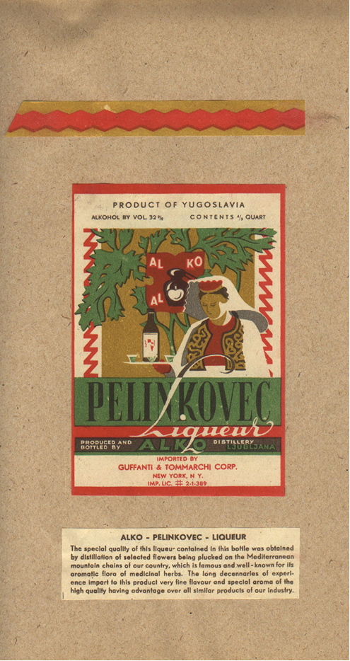

'Pelinkovec' USA export label

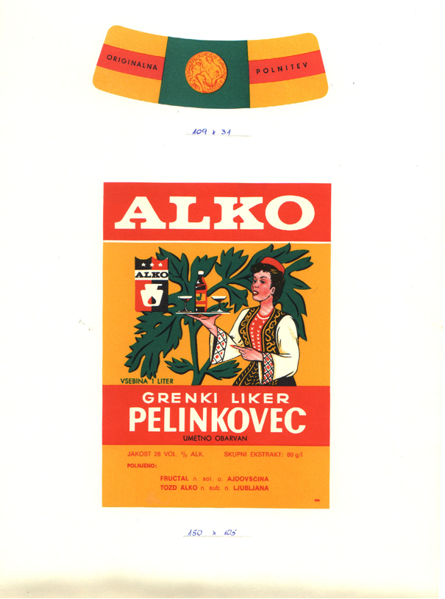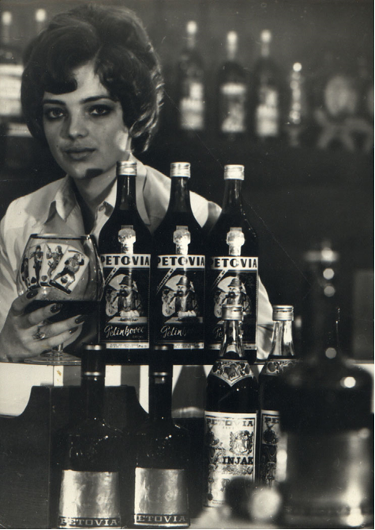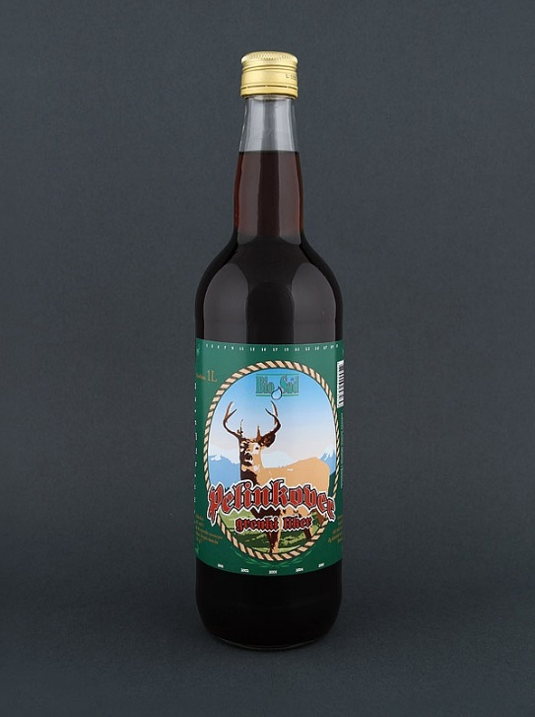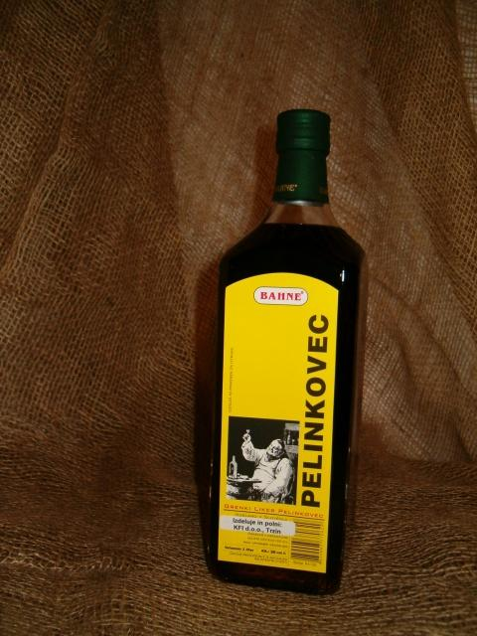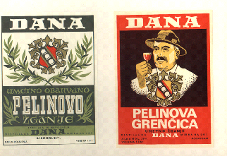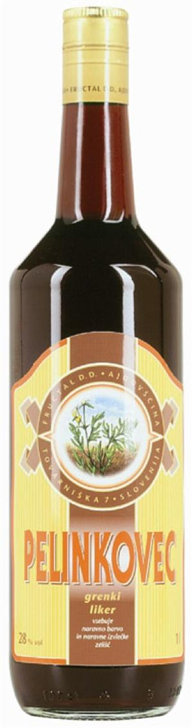

Old and new 'pelinkovec' labels

Prizes won by Fructal's 'pelinkovec'

|  |  |  |  |
| --- | --- | --- | --- |
| **YEAR** | **PLACE** | **PRODUCT** | **PRIZE** |
| 1979 | Viticulture fair | Bitter 'pelinkovec' | Silver medal |
| 2002 | Ljubljana Wine fair | 'Pelinkovec' | Gold Medal |
| 2003 | Ljubljana Wine fair | 'Pelinkovec' – bitter liqueur | Gold Medal |
| 2004 | Ljubljana Wine fair | 'Pelinkovec' – bitter liqueur | Gold Medal |
| 2005 | Ljubljana Wine fair | 'Pelinkovec' – bitter liqueur | Silver medal |
| 2007 | Ljubljana Wine fair | 'Pelinkovec' – bitter liqueur | Gold Medal |

**(f) Any requirements laid down by Community and/or national and/or regional provisions**

The 'Pelinkovec' geographical indication may be used by producers on the basis of a report drawn up by a test laboratory designated under the Agriculture Act to check the compliance of spirit drinks and other alcoholic drinks and certifying that their 'pelinkovec' meets all the requirements set out in the technical file.

**(g) Name and contact address of the applicant**

Ministry of Agriculture, Forestry and Food

Dunajska 22

SI-1000 Ljubljana

Slovenia

**(h) Any supplement to the geographical indication and/or any specific labelling rule, according to the relevant technical file**

In addition to the markings specified in the rules on pre-packaged foodstuffs and the rules on spirit drinks, the geographical indications on the label must include the acronym of the laboratory that carried out compliance testing, the number of the compliance report, and an indication of the volume for which the report was drawn up (optional).

Rules on the 'Pelinkovec' geographical indication have been published in [Uradni List (UL RS; Official Gazette of the Republic of Slovenia) No 70/2010, 3.9.2010](http://www.uradni-list.si/1/index?edition=201070).