Technical file for ‘Domači rum’

(a) Name and category of the spirit drink, including the geographical indication

‘Domači rum’ with a geographical indication is a spirit drink produced in Slovenia.
It belongs to the category ‘Other spirit drinks’ in Annex III to Regulation (EC) No 110/2008.

(b) Description of the spirit drink, including the principal physical, chemical and/or organoleptic characteristics of the product, as well as the specific characteristics of the spirit drink as compared to the relevant category

‘Domači rum’ is a clear spirit drink produced from a distillate obtained from the distillation of fermented syrup of molasses or cane juice distilled to no more than 96 % vol., to which are added the characteristic aroma of rum and colouring to give it a characteristic reddish brown caramel colour.

Physical and chemical characteristics
Alcoholic strength: at least 37.5 %
The rum is marketed with an alcohol content of up to 80 % vol.
Total dry extract: maximum 2 g/l
Total ethyl acetate content (flavouring and alcohol-based products): not more than 500 g/hl ethanol.

Organoleptic properties:

The smell and taste of punch, with hints of vanilla; the smell and taste must be harmonious, the after-taste pleasantly mellow.

‘Domači rum’ is different from the other rums in that it is flavoured and coloured.

(c) Definition of the geographical area concerned

The geographical area for the production of ‘Domači rum’ is the whole territory of Slovenia.

(d) Description of the method for obtaining the spirit drink and, if appropriate, the authentic and unvarying local methods

Method for producing ‘Domači rum’:
- Dilution of cane distillate
- Addition of aromatic substances
- Dissolution of colouring agent
- Mixing
- Organoleptic assessment
- Analysis of alcohol content
- Adjustment and recheck, if necessary
- Resting
- Filtration
- Bottling, sealing, batch numbering and indication of number of the compliance report and acronym of the testing laboratory
- Packing and storage

The speciality of ‘Domači rum’ lies in the special aromas that are added to it and in the resting to ensure that these are well incorporated into the product.

(e) Details bearing out the link with the geographical environment or the geographical origin

Slovenia was once part of the Austro-Hungarian Empire. Because the Empire did not have access to colonies in tropical regions, rum producers originally tried to substitute the flavour of cane or molasses with a mixture of flavours and colouring agents. This drink was originally called rum and later became ‘Domači rum’. ‘Domači rum’ was the substitute that gradually became a speciality and the national drink that is most produced in Slovenia. Today ‘Domači rum’ is produced from a distillate of fermented syrup of molasses or cane juice in accordance with EU rules, and its typical flavour is produced by the traditional added aromas.

‘Domači rum’ is the first spirit drink that they started to produce in industrial distilleries before the First World War. It is mostly used in the preparation of traditional pastries, such as potica, doughnuts, cakes and other pastries.

According to the literature supplied, the spirit drink obtained from ethyl alcohol of agricultural origin and appropriate aromas used to be called rum, while the so-called ‘true rum’ was Jamaica rum. In all probability the name ‘Domači rum’ appeared at the same time as Inlander rum because Slovenia was then part of the Austro-Hungarian empire. The oldest record relating to rum in Slovenian that we have been able to trace was published in the newspaper Slovenija (27 April 1849, vol. 2, number 34).

A Mr Savič wrote in the Trgovski List (Ljubljana, 17 June 1922), ‘Two types of alcoholic drink are produced and consumed in our country, other than wine, namely from fruit, such as brandy, tropinec and cognac, and drinks which are produced from alcohol, such as liqueur, rum, cognac, etc.’
Another article from Kmetijske in rokodelske novice, vol. 3, number 24 (11 June 1845) shows that ‘Domači rum’ was important for the ‘Slovenian’ economy of the time. It reported that, at a craft exhibition in Austria, ‘There are many fine glass products from Slovenian Styria: a bronze
crucifix; ethyl alcohol, rum and brinovec’, where ‘Domači rum’ was also exhibited.

‘Domači rum’ has also been an important article in more recent times. An article in the magazine Zbor občanov in 1988 (vol. 28, number 1a) under the heading ‘How much more does it cost?’ reports that in 1980 ‘Domači rum’ cost 64.90 dinars, 1 479 dinars in 1987 and 2 942 dinars in 1988.

According to the Wikipedia page at https://it.wikipedia.org/wiki/Rum#11_.22doma.C4.87i_rum.22, ‘Domači rum’ was also produced in the former Yugoslavia, but Croatia changed the name on accession, while Slovenia protected the name with a geographical indication and still produces it.

Blaž Ogorevc wrote in the weekly magazine Mladina (2009), in an article entitled ‘Peter Božič and Blaž Ogorevc’, ‘Peter cried out that, as a respected Slovenian writer, he would not accept such police harassment, and File, who despite the early hour already smelt strongly of “Domači rum” [...]’

The newspaper Finance (2013) wrote, ‘APIS “Domači rum” can boast a 50-year tradition, dating back to 1962. It was most popular at the beginning of the 1980s, when sales reached 450 000 litres. Following the bankruptcy of APIS, the brand name was bought by Bio-Sad and in 2012 Apis “Domači rum” emerged again.’

‘Domači rum’ is indispensable in the preparation of Slovenian national sweets and pastries (potica, rum balls, flancat, etc.) and for making cocktails. Jure Apih, in an article entitled ‘Entertaining with potica’, published in the newspaper Delo on 15 December 2014, gave a recipe for making potica, which says, ‘Rinse three or four handfuls of raisins in a colander and soak the washed raisins in water or “Domači rum”.’

An interview with the oil producer Palmieri under the title ‘A bad olive harvest forced us to change’ published in the newspaper Lisa says, ‘Based on a tradition that boasts of more than 500 years of olive production, they introduced Refošk dessert during a crisis on the Slovenian market. Its ingredients included Refošk wine from Slovenia's Primorje region, blossom honey, forest berries and “Domači rum”.’

Today ‘Domači rum’ is produced from a distillate of fermented syrup of molasses or cane juice in accordance with EU rules, and its typical flavour is produced by the traditional added aromas.
In terms of production and quantities ‘Domači rum’ is the spirit drink that is most produced and consumed.

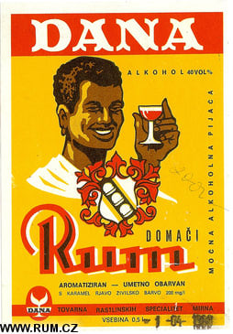 | 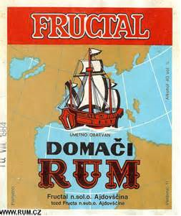 | 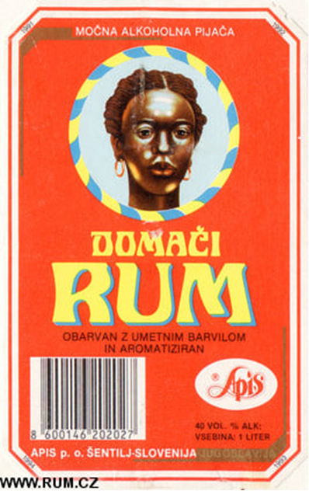
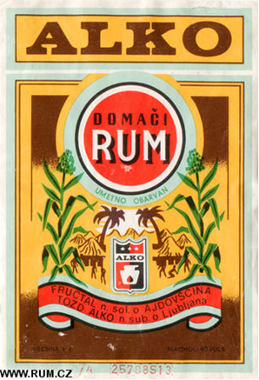 | 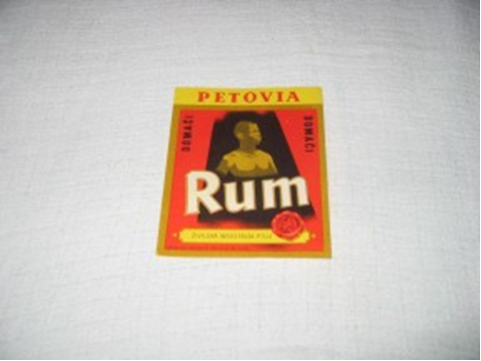
Labels of various Slovenian ‘Domači rum’ producers from the last century.

(f) Any requirements laid down by Community and/or national and/or regional provisions

The ‘Domači rum’ geographical indication may be used by producers on the basis of a report drawn up by a test laboratory designated under the Agriculture Act to check the compliance of spirit drinks and other alcoholic drinks and certifying that their ‘Domači rum’ meets all the requirements set out in the technical file.

(g) Name and contact address of the applicant

Ministry of Agriculture, Forestry and Food
Dunajska 22
SI-1000 Ljubljana
Slovenia

(h) Any supplement to the geographical indication and/or any specific labelling rule, according to the relevant technical file

In addition to the markings specified in the rules on pre-packaged foodstuffs and the rules on spirit drinks, the geographical indications on the label must include the acronym of the laboratory that carried out compliance testing, the number of the compliance report, and an indication of the volume for which the report was drawn up (optional).

Rules on the ‘Domači rum’ geographical indication have been published in Uradni List RS (UL RS; Official Gazette of the Republic of Slovenia) No 70/2010 of 3 September 2010.

