**Technical documentation for Dolenjski sadjevec**

**(a) Name and category of the spirit drink, including the geographical indication**

Dolenjski sadjevec is a fruit spirit produced within the region of Dolenjska. It belongs to Category 9 (Fruit spirit) of Annex II to Regulation (EC) No 110/2008.

**(b) Description of the spirit drink, including the principal physical, chemical and/or organoleptic characteristics of the product, as well as the specific characteristics of the spirit drink as compared to the relevant category**

Dolenjski sadjevec is traditionally produced from apples and pears, although the ratio between them is not precisely defined, but apples predominate (the typical or traditionally usual ratio is roughly ¾ apple and ¼ pear or less. Plums and damsons may also be added. All the fruit comes from extensive meadow orchards and plantations on which fruit is produced using the principles of integrated fruit production.

Dolenjski sadjevec must meet the minimum quality requirements for fruit spirits in accordance with Annex I and Annex II to Regulation (EC) No 110/2008 and the following parameters:

* Ethanol: 37.5–40 % vol.;
* Acetaldehyde: up to a maximum of 1 000 mg/l a.a.;
* Extract: up to a maximum of 5 g/l
* Total acidity of 200 to 1 500 mg/l or a maximum of 6 g/l of absolute alcohol, expressed as acetic acid;
* Ester content of 500 to 5 000 mg/l of absolute alcohol, expressed as ethyl acetate;
* Higher alcohol content of 1 000 to 6 000 mg/l of absolute alcohol;
* Aldehyde content of up to 1 000 mg/l of absolute alcohol;
* furfural content of up to 30 mg/l of absolute alcohol;
* It must be colourless and clear;
* It must have a distinct aroma and taste of the fruit it is produced from;
* It must have a matured taste.

A special feature of Dolenjski sadjevec is the rich tradition behind it and the use of fruit from extensive and integrated production. Spirits distilled from fruit are usually produced from a single fruit and taste of that fruit. Dolenjski sadjevec is a spirit obtained from a mixture of different fruits (primarily apple and pear, to which plums and damsons may also be added), which are mashed and fermented together and then distilled.

**(c) Definition of the geographical area concerned**

The geographical region of Dolenjska covers an area on the right bank of the Sava river from Breg pri Litiji to the Breganščica stream, from Bregana over the Gorjanci hills to triangulation point 824, and from there in a straight line to the villages of Črmošnjice, Dvor, Smuka and Krka and then back to the Sava river at Šmartno pri Litiji.

The area is traditionally known for distilling spirits from fruit and for its distilling heritage.

**(d) Description of the method for obtaining the spirit drink and, if appropriate, the authentic and unvarying local methods**

Dolenjski sadjevec is traditionally produced from apples and pears, although the ratio between them is not precisely defined, but apples predominate (the typical or traditionally usual ratio is roughly ¾ apple and ¼ pear or less. Plums and damsons may also be added. All the fruit comes from extensive meadow orchards and plantations on which fruit is produced using the principles of integrated fruit production.

Properly ripe fruits (the starch test must be negative) are mashed, added to the mashing kettle, and left to ferment for three to four weeks. The fermented mash is then distilled, either in a two-step process in copper stills, which first produces *nanga* or a lighter spirit, which is then re-distilled after the first distillation in the copper stills. The other option is one-step distillation in a column still. In both cases the end result is a distillate with a maximum of 86 % alcohol by volume, in accordance with Category 9 (Fruit spirit) of Annex II to Regulation (EC) 110/2008. Between 1.5 and 2.0% of the foreshots or heads is removed and the middle distillation run (heart) is collected with an alcohol content of up to 45 % volume. The tails of the distillate are returned to the fermented mash for the next distillation. With a column still, therefore, the foreshots are removed, the middle run is taken and the tails are returned to the column. The middle run is the end product, i.e. a natural distillate fruit, which is then matured and before bottling is corrected to drinking strength by being diluted with water.

Dolenjska is a region in south-east Slovenia and, alongside Gorenjska and Notranjska, is one of the three regions forming the historic province of Kranjska (Carniola), from which its name derives (in the past it was known as Spodnja or Dolenja Kranjska, i.e. Lower Carniola). The narrower Dolenjska region comprises rolling hills along the Krka river and its tributaries. This hilly region is characterised by three types of landscape: the Alps, the Pannonian plain and the Dinaric Alps.

The amount of precipitation, the temperature, hours of sunshine and other climatic factors have a significant impact on the growth and productivity of fruit trees. Especially because of the varied relief, altitude, aspect and slope of land, and proximity to water and forests, the micro-climatic characteristics of fruit plantations can differ significantly. The predominant climate in Dolenjska is a moderate continental climate with cold winters and warm summers. The continental climate has more impact on the east of the region, which therefore has more marked extremes of temperature and more frequent summer storms. The west of the region is characterised by the occasional impact of the Atlantic climate, extremes of temperature are rarer, while the total annual precipitation is somewhat higher. The sub-Mediterranean climate has a less frequent impact on the region, being felt mainly in winter when warm southerly winds occasionally blow. The accumulated effective temperature during the growing season falls between 1 100°C in the west and 1 300°C in the east of the region. The orchards are generally over 200 m above sea-level and generally well-exposed to the sun. The average total annual precipitation is between 1 100 and 1 200 mm, which is suitable for fruit-growing. The annual distribution of precipitation is also favourable, with an average of over 100 mm falling per month during the growing season. The total average precipitation during the growing season in Dolenjska is around 781 mm (which is over 65 % of the total annual precipitation), with the change from year-to-year being around 100 mm. All the geological and climatological diversity of the Dolenjska winegrowing region leads to considerable variety in the fruit produced there. After the geographical location, it is not only the climate that is important, but also the traditional preparation and knowledge to be found in this part of Slovenia.

**(e) Details bearing out the link with the geographical environment or the geographical origin**

Dolenjski sadjevec is a mix of different varieties of apple, pear, plum and damson. The popular mixes of individual varieties of fruit offer a distinct fruit aroma, but not specific to one variety of fruit from which it is made. Farmers would turn left-over fruit or fruit with no market value into "sadjevec" (fruit spirit). Distilling developed in Dolenjska at the start of the twentieth century in particular. There are records of a large number of small producers, who sold distillate of varying qualities under the name 'Dolenjski sadjevec'. More extensive and more organised production of fruit spirit only took place in Dolenjska after the Second World War. There is a rich tradition of production. Limiting the area of production protected the specific selection of raw materials and defined it as a geographical region in which Dolenjski sadjevec is produced using specific technology. The geographical and climatic features and the traditional knowledge of the production method give Dolenjski sadjevec a distinct and full-bodied taste.

In his book Taste Slovenia, the ethnologist Janet Bogataj wrote:



The Futura Business Brand Communication group has announced that the Dana company had received the Brumen Award for Viljamovka (Williams Pear spirit) and Dolenjski sadjevec.

An article was published on the blog 'Kako uspešno iskati zaposlitev?' (How to successfully find work) entitled 'Kultura postrežbe in pitja vina – kakovost, ne količina' (Serving and Drinking Wine - Quality, not Quantity), which states: 'Clever and resourceful Slovenian winemakers will be able to offer their wines to the 100 best restaurants in the world; they'll never succeed on a wholesale level. Of course, we also need to think about other Slovenian drinks, such as Dolenjski sadjevec, Brkinski brinjevec (juniper spirit), and why not also the excellent extra-virgin olive oil, which true connoisseurs are willing to fork out for.'

An article published in the Delo newspaper on 21 April 2006, entitled 'Kvaliteta ima prednost pred kvantiteto' (Quality takes precedence over quantity) states: 'The highest quality products include 15 agricultural products that were presented by their producers today. These are extra-virgin olive oil from Slovenian Istria, pumpkin oil from Štajerska and Prekmurje, Dolenjski sadjevec, cheese from Nanos ... '.

The following appeared as a comment on an article entitled 'Around the World in 80 Drinks', published online by Marko Jezernik on 14 December 2013: 'So one person made a connection between rakia and Slovenia's national tradition, someone else, despite making huge mental efforts was unable to recognise the obvious and had no suggestion to make, while a third person without missing a beat, said: Dolenjski sadjevec.'.

The following appeared on a blog entitled Kratek povzetek in novoletni giveaway – Grlorez (Brief Summary and New Year's Giveaway - Gargle Blaster) (2013): 'I shouldn't have to especially point out that we have here a fan of Douglas Adams's Hitchhiker's Guide to the Galaxy, which mentions Pan-Galactic Gargle Blaster. The Grlorez (Gargle Blaster) is actually Dolenjski sadjevec, to which Naga Bhut chillies have been added. This drink is not for sale, but to be distributed among chilli lovers.'

The Dnevnik newspaper included the following advertisement on 13 May 2008: 'I sell good awardwinning cviček and Dolenjski sadjevec.'.

Dolenjski sadjevec has a long tradition within the company Dana, which can be seen from company documentation and its archive of labels.

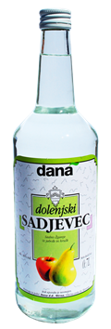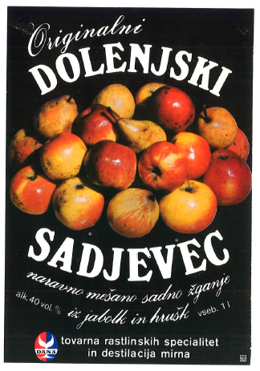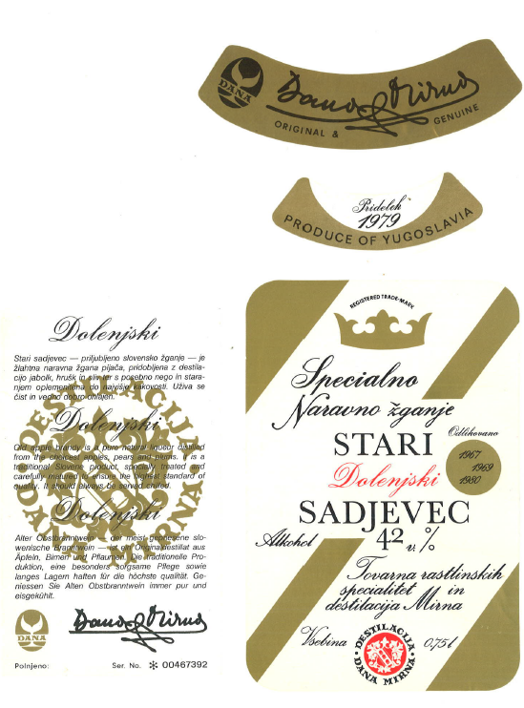

A number of sadjevec labels.

**(f) Any requirements laid down by Community and/or national and/or regional provisions**

Any producer from the relevant geographical region has the right to use the geographical indication of Dolenjski sadjevec on the basis of a report from a test laboratory for the purposes of conformity assessment stating that Dolenjski sadjevec meets all the requirements from the technical documentation.

**(g) Name and contact address of the applicant**

Ministry of Agriculture, Forestry and Food

Dunajska 22

SI-1000 Ljubljana

Slovenia

**(h) Any supplement to the geographical indication and/or any specific labelling rule, according to the relevant technical file**

In addition to the markings specified in the rules on pre-packaged foodstuffs and the rules on spirit drinks, the geographical indications on the label must include the acronym of the laboratory that carried out compliance testing, the number of the compliance report, and an indication of the volume for which the report was drawn up (optional).

[Uradni list RS (UL RS; Official Gazette of the Republic of Slovenia), No 117/2008 of 12 December 2008](http://www.uradni-list.si/1/index?edition=2008117)