**Technical file – Brinjevec**

**(a) Name and category of the spirit drink, including the geographical indication**

'Brinjevec' is a fruit spirit produced in the geographical area of the Republic of Slovenia. Razvrščamo ga v kategorijo 9 »žganje iz sadja« iz priloge II Uredbe (ES) št 110/2008.

**(b) description of the spirit drink, including the principal physical, chemical and/or organoleptic characteristics of the product, as well as the specific characteristics of the spirit drink as compared to the relevant category**

'Brinjevec' is a fruit spirit produced by distillation of fermented mash made from common juniper berries (*Juniperus communis L.*).

Physical and chemical properties:

'Brinjevec' must meet the minimum quality standards for spirit drinks in accordance with Annexes I and II to Regulation (EC) No 110/2008 and comply with the following parameters:

- minimum alcoholic strength by volume of 40 %;

- maximum 1 350 g of methanol per hectolitre of 100 % vol. alcohol;

- minimum of 200 g of volatile substances per hectolitre of 100 % vol. alcohol:

- maximum acetaldehyde content of 3 500 mg/l in 100 % vol. alcohol;

- total acidity of 90–1 500 mg/l, expressed as acetic acid;

- ester content of 300–3 500 in 100 % vol. alcohol; expressed as ethyl acetate;

- higher alcohol content of 3 000–10 000 mg/l in 100 % vol. alcohol;

- colourless, clear, with a prominent aroma and a bitter and astringent taste of juniper berries;

- matured for a minimum of six months.

Given that the maturation stage takes place in oak barrels, the colour may take on a light golden hue, while the aroma and the taste may reflect the wood.

**Aroma profile:**

'Brinjevec' smells and tastes of juniper; the taste should be mild and harmonious, with a characteristic bitterness and astringency typical of juniper berries; the after-taste is pleasantly smooth; there must be no musty smells.

**Characteristics of the spirit drink as compared to the relevant category**

The main characteristic of 'brinjevec' is that it is obtained by distillation of fermented mash made from juniper berries, and cannot be compared with any other drink from the Fruit spirits category. It is astringent and bitter, with a strong aroma of juniper. Juniper belongs to the cypress family, while its berries, botanically speaking, are in fact cones.

On the market, 'brinjevec' is most often compared to gin, 'klekovača' or 'borovička'; however, this comparison is undue since these products are obtained from cereal- or distillate-based ethanol and flavoured with juniper berries, quite unlike 'brinjevec', which is nothing but a distillate of fermented juniper berries.

'Klekovača' is produced mainly in Bosnia and Herzegovina, and Serbia. It is produced in one of the two ways. Single-distilled plum spirit (25 % vol. alcohol) is mixed with around 1 % of juniper berries and left to soak for a few days. The mixture is then distilled and stored in oak barrels. The second method is to mix plums with juniper berries (ca. 10 %), leave the mixture to ferment and then distil the mash.

'Borovička' is similar to 'klekovača'. It is produced mainly in Slovakia, the Czech Republic and Poland. It too is a juniper-flavoured spirit drink.

Another characteristic of 'brinjevec' is that there are two stages to its distillation. The mandatory first stage is batch distillation in copper yielding juniper mash and, as a by-product, juniper oil that is separated using a vessel called a Florentine bottle. We can safely claim that 'brinjevec' is the only drink that is produced by fermenting and distilling juniper berries.

**(c) Definition of the geographical area concerned**

The geographical area for the production of 'brinjevec' is the entire area of the Republic of Slovenia.

**(d) Description of the method for obtaining the spirit drink and, if appropriate, the authentic and unvarying local methods**

'Brinjevec' is a natural fruit spirit (given the name of the category) produced in a specific technological procedure from the berries of the common juniper (*Juniperus communis L.*). In order to be harvested, the juniper berries must have attained the appropriate ripeness (maximum sugar content), which usually happens between August and November. It is recommended that the berries are dried before distillation. Fresh berries have an overwhelmingly resinous and bitter aroma. Unless sufficiently dry, the berries are prone to microbiological spoilage, which is reflected in the 'brinjevec' itself, which acquires a musty aroma. Savin juniper (*Juniperus sabina L.*) may not be used.

Juniper berries are small and impermeable to water, so they need to be crushed in order to soak up enough moisture for fermentation to begin. If there is not enough water, fermentation is incomplete and very slow.

Grinding the berries

Because of the high resin and essential oil content, juniper berries are difficult to grind as the mixture tends to stick to the grinder cylinders. Typically, two wooden cylinders, each with its own drive unit, and placed a few millimetres apart, are used. The berries are just coarsely crushed so that the added water [verb missing] all the soluble substances from the berries. In order to make the most of the fermentation process, it is vital that all water soluble substances dissolve and the yeast ferments the sugars. In the past, the berries would be crushed in a metal mortar and pestle, but this procedure is too time consuming.

Fermentation

If correctly dried, juniper berries should have the right, clean aroma and taste. Their sugar content is 20–30 %, while the essential oil content is 0.5–2 %. They also contain pectin, cellulose, resins, tannins and formic, acetic and malic acid. Aromatic substances, the most important being pinene, can be found in the essential oil.

Ground juniper berries are mixed with 3–4 times the quantity of water heated to 50 °C. After the mixture has cooled down, yeast is added (2 % of the total quantity) which has been tested and confirmed as suitable for fermentation under unfavourable conditions. Since (mainly) aromatic substances slow down fermentation, food for the yeast must be added (ammonium sulphate, 40 g/hl). The vessel must be closed immediately to create anaerobic conditions and prevent, above all, mould growth. Usually, the mash will bubble up due to the CO2 that is being released, which can be prevented by weighing it down with a mesh. This prevents access to air and the forming of volatile acids that can cause one of the most undesirable faults, i.e. vinegar taint, which is difficult to remove from the final product. Alcoholic fermentation lasts one month at 15–20 °C. The end of the process must be confirmed by analysing the sugar content of the mash. There is a higher chance that fermentation will halt in a mash that contains too little water, because of the high content of water-soluble substances.

Distillation

The mash is thicker at the top than at the bottom, so it must be mixed before it is transferred to the still. In the pre-distillation phase, once the mash in the still has boiled, the temperature must be adjusted to avoid seething and allow for slow and even distillation. Pre-distillation must take place in copper stills because copper best removes fatty acids. Pre-distillation yields juniper oil as a by-product (between 0.5 and 2 litres from 100 kg of berries), in addition to alcohol. The temperature of the cooling water is crucial for satisfactory separation of the oil from the distillate and must be sufficiently low. The oil is captured by means of a Florentine bottle, which is a kind of separation vessel where oil, which has a lower density, accumulates at the top and flows into a separate oil tank. At the beginning, the alcohol content in the raw spirit is 60 vol. % and pre-distillation should be finished when the ethanol content drops to 10 vol. %. The recommended still size is 100 l to accommodate 80 l of mash. Pre-distillation yields 17–25 l of raw spirit with an alcoholic strength of 20–25 vol. %. .

Smaller distilleries also use copper stills for the distillation, which they collect at 68–72 % alcohol by volume. Continuous distillation may be used by the industry, which results in less than 86 % alcohol by volume. The distillation must be slow, and the first run (the head) must be separated until the strength of the distillate reaches 80 vol. %. Slow distillation helps keep the unwanted components out of the distillate, which would happen if distillation were rushed. Then the middle run is captured, but only when the strength of the first run reaches 55 vol. %. This keeps higher alcohols and other substances, which could later cause the spirit to become opaque, out of the distillate. When distilled, the middle run contains 60 vol. % of ethanol. It is then diluted with distilled water to no less than 40 vol. %, because further dilution could cause opacity. Unlike other spirits, 'brinjevec' is more prone to opacity. 100 kg of juniper berries yields 20 l of 50 % 'brinjevec'.

It is only after maturing for six months that 'brinjevec' acquires a harmonious aroma.

**TECHNOLOGICAL PROCESS 9** **OBTAINING OIL AND DISTILLATE FROM JUNIPER BERRIES**

PALLET

CARDBOARD

JUNIPER BERRIES

WATER

1. GRINDING

YEAST CULTURE, YEAST FOOD

2. MASHING

3. FERMENTATION

4. EQUALISATION AND TRANSFER TO BATCH STILLS

5. PRE-DISTILLATION

OIL EXTRACTION

COLLECTION OF DISTILLATE IN COLLECTION TANK

RESTING

6. DISTILLATION

CLARIFICATION (DECANTATION)

7. COLLECTION OF DISTILLATE IN COLLECTION TANK

RESTING

8. RESTING

PREPARATION OF OIL PRIOR TO DISPATCH

9. TYPING

10. RESTING IN A TANK

**(e) Details bearing out the link with the geographical environment or the geographical origin**

'Brinjevec' is a spirit drink produced only in Slovenia. The most well known varieties are 'Kraški brinjevec' produced in the areas of Kras and Brkini, and 'Pleterski brinjevec', which is made in the Pleterje charterhouse in Dolenjska (Lower Carniola). 'Brinjevec' is also produced in other areas where juniper grows. Two major distilleries produce 'Brinjevec' in Slovenia: Fructal in the town of Ajdovščina and Dana in Mirna na Dolenjskem.

Distilling 'brinjevec' takes special skills, which guarantee the quality of the end product. The most important step is separation of individual fractions in order to eliminate unwanted components, such as methyl alcohol and aldehydes, which can affect the clarity of the drink.

The classic still is an 80-110 l copper pot still with a pear-shaped lid and a spiral, water-cooled condenser where the distillate is cooled down. The Brkini still, on the other hand, has a unique shape.

The Brkini still is a special distillation still that is indigenous to the area Brkini and also protected. It is made of copper. What distinguishes it is that all distillation stages happen in one place, so there is no need for an extra cooling vessel. The alcoholic vapours condense in the characteristic copper top. The head of the still is covered with a bowl-shaped lid that forms the vapour chamber, which is submerged in cold water. When the vapour touches the cool surface of the lid, it condenses and flows out through a specially designed spout. The top of the head has an additional water inlet and a water outlet (besides the one for collecting the condensate). The bottom one is used for supplying cold water and the top one for draining hot water.

It is not so much the shape of the still as it is knowledge that determines the quality of the product.

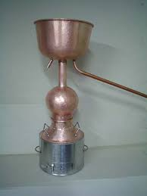

Figure: Brkini still

The earliest written source mentioning 'brinjevec' can be found in J. V. Valvasor's 'The Glory of the Duchy of Carniola' (1689, vol. III, p. 354). According to the 1877 Yearbook of the Slovene Society (*Letopis Matice Slovenske*), 'Valvasor knew of another drink, beside wine, which grows abundant and fine across Dolenjska, Morava, Notranjska and Istria (*vipavec* and *prosečan* varieties), namely a drink made from juniper berries by the peasants themselves – the 'brinjevec', which is still famous today; however the Carniolans [transl. note: old word for Slovenians] also used to very much enjoy their honey schnapps.' Marko Pohlin (with Jožef Eger and Janez Friderik) makes mention of 'brinjevec', [transl. note: spelled 'brinouz'] in his 1781 glossary of three languages *Tu malu besedishe treh jesikov*. Moreover, 'brinjevec', 'češplovec' (plum spirit), 'pelinovz' (wormwood spirit) and other drinks also figure in Pohlin's 1783 grammar of the Slovenian language (*Kraynska grammatika, das ist: Die kraynerische Grammatik, oder Kunst die kraynerische Sprache regelrichtig zu reden und zu schreiben*).

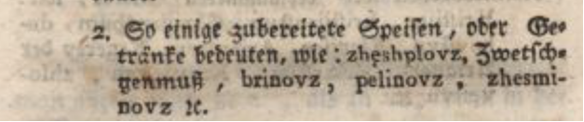

The newspaper *Kmetijske in rokodelske novice* (year 3, No 24, 11.6.1845) published an article on a craft exhibition in Austria (*Avstrijanska obertniska razstava* with the following text: 'There are many fine glass products from Slovenian Styria, a bronze crucifix; ethyl alcohol, rum and 'brinjevec' [transl. note: spelled 'brinovec']; ...'.

*Kmetijske in rokodelske novice* (year 30, No 16, 17.4.1872) published the following invitation: 'The main subject of this extraordinary assembly is how our agricultural society is to attend the grand exhibition in Vienna and what to present. The central committee signed hereunder believes that, among others, Carniolan wines, fruit wines, spirits ('brinjevec', 'slivovec') and vinegar ....'

The *Jutro* newspaper reported in 1926 that '"brinjevec", which was mostly made by the rural folk and transported to Ljubljana, was a favourite among spirit drinkers as far back as the 19th century. "Brinjevec" [spelled as 'brinovček'] is also highly valued as a home medicine. Lore has it that it is the best medicine against digestive cramps.'

'Brinjevec' also appears in more contemporary sources. In his essay, *Dževadova prerokba* ('Dževad's prophecy') presented at the 21st Vilenica International Literary Festival in 2006, Miran Košuta wrote, 'This precious Karstic, Venetian or Istrian "brinjevec" flows only if a minority becomes aware of its specific and hybrid nature, its destiny and role, in short – if it becomes a subject.'

'Brinjevec' is also referred to in foreign-language literature. Veit Heinichen mentioned it in two of his works. In *La calma del más fuerte* [transl. note: the original is in DE, entitled *Die Ruhe des Stärkeren*] he writes, *'Poco antes de ser trasladado a Trieste.* *Entre 1968 y 1974 se habían producido [...] un primer canal de noticias.* *Se sirvió un vaso de "Brinjevec" y dio un largo trago.'*, and in *La larga sombra de la muerte* *'dulce de Istria y de aperitivo un "Brinjevec", una ginebra oscura.'*

The sale of 'brinjevec' was advertised, particularly in areas with Slovenian population. The oldest newspaper advertisement we were able to recover was the one from *Slovenski narod* (year 29, 3.3.1896) for 'Genuine "brinjevec" from Bela Krajina, 1 l bottle at 1 florin and 10 crowns.'

Political daily *Slovenec* (year 36, No 206, 9.9.1908) published the following advertisement: 'Carniolan grape marc spirit "brinjevec" of reliable quality, prize-winning in Paris, available in barrels of 60 l and more at great prices from M. Rosner & Co., a distillery and fruit distillery at Spodnja Šiška, Ljubljana, next to the Kosler's Brewery.' We have found two 'brinjevec' advertisements in the newspaper *Edinost* dated 6 January 1911 and four in an issue that was published on 12 February 1911.

'Brinjevec' was also marketed beyond Slovenia's borders. *Glas naroda* (No 5), a newspaper of Slovenian workers in the United States, published the following advertisement on 21 September 1903: 'Fred Kalin's wholesale wine and spirits shop. In stock: Real Carniolan and Croatian plum spirit, grape marc spirit, juniper spirit, "pelinkovec", etc.'

'Brinjevec' as a typically Slovenian drink is also mentioned in Lonely Planet Western Balkans (p. 338): 'There are dozens of hard-hitting žganje fruit liquors, including češnovec (from cherries), sadjavec (apples), brinjevec (juniper), hruška (pears) and slivovka (plums). Na zdravje! (Cheers!).'

'Brinjevec' is also featured on the website listing the best spirit drinks of all time: http://www.listnerd.com/list/best-distilled-spirit-off-all-time.

The newspaper *Kmetijstvo* published the news on 2.6.2011 about a certain Franc Jelušič receiving the gold medal for his 2008 Brkini plum spirit and the silver medal for his 2009 Kras 'brinjevec' at the international Novi Sad fair in Serbia.

'Brinjevec' has lately figured in Slovenian newspapers. The most notable articles include *Kraški 'brinjevec' je edinstven na svetu* ('Karst "brinjevec" is unique in the world'), published in *Kmečki glas* on 7.8.2013, and *Najbolj slovenski opoj redek in drag kot žafran* ('The most typical Slovenian spirit – rare and costing an arm and a leg'), published in *Delo* on 12.12.2014.

After WWII, 'brinjevec' began to be produced on an industrial scale.

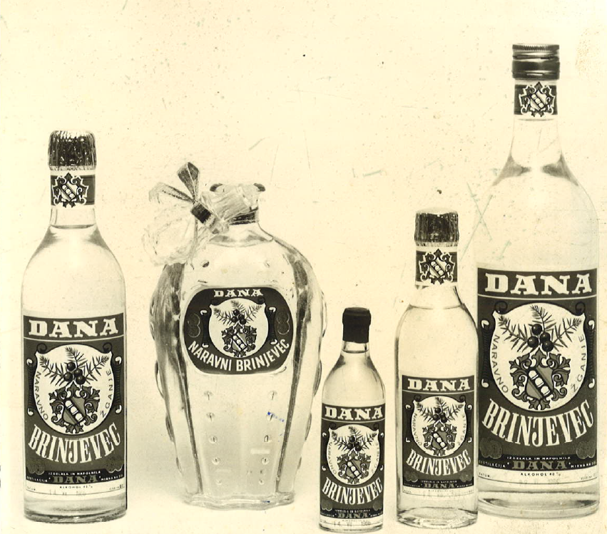

**(f) Any requirements laid down by Community and/or national and/or regional provisions**

The 'Brinejvec' geographical indication may be used by producers on the basis of a report drawn up by a test laboratory designated under the Agriculture Act to check the compliance of spirit drinks and other alcoholic drinks and certifying that their 'brinjevec' meets all the requirements set out in the technical file.

**(g) Name and contact address of the applicant**

Ministry of Agriculture, Forestry and Food

Dunajska 22

SI-1000 Ljubljana

Slovenia

**(h) Any supplement to the geographical indication and/or any specific labelling rule, according to the relevant technical file**

In addition to the markings specified in the rules on pre-packaged foodstuffs and the rules on spirit drinks, the geographical indications on the label must include the acronym of the laboratory that carried out compliance testing, the number of the compliance report, and an indication of the volume for which the report was drawn up (optional).

Rules on the 'Brinejvec' geographical indication have been published in [Uradni List (UL RS; Official Gazette of the Republic of Slovenia) No 70/2010, 3.9.2010](http://www.uradni-list.si/1/index?edition=201070).