Australian National Action Plan on Women, Peace and Security 2021-2031 Progress Report (2023-2025)

Australian National Action Plan on Women, Peace and Security 2021-2031 Progress Report (2023-2025)
ISBN 978-1-74322-645-2 (Online)
ISBN 978-1-74322-646-9 (Print)
Creative Commons
With the exception of the Commonwealth Coat of Arms, the Department of Foreign Affairs and Trade logo, photographs, images, signatures and where otherwise noted, this publication is provided under a Creative Commons Attribution-NonCommercialNoDerivatives 4.0 International (CC BY-NC-ND 4.0) licence, available at https://creativecommons.org/licenses/by-nc-nd/4.0/.
The details of the relevant licence conditions are available on the Creative Commons website (accessible using the link provided), as is the full legal code for the CC BY-NC-ND 4.0 licence, available at https://creativecommons.org/licenses/by-nc-nd/4.0/.
Provided you have not modified or transformed the material in any way, the Commonwealth’s preference is that you attribute this publication (and any material sourced from it) using the following: Department of Foreign Affairs and Trade, Australian National Action Plan on Women, Peace and Security 2021-2031 Progress Report (2023-2025), © Commonwealth of Australia 2025. Licensed from the Commonwealth of Australia under a CC BY-NC-ND 4.0 licence.
Contact
Inquiries about this document should be directed to:
Department of Foreign Affairs and Trade,
RG Casey Building,
John McEwen Crescent,
Barton ACT 0221 Australia
+61 2 6261 1111 (Phone)

Foreword by the Secretary of the Department of Foreign Affairs of and Trade
The Women, Peace and Security (WPS) agenda remains as essential today as it was twenty-five years ago, when the United Nations Security Council adopted Resolution 1325. The world faces complex and evolving challenges—from the climate crisis and digital transformation to rising authoritarianism and conflict-related sexual violence. These challenges have deeply gendered impacts, and the WPS agenda provides a powerful framework for addressing them.
Australia’s commitment to this agenda is steadfast. Our second National Action Plan on Women, Peace and Security 2021–2031 guides our efforts to advance gender equality and uphold the rights of women and girls in fragile and conflict-affected contexts.
This Second Progress Report outlines the key outcomes from 2023–2025 and builds on the achievements of earlier reports.
We have expanded WPS efforts into emerging security domains such as cyberspace, artificial intelligence and maritime security—embedding gender equality into responses to new and evolving threats. In crisis settings, Australia has strengthened humanitarian action and inclusive disaster preparedness.
Through initiatives such as the Pacific Women Mediators Network and Southeast Asian Women Peace Mediators, we are supporting women’s leadership in peacebuilding across our region. We are also deepening our support for survivors of conflict-related sexual violence, including through a new partnership with the Global Survivors Fund.
Progress on the WPS agenda is a shared responsibility. Australia will continue to champion this work through our diplomacy, development, defence and policing—helping to build a future where peace is inclusive, just and enduring.

Jan Adams AO PSM
Secretary of the Department of Foreign Affairs and Trade
Contents
Foreword by the Secretary of the Department of Foreign Affairs of and Trade 2
Introduction 4
Australia’s Commitment to the Women's, Peace and Security Agenda 5
Outcome 1: Support Women’s and Girls’ Meaningful Participation and Needs in Conflict Prevention and Peace Processes 7
Supporting Inclusive Conflict Prevention and Peacebuilding 8
Youth, Peace and Security 10
Building Inclusive Leadership for Conflict Prevention 11
Defence and Peacekeeping Reform 12
Women Leading in Emerging Security Domains 13
Outcome 2: Reduce Sexual and Gender-Based Violence 16
Challenging Harmful Gender Norms and Driving Change 16
Increasing Safety and Security for Women and Girls 20
Protecting and Empowering Refugee and Migrant Women 21
Expanding Access to Justice and Survivor Support 22
Conflict-Related Sexual Violence and Atrocity Prevention 23
Outcome 3: Support Resilience, Crisis Response, and Security, Law and Justice Sector
Efforts to Meet the Needs and Rights of All Women and Girls 24
Inclusive Security and Justice Sector Responses 24
Gender Responsive Humanitarian Action and Disaster Preparedness 26
Women’s Leadership in Crisis Response and Justice Reform 27
Supporting Women-Led Organisations and Inclusive Disaster Preparedness and Response 29
Outcome 4: Demonstrate Leadership and Accountability for the Women, Peace and
Security Agenda 31
Global Leadership and Multilateral and Regional Engagement 31
Regional Leadership and Institutionalisation of WPS 34
Civil Society Engagement and Inclusive Governance 37
Annex – Indicator Data 39
Outcome 1: Support Women’s and Girls’ Meaningful Participation and Needs in Conflict Prevention and Peace Processes 39
Outcome 2: Reduce Sexual and Gender-Based Violence 41
Outcome 3: Support Resilience, Crisis Response, and Security, Law and Justice Sector
Efforts to Meet the Needs and Rights of All Women and Girls 43
Outcome 4: Demonstrate Leadership and Accountability for the Women, Peace and
Security Agenda 44

Introduction
The Women, Peace and Security (WPS) agenda was formally established in October 2000 with the adoption of UN Security Council Resolution 1325—a landmark moment that recognised both the disproportionate impact of conflict on women and girls and their essential role in peacebuilding, conflict prevention, and post-conflict recovery. Advanced through the persistent advocacy of women’s rights and civil society groups, the resolution transformed decades of activism into resounding international policy. Over the past 25 years, the agenda has evolved through nine subsequent resolutions, forming a robust framework that calls for women’s meaningful participation in peace and security processes, protection from gender-based violence, and access to justice and recovery.
Today, the global landscape remains marked by persistent and emerging challenges. Armed conflict, climate disasters, economic instability, digital insecurity, and rising authoritarianism continue to reshape the world. Women and girls are often among the first affected—and also among the first to respond. Their leadership in crisis response, community resilience, and peacebuilding is increasingly recognised as essential to sustainable peace and inclusive development.
In 2024, over 676 million women lived within 50 kilometres of a deadly conflict— a staggering 74 per cent rise since 2010 and the highest number of women exposed to conflict ever recorded (UNSG 2025 Report on WPS; Georgetown Institute on WPS). Conflict-related sexual violence remains widespread, systematic, and disproportionately used against women and girls. Conflict-related sexual violence severely impedes recovery efforts post-conflict by destroying the social fabric of communities. Survivors face lasting and generational trauma, limited access to justice and health care, and under-resourced support systems, whilst perpetrators are rarely held accountable for their crimes.
Despite the evidence that inclusive peacebuilding leads to more sustainable outcomes, women remain largely absent from formal negotiations. In 2024, women comprised just 7 per cent of negotiators and 14 per cent of mediators globally (UNSG 2025 Report on WPS). Nine out of ten peace negotiations included no women negotiators. Only
31 per cent of peace agreements included gender-related provisions, and just two referenced gender-based violence.
Women’s representation in political leadership and diplomacy continues to lag. As of 2025, fewer than 30 countries are led by women, and over 100 have never had a woman head of state (UN Women and UN DESA Gender Snapshot 2025). Women hold just 27 per cent of parliamentary seats globally, with even lower representation in conflict-affected contexts (Inter-Parliamentary Union report Women in Parliament1995–2025). In diplomacy, women remain underrepresented in senior roles, limiting their influence in shaping global peace and security agendas.
Progress in legal protections and safety is uneven. While some regions have seen improvements in perceptions of safety and reductions in child marriage, others have experienced setbacks due to political instability or restrictive legal reforms. Maternal mortality remains high in fragile settings, and human trafficking continues to pose serious risks, especially in displacement contexts. Legal reforms addressing gender equality are advancing in some areas, but gaps persist in enforcement and accessibility.
Insights from the 2025 Women, Peace and Security Survey reveal the lived realities of nearly 3,000 women peacebuilders across 121 countries. While 62 per cent feel empowered to create change in their households, only 21 per cent believe they can influence national governments. Fatigue and burnout are widespread, and displaced women face significantly higher risks. Funding remains a critical barrier—43 per cent of respondents identified long-term financial support as essential, yet 40 per cent reported recent cuts.

Australia’s Commitment to the Women's, Peace and Security Agenda
Australia’s commitment to the WPS agenda is grounded in the understanding that sustainable peace, inclusive development, and national security cannot be achieved without gender equality and the meaningful participation of women and girls in peace and security efforts. As we mark the 25th anniversary of Resolution 1325, this second Progress Report reflects on Australia’s leadership, achievements, and ongoing challenges in advancing the WPS agenda across domestic and international contexts.
Australia’s National Action Plan on WPS 2021–2031 provides a whole-of-government framework for implementing WPS principles in alignment with Australia’s strategic priorities in peacebuilding, humanitarian response, and regional stability. Through coordinated efforts by key implementing partners—including the Department of Foreign Affairs and Trade, Department of Defence, Department of Home Affairs, the Australian Federal Police, and the Australian Civil-Military Centre—Australia has embedded gender-responsive approaches across diplomacy, development, defence, policing, and humanitarian action.
Australia’s commitment to WPS is also reflected as core priority of our International Gender Equality Strategy. It outlines how we will use all tools of our foreign policy to drive gender equality, including through our bilateral and regional programs and relationships, our multilateral diplomacy, trade, development and humanitarian assistance.
Domestically, Australia’s efforts are guided by Working for Women: A Strategy for Gender Equality, released in 2024, which envisions a nation where people are safe, treated with respect, have choices and have access to resources and equal outcomes no matter their gender. There are also more women in our Parliamentary Cabinet than ever before, and in 2025 Australia formed its first ever gender equal Federal Government (49.6%).
This second Progress Report (July 2023 to June 2025) reflects on Australia’s efforts across four outcome areas:
- Supporting women and girls’ meaningful participation in peace processes
- Reducing sexual and gender-based violence
- Supporting inclusive crisis response and justice sector reform
- Demonstrating leadership and accountability for the WPS agenda
Australia’s work has been shaped by inclusive partnerships, evidence-based policy, and a commitment to locally led approaches. Partnerships such as with the Pacific Women Mediators Network and Southeast Asian Women Peace Mediators have elevated women’s leadership in peacebuilding. Investments in inclusive policing, defence operations, and emerging security domains—such as cyberspace, artificial intelligence, and maritime security—have expanded the reach and relevance of the WPS agenda.
Efforts to reduce sexual and gender-based violence (SGBV) have included legal reform, capacity-building for law enforcement, and support for survivor-centred services. Initiatives such as the Women at Risk visa program and expanded Family Violence Provisions have improved safety and access to justice. Australia has also led regional efforts to prevent conflict-related sexual violence and strengthen atrocity prevention frameworks.
In crisis settings, Australia has supported gender-responsive humanitarian action and inclusive disaster preparedness. Programs have delivered sexual and reproductive health services, supported women-led organisations, and embedded gender focal points in disaster response teams—ensuring that women and girls are not only protected but empowered to lead.
Australia’s leadership is reflected in its engagement with multilateral and regional forums, including the UN Peacebuilding Commission, ASEAN, NATO, and the Pacific Islands Forum. Through initiatives such as the Gender Justice Practitioners Hub and the International Alliance on Preventing Sexual Violence in Conflict, Australia has championed inclusive governance and survivor-centred justice.
Progress on the WPS agenda requires collaboration across government, civil society, and communities. The case studies presented in this report demonstrate how Australia’s whole-of-government approach is delivering tangible outcomes, while also identifying areas for continued learning and improvement. As we look ahead, Australia remains committed to advancing gender equality and inclusive peace, ensuring that the WPS agenda continues to evolve in response to emerging challenges and opportunities.

Outcome 1: Support Women’s and Girls’ Meaningful Participation and Needs in Conflict Prevention and Peace Processes
Women’s participation and leadership in peace and security is a proven pathway to more durable, resilient and inclusive peace. For this reason, Australia’s National Action Plan on Women, Peace and Security (2021–2031) increases the participation and leadership of women and girls in conflict prevention and peace processes.
This outcome is underpinned by two medium-term objectives:
- MTO 1.1: Increase women’s meaningful participation in conflict prevention.
- MTO 1.2: Increase women’s meaningful participation in peace processes.
Associated indicators track progress in areas such as:
- The proportion of gender-sensitive conflict prevention efforts.
- The inclusion of gender provisions in peace agreements.
- The number and quality of programs supporting women’s participation in decision-making.
Australia has made significant progress in supporting women and girls’ meaningful participation, leadership and needs in conflict prevention and peace processes. Defence continues to demonstrate its commitment to international gender parity and representation, with specific emphasis on meeting UN gender parity targets in peacekeeping roles and mainstreaming gender across operations. The Australian Federal Police (AFP) has delivered leadership training for women police officers and infrastructure that works for all genders, while Home Affairs has led regional initiatives to increase women’s leadership in border security and cyber security. The Department of Foreign Affairs and Trade (DFAT) has supported women’s participation in mediation, diplomacy, and political processes including through flagship partnerships with the Southeast Asian Women Peace Mediators and Pacific Women Mediators Network.

Supporting Inclusive Conflict Prevention and Peacebuilding
Pacific Women Mediators Network
The Australian Government is supporting the Pacific Women Mediators Network (PWMN) to drive systemic change in peacebuilding across the region. The Network has brought the voices and leadership of Pacific women to global decision-making spaces — including the UN Peacebuilding Commission, UN Security Council, the Commission on the Status of Women, and nuclear disarmament efforts. These high-level engagements have helped shape more inclusive responses to drivers of insecurity, including climate change. Regionally, PWMN’s sustained engagement with Pacific Island Forum leaders has directly influenced the Ocean of Peace Declaration and secured the inclusion of gender, peace and security as formal agenda items in dialogues. At the national level, the Network has supported learning exchanges in the Autonomous Region of Bougainville, Fiji, Tonga and Solomon Islands, which has strengthened women’s leadership in mediation, transitional justice and disaster response. By bridging grassroots expertise with global fora, the Network is reshaping regional security architecture and ensuring women peacebuilders are recognised as essential actors in conflict prevention and climate resilience.
Spotlight: Southeast Asian Women Peace Mediators
The Southeast Asian Women Peace Mediators (SEAWPM) is a regional network of women peacebuilders strengthening women-led mediation and conflict resolution across Southeast Asia and beyond. Established to amplify women’s leadership in peace processes, the Mediators operate through quiet diplomacy and facilitating trauma-informed dialogue between conflict parties, offering trusted accompaniment in some of the world’s most complex and protracted conflicts. Their deep community ties, regional relationships, and trusted presence allow them to engage in ways that are agile, context-sensitive, and grounded in lived experience.
In Timor-Leste, SEAWPM facilitated the Tuban Process—a historic cross-border dialogue between Timorese communities East Timor and displaced groups in West Timor, Indonesia—addressing statelessness, identity loss, and intergenerational trauma – and producing a community-driven roadmap for reconciliation, including truth-telling initiatives, restorative justice, and policy coordination on repatriation and citizenship. In the Philippines, they hosted a pioneering workshop for Israeli and Palestinian women peacebuilders, fostering solidarity and laying the groundwork for ongoing collaboration. In Southern Thailand, learning exchanges with Bangsamoro leaders equipped Thai policymakers with insights into collaborative governance, while engagement with Malaysia’s Chief Facilitator for the Southern Thailand Peace Dialogue strengthened regional mediation.
Beyond Southeast Asia, the Mediators facilitated dialogue between Ambazonian leaders in Southern Cameroons—a significant step toward achieving unified leadership and collaboration among different ideological groups working to address the long-running conflict in the region.
The Mediator’s strategic partnerships—particularly with Association of Southeast Asian Nations (ASEAN) institutions and the Global Alliance of Regional Women Mediator Networks—have increased its impact. Through its work, the Mediators have demonstrated the transformative power of women-led mediation. By centering lived experience, fostering inclusive dialogue, and aligning with regional mechanisms, the Mediators continue to shape peacebuilding practices that are locally grounded, globally connected, and deeply responsive to the needs of conflict-affected communities.
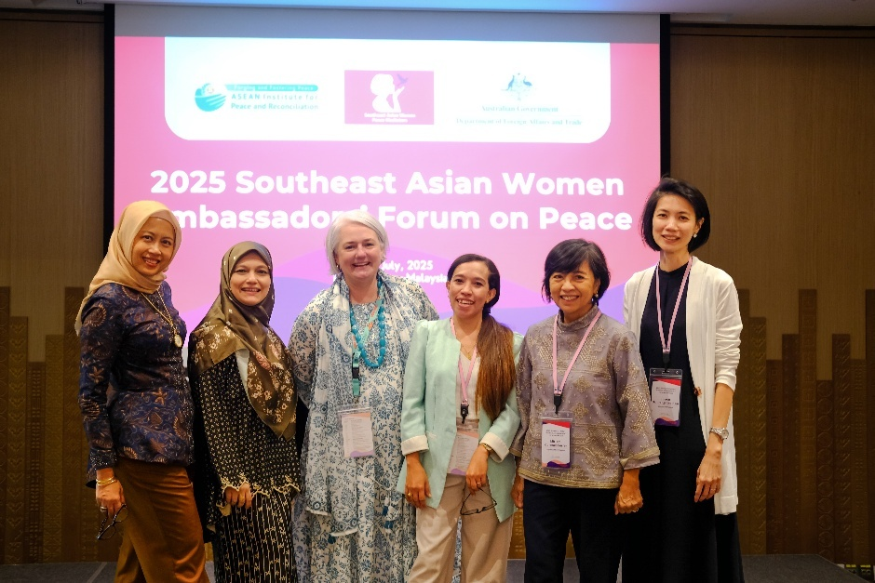
The Southeast Asian Women Peace Mediators shape peacebuilding practices that are locally grounded, globally connected, and deeply responsive to the needs of conflict-affected communities. Photo: SEAWPM.
In the Pacific, Australia’s flagship investment in Pacific Women Lead has supported inclusive governance and women’s leadership in conflict prevention. Initiatives such as Balance of Power and Shifting the Power Coalition have elevated women’s roles in traditional leadership, humanitarian response, and disaster resilience. Programs in Papua New Guinea, including the Autonomous Region of Bougainville, and in Fiji have trained women human rights defenders, strengthened trauma-informed peacebuilding, and embedded women’s leadership in early warning systems.
Since the 2014 Comprehensive Agreement on the Bangsamoro, which led to the creation of the Bangsamoro Autonomous Region in Muslim Mindanao (BARMM), Australia has supported transformative, locally led peacebuilding initiatives. The formation of the Bae Mediators—a network of women from former combatant communities—has resolved local conflicts and gained international recognition for its leadership in reconciliation. Through The Asia Foundation, Australia also supported inclusive policy development in the BARMM Parliament, with regional exchanges informing the draft Disabled Persons and the Gender and Development Code. These insights strengthened policies to reflect women’s leadership and lived experiences of people with a disability. In parallel, Oxfam Pilipinas facilitated the accreditation of two women’s rights organisations, advancing women’s representation in formal political processes.
Through the ASEAN–Australia Political-Security Partnership, Australia has strengthened institutional capacity for WPS implementation. The partnership supported regional learning exchanges, parliamentary roundtables, and cross-regional forums, embedding women’s leadership in ASEAN’s peace and security architecture. The establishment of the annual Southeast Asian Women Ambassadors’ Forum on Peace has elevated women’s diplomatic leadership in regional conflict prevention and resolution. A tangible outcome of the Forum is the establishment of diverse, women-led diplomatic networks that enable context-specific conflict analysis and foster strategic collaboration. Through these networks, the Forum has positioned women as influential actors in shaping peace and security responses across Southeast Asia.
Spotlight: African Women Voices for Peace
Australia’s support for the African Women Voices for Peace Platform, in partnership with ActionAid Australia, has significantly strengthened regional leadership and global visibility of women peacebuilders from the Great Lakes region. This includes forming national and regional working groups and building capacity among survivors of
conflict-related sexual violence in Kenya and Uganda.
The Platform’s participation in high-level forums—including the Beijing+30 Africa Civil Society Organizations’ Regional and Youth consultations—amplified the voices and lived experiences of African women, ensuring their perspectives shaped global policy discourse.
In Ghana, Australia convened a high-level dialogue on democratic transitions and peacebuilding. The event brought together over 150 senior women leaders—including ministers and judges from Ghana, Liberia, and Sierra Leone—whose lived experiences spotlighted both progress and persistent barriers to gender equality in peace and security, reinforcing the need for sustained, inclusive approaches. It also underscored the impact of incremental change and the critical role of male allyship in advancing women’s leadership.
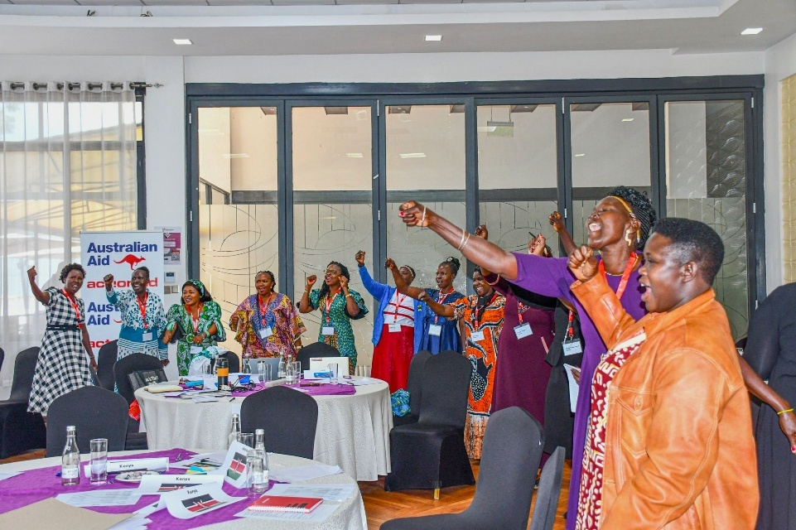
African Women Voices of Peace platform training on women-led community based protection in Narobi. Photo: ActionAid Australia

Youth, Peace and Security
Youth bring vital lived experience, innovation, and energy to conflict prevention and peacebuilding. Their inclusion ensures the WPS agenda remains relevant and sustainable, while fostering future leadership and resilience to emerging challenges like digital security, online gender-based violence, and Artificial Intelligence (AI) ethics.
The UN Women Gen-Forum, held in Bangkok in 2024, convened diverse young leaders from across Asia and the Pacific. The forum focused on building youth leadership and expertise in addressing both traditional and emerging peace and security challenges, including digital threats and AI. Participants—aged 22 to 35 from 20 countries—collaborated to identify regional priorities, share approaches, and develop actionable commitments to strengthen WPS efforts.
Convened under the Regional Framework Towards Peaceful, Inclusive Societies and supported by the Australian Government, the forum launched new research on AI and cybersecurity’s impact on WPS in Southeast Asia. It also facilitated networking, partnerships, and youth contributions to global processes such as the Summit of the Future and the Peacebuilding Architecture Review. An outcome document was produced, reflecting the collective vision and commitments of the participants to drive forward the WPS agenda in the region.
In Papua New Guinea, the Young Women Leaders Program—co-implemented by the International Women's Development Agency and Voice for Change—advanced the WPS agenda by equipping young women with practical skills in leadership, advocacy and financial management. This locally led initiative enhanced women’s participation in decision-making and community leadership, earning participants increased respect and visibility in their communities. Notably, two women subsequently ran for local government office, demonstrating the program’s success in fostering political aspirations and reinforcing women’s roles as agents of peace and public leadership.

Building Inclusive Leadership for Conflict Prevention
Australia has facilitated leadership and technical training for women police officers across the Pacific, Southeast Asia, and Africa, including bespoke programs delivered through the Australian Institute of Police Management, the Jakarta Centre for Law Enforcement Cooperation and the Pacific Community for Law Enforcement Cooperation. These programs have reached hundreds of women, building their capacity to lead and influence within their agencies. The Australian Federal Police (AFP) collaborated with the United Kingdom Metropolitan Police to deliver leadership training to women in South Africa and has collaborated with International Anti-Corruption Coordination Centre to provide mentoring across Botswana, Angola, Zambia, Seychelles, and Mauritius. These initiatives reflect Australia’s commitment to advancing the WPS agenda by supporting women’s leadership in law enforcement, promoting gender equality, and enhancing international cooperation. Through active engagement in global forums and targeted capacity-building, Australia is helping to build a more inclusive and accountable policing and justice sector.
In Solomon Islands, infrastructure projects have improved workplace inclusion for women police officers. At Naha Police Station, the construction of a dedicated female dormitory, along with upgrades to facilities supporting privacy, hygiene, breastfeeding, and personal care, has enhanced safety and dignity for women in uniform. The Kukum Traffic Centre, opened in 2023, was designed with gender and disability inclusion in mind, removing physical barriers to participation. Complementary workshops on sexual harassment and workplace wellbeing, reinforced the importance of respectful, inclusive environments that support women’s full participation in policing.
The Vanuatu Australia Policing and Justice Program (VAPJP) significantly advanced women’s participation and leadership in policing and justice. The inaugural Vanuatu Probationary Constables Completion Course equipped 38 new constables—27 per cent of whom were women—with skills to effectively handle cases involving women and children—an essential step in building trust, ensuring survivor-centred responses, and promoting inclusive policing in communities affected by violence and inequality. A subsequent review found these officers demonstrated greater effectiveness in supporting female victims of violence. Female representation in the Vanuatu Police Force rose by 112 per cent in 2024, with women comprising 26 per cent of the workforce. That same year, a specialised detective training course, delivered in partnership with the AFP, enhanced investigative capacity and victim support. Five of the twelve graduates were women, further strengthening gender-responsive policing and prosecution outcomes.
Spotlight: Women’s Profession Development Program
Australia has emerged as a regional leader in advancing gender equality through
Home Affairs’ Women’s Professional Development Program. Since 2021, the program has equipped nearly 200 women from 30 Asia-Pacific countries with the skills and networks to lead in global border security.
Program alumni have advanced into senior leadership roles—including Fonoti Talaitupu Lia-Taefu, who was appointed in 2023 as CEO to Samoa’s Ministry of Customs and Revenue —and driven cross-border operational collaboration. These regional networks have delivered tangible operational outcomes. For instance, a connection facilitated between Customs administrations in Fiji and the Netherlands enabled the Fiji Revenue and Customs Service (FRCS) to obtain critical evidence in a revenue evasion investigation—a key priority for FRCS. An FRCS officer, who is also a PWPDP alumna, was able to leverage the PWPDP network to secure documents confirming that goods had been mis-declared.
Recognised in 2022 with a UN Gender Award, the program fosters lasting change by building inclusive workplace cultures and mentoring future leaders. As one participant reflected, “It takes a network to defeat a network.” This program cultivating a regional network of women, strengthening border security and advancing gender equality across the Asia Pacific.
The inaugural Papa New Guinea (PNG) Border Agencies Women in Leadership Conference, held in May 2024, brought together 90 women from across Papua New Guinea’s border agencies. Targeted breakout sessions addressed gender equality and inclusion challenges in the PNG context. Ninety-six per cent of participants reported that the conference was valuable for their career development, and 80 per cent gained a clearer understanding of how to progress outcomes within their organisations. Importantly, the conference catalysed the establishment of a PNG border agencies gender equality and social inclusion community of practice, and a commitment to holding the event annually. These developments represent a strategic investment in sustained leadership development, peer support, and institutional change—ensuring that women’s participation and leadership are embedded in the future of PNG’s border security landscape.

Defence and Peacekeeping Reform
The Elsie Initiative Fund, launched in 2019, is driving global reform to close the gender gap in peacekeeping. It supports countries to remove systemic barriers—such as infrastructure, bias, and training gaps—and increase the meaningful participation of uniformed women in UN military and police missions, including in leadership and operational roles. Australia is the third-largest contributor since 2020—and joined the Steering Committee in 2025–26, with plans to co-chair from 2027.
Since its launch, the Fund has delivered measurable impact. Supported countries have deployed military contingents with 10.5 per cent women — exceeding the global average of 7.4 per cent — and women’s participation in police deployments has reached 16.9 per cent. Seven units with high levels of female representation and leadership, have demonstrated that inclusive teams perform effectively in complex environments. In addition, infrastructure that meets the specific needs of women such as separate bathrooms and sleeping facilities has been built in several countries, improving safety and operational support for women in peacekeeping roles. By investing in women’s participation, peace operations become more credible, effective, and better equipped to address the distinct needs and experiences of diverse communities.
The AFP has also played a key role in peacekeeping readiness, delivering UN Police Pre-deployment Training to Pacific counterparts including more than 40 per cent women, with modules on conflict-related sexual violence, sexual exploitation and abuse, and WPS. The AFP supported Pacific participation in global forums, such as the International Women in Policing Conference and UN workshops, ensuring that Pacific perspectives on gender equality and inclusion shape international approaches to policing.
Defence is strengthening gender integration through targeted reforms and increased female representation. As of July 2025, Australian Defence Force (ADF) female representation increased to 20.9 per cent, with the Air Force leading at 27.3 per cent. Defence remains committed to achieving its overall ADF target of 25 per cent by 2030, with agreed targets of 18 per cent Army, 28 per cent Navy and 35 per cent Air Force respectively. From 2023–2025, women comprised 17 per cent of deployed personnel, with ongoing efforts to improve gender balance across all operations. Additionally, the ADF continues to integrate gender advisors and gender focal points in operations and exercises while also mainstreaming WPS into workforce segments and disciplines.
In 2023 and 2024, Defence exceeded the UN Gender Parity Target of 21 per cent for Military Experts on Mission and Staff Officers, marking a significant milestone in advancing gender equality in peacekeeping roles. These achievements reflect a deepening institutional commitment to fostering an inclusive military culture and ensuring Defence personnel are equipped to understand and respond to the needs of women and girls in all operational contexts.

Women Leading in Emerging Security Domains
Globally, Australia has promoted women’s participation in emerging security domains. The Women in International Security and Cyberspace Fellowship and Women in AI Fellowship have equipped women from Southeast Asia and the Pacific with the skills and networks to engage in multilateral negotiations on cyberspace and AI governance. These fellowships have led to increased representation and influence of women in UN peace and security processes, positioning Australia as a leader in embedding gender in cyberspace governance.
Spotlight: Women in Maritime Security
The Southeast Asia Women in Maritime Security program, delivered by the University of Wollongong’s Australian National Centre for Ocean Resources and Security, is reshaping the region’s maritime security landscape by equipping women from across the region with critical expertise in maritime law, leadership and conflict prevention. Through immersive training and strategic field visits, the program empowers participants to actively shape policy, lead operational reform, and embed gender perspectives in security institutions. The program has directly contributed to alumnae promotions and competitive placements, and its growing network of female leaders is strengthening Southeast Asia’s security sector by driving inclusive, informed engagement on maritime challenges and peacebuilding efforts.
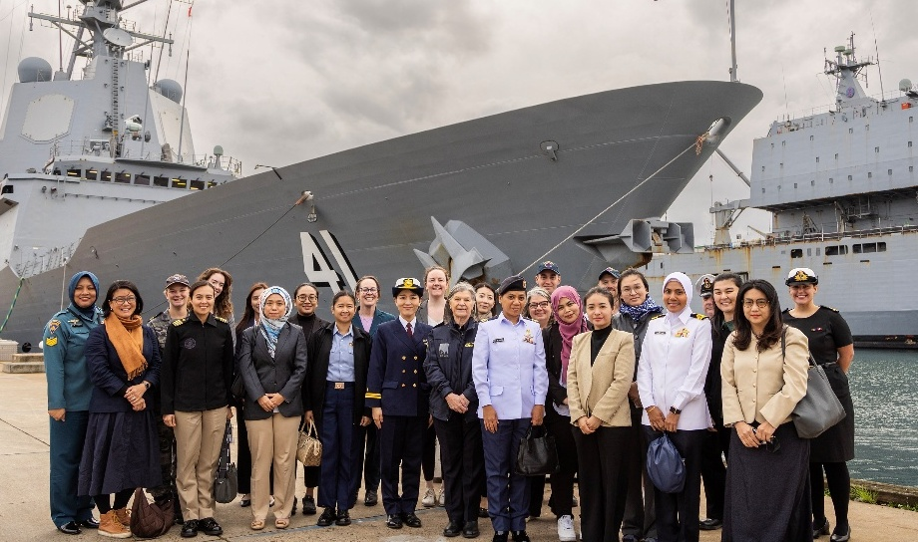
The Women in Maritime Security (WIMS) program has brought together 17 women from the Navy, Coastguard and Foreign Affairs in Australia, Brunei, Indonesia, Japan, Malaysia, the Philippines and Vietnam for a two-week program in Australia.
Spotlight: Diversity at the Frontier
The Diversity at the Frontier: Gender Equality in Space conference, held in 2023, marked a groundbreaking moment in Australia’s leadership on inclusive space governance. Delivered in partnership with the Global Institute for Women’s Leadership, the Australian Space Agency, the Australian Academy of Science, and the US Government, this landmark collaboration brought together leaders from government, industry, academia, and civil society to champion gender equality as a strategic necessity in Australia’s emerging space sector—critical for driving innovation, resilience, and addressing workforce shortages.
First Nations leaders advocated for Indigenous knowledge to shape Australia’s space future. The conference spotlighted urgent gaps—particularly for women, LGBTQIA+ communities, culturally and linguistically diverse groups, First Nations peoples, people with disabilities, and those in remote or low-income areas—framing these as critical priorities for reform in space research, policy, and practice.
By spotlighting these systemic barriers, the event catalysed momentum for more equitable and representative governance in Australia’s space sector. Outcomes included the establishment of the Women in Space Network and new cross-sector collaborations. It positioned Australia at the forefront of global efforts to embed equity in emerging security domains.
Diversity in Australia’s cyber security workforce is a strategic capability in the national interest. With a projected shortfall of up to 30,000 cyber specialists and women comprising only 17–20 per cent of the sector, Home Affairs and the National Cyber Security Coordinator are working to close this gap by fostering a gender-responsive and inclusive workforce. Through initiatives like the Women in Cyber Security Summit and the Quad Cyber Challenge at Government House, the Department is actively nurturing future women leaders in cybersecurity. These events highlight the power of partnerships and youth engagement in shaping a secure digital future. To support systemic change, Home Affairs also commissioned guidance on inclusive recruitment practices, aiming to remove barriers and create pathways for more women—including young women and girls—to enter and thrive in the cybersecurity.
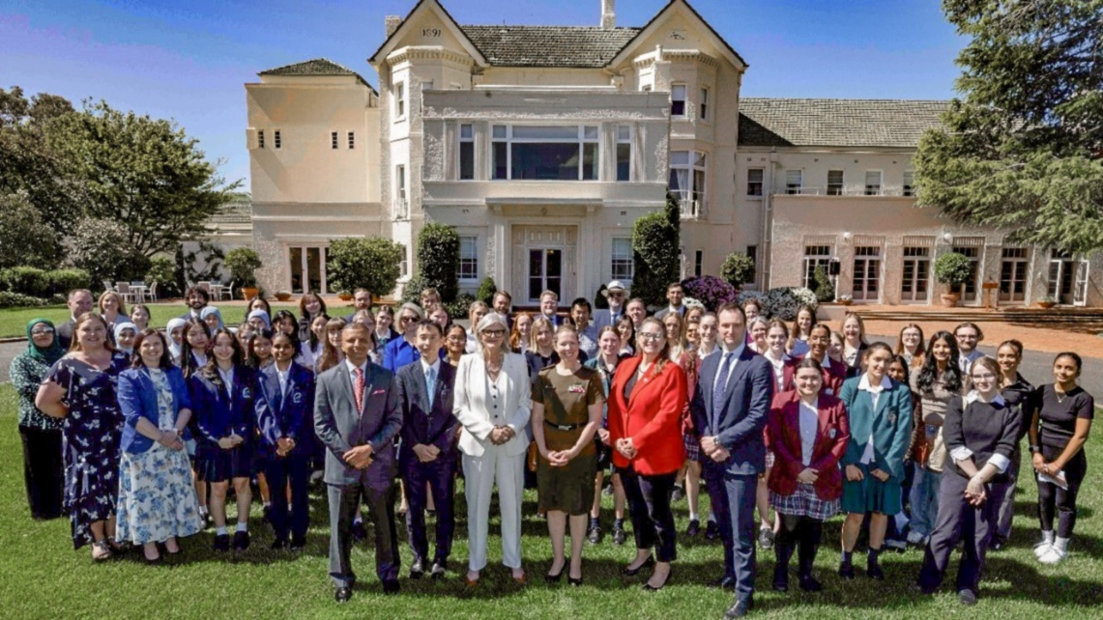
The second QUAD Cyber Challenge was hosted by the Governor General Her Excellency the Honourable Sam Mostyn AC and Cyber Security Coordinator Lieutenant General Michelle McGuinness, CSC. Photo: Home Affairs.

Outcome 2: Reduce Sexual and Gender-Based Violence
Sexual and Gender-Based Violence (SGBV) undermines human rights, destabilises communities, and obstructs women’s full participation in peace and security. Australia’s National Action Plan is working to reduce SGBV across different contexts — including conflict, crisis, and post-conflict settings — through coordinated, survivor-centred approaches that address the root causes of gender inequality which drive the perpetration of SGBV.
This outcome is supported by three medium-term objectives:
- MTO 2.1: Reduce harmful gender norms.
- MTO 2.2: Increase safety and security for women and girls.
- MTO 2.3: Increase access to justice for victims and survivors of SGBV.
Indicators measure progress in areas such as:
- Legal and policy reform.
- Prevention and response efforts (including technology-facilitated abuse).
- Perceptions of safety and access to justice.
Australia’s efforts have delivered tangible results to prevent and respond to SGBV. Defence has deployed gender advisors and focal points across operations and the Australian Federal Police (AFP) has led regional efforts to combat technology-facilitated SGBV, supported inclusive policing strategies, and strengthened investigative capacity in Pacific law enforcement. Home Affairs has prioritised refugee women refugees in vulnerable situations and their dependents through the Women at Risk visa program and expanded Family Violence Provisions to remove visa-related barriers to safety. DFAT has invested in survivor-centred SGBV services and led efforts to prevent conflict-related sexual violence including through atrocity prevention frameworks.

Challenging Harmful Gender Norms and Driving Change
A key achievement of the Pacific Partnership for Ending Violence Against Women, supported by Australia and the EU and coordinated by UN Women and Shifting the Power Coalition, was the development of Samoa’s first national prevention framework. Pola Puipui—a ten-year, cross-sector initiative rooted in Fa’a Samoa and faith, was developed collaboratively with government, civil society, and communities. It focuses on primary prevention and actively engages men and boys, integrating training for officials, village leaders, and frontline workers to promote a shared understanding of Gender-Based Violence (GBV), its root causes, and survivor-centred approaches.
The Australia-Indonesia Partnership Towards an Inclusive Society, or INKLUSI, is working to increase the participation of marginalised groups in sociocultural, economic, and political development. The program has empowered communities to challenge entrenched gender norms and reduce child marriage. In North Aikmel village, East Lombok, child marriage cases dropped from 17 to just one following the introduction of community-led regulation. This locally driven reform demonstrates the impact of inclusive governance to shift harmful norms, protect girls’ rights, and deliver measurable changes in gender equality at the grassroots level.
The Southeast Asian Network of Civil Society Organisations program, delivered by Home Affairs in partnership with Deakin University, supports more than 60 like-minded CSOs from Indonesia, Malaysia, the Philippines and Thailand to strengthen community resilience to violent extremism. Since its inception in 2016, the program has fostered regional collaboration and shared learning about transformative impact of grassroots initiatives. One powerful example from Sulu, in the Bangsamoro Autonomous Region in Muslim Mindanao (BARMM), Philippines, highlights how culturally grounded, women-led interventions have facilitated the reintegration of ex-Abu Sayyaf widows. Supported by the BARMM armed forces, these efforts addressed deep-seated trauma and social stigma, while promoting healing and reconciliation in a post-conflict setting. Through such initiatives, the program has helped shift regional narratives—recognising women not merely as victims of conflict, but as central actors in peacebuilding, rehabilitation, and long-term resilience. The program continues to catalyse a growing movement of empowered civil society leaders working collaboratively to prevent violent extremism and foster inclusive, peaceful communities.
The Australian Cultural Orientation Program, delivered in partnership with the International Organisation for Migration, is a voluntary program offered to refugee and special humanitarian program entrants prior to their departure for Australia. The program works to reduce harmful gender norms and support women and girls’ safety by providing information on Australian law, including in relation to equality in the workplace, and focuses on domestic and family violence, sexual assault and forced marriages. During the reporting period, the program reached over 21,500 humanitarian entrants, including 815 Women at Risk visa holders. This early intervention helps lay the foundation for safer settlement experiences in Australia.
Gender advisors play a vital role in transforming policing practices by embedding gender equality and inclusion into operational frameworks. The Timor-Leste Police Development Program applied a gender mainstreaming approach, supported by a dedicated Gender Equality Disability Social Inclusion Advisor. A gender analysis revealed significant underreporting of GBV, prompting targeted workshops to strengthen investigative skills and improve victim-survivor care, as well as practical improvements to Vulnerable Person Unit equipment and infrastructure. These efforts have directly enhanced the Policia Nacional de Timor-Leste’s capacity to respond to GBV, improving protection for women, children, and vulnerable groups at the local level.
Through the Pacific Community for Law Enforcement Cooperation, the Northern Mariana Islands requested the AFP support to deliver gender diversity training in, improving police engagement with LGBTQIA+ communities. Across all activities, the integration of gender advisors has led to more inclusive policing environments and better outcomes for women, girls, and vulnerable groups.
Spotlight: Promoting Positive Gender Norms through Defence Diplomacy
Indo-Pacific Endeavour is Australia’s flagship defence regional engagement initiative, reflecting Australia’s whole-of-government commitment to a peaceful, stable, and prosperous Indo-Pacific region. Through collaboration and capacity building humanitarian assistance and peacekeeping with regional militaries, Indo-Pacific Endeavour enables Australia to promote shared values and positive gender norms, respect for sovereignty, and adherence to international rules and norms. These efforts embed the WPS agenda across the region, fostering environments where women’s rights and protection are prioritised in security responses.
In 2024, the Australian Defence Force (ADF) and other government agencies partnered with 14 nations across Southeast Asia and the Northeast Indian Ocean to deliver diverse activities from interactive workshops to train-the-trainer programs, and women’s networking events:
- Cambodia: Mobile Training Teams delivered a Protection of Civilians course and a Gender in Military Operations workshop for Royal Cambodian Army personnel preparing for UN deployments.
- Philippines: Facilitated a Gender, Peace and Security Awareness Workshop for Defence staff at the Australian Embassy in Manila and co-developed a pilot WPS Workshop with the Armed Forces of the Philippines and the Department of National Defense, supporting WPS operationalization.
- Timor-Leste: Delivered a WPS Workshop for women from the Timor-Leste Defence Force, followed by a visit to Australia where participants engaged in combat first aid, combative training, and live-fire exercises with the Australian Defence Force (ADF), strengthening capability development and people-to-people links.
- Vietnam: The Vietnam Department of Peacekeeping Operations hosted an Australia–Vietnam WPS Seminar focused on UN peacekeeping. The 2024 theme, “What can we learn from better preparation and experience,” featured insights from ADF and Vietnam People’s Army personnel, deepening bilateral cooperation and shared understanding of women’s participation in peacekeeping.
The WPS agenda will continue to be embedded across future regional engagement activities, tailoring support to partner nations and identifying engagement strategies that meet the needs of diverse stakeholders.
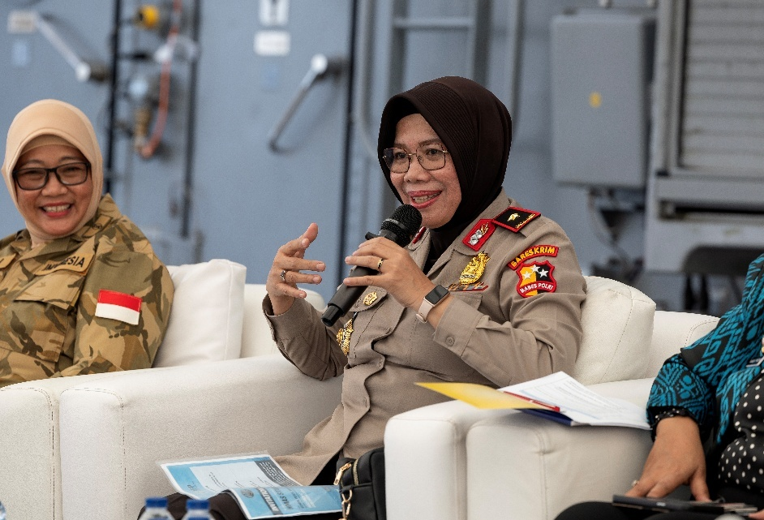
Police Brigadier General Desy Andriani, Director of Directorate of Crimes Against Women and Children (PPA) and Human Trafficking (PPO), Indonesian National Police speaks during the Gender, Peace and Security workshop held on the flight deck of HMAS Stuart as part of Indo-Pacific Endeavour 2024 in Jakarta, Indonesia. Photo: LSIS Rikki-Lea Phillips
Spotlight: Engaging Men and Boys to Prevent Sexual Gender-Based Violence
Engaging men and boys is essential to preventing SGBV. By challenging harmful masculinities and promoting respectful relationships, these efforts foster lasting cultural change and safer communities for women and girls.
In Bangladesh, Australia supports the United Nations High Commissioner for Refugees (UNHCR) Male Role Models Program, which empowers men and boys in Rohingya refugee communities to challenge gender norms and prevent SGBV. Graduates lead outreach programs in their communities, promoting equality and non-violence.
In the Pacific, the Pacific Women Lead program has trained over 1,500 male advocates and engaged law enforcement. In 2025 alone, more than 35,000 people participated in activities promoting women’s rights and respectful relationships.
In Papua New Guinea, the Men and Boys Engagement Framework has boosted male involvement in GBV prevention. Through Femili PNG, over 13,000 men and boys across Morobe Province have participated in school and community outreach on GBV laws and gender norms.
These initiatives show that when men and boys are meaningfully engaged—as allies, role models, and advocates—they become powerful agents of change, to help to shift entrenched harmful gender norms and end SGBV.
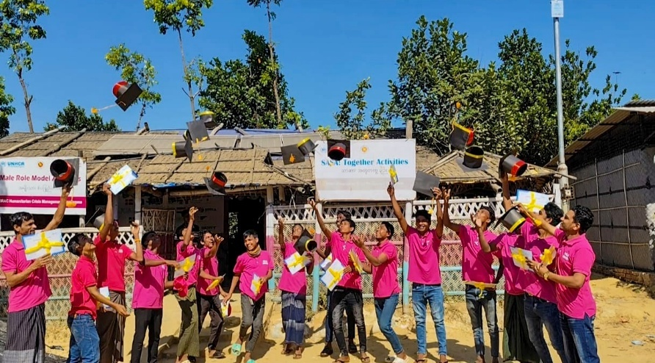
Empowered to lead. Rohingya male role models at Camp 4, Ukhiya, Cox’s Bazar, graduated after successfully completing 30 sessions in three months. They will now engage with their refugee community and lead in addressing critical issues like child marriage and domestic violence. Photo: Nerupon Barua / BRAC
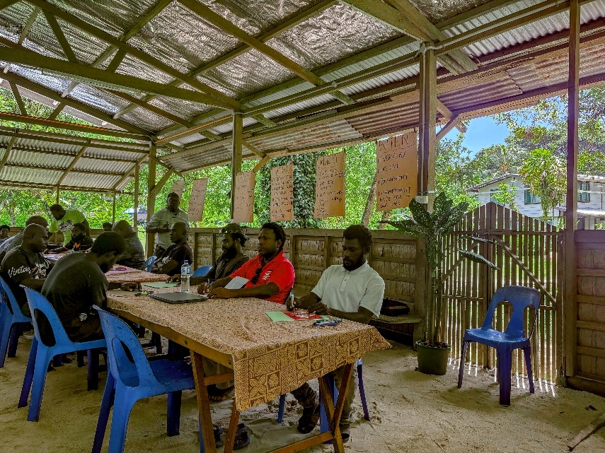
Opening of the PNGWL’s supported Male and Boys advocate training in May 2025 run by Nazareth Centre for Rehabilitation in Bougainville. Photo: DFAT

Increasing Safety and Security for Women and Girls
Spotlight: Gender Focal Points in the Pacific
The Pacific Response Group’s Pacific Special Advisory Team, a small, rapidly deployable team based in Brisbane, supports civilian-led disaster response planning and became operational in November 2024. In January 2025, all in-country members — comprising personnel from the ADF, French Armed Forces, His Majesty’s Armed Forces (Tonga), Papua New Guinea Defence Force, and Republic of Fiji Military Forces — completed the ADF’s Gender Focal Point course.
At the request of the Pacific Response Group’s Fijian Deputy Commander, the Australian Commanding Officer and Army Gender Advisor facilitated gender focal point training during the team’s 2025 skilling period to advance the South Pacific Defence Ministers’ Meeting commitment to WPS implementation. The training strengthened understanding of how to integrate gender perspectives into operations and reflected shared values across the Blue Pacific.
All participants formally qualified as Gender Focal Points, enhancing both individual capability and collective capacity to operationalize WPS principles in regional operations. Since qualifying, members have participated in regional activities, including Exercise Croix Du Sud in New Caledonia and the team plans to include Gender Focal Points training in its skilling program ahead of the next high-risk weather season.
This initiative demonstrates Australia’s leadership in embedding gender perspectives into regional disaster response operations. It strengthens interoperability among Pacific defence forces, operationalises commitments by South Pacific Defence Ministers’, and builds sustainable capacity for gender-responsive planning in humanitarian and security contexts.
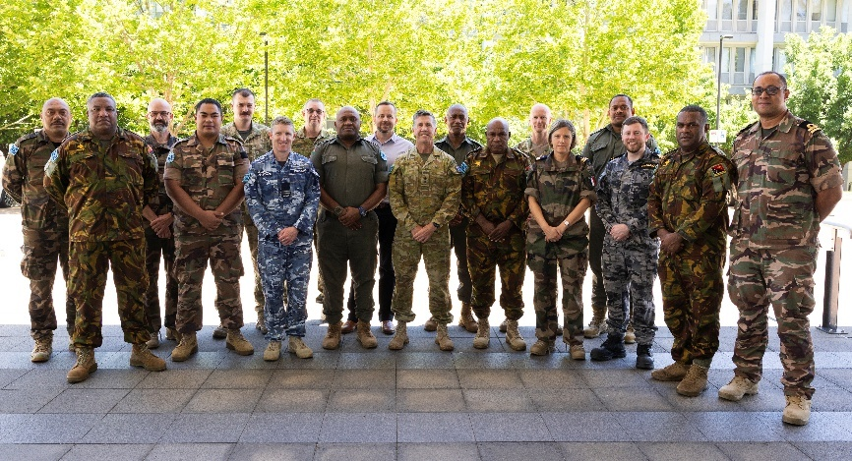
Members of the Pacific Response Group (PRG), a multinational Pacific military capability with a focus on providing humanitarian assistance and disaster relief, established under the auspices of the South Pacific Defence Ministers’ Meeting (SPDMM). The PRG is comprised of personnel from Australia, Fiji, France, New Zealand, Papua New Guinea and Tonga. Photo: Kym Smith
The AFP advanced efforts to increase the safety and security of women and girls, particularly in the digital space. Through programs like Cyber Safety Asia and Cyber Safety Pasifika (CSP), the AFP has trained thousands of frontline police to respond to technology-facilitated GBV. These programs were co-designed with Asian and Pacific stakeholders and delivered in collaboration with local organisations, strategic partners and regional crisis centres. Notably, female police officers across the Pacific regularly take on leadership roles as trainers and mentors, with participants now able to provide improved support services to women and children experiencing technology-enabled family and domestic violence.
“The participation of women in Cyber Safety Pasifika programs as trainers is a testament to the commitment of gender equality and breaking down of barriers of gender norms in a Pasifika setting. I am personally grateful to the AFP-CSP team, for recognising capabilities of women in Pacific policing, and for providing the platform for us to demonstrate inherent unique and beautiful qualities of our Pasifika people."
Australia has supported the development of the UN Women Asia-Pacific Digital Security eLearning Platform, a free, multilingual online training initiative designed to increase women's digital resilience and leadership in cybersecurity. This Platform offers self-paced learning modules and facilitator guides that equip women—particularly human rights defenders and peacebuilders—with the skills to navigate digital threats such as surveillance, harassment, disinformation and artificial intelligence. Its significance lies in addressing the gendered dimensions of digital insecurity, which can silence women’s voices and undermine their participation in peace processes. By empowering women to safely engage in digital spaces, the Platform strengthens their role in conflict prevention, resolution, and recovery, especially in regions where digital gender divides and online harms are prevalent.

Protecting and Empowering Refugee and Migrant Women
The Women at Risk visa program, under Australia’s Humanitarian Program and implemented by Home Affairs, provides a vital resettlement pathway for women refugees in vulnerable situations and their dependents. Eligible applicants are those facing persecution, registered as being of concern to UNHCR, and living without the protection of a male relative or at risk of GBV. Between 1 July 2023 and 30 June 2025, 1,733 offshore humanitarian visas were granted through the program, representing approximately five per cent of all offshore humanitarian visas issued during this period. The top countries of origin included Afghanistan, the Democratic Republic of the Congo, Venezuela, Syria, and Somalia. In collaboration with UNHCR, Australia prioritised the resettlement of women at risk across two consecutive program years—2023-24 and 2024–25—maintaining a record-high 20,000 places annually in the Humanitarian Program. This marked the first time since 1982 that Australia sustained such an intake over two years.
Complementing the visa program, the Humanitarian Settlement Program, implemented by Home Affairs, delivers tailored support to newly arrived women and children, particularly those without male family members. Services include personalised case management focused on physical, mental, and social wellbeing, helping women build independent lives in Australia with the skills and confidence to thrive.
To increase safety and security for women and girls, the Settlement Engagement and Transition Support Program enhanced domestic and family violence support for refugee and vulnerable migrant women. This program has enabled delivery of specialised services—including crisis intervention, legal education, respectful relationships training, and group sessions on Australian laws and values. During the reporting period, these services were delivered to more than 3,800 individual clients—83 per cent of whom were women. Notably, 71 per cent of clients reported improved safety outcomes in their personal and family safety.
The Community Liaison Office Network is reducing barriers to reporting domestic and family violence and improving access to prevention and responses services. By connecting a wide range of cultural, ethnic and faith-based community stakeholders to government, police and domestic and family violence service providers, the Network is increasing safety and security for migrant women.
The expanded Family Violence Provisions under the Migration Regulations 1994 have reduced SGBV, increased safety and security and access to justice by ensuring visa applicants are not forced to remain in violent relationships to secure permanent residency. The expansion, effective from 17 December 2024, covers 20 visa subclasses, including secondary applicants and additional partner visa cohorts. As of June 2025, 244 family violence provision claims were made under the expanded provisions, with over 100 visas granted. These reforms represent a significant step toward removing visa-related barriers for victim-survivors seeking safety.

Expanding Access to Justice and Survivor Support
To improve access to justice, the AFP delivered targeted sexual and GBV training across the Pacific. In Nauru, 30 police officers—half of them women—received specialised training on family and sexual violence. In Samoa, the AFP supported the launch of the country’s first Domestic and Family Violence Strategy, a milestone in institutionalising survivor support and accountability. In the Philippines, the AFP trained law enforcement personnel to investigate and respond to SGBV and online child exploitation under the six-year SaferKidsPH initiative.
In partnership with UNFPA, UN Women, UNICEF, and the Government of Vietnam, Australia is supporting the Elimination of Violence Against Women and Children in Vietnam program to combat violence against women and children through coordinated prevention, response, and legal reform efforts. A key achievement of this program was the revision of Vietnam’s Domestic Violence and Prevention Law—introducing protection orders and contact restrictions for the first time. The updated law also established a national hotline and enhanced survivor support services, marking a major step forward in access to justice and institutional accountability for ending domestic violence.
During the 2023 Pacific Games, AFP advisors supported the Royal Solomon Islands Police Force’s Sexual Assault Team in investigating a case of aggravated sexual assault involving the release of imagery on social media—the first of its kind. The provision of support led to the successful identification, arrest, and charging of the suspect. This landmark case not only strengthened the team’s investigative capability in digital abuse, but importantly enhanced access to justice for the survivor.
In Cambodia, Australia has significantly expanded survivor-centred support for GBV, enabling over 900 survivors in 2024 to access counselling, legal aid, and medical care through a trained, inclusive provider network. With more than 1,000 service providers—including women, people with disabilities, and Indigenous leaders—trained in national Essential Service Guidelines, the program has enhanced the safety, confidentiality, and quality of care across all levels of the community.
In Papua New Guinea, the PNG Women Lead program is driving systemic, locally led efforts to prevent violence against women and girls, reaching over 63,000 people during the reporting period—including more than 300 people with disabilities—through inclusive GBV prevention initiatives. The program also established four crisis support centres across provinces, delivering integrated, survivor-centred services to over 5,500 survivors—most of them women and girls—including medical care, legal and policing support, safe housing, counselling, and economic empowerment tools.

Conflict-Related Sexual Violence and Atrocity Prevention
Conflict-Related Sexual Violence (CRSV) refers to sexual violence that is directly or indirectly linked to conflict and includes acts such as rape, sexual slavery, forced prostitution, forced pregnancy, and other forms of sexual violence committed by armed actors or in conflict-affected settings. CRSV is a recognised early warning sign of mass atrocity crimes and may itself trigger the international community’s Responsibility to Protect—the obligation to protect populations from genocide, war crimes, ethnic cleansing, and crimes against humanity. Through the Asia Pacific Centre for the Responsibility to Protect, Australia supports the Gender Working Group of the Asia Pacific Partnership for Atrocity Prevention.
A key milestone was the publication of the Framework for Action for Responsibility to Protect in 2023, which highlights critical gender dimensions of atrocity prevention, including women’s mediator networks, redress for survivors, and recommendations for women’s participation in peace processes. In 2024, the Gender Working Group released a landmark report demonstrating how gender-responsive indicators can strengthen early warning systems and improve responses to emerging threats. The group also supported the Asian Muslim Action Network in digitising national SGBV data in Indonesia, enhancing the tracking of risks and informing policy responses. These indicators are vital tools for identifying risks and ensuring women’s experiences and leadership are central to atrocity prevention efforts, helping shape more inclusive and effective early warning systems across the region.

Outcome 3: Support Resilience, Crisis Response, and Security, Law and Justice Sector Efforts to Meet the Needs and Rights of All Women and Girls
Women and girls face heightened risks during crises — including Sexual and Gender-Based Violence (SGBV), loss of livelihoods, and limited access to essential services. Yet they are also leaders in community response, recovery, and resilience. Australia’s National Action Plan ensures that crisis response, humanitarian action, and law and justice efforts are inclusive, rights-based and responsive to diverse needs.
This outcome is underpinned by two medium-term objectives:
- MTO 3.1: Increase access to security, law and justice responses.
- MTO 3.2: Increase access to humanitarian action, stabilisation and disaster management.
Indicators track progress in areas such as:
- Gender-sensitive justice reform.
- Inclusive disaster preparedness.
- Survivor-centred humanitarian assistance.
Australia has embedded gender equality and inclusion across domestic and international crisis responses. Defence has deployed Gender Advisors and Gender Focal Points in disaster operations, including responses to Tropical Cyclone Megan and supported regional initiatives such as the Pacific Response Groups’ Gender Focal Point training.
The Australian Federal Police (AFP) has supported gender-responsive policing in elections and emergencies and led regional forums to elevate women’s leadership in crisis settings. Home Affairs has delivered targeted support to migrant women experiencing violence and strengthened regional reintegration efforts for women and children affiliated with foreign terrorist fighters. DFAT has advanced inclusive humanitarian action including supporting sexual and reproductive health services, women-led organisations, and inclusive disaster risk reduction.

Inclusive Security and Justice Sector Responses
A key area of impact has been the Australia’s support for partner law enforcement agencies to address gender related crimes such as human trafficking, forced marriage, and SGBV. The Australian Federal Police (AFP) delivered targeted training and awareness programs in countries including Türkiye, the Philippines, Indonesia, Sri Lanka, and across the Pacific, equipping police officers with the skills to investigate and respond to complex crimes. These efforts have strengthened justice sector responses and improved access to justice for women and girls.
Australia’s support for inclusive, rights-based justice systems in Southeast Asia includes addressing the specific needs of women in detention. In 2021, the Philippines had the seventh highest rate of incarcerated women globally, with many imprisoned due to poverty-related offences or as a result of surviving domestic violence, sexual abuse, or trafficking. Through the FAIR program, Australia supported justice reform through the development of a manual and protocol for handling women’s legal cases, aligned with the Bangkok Rules on the Treatment of Women Prisoners. These resources guide justice stakeholders in trauma-informed approaches to intake, healthcare, case tracking, non-custodial measures, and diversion programs—strengthening access to SRHR and protection from Gender-Based Violence (GBV) within the justice system.
The Australia Indonesia Partnership for Justice’s support has significantly contributed to improve access to justice for women and girls in Indonesia, addressing critical gaps in legal protections, service delivery, and rights awareness. Delivered in partnership with Indonesian civil society organisations, a dedicated working group established by the Supreme Court, and through a partnership with the Family Court of Australia, this program has strengthened institutional frameworks, promoted the prevention of child marriage and enhanced protections for persons with disabilities. A key achievement was the landmark Supreme Court Regulation No. 3/2017 on Women in Contact with the Law, promoting fair treatment of women in judicial processes. In Aceh, the program strengthened legal protections, institutional capacity, and local policies, culminating in the enactment of Qanun No. 4/2025, which embeds women’s rights in religious law—including protections for divorced women, disaster-affected women, and survivors of past human rights violations.
The AFP also played a leading role in countering violent extremism through gender-focused forums and training. Notably, the International Women in Counter Terrorism Forum hosted at the Jakarta Centre for Law Enforcement Cooperation brought together female leaders from the Association of Southeast Asian Nations (ASEAN) member states to explore the evolving role of women in extremist movements and the importance of gender diversity in national security. Our engagement helped shape regional responses to the repatriation of female foreign terrorist fighters and informed prosecutorial approaches in the Philippines.
Home Affairs’ Domestic and Family Violence Support Service supports temporary visa holders experiencing domestic and family violence to regularise their visa status, ensuring they are not forced to remain in unsafe relationships due to migration concerns. Delivered through a national network of specialist Visa Support Officers, the service provides tailored case management, connects clients to legal and support services, and engages with stakeholders to raise awareness and inform policy. During the reporting period, the service received 1,883 referrals—91 per cent from women—and conducted 160 stakeholder engagements, marking a 90 per cent increase from the previous period. The program has become a critical pathway to safety and justice for migrant women, helping remove visa-related barriers to escaping violence.
Spotlight: Adult Migrant English Program
Language support services such as the Adult Migrant English Program (AMEP) and the Free Interpreting Service played a vital role in enabling migrant women to access legal, health, and social services. With women comprising 70 per cent of participants and women at risk visa (204) holders the highest participants from all visa cohorts, these programs were instrumental in promoting social and economic inclusion.
One recent client, Kate, who fled the war in Ukraine, reflected “the AMEP is the place that will give you much more than just learning a new language. It will give you new friends, widen your understanding of life and open you up to the world, to different countries and their cultures and traditions.”
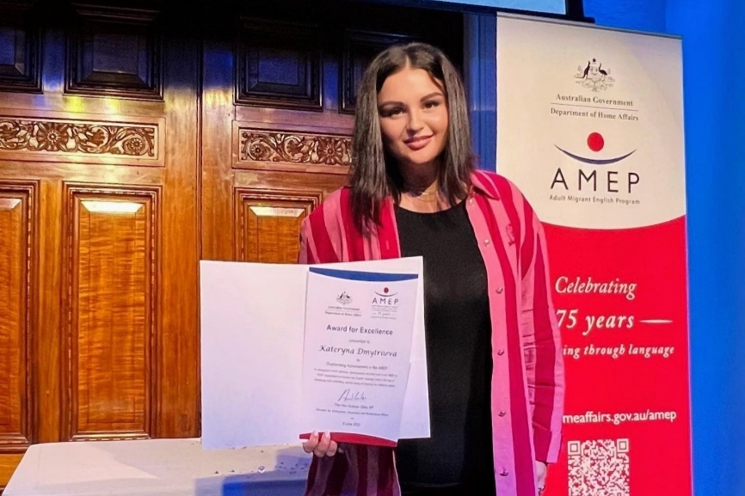
Kate, accepting the Adult Migrant English Program 75th ​Anniversary Award for Excellence in 2023. Photo: AMEP.

Gender Responsive Humanitarian Action and Disaster Preparedness
In humanitarian settings, Australia’s support has enabled lifesaving, dignity-preserving assistance. Australia supports the United Nations Population Fund (UNFPA) Regional Prepositioning Initiative, which prepositions sexual and reproductive health and GBV supplies across disaster-prone Indo-Pacific countries for rapid humanitarian response. In 2024, the initiative enabled timely distribution in 35 emergencies—reaching more than 30,000 people – 90 per cent of whom were women and girls – as well as over 600 people with disabilities. Tailored dignity kits, including for older women in Myanmar and survivors of sorcery-related violence in Papua New Guinea, and training for over 300 professionals in inclusive supply chain management, ensured responses met diverse needs, including those of people with disabilities and LGBTQIA+ communities.
Australia’s investments in SRHR have been critical to safeguarding the wellbeing, dignity, and autonomy of women and girls in humanitarian and crisis contexts. Through partnerships including with International Planned Parenthood Foundation and UN Populations Fund, Australia has delivered lifesaving services to tens of thousands across Asia and the Pacific. These efforts ensure that humanitarian responses are inclusive and responsive to diverse needs—including those of women with disabilities and individuals of diverse gender identities—through provision of customised dignity kits, targeted support, and inclusive training. In disaster settings such as Typhoon Doksuri (Egay) in 2023, DFAT’s partnership with the Philippine Red Cross delivered prepositioned relief to 4,250 people, including 250 pregnant and nursing mothers in Abra. In South Sudan, where nearly three-quarters of the population need urgent assistance, Australia’s support enabled the delivery of SRHR services to nearly 15,000 people, the majority of whom were women. Survivors received clinical care—such as counselling, sexually transmitted infection screening, and emergency contraception—and where required were referred to legal, protection, and livelihood services. These examples demonstrate that integrating SRHR into humanitarian response is not only lifesaving—it is foundational to gender equality, resilience, and recovery.
In January 2025, Defence conducted Gender Focal Points training to the Pacific Response Group’s Pacific Special Advisory Team - a multinational team comprising personnel from Australia, France, Tonga, Papua New Guinea, Fiji, and New Zealand. This training equipped participants with gender-sensitive skills to support humanitarian assistance and disaster relief operations, enhancing individual capabilities and strengthening regional interoperability. This initiative builds collective capacity to operationalise the WPS agenda, with participants reporting increased confidence and readiness to apply gender considerations in future deployments and preparations for high-risk weather season preparations.
In Myanmar, Australia supported a World Food Programme initiative that placed women at the centre of emergency food assistance, recognising their heightened vulnerability to food insecurity. By engaging women as volunteers and distribution agents, the program fostered culturally sensitive communication, built trust, and strengthened women’s resilience and decision-making within households and communities—demonstrating how inclusive responses can lead to more effective, and sustainable humanitarian outcomes.
Following the 2023 Türkiye earthquake, Australia’s partnership with World Vision provided protection and counselling to displaced women like Hayat*, a Syrian refugee displaced to a camp in Gaziantep, experienced domestic violence following the disaster: “I was feeling weak and hopeless, and the support I received here made me more resilient. I went through very difficult processes, but now I have the strength to fight,” she said. Hayat’s story illustrates the importance of accessible support mechanisms in post-disaster settings and the transformative impact of survivor-centred assistance.
Australia also strengthened inclusive humanitarian action and disaster preparedness through the Women’s Resilience to Disasters (WRD) program. The program supports national and regional efforts to ensure women and marginalised groups are central to disaster prevention, preparedness, and recovery. The program has helped mainstream gender equality approaches to disaster resilience by providing technical assistance, facilitating inclusive consultations, and building institutional capacity across governments and regional bodies. In Fiji, Kiribati, Solomon Islands, and Vanuatu, WRD supported inclusive disaster governance and gender-responsive planning. Fiji integrated sex, age, and disability data into disaster policy and strengthened women’s leadership. Vanuatu advanced gender budgeting across five ministries and aligned disaster risk reductions policies. In Shefa Province, the program promoted women’s leadership in climate resilience through community initiatives like coastal protection and sustainable livelihoods from recycling and waste reuse. The program also trained women-led civil society leaders—including LGBTQIA+ and disability advocates—in disaster risk reduction, boosting their capacity to lead and influence policy.

Women’s Leadership in Crisis Response and Justice Reform
Spotlight: Countering Violent Extremism in Prisons
The Countering Violent Extremism in Prisons Program is a long-standing initiative aimed at strengthening Indonesia’s ability to investigate, prosecute and manage high-risk terrorist and violent extremist offenders in custodial settings. Since its inception in 2017, the program has provided technical assistance to the Indonesian Directorate General of Corrections, with a particular focus on rehabilitation and reintegration to address the unique needs of women and children associated with terrorism and violent extremism.
A key achievement has been the development of a skilled cohort of female wali (prison officer) trainers who deliver training to other female prison officers. These trainings have yielded some of the strongest outcomes across the program, reflecting the effectiveness of the curriculum and its relevance to the Indonesian context.
With the anticipated return of foreign terrorist fighters and their families from overseas conflict zones, the demand for inclusive rehabilitation systems is expected to grow. These efforts will ensure that Indonesia is equipped with sustainable, locally led systems to manage the complex rehabilitation and reintegration needs of women and children affected by terrorism.
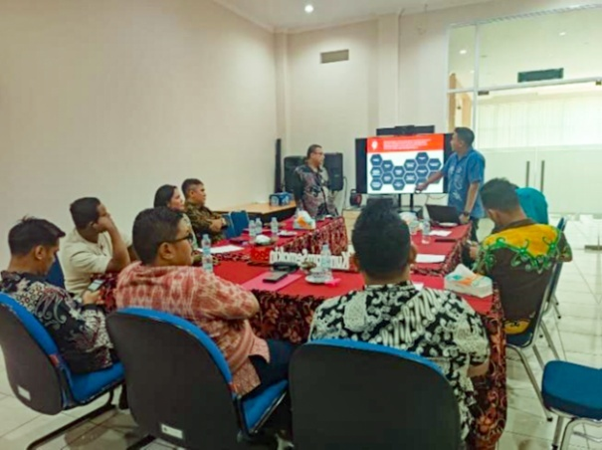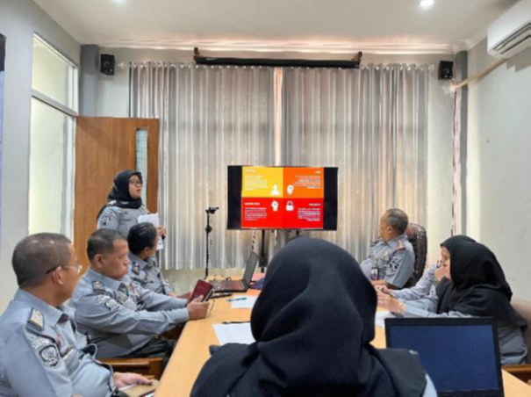
Knowledge sharing activities in the Bekasi probation office (left) and the Tangerang probation office (right) led by Bandung training development workshop participants. Photo: Home Affairs.
Australia supported capacity-building initiatives to strengthen Indonesia’s law and justice response to terrorism, with a focus on managing the complex challenges of repatriating and reintegrating women and children affiliated with foreign terrorist fighters. Working with key partners—including the Institute for Policy Analysis of Conflict, and the UNODC Australia helped build institutional capability to support women and children returning from conflict zones. Initiatives promoted strategic communications to foster multi-agency coordination and community resilience, and research into repatriation pathways informed more systematic reintegration approaches. UNODC developed decentralised training and mentorship programs across 31 provincial rehabilitation centres and convened a high-level dialogue with senior Indonesian officials, resulting in strengthened policy commitments to child protection in counterterrorism contexts. These efforts have significantly enhanced Indonesia’s capacity to manage the complex challenges of repatriating and reintegrating women and children affiliated with foreign terrorist fighters, embedding sustainable, locally led solutions within existing institutional frameworks.
Australia also supported the inaugural Solomon Islands Women in Emergencies Forum, which brought together women from emergency response agencies to strengthen collaboration and leadership during crises. This initiative marked a significant step in recognising and empowering women in frontline disaster and emergency roles across the Pacific.
In partnership with the Association of Mobilising Communities Resources in Sri Lanka, Australia is reducing the risk of vulnerable communities undertaking dangerous irregular maritime ventures by investing in women’s economic empowerment.
In Batticaloa district, the project has equipped women with business, leadership, and financial skills, supported by start-up capital and ongoing mentoring. With a goal to establish 150 self-help groups and reach 1,500 women, the initiative is fostering long-term economic independence and resilience. By strengthening women’s livelihoods, the program is disrupting the drivers of displacement and reinforcing community-led solutions to insecurity.
Spotlight: Ex-Tropical Cyclone Megan
In March 2024, Ex-Tropical Cyclone Megan struck the Northern Territory, prompting the Australian Defence Force to prepare for the evacuation of communities around Borroloola. Although extreme weather prevented the evacuation, the operation demonstrated a proactive and inclusive approach to humanitarian assistance and disaster response. The deployment included a Gender Focal Point, Indigenous Liaison Officer, and mixed-gender teams across aircrew, loadmasters, and mobile air load teams—ensuring cultural and gender considerations were embedded in planning and execution.
The Gender Focal Point, an experienced Air Force member, played a critical role in advising on gender-specific needs, including seating arrangements for female and Indigenous evacuees, family separation protocols, and support for vulnerable groups such as pregnant women, children, and the elderly. The Gender Focal Point provided real-time guidance that enhanced preparedness and responsiveness.
Key measures focused on keeping families together during the evacuation unless advised otherwise by local authorities, assigning female personnel to support female evacuees during boarding and in-flight safety and respecting cultural protocols for Indigenous evacuees, such as appropriate seating arrangements. The operation also prioritised identifying and supporting vulnerable individuals, including unaccompanied children and those with medical conditions.
This demonstrates Australia’s commitment to operationalising WPS principles in domestic disaster response. It highlights how gender considerations enhance cultural sensitivity, safety, and mission effectiveness, setting a benchmark for future large-scale evacuations.
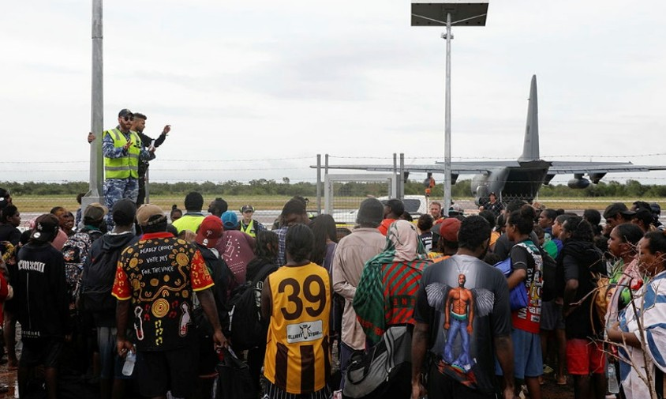
Royal Australian Air Force aviator Leading Aircraftman Louis Allix from No. 27 Squadron delivers a pre-flight briefing to residents of Borroloola prior to evacuation via C-130J Hercules aircraft following Tropical Cyclone Megan. Photo: SGT Andrew Eddie

Supporting Women-Led Organisations and Inclusive Disaster Preparedness and Response
Australia’s humanitarian action prioritises inclusive, rights-based approaches that centre women’s leadership across prevention, preparedness, response, and recovery.
By supporting Women-Led Organisations, Australia strengthens governance, mainstreams gender equality in overseas development assistance programming, and ensures women’s meaningful participation in crisis decision-making. Australia contributed to revised UN guidelines mandating women-led organisation representation on all 19 pooled fund advisory boards. In 2024, 11 per cent of pooled fund allocations went to women-led organisations—a four per cent increase from 2023.
Australia has supported the Women’s Peace and Humanitarian Fund (WPHF) since its inception in 2016. The WPHF invests in local women-led and women’s and girls’ human rights organisations in conflict and crisis settings to support their efforts to prevent conflict, end sexual and gender-based violence, respond to emergencies, and advance peacebuilding. In 2023, Australia’s core funding helped WPHF approve 188 new grants, benefiting 293 civil society organisations—89 per cent of which operate at local and subnational levels. Through its innovative Funding Window for Women Human Rights Defenders, WPHF has supported 456 defenders, including persons with a disability, and 1,221 dependents across 22 crisis-affected countries since 2022. This has strengthened their safety, with more than half receiving support for relocation, livelihoods, and mental health.
Australia’s support to the UN Office for the Coordination of Humanitarian Affairs (OCHA)Ukraine Humanitarian Fund helped pioneer inclusive and innovative funding models. These models ensure smaller community-based and volunteer organisations, including women-led organisations, can access direct funding.
ActionAid Australia is a women’s rights organisation working in over 60 countries to end poverty and injustice. It partners closely with women’s rights groups in the Pacific and maintains strong ties with ActionAid offices in Asia and Africa. As co-Chair of the Australian Civil Society Coalition on WPS, it has played a key role in promoting inclusive peacebuilding and strengthening civil society engagement in the WPS agenda. In the Asia-Pacific, ActionAid led the development of the region’s first policy brief on LGBTQIA+ inclusion in WPS, advancing recognition of queer peacebuilders and their leadership in conflict-affected contexts.
Spotlight: A-I-R Partnership
The Amplify–Invest–Reach partnership is an innovative pilot that pioneers a new funding model by directly resourcing Women’s Funds in Asia and the Pacific to grow sustainable aid architecture and empower rights-based organisations to lead social change across the region. Women’s Fund Asia, Urgent Action Fund Asia Pacific, Pacific Feminist Fund and Women’s Fund Fiji operate as local intermediaries, channelling funding to small and marginalised women’s rights organisations that are often excluded from mainstream aid, demonstrating best practice in locally led development.
Following the December 2024 Vanuatu earthquake, Urgent Action Fund Asia Pacific leveraged local networks to mobilise support for Ni-Vanuatu women, LGBTQIA+ communities, and people with disabilities, disbursing emergency grants to six grassroots organisations—demonstrating the effectiveness of women-led organisations in delivering fast, inclusive, and locally led humanitarian aid.
Following the 28 March 2025 earthquake in Myanmar, Women’s Fund Asia and Urgent Action Fund Asia Pacific rapidly disbursed over grants to women-led organisations across Myanmar, Thailand, and the diaspora, delivering inclusive, intersectional relief led by local activists, strengthening disaster response systems, and overcoming political and logistical barriers to ensure safe, flexible aid for marginalised communities.

Outcome 4: Demonstrate Leadership and Accountability for the Women, Peace and Security Agenda
Leadership, accountability and coordination are critical for the effective implementation of the WPS agenda because it ensures that Australia’s National Action Plan commitments are translated into meaningful action.
This Outcome is supported by three Medium-Term Objectives:
- MTO 4.1: The Australian Government demonstrates commitment to, and leadership of, the WPS agenda.
- MTO 4.2: The Australian Government demonstrates effective accountability for its WPS efforts.
- MTO 4.3: Australia’s efforts to support the WPS agenda are harmonised.
Indicators measure progress in areas such as:
- Australia’s leadership in multilateral and regional forums.
- Integration of WPS principles across government policies and operations.
- Engagement with civil society and publication of progress reports.
Australia has demonstrated strong global and regional leadership on the WPS agenda. Defence and Australian Federal Police (AFP) have advanced WPS through Pacific defence cooperation, and regional policing initiatives and strengthened multilateral partnerships. Home Affairs has driven inclusive security through the Bali Process and modern slavery frameworks. DFAT has led multilateral engagement through the UN Peacebuilding Commission, International Criminal Court and International Court of Justice, and ASEAN forums. Civil society engagement has been strengthened through annual dialogues, youth forums, and support for women-led networks.

Global Leadership and Multilateral and Regional Engagement
Australia’s term on the UN Peacebuilding Commission and engagement in the Peacebuilding Architecture Review have elevated inclusive peacebuilding, including First Nations voices.
Australia has increased investment in the UN Secretary-General’s Peacebuilding Fund, the UN’s primary financing mechanism for conflict prevention and peacebuilding. Guided by principles of inclusion, regional cooperation, and transitional support, Australia is ensuring that inclusion and WPS is at the core of the Peacebuilding Commission’s work. The Fund’s support for the revitalized agreement on the resolution of the conflict in the Republic of South Sudan exemplifies this approach. A network of 178 women in security forces was established to promote peer learning and accountability, leading to the creation of 41 Police Community Relations Committees and the deployment of women to Special Protection Units. These initiatives have helped reduce gender-based violence and build trust between communities and security institutions.
Both the International Criminal Court (ICC) and the International Court of Justice (ICJ) play important but distinct roles in advancing accountability, justice, and gender-responsive approaches to conflict resolution and peacebuilding. Together, they contribute to the legal architecture that supports the WPS agenda by promoting accountability for gender-based crimes, strengthening legal norms around protection and participation and enhancing access to justice for all women and girls affected by conflict. On 25 September 2024, the Foreign Minister, together with her Canadian, Dutch and German counterparts, announced a joint initiative to hold Afghanistan to account for violations of the Convention on the Elimination of All Forms of Discrimination Against Women. The legal action, led by DFAT, is in its early stages and demonstrates Australia’s leadership on accountability for gross and systematic violations of the human rights of women and girls in Afghanistan. Australia continues to co-chair the Complementarity and Gender-Based Crimes facilitation within the Assembly of States Parties to the ICC, alongside Uganda. Through this role, Australia has convened multiple meetings to advance the ICC’s efforts relating to sexual and gender-based crimes and contributed to the revision of the Office of the Prosecutor’s Policy on Gender-Based Crimes. The updated policy adopts a survivor-centred, trauma-informed approach and promotes gender-sensitive investigations and prosecutions.
Spotlight – Gender Justice Practitioners Hub
Australia’s support has catalysed the establishment of the Gender Justice Practitioners Hub —a global initiative advancing gender justice in international criminal law. The Hub strengthens accountability for serious international crimes, including war crimes, crimes against humanity, and genocide, by promoting feminist and intersectional legal approaches. In response to growing challenges for international justice institutions, especially in conflict and post-conflict settings, the Hub fosters resilience, solidarity, and collective resistance among gender justice advocates. It provides a dynamic, collaborative space for practitioners to exchange strategies, access tailored resources, and implement survivor-centred, action-oriented solutions that directly address the needs of those working to advance gender justice on the ground.
Australia’s support also facilitated the Hub’s convening the inaugural Gender Justice & International Criminal Law Conference in 2024. The historic gathering brought together over 200 practitioners and academics, deepened our understanding of gender and international criminal law, highlighting the need for institutional transformation and survivor-centred justice. The emergence of survivor communities as experts and leaders was recognised as a powerful force for restructuring injustice. The conference called for collective action, inclusive alliances, and a reimagining of justice that honours our past, engages the present, and envisions a more equitable future. Through its work, the Hub aims to cultivate a more coordinated, informed, and empowered global community of practitioners committed to embedding gender justice in international accountability processes.
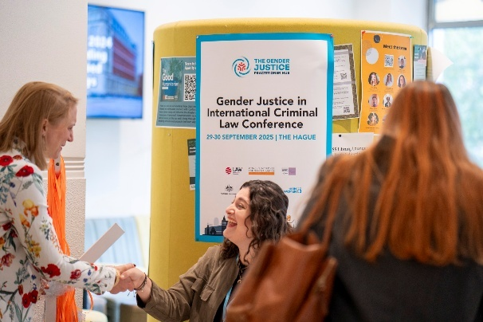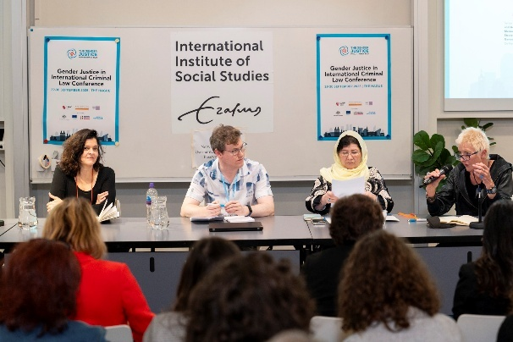
Gender Justice in International Criminal Law Conference. Photo: Robert Tjalondo
Demonstrating its commitment to justice and survivor support, the Australian Government made a voluntary contribution to the International Criminal Court’s Trust Fund for Victims. Since 2021, priority has been given to Ntaganda-related programmes benefitting former child soldiers and victims of war crimes and crimes against humanity in the Democratic Republic of the Congo. To date,139 survivors, almost all of whom experienced sexual and gender-based violence, have accessed medical and psychological support, with 108 also participating in vocational training or income-generating activities. Additionally, 27 former child soldiers have received comprehensive support services. These efforts reinforce Australia’s leadership in advancing accountability for conflict-related gender-based crimes and supporting survivor-centred, trauma-informed approaches to international justice.
Through its leadership in multilateral forums—including as a founding member and 2024 co-Vice Chair of the International Alliance on Preventing Sexual Violence in Conflict—Australia champions global efforts to eliminate Conflict-Related Sexual Violence (CRSV). Australia has taken concrete steps to end impunity, including targeted sanctions against individuals responsible for CRSV in Ukraine. Australia participates in the UN Security Council’s annual open debate on CRSV.
Australia supported Justice Denied: Fighting Widespread Impunity for Conflict-Related Sexual Violence, the first international convening on CRSV to be held in Australia. In partnership with the Australian Research Council’s Centre of Excellence for the Elimination of Violence Against Women, the conference brought together over 190 participants—including survivors, advocates, researchers, and policymakers—from more than 20 countries with a strong focus on Indo-Pacific experiences. The conference was distinguished by its survivor-centred approach, placing lived experience and community-led justice at the heart of discussions. Speakers shared powerful testimonies and practical strategies from conflict-affected regions such as Myanmar, Afghanistan, Sri Lanka, Kosovo, and Papua New Guinea, highlighting the entrenched impunity and systemic barriers survivors face in seeking justice, and showcased innovative responses—from arts-based healing to legal accountability. It catalysed new initiatives, including a commitment to establish an Indo-Pacific CRSV network and biennial convenings, setting a new benchmark for survivor-centred advocacy in the region and cross-border collaboration.
Australia’s seconded Strategic Military Adviser to UN Women reflects the commitment to multilateralism and to the WPS agenda as a cornerstone of international peace and security. The advisor plays a vital role in advancing gender equality within global peace and security frameworks, leveraging extensive operational experience in fragile and conflict-affected settings, to support military and peacekeeping forces with integrating gender perspectives into security sector reform and operational planning. Beyond technical guidance, the adviser actively advocates for the inclusion of women’s participation and leadership in peacebuilding processes, and for the protection of women and girls from violence in conflict zones. The AFP Police Advisor to the UN in New York collaborated with UN Women, UN Office on Drugs and Crime, and the International Association of Women Police to develop the 2021 Handbook on Gender-Responsive Police Services for Women and Girls Subject to Violence, now adopted as a global resource guiding police responses to gender-based violence. Through collaboration with UN entities, defence partners, and civil society organisations, these roles strengthen partnerships that drive WPS agenda forward, reinforcing Australia’s commitment to inclusive and sustainable peace.
Australia has played a leading role in mainstreaming gender equality in disarmament diplomacy, serving as Co-Chair of the International Gender Champions Disarmament Impact Group. Through this role, Australia advanced the use of the Gender and Disarmament Resource Pack across major forums, including the Conference on Disarmament, the Non-Proliferation Treaty, the Biological Weapons Convention, and conventional weapons meetings. Australia also sponsored a high-level side event at the 2024 Non-Proliferation Treaty Preparatory Committee, spotlighting gendered approaches to nuclear policy and inclusive participation in arms control. This engagement reinforced Australia’s commitment to integrating gender equality into disarmament efforts and shaping inclusive global security policy.
Australia’s engagement was further highlighted at the Committee’s annual conference, which focused on gender perspectives in the Australia–Pacific region. Australia was one of only two countries invited to formally contribute to the thematic deep dive, reflecting growing international recognition of its leadership in sharing WPS expertise, building partnerships, and promoting gender-responsive approaches in military and security sectors.

Regional Leadership and Institutionalisation of WPS

Pacific Islands Forum
As a founding member of the Pacific Islands Forum (PIF), Australia is committed to addressing the region’s shared challenges, strengthen cooperation, and advance collective priorities. Australia’s contributions to the Ocean of Peace Declaration and the Boe Declaration Action Plan and the PIF WPS Guidance Note have embedded WPS as a cross-cutting priority in regional security. Defence engagement through the South Pacific Defence Ministers Meeting and trilateral working groups with the US and New Zealand led to significant regional collaboration. These efforts culminated in the establishment of the Indo-Pacific Defence WPS Steering Committee with the US, Canada, New Zealand, Japan, Papua New Guinea, Philippines and the trilateral WPS working group with the US and Japan. AFP’s engagement through Pacific Police Support Group, a multi-country capability of trained Pacific police officers ready to deploy during crises, reinforces inclusive policing as a core priority. These efforts are helping to ensure that peace and security responses during planned and unplanned events—including elections, humanitarian and climate disasters, and civil unrest—are inclusive, responsive, and sensitive to the distinct needs of women and girls and do not inadvertently exacerbate existing drivers of insecurity, such as inequitable access to protection and justice services.

ASEAN Partnerships
Australia’s support for the ASEAN Regional Plan of Action on WPS and the biennial ASEAN WPS Summit has institutionalised gender equality in regional peace and security frameworks. Action on WPS is a central pillar of the ASEAN-Australia Comprehensive Strategic Partnership and through targeted technical and financial support, capacity-building, and cross-sectoral collaboration, Australia has helped institutionalising WPS within ASEAN’s regional architecture.
Australia also engages actively with the ASEAN WPS Advisory Group, serving as an observer since 2023 and contributing to policy dialogue and coordination. Technical assistance and policy dialogue have strengthened ASEAN member states’ capacity to implement WPS. Australia advocates for WPS integration across regional Expert Working Groups on counterterrorism, humanitarian assistance, maritime security, and cybersecurity.
The ASEAN–Australia Counter Trafficking program demonstrates Australia’s commitment to gender-responsive justice by strengthening protection for women and children vulnerable to trafficking. A key achievement was the development of the ASEAN Do No Harm Guide, now adopted across multiple ASEAN Member States, setting a regional standard for safeguarding victim-survivors. In Vietnam, the program supported landmark reforms to the Trafficking in Persons Law, aligning it with international standards and improving access to justice through clearer definitions, stronger protections, and legal entitlements for victims.
Australia strengthened ASEAN partnerships by embedding WPS in regional defence cooperation. Following the ASEAN Regional Plan of Action on WPS (2022) and the ASEAN Defence Ministers’ Meeting Plus (ADMM-Plus) Joint Statement (2023), Australia actively supported WPS integration into ADMM-Plus Expert Working Group (EWG) work plans for 2024–2027. Highlights include WPS presentations at EWGs on Counter-Terrorism, Humanitarian Assistance and Disaster Relief, Military Medicine, and Cyber Security, hosting dialogue on WPS and cyber security, and delivering Gender, Peace and Security training through ASEAN-Australia programs. Defence also engaged in high-level WPS events, reinforcing Australia’s commitment to embedding WPS across ASEAN defence activities.
Complementing these efforts, Australia’s five-year partnership with UN Women to support the Regional Framework Towards Peaceful, Inclusive Societies: Advancing the WPS Agenda in the Asia-Pacific Region significantly amplifies regional impact. Through this initiative, UN Women delivers targeted technical assistance to ASEAN member states to develop and review WPS National Action Plans; produces research and tools on emerging WPS challenges, including the intersection with climate change; and amplifies the leadership and advocacy of women’s rights organisations. This partnership has already yielded tangible outcomes: Vietnam and Timor-Leste released their first WPS National Action Plans, while the Philippines launched its fourth iteration. These milestones underscore Australia’s commitment to supporting ASEAN’s leadership in advancing inclusive peace and security across the region.

Climate, Peace and Security
Australia has demonstrated a growing commitment to gender-responsive climate action through international funding, domestic policy alignment, and active engagement in United Nations Framework Convention on Climate Change (UNFCCC) processes. It has supported initiatives like the Green Climate Fund and regional programs in the Pacific that integrate gender equality into climate resilience efforts. Domestically, Australia’s policies increasingly recognise the disproportionate impacts of climate change on women and promote Indigenous women’s leadership in adaptation and land management. Civil society organisations have played a key role in advocating for stronger gender integration in climate policy.
At the international level, Australia co-facilitated negotiations on the next UNFCCC Gender Action Plan at the 62nd session of the UNFCCC Subsidiary Bodies, contributing to a draft framework that reflects diverse Party views, including contested areas like intersectionality and human rights. Australia has also committed to engaging domestic stakeholders on the draft Gender Action Plan to ensure inclusive input and alignment with existing mechanisms, with further progress expected ahead of the 30th session of the Conference of the Parties (COP30).

The Bali Process
The Bali Process, established in 2002 and co-chaired by the Governments of Australia and Indonesia, is a regional, non-binding multilateral forum that promotes cooperation, dialogue, and policy development to address irregular migration across the Asia-Pacific and beyond. It brings together 45 Member States, four Member Organisations (IOM, UNHCR, UNODC, ILO), 18 Observer States, and nine Observer Organisations, providing a platform for governments and stakeholders to share knowledge, coordinate responses, and strengthen collective efforts to combat people smuggling, trafficking in persons, and related transnational crime. Women and girls are disproportionately affected by these issues—often as victims of exploitation and abuse—yet their voices and needs are frequently overlooked in policy and operational responses.
The Regional Support Office, established in 2012 and supported by Home Affairs, delivers practical, on-the-ground support to Bali Process Members. It facilitates knowledge exchange, capacity building, and operational cooperation across member states.
From July 2023 to June 2025, the Office conducted a number of capacity development activities, reaching over 1,000 participants—including border, law enforcement, diplomatic, immigration, and consular officials. To address gender imbalances in security sectors, it actively promoted the nomination of women frontline officers, resulting in a rise from 92 female participants in 2023–24 to 218 the following year.
The Office partnered with the Australian Institute of Criminology and UN Women to examine vulnerabilities in cyber-scam trafficking in the Philippines and Thailand. Findings informed practical recommendations, including increasing female law enforcement officers to improve victim support and interviewing practices. In Sri Lanka, it convened a cross-government dialogue with 140 officials, resulting in strengthened coordination, improved referral pathways, and enhanced justice and support services for women trafficked into forced criminality.

Asia-Pacific Economic Cooperation
Within Asia-Pacific Economic Cooperation (APEC), Australia has played a leading role in embedding gender equality into regional economic policy. In 2024, Australia led the development of the APEC Gender Equality Principles and Recommendations, which were endorsed by all 21 APEC economies. These principles reaffirmed commitment to women’s economic empowerment, including access to education, training, capital, markets, and leadership opportunities. The recommendations specifically addressed the need to prevent discrimination and stereotypes that hinder women’s advancement, and to combat violence, abuse, and harassment—including online bullying and technology-facilitated gender-based violence—that limit women’s participation in the economy.

North Atlantic Treaty Organization
Australia and North Atlantic Treaty Organizations (NATO) sustained commitment to gender-responsive security cooperation is reflected in the inclusion of WPS as one of 13 lines of effort under the NATO–Australia Individually Tailored Partnership Program. Australia remains an active contributor to NATO’s WPS agenda, engaging in policy dialogues, seminars, and the Annual Conference of the NATO Committee on Gender Perspectives. Australia also holds a seat on the NATO Civil Society Advisory Panel for WPS (2023–2026), ensuring consistent civil–military engagement.
In December 2023, Australia hosted the NATO Secretary General’s Special Representative for WPS, Irene Fellin, highlighting Australia’s progress on WPS and reaffirming alignment with NATO’s 2024 WPS Policy. Australia formally associated with the policy in October 2024, reinforcing its commitment to cooperation on WPS.
Australia became the first non-NATO nation to achieve Partner Nation status with the Nordic Centre for Gender in Military Operations in 2023—marking a significant milestone. The accession, celebrated at the NATO Committee on Gender Perspectives Annual General Meeting in Brussels, recognised Australia’s leadership in integrating gender into defence and peacekeeping operations. This partnership continues to strengthen Australia’s regional leadership in inclusive conflict prevention peace processes, and post-conflict reconstruction while enhancing collaboration with NATO and global partners in advancing the WPS agenda.

Australia-UK Strategic Dialogue and Joint Ministerial Statement on the 25th Anniversary of UNSCR 1325
Australia’s bilateral WPS commitments — including with the UK through the annual Strategic Dialogue on Gender Equality — have reinforced shared leadership on inclusive peacebuilding and survivor- centred justice. For example, at the inaugural Australia–United Kingdom Strategic Dialogue on Gender Equality (October 2023), both countries reaffirmed their shared commitment to advancing gender equality and the human rights of all women and girls, including through global leadership on WPS. Australia and the UK agreed to deepen collaboration through platforms such as the International Alliance on Preventing Sexual Violence in Conflict, resulting in both countries becoming co-Vice Chairs in 2024. Held in May 2025, the second dialogue took place amid increasing global efforts to reverse progress on gender equality and ongoing conflict-related harms disproportionately affecting women and girls. It built on existing commitments and laid the groundwork for the subsequent AUKMIN joint ministerial statement, marking the 25th anniversary of the WPS agenda, in which Australia and UK reaffirmed their shared commitment to WPS as a cornerstone of foreign and defence policy.

Civil Society Engagement and Inclusive Governance
The Australian Government values the expertise, insights, and experiences of civil society, including women's rights organisations and women's human rights defenders, and recognises their roles in implementing the WPS agenda. The Framework for Civil Society-Government Engagement on WPS establishes mechanisms for civil society to advise and hold government accountable on WPS implementation.
Australia partners with civil society in regional and global forums to amplify voices from the Global South and promote survivor-centred approaches to justice and peace. For example, Australia partnership with ASEAN-Institute for Peace and Reconciliation and the ASEAN Women for Peace Registry has facilitated cross-regional dialogues and knowledge exchange with the Australian Civil Society Coalition on WPS and with Middle East and North Africa partners. These exchanges explored civil society advocacy, climate security, and disaster response, deepening regional understanding of inclusive prevention strategies.
Spotlight: Annual Government–Civil Society Dialogue on WPS
The Australian Civil-Military Centre convenes an annual Government–Civil Society Dialogue to foster collaboration, transparency, and shared leadership in progressing the WPS agenda. This flagship initiative exemplifies Australia’s commitment to inclusive governance and whole-of-government accountability.
The 2025 Dialogue brought together over 120 participants, approximately 70 per cent from civil society and 30 per cent from government—representing a diverse cross-section of WPS stakeholders. Attendees included government implementing partners, members of the Australian Civil Society Coalition on WPS, regional partners such as the Royal Solomon Islands Police Force, Papua New Guinea Defence Force, Vanuatu Police, and the Pacific Women Mediators Network.
The program featured panel discussions on the implementation of the WPS National Action Plan, the impact of climate security on peacebuilding, and the importance of LGBTQIA+ inclusion in WPS frameworks. A workshop on the WPS Coalition’s report “Towards a Queer-Inclusive WPS Agenda in the Asia-Pacific” provided a platform for critical reflection and policy dialogue.
The Dialogue supported stakeholder diversification, constructive engagement, and partnership building. The event strengthened solidarity across sectors and reaffirmed Australia’s leadership in navigating complex geopolitical and climate-related challenges to the WPS agenda.
By facilitating open dialogue, amplifying diverse voices, and creating space for inclusive policy development, the Australian Civil-Military Centre (ACMC) annual Dialogue serves as a cornerstone of Australia’s accountability and leadership.
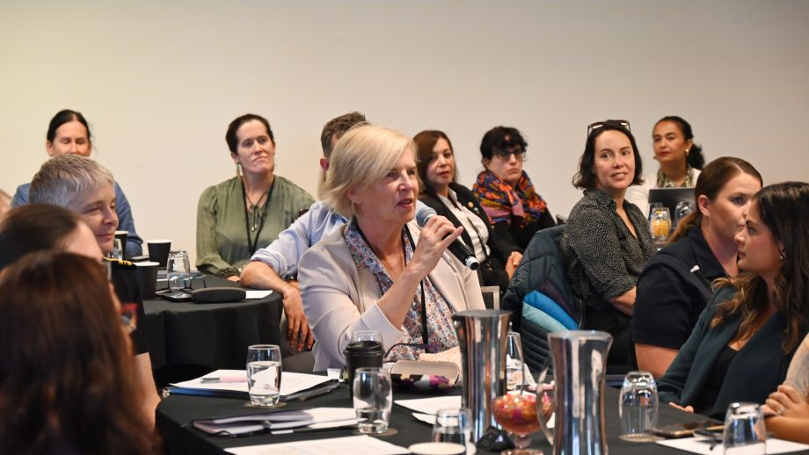
The 2025 Government-Civil Society Dialogue brought together a diverse cross-section of WPS stakeholders and fostered collaboration, transparency and shared leadership in progressing the WPS agenda. Photo: Humanitarian Action Group.

Annex – Indicator Data

Outcome 1: Support Women’s and Girls’ Meaningful Participation and Needs in Conflict Prevention and Peace Processes
Indicator | Baseline | 2023 | 2025
Outcome Indicator 1.1  Discriminatory laws and practices that restrict women’s access to public space, their political voice and their participation in all aspects of public life  Source: Civil Liberties’ indicator within Gender Institutions and Development Database  https://stats.oecd.org/index.aspx?datasetcode=SIGI2023 | Global: 28.52  SE Asia: 41.26  Pacific: no data  (2019) | Global: 28.64  SE Asia: 36.41  Pacific: no data  (2023) | No new data
Outcome Indicator 1.1  Discriminatory laws and practices that restrict women’s access to public space, their political voice and their participation in all aspects of public life  Source: Civil Liberties’ indicator within Gender Institutions and Development Database  https://stats.oecd.org/index.aspx?datasetcode=SIGI2023 | Global: 28.52  SE Asia: 41.26  Pacific: no data  (2019) | Global: 28.64  SE Asia: 36.41  Pacific: no data  (2023) | No new data

MTO 1.1: Increasing women’s meaningful participation in conflict prevention
MTO Indicator | Baseline | 2023 | 2025
MTO Indicator 1.1.1  Conflict analysis and early warning processes actively involve women and consider a range of gender issues (case studies) | N/A | N/A | N/A
MTO Indicator 1.1.2  Quality of initiatives that support women’s meaningful participation in local, sub-national and national decision-making structures (case studies) | N/A | N/A | N/A

MTO 1.2: Increasing women’s meaningful participation in peace processes
MTO Indicator | Baseline | 2023 | 2025
MTO Indicator 1.1.1  Conflict analysis and early warning processes actively involve women and consider a range of gender issues (case studies) | Global: 412/1959 (21%) peace agrements between 1990- July 2021 have provisions on women, girls, gender or sexual violence.  Specific:  VAW provisions: 29% (1990-2021 baseline);  Women’s participation: 42% (1990-2021 baseline). | Global: 20/57 (35%) peace agrements between July 2021 – June 2023 have provisions on women, girls, gender or sexual violence.  Specific:  VAW provisions: 20% or 4/20 (South Sudan, Tigray, Sudan).  Women’s participation: 30% or 6/20 (Colombia, Niger, Haiti, South Sudan, Sudan, India)  Asia: (only one peace agreement in Asia/Pacific 2021-2023) – India (Assam) provided a quota for 4% women in a power sharing Council.  Asia: 1 (out of 3) peace agrements after July 2023 which have provisions on women, girls, gender or sexual violence. | Global: 18/76 (24%) peace agreements between July 2023 - April 2024 have provisions on women, girls, gender or sexual violence.  Specific:  LGBTQAI+ provision: three agreements in Colombia note guarantees for participation among LGBTQIA+ people.  Asia Pacific: 0/4 peace agreements between July 2023 - April 2025 in the Asia Pacific with provisions on women, girls, gender or sexual violence.
MTO Indicator 1.1.2  Quality of initiatives that support women’s meaningful participation in local, sub-national and national decision-making structures (case studies) | Global average (1992-2019): 6% women mediators; 6% women signatories. Roughly 70% of peace processes did not include any women mediators or women signatories. | Data not available. | Global average: in 2023, women made up 9% of mediators and 19% of signatories to peace and ceasefire agreements. The proportion of women signatories drops to 3.75% if Colombia’s agreements are excluded.

Outcome 2: Reduce Sexual and Gender-Based Violence
Indicator | Baseline | 2023 | 2025
Outcome Indicator 2.1  Proportion of ever-partnered women and girls aged 15 years and older subjected to physical, sexual or psychological violence by a current or former intimate partner in the previous 12 months, by form of violence and by age  Source: SDG Indicator 5.2.1. Data collection co-owned by UN Women and Unicef. Location: https://unstats-undesa.opendata.arcgis.com/ | Global average. (2018): 11.02%  SE Asia: 9.27%  Pacific: 19.37% | Data not available. | Data not available.
Outcome Indicator 2.2  Proportion of women and girls who have experienced non-partner sexual violence in their lifetime  Source: UNWomen Global Database on Violence Against Women. https://evaw-global-database.unwomen.org/en | Global average. (2018): 6% | Data not available. | Data not available.

MTO 2.1: reducing harmful gender norms
MTO Indicator | Baseline | 2023 | 2025
MTO Indicator 2.1.1  Participation rate of youth and adults (sex disaggregated) in formal and non-formal education and training in the previous 12 months  Source: SDG Indicator 4.3.1. Data collection owned by UNESCO. Location: https://databrowser.uis.unesco.org/ | Global (2000-2018): 21.35% (female); 21.15% (male)  SE Asia: 12.19% (female); 11.43% (male)  Pacific: 12.27% (female); 12.35% (male) | Data not available | Global (2019-2024): 16.99% (female); 15.92% (male)  SE Asia: 13.36% (female); 13.06% (male)  Pacific: 13.77% (female); 12.57% (male)"
MTO Indicator 2.1.2  Number of countries that have more inclusive social institutions in relation to gender and percentage improvement  Source: https://www.genderindex.org/ranking/  Social Institutions Gender Index overall score. Data collection owned by OECD. Location: https://stats.oecd.org/index.aspx?datasetcode=SIGI2023  Score (0 to 100)  0 indicates no discrimination and 100 indicates absolute discrimination against women. | Global average SIGI score (2019): 29.50  SE Asia average: 35.04 | Global average SIGI score (2023): 29.89  66 countries improved (decreased) their inclusive social institutions score  SE Asia average: 37.72  6 countries improved (Cambodia, Thailand, Indonesia, Laos, Philippines, Vietnam); 2 countries deteriorated (Singapore, Myanmar)." | No new data available.

MTO 2.2: Increasing safety and security for women and girls
MTO Indicator | Baseline | 2023 | 2025
MTO Indicator: 2.2.1  Percentage of women aged 15 years and older who report that they “feel safe walking alone at night in the city or area where you live”.  Source: Women, Peace and Security Index (from reporting for SDG Indicator 16.1.4). Data collection owned by Georgetown Institute for WPS. Location: https://giwps.georgetown.edu/the-index/ | Global average (2021): 57.40%  SE Asia: 62.87%  Pacific: 74.03%" | Data not available | Global average (2023): 64.79%  SE Asia: 67.22%  Pacific: data not available"
MTO Indicator 2.2.2:  Proportion of women aged 20–24 years who were married or in a union before age 15 and before age 18  Source: SDG Indicator 5.3.1. Data collection owned by Unicef. Location: https://unstats-undesa.opendata.arcgis.com/ and https://data.unicef.org/sdgs/ | Global average (2005-2020): 5.35% (before 15); 22.20% (before 18)  SE Asia: 2.40% (before 15); 16.20% (before 18)  Pacific: 3.40% (before 15); 19.88% (before 18)" | Data not available | Global average: 4.95% (before 15); 20.58% (before 18)  SE Asia: 2.62% (before 15); 15.43% (before 18)  Pacific: 3.04% (before 15); 18.11% (before 18)"

MTO 2.3: Increasing access to justice
MTO Indicator | Baseline | 2023 | 2025
MTO Indicator 2.3.1:  Number of countries that have national laws that criminalise sexual and gender-based violence  Source: SDG Indicator 5.1.1. Data collection owned by the World Bank. Women, Business and the Law. Location: https://wbl.worldbank.org/ | Globally (2021): 158/190  SE Asia: 10/11  Pacific: 12/12 | Globally (2023): 162/190  SE Asia: 10/11  Pacific: 12/12 | Globally (2024): 105/189  SE Asia: 10/11  Pacific: 12/12

Outcome 3: Support Resilience, Crisis Response, and Security, Law and Justice Sector Efforts to Meet the Needs and Rights of All Women and Girls
Indicator | Baseline | 2023 | 2025
Outcome Indicator 3.1  Number and percentage of countries that have laws and regulations that restrict women's ability to participate in society and the economy, relative to men  Source: Women, Business and the Law https://wbl.worldbank.org/en/reports | Globally (2021): 179/190.  Average score: 76.04 | Globally (2023): 176/190  Average score: 77.1 | A suggested adapted measure for this report would give the following score at the global level (2024): 179/190  Average score: 64.1
Outcome Indicator 3.2  Maternal mortality ratio  Source: SDG Indicator 3.1.1. Data collection co-owned by UNODC and WHO. Location: https://unstats-undesa.opendata.arcgis.com; https://www.who.int/data/gho/data/indicators/indicator-details/GHO/maternal-mortality-ratio-(per-100-000-live-births) | Global average (2017): 144.51 (deaths per 100,000 live births)  SE Asia: 110.09  Pacific: 132.27 | Global average (2021): 148.48 (deaths per 100,000 live births)  SE Asia: 126.09  Pacific: 147.00 | Global average (2023): 118.30 (deaths per 100,000 live births)  SE Asia: 90.92  Pacific: 121.45

MTO 3.1: Increasing access to securtiy, law and justice responses
MTO Indicator | Baseline | 2023 | 2025
MTO Indicator 3.1.1:  Number of victims of human trafficking per 100,000 population  Source: SDG Indicator 16.2.2. Data collection co-owned by UNODC and WHO. Location: https://unstats-undesa.opendata.arcgis.com/ | Global average (2008-2017): 2.66 (victims per 100,000 population)  SE Asia: 1.22  Pacific: - | Data not available | Global average (2019-2023): 3.01 (victims per 100,000 population)  SE Asia: 0.87  Pacific: 26.12
MTO Indicator 3.1.2:  Quality of gender-related initiatives in security, justice and law responses | Data not available | Data not available | Data not available

MTO 3.2: Improving humanitarian action stabilisation and disaster management
MTO Indicator | Baseline | 2023 | 2025
MTO Indicator 3.2.1:  Number of women and men, girls and boys, provided with life saving assistance in crisis situations | Data not available | Data not available | Data not available
MTO Indicator 3.2.2:  Quality of opportunities for women and girls to influence humanitarian and disaster responses | Data not available | Data not available | Data not available

Outcome 4: Demonstrate Leadership and Accountability for the Women, Peace and Security Agenda
Indicator | Baseline | 2023 | 2025
Outcome Indicator 4.1  Examples of meetings held by Australian posts with women mediators and participants to peace processes, as well as women's rights organisations, on peace processes | Data not available | Information reflected in narrative of report | Information reflected in narrative of report
Outcome Indicator 4.2  Number of times that Women, Peace and Security is referenced in public statements by the Australian Government | Data not available | Information reflected in narrative of report | Information reflected in narrative of report
Outcome Indicator 4.3  Number and percentage of missions and operations with mandates and planning documents that include clear references to women, peace and security issues and that report on this | Data not available | Data not available | Data not available

MTO 4.1: The Australian Government demonstrates commitment to, and leadership of, the WPS agenda
MTOWor Indicator | Baseline | 2023 | 2025
MTO Indicator 4.1.1:  Quality of support through the Australian aid program for a NAP or an equivalent | Data not available | Information reflected in narrative of report | Information reflected in narrative of report

MTO 4.2: The Australian Government demonstrates effective accountability for its WPS efforts
MTO Indicator | Baseline | 2023 | 2025
MTO Indicator 4.2.1:  Timely release of Progress Reports and Departmental Implementation Plans | N/A | See https://www.dfat.gov.au/international-relations/themes/gender-equality/women-peace-security | See https://www.dfat.gov.au/international-relations/themes/gender-equality/women-peace-security

MTO: 4.3: Australia’s efforts to support the WPS agenda are harmonized
MTO Indicator | Baseline | 2023 | 2025
MTO Indicator 4.3.1:  Number and percentage of Australian government employees deployed and posted to fragile, conflict affected and humanitarian and disaster settings | Data not available | Data not available | Data not available
MTO Indicator 4.3.2:  Number of relevant policies and strategies into which WPS is integrated | Data not available | Data not available | Data not available

