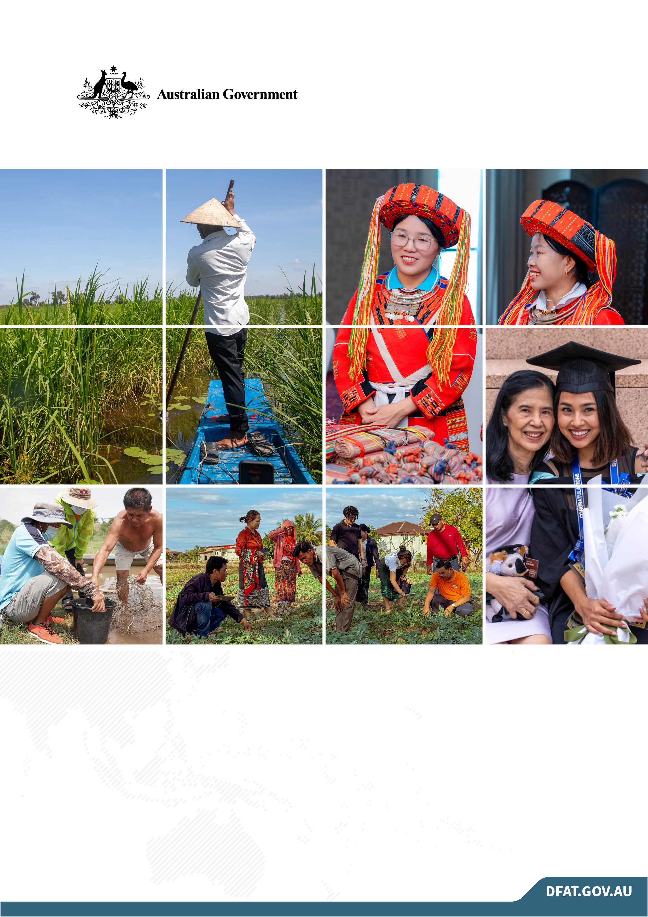

MEKONG-AUSTRALIA PARTNERSHIP
ANNUAL REPORT
2025

Contents
Executive summary 6
Portfolio snapshot 6
Portfolio results 7
Key risks and challenges 8
Priorities for 2026 9
1 Strategic overview 10
Portfolio logic 10
Governance, approach, and delivery modalities 11
2 EOPO progress 12
EOPO 1 12
EOPO 2 13
EOPO 3 14
EOPO 4 15
EOPO 5 16
3 progress by thematic area 17
Climate resilience 17
Water security 21
Gender equality, disability equity and social inclusion 24
Economic resilience and subregional integration 26
Transnational crime 29
4 Progress in cross-cutting areas 32
Leadership and skills 32
GEDSI 35
Climate mainstreaming 36
Communications 37
Monitoring, evaluation and learning 37
5 Stakeholder engagement 39
Stakeholder reach 39
Engagement with regional organisations and development partners 40
6 Risks, challenges and lessons learned 41
Risks and mitigation 41
Lessons for better delivery 41
7 Looking forward 43

ANNEXES
ANNEX 1 – MAP’S PROGRAM LOGIC
ANNEX 2 – FIGURE ALT TEXT LIST
Images Credit:
Images used in this publication are sourced from the Department of Foreign Affairs and Trade or from third parties as otherwise credited.


Glossary
Abbreviation | Name
3SPN | 3 Rivers Protection Network
AA-MAP | Australia Awards Mekong-Australia Partnership
AANZFTA | ASEAN-Australia-New Zealand Free Trade Area
ABF | Australian Border Force
ACIAR | Australian Centre for International Agricultural Research
ACMECS | Ayeyawady-Chao Phraya-Mekong Economic Cooperation Strategy
ADB | Asian Development Bank
ADB BCG | Asian Development Bank Bio-circular Green Economy investment
AFP | Australian Federal Police
AGA | Australian Government agencies
ANU | Australian National University
ANU Solar | Accelerating the transition to solar energy in Thailand investment
ASEAN | Association of Southeast Asian Nations
ASIC | Australian Securities and Investment Commission
ATO | Australian Taxation Office
AUSTRAC | Australian Transaction Reports and Analysis Centre
AWP | Australian Water Partnership
BASIN | Building Climate-Adaptive Solutions through Inclusive Market Networks
CAPRED | Cambodia Australia Partnership for Resilient Economic Development
CEO | Chief Executive Officer
CRMN | Core River Monitoring Network
CSIRO | Commonwealth Scientific and Industrial Research Organisation (Australia)
CRxN | Climate Resilient by Nature
CWSIP | Cambodia Water Security Improvement Project
DEDE | Thailand’s Department of Alternative Energy Development and Efficiency
DFAT | Australian Department of Foreign Affairs and Trade
DoI | Department of Irrigation, Thailand
DP Hanoi | Hanoi Association of People with Disabilities
DRM | Disaster risk management
DWR | Department of Water Resources (Vietnam)
EbA | Ecosystem-based Adaptation
EEC | Eastern Economic Corridor of Thailand
EGAT | Electric Generating Authority of Thailand
EOPO | End-of-portfolio outcome
ESGM | Enhancing Sustainable Groundwater Management in Laos
FICG | Financial Intelligence Consultative Group
GDA | Gender and Development Association
GEDSI | Gender Equality, Disability Equity and Social Inclusion
GRP | Gender-responsive procurement
DHA | Australian Department of Home Affairs
INGO | International Non-Governmental Organisation
IAI | Initiative for ASEAN Integration
IMRs | Investment monitoring reports
IoT | Internet of Things
IP2 | Oxfam’s Mekong Inclusion Project Phase 2
IP3 | Oxfam’s Mekong Inclusion Project Phase 3
IWMI | International Water Management Institute
LIFT4Laos | Laos-Australia Investment Facilitation and Transformation for Economic Resilience
MARD | Ministry of Agriculture and Rural Development (Vietnam)
MAP | Mekong-Australia Partnership
MAP SU | Mekong-Australia Partnership Support Unit
MAP-TNC | Mekong-Australia Partnership on Transnational Crime
MEL | Monitoring, Evaluation and Learning
MKS | Mekong Strategy Section in the Office of Southeast Asia, DFAT
MNET-CTC | Mekong Network to Counter Transnational Crime
MRC | Mekong River Commission
MSME | Micro, Small and Medium enterprises
MSU | Mahasarakham University
MTT | Mekong Think Tanks
MVi | My Village Organisation
NbS | Nature-based solutions
ODA | Official Development Assistance
OECD-DAC | OECD Development Assistance Committee
OPD | Organisations of persons with disabilities
OSINT | Open-Source Intelligence
PDIES | Procedures for Data and Information Exchange and Sharing
PHES | Pumped Hydro Energy Storage
PSH | Pumped Storage Hydro
RCEP | Regional Comprehensive Economic Partnership
ReTrEAT Cities | Resettlement, Transformation, Eco-Adaptation Typology
RMIT University | Royal Melbourne Institute of Technology
RTP | Royal Thai Police
RTP-OFS | Royal Thai Police Office of Forensic Science
RUCaS | Resilient Urban Centres and Surrounds investment
SEA | Southeast Asia
SCR | Oxfam’s Strengthening Climate Resilience in Lower Mekong investment
SEI | Stockholm Environment Institute
SME | Small and Medium Enterprise
SRO | Senior Responsible Officer
SWMC | Sustainable Water Management Committee
TEI | Thailand Environment Institute
TNC | Transnational crime
UNODC | United Nations Office on Drugs and Crime
VDF | Village Development Fund
WBST | Water Balance Scenario Tool
WRT | Women’s Economic Empowerment in the Mekong
WSP2 | Asia Pacific Water Scarcity Programme Phase I Extension

Executive summary
Australia’s security, prosperity and economic future are intrinsically linked to Southeast Asia. Australia is deepening engagement with Southeast Asia and the Mekong subregion with a focus on strengthening Mekong resilience, development and integration, notably through the Mekong-Australia Partnership (MAP). MAP aims for a more resilient and inclusive Mekong subregion that pursues joint solutions to shared and transboundary challenges. The purpose of MAP is to reinforce that Australia is a trusted and reliable partner in supporting a resilient, inclusive and sustainable Mekong subregion.
MAP covers 5 thematic areas:
- climate resilience
- water security
- gender equality, disability equity, and social inclusion (GEDSI)
- economic resilience and subregional integration
- transnational crime
Leadership and skills is a cross-cutting theme. 2025 is the second year of implementation of the second phase of MAP.

Portfolio snapshot

Number of activities
In 2025, MAP’s portfolio comprised 41 projects (See Annex 1), including 15 new projects launched in 2024. Sixteen legacy projects were completed during the year, with the additional 10 investments ongoing. Most investments focused on economic resilience and subregional integration (13) and water security and climate change resilience (12). Although only two projects specifically targeted GEDSI, all contribute to GEDSI outcomes. The Mekong Hub, based in the Australian Embassy Bangkok managed 21 projects, the Australian Embassy Vientiane managed 13, while the Australian Embassy in Phnom Penh handled 3, with Australian Department of Foreign Affairs and Trade (DFAT) teams in Hanoi and Yangon managing one project each and 2 legacy projects managed by the Mekong Strategy Section in Canberra.

Geographic coverage
MAP was implemented across 5 countries. MAP investments were implemented in 11 provinces (out of 25) in Cambodia, 11 provinces (out of 17 provinces and one prefecture) in Lao People's Democratic Republic (Laos), 20 provinces (out of 76 provinces and one special administrative region) in Thailand, 19 provinces (out of 28 provinces and 6 megacities) in Vietnam and 3 administrative divisions (out of 15 top level divisions) in Myanmar.

Stakeholder engagement
MAP engaged with a total of 745 stakeholder organisations, 10% of which were international and regional institutions. Across the Mekong subregion, MAP and delivery partners engaged with 206 national government agencies, 199 local government units, 83 civil society organisations and 78 universities and research institutes.
Figure 1. Number of Provinces in Mekong subregion countries where MAP is implemented
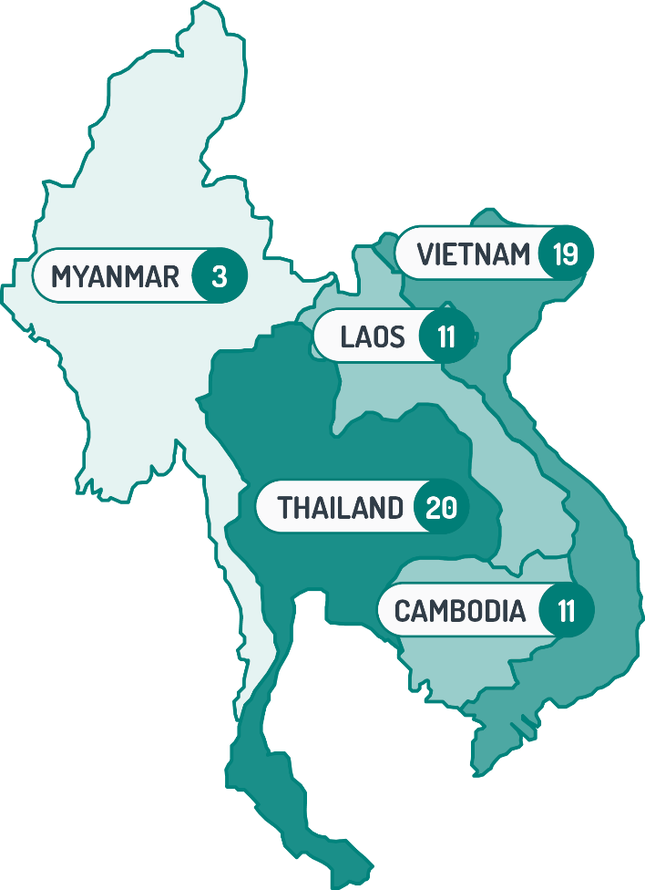

Portfolio results
MAP’s 2025 performance shows strong progress in strengthening climate resilience, water security and inclusive development outcomes across the Mekong subregion. MAP’s climate resilience work in 2025 moved from pilot projects to systemic change in how governments and communities anticipate and manage climate risks. Research and environmental monitoring generated policy-relevant evidence on urban heat, water storage, sea-level rise and nature-based solutions, while local actors used climate and hydrometeorological data to strengthen disaster preparedness. Climate-smart livelihood models delivered measurable gains: in Laos, MAP-supported producer groups more than doubled their household incomes (121%) between 2024 and 2025, and MAP-supported Village Development Funds supported 497 people (387 women) to diversify livelihoods and finance restoration activities of river ecosystems.
MAP is also assisting countries to move toward basin-wide, multi-sector water management. At the Mekong basin level, through support to the Mekong River Commission (MRC), updated procedures for data and information exchange enabled a joint hydrological study covering all 6 riparian and downstream countries, with shared climate-scenario projections and adaptation options produced in early 2025. At the same time, all 13 dams in the 4 MRC member countries were sharing daily operational data with the MRC Secretariat, and a redesigned core river-monitoring network was fully operational. MAP investments in both climate resilience and water security have strengthened the climate resilience of 9,833 people (4,311 women).
MAP has contributed to translating gender equality, disability equity and social inclusion commitments into tangible leadership and economic opportunities, while at the same time strengthening inclusive policies. For example, with UN Women’s policy analysis and technical input, Vietnam achieved a procurement policy shift by amending the Public Procurement Law, introducing preferential conditions for contractors employing women workers, people with disability, war veterans and ethnic minorities. In Cambodia, targeted grants (AUD46,500) and coaching for disability-owned businesses delivered in 2025 are projected to generate 24 new jobs and over AUD155,000 in additional revenue in 2026.
MAP also delivered activities to strengthen economic resilience. In the Laos, technical assistance and support on tax and revenue reforms helped operationalise a new income-tax law and a digital VAT system that generated about USD10 million in VAT revenue from 31 companies by the end of 2025, providing much-needed fiscal space in a constrained environment. In Thailand’s Eastern Economic Corridor, MAP-funded water balance modelling underpinned a May 2025 Memorandum of Understanding among 10 water agencies and the creation of a Sustainable Water Management Committee by the Federation of Thai Industries, embedding more integrated water industry planning in a flagship growth corridor.
Analytical work on safeguards, political economy and value chains through the Mekong Safeguards and Building Climate-Adaptive Solutions through Inclusive Market Networks (BASIN) investments across multiple countries created a robust evidence base for climate-resilient agrifood and infrastructure investments and informed discussions with local communities and relevant government agencies on diversification and binding growth constraints.
Finally, collaboration on combating transnational crime is deepening by strengthening institutional and operational capabilities. A total of 612 officials (38% women) from Cambodia, Laos, Thailand and Vietnam participated in 29 Australian Government agency trainings and capacity building activities across different areas in law enforcement, investigation, customs, cryptocurrency, anti-money laundering, leadership and communications in 2025. Trained law enforcement officers are starting to apply new tools and techniques – such as digital forensics and open-source intelligence. Australian Taxation Office-supported training in Vietnam produced a jointly developed tax crime investigation curriculum, which is now awaiting ministerial sign-off for national rollout. Thailand's Royal Thai Police forensic unit was positioned as a regional training hub using an Australian train-the-trainer model.

Key risks and challenges
Contextual risks remained the biggest challenge for MAP implementation. The political and security situation in the region shifted dramatically in 2025. The Thailand-Cambodia border dispute impacted delivery through limitations on travel for investment participants. In 2025, MAP also navigated the impact of wide-ranging government restructures in Vietnam and Laos and navigated the reduction in development assistance from a number of partners.

Priorities for 2026
In 2026, MAP is focusing on advancing Australia’s strategic engagement in the region while strengthening program performance. MAP will translate results and lessons from existing investments into providing policy options for key partners by prioritising areas with strong enabling conditions, building on progress seen in 2025 (for example, fish-friendly infrastructure, gender-responsive procurement and data sharing). MAP is also responding to shifting development dynamics, including reduced donor presence, by targeting gaps where Australia can add value – such as GEDSI – and reinforcing its role as a reliable partner. Amid evolving geostrategic challenges, MAP is supporting regional integration by using its investments to strengthen partnerships, collaboration and personal and institutional relationships across the Mekong.
To improve performance, MAP will deepen GEDSI integration, strengthen cross-border and multi-level collaboration, and better connect existing initiatives through targeted partnerships. Capacity building will become more outcome-focused with applied learning and follow-up tracking. Communications will be enhanced through clearer, targeted messaging on MAP achievements and activities, while monitoring, evaluation and learning (MEL) systems will be strengthened to support evidence-based decision-making, learning and adaptation across the portfolio.
Figure 2: Program summary

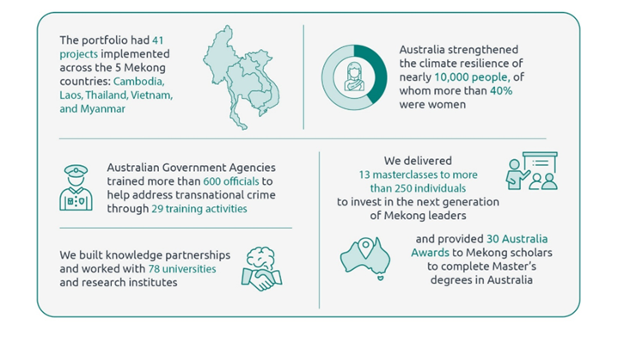

Strategic overview
Australia’s engagement in the Mekong subregion in 2025 occurred against the backdrop of a more contested and uncertain regional environment. Significant reductions in development assistance from major donors, including the changing Official Development Assistance (ODA) landscape created financing and capability gaps.
Political transitions in Thailand and government structure changes in Laos and Vietnam affected regional cooperation dynamics. The Thailand-Cambodia border dispute underscored the fragility of subregional stability. The ongoing conflict in Myanmar continued to present challenges for the region and implementation of MAP. Meanwhile, the rapid expansion of transnational organised crime, particularly scam centres elevated shared security risks and drew greater regional and international attention.
These shifts mattered for Australia and the Mekong-Australia Partnership (MAP) in 3 key ways. First, they reinforced the importance of reliable, consistent partners that can sustain engagement during periods of uncertainty. Second, they highlighted the need to strengthen regional institutions and cooperation mechanisms to manage shared and transboundary challenges. Third, they increased demand for practical support in areas such as economic resilience, water governance and transnational crime.
In this context, MAP remained aligned with Australia’s International Development Policy (2023) and DFAT’s Southeast Asia Regional Development Partnership Plan. Designed for transboundary challenges, MAP seeks to increase subregional cooperation and coordination, complementing bilateral needs and investments. The program continued to focus on strengthening resilience, supporting inclusive and sustainable growth and reinforcing rules-based cooperation. MAP contributes to these objectives while reinforcing Australia’s reputation as a trusted and reliable partner.

Portfolio logic
MAP adopts a flexible, partnership-based approach that responds to evolving regional needs, focused on strengthening cooperation, institutions and capabilities to address shared and transboundary challenges. MAP builds on Australia’s bilateral relationships and development partnerships with Southeast Asian partners, MAP seeks to reinforce that Australia is a trusted and reliable partner supporting a resilient, inclusive, and sustainable Mekong subregion.
MAP is guided by 5 end-of-portfolio outcomes (EOPOs) as indicated in Box 1.

Box 1. MAP’s end-of-portfolio outcomes
The design of the second phase of MAP articulated 5 end-of-portfolio outcomes (EOPO), aligned to Southeast Asia Regional Development Partnership Plan objectives:
EOPO 1: Mekong subregion partners reduce vulnerability to impacts of climate change
EOPO 2: Mekong subregion partners manage water resources in a more coordinated and sustainable way
EOPO 3: Mekong subregion partners increase leadership and economic opportunities for women, people with disability, and other marginalised groups
EOPO 4: Mekong subregion partners enable strengthened economic resilience and subregional integration
EOPO 5: Mekong subregion partners better prevent and counter targeted transnational crime
(See MAP Program Logic in Annex 2.)

Governance, approach, and delivery modalities
In 2025, senior DFAT leadership continued oversight and strategic guidance of MAP. The MAP Steering Committee met quarterly to provide strategic direction, review program implementation, approve funding proposals and assess risks. The Mekong Hub, based in Bangkok, continued to oversee the majority of MAP investments, pipeline development, budget and risks. Mekong posts contributed to pipeline planning, managed bilateral allocations and led engagement with in-country stakeholders. The Mekong Strategy Section (MKS) in DFAT’s Southeast Asia Regional & Mainland Division oversaw implementation of the portfolio’s strategic direction and collaborative planning of high-level budget allocations.
Tetra Tech International Development was engaged through an open, competitive tender to set up a MAP Support Unit (MAP SU) to provide:
- support services through the provision of technical advisory, administrative and logistical, and communication support
- enabling services to Australian Government agencies (AGAs) delivering the Mekong-Australia Partnership on Transnational Crime (MAP-TNC) program
- delivery of the Leadership and Skills program.
The objective of the MAP SU is to service MAP activities and contribute to ensuring that MAP achieves its outcomes.

EOPO progress

EOPO 1

Mekong subregion partners reduce vulnerability to impacts of climate change

Overall Progress
4 – Largely On track: Activities are being implemented effectively and efficiently. Early evidence shows momentum toward outcomes and partnerships are functioning well. Only minor adjustments or additional support may be needed to sustain progress.
MAP investments under the climate resilience theme made clear progress in 2025 toward reducing vulnerability to climate impacts across the Mekong subregion, especially in Cambodia, Laos, Thailand, and Vietnam, with several concrete adaptation and resilience outcomes already visible at community, subnational and national levels. Supported partner organisations implemented a diverse set of climate adaptation initiatives, from research to environmental monitoring, to community-based adaption and livelihood initiatives.
The Mekong Think Tanks (MTT) investment, for example, supported flagship studies on urban heat resilience, water storage and disaster risk reduction, inclusive transboundary groundwater management, and sea-level rise and resettlement in cities, as well as rapid response projects on agricultural livelihoods, solar energy and equitable water sharing. These research projects provide concrete policy recommendations to support Mekong partner national and subnational governments, including, for example Thailand's draft National Cooling Action plan, Laos' district-level Fish Conservation Zone and Biodiversity Conservation Area legislation and a district-approved action plan on equitable sharing of water resource benefits in Tuon Duong District, Nghe An Province, Vietnam.
Delivery partners enabled the use of climate data and decision-support tools to enhance climate resilience. For example, Resilient Urban Centres and Surrounds investment (RUCaS) introduced environmental monitoring networks and low-cost Internet of Things (IoT) sensors in Bangkok, Hanoi, Luang Prabang and Can Tho to monitor temperature, humidity, air quality, and water quality, with city planning to integrate sensor monitoring data into ecosystem management. The Strengthening Climate Resilience in Lower Mekong (SCR) investment, on the other hand, enabled local actors in riverine communities in Laos and Cambodia to interpret hydrometeorological and climate risk data via government-sponsored mobile phone apps, leading to practical responses such as pre-season drainage clearing and adjusted irrigation schedules to reduce flood and salinity risks.
MAP investments directly improved resilience for vulnerable and marginalised communities by combining climate information, inclusive planning, and livelihood support. In Laos, Climate Resilient by Nature (CRxN) organised 112 households into 12 agricultural production groups (for example, red onion and chicken) and secured contracts for household producers with buyers. This resulted in household income more than doubling (121%) in 2025 compared with 2024. At the same time, the Village Development Funds (VDFs) facilitated through the project supported 497 people (110 men, 387 women) to diversify livelihood activities such as farming, animal raising and other small business, while also financing riverscape restoration activities.
SCR also worked with small producers, farmers and fisherfolk in riverine communities across 4 countries to co-develop community-based disaster risk management (DRM) and contingency plans. In addition to integrating DRM and climate change adaptation (CCA) into commune and district development plans, and pilot climate-smart livelihood options such as solar water pumping in drought-affected Ratanakiri, Cambodia and climate-smart irrigation demonstrations in Soc Trang, Vietnam. Finally, MTT rapid response projects on agricultural livelihoods in Savannakhet, Laos; fisheries resilience in Luang Prabang, Laos; and communities’ resilience in Stung Treng, Cambodia supported nature-based adaptation, community savings mechanisms, and local planning processes that align with provincial water resource management policies.
MAP supported policy and practice improvements on climate resilience at the country level. The Asian Development Bank’s (ADB) Strengthening Bio-Circular-Green Economy (BCG) technical assistance project supported production of Thailand’s Sponge City National Guidelines and a national e-mobility roadmap, which collectively address climate hazards such as floods and coastal risks while decarbonising key sectors. In the energy sector, Energy Lab enhanced energy transition initiatives in Laos by working with the Ministry of Industry and Commerce and the Électricité du Laos by providing training, clean energy fellowships and energy modelling.

EOPO 2

Mekong subregion partners manage water resources in a more coordinated and sustainable way

Overall Progress
4 – Largely On track: Activities are being implemented effectively and efficiently. Early evidence shows momentum toward outcomes and partnerships are functioning well. Only minor adjustments or additional support may be needed to sustain progress.
The 2025 portfolio under the water security theme shows clear, concrete progress toward the outcome that Mekong subregion partners manage water resources in a more coordinated and sustainable way. In Cambodia, the Australian Water Partnership (AWP) supported the Tonle Sap Authority to advance a basin diagnostic, providing a shared evidence base on hydrology, uses and risks in the Tonle Sap Great Lake system. This diagnostic tool is now informing basin planning and co-investment including with the World Bank. In Laos, the Fishtech investment with Australian Centre for International Agricultural Research (ACIAR) and Charles Sturt University continued to generate data needed to align hydropower operations with river and fisheries health. By early 2026, the project had tagged and released 7,361 fish across multiple species and sites, supported by refined acoustic and sensor-fish monitoring systems. In Thailand’s Eastern Economic Corridor (EEC), the EEC water project developed a simple water balance scenario tool (WBST) to inform both planning and institutional innovation. The WBST produced a shared quantitative understanding of current and future water demand and supply under uncertainty in the corridor.
MAP’s support to eWater (as implementing partner of the AWP) and the MRC illustrated how shared evidence and coordinated responses to transboundary challenges such as drought, floods and hydropower development are critical. eWater’s low-flows and drought analysis and the Joint MRC–Lancang Mekong Cooperation hydrological studies are addressing reservoir and hydropower operations, providing more evidence-based understanding of climate and flow dynamics. The MRC’s data-sharing agreements covering 13 dams and the operational Core River Monitoring Network are institutionalising mechanisms for more transparent and coordinated management of river flows.
The portfolio also demonstrates that coordination and sustainability are not purely technical issues. Oxfam’s Mekong Inclusion Project Phases 2 and 3 (IP2 and IP3) show that water security outcomes are more just when rights-based analysis, gender and social inclusion, and civil society voices are woven into governance processes. IP3’s work with indigenous and disability-rights advocates at Association of Southeast Asian Nations (ASEAN) forum, the MRC council and development partners meetings and national leadership events in 2025, and IP2’s tracking of rights-based policy uptake, ensure that questions of who benefits and who bears the risks were central to discussions on water and energy investments. The Mekong Plastics investment also addressed water quality threats through inclusive innovation around plastic leakage, by involving key stakeholders, including women and marginalised groups, in the design of activities that reduce plastic waste pollution.
Finally, the depth and breadth of collaboration between Australian and Mekong institutions – seen in the AWP–MRC relationship, the partnership under the Enhancing Sustainable Groundwater Management in Laos investment, EEC’s co-designed tools, Australian National University’s (ANU) Pumped Storage Hydro (PSH)’s joint planning scenarios and eWater’s long-term modelling support – provide the relational and institutional glue needed for coordination to endure beyond individual projects. Although many changes are still at the level of enabling conditions (frameworks, tools, platforms and capacity), progress towards end result is on track. MAP is supporting the Mekong subregion to progressively build the systems, knowledge and partnerships required to manage its water resources in a way that is more coordinated across borders and sectors, and more cognisant of community and ecosystem needs.

EOPO 3

Mekong subregion partners increase leadership and economic opportunities for women, people with disability, and other marginalised groups

Overall Progress
3 – Moderately On track: Implementation is generally proceeding as planned, with most activities completed or underway. While some delays or uneven progress remain, the program is broadly on track to achieve intermediate outcomes if current efforts continue.
Mekong subregion partners are converting GEDSI commitments into leadership and economic opportunities for women, people with disability and other marginalised groups. Under WE RISE Together Phase 2 (WRT), UN Women partnered with the International Finance Corporation and the Sustainable Stock Exchanges Initiative to promote gender equality among private sector buyers within capital markets. UN Women also engaged with the ASEAN Coordinating Committee on Micro, Small and Medium Enterprises (MSMEs) to provide opportunities to influence policymaking for MSMEs development. These partnerships provide high level policy and market entry points for women-owned small and medium enterprises.
In parallel, eWater’s collaboration with the MRC has strengthened institutional leadership on GEDSI. A January 2025 workshop with staff from all MRC Secretariat (MRCS) divisions and the Office of the Chief Executive Officer (CEO), led by the first woman CEO of the MRC, Madame Busadee Santipitaks reframed gender and inclusion as an organisational responsibility. The workshop also secured a public commitment to stronger gender disaggregated data collection underpinning more inclusive basin wide decision making in the medium term.
At country level, WERISE Together (WRT) and MekongElevate investments are building coalitions that place women, people with disability and ethnic minorities in more visible and influential leadership roles, particularly in Cambodia, Laos and Vietnam. WRT has identified, onboarded and engaged key gender equality actors such as the Cambodian National Council for Women, the Cambodian Disabled People’s Organisation and the Lao Women with Disabilities Association. MekongElevate on the other hand, worked with My Village Organisation, Save Vulnerable Cambodians, Women’s Media Centre and Mondulkiri Indigenous People Association for Development to co-design and implement climate and environmental initiatives
WRT support has also enabled women led businesses like Moreloop to connect with the Department of International Trade Promotion at the Royal Thai Embassy in Austria and potential buyers linked to Vienna Fashion Week, increasing their visibility, export readiness and revenue opportunities.
While there has been significant progress to increase gender equality through MAP investments, structural and societal challenges remain and will continue present challenges to increasing gender equality across the Mekong subregion. Further, evidence on disability equity and social inclusion of marginalised groups through MAP investments remains at its early stages and will require further strengthening in subsequent years.

EOPO 4

Mekong subregion partners enable strengthened economic resilience and subregional integration

Overall Progress
3 – Moderately On track: Implementation is generally proceeding as planned, with most activities completed or underway. While some delays or uneven progress remain, the program is broadly on track to achieve intermediate outcomes if current efforts continue.
Most of MAP’s Economic Resilience investments are in their first year of implementation. Across the subregion, Mekong Safeguards and BASIN investments are building the analytical foundations, including value chain assessments, GEDSI baselines and political economy analyses that will shape our future investments.
Under the Mekong Safeguards investment, comprehensive political economy, legal, GEDSI, and safeguards analyses produced robust evidence base on how environmental and social standards are integrated into infrastructure planning, resulting in recommendations on transboundary cooperation, civil society engagement and enforcement. The BASIN investment initiated a detailed mapping of evidence gaps, good practices and policy environments for climate-resilient agrifood systems in the lower Mekong subregion and has initiated discussions with country stakeholders to inform the agricultural value chains to be supported. MAP also invested in Cambodia Australia Partnership for Resilient Economic Development’s (CAPRED) collaboration with the Harvard Growth Lab to support analytical work to identify binding constraints to economic growth and opportunities for diversification.
Investments in MAP Phase 1 that continued to Phase 2 have achieved important results. In Laos, engagement with the Ministry of Finance produced a new Income Tax Law and a digital VAT system that has already generated USD10 million in revenue. In Cambodia, MAP funded targeted grants and coaching projected to generate 24 jobs and over AUD155,000 in new revenue for disability-owned businesses.

EOPO 5

Mekong subregion partners better prevent and counter targeted transnational crime

Overall Progress
4 – Largely On track: Activities are being implemented effectively and efficiently. Early evidence shows momentum toward outcomes and partnerships are functioning well. Only minor adjustments or additional support may be needed to sustain progress.
MAP-TNC activities show encouraging progress toward the goal of helping partners in the Mekong subregion better prevent and counter transnational crimes. Although most intermediate outcomes are advancing, it is still early to observe large-scale organisational or policy-level changes. The momentum, however, suggests growing institutional engagement and responsiveness among regional partners.
Mekong countries are deepening collaboration with Australian Government Agencies (AGAs), particularly the Australian Federal Police (AFP), through specialised capacity-building initiatives. Training programs such as Digital Forensics in Vietnam and the ‘Australia Rooms’ forensic series in Thailand reflect mutual trust and sustained technical cooperation. Through MAP, the AFP supported Mekong agencies to address technology-enabled crime, such as scam centres through anti-money laundering, cryptocurrency, digital forensics, and broader financial crime initiatives, training joint operational cooperation. These efforts not only strengthen bilateral ties but also position Mekong partners – like the Royal Thai Police Office of Forensic Science – as leaders in forensic and investigative capabilities within the region.
At the operational level, trained law enforcement officers across Cambodia, Thailand, Vietnam, and Laos have begun applying new tools and techniques – such as Open-Source Intelligence (OSINT) and Trade-Based Money Laundering investigations – to enhance their responses to transnational crime. Through initiatives like the Lao Cryptocurrency Training and the Mekong Women in Law Enforcement program, partners are better equipped to address the social dimensions of crime prevention and protection across diverse groups.

progress by thematic area

Climate resilience

IO1: Mekong subregion partners increasingly adopt inclusive, evidence-based mitigation/adaptation initiatives.
Various climate initiatives that explicitly use data and evidence in their design are implemented by different MAP partners across the region. Examples include the Mekong Think Tanks (MTT) flagship and rapid response studies implemented by the Stockholm Environment Institute. The climate resilience projects implemented by Oxfam and WWF both built on hydrological, socio-economic and climate risk analysis to identify targeted adaptation actions, ranging from solar-powered groundwater pumping in remote Cambodian communities to ecosystem-based adaptation initiatives such as riverbank restoration and fish conservation zones for farmers in Savannakhet in Laos.
RUCaS (implemented by Monash University) complements these initiatives by piloting hybrid nature-based solutions (NbS) case studies that embed inclusive evidence generation in infrastructure and planning decisions. In 2025, detailed NbS designs for Battambang’s Road 501 were co-developed through a multi-stakeholder workshop involving over 40 participants, including provincial departments, women’s affairs, organisations of persons with disabilities (OPDs), and youth groups, using mapping, site walks, and technical analysis to balance drainage, heat, accessibility and safety objectives.
From a community perspective, the Strengthening Climate Resilience investment (SCR, implemented by Oxfam) demonstrates how inclusive participatory tools anchor evidence-based adaptation in people’s lived experience. In 2025, communities in Cambodia, Laos, Thailand and Vietnam used Participatory Capacity and Vulnerability Analysis and vulnerability risk assessments to identify context-specific risks and design interventions such as solar-driven groundwater pumps, shade houses, organic fertilisers, and improved drainage systems – integrated into the disaster risk management (DRM) and climate change adaptation (CCA) measures in district and commune development plans in Cambodia and Vietnam.

IO2: Mekong subregion partners strengthen subregional cooperation on climate hazards and risks.
Several MAP investments provide platforms for discussion and cross-country collaboration among various Mekong subregion stakeholders. RUCaS, for example, built networks of NbS champions and government partners who engaged in cross-country training, seminars, and site visits. As of 2025, RUCaS had reached 1,489 participants from over 30 countries (4 from the Mekong subregion, and 26 from other countries attending online) through 60 events, with 369 new participants in 2025, and particularly strong government engagement (57% of participants). For 2025, results indicate an emerging regional community of practice around hybrid NbS for climate resilience. As a result, these networks not only share information but co-produce ideas for scaling NbS and aligning them with national adaptation and urban development goals.
Learning events and dialogues are one of the primary means by which MAP investments facilitate the development of collaborative initiatives. MTT hosted a major event: Mekong Environmental Resilience Week in Bangkok, which gathered knowledge-based organisations from across the subregion to share key learnings from their research and reflect on how to take a holistic approach to work at the nexus of climate, energy and water.
Joint studies and research are also used by investments to promote cross-country collaboration. Under MTT, the research study on water storage management implemented by Mahasarakham University, National University of Laos, and Thailand Environment Institute engaged stakeholders in Thailand and Laos on transboundary water storage, flood and drought management, contributing to the MRC processes including the Proactive Regional Planning initiative.
Several MAP investments translated this cooperation into tangible subregional and multi-level policies and processes. SCR’s work on hydrometeorological data sharing across Cambodia, Laos, Thailand, and Vietnam produced 28 data-sharing platforms and 15 government dialogues, strengthening regional technical cooperation on early warning and climate risk information. The Asian Development Bank Bio-circular Green Economy investment (ADB BCG) contributed to regional and international climate finance and policy dialogues, including participation in the Asian Climate Finance Dialogue and ADB Annual Meeting which connected Mekong subregion officials to peers and global climate finance institutions, thereby positioning the subregion’s adaptation and mitigation agendas within a wider regional and global cooperation framework.
Image 1: Le Thi Thong farms lotus in the flood plains of Vietnam’s Mekong Delta. The CRxN project has helped women like Le Thi Thong use flood-season conditions productively, access new markets and earn stable income.
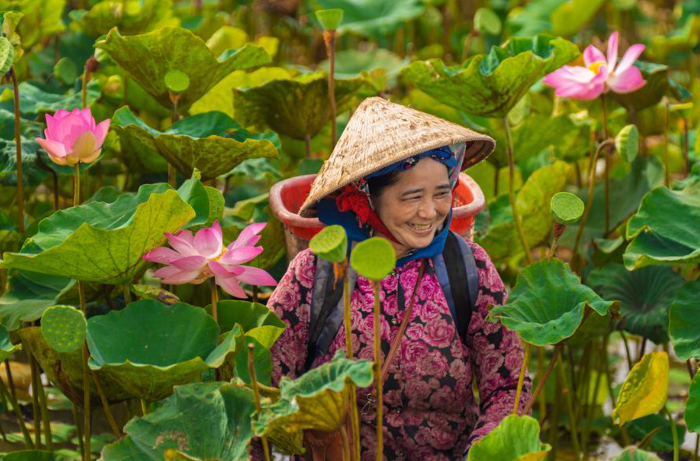

IO3: Australian and Mekong institutions enhance collaboration to facilitate knowledge and technology sharing for strengthened capacity to adapt to climate change.
Collaboration between Australian and Mekong partners on climate resilience remained deep in 2025, particularly through MTT, RUCaS, the accelerating the transition to solar energy in Thailand investment (ANU Solar), and ADB BCG-linked technical assistance activities. Through ANU Solar, Australian National University partnered with the Thai Department of Alternative Energy Development and Efficiency (DEDE) in 2025. The project provided technical analysis of solar integration and grid-forming technology and joint study tours that included DEDE, the grid operator, and investment authorities helping to align Thai agencies around a shared evidence-based understanding of renewable energy pathways and build trust in Australia as a clean energy partner. Outcomes included DEDE’s endorsement of policy recommendations and new government funding for continued capacity-building exchanges with Australia.
RUCaS is an Australian–Mekong partnership anchored in hybrid NbS. In 2025, Australian organisations such as the International Centre for Environmental Management, Queensland University of Technology, Alluvium and E2D Consultants worked with Mekong partners including Cambodia’s Ministry of Land Management, Luang Prabang World Heritage Office, Bangkok Metropolitan Administration, Can Tho University and Hanoi University of Civil Engineering. Collaboration included joint NbS design in Battambang, Cambodia, shared environmental monitoring using Internet of Things (IoT) sensors, and co-development of guidelines such as Thailand’s Guidelines for Risk Assessment of Disused Land and the Inclusive and Equitable Urban NbS Practical Guide, with Australian tools translated and adapted into Mekong languages and planning systems.
MTT’s flagship and rapid response studies involve Australian institutions such as the Royal Melbourne Institute of Technology (RMIT University) and Alluvium Group, working alongside Mekong partners including Thailand Environment Institute (TEI), National University of Laos, Mahasarakham University and Can Tho University on climate-related research-policy interfaces. These collaborations co-produce policy-oriented knowledge products and support joint policy engagement at regional, national and subnational levels, ranging from Bangkok’s heat action planning to benefit-sharing frameworks for hydropower in Vietnam.

IO4: Mekong subregion partners increasingly recognise and integrate of the voices of women, people with disability, and other marginalised groups in climate change policy and practice.
Across the portfolio, 2025 data show meaningful but uneven progress in recognising and integrating the voices of women, people with disability and other marginalised groups in climate-related decision making. SCR provides some of the clearest evidence. In 2025, there were 32 documented cases (14 in Cambodia, 8 in Laos, 4 in Thailand, 6 in Vietnam) where local authorities integrated perspectives of women, people with disability, and marginalised groups into disaster risk management and climate-change adaptation policies and programs. These outcomes were driven by inclusive processes such as community-based vulnerability analysis, and participatory planning that explicitly targeted marginalised groups and adapted logistics (for example, providing childcare) to enable their participation.
SCR also documented at least 15 cases of women, youth, people with disability, and representatives of marginalised groups taking leadership roles in DRM/CCA events and platforms at community, commune and district levels across the 4 countries. Examples include women leading mushroom cultivation and climate-resilient irrigation demonstrations in Laos and Vietnam, women’s unions participating in disaster management committees, and women and youth in Champee village, Laos leading early warning and evacuation planning. These leadership roles went beyond attendance to decision-making and peer learning.
RUCaS embedded GEDSI into its case studies and policy workstreams, using the Inclusive and Equitable Urban NbS Practical Guide and a GEDSI technical advisory group. In 2025, the Guide was applied to pilots such as Battambang’s Road 501, where co-design workshops included provincial departments of women’s affairs, OPDs, youth groups and local residents; participants explicitly considered lighting, kerb heights, surfaces, seating and shade to ensure safe and accessible public space for women, people with disability, children and older people. GEDSI principles were also integrated into the Wetland City Typologies Catalogue in Cambodia, Lao’s Ecosystem-based Adaptation (EbA) Guidelines for Flood Risk Reduction, and Thailand’s Risk Assessment of Disused Land guidelines, reflecting a shift toward mandating inclusive participation and risk assessment in national and local climate-related policies and tools.
The Mekong Think Tanks investment’s climate-focused work provided further examples of GEDSI integration in climate policy and practice. One of the supported research projects developed guidelines on mainstreaming GEDSI into groundwater management policies and projects for Cambodia and Vietnam, while another applied gender-sensitive analysis to water-climate infrastructure planning and helped establish a women entrepreneurs’ club and infrastructure planning processes that consider women’s needs. MTT fellows also produced blogs, podcasts, and research that highlight GEDSI and climate policy intersections, including in aquaculture and NbS.

Box 2. Strengthening climate resilience of farmers in Ratanakiri, Cambodia
Theary Choun lives in Seda commune, Lumphat district in Kaeng Sann village about 60 kilometres from Ratanakiri, Cambodia. Life has been challenging, especially for smallholder farmers like her and her husband, who have long relied on traditional farming to support their family of 4 including 2 school-age children.
Through Oxfam’s Strengthening Climate Resilience in the Mekong Subregion project – supported by MAP and implemented by the 3S Rivers Protection Network – Theary was selected to receive hands-on training in climate-smart agriculture techniques, including composting, drip irrigation, recordkeeping, and the use of solar-powered water systems. The project provided Theary a movable solar water pump, valued at AUD2,300, along with a water-saving drip irrigation system. After receiving their first batch of seeds, Theary started to work on her farm that now has become a flourishing garden that produces cucumbers, string beans, chilies, eggplants and morning glory. Together with other farmers supported by the project, she now earns an average of 2 million Riels (around AUD720) per month by wholesaling vegetables at the local commune market.
“Before, I couldn’t afford to send my eldest daughter to school regularly. Now, I can support both of my children’s education – including AUD20 a week for my daughter’s dormitory expenses,” said Theary.
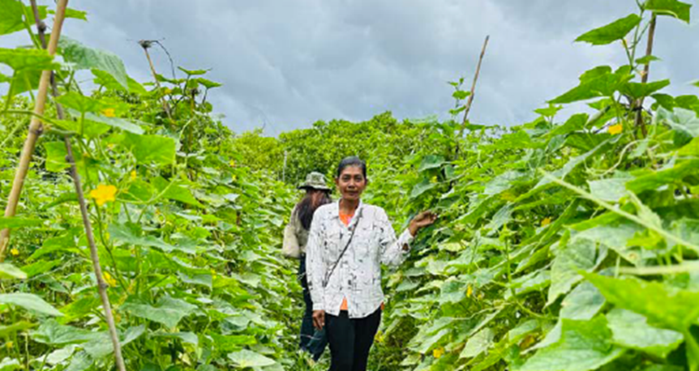

Water security

IO1: Subregional and national water governance structures, policies and practices, are increasingly becoming more effective and inclusive.
In Laos, the Enhancing Sustainable Groundwater Management in Laos (ESGM) investment laid the foundations for more effective groundwater governance by completing the country’s first structured review of its groundwater policy and regulatory framework. Working with the Department of Water Resources (DWR) and Department of Irrigation (DoI) under the Ministry of Energy and Mines, International Water Management Institute (IWMI) assessed the Water and Water Resources Law, associated regulations and literature to understand how existing rules support coordinated and sustainable groundwater management. The assessment found that Lao’s national framework is broadly coherent, but highlighted implementation gaps, especially around monitoring, enforcement and technical capacity, which constrain sustainable groundwater use in practice. This shared diagnosis provides a reference point for government and partners as they plan Year 2 activities focused on operationalising and strengthening the framework.
AWP made progress in translating climate-resilient water management concepts into concrete tools and practices embedded in national governance systems. In Cambodia, AWP supported the Tonle Sap Authority to complete a basin diagnostic, providing a shared evidence base on hydrology, uses and risks in the Tonle Sap system. This diagnostic is now informing basin planning and co-investment, including with the World Bank, and has helped position water security as a cross-sectoral planning issue rather than a narrow technical concern. AWP also worked with Vietnam’s Ministry of Water Resources and Meteorology to co-design governance tools for climate-resilient water management, and with the then Vietnam’s Ministry of Agriculture and Rural Development (MARD) (now the Ministry of Agriculture and Environment) to develop and trial planning tools and practices for climate-resilient rural water supply. These tools are being applied through government systems, strengthening the ability of national and provincial agencies to adjust allocations and services in response to climate shocks.
At the regional level, the MRC continued to anchor regional water governance, with explicit climate and water-security implications. In 2025, MAP supported the MRC to revise its Procedures for Data and Information Exchange and Sharing (PDIES) technical guidelines, setting updated standards for cross-border data sharing, including operational data from dams. By 2025, all 13 key dams across the 4 member countries had agreed to share daily operational data with the MRC Secretariat. The redesigned Core River Monitoring Network (CRMN) was fully operational in all 4 member countries, providing the data backbone for evidence-based basin management, drawing on Australian systems and expertise

I02: Mekong partners have improved data, information, and evidence production and sharing to strengthen decision-making in the water sector.
Australian support aided the MRC's analysis of low flows in 2019–2021, leading into a 2022 Report on Low Flows and Drought in the Mekong River Basin and a joint MRC-Lancang-Mekong Cooperation Study. Phase 1 of the study (October 2023) delivered the first comprehensive assessment of changing hydrological patterns for all 6 riparian countries, and the Phase 2 Interim Report (2025) presented shared projections of future hydrology under climate scenarios along with adaptation options.
In Cambodia, the Asia Pacific Water Scarcity Programme Phase I Extension (WSP) generated concrete evidence to inform basin-level water management. The team prepared a comprehensive water-scarcity diagnostic for the Stung Staung basin, aligned with the World Bank financed Cambodia Water Security Improvement Project (CWSIP). This diagnostic drew on a literature review, community field surveys and interviews with organisations from national to local levels, engaging more than 104 people with gender-balanced participation. It provides targeted recommendations for addressing water scarcity and for structuring Phase II WSP and CWSIP activities.
In Laos, the ACIAR-DFAT Fishtech investment continued to generate data needed to align hydropower operations with river and fisheries health. By early 2026, the project had tagged and released 7,361 fish across multiple species and sites, supported by refined acoustic and sensor-fish monitoring systems. In 2025, 5 field deployments were carried out at Xayaburi Hydropower Project and nearby Mekong sites (March, May, August, October/November 2025 and February 2026), maintaining and expanding core datasets. These technical advances strengthen the evidence base for fish-friendly design criteria and operating rules that can be applied in existing and future hydropower projects.
In Thailand’s Eastern Economic Corridor (EEC), the EEC water project used modelling to inform both planning and institutional innovation. The EEC Water Balance and Pricing Study, supported by the Water Balance Scenario Tool (WBST), produced a shared quantitative understanding of current and future water demand and supply in the corridor. In December 2025, the study’s results were presented to 57 participants from public and private water businesses at a seminar attended by the Australia’s Ambassador to Thailand Dr Angela Macdonald PSM and the EEC Office Secretary-General, reinforcing the link between robust analysis and high-level policy discussion. This modelling work influenced the formation of new institutional mechanisms. In May 2025, a Memorandum of Understanding was signed by 10 water agencies, and the Federation of Thai Industries established the Sustainable Water Management Committee (SWMC), illustrating how data and models are being iteratively improved through multi-agency use.
Image 2: Through Inclusion Project 2, Oxfam and partners support communities in Koh Snaeng, Cambodia, to protect livelihoods, advocate for their rights and prepare for floods. Women lead early warning, river monitoring and community education efforts.
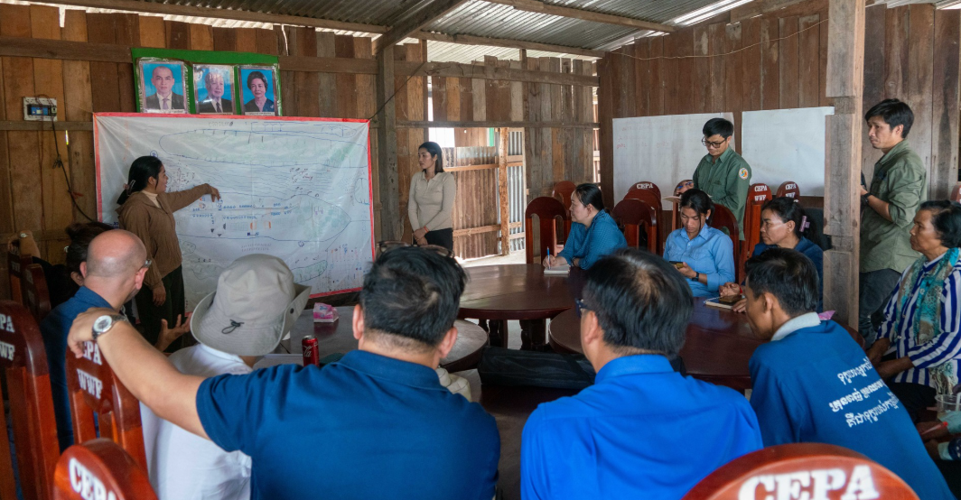

IO3: Civil society organisations strengthen their capacities and influence on water governance issues.
IP3 significantly increased the visibility and influence of civil society, especially marginalised groups, in water governance. An Indigenous woman from Cambodia’s 3 Rivers Protection Network (3SPN) and a representative from the Hanoi Association of People with Disabilities participated in the ASEAN Civil Society Conference in Vientiane, where they highlighted how climate and water-related shocks disproportionately affect Indigenous Peoples and people with disability and called for climate initiatives that address these vulnerabilities. Their interventions reinforced civil society demands for inclusive governance, sustainable energy options and increased government investment in climate action.
Following this regional engagement, the 3SPN woman leader representative spoke at Cambodia’s National Forum on Women in Leadership and Governance, convened by the Ministry of Women’s Affairs, where she advocated for greater recognition of women’s leadership in climate change and disaster risk reduction. These examples illustrate how IP3’s local organisation and evidence generation translate into influence at higher-level policy spaces, consistent with IO3 on civil-society capacity.
IP3's progress builds on IP2’s key foundational achievements. As a result, women-centred, rights-based recommendations are being recognised or endorsed by decision-makers at local, national or regional levels; targeted government and private-sector stakeholders are adopting gender and social analysis in water and renewable-energy policies, guidelines and research; and Gender Impact Assessments are starting to be integrated into Environmental Impact Assessment and Strategic Environmental Assessment processes.

IO4: Australian and Mekong institutions are strengthening collaboration for shared learning in water governance is improved.
The AWP–MRC relationship is a core pillar of Australian–Mekong collaboration under this thematic area. Australian technical advisors embedded in the MRC provide support on sustainable hydropower, flood forecasting and dam operations, helping the MRC integrate climate resilience and GEDSI considerations into regional frameworks. The MRC and AWP report that this collaboration not only improves technical outputs but also helps the MRC ‘see the big picture,’ break down silos and align work across sectors and member countries. Australia’s partnership with the MRC goes beyond this. The Australian Embassy in Laos nurtures the relationship with the MRC through its active participation with the MRC’s governance mechanisms. Australia became chair of the Mekong River Commission Development Partner Committee from 1 July 2025 (for a period of 12 months). This partnership also gave MAP a direct engagement with the MRC to discuss technical challenges and priorities, informing the design of Australia’s support.

Box 3. Strengthening pumped storage hydropower capacity through targeted capacity building
The Electricity Generating Authority of Thailand (EGAT) plays a critical role in shaping Thailand’s policy and strategic planning for Pumped Hydro Energy Storage (PHES), a key component of the country’s future energy security and renewable energy integration. MAP supported EGAT, through the Australian National University (ANU) to strengthen its approach to site selection for pumped storage hydropower development in Thailand’s southern region.
Peetiya Nidhinandana, Head of the Dam and On Ground Structure Project Section within the Pumped Storage Investigation and Study Project at EGAT, received targeted support from ANU, including technical assistance and participation in a study tour.
Over an 18-month collaboration, Peetiya and her team worked closely with ANU experts to apply advanced modelling tools and develop a pumped hydro atlas for the southern region. Rather than relying solely on internal databases, EGAT identified additional feasible pumped storage hydropower sites in 2 more provinces, Phang Nga and Krabi, substantially reducing planning risk and increasing strategic flexibility. These findings have already influenced national level planning. The current draft of Thailand’s Power Development Plan, pending Cabinet approval, has shifted its reference from a specific site to the broader ‘southern region’ for PHES development. This enables EGAT to select the most suitable site based on future feasibility studies, strengthening long-term energy planning.
ESGM’s work in Laos is built on a partnership between IWMI, Flinders University and the Department of Water Resources (DWR), with Gender and Development Association (GDA) providing GEDSI expertise. In 2025, these partners jointly conducted a capacity-needs assessment that identified hydrogeology and applied field skills as major gaps across government, academia and the private sector. The assessment is now informing a multi-year capacity-building plan that will be co-developed and implemented, ensuring that technical training is directly aligned with national groundwater governance needs.
In Thailand’s Eastern Economic Corridor, Water Sensitive Cities Australia (WSCA) and Thai partners such as Eastern Economic Corridor Office, Office of National Water Resources and Royal Irrigation Department co-designed tools and frameworks to manage water risks in a rapidly industrialising landscape. The EECiti Design Guidelines articulate how water-sensitive urban design, integrated blue–green corridors and modular infrastructure, and inclusive approaches can be applied at urban, precinct and building scales.
The MRC-PSH project facilitated deep collaboration between ANU and Mekong partners like EGAT, Lao energy agencies and the MRC. ANU’s development of Scenario 5 for the MRC’s Proactive Regional Planning process relied on Australian modelling and global PHES mapping, but also on Thai and regional planning parameters provided by EGAT and the MRC. Study tours in 2025 enabled Thai and Lao officials to visit Australian hydropower and storage sites, meet regulators and utilities, and compare policy frameworks. Participants reported increased confidence in advocating for PHES-related policy reforms, concession renegotiation and renewable-energy regulation at home (see Box 3).

Gender equality, disability equity and social inclusion

IO1: Mekong subregion partners are increasingly generating and using GEDSI analysis.
Across the MAP portfolio, investments are strengthening how national and regional actors generate, systematise and use GEDSI analysis in their work. The eWater–AWP support to the MRC is a central example. Building on 2024 gender workshops, eWater convened a January 2025 workshop for chiefs, specialists and officers from all four MRCS divisions and the Office of the CEO, explicitly framing GEDSI integration as an organisational responsibility rather than a task for a single gender focal point. As a concrete action to this commitment, the MRC published the Regional Report on Improving Equity for Vulnerable Groups 2025, which introduced structured methods to analyse how gender intersects with poverty, remoteness, ethnicity, livelihoods and climate risk, moving beyond participation metrics to examine exposure, sensitivity and adaptive capacity. The document informed the development of the MRC’s Gender Equity and Vulnerability Action Plan 2026–2030, embedding gender and vulnerability considerations across water, energy and food security priorities of the MRC member countries.
Several investments have focused specifically on building analytical tools and baselines that put GEDSI at the centre of sectoral work. The Building Climate-adaptive Solutions through Inclusive Market Networks project (BASIN) implemented by World Vision, has completed a contextualised version of the Gender Inclusive Financial Literacy Training (GIFT) manual and training package in December 2025, tailored to the realities of smallholder farmers and micro entrepreneurs in Cambodia and Laos.
In Laos, the IP3 investment has engaged the GDA to co-develop a baseline framework for gender inclusive groundwater management, explicitly covering GEDSI-oriented training, implementation and coordination. During the December 2025 inception and technical consultation, GDA identified key risks faced by women, people with disability, and other marginalised groups in accessing and managing groundwater in the 3 study areas. This early engagement ensures that subsequent field consultations and technical assessments go beyond generic household level data to focus on differentiated access, decision making and benefit sharing.

IO2: MAP partners take a more targeted and deliberate approach to disability inclusion.
Acknowledging weaknesses in disability inclusion in MAP investments, several partners have undertaken a more proactive approach in involving people with disability and highlighting their issues and concerns in public discussions. For example, the Mekong Think Tanks investments implemented by Stockholm Environment Institute-Asia organised various activities including the Vietnam Disability Inclusion Seminar, delivered in partnership with Monash University and the Hanoi Association of People with Disabilities (DP Hanoi). This deepened engagement with disability inclusion principles, strengthened capacity for inclusive co-production and policy influence, and identified next steps to advance disability equity across projects.
Through the Australian Water Partnership, a disability inclusion training curriculum and tools have been developed and delivered in Vietnam and Cambodia, reaching around 200 people across government, civil society and private sector stakeholders and embedding practical tools for assessing barriers and designing more accessible programs.

Box 4. How gender-responsive procurement opened global doors for MoreLoop
Moreloop – a women-led enterprise in Thailand which repurposes industrial deadstock fabric into new clothes – has experienced transformative growth in its journey toward gender-responsive procurement (GRP). WRT’s support to Moreloop WRT Phase 2 deepened the company’s commitment to embedding GRP principles into its operations and value proposition, particularly by highlighting women’s leadership to better meet the expectations of public and private buyers seeking gender responsive suppliers.
UN Women supported Moreloop’s participation in Thailand’s SheCommerce program and provided GRP, trade readiness and market positioning support. These efforts enabled Moreloop to access new international networks, including a trade mission to Vienna, supported by the Thai government where it engaged with government representatives and potential buyers linked to Vienna Fashion Week.
The Mekong Plastics project promotes disability-inclusive development in line with countries’ international commitments. For example, in Laos, the venture company Print Square shifted disability inclusion from a secondary outcome to a primary design driver, engaging directly with members of targeted disability communities prioritising customised prosthetics and planning for safer processing practices. By engaging engineers, academics and disability community members, the venture has effectively created a multi-stakeholder learning and advocacy platform for inclusive technology that will potentially benefit people with disability. Similarly, in Vietnam, ventures such as UpGreen and Nhan Van Ecotoys have adopted more inclusive recruitment practices, increased the participation of women and people with disability in their teams, and built local networks with schools, community organisations and women’s unions.

IO3: Mekong subregion partners are increasingly shaping development and implementation of policies and strategies to promote GEDSI
There is growing evidence that GEDSI actors – representative organisations, women leaders, experts and networks – are influencing policy directions, institutional practices and the design of sectoral strategies. For example, in Thailand’s energy sector, the ANU Solar Energy Transitions project illustrates how women leaders within government can act as key GEDSI actors shaping policy and regulatory frameworks. The DEDE has ensured that women, such as the Director of the Solar Energy Development Division and a professional-level scientist in the Solar Energy Taskforce, play central roles in project analyses, policy review and capacity-building. Their leadership did not only help shape recommendations that addressed technical and economic priorities, but they also supported inclusive decision-making and equitable access to renewable energy benefits.
MAP’s support enabled the drafting and implementation of relevant policies and strategies to ensure that concerns and priorities of women, people with disability, and marginalised groups are addressed. With UN Women’s policy analysis and technical input under the WE RISE Together investment, Vietnam achieved a procurement policy shift by amending the Public Procurement Law, as reflected in Resolution 198/2025. The Resolution introduced preferential conditions for contractors employing women workers, people with disability, war veterans and ethnic minorities, translating advocacy and evidence generated through the project into binding legal provisions. This resulted from sustained engagement, technical support and long-term investment from the project’s first phase also supported by MAP.
Image 3: A gathering of 100 participants under the WE RISE Together investment, including from public agencies, private enterprises, and international organisations, in Hanoi on 25 November 2025, explore the link between gender equality and business competitiveness through inclusive procurement practices.
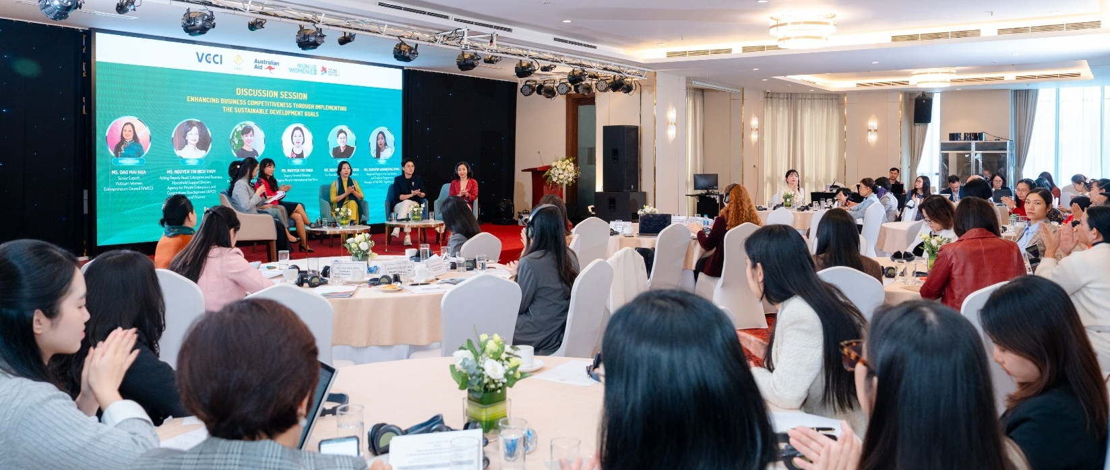
The Climate Resilient by Nature (CRxN) project, implemented by WWF in Vietnam, in collaboration with the Cu Lao Women’s Union, CRxN supported the establishment of the Cu Lao Dung Women Entrepreneurs Club, a women-led association that manages livelihood development funds and co-implements 2 innovative climate-resilient livelihood models in An Thanh Nam and An Thanh Dong communes, including semi-dried nipa palm fruit and mangrove apple flower- and-leaf tea. These collective enterprises not only improve incomes but also create platforms where women can share knowledge, coordinate with local authorities and help inform decisions on resource use and market engagement.

Economic resilience and subregional integration
MAP investments focused on laying the foundations for stronger economic resilience and subregional integration. Most investments are either at inception or early implementation stages, except for a small number of legacy investments funded in the first phase of MAP.

IO1: MAP partners are increasingly relying on systematic analysis and knowledge products to steer interventions toward sustainable, inclusive economic growth
In 2025, several of the MAP investments prioritised rigorous analyses and assessments as deliberate first steps towards achieving its goals for economic resilience. Mekong Safeguards completed 4 major strategic studies on the political economy, legal frameworks, GEDSI integration, and policy gaps in environmental and social safeguards in infrastructure. This will serve as a basis in designing activities to promote regional cooperation, engage private sector entities to adopt improved standards, and involve civil society organisations, women’s rights organisations, and organisations for people with disability in infrastructure decision-making.
World Vision’s BASIN project undertook an Inclusive Market Assessment and complementary GEDSI analysis to identify potential value chains in its target provinces: Kratie (Cambodia), Champasak (Laos) and An Giang (Vietnam). During the reporting period, a design workshop with all country teams was conducted, which enabled teams to share specific country contexts and align these with the program’s theory of change and expected outcomes/outputs. World Vision also initiated foundational activities in partnership with the University of the Technology Sydney to design the research agenda for the BASIN investment, including future policy dialogues and subregional knowledge-sharing platforms.

Box 5. How MAP strengthens Laos’ public financial management
In Laos, MAP supported the World Bank’s technical assistance program to assist the Ministry of Finance’s Tax Department in completing the new Income Tax Law, which introduced global minimum tax and transfer pricing provisions. The Bank provided legal drafting support through technical experts and organised stakeholder consultations in March 2025. The law was submitted and approved by the National Assembly in June 2025.
The project also supported the revision and implementation of the revised Value Added Tax (VAT) Law by preparing sector-specific implementation guidelines and conducting dissemination. Since the introduction of the digital VAT law (implemented in August 2025), the government has generated USD10 million, from 31 registered companies.
MAP investments in CAPRED support Cambodia’s economic resilience and/or transition from Least Developed Country status. Through the newly commenced collaboration with the Harvard Growth Lab, CAPRED is supporting analytical work to identify binding constraints to economic growth and opportunities for diversification. This engagement is expected to deliver a deeper understanding of Cambodia’s growth trajectory, a set of actionable policy recommendations, and strengthened capacity within government stakeholders to apply these insights in practice with a focus on tangible and implementable reforms.
In Laos, the Laos-Australia Investment Facilitation and Transformation for Economic Resilience (LIFT4Laos) has commenced engagement with the Investment Promotion and Management Committee Office, by supporting the development of the investment attraction strategy and lead generation approach in identifying, attracting and nurturing potential investors to initiate interest in the country’s offerings. As part of this process, the project trained 21 officials (8 women, 13 men) on the revised Investment Promotion Law, its procedures and linkages to investor services and promotion functions.

IO2: MAP partners have laid the foundation for stronger regional collaboration to address shared challenges
Mekong Safeguards positions environmental and social safeguards in infrastructure as a shared regional challenge and has mapped and engaged a wide range of stakeholders – including the Mekong River Commission, ASEAN Bankers Association, Asian Development Bank, International Finance Corporation, Fair Finance Asia and key ministries in Cambodia, Laos, Thailand and Vietnam.
In the same way, MAP’s support to the IAI Work Plan V enable practical technical assistance to ASEAN’s least developed member countries, including Cambodia, Laos, Myanmar and Vietnam, and now Timor-Leste. The IAI Work Plan V’s focus is to support countries close the development gap with other ASEAN economies through 6 strategic areas, education and support deeper economic integration across ASEAN.

IO3: MAP delivery partners focused on creating an enabling environment to facilitate assisting vulnerable communities to become more resilient to economic shocks and pressures
In Cambodia, CAPRED targeted women’s economic participation through the establishment of a Caregiver Training Academy. CAPRED mobilised Planète Enfants & Développement to deliver technical guidance, including caregiver training based on Ministry of Education, Youth and Sport’s approved curricula. The Academy is designed as a demonstration model to raise standards in early childhood care while creating a skilled labour pool and incentives for private sector investment in childcare. By addressing care constraints, the initiative will directly support reduced absenteeism and improved workforce retention among women employees.
At the same time, CAPRED advanced inclusive entrepreneurship for people with disability by supporting 3 participants from the Mekong Inclusive Ventures accelerator. Despite identifying viable business expansion opportunities, these entrepreneurs were unable to access finance, likely due to perceived risks associated with disability. CAPRED provided targeted grants (AUD15,500 each), alongside coaching, to support capital investments such as solar panels, beekeeping equipment, and sewing machinery, enabling business expansion and job creation. This initiative is expected to generate 24 new jobs, increase income by AUD133,920, and drive over AUD155,000 in additional revenue for disability-owned businesses in the ensuing year. Projections of job creation, income increases, and revenue growth are based on partner interviews, business plans and value-for-money calculations conducted by CAPRED and implementing partners.
In Myanmar, MAP contributed resources to the LIFT program where 4,306 individuals (82% women) completed LIFT-supported skills development training on livelihood and income generation and 1,994 individuals (81% women) received material, financial and job-matching support to start or expand enterprises or secure employment. There is increasing evidence that this support resulted in participants moving from training into small business activity, self-employment or more stable income generation.
Regionally, BASIN demonstrates how collaboration is already working in practice to address shared climate and livelihood challenges, especially for vulnerable groups and at-risk communities. BASIN’s work in Kratie Province (Cambodia), Champasak Province (Laos) and An Giang Province (Vietnam) focuses explicitly on smallholder farmers, women, people with disability and ethnic minorities who are highly exposed to climate and market volatility. Cooperative assessments in Kratie involved 50 cooperative steering committee members, including strong representation of women and the Kouy ethnic minority; GEDSI assessments across all 3 countries have generated detailed insights into household decision-making, time poverty, mobility constraints and leadership barriers.
Image 4. World Vision team discussing the challenges faced by green vegetable farmers in Soukhouma District, Champasak Province. World Vision, through the BASIN project, will train farmers on climate-smart agricultural practices and link them with profitable markets.
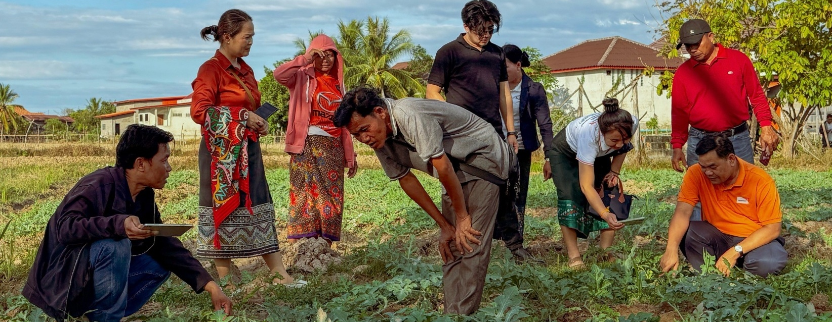

Transnational crime
MAP-TNC activities are demonstrating progress towards the 4 intermediate outcomes (IOs). Results to date are demonstrating progress towards most IOs, building the foundation for changes at the organisational, operational and policy levels.

IO1: Mekong subregion partners continue to demonstrate interest and commitment to develop and nurture institutional relationships with australian government agencies
Mekong partners are actively seeking further transnational crime guidance from AGAs, demonstrating trust and a clear demand for ongoing technical cooperation. For example, the Digital Forensics training in Vietnam built on both the AFP’s positive relationship with Vietnam’s Ministry of Public Security (MPS) and previous digital forensics training delivered under MAP-TNC in Cambodia and Thailand. The Government of Vietnam’s request to the AFP for additional training demonstrates their commitment to deepen their learning from Australian expertise. In the same way, after Lao Government officials attended the Fundamental Cryptocurrency Training, AFP received a follow-up request from Lao authorities to facilitate a cryptocurrency tracing license course.
In Thailand, the Royal Thai Police Office of Forensic Science (RTP-OFS) worked closely with an AFP team to implement the Australia Rooms suite of training activities as a collaboration between AFP and Royal Thai Police (RTP). Adopting a train the trainer model, this activity aimed to position the RTP-OFS Lampang office as a training centre for the Mekong region. This will enable RTP to be leaders in forensic investigation capabilities and provide training to other Mekong countries.
Image 5: Australia Room Crime Scene Examination Training in Thailand (May 2025): 25 forensic officers from the Royal Thai Police Office of Forensic Science are deepening their crime scene examination skills through expert training delivered by the Australian Federal Police.
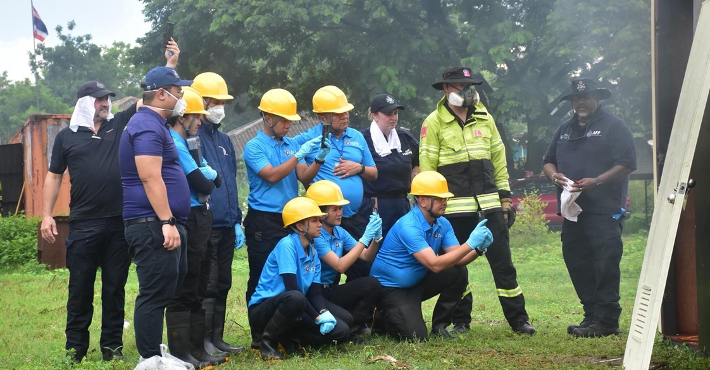

IO2: Trained participants from agencies across the Mekong started to apply what they learned to strengthen operational responses to transnational crimes
Mekong subregion partners across Cambodia, Laos, Thailand and Vietnam started to implement and amend their work practices driven by learning from the MAP-TNC training courses. The Open Source Intelligence Training (OSINT) training implemented by Australian Transaction Reports and Analysis Centre (AUSTRAC) encouraged participants from Cambodia, Laos, Thailand and Vietnam (38 participants, 23 women) to apply new online searching techniques and verification tools. Participants reported improvement in their ability to collect, assess and verify data gathered from social media and websites using OSINT tools provided. While there is still limited evidence of the usage of this software in countries, it is an important step to wider adoption.
Most workshop participants acknowledged that Trade-Based Money Laundering is a new concept, and the training has helped enhance their knowledge and skills for better investigation of money laundering. Most participants reported that the training significantly improved their knowledge and skills in both preventing transnational crime and understanding an ecosystem of Trade-Based Money Laundering.
In Vietnam, the Australian Taxation Office’s (ATO) series of training on tax crime investigations resulted in the development of a training curriculum jointly developed by the Ministry of Public Security and the Ministry of Finance. The course, Advanced Skills for Tax Investigation, is awaiting Vietnamese ministerial approval to commence implementation.
The United Nations Office on Drugs and Crime’s (UNODC) work in Cambodia built the capacity of the National Authority for Combating Drugs and the National Authority for Chemical Weapons in hazardous chemical handling, storage management and safe transport protocols. As a result of the training, Cambodia was able to safely remove and safely dispose at least 200 tons of toxic chemicals from illegal drug labs in 2025.

Box 6. Participation in Australian Government agency activities to combat and counter transnational crime.
A total of 612 officials (38% women) from Cambodia, Laos, Thailand and Vietnam participated in 29 Australian Government Agencies trainings and capacity building activities in law enforcement, investigation, customs, cryptocurrency, anti-money laundering, leadership and communications.

IO3: Mekong partners demonstrate improved awareness, knowledge, and skills on GEDSI and how to integrate GEDSI in their responses to transnational crimes
Across the various activities implemented by Australian Government Agencies (AGAs), evaluation results showed that 81% of participants, on average, improved their understanding of GEDSI, and how consideration of GEDSI can strengthen the design and implementation of initiatives to combat transnational crimes.
In the Mekong Regional Women in Law Enforcement training implemented by AFP, 90% of participants (19 out of 21) reported that the training increased their understanding of how GEDSI topics intersect with transnational crime and how this should be considered in law enforcement.
In the Lao Fundamental Cryptocurrency Training implemented by AFP, Lao participants showed understanding of how GEDSI can be used to understand vulnerabilities to TNC, including how people with disability in the country are at heightened risk of being exploited as money mules.
There is also evidence to show that the integration of GEDSI has started to inspire more support for women in the law enforcement sector. In the Mekong Regional Women in Law Enforcement training, senior Mekong law enforcement officers acted as mentors alongside Australian trainers, reflecting a shift in relationships between the AFP and their Mekong counterparts. This approach enabled senior male officers from Mekong agencies to act as ‘GEDSI Champions’, acknowledging that for women to be promoted to leadership roles they require the support of men who hold senior positions.
Participant feedback from the Trusted Insiders Training in Thailand and Vietnam indicated most participants (96% in Thailand; 72% in Vietnam) reported improved understanding of gender inequality, vulnerability factors as well as gender-responsive and victim-centred approaches. Participants commented that the victim-centred session highlighted how they can be more sensitive and considerate to their clients in the future.

IO4: Mekong subregion partners strengthen information sharing with counterparts to align their operational approaches to combat transnational crime
Several initiatives – such as chat groups formed by participants domestically and regionally – have facilitated informal and formal exchanges of case information, investigation practices and financial intelligence. These actions point to increasing information-sharing behaviour though systematic and institutionalised alignment across Mekong partners remains in an early stage.
The Financial Intelligence Consultative Group (FICG) Plenary implemented by AUSTRAC fosters broader regional collaboration by providing a valuable face-to-face platform for senior Financial Intelligence Unit officers to engage and network. AUSTRAC’s purpose-built information sharing platform, CLEO, was highlighted as an effective tool for quickly connecting, communicating and sharing intelligence with other FICG members. During this period, 84% of participants (86% of Thai; 82% of Vietnamese) reported their interest to continue using the CLEO Platform. AUSTRAC has reported that active information sharing occurs between Australia, Vietnam and Thailand, including requests for Australian support.
In 2025, Mekong Network to Counter Transnational Crime (MNET-CTC) published the first Mekong Risk Monitor, a multi‑country analytical report that tracks developments in the illicit economies of Cambodia, Laos, Myanmar, Thailand and Vietnam, and examines how these trends intersect with governance, development and security dynamics. The project delivered expert briefings, including on the Global Organized Crime Index and emerging cyber scam trends, reaching policy, practitioner and donor audiences.
MNET-CTC also published 3 podcast episodes in 2025 (Youtube and Spotify) on financial crimes in Thailand’s Buddhist temples, Cambodia migrant workers and labour trafficking, and the state of organised crimes in the Mekong, generating a total of 1,256 long-form views, 8,279 shorts views, 225 podcast downloads, 193 website views, and 11,612 social media impressions. This indicates strong interest in transnational crime issues across the region.

Progress in cross-cutting areas

Leadership and skills

Scholarships
In 2025, 30 Australia Awards Mekong-Australia Partnership (AA-MAP) scholars were selected out of 665 applicants from all 5 Mekong countries. Among the 30 scholars (5 men, 25 women), 15 were scheduled to commence their studies in January 2026. The rest were scheduled to begin their studies in the second semester of the 2026 academic year (13 scholars) and the first semester of the 2027 academic year (2 scholars). The selected scholars will undertake master’s‑level degrees by coursework across 4 MAP thematic and priority areas (except water security) at 9 universities located in 4 states across Australia. Only 4% of applicants interviewed had nominated water security as an area of study. The MAP SU will expand the examples of possible study areas within water security to help raise interest among applicants for future intake.
Figure 3. Profile of the first intake of Australia Awards Mekong-Australia Partnership

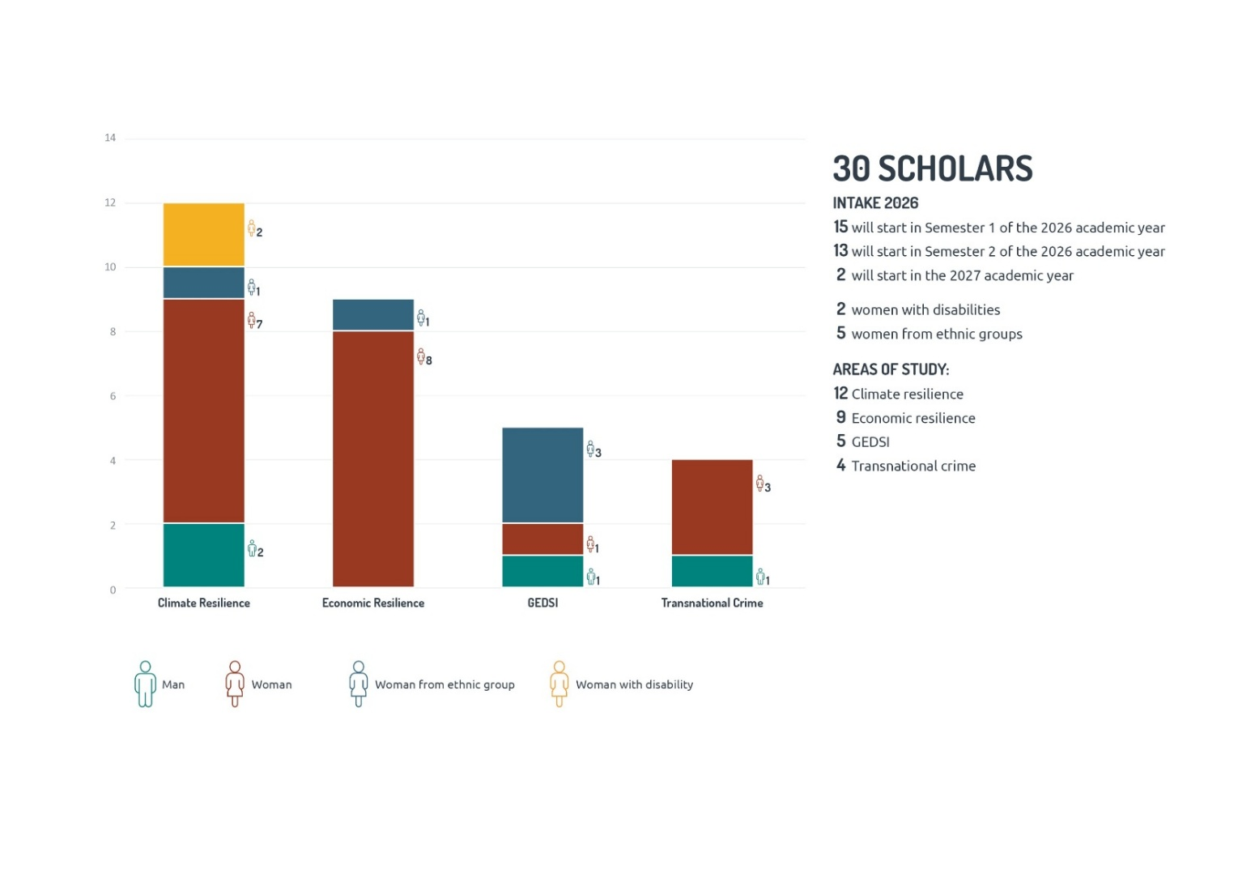
The first Mekong Leaders Network activity in November 2025 brought together 27 AA-MAP scholars (23 women) from all 5 Mekong countries. 92% of surveyed scholars rated the workshop as effective in helping them build bonds across the cohort, including 57% that rated it extremely effective. In addition, the online platform used by the Mekong Leaders Network connected 30 AA-MAP 2026 scholars with 47 AA-MAP 2022 scholars and organised communities of practice on climate change adaptation, sustainable agriculture, environmental guardianship, social inclusion and related themes.

Masterclasses
A total of 13 masterclasses (4 regional, 9 bilateral) were delivered in 2025 across various areas – GEDSI, energy and climate change, leadership and diplomacy, business and economic resilience, and strategic analysis and communications. A total of 266 participants (165 women, 99 men, 2 prefer not to say) from government, civil society and the private sector. Across all masterclasses, more than 80% reported an increase in knowledge and skills among attendees and expressed that the training provided through MAP has concrete application opportunities in their areas of work.
The regional masterclasses provided opportunities for countries across the Mekong to collaborate and address shared challenges. For example, there is strong interest and commitment by Lao and Vietnamese participants to continue communication and collaboration after the regional training on strategic analysis and analytical writing. The Leadership and Skills thematic area provides a platform to foster these collaborations.
The program has reached a substantial number of participants from equity groups. From the masterclasses, a total of 173 participants (from a total of 266) were from equity groups, including women, people with disability, and minority-group participants. Women were strongly represented in several activities, including 14 of 20 participants in the environmental resilience trilateral masterclass (Australia, Laos and Vietnam), 15 of 20 in the gender mainstreaming masterclass, 23 of 25 in Thailand’s climate-smart agribusiness masterclass, and 20 of 25 in Myanmar’s inclusive education course.

Figure 4. MAP Masterclass statistics
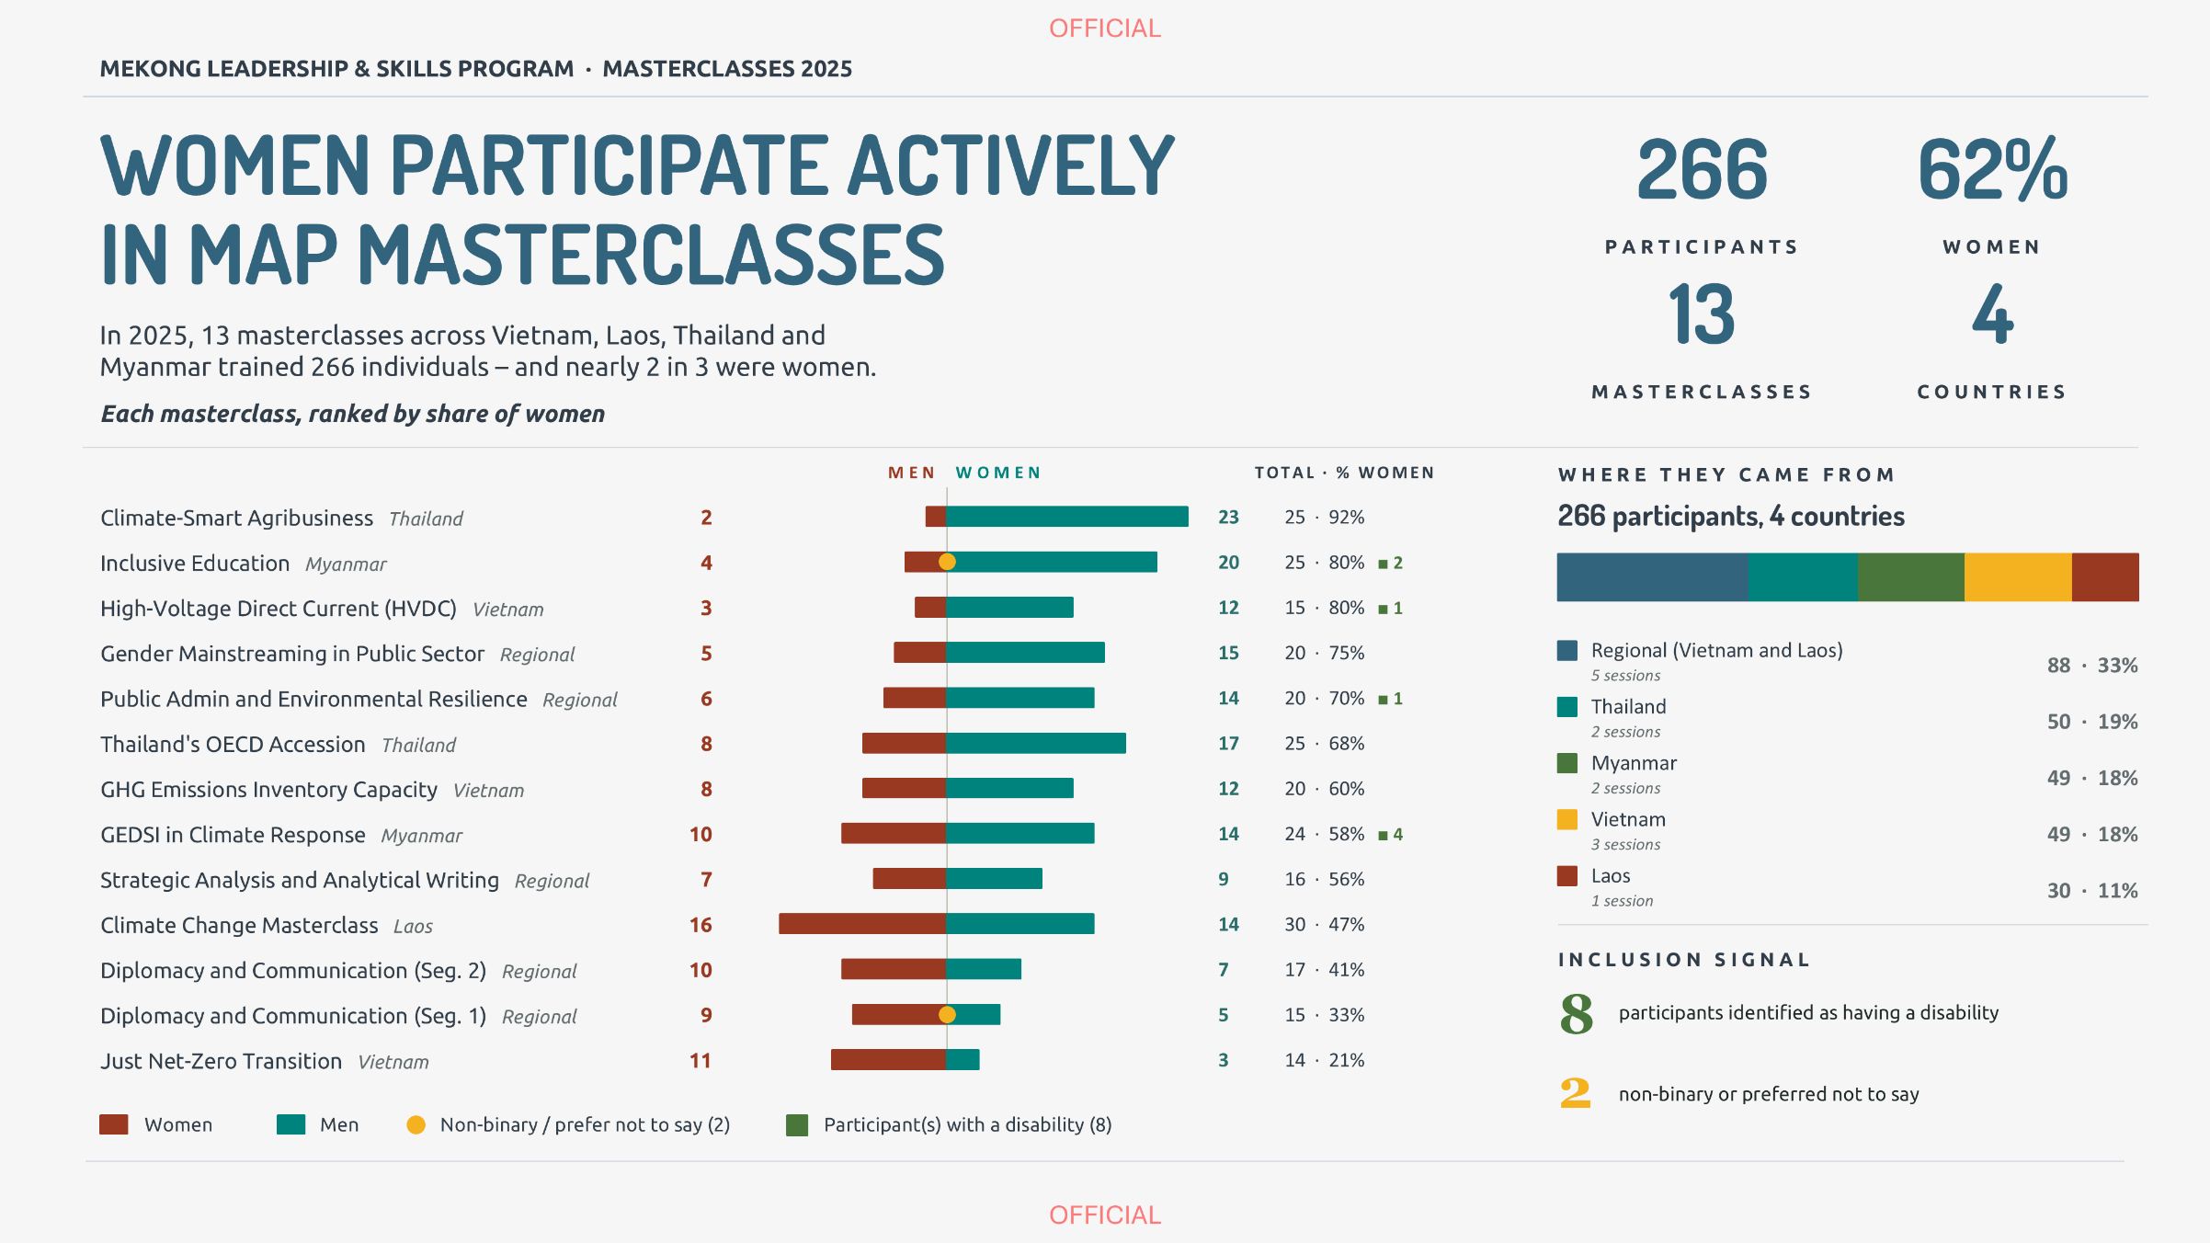
Some courses such as Myanmar’s inclusive education and GEDSI in climate response were explicitly inclusion-focused, indicating that the program is building inclusive foundations and demonstrating early leadership gains, particularly for women. For example, several women masterclass participants have led significant efforts in empowering disability voices in Myanmar, embedding GEDSI into organisational strategies in the private sector, and ensuring that GEDSI is informing the design of biodiversity and conservation initiatives.

GEDSI
In 2025, 7 investments that underwent an annual internal performance assessment were rated an average of 3.7 in gender equality and 3.6 in disability equity against a target of at least 4.0 (adequate effectiveness) out of 6.0. These scores reflect the composition of the reporting cohort: 3 of the 7 investments closed in 2025, each carrying identifiable constraints on their GEDSI performance. Across the continuing portfolio, gender equality was rated at the adequate standard (4.0) and disability equity approached it (3.75). The 2025 performance results are the baseline for the strengthened system now in place.
In 2025, MAP ensured that GEDSI is systematically addressed throughout the program cycle using tracking tools such as the GEDSI Guidance Checkers and the Guidance Checklist, especially for all new investments valued over AUD3 million. As a result, all new investments have gender and disability analysis, as well as accompanying strategy, appropriate GEDSI resourcing, and MEL frameworks that track GEDSI quantitative and qualitative indicators. Importantly, 29.7% of MAP’s budget is directed towards investments that actively integrate GEDSI outcomes, including human resourcing that supports this integration.
In line with DFAT policy and the OECD Development Assistance Committee (OECD-DAC) Gender Equality Policy Marker framework, 80% of MAP-funded investments are targeted to be gender responsive or gender transformative, with the remaining 20% at a minimum, gender sensitive. To date, 85% of new investments are responsive and 15% are sensitive for gender equality. For disability equity and social inclusion, 62% are responsive and 38% are sensitive.
World Vision’s BASIN, for example, has identified in its primary data analysis that women, people with disability, and ethnic minorities face several barriers at the household and community level. Responsive actions include the MenCare model that aims to redistribute unpaid care work and establish labour-saving technology in households, norms-changing interventions to shift attitudes in communities from pity to empowerment, and targeted communication activities to promote more inclusive practices.
Finally, MAP aims to elevate the expertise of women, people with disability, and other groups, whose perspectives have historically been excluded into processes of knowledge creation and decision. MAP investments are currently embedding GEDSI in governance through participatory and transparent leadership selection; representation targets for women, people with disability, and ethnic minorities in decision-making bodies; and recognition of WROs, OPDs, and Indigenous Peoples’ organisations as formal governance actors. For example, the Mekong Think Tanks investment co-designed capacity building program with the Hanoi City Disabilities People Association (DP Hanoi) and implemented this across over 40 knowledge-based organisations in the Mekong subregion. This resulted in concrete actions to strengthen disability inclusion in their research projects, including targeted engagement with organisations of people with disability and intentional tracking of disability equity outcomes.

Climate mainstreaming
The varied impacts of climate change continued to be evident across the Mekong subregion in 2025, with the MAP portfolio responding to policy and management challenges arising. Manifestations of climate change and Mekong responses are integral to the majority of MAP investments. MAP partners are focusing on building climate resilience as a cross-cutting dimension of sustainable development. A few examples across the themes are illustrated below:
- Green procurement: The UN-Women WE RISE Together Phase 2 investment is focused on gender-responsive procurement, however, in 2025 initial steps have been taken to include climate-responsive, ‘green procurement’ in the scope, involving assessment of products, materials and services based on their environmental impact.
- Reducing plastics production and pollution: The Mekong Plastics investment, concluded in 2025, was also climate-responsive, given that 98% of single-use plastic is made of petrochemicals. The investment aligned with global efforts to address climate change by tackling the plastic waste crisis, a key contributor to greenhouse gas emissions, by fostering circular economy principles and encouraging innovation in plastics waste management.
- Comprehensive assessments: Understanding climate-water dynamics has been a key feature of a suite of multistakeholder assessments, mobilising members of the Australian Water Partnership. ICEM is leading an extensive Tonle Sap Basin Diagnostic with Cambodia’s Tonle Sap Authority and World Bank. ICEM is also leading a national stocktake of irrigation infrastructure across Cambodia for the Ministry of Water Resources and Meteorology, to determine if the current assets are fit-for-purpose and climate resilient. ICEM is also supporting the Lao Ministry of Agriculture and Environment to assess the national state of water resources, economic value of multiple use scenarios and accessibility of access to climate finance. Alluvium is supporting the Vietnam Ministry of Agriculture and Environment to assess the status of the rural water supply sector and set new policy directions.
- Transboundary biodiversity landscapes: Biodiversity landscape changes are being assessed across the subregion by the International Centre for Environmental Management in the PAD3 investment. ICEM has downscaled the models generated by the Intergovernmental Panel on Climate Change (IPCC) in combination with vegetation, soil, temperature and altitude data to anticipate changes to biodiversity landscapes (ecoregions) in the coming decades.
- Climate-smart agriculture: The Building Climate-Adaptive Solutions through Inclusive Market Networks (BASIN) investment, being implemented by World Vision, has a particular focus on developing climate-smart agriculture enterprise options. ELEVATE, being implemented by CARE in Vietnam, Cambodia and Laos, is also testing alternative climate resilience strategies in its transboundary efforts to build economic resilience, with a particular focus on supporting women and ethnic minorities.
- Climate leadership and skills: University of Queensland (UQ) delivered Masterclasses that covered climate change research, adaptation, policy and mitigation. In 2025, UQ delivered Laos-focused training on Foundations of Climate Change. The University of Adelaide provided a Master Class program for Laos and Vietnam on leadership for responsive public administration towards environmental resilience, that included climate action foundations.
- Coastal erosion: Coastlines are being degraded by a combination of sea-level rise, delta sinking, mangrove depletion and intensified battering by storms. MAP investment in ReTrEAT Cities Project (Resettlement, Transformation, Eco-Adaptation Typology) through Mekong Think Tanks is empowering local communities to craft effective retreat plans, mitigating the social and economic disruption of forced displacements.
- Reimagining urban design: Partnership with the EEC Office is developing designs for a new city in the EEC that is water secure and climate resilient. Urban heat ‘islands’ are being studied by a consortium in a MAP investment led by Asian Disaster Preparedness Centre. The islands exacerbate rising temperatures in cities, disproportionately affecting the urban poor who live in low-quality, overcrowded housing with limited access to cooling.
- Nature-based solutions (NbS) projects being implemented by WWF bring together landscape management, freshwater ecosystem restoration and flood-based/aquaculture livelihood activities. Monash University has commenced work with the Thai Royal Irrigation Department aiming to improve flood risk mitigation by incorporating NbS into their strategic management approaches.

Communications
In 2025, the Mekong Hub developed a suite of MAP products in consultation with MKS and Posts, including country factsheets, placemats, presentations, and materials translated into regional languages, improving reach and usability. These products were used in partner engagement, internal briefings and senior-level engagements.
The communications campaign for a visit by Australia’s Minister for Foreign Affairs, Senator the Hon Penny Wong to Vietnam in August 2025, generated recognition of Australia’s investments in the Mekong subregion including 34 positive responses from key stakeholders and partners, including MAP contacts.
MAP worked with delivery partners to amplify messages on Australia’s commitment to the region. While the quality and reporting of communications efforts by delivery partners were inconsistent in 2025, some projects demonstrated positive communications results. RUCaS’ participation in the Thailand Sustainability Expo in 2025 led to increased media and public recognition of Australia as an expert in nature-based solutions and green spaces, including on Amarin TV, a Thai media outlet.
Monitoring the results of the communications strategy will be a priority in 2026, with 2025 figures serving as comparison data. In 2026, MAP will prioritise monitoring uptake and use of communication outputs; and work with delivery partners to track the results of their communication activities.

Monitoring, evaluation and learning
In 2025, MAP’s monitoring, evaluation and learning (MEL) function focused on strengthening processes and systems to collect and analyse performance data that will provide credible evidence on MAP’s progress towards its committed outcomes. This includes:
- ensuring that new investments are positioned to use DFAT-compliant MEL system to steer results measurement and learning, as well as report on MAP outcomes
- building the capacity of investment managers and delivery partners on implementing fit-for-purpose MEL systems
- connecting MEL practitioners across MAP through regular community of practice sessions and newsletters
- conducting learning studies to inform the implementation of MAP and harvest lessons for adaptive management.
Partners consciously track impact stories, contributing to the portfolio’s bank of most significant change stories and project reporting on quantitative data has improved. The preparation of this report is a culmination of these processes, alongside the prompt preparation of DFAT’s annual investment monitoring reports (IMRs) and partner performance assessments.
At the same time, learning has been embedded into MEL processes. Besides conducting lessons learned sessions with delivery partners and investment managers – that led to the preparation of a lessons learned paper from delivery partners in 2025 and a learning paper for investment managers – learning discussions with individual investments have been intentionally conducted over the year to support decision-making and implementation

Stakeholder engagement
Stakeholder engagement is a critical component of MAP and aligns with DFAT’s localisation strategy. MAP delivery partners collaborate and work with in-country government agencies to strengthen local ownership and promote uptake and sustainability of development interventions. Participatory approaches that bring together ministries, subnational government agencies, the private sector, local communities, civil society actors, and other development partners are critical to MAP’s success as a program.
Figure 5. Number of stakeholders engaged by MAP per country
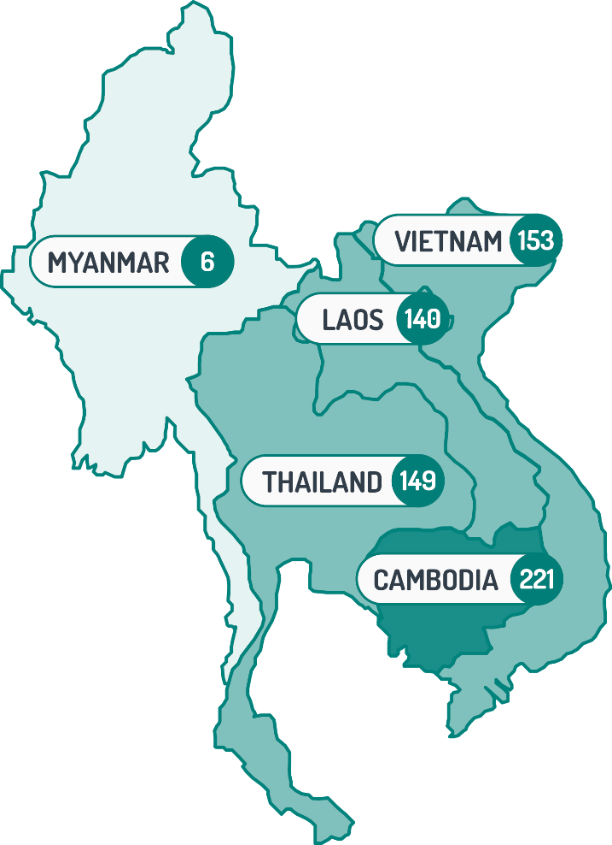

Stakeholder reach
In 2025, MAP engaged with a total of 745 stakeholder organisations, 10% of which were international and regional institutions. Across the Mekong subregion, MAP and delivery partners engaged with 206 national government agencies, 199 local government units, and 83 civil society organisations.
As MAP prioritises evidence-based approaches to the design of projects and activities, a total of 78 universities and research institutes from Australia and within the region were engaged to assist in conducting research and evidence-building activities to inform and influence policy and practice. MAP investments that are targeted at linking local producers to market opportunities engaged a total of 94 private sector stakeholders, while those implementing social and community development initiatives engaged with 83 civil society organisations and community-based associations. Overall, MAP’s engagement with media organisations is relatively low (only 2% of total stakeholders).
Table 1. Stakeholder engagement in 2025 by country and by type
Country | International NGOs, multilaterals | National and local governments | Private sector | Civil society | Media | Academia
Cambodia | 13 | 138 | 29 | 36 | 1 | 4
Laos | 11 | 90 | 12 | 13 | 3 | 11
Myanmar | 1 | - | 1 | 3 | - | -
Thailand | 1 | 81 | 12 | 16 | 1 | 37
Vietnam | 4 | 96 | 13 | 14 | 6 | 20
Cambodia has the highest number of stakeholders engaged (30% of total), while Laos, Thailand, and Vietnam share a relatively similar number of stakeholders. Stakeholder engagement in Myanmar is expectedly low given the ongoing crisis. Australia does not provide any direct funding to the Myanmar authorities. We take proactive steps to ensure that Australian assistance is not diverted to the Myanmar authorities and does not legitimise nor give credibility to them.

Engagement with regional organisations and development partners
MAP proactively engages with key regional institutions such as the MRC, Ayeyawady-Chao Phraya-Mekong Economic Cooperation Strategy (ACMECS), Mekong Institute and ASEAN.
Australia’s long-term support of the MRC has included core financial support, membership in and chairmanship of the MRC Development Partner Committee (2025), and technical assistance through Australian entities, such as the Australian Water Partnership, the Australian National University and Charles Sturt University. In 2025, MAP responded to requests from the MRC for additional support, including providing financial and technical assistance to strengthen cybersecurity and contribute funding to its river basin survey.
During this reporting period, MAP supported ACMECS by providing support to the Mekong Institute in strengthening its internal capacities to provide secretariat support to the ACMECS’ interim secretariat. MAP also provided a modest contribution to Mekong Institute for its annual Mekong Forum 2025 held in Phnom Penh and co-organised by Cambodia’s Ministry of Planning.
MAP provided support to ASEAN’s IAI Work Plan, which assists ASEAN’s least developed members (Cambodia, Laos, Myanmar and Vietnam) to leverage potential benefits of regional integration, while helping them cope with challenges and economic risks. MAP co-funding supported the drafting of the IAI Work Plan V and associated capacity-building initiatives. MAP also provided support to the Regional Trade for Development program to respond to ASEAN’s priorities for trade policy capacity building and economic cooperation to implement and maximise the benefits of the ASEAN-Australia-New Zealand Free Trade Area (AANZFTA) and the Regional Comprehensive Economic Partnership (RCEP) Agreement.
In 2025, MAP entered a co-funding arrangement with the Swiss Agency for Development and Cooperation to support the Inclusion Project Phase 3 implemented by Oxfam. MAP will continuously explore partnership arrangements with like-minded partners to strengthen support to the Mekong subregion.

Risks, challenges and lessons learned

Risks and mitigation
Contextual risks remain the biggest challenges for MAP implementation. The political or security situation in operating environments in partner countries significantly impacted the ability of MAP and its delivery partners to implement activities to achieve outcomes. Difficulties to travel across borders, for example, has been exacerbated with the Thailand-Cambodia border dispute.
MAP also monitored the impact of wide-ranging restructures in Vietnam and Laos that resulted in the amalgamation of ministries at multiple levels and provinces in Vietnam and new local government system in Laos. MAP also responded to the shifting ODA landscape across the Mekong.
In 2025, MAP monitored these risks and assessed impacts on program implementation.
Mekong Hub maintained regular structured risk dialogues with Posts through the thematic working groups and the MAP Steering Committee, with findings feeding directly into investment-level management decisions. Mitigating measures were initially identified below:
- MAP shifted regional masterclasses/joint activities to neutral locations or online where suitable to respond to sensitivities on training and activity locations arising from the Thailand-Cambodia border dispute.
- Mekong Posts and MAP delivery partners adjusted engagement with key ministerial counterparts where necessary in response to restructure processes in Laos and Vietnam.
- MAP worked proactively with delivery partners in identifying ways to minimise the impacts of economic disruptions to their investments, and the ability of their project participants to weather economic shocks and pressures.

Lessons for better delivery
2025 implementation of MAP highlights several cross-cutting lessons:
- Strategic design grounded in evidence and context is essential for relevance and sustainability. Early investments in diagnostics–such as market analyses, political economy assessments, and baseline studies–as experienced by the several of the new investments (BASIN, Mekong Safeguards, and PAD3), consistently improved targeting and reduced implementation risk across sectors. Investments that align with national policies, existing systems and real market conditions were more likely to gain traction and sustain results beyond project timelines.
- Inclusive outcomes require intentional design, resourcing and accountability from the outset. GEDSI is most effective when embedded as a core objective across all thematic areas rather than treated as an add-on or compliance requirement. Shifting from participation to influence, leadership and equitable outcomes will strengthen the achievement of inclusive results. Investments such as MAP-TNC and MNET-CTC, despite challenges in the law enforcement sector to integrate gender equality and disability equity considerations, can move the needle further in terms of achieving inclusive outcomes.
- Multi-level and multi-stakeholder engagement drives stronger and more durable results. Engagement across community, subnational, national and regional levels help ensure that local gains are supported by enabling policies and systems, builds ownership and improves implementation quality.
- Strong partnerships and locally embedded delivery models are central to effectiveness. Trusted, long-term relationships with government counterparts and in-country partners enable navigation of complex political and institutional environments. Partnerships that combine Australian expertise with local knowledge produce more context-responsive and credible interventions. For example, Fishtech leveraged its long-term relationships with in-country partners, including government agencies, universities, and regional stakeholders, to convert pilot interventions to mainstreamed policy actions beyond pilot locations
- Practical and applied approaches to capacity building and policy engagement enhance uptake. Hands-on demonstrations, pilots, and experiential learning are more effective than purely technical or theoretical inputs in influencing behaviour and decision-making. Linking capacity building to real-world applications–such as policy processes, infrastructure or joint initiatives–improves the likelihood of sustained use.
- Leveraging networks, creating platforms for cooperation and connecting existing initiatives within and outside of MAP, will strengthen collaboration to address shared challenges. Connecting existing investments and partners, engaging with regional platforms and strengthening communities of practice reduces duplication and strengthens coherence across investments. At the same time, it will facilitate the development and implementation of shared solutions to shared challenges.

Looking forward
In 2026, MAP will focus on improving performance as the portfolio moves into greater implementation.
MAP will focus on translating the foundational gains of the programs into supporting policy change. There is evidence that MAP has shaped policies in 2025 through the efforts of delivery partners, including work on Fishtech, procurement and data sharing, and will continue to do so for key policy areas where the enabling environment is conducive for institutionalising current gains.
MAP will also actively seek opportunities in the challenges facing development assistance.
Finally, the Thailand-Cambodia border dispute and the disruption caused by the Middle East crisis, among other geostrategic issues, reinforces the need for regional integration to achieve more resilient and inclusive outcomes. As MAP is strengthening Australia’s partnerships with the region and supporting regional collaboration, MAP will intentionally utilise investments and activities that are best positioned to bring regional stakeholders together and to strengthen people-to-people and institutional relationships.

Improving MAP performance
The second year of MAP implementation has laid the groundwork for achieving the portfolio’s EOPOs. In 2026, MAP’s key focus will be the following:
- Deepen practical GEDSI integration beyond participation. This will involve intentional design, implementation and tracking of concrete GEDSI outcomes targeted in every investment. MAP will provide hands-on GEDSI implementation support (clinics, coaching, peer-learning sessions) to help delivery partners move from including equity groups to enabling them to influence systems and strengthen disability equity in investments.
- Strengthen multi-level and cross-border collaboration. MAP, through its delivery partners, will find opportunities to connect community initiatives to national and regional spaces and platforms and use existing regional and trilateral platforms (masterclasses, communities of practice, regional networks) as convening spaces. MAP will also use its existing communities of practice on MEL and GEDSI to promote cross-learning and provide opportunities for partners to work together.
- Leverage and connect existing initiatives and platforms. MAP will identify related programs and platforms across thematic and country contexts and identify a small number of practical linkage opportunities (joint events, shared data products, co-pilots).
- Ensure that capacity building initiatives are more applied and outcomes focused. MAP will ensure that training, leadership and skills initiatives will include structured follow-up components and prioritise experiential methods–demonstrations, pilots, field visits and practice-oriented assignments–over stand-alone classroom-style or one-off online events where possible. MAP will work with delivery partners to track how alumni and participants apply learning using short follow-up surveys and targeted stories of change.
- Enhance communication through clear and targeted messaging. MAP will assess its communication outcomes and review its communications plan to strengthen the development of communication materials each year per theme and ensure they are tailored to audiences and build recognition of MAP across key policy actors in the subregion.
- Improve MEL implementation to inform decision-making. MAP will strengthen its core MEL framework at portfolio level to improve data-use practices by scheduling regular learning and reflection sessions where teams and partners review evidence, discuss implications, and explore opportunities not only on course correction but also innovation.

Annex 1 – MAP’s program logic
Figure 6: MAP's program logic
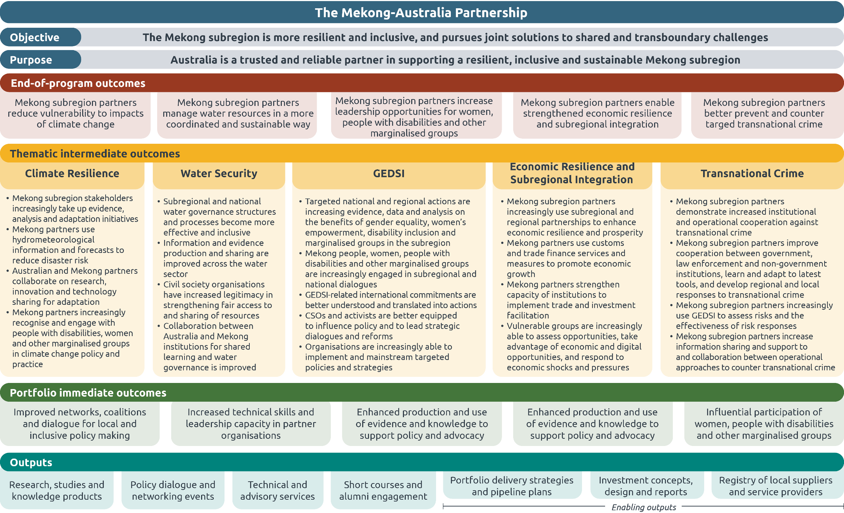

Annex 2 – Figure alt text list

Alt text for Figure 2: Program summary
An infographic summarizing program outcomes across the five Mekong countries.
- The portfolio had 41 projects implemented across the five Mekong countries: Cambodia, Laos, Thailand, Vietnam, and Myanmar.
- Australia strengthened the climate resilience of nearly 10,000 people, of which more than 40 per cent were women.
- We trained more than 600 officials to help address transnational crime through 29 different training activities offered by Australian Government Agencies.
- We delivered 13 masterclasses to more than 250 individuals to invest in the next generation of Mekong leaders and selected 30 Australia Awards for Mekong scholars to complete a Masters’ degree in Australia.
- We built knowledge partnerships and worked with 78 universities and research institutes.

Alt text for Figure 3. Profile of the first intake of Australia Awards Mekong-Australia Partnership
A map of Australia shows scholarship distribution by state and category. The map is divided into Queensland, South Australia, New South Wales including Canberra, and Victoria, with small person icons indicating scholars in each area. A legend at lower left explains the icons for man, woman, woman from ethnic group, and woman with disability.
On the right, text reads 30 scholars and intake 2025
followed by:
- 15 will start in Semester 1 of the 2026 academic year
- 13 will start in Semester 2 of the 2026 academic year
- 2 will start in the 2027 academic year
It also states:
- 2 women with disabilities
- 5 women from ethnic groups.
Under AREAS OF STUDY it lists
- 12 climate resilience
- 9 Economic resilience
- 5 GEDSI
- 4 Transnational crime

Alt text for Figure 4. MAP Masterclass statistics
Title: “WOMEN PARTICIPATE ACTIVELY IN MAP MASTERCLASSES”
Subtitle: “MEKONG LEADERSHIP & SKILLS PROGRAM · MASTERCLASSES 2025”
Summary text: “In 2025, 13 masterclasses across Vietnam, Laos, Thailand and Myanmar trained 266 individuals – and nearly two in three were women.”
- Key figures on the right:
  - “266 PARTICIPANTS”
  - “62% WOMEN”
  - “13 MASTERCLASSES”
  - “4 COUNTRIES”
- Main layout: A horizontal infographic with a ranked list of 13 masterclasses on the left and center, showing men and women participation with stacked bars. Women are shown in rust red, men in teal, non-binary / prefer not to say in yellow, and participant(s) with a disability in green.
- Section heading: “Each masterclass, ranked by share of women”
- Masterclass list and totals:
  - “Climate-Smart Agribusiness – Thailand” – “2” – total “23” – “25=92%”
  - “Inclusive Education – Myanmar” – “4” – total “20” – “25=80%”
  - “High-Voltage Direct Current (HVDC) – Vietnam” – “3” – total “12” – “15=80%”
  - “Gender Mainstreaming in Public Sector – Regional” – “5” – total “15” – “20=75%”
  - “Public Admin and Environmental Resilience – Regional” – “6” – total “14” – “20=70%”
  - “Thailand’s OECD Accession Thailand” – “8” – total “17” – “25=68%”
  - “GHG Emissions Inventory Capacity – Vietnam” – “8” – total “12” – “20=60%”
  - “GEDSI in Climate Response – Myanmar” – “10” – total “14” – “24=58%”
  - “Strategic Analysis and Analytical Writing – Regional” – “7” – total “9” – “16=56%”
  - “Climate Change Masterclass – Laos” – “16” – total “14” – “30=47%”
  - “Diplomacy and Communication (Seg. 2) – Regional” – “10” – total “7” – “17=41%”
  - “Diplomacy and Communication (Seg. 1) – Regional” – “9” – total “5” – “15=33%”
  - “Just Net-Zero Transition – Vietnam” – “11” – total “3” – “14 · 21%”
- Right-side panel heading: “WHERE THEY CAME FROM”
- Right-side panel text: “266 participants, 4 countries”
- Country/source breakdown:
    - “Regional (VN and LA) – 5 sessions – 88 · 33%”
    - “Thailand – 2 sessions – 50 · 19%”
    - “Myanmar – 2 sessions – 49 · 18%”
    - “Vietnam – 3 sessions – 49 · 18%”
    - “Laos – 1 session – 30 · 11%”
- Inclusion signal:
  - “8 participants identified as having a disability”
  - “2 non-binary or preferred not to say”
- Overall description: A clean, data-heavy infographic on a white background with blue headline text, ranked bar charts in the centre, summary statistics at the top right, and source/inclusion breakdowns on the right and bottom.

Alt text for Figure 6: MAP's program logic
A horizontal, multi-row logic-model style infographic with a dark teal header, stacked full-width bands, and five main columns of boxed text. The layout runs top to bottom and shows the Mekong-Australia Partnership from overall objective and purpose through end-of-program outcomes, thematic intermediate outcomes, portfolio immediate outcomes, and outputs.
Top header: “The Mekong-Australia Partnership”
Below the header are two full-width blue-gray bands:
- Objective: “The Mekong subregion is more resilient and inclusive, and pursues joint solutions to shared and transboundary challenges”
- Purpose: “Australia is a trusted and reliable partner in supporting a resilient, inclusive and sustainable Mekong subregion”
A red-orange band labeled “End-of-program outcomes” contains five adjacent rounded boxes:
- Mekong subregion partners reduce vulnerability to impacts of climate change
- Mekong subregion partners manage water resources in a more coordinated and sustainable way
- Mekong subregion partners increase leadership opportunities for women, people with disabilities and other marginalised groups”
- Mekong subregion partners enable strengthened economic resilience and subregional integration
- Mekong subregion partners better prevent and counter targeted transnational crime
Below that, a yellow band labeled “Thematic intermediate outcomes” spans the page and divides into five vertical columns:
- Climate Resilience
  - Mekong subregion stakeholders increasingly take up evidence, analysis and adaptation initiatives
  - Mekong partners use hydrometeorological information and forecasts to reduce disaster risk
  - Australia and Mekong partners collaborate on research, innovation and technology sharing for adaptation
  - Mekong partners increasingly recognise and engage with people with disabilities, women and other marginalised groups in climate change policy and practice
- Water Security:
  - Subregional and national water governance structures and processes become more effective and inclusive
  - Information and evidence production and sharing are improved across the water sector
  - Civil society organisations have increased legitimacy in strengthening fair access to and sharing of resources
  - Collaboration between Australia and Mekong institutions for shared learning and water governance is improved
- GEDSI:
  - Targeted national and regional actions are increasing evidence, data and analysis on the benefits of gender equality, women’s empowerment, disability inclusion and marginalised groups in the subregion
  - Mekong people, women, people with disabilities and other marginalised groups are increasingly engaged in subregional and national dialogues
  - GEDSI-related international commitments are better understood and translated into actions
  - CSOs and activists are better equipped to influence policy and to lead strategic dialogues and reforms
  - Organisations are increasingly able to implement and mainstream targeted policies and strategies
- Economic Resilience and Subregional Integration:
  - Mekong subregion partners increasingly use subregional and regional partnerships to enhance economic resilience and prosperity
  - Mekong partners use customs and trade finance services and measures to promote economic growth
  - Mekong partners strengthen capacity of institutions to implement trade and investment facilitation
  - Vulnerable groups are increasingly able to assess opportunities, take advantage of economic and digital opportunities, and respond to economic shocks and pressures
- Transnational Crime:
  - Mekong subregion partners demonstrate increased institutional and operational cooperation against transnational crime
  - Mekong subregion partners improve cooperation between government, law enforcement and non-government institutions, learn and adapt to latest tools, and develop regional and local responses to transnational crime
  - Mekong subregion partners increasingly use GEDSI to assess risks and the effectiveness of risk responses
  - Mekong subregion partners increase information sharing and support to and collaboration between operational approaches to counter transnational crime
A green band labeled “Portfolio immediate outcomes” contains five boxes:
- Improved networks, coalitions and dialogue for local and inclusive policy making
- Increased technical skills and leadership capacity in partner organisations
- Enhanced production and use of evidence and knowledge to support policy and advocacy
- Enhanced production and use of evidence and knowledge to support policy and advocacy
- Influential participation of women, people with disabilities and other marginalised groups
At the bottom, a teal band labeled “Outputs” contains seven boxes:
- Research, studies and knowledge products
- Policy dialogue and networking events
- Technical and advisory services
- Short courses and alumni engagement
- Portfolio delivery strategies and pipeline plans
- Investment concepts, design and reports
- Registry of local suppliers and service providers
The infographic uses color-coded sections, rounded boxes, and a structured top-to-bottom flow to show how the partnership’s objective and purpose connect to outcomes and outputs.

The Mekong Hub is based in the Australian Embassy, Bangkok with dedicated DFAT staff, technical advisers and networks for the implementation of MAP.
A sponge city is an urban planning model that mimics a natural sponge to absorb, store, and release rainwater; making use, for example of green infrastructure, rooftop gardens, and permeable pavements to manage drainage waters efficiently.
Plastic leakage means the amount of plastic waste that escapes the waste management system established by a certain jurisdiction and ends up accumulating in the natural environment.
Each thematic area has intermediate outcomes (IO) identified in the program logic. The achievement of IOs underpins the achievement of the thematic area’s EOPO. See Annex 2 for MAP’s Program Logic.
Nature-based Solutions (NbS) are actions to address societal challenges through the protection, sustainable management and restoration of ecosystems, benefiting both biodiversity and human well-being. “Hybrid NbS” combine nature-based solutions (e.g. wetlands, mangroves) with grey infrastructure (e.g. seawalls or concrete levees).
See Australia’s International Gender Equality Strategy: contributing to a safer, more prosperous Indo-Pacific and world.
Mainstreaming climate change through Australia’s development program involves actively assessing and responding to climate and disaster risks, impacts and opportunities throughout the investment lifecycle. (See DFAT’s Good Practice Note on Integrating Climate Change into Australia’s Development Assistance for Implementing Partners, January 2026).

