2017-18 Australian NGO Cooperation Program (ANCP) Performance snapshot

The Australian NGO Cooperation Program (ANCP) is the Australian Government's longest running and largest NGO program. For over 40 years, the ANCP has provided annual grants to support locally-led and sustainable development. ANCP’s community-based development approach allows ANCP NGOs – and by extension Australia’s aid program – to be involved in long-term programming. The ANCP supports accredited Australian NGOs to implement their own programs and strategic priorities, consistent with the goals of the Australian aid program.

|  |  |  |  |
| --- | --- | --- | --- |
|  |  |  |  |
| $129.5 million from DFAT in 2017-18  +  Additional $32.4 million from NGO contributions | 57 Accredited Australian NGOs worked with 1820 implementing partners | 18.2million people benefitted  55% women & girls  10% people with disability | 455 projects  54 countries  87% projects in Indo‑Pacific |

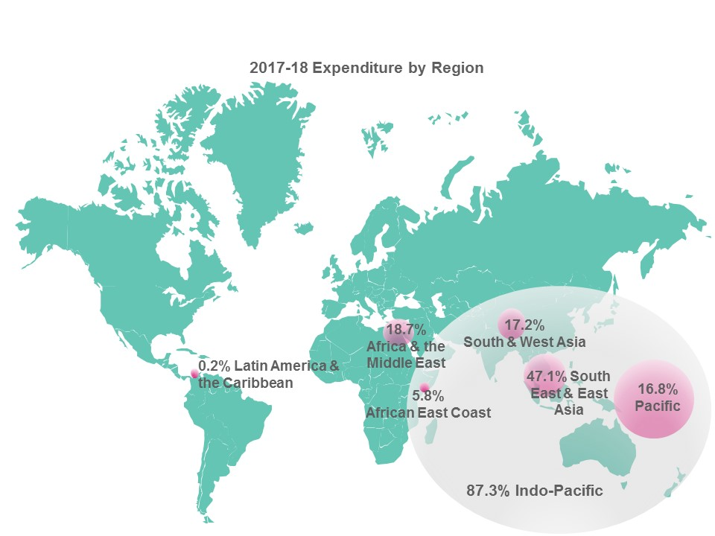

ANCP was allocated **$129.5 million in 2017-18** – an increase of $2.2 million from 2016-17. Of the total budget allocation, $128.8 million was disbursed as grant funds and half of one percent ($700,000) was used for program support costs including public diplomacy, monitoring, evaluation and learning activities. ANCP NGOs are required to contribute one dollar of their own funds for every five dollars provided by DFAT. ANCP NGOs exceeded this minimum contribution by 8 per cent, **contributing $32.4 million** to ANCP projects. In addition, 106 projects (24 per cent) attracted funding from other sources to the value of $27.9 million.

### Key development results[1]

* 11.7 million people benefitted from integrated community approaches to health and wellbeing (49.7 per cent women and girls, 0.5 per cent people with disabilities)
* 10.5 million people received increased access to essential medicines and health commodities including HIV treatment (49.5 per cent women and girls, 0.1 per cent people with disabilities)
* 2.9 million people increased hygiene practices (51 per cent women and girls and 0.2 per cent people with disabilities)
* 521,784 adults and children participated in preventative and awareness raising activities related to child protection (53.5 per cent women and girls and 1.2 per cent people with disabilities)
* 300,778 people were exposed to awareness raising campaigns/activities highlighting climate change and environmental issues (51.8 per cent women and girls and 1.3 per cent people with disabilities)
* 15,536 births were attended by a skilled birth attendant

2017-18 also saw major program achievements in the review and updating of accreditation criteria; the completion of recommendations from the Office of Development Effectiveness Evaluation; and stronger program monitoring with over 30 per cent of ANCP NGOs visited in the field.

Outcome 1: EFFECTIVE AND VALUE FOR MONEY PROGRAMMING

There was consistent, positive progress towards intermediate outcomes under this objective as outlined in the Monitoring Evaluation and Learning Framework (MELF) including the ANCP contributions to DFAT performance benchmarks, evidence of shared learning, innovation and good development practice and efficient program management systems.

### Gender Equality

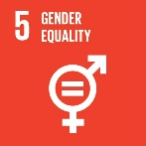66 per cent of ANCP projects addressed gender equality issues – short of the performance benchmark of 80 per cent. This included 55 projects (12 per cent) marking gender equality as the principal objective with expenditure of $15.5 million reaching 659,387 beneficiaries.

The reduction in the percentage of projects targeting gender equality (down from 87 per cent in 2015-16 and 69 per cent in 2016-17) is largely due to increased guidance and rigour of new minimum recommended criteria for the Organisation for Economic Cooperation and Development (OECD) Development Assistance Committee (DAC) gender equality policy marker.

Key results for gender in the 2017-18 period included[2]:

* 2,773 women’s groups, organisations and coalitions supported
* Over 83,000 women accessed training and other support services to enable them to participate in governance or other decision making processes at community and/or sub national level (2.8 per cent women with a disability)
* 95 women supported to stand for formal election at sub-national or national levels
* Over 725,000 people provided with awareness raising/training on gender issues and women's equal rights (54 per cent women and girls and 1.3 per cent people with a disability)
* Almost a million people exposed to awareness raising campaigns/activities in communities highlighting issues of violence against women including harmful cultural practices (51.6 per cent women and girls and 0.5 per cent people with a disability)

**Gender Action Platform**

The Gender Equality Fund provided $10 million as a one off competitive grant round available to ANCP NGOs to strengthen gender equality programming in the Indo-Pacific. The six projects are being implemented in nine countries for up to three years and began in July 2017. In its first year of implementation, the GAP projects reached over 40,000 beneficiaries, including:

* Over 14,000 people (61 per cent women) were made aware of gender issues and women’s equal rights
* Over 7,500 people (50 per cent women) were made aware of climate change and environment issues
* Over 6,000 people (83 per cent women) were made aware of issues of violence against women including harmful cultural practices
* 3,733 family planning services were provided
* 3,701 children (59% girls) increased knowledge of hygiene practices
* 1,068 women were supported to participate in governance or other decision-making processes at community and/or sub national level.

### Disability inclusive development

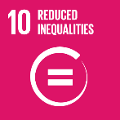In 2017-18, 42 per cent of ANCP projects addressed disability inclusion – a reduction from 2016-17 where 61 per cent addressed disability inclusion. The reduction in the percentage of projects targeting disability inclusion is largely attributable to increased guidance and rigour of new minimum recommended criteria for the OECD DAC disability inclusion policy marker. Disability inclusion was the principal focus in 49 projects (11 per cent) with a total expenditure of over $10.6 million reaching over 1.1 million beneficiaries.

Key results in 2017-18 included[3]:

* 53,750 people provided with disability services like prostheses and assistive devices (50.2 per cent women and girls)
* 779 local in-country partners that collect disability disaggregated data
* 11,229 children able to access schools that have been made more accessible to children with disabilities (48.3 per cent girls)
* 2,996 adults with disability who successfully obtain a livelihood as a result of skills training or capacity building (51.2 per cent women)
* 630 in-country Disabled Persons Organisations (DPOs) receiving capacity building
* 8,507 teachers trained in disability inclusion (52.4 per cent women and 3.9 per cent people with a disability)

### Private Sector Engagement

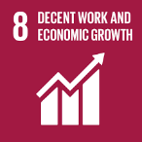In 2017-18, 44 per cent of projects involved engagement with the private sector consistent with 2016-17 far exceeding the performance benchmark of 20 per cent. In 2017-18, ANCP NGOs engaged with 2,996 representative organisations (peak bodies /chambers of commerce /other business groups) and 7,209 individual businesses (excluding managing contractors) in the design, delivery, management, or evaluation of projects.

### Sharing evidence of learning, innovation and good development practice

ANCP NGOs participated in a range of events and forums to share evidence of learning, innovation and good development practice in 2017-18 including the Annual Reflections workshop, webinars, information sessions, DFAT hosted NGO roundtables in-country, ACFID communities of practice and the ANCP learning forum.

The 2017 ANCP Learning Forum: *Partnering for Impact: NGOs and private sector working together to achieve sustainable development outcomes* was held in Canberra 28 November 2017. The forum was attended by 67 representatives from 23 ANCP NGOs as well as ACFID and a range of staff from DFAT including NVB and country and thematic areas. ANCP NGOs organised the event, in cooperation and engagement with DFAT.

**Learning**

2017-18 Annual Performance Reports included numerous examples of shared learning amongst ANCP NGOs – both one on one as well as through groups such as the Church Agencies Network (CAN), the International Sexual and Reproductive Health and Rights Consortium, the Research for Development Impact (RDI) Network, ACFID Communities of Practice as well as a range in of in-country and international networks, groups and forums.

The ANCP Community of Practice (CoP) was established in January 2018 and is open to all ANCP NGOs – there are currently 111 members. The CoP provides a forum to come together to share, discuss, reflect and play an active role in strengthening the Australian NGO sector and civil society organisations in partner countries, primarily meeting online.

In 2017-18 196 staff from ANCP NGOs participated in eight DFAT webinars – four of these webinars covered the annual program cycle (including accreditation) and the other four concerned Child Protection, Disability Inclusion, Fraud and Communications. In addition to live participants, these webinars were viewed 308 times on YouTube[4].

In addition to the webinars, in March and August 2018 DFAT conducted face-to-face ANCP Information sessions in Melbourne, Sydney and Canberra attended by 112 NGO staff members. These information sessions covered program updates, policy developments, Annual Development Plan and Performance Report submission guidance. In August 2018, the fourth annual ANCP Reflections Workshop was held with sessions in both Sydney and Melbourne. The workshops were attended by DFAT, ANCP NGOs and ACFID. There was good attendance and excellent participation by the ANCP NGOs in both Sydney and Melbourne. The purpose of the workshops was to reflect on the highlights of 2017-18; discuss and share approaches to key quality programing issues; provide an opportunity to share feedback on ANCP and discuss emerging issues.

### Efficient program management systems

Accreditation

Twelve accreditation reviews were completed in 2017-18. DFAT provided two NGOs with technical assistance to help prepare for accreditation – one of these was a new applicant seeking to apply and the other was a current base NGO considering an upgrade in 2017-18. Feedback on the process from NGOs who underwent accreditation in 2017-18 was largely positive regardless of the accreditation outcome.

|  |  |
| --- | --- |
| **Accreditation type** | **Result** |
| 9 scheduled reaccreditations | Eight full and one base – one applicant for full was downgraded to base |
| 2 unscheduled applications to upgrade from base to full | One NGO successfully upgraded to full and one withdrew after desk assessment (remains at base) |
| 1 new applicant for base accreditation | Unsuccessful |

The 2017-18 window for accreditation applications was 1 August to 31 October. This timing was earlier than in previous years, allowing more time for successful NGOs to compile their ADPlans and associated program management.

OUTCOME 2: A DIVERSITY OF NGOS DRAW ON FUNDING AND EXPERTISE FROM A RANGE OF SOURCES

### Leveraged funding

The flexible nature of the ANCP makes it ideal for leveraging additional funds from other sources (including international networks, donors and the private sector). In 2017-18, 106 projects (24 per cent) received funding from other sources to the value of $27.9 million (a reduction from 2016-17 when 74 per cent of projects received finding from other sources to the value of $31.9 million).

### Ways of Working

In 2017-18 Performance reports, many NGOs reported on the value of the ANCP in supporting long-term engagement with in-country partners (through predictable funding via the ANCP funding model), ability to direct funds in a flexible manner towards complex, innovative projects as well as pilots to test new approaches that are less easy to raise funds for from the Australian public and other sources.

The ANCP funding model provides reliable multi-year funding projections enabling ANCP NGOs and their partners to plan strategically for sustainability of outcomes. The specific allocation of Design, Monitoring and Evaluation (DME) funding enables ANCP NGOs to implement robust monitoring and evaluation frameworks which can be difficult to achieve through private funds or other grants.

NGOs commented on the value of ANCP accreditation in supporting best practice approaches by Australian NGOs and providing networks and forums for exchange in approaches/ lessons both in Australia and in-country. Many noted ANCP accreditation is vital for their public standing and ability to fundraise from the Australian public. Annual Performance report feedback from ANCP NGOs on their relationship with DFAT was overwhelmingly positive.

**Collaboration**

Promotion of Women’s Empowerment and Rights Targeting Rural Women (POWER) is a collaboration between Australian Lutheran World Service, International Nepal Fellowship Australia, Caritas Australia and Adventist Development and Relief Agency (ADRA) Australia and in-country partners in Nepal to advance the position of women in western Nepal. Since October 2016, they have been sharing good practice in gender equality through meetings, joint visits and resource sharing. A follow-up workshop took place in April 2018 to reflect and plan based on data gathered from various gender context analyses. Each agency identified priorities and follow-up actions for their own existing development projects and for new joint action through the POWER Project.

OUTCOME 3: EFFECTIVE ENGAGEMENT WITH IN-COUNTRY PARTNERS

In 2017-18, projects from 30 ANCP NGOs were visited (52 per cent of the 57 NGOs in the ANCP). 15 NGO roundtables were held at 14 embassies and high commissions in conjunction with the monitoring and evaluation project visits.

ANCP NGOs worked with 1820 partners to implement projects in 2017-18. NGOs worked with a broad range of implementing partners with Government (local, provincial and national) making up 33 per cent of implementing partners.

In 2017-18, NPQ finalised the ANCP Roles and Responsibilities policy following feedback from 13 Posts and country programs. Good progress was made implementing the ANCP Communications Strategy (developed in 2016-17). A survey of ANCP stakeholders – both internal (DFAT staff from Posts, Country Programs and Thematic Areas) as well as external (ANCP’s 57 NGO partners) indicates much progress has been made to strengthen the relationship between ANCP NGOs and country/thematic area in DFAT.

**Public Diplomacy**

Feedback from Posts was overwhelmingly positive highlighting the value of the ANCP as critical in achieving Post’s broader economic and commercial diplomacy and foreign policy objectives in the region by actively demonstrating that Australia is a supportive partner on a wide range of shared interests.

Program Management and Operations

In 2017-18, a review of ANCP accreditation criteria was completed following extensive consultation with the sector. It examined the ANCP accreditation criteria and processes to ensure that they met DFAT’s current and anticipated risk parameters and the requirements included in DFAT’s Due Diligence Framework. The revised accreditation criteria was released in May 2018. NPQ supported applicants by delivering an ANCP accreditation webinar in July 2018 which outlined the main improvements and changes to the criteria.

2017-18 saw finalisation of the recommendations from the Office of Development Effectiveness Evaluation of ANCP with the completion of a [data systems validation review](https://dfat.gov.au/about-us/publications/Pages/aus-ngo-cooperation-program-ancp-data-systems-validation-review.aspx).[5] The review found that overall there is relatively robust level of rigour in the output data provided by accredited Australian NGOs (ANGOs) to DFAT through the online portal, ANCP Online. The Review’s recommendations will be implemented through a re-convened Monitoring Evaluation and Learning (MEL) Reference Group.

management actions

Progress in implementing the management responses from the previous reporting period was good with two achieved and one partly achieved – see table below.

|  |  |  |
| --- | --- | --- |
| **Management actions identified in 2016-17 APPR** | **Rating** | **Progress made in 2017-18** |
| Strengthen the ANCP MELF | Partly achieved | The data validation exercise was completed in 2017-18. Work on a Monitoring Evaluation and Learning Framework (and program logic) refresh will be progressed through the re-convened MEL reference group in 2018-19. This will include consideration of how the program will respond to the SDG agenda and indicators as ANCP Performance Assessment Framework and performance benchmarks. |
| Clarify the role of Posts and increase ANCP’s visibility within DFAT | Achieved | ANCP Roles and Responsibilities policy finalised in addition to guidance and tools (available on ANCP SharePoint page) to support Posts and Country Programs to understand the ANCP, conduct monitoring and engagement activities, and provide feedback on ANCP Annual Development Plans. |
| Improve communication and the sharing of lessons between ANCP NGOs, local NGOs and DFAT | Achieved | Good progress was made implementing the ANCP Communications Strategy (developed in 2016-17). An ANCP Community of Practice established and active. Good participation at the Annual Reflections workshop and annual learning event. This becomes an ongoing implementation. |

### Next Steps

* 1. Engage with ANCP NGOs in the development of a new Policy on the Prevention of Sexual Exploitation and Abuse;
  2. Engage with ANCP NGOs and DFAT staff from safeguards and Country Programs on programming in high risk locations;
  3. Work with ANCP NGOs to implement the recommendation of the Data Systems Validation Review Report as detailed in the Management Response;
  4. Develop a Strategic Communications Strategy for the Program; and
  5. Develop a plan for strengthening gender equality in the ANCP

1. Results drawn from the 2017-18 Performance Reports from ANCP NGOs against the ANCP Monitoring, Evaluation and Learning Framework (MELF) indicators
2. Results drawn from the 2017-18 Performance Reports from ANCP NGOs against the ANCP Monitoring, Evaluation and Learning Framework (MELF) indicators
3. I Ibid
4. As at December 2018. The most viewed webinars on YouTube were Child Protection and Communications with 130 views each.
5. Australian NGO Cooperation Program (ANCP) Data Systems Validation Review available online at <https://dfat.gov.au/about-us/publications/Pages/aus-ngo-cooperation-program-ancp-data-systems-validation-review.aspx>