**TECHNICAL FILE ‘GRAPPA DEL TRENTINO’/‘GRAPPA TRENTINA’ GEOGRAPHICAL INDICATION**

1. **Name of the spirit drink including the geographical indication:**

‘Grappa del Trentino’/‘Grappa trentina’

1. **Category of the spirit drink including the geographical indication:**

Grape marc spirit.

The name ‘Grappa del Trentino’/‘Grappa trentina’ is exclusively reserved for grape marc spirit made from raw materials in excellent condition obtained from grapes produced and processed in the territory of the Autonomous Province of Trento, distilled and bottled in facilities located in Trentino.

1. **Description of the spirit drink:**
2. Physical, chemical and/or organoleptic characteristics of the category

* it is produced exclusively from grape marc fermented and distilled either directly by water vapour or after water has been added;
* a quantity of lees may be added to the grape marc that does not exceed 25 kg of lees per 100 kg of grape marc used;
* the quantity of alcohol derived from the lees must not exceed 35% of the total quantity of alcohol in the finished product;
* the distillation must be carried out with the grape marc itself at less than 86 % vol.;
* redistillation at the same alcoholic strength is authorised;
* it contains a quantity of volatile substances equal to or exceeding 140 grams per hectolitre of 100% vol. alcohol and has a maximum methanol content of 1000 grams per hectolitre of 100% vol. alcohol;
* it must contain no added ethyl alcohol, diluted or undiluted;
* it contains no flavourings; this does not affect the traditional production methods set out in (d) below;
* ‘Grappa del Trentino’/‘Grappa trentina’ matured for at least twelve months may contain caramel only as colouring, in accordance with applicable EU and national legislation;
* ‘Grappa del Trentino‘/‘Grappa trentina’ is either colourless or with other tones deriving from ageing or aromatisation with plants or parts thereof. It has a complex, light or aromatic scent, depending on the type of grape marc used to obtain it. It has no obvious defects due to poor storage of the raw material or incorrect distillation. Its main characteristic is the clean and fresh nature of its main aromas, combined with its delicate taste which is more or less pronounced depending on the original marc;
* to ensure that the marc is fresh, ‘Grappa del Trentino’/‘Grappa trentina’ must be distilled before 31 December of the year in which the marc is produced, except for marc and lees from the processing of wines from raisined or overripe grapes and ‘late harvest’ wines; here the deadline is extended to 30 April of the year following the year of production.

1. Specific characteristics of the spirit drink as compared to the relevant category

* alcoholic strength of not less than 40% and not more than 60% vol.;
* quantity of 2-butan-1-ol not exceeding 100 grams per hectolitre of 100% vol. alcohol;
* quantity of volatile acids (expressed as acetic acid) not exceeding 50 grams per hectolitre of alcohol for non-matured grappas and 100 grams per hectolitre for matured, extra-matured and reserve grappas;
* quantity of copper not exceeding 5 milligrams per litre;

‘Grappa del Trentino’/‘Grappa trentina’ is currently monitored by the Association, aided by the Istituto Agrario di San Michele all’Adige (now known as the Fondazione Mach) and by the Camera di Commercio di Trento. This work of monitoring and studying the product has been reflected in numerous scientific publications and in working methods which are consolidated and devoted solely to quality production. The small scale of production, the strong competition, the presence of the research institute, together with the commitment of the producers, are elements which have resulted in a particular quality image which is recognised today in ‘Grappa del Trentino’/‘Grappa trentina’.

1. Geographical area concerned

The entire territory of the Autonomous Province of Trento.

1. Method for obtaining the spirit drink

‘Grappa del Trentino’/‘Grappa trentina’ is produced exclusively from grape marc fermented and distilled either directly by water vapour or after water has been added; a quantity of lees may be added to the grape marc that does not exceed 25 kg of lees per 100 kg of grape marc used.

Redistillation is authorised for the production of ‘Grappa Trentina’.

‘Grappa del Trentino’/‘Grappa trentina’ is produced by distillation of fermented marc in discontinuous or continuous stills. Distillation may take place in discontinuous bain-marie stills with the addition of water to the still; the use of direct water-vapour distillation or other types of still is permitted. For production of the grappa, the use of natural liquid wine lees is allowed in the maximum amount of 25 kg per 100 kg of grape marc used. The quantity of alcohol derived from the lees must not exceed 35% of the total quantity of alcohol in the finished product. The natural liquid lees can be used either by adding the lees to the grape marc before distillation, or by parallel alcohol removal from the grape marc and the lees and by distillation of the mixture of the two low wines (flemme) or by the separate removal of alcohol from the grape marc and the low wines and subsequent direct distillation of the mixture of the low wines. These operations must be carried out at the same producing distillery.

The distillation of the fermented or semifermented grape marc, in a continuous or discontinuous still, must take place at less than 86% vol. The product obtained may be redistilled within this limit value. Compliance with the established limit values must be recorded in registers with entries of the quantities of the grape marc, of the natural liquid lees sent to distillation, and of the low wines, if the latter are sent to distillation after being produced.

While ‘Grappa del Trentino’/‘Grappa trentina’ is not flavoured, this does not rule out traditional production methods such as the use of aromatic plants or parts of plants, or fruits, to impart a particular aroma, flavour and colour to the product in which these are infused. The long tradition of using plants and parts thereof (e.g. roots, leaves or flowers) has its roots in folk medicine, as the botanical species involved often have curative and soothing properties, and can therefore have benefits when used in moderation in grappas. The main plants used in Trentino to flavour ‘Grappa del Trentino’/‘Grappa trentina’ are:

* woodruff,
* herb of grace/rue,
* gentian,
* juniper,
* mountain pine,
* nettle,
* camomile,
* rosemary,
* and other species of plants or parts thereof.

Plant(s) or parts thereof used in the production of flavoured ‘Grappa del Trentino’/‘Grappa trentina’ must be clearly indicated in the sales denomination.

In making ‘Grappa del Trentino’/‘Grappa trentina’, the following additives are allowed:

* sugars, in a maximum amount of 18 grams per litre, expressed as invert sugar in accordance with the definitions laid down in point 3(a), (b) and (c) of Annex I to Regulation EC No 110/2008;
* caramel, only when the spirit drink is aged for at least 12 months, in accordance with applicable EU and national legislation.

‘Grappa del Trentino’/‘Grappa trentina’ may be matured in casks, barrels and other wooden containers. In presentation and promotion the words ‘vecchia’ (old) or ‘invecchiata’ (matured) may be used for ‘Grappa del Trentino’/‘Grappa trentina’ matured in unpainted and uncoated wooden containers for not less than 12 months as monitored by tax authorities, in facilities located in Trentino. The normal wood preservative treatments are allowed. The words ‘riserva’ (reserve) or ‘stravecchia’ (extra matured) may be used for ‘Grappa del Trentino’/‘Grappa trentina’ matured in wooden containers for at least 18 months. The maturation period may be stated in years and months or solely in months.

1. Details bearing out the link with the geographical environment or the geographical origin

As shown by many historical documents preserved in the Museum of Trentino Popular Customs in San Michele all’Adige and in other Trentino museums, ‘Grappa del Trentino’/‘Grappa trentina’ has been traditionally produced by direct distillation of the grape marc and is closely linked to its area of origin. The discontinuous distillation method used was developed by local distiller Tullio Zadra, master in the construction of distillation stills, who in the 1950s and 1960s perfected the ‘discontinuous bain-marie method’ that still bears his name. The production of ‘Grappa del Trentino’/‘Grappa trentina’ is consistent with the Province’s winegrowing vocation and with the wide variations in environmental conditions and varieties grown. The activity of distilling products of winemaking is well established as far as the production of single-variety grappas (from aromatic varieties or varieties local to Trentino) is concerned. The cooperatives from which the fresh and fermented grape marc is obtained are situated close to the distilleries; as a result, the marc can be processed quickly before it starts to deteriorate, thus allowing the organoleptic characteristics of the grapes to be preserved. This is crucial to the extraction of the aromas and compounds which determine the organoleptic characteristics of ‘Grappa Trentina’.

The origin of the raw materials must be stated in shipping documents and the distillers’ registers.

To respect and uphold the specificities and the territorial elements characterising the entire production chain, such as short storage of the raw material, the distillation method and in particular the dilution degree carried out with water of particular value from natural sources, it is essential to carry out all operations of production and bottling within the territory of the Province of Trento.

1. Requirements laid down by Community and/or national and/or regional provisions

Presidential Decree No 297 of 16 July 1997; Circulars of the Ministry of Industry, Commerce and Craft Nos 163 of 20 November 1998 and 166 of 12 March 2001.

1. Terms additional to the geographical indication and specific rules on labelling

Grappa del Trentino’/‘Grappa trentina’ must be labelled in accordance with Legislative Decree No 109 of 27 January 1992, as amended, and in compliance with the following principles:

The name ‘Grappa del Trentino’/‘Grappa trentina’ may be supplemented by reference to:

1. the name of a grape variety, where the grappa was produced by distilling raw materials coming to a level of 100 % of their weight from winemaking from this grape variety: a tolerance threshold of other grape varieties is admitted up to 15% by weight;
2. the names of not more than two grape varieties, if obtained from the distillation of raw materials entirely coming from winemaking from those grape varieties. The grape varieties must be stated on the label in decreasing order of weight. Grape varieties accounting for less than 15% of total weight may not be indicated on the label. The grape varieties must be printed on the label in the same font and with the same prominence;
3. the name of a DOC, DOCG or IGT wine if the raw materials come from grapes covered by the product specification employed in the production of such wine; in this case, it is forbidden to use the symbols and wordings (DOC, DOCG and IGT) (DOP, IGP) either as acronyms or in full;
4. the distillation method, continuous or discontinuous, and type of still.

For those grappas which meet more than one of the labelling requirements under points (a), (b) and (c) above, only one sales denomination must be used.

The logo shown below must appear on the bottles used for the GI ‘Grappa del Trentino’/‘Grappa trentina’ as well as the wording provided for in legislation in force:

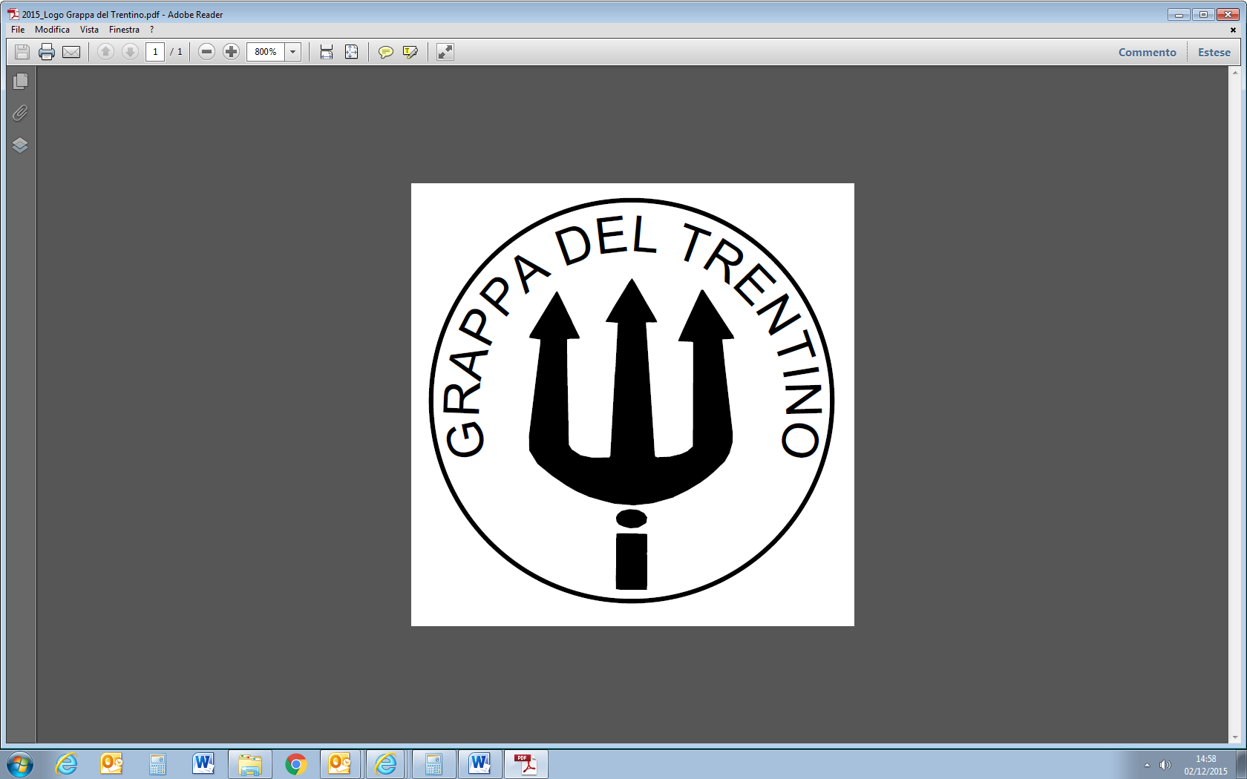

1. Name and address of applicant Istituto Tutela della Grappa del Trentino, via Suffragio 3, IT-38100 Trento (TN).