**ANNEX I**

**SUMMARY TECHNICAL SPECIFICATIONS**

**FOR REGISTRATION OF GEOGRAPHICAL INDICATIONS**

**NAME OF THE GEOGRAPHICAL INDICATION:**

TALEGGIO

**CATEGORY OF THE PRODUCT FOR WHICH THE NAME IS PROTECTED**

Class 1.3 Cheeses

**APPLICANT:**

Consorzio Tutela Taleggio

Via Roggia Vignola 9 - 24047 Treviglio (BG)

**PROTECTION IN EU MEMBER STATE OF ORIGIN**

- Decreto del Presedente della Repubblica del 15.09.1988;

- Regolamento (CE) n. 1107/96 della Commissione del 12 giugno 1996 relativo alla registrazione delle indicazioni geografiche e delle denominazioni di origine nel quadro della procedura di cui all'articolo 17 del regolamento (CEE) n. 2081/92 del Consiglio

**DESCRIPTION OF THE AGRICULTURAL PRODUCT OR FOODSTUFF**

Soft raw table cheese made only with whole cow’s milk.

The physical characteristics of the TALEGGIO cheese are as follows:

1) wheel: parallelepiped quadrangular. With sides from 18 to 20 cm;

2) heel: straight 4 / 7 cm with flat surfaces and sides of 18 / 20 cm;

3) average weight: from 1.7 to 2.2 kg per wheel, more or less, for both characteristics in relation to the technical processing conditions. At any rate, the variation cannot exceed 10% ;

4) rind : thin, soft consistency, natural rose colour (l ≤ 77 a/b ≥ 0.2 at tristimulus colorimeter), with presence of typical microflora. No processing of the rind is allowed.

5) paste: cohesive structure; no holes with only a few extremely small ones irregularly distributed; basically compact consistency, softer right underneath the rind;

6) colour of the paste: from white to straw yellow;

7) taste: characteristic, slightly aromatic;

8) chemical characteristics: fat content per dry matter 48%; minimum dry extract 46% ; maximum water content 54%, furosine max 14mg/100g proteins.

## Raw materials (only for processed products)

Milk, salt, rennet, milk enzymes.

## Specific steps in production that must take place in the identified geographical area

The milk has to come from the place of origin. Pasteurized milk can be used. The processing phases can be summarized as follows:

preparation of natural starter;

milk clotting;

breaking of the curd;

putting in the moulds;

stewing;

turning the cheese inside the moulds;

salting;

turning inside the moulds;

aging.

## Specific rules concerning slicing, grating, packaging, etc.

(Packaging in the place of origin)

Packaging is the handling of the product that determines its physical characteristics. Given that the identifying mark is impressed exclusively on the flat surface of the product, please note that Taleggio, once packed, could be easily confused with a similar product, thus preventing its proper identification. Should this processing take place outside the place of origin, it would be difficult to guarantee for certain the traceability of the product. Hence, the consequent and subsequent use of the wrappings to dress up the product are deemed to be legally done only if carried out in the place of origin.

**CONCISE DEFINITION OF THE GEOGRAPHICAL AREA**

Provinces of Milan, Pavia, Lecco, Como, Lodi, Novara, Bergamo, Brescia, Cremona and Treviso.

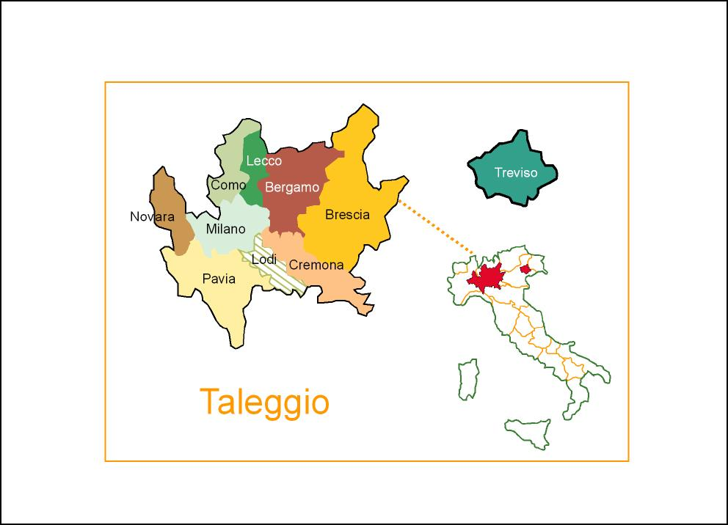

# Link with the geographical area

The elements that prove the link between product quality and geographical area of origin, in addition to the mentioned historical references (please refer to the Historical Report), are basically tied to the sensibility and dairy culture of the operators, to the special salting conditions adopted, as well as the aging technique, and the geographical conditions of the territory, meaning climate and predominant agriculture. The set of these elements or factors provide the product in question (Taleggio cheese) with those characteristics of uniqueness and irreproducibility that allow one to state that the product in question is one whose overall traits - which therefore comprise all the phases, starting from the raw material, to the processing, to the transformation through aging, cannot be repeated.

# Specific rules concerning labelling

As indicated in Art. 11 of the Internal Regulations, the consortium’s mark to be affixed to the outer packaging of the Taleggio cheese consists of the symbol (mark no. 392.837), as shown in the image provided here below:



**CONTROL AUTHORITY/CONTROL BODY**

Certiprodop Srl

Indirizzo:Via Giuseppe Di Vittorio n. 2 I-26013 Crema (CR) Tel.: +039/0373 259662 Fax: +039/0373 253530 e-mail: info@certiprodop.it