**Summary technical specifications**

**for registration of geographical indications**

**Name Of The Geographical Indication:**

Pecorino Romano

**Category Of The Product For Which The Name Is Protected**

Cheese produced with whole fresh sheep milk

**Applicant:**

Consorzio per la Tutela del Formaggio Pecorino Romano

Address : Corso Umberto 1226, 08015 Macomer (NU), ITALY Tel. +39 078570537 Fax +39 078572215 E-mail:

[mfo@pecorinoromano.com](mailto:mfo@pecorinoromano.com)

Further information about the Consortium and its activities may be collected surfing on its website reachable at the following link [www.pecorinoromano.com](http://www.pecorinoromano.com)

**Protection In EU / Member State of Origin:**

"PECORINO ROMANO", protected since 1951, as cheese listed in the Annex A of the Stresa Internation Convention, has been successively recognized as Protected Designation of Origin in the EU in 1955, as set forth by D.P.R. No. 1269 of 30 October 1955.

Protected in EU according to Commission Regulation (EC) n. 1107/96 of 12 June 1996 on the registration of geographical indications and designations of origin under the procedure laid down in Article 17 of Council Regulation (EEC) No 2081/92.

**Description Of The Agricultural Product Or Foodstuff**

‘Pecorino Romano’ PDO is a hard, cooked cheese produced exclusively from fresh full-fat sheep’s milk obtained from sheep bred in the geographical area Sardinia, Lazio and the area of Grosseto in Tuscany. When it is marketed for human consumption it is cylindrical in shape with flat sides and the diameter of its flat sides is between 25 and 35 cm. Its weight varies from 20 to 35 kg, according to the size of the cheese wheel. The crust is fine, and ivory or natural straw in colour, and is sometimes covered with special protective covers. The rind has a compact or slightly open structure; when cut it is of a colour varying between white and a more or less intense straw colour. The taste is aromatic and slightly spicy for the table cheese, and spicy, intense and pleasant at the advanced stage of maturing for the grating cheese. ‘Pecorino Romano’ has a characteristic aroma. Fat content of the dry matter: not less than 36 %.

**Concise Definition Of The Geographical Area :**

The areas of production as set forth by the Technical of Production of the PDO "PECORINO ROMANO" are in Sardinia, Lazio and the area of Grosseto in Tuscany, (see enclosure II - map of the areas of production -).

**Link With The Geographical Area:**

The pastoral activities and the dairy traditions of the geographical areas of the production of Pecorino Romano were known beyond the borders of the Mediterranean area since the Roman age. It is quite relevant the evidence provided by historians like Marco Terenzio Varrone and Columella in his "De re rustica", where he dedicated an entire paragraph, "Casei facendi ratio", to the technical of making and salting cheese, which closely resembles to the one still used in the production of Pecorino Romano, today. He also observed that, in this way, it is possible to produce a cheese which keeps a good freshness, stating "Hoc genus casei potest etiam maria permiti". This information related to the exportation of this particular cheese suggests that Pecormo Romano was a well-known cheese and its market was overspread, in the past.

The geographical areas of production are characterized by homogenous factors, such as:

Sheep farm and business management

The sheep farm is characterized by the presence of a breed native population, the Sarda race, which is bred without cross and widespread in all the territory and representing 95% of the all ovine patrimony of the area of production. The breeding farms have an extensive character in 96% of the farms, where the herds are bred in the wild and semi-wild, often transhumant, nourished with natural pasture. The natural pasture contributes for 80% to the annual allowance per animal bred. The remaining 20 % is represented by grassland which grows in autumn and winter and are mowed and used as provisions (hay), in late Springtime. The lactation period has a season trend and it is affected by the climate, the breed structures, and the availability of pastures, varying from 160 to 220 days/year.

The peculiar climatic, environmental and food conditions, as well as the genetic peculiarities of the native breed, allowed to the Sarda sheep to spread into the area of production. Over the centuries, the Sarda sheep has only undergone a natural selection getting perfectly integrated into the environment and qualifying the areas of production all over the times, as an exclusive element of characterization. The assertion of the French geographer Maurice Le Laimou is quite significant : "the sea allowed the Sarda sheep to expand in areas that are similar to the Island's climate and to the amenities of the place". (Maurice Le Lannou, Patres et Paysans de la Sardaigne, 1941).

The process of production:

The process of production of Pecorino Romano has kept unchanged the traditional characteristics both in the transformation process and in the use of characterizing and technological adjuvants such as the enzyme rennet originated from the stomach of lambs (abomasum) that are only bred in the area of production of the cheese and the use of native natural bacterial culture. The process of salting the cheese is still made according to an old and complex home­made technique that characterizes the product.

The economic aspect:

40% of the domestic sheep resources is in the area of production of Pecorino Romano where 55% of domestic production of sheep milk, is made:

The production is usually set in peripheral areas where breeding farms and the transformation process often represent the only economic activity.

Pecorino Romano is a famous cheese thanks to exportations to the North and South America due to a large number of compatriots, starting from the end of the 19th century (the first trades date back to 1884).

Even today, it is still the sheep cheese produced in the EU among the most exported all over the world.

**Specific Rules Concerning Labelling (If Any):**

According to the technical police of production of the PDO "PECORINO ROMANO", on the wheel of Pecorino must appear one of the logos here below reproduced :

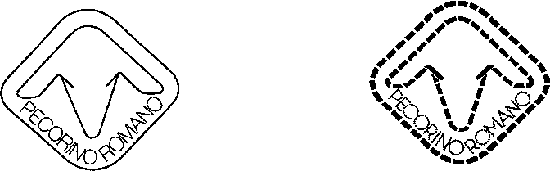

**Control authority/control body :**

INEQ _ Istituto Nord Est Qualita'

Address: Via Rodeano, №71 33038 San Daniele del Friuli (UD) tel: +39 0432 940349 /fax : +39 0432 943357 e-mail : info@.ineo.it

Enclosures of Annex I

Enclosure I

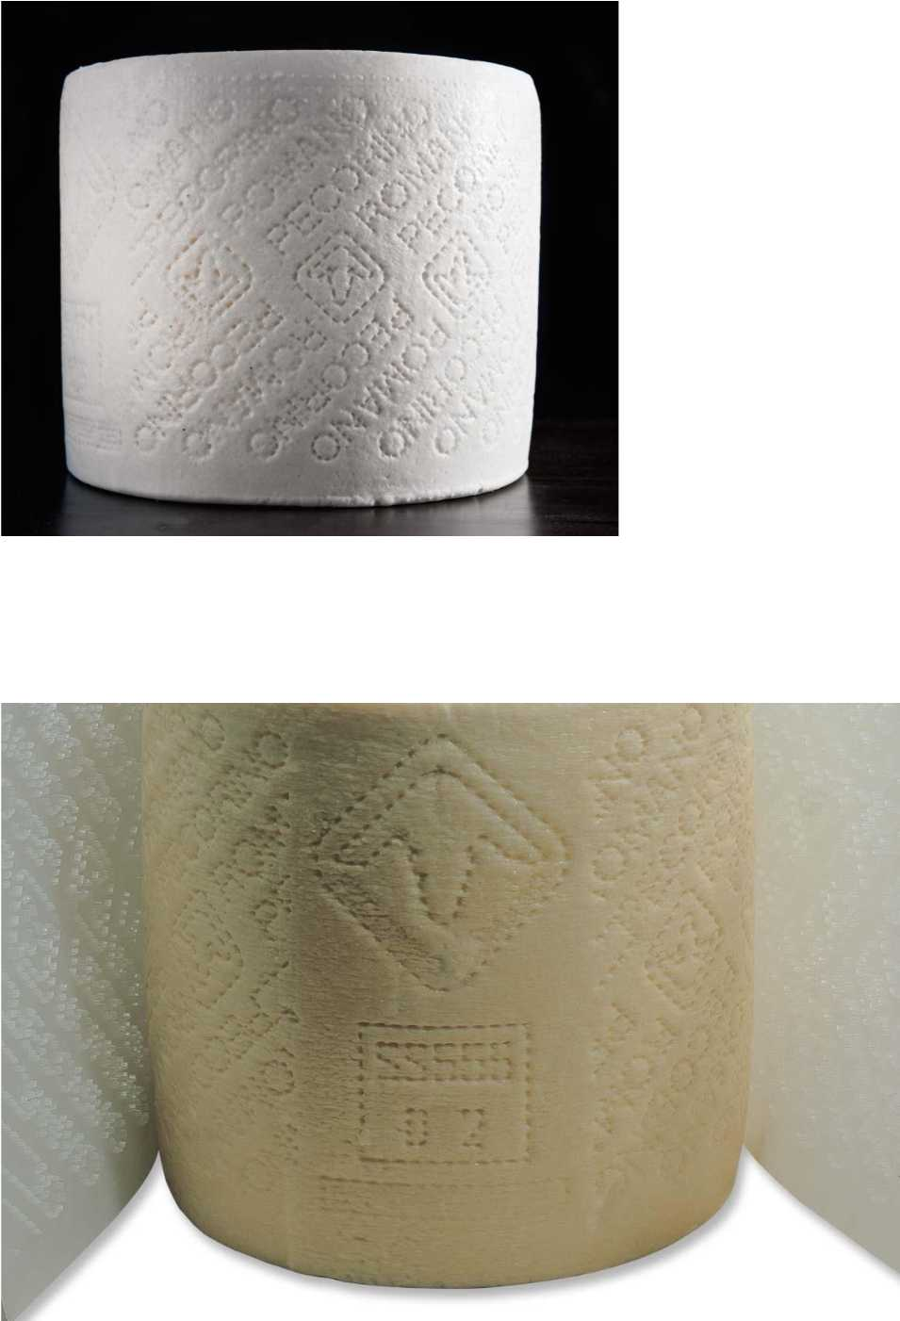

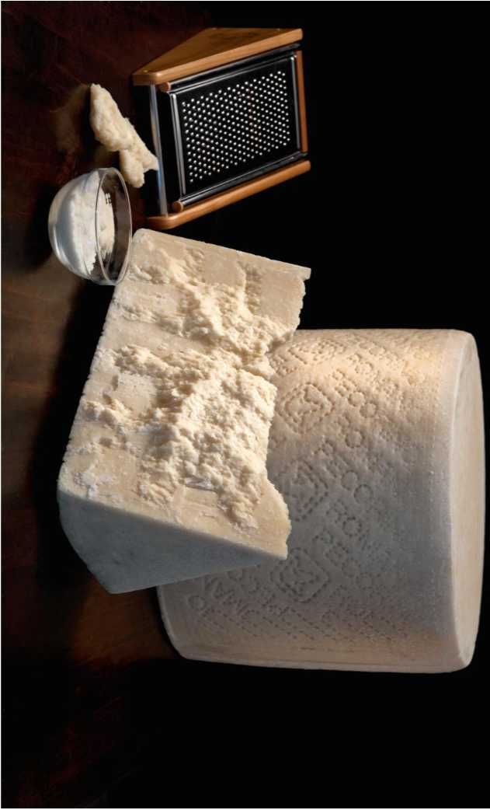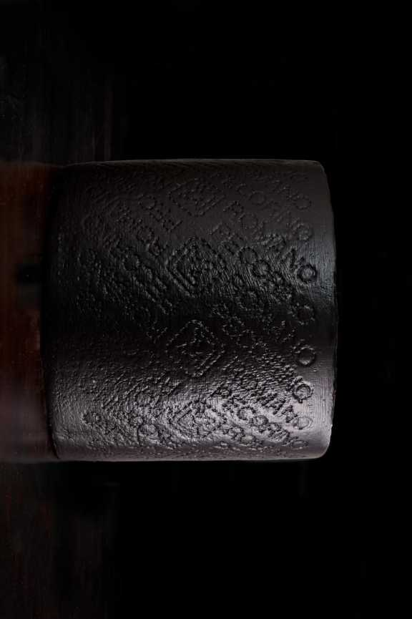

* **Enclosure II**

