

V
IMC HEADQUARTERS CONTACT:
RABIH TORBAY
VP International Operations
1313 L Street NW, Suite 220
Washington, DC 20005
Tel: +1 202 828 5155
Fax: +1 202 828 5156 rtorbay@imcworldwide.org

IMC IRAQ FIELD CONTACT:
GERALD EVANS, Ph.D.
Country Director
Al-Karada Kharej, Hay Al-Wahda
Mahalla 904—Zukak 9, Dar 5
Baghdad, Iraq
Tel: +0790 191 2164 gevans@imcworldwide.org

Picture Caption
EMCD-III Quarterly Report
April-June 2011

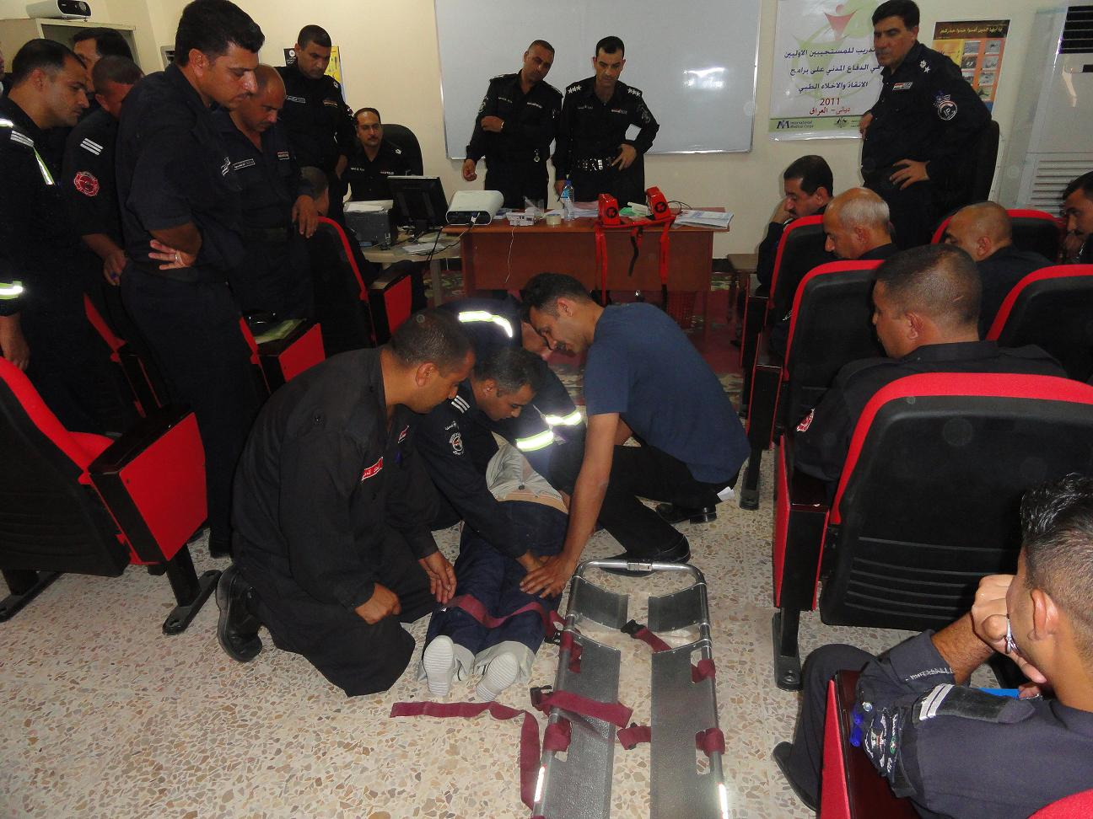

Training of Ministry of Interior Civil Defense first responders

[
Contents

Goals and Objectives 3
Progress on Outputs 8

GOALS and OBJECTIVES
1.Improve public education with regards to emergency medical care.
1.1Implement community outreach programs that focus on injury prevention and safety promotion, including first aid community responders training.
2.Further strengthen the Iraqi pre-hospital system.
2.1Expand the current IMC/AusAID EMCD pre-hospital training program to additional governorates.
2.2Expand the current emergency medical training of the Ministries of Interior and Defense.
2.3Improve the emergency response to Multiple Casualty Incidents (MCIs).
3. Further improve hospital-based emergency medical care.
3.1Improve the education of Iraqi physicians currently providing emergency medical care countrywide.
3.2 Improve the training of Iraqi emergency department nursing personnel.

Goals and Objectives

The Iraq Emergency Medical Care Development III (EMCD III) Program is the third consecutive program that supports the strengthening of emergency response and care provision in Iraq funded by AusAID and implemented by IMC. This program builds off the strong foundation established through the EMCD I and II programs that focused on improving the pre-hospital and in-hospital systems in Baghdad, Ninewa, Anbar, and Thi-Qar. EMCD III extends training and systems strengthening programs across the remaining governorates in Iraq and expands the program to include support for first responders, ancillary support staff, and multi-casualty incident management.

Goal 1: Improve public education with regards to emergency medical care.
Objective 1: Implement community outreach programs that focus on injury prevention and safety promotion, including first aid community responders training
The Community Outreach program to promote general health education, safety promotion and injury prevention is underway. IMC designed and printed posters on different topics in health and safety promotion, as well as injury prevention. In addition, IMC developed and printed a community first aid provider manual for distribution to high school teachers and students who will participate in the class. To date, 15,000 first aid manuals and 5,000 posters have been printed.
The community first aid provider course targets high school students and selected high school teachers in each governorate. The training focuses on the principles of first aid, common injuries, and practical skills in first aid. With the cooperation of the Directorates of Education in each governorate, high school biology and chemistry teachers from have been nominated to take part in these trainings.
Two additional Training-of-Trainers (ToT) courses for teachers were held, one each in Missan and Salah Eldeen during this reporting period, with an additional 46 high school teachers trained as ToTs, prior to the first high school student trainings which followed. Each teacher subsequently taught a 3-day training course to their respective science classes at their schools thus delivering the injury prevention, safety promotion and first aid training to approximately 1,380 students, at an average ratio of 30 students per teacher (detailed in the table below). In the next reporting period, we expect to near completion of these community trainings with roll-out to the final governorates.

Community first aid ToT training courses, April–June 2011
Site | Completion Date | Male | Female | Total
Missan | 23.04.11 | 16 | 9 | 25
Salah Al-Din | 10.04.11 | 16 | 5 | 21
Total |  | 32 | 14 | 46

Goal 2: Further strengthen the Iraqi pre-hospital system.
Objective 2.1: Expand the current IMC/AusAID EMCD pre-hospital training program to additional governorates
The expansion of the pre-hospital training program under EMCD-III continues to train EMTs through new training centers in all of the 11 remaining governorates.
Regional training centers have now been established in all of the governorates. Each training center is equipped with computers, manikins and reference books and is ready to deliver trainings. Under the last quarter, EMCD-III has expanded pre-hospital trainings to conduct them in all 11 governorates (see Table). In total, 877 EMTs were trained in this period (for a total of 970 EMTs under EMCD-III), successfully surpassing the expected output of trained EMTs under EMCD-III (goal = 700). The table below outlines the EMT training conducted in the current reporting period.

Pre-hospital (EMT) training courses, May–June 2011
Governorate | Completion Date | Male | Female | Total
Wasit | 07.04.11 | 29 | 0 | 29
 | 08.05.11 | 29 | 1 | 30
 | 06.06.11 | 29 | 1 | 30
Diyala | 21.04.11 | 28 | 0 | 28
 | 22.05.11 | 27 | 2 | 29
 | 23.06.11 | 27 | 3 | 30
Diwaniyah | 03.04.11 | 33 | 2 | 35
 | 28.04.11 | 35 | 1 | 36
 | 16.06.11 | 33 | 3 | 36
Basrah | 21.04.11 | 30 | 2 | 32
Babel | 03.04.11 | 28 | 0 | 28
 | 05.05.11 | 29 | 1 | 30
 | 02.06.11 | 23 | 7 | 30
 | 30.06.11 | 26 | 4 | 30
Karblaa | 14.04.11 | 30 | 0 | 30
 | 12.05.11 | 30 | 0 | 30
 | 09.06.11 | 30 | 0 | 30
Salah Al- Din | 19.05.11 | 29 | 0 | 29
 | 30.06.11 | 25 | 0 | 25
Missan | 07.04.11 | 26 | 4 | 30
 | 12.05.11 | 29 | 0 | 29
 | 09.06.11 | 30 | 0 | 30
Al-Muthana | 24.04.11 | 26 | 1 | 27
 | 02.06.11 | 28 | 4 | 32
 | 30.06.11 | 32 | 0 | 32
AlNajaf | 14.04.11 | 24 | 6 | 30
 | 15.05.11 | 24 | 6 | 30
 | 09.06.11 | 30 | 0 | 30
Kirkuk | 09.06.11 | 25 | 5 | 30
Total |  | 824 | 53 | 877

Objective 2.2: Expand the current emergency medical training of Ministries of the Interior and Defense
Based on assessment of the skills and prior training of MOI civil defense first responders and with the agreement of the MOI from meetings held in the last reporting period, IMC has developed a training curriculum that will be delivered to MOI trainers and first responders. A Master Trainer course has been structured to take maximum advantage of the skills of this group and establish a team of trainers that can cascade training to the typical first responder. It has been designed based on international standards of emergency medicine training adapted to the Iraqi context, and provides a systematic method to evaluate and treat patients in medical emergencies. Participants in trainings also receive training materials to reinforce their learning, including textbooks developed and translated into Arabic for this program.
In this quarter, an additional 116 first responders were trained in three additional governorates.
First responders training courses, April–June 2011
Governorate | Completion Date | Male | Female | Total
Wasit | 03.05.11 | 38 | 0 | 38
Basrah | 30.06.11 | 35 | 0 | 35
Missan | 28.04.11 | 43 | 0 | 43
Total |  | 116 | 0 | 116

Objective 2.3: Improve emergency response to Multiple Casualty Incidents (MCIs)
The present state of response to Multiple Casualty Incidents in Iraq is marked by a lack of coordination among responders, little or no collaborative effort between different responding agencies/teams, and sub-optimal medical outcomes for people affected by violence. To improve inter-agency coordination, EMCD-III includes a series of multiple-agency workshops to improve MCI response and coordination. Senior IMC medical consultants have developed curriculum for these workshops.
In this quarter, EMCD-III successfully held the first of these MCI workshops, bringing together personnel responsible for emergency coordination and MCI response from the Ministry of Health, Ministry of Defense, Ministry of Interior (including police and fire/”Civil Defense”).
This introductory workshop addressed the concepts of MCI, including Incident Command Systems (ICS) and Multiple Agency Coordination (MAC) groups. Participants openly discussed problems with current MCI response in Iraq, beginning to alleviate a history of distrust that has hampered cooperation and collaboration. For most of the members, all responsible for MCI response for their respective agencies, this was the first time they had met in person, with multiple people exchanging contact information.
This, very successful first MCI workshop, will be followed by monthly ongoing meetings in to continue to build multiple agency coordination in the following reporting periods.

Goal 3: Further improve hospital-based emergency medical care
Objective 3.1: Improve the education of Iraqi physicians currently providing emergency medical care countrywide
The physician training program continues to successfully train doctors who provide emergency care at the front lines in hospital emergency departments across the country. From April to June 2011, three new courses were completed and a total of 66 new physicians were trained. The table below details the dates and locations of training for the doctor courses that were administered. The expanded reach of the doctor training course has allowed for expansion of the regional/governorate level training centers to allow every governorate to be represented at these sessions, as well as for a second regional training center in Basrah to be established.
The course itself combines didactic and practical training modules tailored toward physician specialists working in the emergency department. Using a core curriculum adapted from ACLS and advance trauma training as the backbone, combined with practical skills like trauma ultrasound training, this course has equipped physician emergency medicine providers with important skills that are saving patient lives every day.

Physician training courses, April–June 2011
Site | Completion Date | Male | Female | Total
Baghdad | 21.04.11 | 23 | 4 | 27
 | 07.07.11 | 17 | 7 | 24
Basrah | 26.05.11 | 14 | 1 | 15
Total |  | 54 | 12 | 66

Objective 3.2: Improve the training of Iraqi emergency department nursing personnel
A training curriculum designed specifically for emergency department nurses was developed to improve its content and focus on skills training relevant to the emergency department setting. This is a three-week training course derived from the successful EMT training program, which emphasizes BLS skills and other procedural skills relevant to nurses working in the Emergency Department. The revised curriculum was finalized during this reporting period; new “IMC Nurse Course” textbooks have been printed and are being circulated to all course participants. IMC has delivered a total of 10 nurse courses to date: three in the first six months, and seven in this reporting period.
In addition, IMC is using a survey instrument to examine the effects of the nurse course delivery on nursing practice and behavior in the Emergency Department, with the intent of measuring the impact of the nursing course on ED practice. A component of the nursing course introduces the concept of standard emergency department triage using an adapted Arabic translation of the Manchester Triage System. The introduction of emergency department triage is a novel concept in Iraq and implementation of this new triage system will improve emergency department function by optimizing care delivery to patients based on acuity of illness.
In this reporting period, 119 nurses were trained in Baghdad, as detailed in the table below.

Nurse training courses, Jan–March 2011
Site | Completion Date | Male | Female | Total
Medical City, Baghdad | 03.04.11 | 27 | 4 | 31
 | 01.05.11 | 1 | 0 | 1
 | 02.05.11 | 23 | 6 | 29
 | 30.06.11 | 23 | 5 | 28
Al-Yarmouk, Baghdad | 08.05.11 | 23 | 7 | 30
 | Total | 97 | 22 | 119

Progress on Outputs
EMCD-III: Target outputs and progress to date
Output Indicators | Unit of Measure | Program expected output | Quarterly Progress | Cumulative Results
Goal 1: Improve public education in emergency medical care
Objective 1.1: Implement community outreach programs that focus on injury prevention and safety promotion, including first aid community responders training
Number of Community First Aid and Injury Prevention events held and people reached | Number | 4,000 people reached through 3 training events in each targeted governorate | 2 additional ToT courses for 46 additional high school teachers; 1,380 students reached | 4 ToT courses for 96 high school teachers; 2,880 students reached
15 PSAs produced | Number | 15 | N/A | Complete: 15 PSAs were produced as part of a comprehensive public health education campaign (PSAs developed and presented to the MOH for broadcast)
Print materials produced and distributed | Number | 78,000 brochures, 2800 posters to distribute in 14 governorates | N/A | Curriculum developed and 30 page Community First Aid and Injury Prevention Manual designed.  15,000 copies of the manuals were printed for distribution.  5000 posters on same First Aid and injury prevention topics were printed. 2000 posters distributed
Goal 2: Further enhance the capacity of the Iraqi pre-hospital system to deliver quality emergency medical services
Objective 2.1: Expand the current IMC/AusAID EMCDP pre-hospital training program to additional governorates
Governorate training centers established and equipped for emergency department physicians and EMT training | N/A | Governorate training centers established and operating | Training centers established and operating in all 11 governorates | Completed
700 EMTs trained | Number | 700 EMTs | 877 EMTs from all 11 governorates | Completed. 970 EMTs trained (plus 18 Master ToTs)
EMT Equipment Packages procured | Number | 800 equipment packages | 800 equipment packages distributed | Complete.
Objective 2.2: Expand the current emergency medical training of Ministries of the Interior and Defense
Central Training Center established in Baghdad (for first responders in advanced first aid) | N/A | Central Training Center established | Training Center Established | Complete.
Curriculum for first responder training program in advanced first aid (MOI/MOD) developed | N/A | Curriculum developed | Curriculum designed and implemented | Complete.
Number of First Responders trained | Number | 150 | 116 first responders/master trainers trained this reporting period | Completed. 361 MOI First Responders and Master trainers trained to date
Objective 2.3: Improve emergency response to Multiple Casual Incidents (MCIs).
Central Training Center established in Baghdad | N/A | Central Training Center established | To establish a physical training center facility, 4 large LCD screens were been purchased and installed at MOSS-MOH where trainings and workshops will be held | Completed.
Establish links with International Technical Experts | N/A | Links with International Technical Experts established | Primary contacts with technical experts established | Completed.
MCI Curriculum developed | N/A | MCI Curriculum developed | Completed | Completed.
3 MCI trainings held | Number | 3 | One MCI training/ workshop held | One MCI training/ workshop held
Develop policy with appropriate governmental stakeholders to further interagency cooperation | N/A | Policy developed | Initial meetings to initiate policy making | Working policy documents will be created during the process of the following MCI workshops
Policy Conference/Workshop held | N/A | Policy Conference/Workshop held | One MCI training/ workshop held | One MCI training/ workshop held
Goal 3: Further improve hospital-based emergency medical care
Objective 3.1: Improve the education of Iraqi physicians currently providing emergency medical care countrywide
Governorate Training Centers established | N/A | Governorate Training Centers established | Training centers have been established all governorates | Completed.
300 EM doctors trained | Number | 300 | 66 physicians trained in this reporting period. | A total of 290 physicians trained to date
Conferences/workshops held | N/A | Conferences/workshops held | NA | Three events have been held to date: two PALS workshops and one EM Conference on special topics and evidence-based EM.
Objective 3.2: Improve the training of Iraqi emergency department nursing personnel in Iraq
Curriculum developed for nurses | N/A | Curriculum developed | N/A | Complete: Curriculum developed and modified emphasizing BLS, and important procedural skills for nurses
100 nurses trained in Baghdad | Number | 100 | 119 nurses trained from Baghdad. | Completed. 301 nurses trained to date.  Manchester Triage System-adapted, Arabic version introduced.

