TECHNICAL FILE

FOR THE GEOGRAPHICAL INDICATION

'OUZO OF MITILENE'

(amended)

Date of receipt:

Number of pages (including this page): 10

Application submitted in: Greek
File reference: PGI-GR-O1838
Established geographical indication: 'Ούζο Μυτιλήνης' / 'Ouzo of Mitilene'
Category of spirit drink:
Distilled anise (as laid down in Annex III to Regulation (EC) No 110/2008 – product category 29).

Contents
Description of 'Ouzo of Mitilene' 3-4
Physical, chemical and/or organoleptic characteristics
3
Specific characteristics (compared with other spirit drinks in the same category) 3
Geographical area 4
Method of production of 'Ouzo of Mitilene' 4-5
Link with the geographical environment or origin 6-7
Link between reputation and geographical area 6
Natural factors 7
EU provisions or national/regional provisions 7-8
EU provisions 7
National provisions 8
The applicant 8
Annex 9-10

Description of 'Ouzo of Mitilene'

'Ouzo of Mitilene' is a compound geographical indication that includes the geographical indication 'Ouzo'. Therefore, it meets the basic requirements for Ouzo, as regards method of production and quality characteristics, while its reputation is linked with the geographical area defined by the words 'of Mitilene'.

Physical, chemical and/or organoleptic characteristics
'Ouzo of Mitilene' is a colourless, transparent liquid. As a rule it turns white (usually cloudy), when mixed with water and/or ice. This is because a reduction in temperature and ethyl alcohol concentration reduces the solubility of the aromatic compounds it contains.
Aroma and taste: the alcohol is flavoured by distillation and/or maceration with aniseed, mastic from the native Chios mastic tree (Pistacia Lentiscus Chia or Latifolia) and other aromatic seeds, plants and fruit.
The characteristics of each product depend on the type, quantity and proportion of aromatic substances used and on the production process. There are 'light' products with a smooth aroma and taste, and 'heavy' products for connoisseurs.

Specific characteristics (compared with other spirit drinks in the same category)
1. The main aromatic raw material used to flavour 'Ouzo of Mitilene' is aniseed grown on the island of Lesbos, especially in the Lisvori area. Other flavourings are also used, such as Chios mastic (as provided for in the relevant legislation), barley (Hordeum vulgare) and onion (Allium cepa).
The specific aromatic profile varies from one product to another, depending on the type of flavouring and the proportion used by the producer (together with the distillation conditions) but the anise flavour is always predominant.

2. The flavouring of ethyl alcohol by distillation takes place exclusively in traditional discontinuous copper stills with a capacity of up to 1 000 litres, and the distillate obtained has an alcoholic strength of at least 55 % νοl and not more than 80 % νοl.

3. The minimum alcoholic strength is 37.5 % vol.
4. Flavourings: only flavourings that have been extracted or distilled from the same aromatic seeds, plants or/and fruit as those used to flavour the ethyl alcohol by maceration or distillation are permitted.
5. If sweeteners are used, they are added in small amounts, so that the dry matter content of 'Ouzo of Mitilene' made available for consumption does not exceed 50 g per litre.

Geographical area
'Ouzo of Mitilene' is produced in Greece, more specifically on the island of Lesbos, but not in the municipal unit of Plomari.

Map of Lesbos

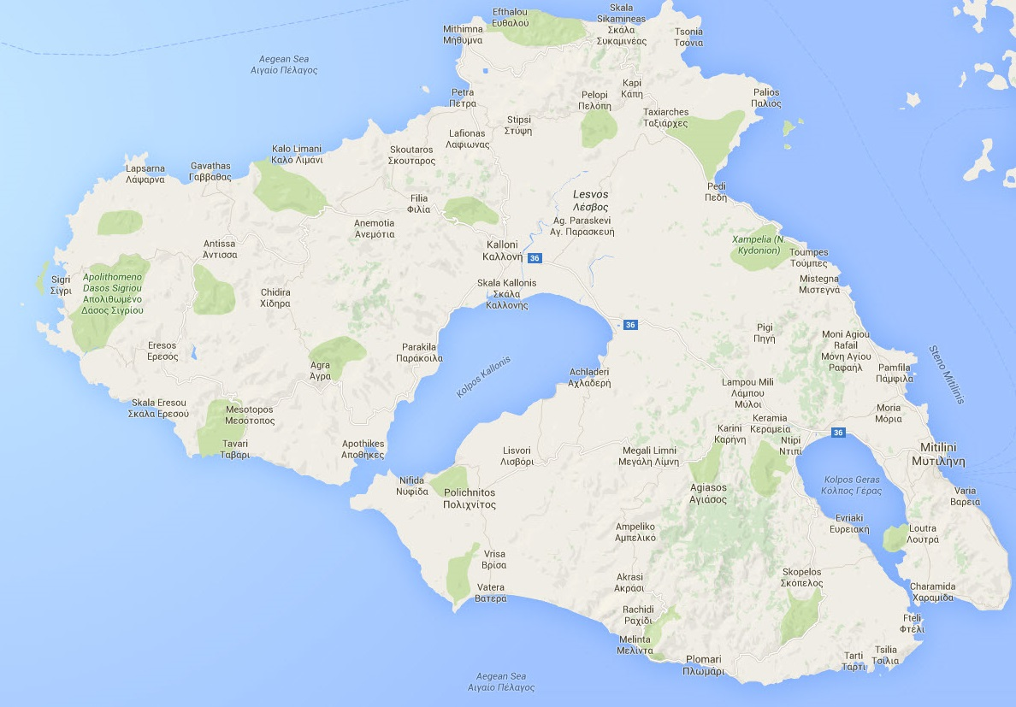
The steps in production that must take place within the defined geographical area are:

- flavouring of ethyl alcohol with aromatic raw materials (seeds, plants, fruit) by
maceration and/or distillation
- blending of the flavoured alcohols
- addition of flavourings and sweeteners
- dilution with water to obtain the final alcoholic strength
- bottling

Method of production
'Ouzo of Mitilene' is produced by blending alcohols that have been flavoured by distillation or maceration with aniseed and possibly fennel, mastic from the native Chios mastic tree (Pistacia Lentiscus Chia or Latifolia) and other aromatic seeds, plants and fruit.
The specific aroma and taste of 'Ouzo of Mitilene' is due in particular to the aniseed (Pimpinella anisum) grown on the island of Lesbos in the Lisvori area.
The aniseed is stored in closed packaging to retain as much of its aroma as possible. Before use, the requisite quantity is rinsed in water and placed with the other aromatic materials in the distillation still, usually in a muslin bag.
For a more intense aroma, the aniseed is first soaked in water for approximately 24 hours.
Other aromatic materials used are, from Lesbos, onion (which gives the product body, sweetness, softens the distillate and removes foreign odours) and barley (gives the product body, dryness and removes foreign odours) and from Chios, mastic (which adds extra aroma and removes foreign odours).
The still is filled with ethyl alcohol, which may be flavoured with anethole, salt and water and is sealed so that distillation can take place; this comprises the following steps:
- The mixture in the still is brought to the boil over a high heat. The steam flow is then turned down and the first parts of the distillate, generally known as the 'heads', start coming off the still. These are collected in a separate receptacle.
- Next comes the main stage of distillation, lasting several hours. The main fraction of the distillate (the middle run or 'hearts') is collected in the appropriate tank and the operation is continuously monitored (using an alcoholmeter and thermometer) to ensure that the temperature does not rise too high. For the most part it comes out with an alcoholic strength of 80 % vol, which gradually diminishes. When the alcoholic strength falls below a certain level, collection of the middle run stops, so that the main fraction of the distillate will be of the desired quality.
- Distillation continues but the distillate (known as the 'tails') is collected in a separate receptacle, until almost all the ethyl alcohol has come out. At this point the heat is turned off.

Τhe main fraction of the distillate (the 'hearts') is used to prepare the final product, either immediately or, as a rule, after it has been matured in tanks for the requisite length of time. The distillate must account for at least 20 % of the alcoholic strength of the final product; there are however types of 'Ouzo of Mitilene' where all (100 %) of the ethyl alcohol content comes from distillation.

The distillate, the ethyl alcohol and the anethole are put in a tank fitted with a stirrer. Then water is added and (sometimes) sugar to obtain the desired volume and stirring continues until the ingredients are completely homogenised. The alcoholic strength of the mixture is measured (after distillation of the relevant sample) and is corrected by adding water until the requisite value is obtained.

The final product, which may have been chilled first, is filtered using a filter that catches any floating particles and then it goes to a storage tank where it is kept at the appropriate temperature until it is bottled, when it goes to the bottling line. At the bottling stage the product is also labelled. The bottles are then packed in crates, placed on pallets and stored until they are sold.

Link with the geographical environment or origin

The island of Lesbos is of special importance in the history of ouzo production in Greece. With an area of 1 636 km² (1.2 % of Greece's territory) and a population of 85 330 (0.8 % of Greece's total population), it produces almost 17 % of the country's ouzo.

Lesbos is unique in that it is the only area of Greece with two geographical indications for ouzo ('Ouzo of Mitilene' and 'Ouzo of Plomari').

'Ouzo of Mitilene' is produced on the island of Lesbos, excluding the municipal unit of Plomari (see 'Geographical area' above).

In the geographical area there are 12 distilleries of widely varying production capacity, whose basic product, and in some cases the only product, is 'Ouzo of Mitilene'. In 2014 for example, over 1 600 000 litres of 'Ouzo of Mitilene', accounting for around 20 % of all the ouzo consumed in Greece, were made available for consumption.

The following factors attest to the link between 'Ouzo of Mitilene' and the geographical area:

Link between the reputation of 'Ouzo of Mitilene' and the geographical area

There is a long ouzo production tradition throughout Greece, but certain areas in particular stand out. Over time, distillers in these areas have developed their own special recipes, 'the secrets of their art', as they say with a smile, which they safeguard with extreme care as an integral part of a traditional art. As a result, these areas have become famous for their ouzo and the products are well known on the market.
Mytilini's ouzo tradition began in the mid-nineteenth century. The first recipes were brought to the island by Greeks from Constantinople and Odessa. In the wake of the Asia Minor disaster (1922) distillers arrived on Mytilini as refugees, bringing their own knowledge and experience with them. The refugees and the local distillers worked together, complementing and competing with one another to create a thriving and unique industry on the island.
As early as the start of the 20th century there were more than 20 distilleries in Mytilini, according to records held at the General State Chemical Laboratory. All the distilleries use their own trade names for the product, plus the geographical indication 'Ouzo of Mitilene'. In 1967, 17 of these distilleries joined forces to form the Mytilini Distillers Union.
The production of 'Ouzo of Mitilene' has continued uninterrupted until today. Over the years the distillation and preparation rituals have remained unchanged and they continue to be performed the same traditional, meticulous way in the traditional hand-crafted copper stills, using the unique aniseed from the Lisvori hills with its strong aroma together with other aromatic plants grown on the island, and faithfully adhering to the traditional distillation process.
Finally, in 1924, a few years after Lesbos was liberated from the Turks, the island's distillers joined forces with a common aim, and set up the Lesbos Distillers Association whose aim until today has been to promote, improve and develop ouzo production on Lesbos, defend producers' interests and showcase and promote the island.

Geographical area – natural factors

- Water. In every area the water tastes different, and there are even differences between water from neighbouring areas, due to the dissolved salt and gas content. Many producers maintain that the water they use for distillation is crucial in determining the characteristics of the final product.

- Raw materials. One of the basic raw materials used to flavour 'Ouzo of Mitilene' is the aniseed grown in the Lisvori area. Lisvori is a small village 3.5 kilometres from the Gulf of Kalloni. The semi-closed Gulf of Kalloni, covering an area of approximately 110 km² and with an average depth of 10 m, has salt ponds and wetlands on its shores. The climate, influenced by the specific features of the gulf, and the fertile soil favour the production of aniseed (Pimpinella anisum) with an intense aroma.
Anise (Pimpinella anisum) is an annual plant that is sown in January and harvested in July and August. It originated in Asia and north Africa. It grows to a height of 50-80 cm and has white or yellowish flowers and highly aromatic oval or oblong fruit. An essential oil is extracted from its fruit whose main component is anethole.

EU provisions and national/regional provisions

EU provisions

'Ouzo of Mitilene' is a geographical indication registered for Greece under 'distilled anise' (product category 29 in Annex III to Regulation (EC) No 110/2008).
Its production and presentation is governed by specific EU legislation on spirit drinks, namely Regulation (ΕC) No 110/2008 and Implementing Regulation (EU) No 716/2013, and Regulation (EU) No 1169/2011 on the provision of food information to consumers, without prejudice to the specific provisions and exceptions for spirit drinks provided for in that Regulation.

National provisions

The production and presentation of 'Ouzo of Mitilene' is governed by the applicable national legislation on the production and distribution of spirit drinks and Ouzo in general.
In addition, the specific conditions governing the use of the geographical indication 'Ouzo of Mitilene' are laid down in Decision No 3006716/772/0029/10-8-2004 of the Deputy Minister for Economic Affairs and Finance (Government Gazette, Series II, No 1283/23-8-2004) recognising the geographical indication 'Mytilini' as a supplement to the sales denomination 'ouzo', as amended by Decision No 3021229/2588/0029/2-11-2004 of the Minister for Economic Affairs and Finance (Government Gazette, Series II, No 1680/12-11-2004).
(The consolidated text of the decision is attached as an annex.)

Applicant

Member State: Greece

Competent authority:

MINISTRY OF FINANCE

SECRETARIAT-GENERAL FOR
PUBLIC REVENUE

DIRECTORATE-GENERAL FOR THE
GENERAL STATE CHEMICAL LABORATORY
DIRECTORATE FOR ALCOHOL AND FOOD
SECTION Α
Address : A. Tsocha 16
: Athens 115 21, Greece
Tel. : 0030-210-6479273, -221

Fax : 0030-210-6468272
e-mail : alcohol_food@gcsl.gr

ANNEX
(consolidated text incorporating the amendments)

No 3006716/00772/0029
Recognition of the geographical indication 'Mytilini' as a supplement to the sales denomination 'ouzo'.

THE DEPUTY MINISTER
FOR ECONOMIC AFFAIRS AND FINANCE
Having regard to:
- The applications received from distillers in the Mytilini area of the island of Lesbos, and the information contained in the files submitted to the relevant department;
- The provisions (Article 1(4)(o) and Article 5(1) and (2)) of Regulation (EEC) No 1576/89 laying down general rules on the definition, description and presentation of spirit drinks;
- The provisions of Article 5(4)(f) of Law No 2969/2001;
- The provisions (Article 7(2) and (5)(a)) of Decision No 3010878/1396/2003 on the production of marketing of spirit drinks (Government Gazette, Series II, No 832/25-6-2003);
- Joint Decision No 14650/Δ10Ε85/17-3-2004 of the Prime Minister and the Minister for Economic Affairs and Finance delegating powers of the Minister for Finance to the Deputy Ministers for Finance (Government Gazette, Series II, No 519/17-3-2004);
- The fact that this Decision entails no expenditure under the national budget;

has decided as follows:

Article 1
- The geographical indication 'Mytilini' shall be recognized as a supplement to the sales denomination 'ouzo', provided that the spirit drink is produced and bottled on the island of Lesbos, excluding the municipal unit of Plomari, in accordance with Article 7(2) of our Decision No 3010878/1396/2003.
- The said geographical indication shall be written in the genitive case 'Mytilinis' [of Mitilene] on the packaging, next to the sales denomination 'ouzo' and in letters that are the same size.

Article 2
- For use of the said geographical indication to be allowed, the following requirements must be met:
(a) the entire production process, from the flavouring (by distillation or maceration) of the ethyl alcohol, to the final preparation of the drink, shall take place in the production facilities of undertakings located in the geographical area concerned.
(b) the drinks shall be bottled within the said geographical area.
- Ouzo may not be made available for consumption bearing the above geographical indication unless the terms of this decision are met.
- The trade names of other spirit drinks may not contain the word 'Mytilini', even in derivative or compound form.
Article 3
- Distillers who wish to market ouzo bearing the geographical indication 'Mytilini' shall submit all relevant information supporting their entitlement to use that geographical indication to the Chemical Service of Mytilini. After examining the information, the Chemical Service of Mytilini may approve the use of the geographical indication by those distillers.
- The Chemical Service of Mytilini shall be responsible for regularly inspecting the distillers who make use of this geographical indication and for revoking authorisation in the event of the terms of Articles 1 and 2 of this decision being contravened.
3. Failure to comply with the terms and conditions of this decision shall constitute a breach of Law No 2969/2001, which shall be punishable in accordance with the provisions of Article 11(2)(l) and Article 12(h) of that law.

Article 4
This Decision shall be published in the Government Gazette and shall enter into force on the date of its publication.

Athens, 10 August 2004

THE DEPUTY MINISTER

ADAM REGOUZAS

