**TECHNICAL FILE  
FOR THE GEOGRAPHICAL INDICATION  
ΟΥΖΟ ΜΑΚΕΔΟΝΙΑΣ/OUZO OF MACEDONIA  
(amended)**

**Date of receipt:**

**Number of pages (including this page): 11**

**Application submitted in:** Greek

**File reference:** PGI-GR-01842

**Established geographical indication:** Ούζο Μακεδονίας/Ouzo of Macedonia

**Category of spirit drink:**

Distilled anise, as laid down in Annex III to Regulation (EC) No 110/2008 – product category 29.

Contents

Description of ‘Ouzo of Macedonia’ 3

Physical, chemical and/or organoleptic characteristics 4

Specific characteristics (compared with other spirit drinks in the same category) 4

Geographical area 4

Method of production 5

Link with the geographical environment or origin 6

Link between reputation and the geographical area. 6

Natural factors 7

EU provisions and national/regional provisions 8

EU provisions 8

National provisions 9

Applicant 9

ANNEX I 10

**Description of ‘Ouzo of Macedonia**

Ouzo of Macedonia is a compound geographical indication that includes the geographical indication ‘Ouzo’. Therefore, it meets the basic requirements for Ouzo, as regards method of production and quality characteristics, while its reputation and certain specific characteristics are linked with the geographical area denoted by the words ‘of Macedonia’.

Physical, chemical and/or organoleptic characteristics

‘Ouzo of Macedonia’ is a colourless, transparent liquid. As a rule, a white emulsion (or cloudiness) appears when it is mixed with water and/or ice. This is because a reduction in temperature and ethyl alcohol concentration reduces the solubility of the aromatic compounds it contains.

It has a particularly mellow taste and refined, pleasant aromas of Macedonian fennel.

Its characteristics depend on the type, quantity and proportion of aromatic substances used and on the production process.

Specific characteristics (compared with other spirit drinks in the same category)

1. The main aromatic raw materials used to flavour ‘Ouzo of Macedonia’ are fennel seeds (Foeniculum vulgare). Fennel is related to anise and their seeds are very similar. However their set of essential oils differ since fennel extracts from have a sweeter taste than anise extracts and they have a lower anethole content. Apart from fennel, the following are used in small quantities: aniseed (Pimpinella anisum), star anise (Illicum verum), coriander (Coriandum sativum), cardamon (Eletteria cardamomum), dried linden flowers (Tilia cordata) and others.
2. The flavouring of ethyl alcohol by distillation takes place exclusively in traditional discontinuous copper stills with a capacity of up to 1 000 litres, and the distillate obtained has an alcoholic strength of minimum 55 % vol. and maximum 80 % vol.
3. The alcohol flavoured by distillation (the distillate) accounts for at least 30 % of the product’s alcoholic strength.
4. The minimum alcoholic strength is 38 % vol.
5. Only flavourings that have been extracted or distilled from the same aromatic seeds, plants and/or fruit as those used to flavour the ethyl alcohol by maceration or distillation may be added.
6. The dry matter content must not exceed 3.5 grams per litre.

**Geographical area**

‘Ouzo of Macedonia’ is produced in Greece, more specifically within the boundaries of Macedonia, which includes the regional units (former prefectures) of Grevena, Drama, Imathia, Thessaloniki, Kavala, Kastoria, Kilkis, Kozani, Pella, Pieria, Serres, Florina and Halkidiki.

Map of Macedonia

(The region of Macedonia is highlighted in blue on the map of Greece).

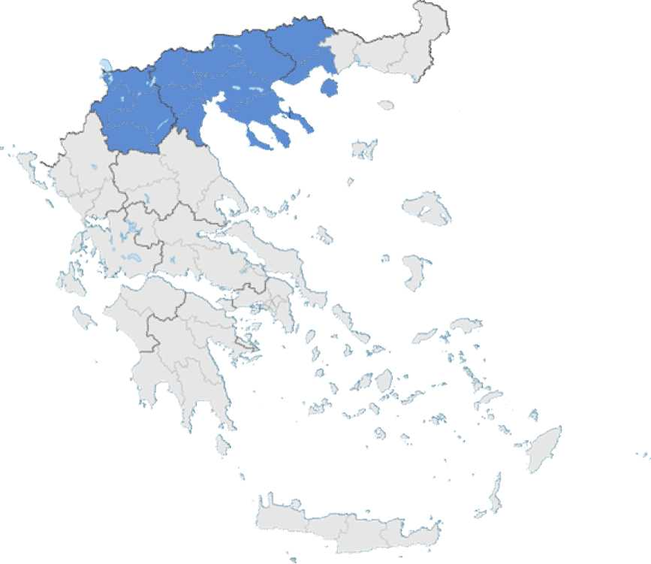

The stages of production that must take place within the defined geographical area are:

-flavouring of ethyl alcohol with aromatic raw materials by maceration and/or distillation;

-blending of the flavoured alcohols;

-addition of flavourings and sweeteners;

-dilution with water to obtain the final alcoholic strength;

-bottling.

**Method of production**

‘Ouzo of Macedonia’ is produced by blending alcohols that have been flavoured by distillation with fennel seeds, aniseed and other aromatic seeds, plants and/or fruit.

The following method is used to produce ouzo in 1 000-litre stills:

The fennel seeds, which come from farms in the regions of Macedonia, are checked for their essential oil and moisture content and are stored in special containers. Two days before distillation, they are washed well with water in order to remove foreign bodies and to soak them. The seeds are then stored in special bags.

The following are added to the still one day before distillation: the fennel seeds, the remaining aromatic plants and the hydro-alcoholic solution, up to 2/3 of the total capacity of the distillation still (750 litres). The total quantity of aromatic seeds and plants added to the solution must be at least 10 grams per litre of the hydro-alcoholic solution, and at least 80 % must be fennel seeds.

The hydro-alcoholic solution is kept in the still together with the seeds for 18 hours in order to extract the flavourings. It is then distilled by steam heating.

The first fraction of the distillate (the ‘head’) is collected separately.

The main part of the distillate (the ‘heart’) is then collected in a separate tank. Its average alcoholic strength is 60-70 % vol. The collection of the ‘heart’ is stopped according to the alcoholic strength and/or organoleptic characteristics of the distillate.

Distillation continues until all the ethyl alcohol is distilled. The last fraction of the distillate (the ‘tail’) is collected in separate tanks.

The main part of the distillate (the ‘heart’) is used to produce ‘Ouzo of Macedonia’, while the first and third (last) fractions (‘head’ and ‘tail’) are used in the next distillation.

After the distillation process is complete, the distillate (‘heart’) is transferred to a separate tank where its alcoholic strength and anethole level are verified. The distillate is then mixed with deionised water and ethyl alcohol of agricultural origin in proportions such that the alcohol contained in the distillate accounts for more than 30 % of the alcoholic strength of the end product. Natural anethole is added to the hydro-alcoholic mix so that the anethole content of the final product is approximately 0.7 g/l.

The end product is checked with regard to its alcoholic strength, its density and whether it becomes cloudy when water is added. It is then passed through a plate filter and stored in a non-corrosive tank until it is fed to the bottling line and bottled. At the next stage on the production line, the bottles are labelled, so that the product is identified as ‘Ouzo of Macedonia’ (and marked with all the information required by the legislation).

Finally, the bottles are marked with the lot number.

These pre-packaged products are placed in cardboard boxes, which are also marked with the lot number. The lot number also has to be marked on the boxes because of the requirements of the quality and safety systems with regard to traceability. The boxes are then loaded onto pallets and the pallets are taken to the finished product warehouse, where they are stored in controlled humidity and temperature conditions that are suitable for ‘Ouzo of Macedonia’, until they are placed on the market.

**Link with the geographical environment or origin**

‘Ouzo of Macedonia’ currently accounts for 4 % of total ouzo production in Greece. The product is highly oriented towards exports, which have increased steadily over the last three years.

The following factors attest to the link between ‘Ouzo of Macedonia’ and the geographical area:

Link between the reputation of ‘Ouzo of Macedonia’ and the geographical area.

**Historical factors**

Since the time of Hippocrates, fennel fruit has been used as an appetizer, diuretic, antipyretic and generally to treat problems concerning the digestive system.

Dion, the sacred town of ancient Macedonia was later named Malathria, which comes from the word ‘μάλαθρον’ (malathron), another name for fennel, due to the fennel grown in this region.

In modern history, Greek distillers fleeing the coast of Asia Minor settled in the regions of Macedonia. By then, tsipouro, the alcoholic raw material used to produce spirit drinks had already been replaced by pure ethyl alcohol. Upon their arrival in Macedonia, the Greek distillers found fennel, a plant with similar characteristics to that of aniseed, growing abundantly in the area. They thus replaced aniseed with fennel, giving ‘Ouzo of Macedonia’ a distinctive character.

‘Ouzo of Macedonia’, the main alcoholic beverage produced in the region of Macedonia, went through various phases to reach the form we know today in the early 20th century.

The production of ouzo in Macedonia began in the 19th century and continued, uninterrupted, throughout the 20th century. In the inter-war years (1919-1940), around thirty small factories operated in the distillery industry. During the same period, the ‘Greek Federation of Macedonian Distillers’ was established in Thessaloniki with 21 founding members, as well as the ‘Halkeon’ Federation of Thessaloniki with 35 founding members. (‘Halkeis’ was the name used to refer to manufacturers of the copper stills used to flavour ethyl alcohol through distillation).

**Economic aspects**

There are currently 27 ouzo production units registered in the region of Macedonia. Many of these were established at the end of the 19th century or beginning of the 20th century. These units cover a wide range of manufacturing volumes, from small family businesses marketing their entire production in the regional unit (or prefecture) where they are based, to large companies with strong export activity to EU countries as well as third countries such as the USA, Canada, Australia, Russia etc.

The operation of these units, depending on their size, contributes directly and indirectly to the local economy in several ways. In particular, it supports agricultural production, given that only fennel which is grown in the rural areas of Macedonia is used to produce ‘Ouzo of Macedonia’.

**Social aspects**

Ouzo is firmly rooted in the everyday lives of people from Macedonia, all year round. A rich vocabulary including ouzo and its diminutive ‘ouzaki’ ‘ouzadiko’ and ‘ouzeri’ (establishments serving ouzo) ‘ouzo mezedes’ (meze to accompany ouzo) etc., can be heard in all regions of Macedonia at various everyday events.

Many establishments serve ouzo, together with ‘ouzo mezedes’, mainly seafood. These establishments are found along the vast beaches of Macedonia from Keramoti in Kavala to Platamonas in Pieria, and as far as inland Macedonia.

Geographical area – natural factors

**Aromatic raw materials**

The main aromatic raw material for ‘Ouzo of Macedonia’ is fennel (Foeniculum vulgare) which is grown in the wider area of Macedonia. Fennel is a herbaceous, aromatic plant which reaches a height of two metres. Its flowers look like yellow umbrellas. It comes from southern Europe and the Middle East and thrives in temperate climates.

In Ancient Greece, fennel was a symbol of victory and success. In mythology, it is referred to as the symbolic plant used by the gods to pass on their knowledge to humans. In Ancient Greece it was considered to be a strong aphrodisiac while in Egypt it was used to fight migraines. It became widely available in Europe during the time of Charlemagne. It is linked to the most ancient medical cures and it is believed to have beneficial effects for eyesight and easing stomach complaints and abdominal pain (ideal for babies).

In addition to anethole, the main aromatic compound in terms of quantity, it contains a large number of other aromatic compounds: anisaldehyde, anisketone, limonene, alpha-pinene, fenchone, estragol, methyl-kavicole, camphene, beta-pinene, sampinene, myrcene, alpha-phellandrene, delta-3-carene, gamma-terpinene, 1.8-cineole, p-cymene, terpinolene, cis-ocimene, octanale, nonanale, citronellale, decanale, linalool, linalool acetate, camphor, alpha-fenchol, terpinen-4-ol, alpha-terpineol, citrale, carvone.

It is well known that the overall content of essential oils varies greatly in terms of their different components and mainly depends on the plant variety, soil and climate conditions, farming conditions and farming practices, as well as the post-harvest treatment used.

The characteristics of the variety of fennel grown in Macedonia are addressed in a detailed comparison with the characteristics of the variety grown in the neighbouring countries - Turkey and Bulgaria - in the study: ‘Investigation into the factors defining the quality of fennel (Foeniculum Vulgarae Mill) grown in northern Greece’ *(Διερεύνηση των παραμέτρων που καθορίζουν την ποιότητα του μαράθου (Foeniculum Vulgarae Mill.) που καλλιεργείται στο βορειοελλαδικό χώρο)* carried out as part of the Research and Technology Operational Programme EPET II.

According to the results of this study, as set out in the final report (ref. ΠΑΒΕ 97ΒΕ304, October 2001), the Macedonian variety has a higher yield of essential oil than the Turkish one, while the aromatics content of the two varieties is similar. The Bulgarian variety yields more essential oil. However, this contains much less anethole compared to the other two varieties. Specifically, the anethole content of the Macedonian and Turkish varieties ranges from 82-89 % while the content of the Bulgarian variety ranges from 59-68 %.

Apart from anethole, the main components of the essential oils of all three varieties are estragole, fenchone and beta-limonene. Differences can also be observed in terms of the content of these components. Specifically, the fenchone content is particularly high in the Bulgarian variety (20-25 %), in contrast with the Macedonian and Turkish varieties (0.5-2 %). Differences are also observed in the content of beta-limonene and estragole (2.5 % in the Bulgarian variety and 3.5-4.5 % in the Macedonian and Turkish varieties).

**EU provisions and national/regional provisions**

EU provisions

‘Ouzo of Macedonia’ is a geographical indication registered for Greece under ‘distilled anise’ (product category 29 in Annex III to Regulation (EC) No 110/2008).

Its production and presentation is governed by specific EU legislation on spirit drinks, namely Regulation (ΕC) No 110/2008 and Implementing Regulation (EU) No 716/2013, and Regulation (EU) No 1169/2011 on the provision of food information to consumers, subject to the specific provisions and exceptions for spirit drinks provided for in that Regulation.

National provisions

The production and presentation of ‘Ouzo of Macedonia’ is governed by the applicable national legislation on the production and distribution of spirit drinks and Ouzo in general.

In addition, specific conditions governing the use of the geographical indication ‘Ouzo of Macedonia’ are laid down in Decision 30/077/1193/18-5-2011 of the Deputy Minister for Finance (Government Gazette, Series II, No 935 of 23 May 2011) on conditions governing the use of the geographical indication ‘Ouzo of Macedonia’.

(The text of the Decision is attached as Annex I).

**Applicant**

Member State: Greece

Competent authority:

**MINISTRY OF FINANCE**

**SECRETARIAT-GENERAL**

**FOR PUBLIC REVENUE**

**DIRECTORATE-GENERAL**

**GENERAL STATE CHEMICAL LABORATORY**

**DIRECTORATE FOR ALCOHOL AND FOODSTUFFS**

**SECTION Α**

Address: : A. Tsocha 16

Athens 115 21,

Greece 0030-210-

Tel.: 030-210-6479273

Fax: 221 0030-210-6468272

Email: alcohol_food@gcsl.gr

In English:

**Hellenic Republic**

**Ministry of Finance**

**General Secretariat**

**FOR PUBLIC REVENUE**

**General Directorate**

**of General Chemical State Laboratory Directorate of Alcohol & Foodstuffs SECTION A'**

Address : Anast. Tsocha 16

Athens 115 21, Greece Tel : 0030-210-6479273, -221

Fax : 0030-210-6468272

e-mail : [alcohol_food@gcsl.gr](mailto:alcohol_food@gcsl.gr)

**ANNEX I**

No 30/077/1193

Conditions governing the use of the geographical indication ‘Ouzo of Macedonia’

**DECISION**

**THE DEPUTY MINISTER FOR FINANCE**

**Having regard to:**

1. The provisions under Chapter III ‘Geographical indications’ of Regulation (EC) No 110/2008 on the definition, description, presentation, labelling and the protection of geographical indications of spirit drinks and repealing Council Regulation (EEC) No 1576/89;
2. Point 29 of Annex III to that Regulation, which lists, with respect to Greece, the ‘Ούζο Μακεδονίας’/‘Ouzo of Macedonia’ geographical indication as a spirit drink in the category ‘distilled anise’;
3. The provisions of Article 5(4)(f) of Law 2969/2001;
4. The provisions of Article 7(1), (2) and (5)(a) on geographical and traditional designations and names of Decision No 3010878/1396/2003 of the Minister for the Economy and Finance on the production and distribution of spirit drinks (Government Gazette, Series II, No 832 of 25 June 2003), as amended by Decision No 3018093/2377/0029/9.8.2007 of the Minister for the Economy and Finance (Government Gazette, Series II, No 1634 of 17 August 2007);
5. The provisions on ouzo (Chapter I of Article 6) of the same Decision;
6. Joint Decision No Δ6Α1142500 ΕΞ 2010/26.10.2010 of the Prime Minister and the Minister for Finance delegating powers to the Deputy Minister for Finance, Mr Dimitrios Kouselas (Government Gazette, Series II, No 1725 of 3 November 2010);
7. The application of the distillers concerned and the information recorded in the file submitted;
8. The recommendation dated 23 March 2011 from the Directorate for Alcohol, Alcoholic Beverages, Wine and Beer of the General State Chemical Laboratory to the Deputy Minister for Finance on the publication of a decision;
9. The fact that this Decision entails no expenditure under the national budget,

**Has decided as follows  
Article 1**

1. This Decision lays down the production terms and monitoring procedures required for ouzo to be placed on the market bearing the geographical indication ‘Ouzo of Macedonia’, which has already been registered for Greece pursuant to Regulation (EC) No 110/2008. ‘Ούζο Μακεδονικό’ (Macedonian Ouzo) may be used as an alternative indication.
2. The ‘Μακεδονίας’ (of Macedonia) or ‘Μακεδονικό’ (Macedonian) indication shall be printed on the bottle next to the sales denomination ‘ούζο’ (ouzo) in a font no larger than the font used for the sales denomination.

**Article 2**

1. In order for the geographical indication to be used, the entire production process, from the stage of flavouring distilled ethyl alcohol to the final preparation of the drink and its bottling, must be carried out at the production facilities of businesses located within the boundaries of the region of Macedonia, which includes the regions of West and Central Macedonia and the regional units of Drama and Kavala in the region of Eastern Macedonia and Thrace.
2. The geographical indication may not be used in any way on the labelling of ouzo if the conditions herein are not met.
3. The trade names of other spirit drinks may not contain the word ‘Μακεδονία’ (Macedonia), even in derivative or compound form.

**Article 3**

1. Distillers who wish to produce and market ouzo bearing the geographical indication ‘Μακεδονίας’ (of Macedonia) or ‘Μακεδονικό’ (Macedonian) shall submit all relevant information supporting their entitlement to use that geographical indication to the local Chemical Service. The Chemical Service, following the examination of the evidence, shall grant the approval to use the geographical indication in question to the interested parties.
2. The local Chemical Service shall inspect regularly the distillers who make use of this geographical indication, and shall revoke the above approval if the distillers breach Articles 1 and 2 of this Decision.
3. Failure to observe the terms and conditions of this Decision constitutes a breach of Law 2969/2001, which is punishable in accordance with Article 11(2)(l) and Article 12(h) of that Law.

**Article 4**

This Decision shall be published in the Government Gazette and shall enter into force on the date of its publication.

**THE DEPUTY MINISTER FOR FINANCE**

**DIMITRIOS KOUSELAS**